ТестТЕСТ  
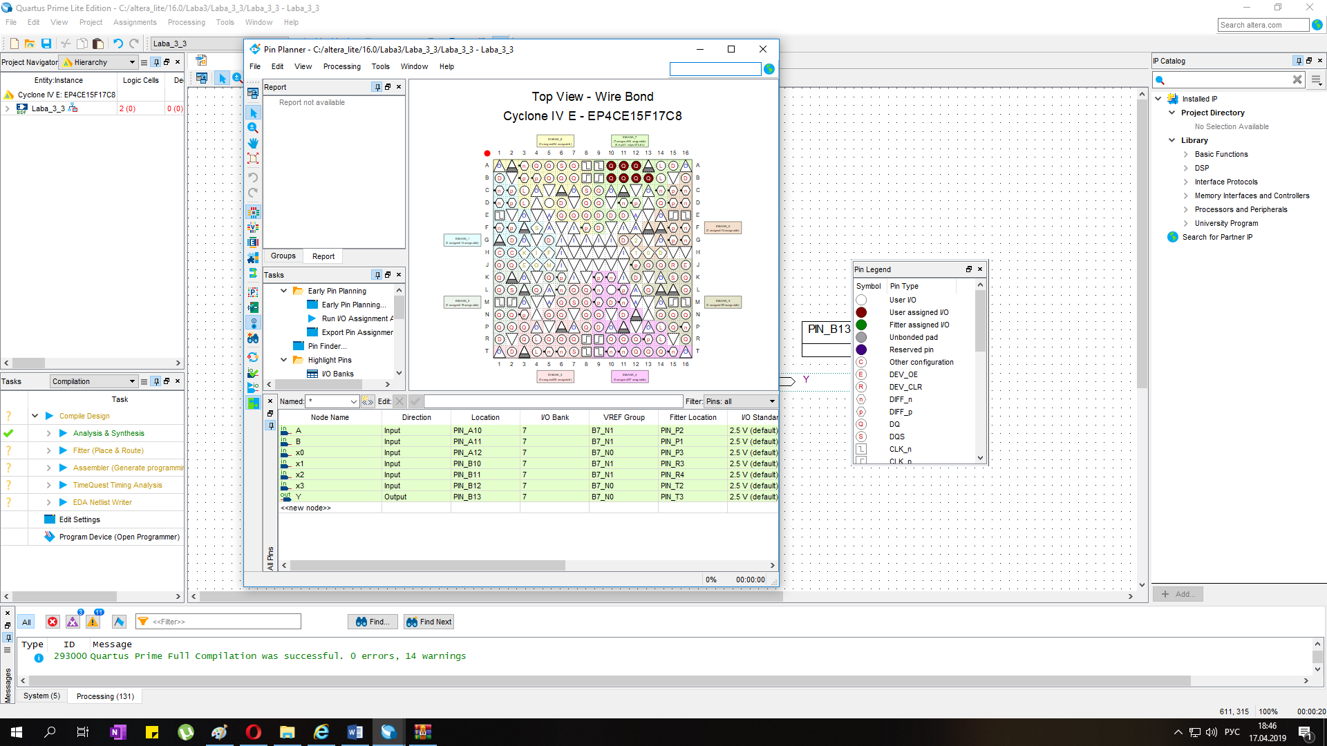

|  |  |  |  |  |  |  |  |  |
| --- | --- | --- | --- | --- | --- | --- | --- | --- |
| павпвп |  |  |  |  |  |  |  |  |
|  |  |  |  |  |  |  |  |  |
|  |  |  |  |  |  |  |  |  |
|  |  |  |  |  |  |  |  |  |
|  |  |  |  | ИГЩИ |  |  |  |  |
|  |  |  |  |  |  |  |  |  |
|  |  |  |  |  |  |  |  |  |
|  |  |  |  |  |  |  |  |  |

$${\left(x+a\right)}^{n}=\sum_{k=0}^{n}{\left({n \atop k}\right)x^{k}a^{n-k}}$$