**Name: Natalia Russu**

SQL SELECT, WHERE, DISTINCT practice

1. Write a select statement to return all columns and rows from the customer table.

Re: ​​**select** * **from** customer;

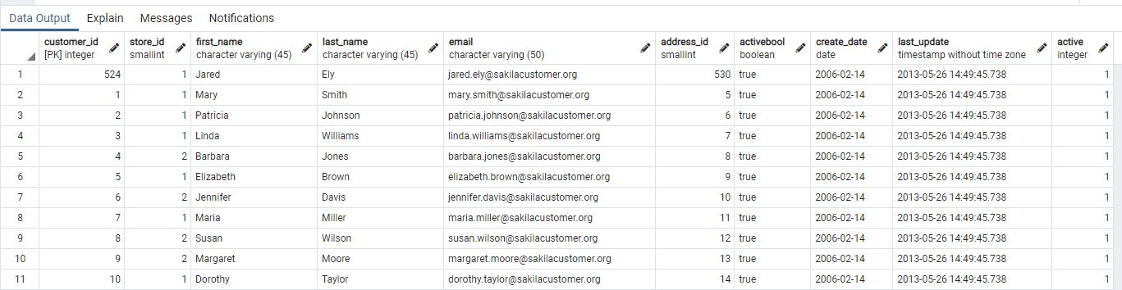

1. Write a query to select first name, last name, and email from the customer table.

RE: **select** last_name, first_name, email **from** customer;

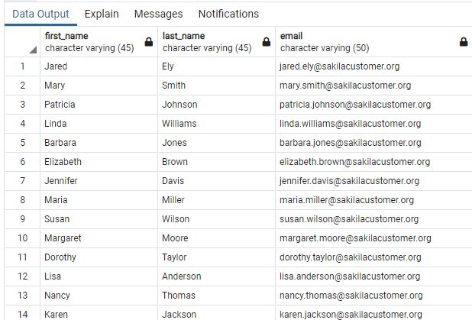

1. Write a query to return all rows and columns from the film table.

RE: ​​**select** * **from** film;



1. Write a query to return unique rows from the release_year column in the film table.

Re:  **select distinct** release_year **from** film;

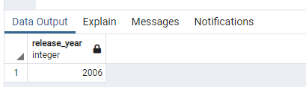

1. Write a query to return unique rows from the rental_rate column in the film table.

Re: **select distinct** rental_rate **from** film;

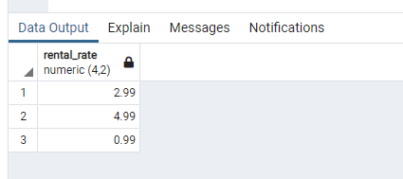

1. A customer left us some feedback about our store. Write a query to find her email address – for Nancy Thomas.

RE : SELECT email FROM customer

WHERE first_name='Nancy'

AND last_name='Thomas';

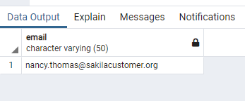

1. We’re trying to find a customer located at a certain address ‘259 Ipoh Drive’ – can you find their phone number?

re: **select** phone **from** address **where** address='259 Ipoh Drive';

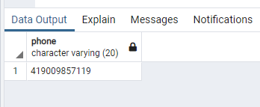

1. Write a query from the customer table, where store id is 1 and address id is greater than 150.

re : SELECT * FROM customer WHERE store_id=1 AND address_id > 150;

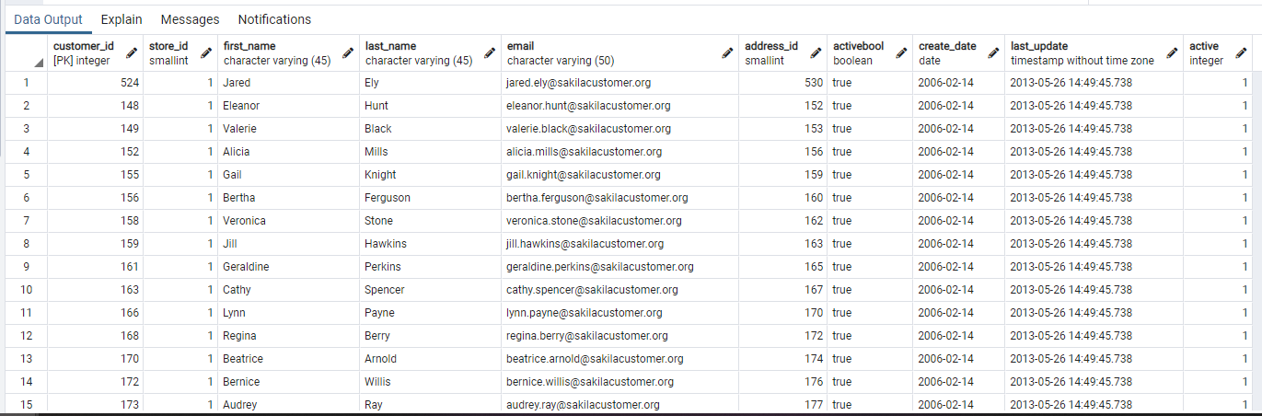

1. Write a query from the payment table where the amount is either 4.99 or 1.99.

re : SELECT * FROM payment WHERE amount=4.99 OR amount=1.99;

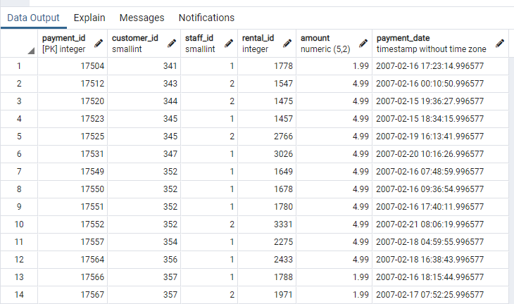

1. Write a query to return a list of transitions from the payment table where the amount is greater than 5.

re:  **SELECT** * **FROM** payment **WHERE** amount>5;

