Architecture

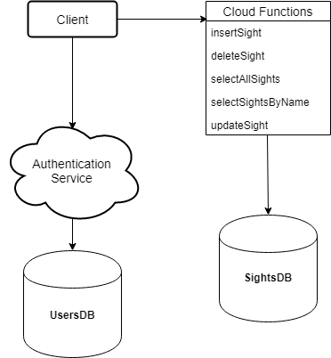

A **serverless** application (**firebase(db & cloud functions)** + **react(client)**).

Language: **JS**.

# Server

**Firebase database** and **cloud functions for firebase**

### Database

The Firebase Realtime Database is a cloud-hosted database. Data is stored as JSON and synchronized in realtime to every connected client. When you build cross-platform apps with our iOS, Android, and JavaScript SDKs, all of your clients share one Realtime Database instance and automatically receive updates with the newest data.

### Cloud Functions

Cloud Functions for Firebase let’s you automatically run backend code in response to events triggered by Firebase features and HTTPS requests. Your code is stored in Google’s cloud and runs in a managed environment. There’s no need to manage and scale your own servers.

# Client

**React**

In computing, React is a JavaScript library for building user interfaces. It is maintained by Facebook and a community of individual developers and companies. React can be used as a base in the development of single-page or mobile applications.

DB

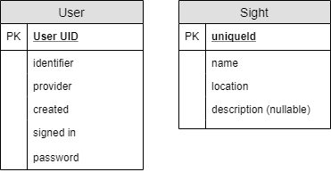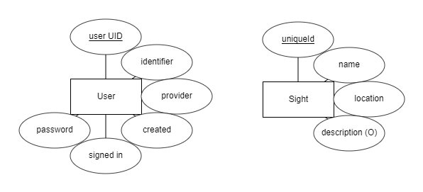

Components

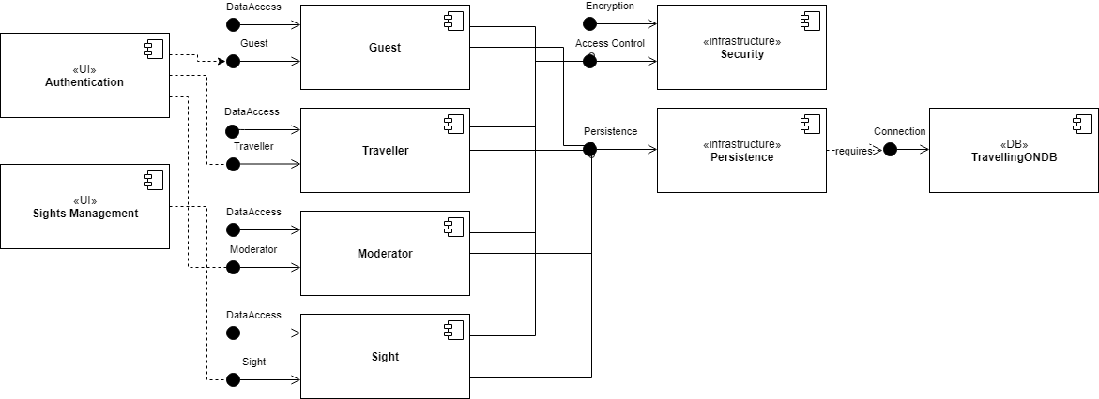

Sequence

# View All Sights

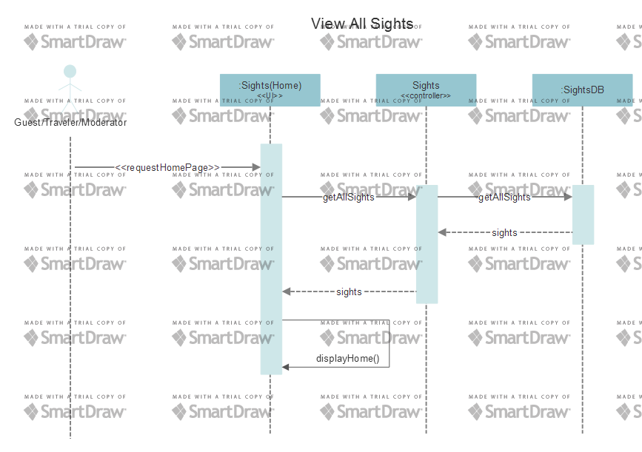

# Add New Sight

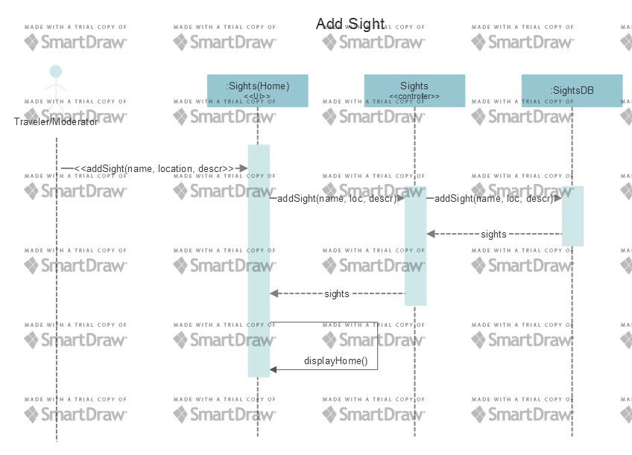

# Update Sight

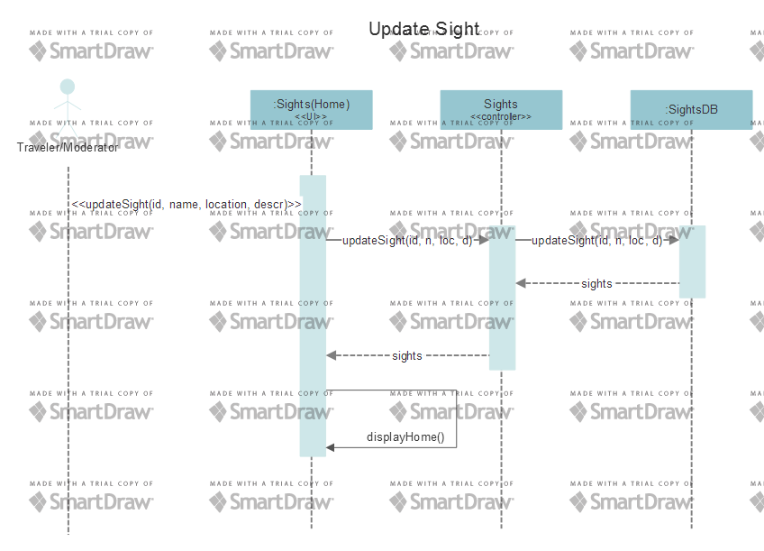

# Delete Sight

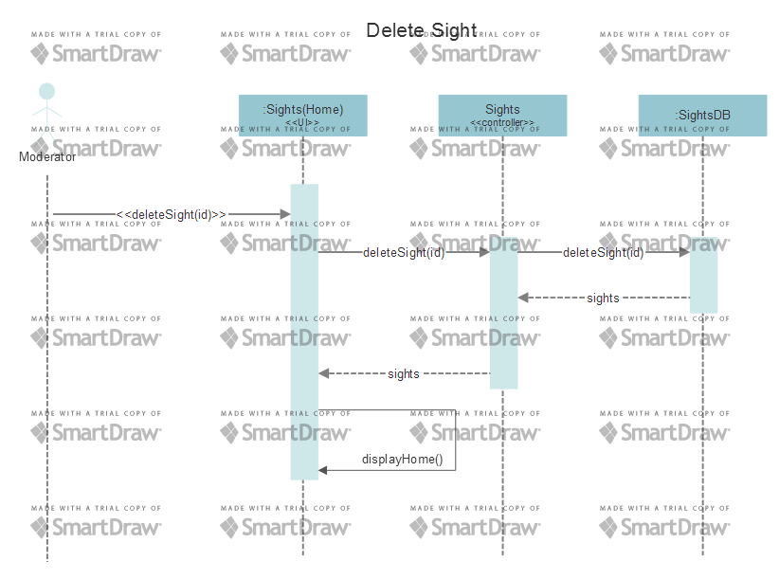

# Delete All Sights

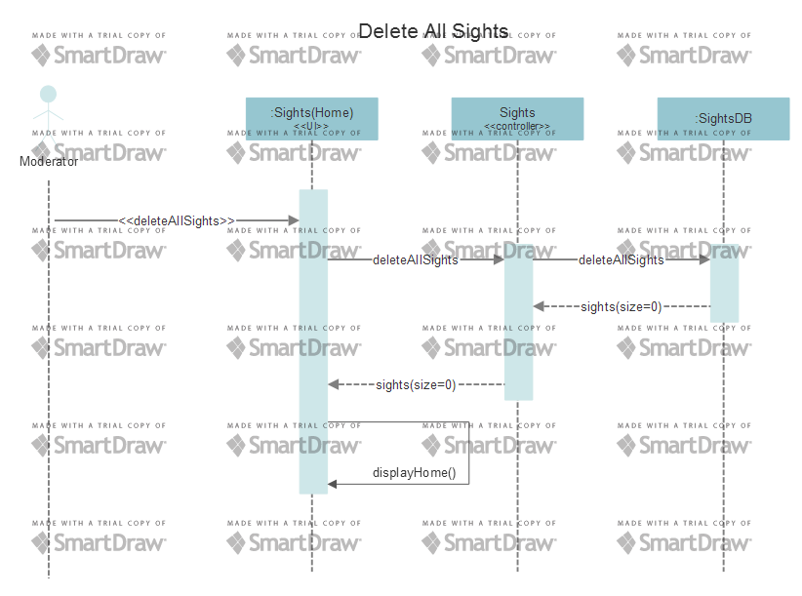

# Sign up

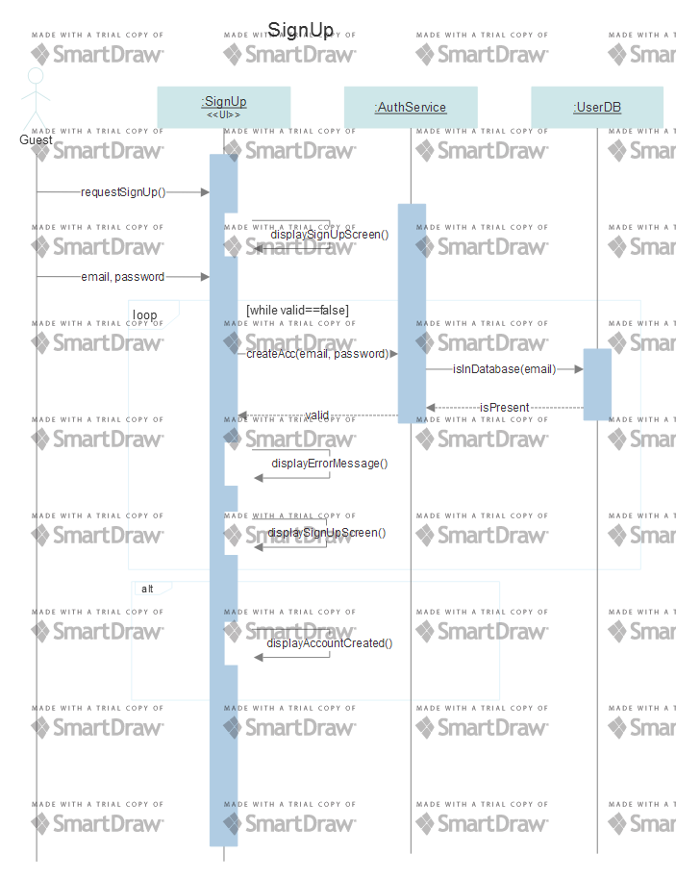

# Sign in

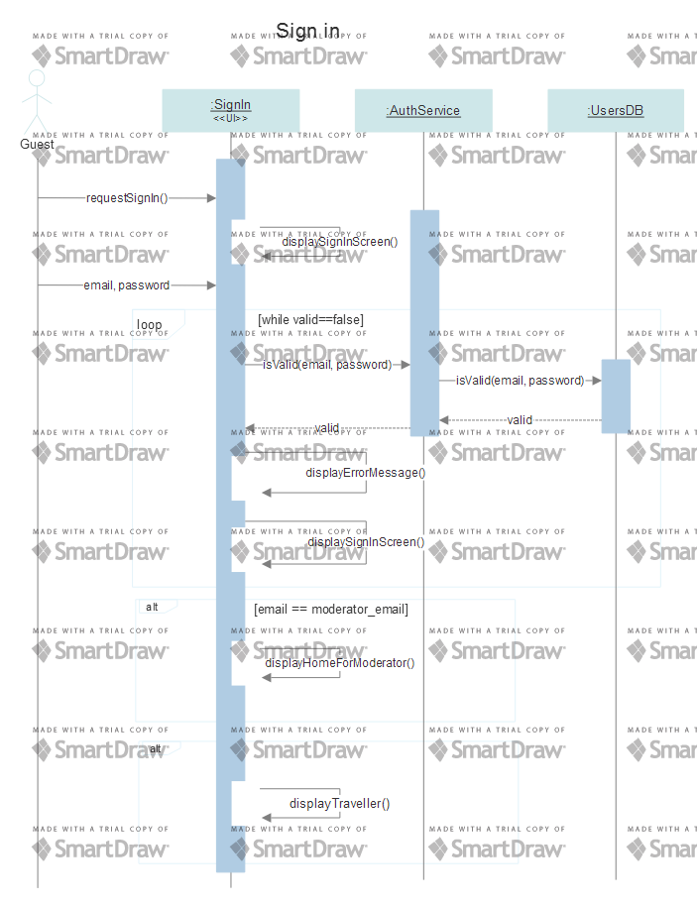

# Sign out

