Requirements

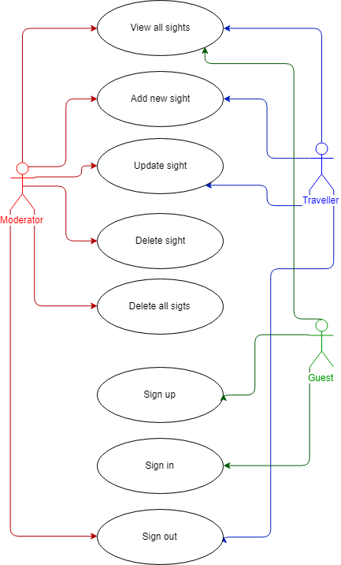

Img.1 Use-Case Diagram

Roles

# Guest

Not logged in user

# Traveler

Logged in user

# Moderator

Logged in with moderator credentials user

# View All Sights

**As** Guest/Traveler,   
**I want** to be able to view all the existing sights,   
**So that** I can choose the one I like the most to go on a trip to.

**As** Moderator,   
**I want** to be able to view all the existing sights,   
**So that** I can check if they exist and if the information is correct.

**Given** I am a Guest/Traveler/Moderator,

**When** I click the Home tab on menu bar

**Then** system redirects me to the Home page, shows “Amount of sights found: [amount of sights]” message on the top and displays all the existing sights sorted by time they were added to the database in the 5-column table below (columns: Number, Name, Location, Description, Actions (If I am a Guest Actions column is empty, if I am a Traveler is has “View Trips” and “Update” buttons, if I am a Moderator it has “View Trips”, “Update” and “Remove” buttons as well as the “Remove All” button below the table)) if there are any sights in the database and shows “No sights found” message on the top if there are no sights in the database.

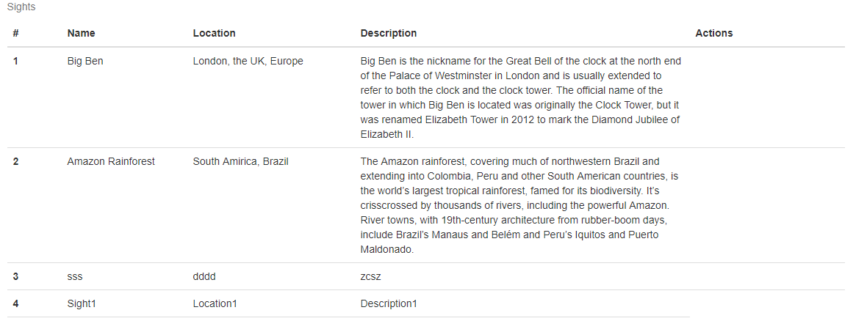

Img.2 View All Sights Mockup (Guest)

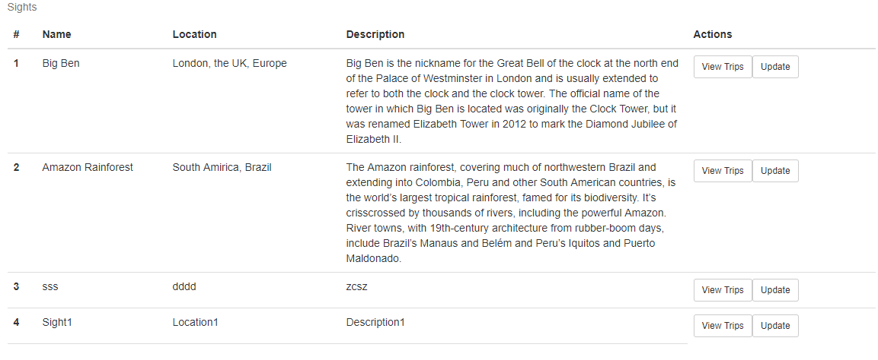

Img.3 View All Sights Mockup (Traveler)

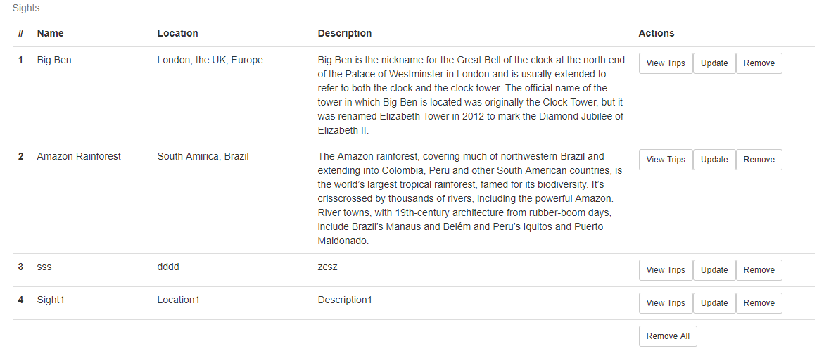

Img.4 View All Sights Mockup (Moderator)

# Add New Sight

**As** Traveler/Moderator,   
**I want** to be able to add new sight,   
**So that** I can share the information with other users and give them one more possible destination to go on a trip to.

**Given** I am a Traveler/Moderator and I am on the Home page,

**When** I fill in the “Name”, “Location” and “Description” fields with new sight data and I click the Add button

**Then** the system adds new sight to database, reloads the page, shows “New sight added. Amount of sights found: [amount of sights]” message on the top and displays the new sight with the others in the table below.

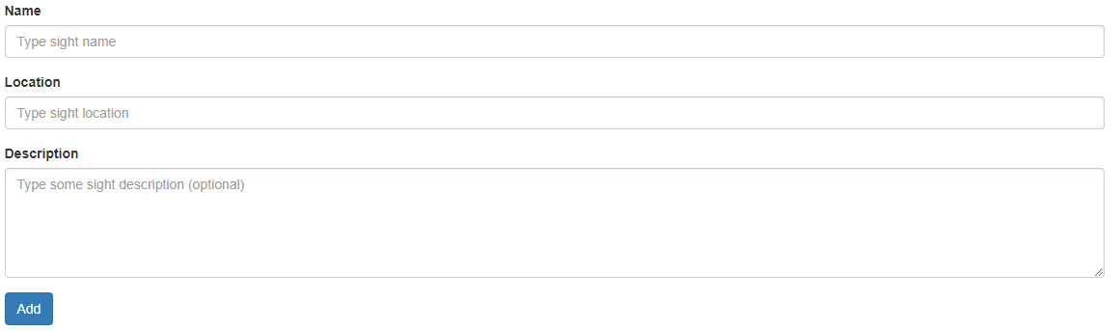

Img.5 Add New Sight Form Mockup

# Update Sight

**As** Traveler/Moderator,   
**I want** to be able to update the sight data,   
**So that** I can adjust the sight data such as add new details in the description, correct spelling mistakes.

**Given** I am a Traveler/Moderator and I am on the Home page,

**When** I scroll down and find the sight, I want to update in the table, I click the Update button, I scroll down to the bottom to where the chosen sight data displayed, I update the content of the “Name”, “Location” and “Description” fields and I click the Submit button

**Then** the system updates the sight data in database, reloads the page, shows “Sight updated. Amount of sights found: [amount of sights]” message on the top and displays the updated data in the table below.

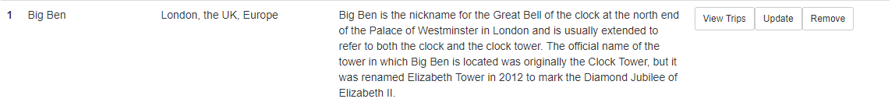 Img.6 Update Button Mockup

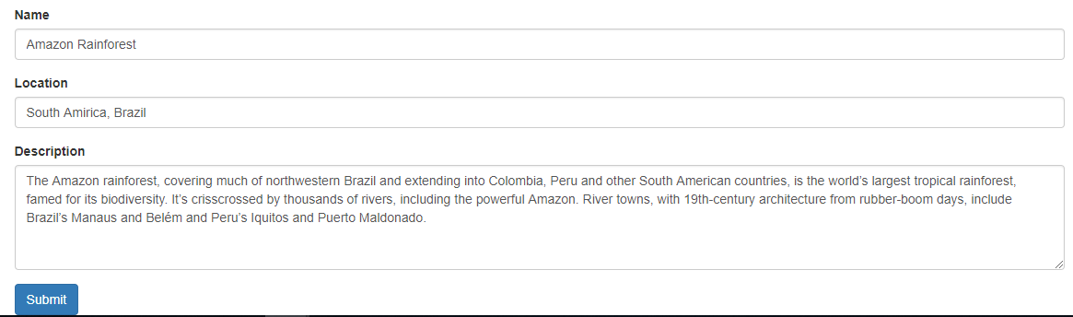

Img.7 Update Sight Form Mockup

# Delete Sight

**As** Moderator,   
**I want** to be able to delete the sight,   
**So that** I can remove the “spam” sight or the sight, which is no longer valid.

**Given** I am Moderator and I am on the Home page,

**When** I scroll down and find the sight, I want to delete in the table and I click the Remove button

**Then** the system deletes the sight from database, reloads the page and shows “Sight removed. Amount of sights found: [amount of sights]” message on the top and does not display the deleted sight in the table below if there is at least one more sight left in the database and shows “Sight removed. No sights found” message on the top if there are no sights left in the database.



Img.8 Remove Button Mockup

# Delete All Sights

**As** Moderator,   
**I want** to be able to delete all sights,   
**So that** I can clean up the sights database in case of an attack on the server occurred and refill it just with valid sights data.

**Given** I am Moderator and I am on the Home page,

**When** I scroll down and I click the Remove All button

**Then** the system deletes all sights from database, reloads the page and shows “No sights found” message on top.



Img.9 Remove All Button Mockup

# Sign up

**As** Guest,   
**I want** to be able to sign up to the website,   
**So that** I have my own account.

**Given** I am a Guest and I am on Sign Up page,

**When** I fill in the “Email” and “Password” fields and I click the Submit button

**Then** the system creates new account, redirects me to Account Created page and shows “Account created. Would you like to log in?” message on the top.

**Given** I am a Guest and I am on Account Created page,

**When** I click the Log In link

**Then** the system redirects me to Log in page and shows Log In form with “Email” and “Password” fields.

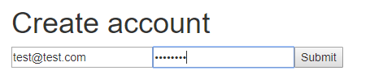

Img.10 Sign Up Form Mockup



Img.11 Account Created Mockup

# Sign in

**As** Guest,   
**I want** to be able to sign in to the website,   
**So that** I have access to more functional.

**Given** I am a Guest and I am on Log In page,

**When** I fill in the “Email” and “Password” fields with my authentication credentials and I click the Submit button

**Then** the system signs me in, redirects me to Home page, makes Create Account and Login tabs on menu bar invisible, makes Logout tab on menu bar visible and shows me “You are logged in as [my email]” message on top right corner.

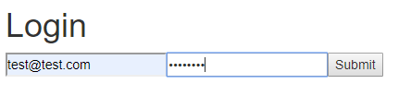

Img.12 Login Form Mockup



Img.13 Menu bar (before signing in) Mockup



Img.14 Menu bar (after signing in) Mockup

# Sign out

**As** Traveler/Moderator,   
**I want** to be able to sign out,   
**So that** I can secure my account from not being used by someone but me, I can create another account and I can login with other credentials.

**Given** I am a Guest and I am Home page,

**When** I click the Logout tab on menu bar

**Then** the system signs me out, reloads the page, makes Logout tab on menu bar invisible, makes Login and Create Account tabs on menu bar visible and shows me “You are not logged in” message on top right corner.



Img.15 Menu bar (before signing out) Mockup



Img.16 Menu bar (after signing out) Mockup