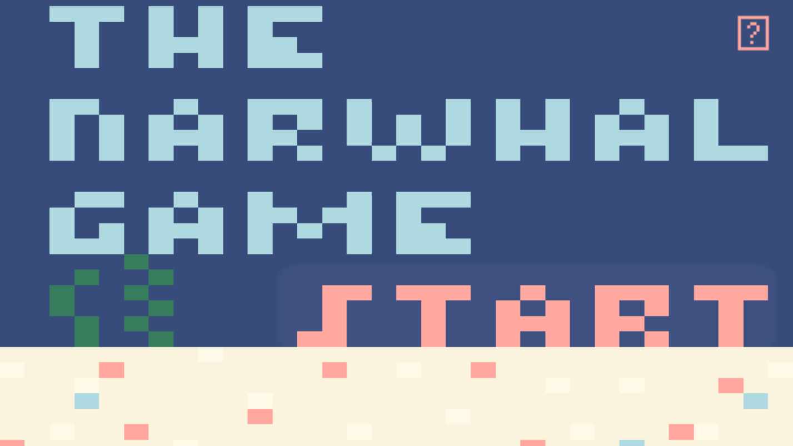Title: The Narwhal Game

Team: Natalie Bellido (Programmer) and Michelle Quan (Designer)

Link(s): <https://nbart108.itch.io/narwhal-game> or <https://nataliebellido.github.io/NarwhalGame/>

In this endless runner, guide the narwhal through the ocean while avoiding the nets, plastic bags, and hungry orcas by using the up/down or w/s keys\*! If the narwhal hits one of these obstacles, the player can collect fishes to regenerate their lives. After the narwhal lost all of its three lives, the game ends and the player can press "r" to start another swim or "m" to return to the main menu!

\*These instructions can also be found by clicking on the question mark on the main menu :)