|  |
| --- |
| Anteros Labs Inc |
| ALMC-100 Specifications |
| **Preliminary** |

|  |
| --- |
| 11/1/2009 |

Table of Contents

Features 3

Overview 4

System Diagram 5

Mechanical Specifications 6

ALMC-100 Physical Models and Component Locations 6

Weight 8

Turning radius spec and speed profiles 8

Communication Specifications 9

Overhead Tracking Broadcast 9

Inter-Vehicle or Vehicle-User Communication 9

Electrical Characteristics 9

Absolute Maximum Ratings 9

Recommended Operating Conditions 10

Register Table 10

Revision History 12

Contact Information 12

# Features

* + **Processors:** 
    - 350MHz-rated Virtex-4 FPGA for on-board image processing and user interface
    - 50MHz ARM Cortex-M3 microcontroller for motion control
  + **Memory:**
    - Fx12 Mini Module features external 64MB DDR SDRAM and 4MB flash
    - Microcontroller features internal 8KB SRAM and 64KB flash
    - 1KB (16-bit) EEPROM for storing system control parameters
  + **Sensors:**
    - A 640x480 camera
    - 140Hz analog gyroscopes for on-board orientation sensing
    - 0.45° resolution optical encoder for on-board speed sensing
  + **Communications:** 
    - 2 serial radio modules dedicated to positioning and inter-vehicle communication
    - Each can transmit and receive at up to 112.5 kbps
  + **Drive and steering system:**
    - Rear wheel drive with speed up to (TBA) m/s
    - Axle-articulated steering system with +/- 30° range
  + **Power:**
    - 4 AAA batteries with at least 30 min runtime
    - Battery voltage-level warning system
  + **Dimensions:**
    - 4in x 2in x 2in
    - 6.89 Oz

# Overview

The ALMC-100s are palm-size wireless autonomous vehicles designed for the robotic testbed in UCLA Applied Math Lab (AML). They can be programmed to perform group maneuvers and carry out cooperative tasks, which are of high interest in today’s cooperative control research.

The AML robotic testbed currently features a 2m x 1.5m arena and a camera-based overhead tracking system that can detect and identify tag-wearing micro-vehicles in real-time (30Hz). Through a dedicated wireless serial link, the ALMC-100s can receive broadcasted positioning information from the tracking system. Through a separate wireless link featuring Carrier Sensing Multiple Access (CSMA), the vehicles can achieve peer-to-peer communication. The vehicles are also built with a front-facing camera, two gyroscopes providing pitch, roll, and yaw information, and an optical encoder (attached to the drive motor) providing accurate speed sensing. All these real-time sensing capabilities are integrated into a fairly compact chassis, thus allowing users to achieve complex cooperative control in a relatively small area. This is immensely valuable to users who wish to verify abstract control theories in a real environment but are hindered by lack of physical space.

Electronic components of the vehicle are divided into two layers (two PCBs, see Figure 2 to Figure 4), which are stacked vertically to form the main body of the chassis. The upper layer features the FX12 Mini Module with a Xilinx Virtex-4 FPGA, a 640x480 camera, and a serial wireless communication module. The lower board houses a 50MHz ARM Cortex-3 microcontroller, a separate serial wireless module, and two high performance gyroscopes. Batteries and the vehicle’s drive and steering systems are also mounted on or attached to the lower board. While the lower board alone is fully capable of controlling the vehicle’s motion, the upper board adds powerful processing, larger memories, enriched sensing, inter-vehicle communication, and simplified user interface. Such a design achieves a good balance in terms of minimizing vehicle footprint and center of gravity.

Four rechargeable AAA (4.8V 800mAH) batteries form the power source of the vehicle. The vehicle can continue to operate until the serial battery voltage drop below 4.2V. Under normal usage load, a single charge should last 30-60min (This number is only an estimate based on power consumptions of major components. It may be revised once field trials are conducted).

The lower board microcontroller would come loaded with driver software to perform basic drive and steering control, access on-board sensors, receive positioning information, and communicate with the upper board FPGA. To program the vehicles, the user would mainly operate within the FPGA. Simple examples that illustrate major capabilities plus detailed documentation of user-accessible components will be provided also.

# System Diagram

Major electronic components of AML-100 and their interfaces are illustrated as below:



Figure : System Diagram

# Mechanical Specifications

## ALMC-100 Physical Models and Component Locations

The following three figures show a 3D model of ALMC-100 from various angles, each with dimension and component labels.

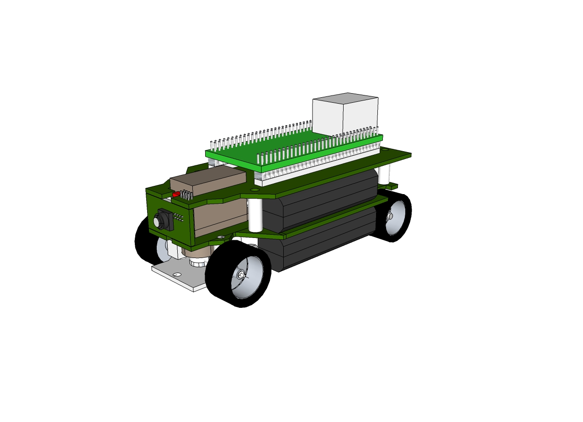

**2.0 in**

**4.0 in**

**1.8 in**

Figure : Isometric view of an ALMC-100 and its physical dimensions

Figure : Side view of an ALMC-100 plus visible component locations

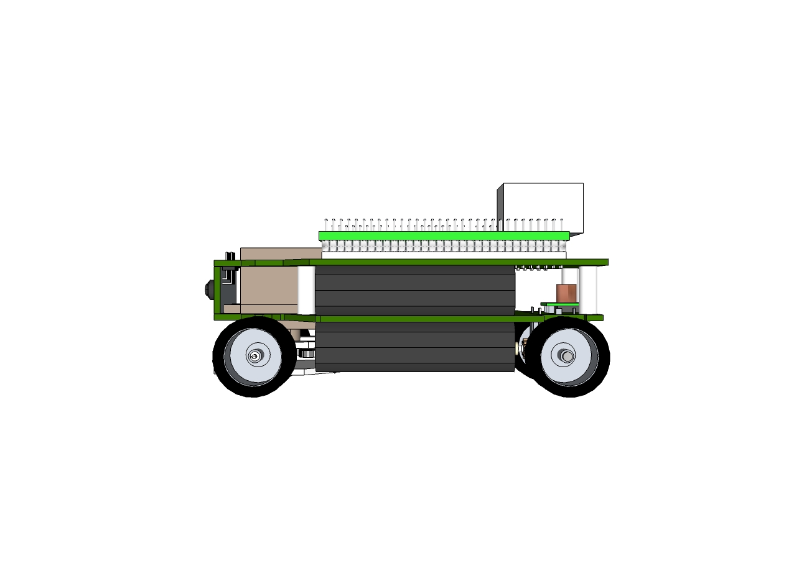

**Ethernet Connector**

**AAA Batteries**

**Fx12 Mini Module**

**Servo**

**Camera**

**Back Wheel**

**Front Wheel**

**3.3 V Regulator**

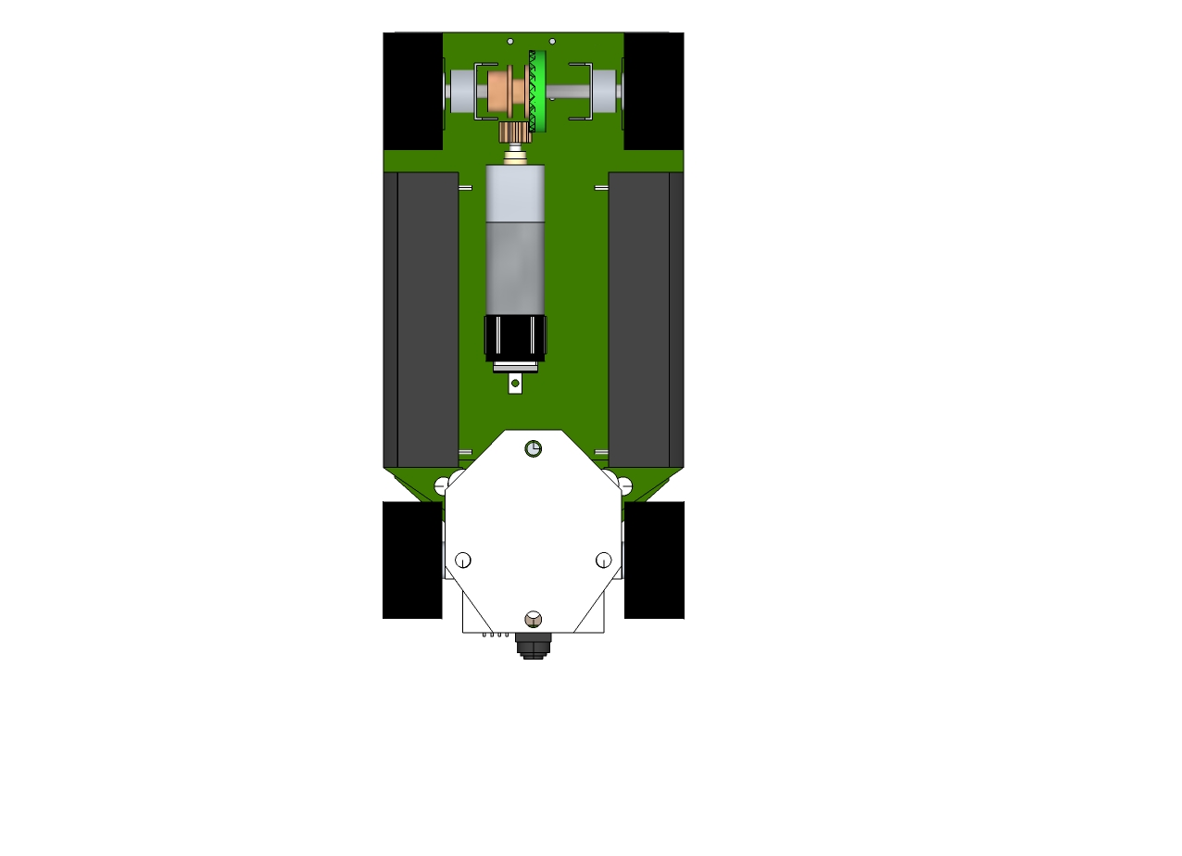

**Camera**

**AAA Batteries**

**Back Wheel**

**Front Wheel**

**Motor + Encoder Assembly**

Figure : Bottom view of an ALMC-100 plus visible component locations

## Weight

195.4g or 6.89Oz (including long-range sensor, but no tag)

## Turning radius spec and speed profiles

To be specified

# Communication Specifications

## Overhead Tracking Broadcast

The ALMC-100s are designed to work with an existing overhead tracking system, which broadcasts positions and orientation information of all the vehicles present on the arena. In addition to its own information, each vehicle can also extract other vehicles’ from the broadcast when required by the application. The broadcast is updated at the rate of the overhead camera (30 Hz). The radio modules can transmit and receive at up to 112.5 kbps. This would easily allow dozens of vehicles’ information to be broadcasted, which well exceeds the current spatial capacity of the arena.

## Inter-Vehicle or Vehicle-User Communication

The upper board features another radio module that’s directed connected to the FPGA. This module is dedicated to inter-vehicle communication and vehicle-user communication. This module would be configured to operate at a different channel that the tracking radio to avoid interference. It can also transmit and receive at up to 112.5 kbps. This module also features CSMA medium access control, which would effectively minimize packet losses due to concurrent transmissions at the physical level. However to achieve efficient sharing of information among vehicles, the users would still need to device an application/transport layer protocol that’s suitable to the application.

# Electrical Characteristics

## Absolute Maximum Ratings

|  |  |  |  |  |
| --- | --- | --- | --- | --- |
| **Components** | **Characteristics** | **Min** | **Max** | **Unit** |
| Lower Board | Supply Voltage | -0.6 | 12.1 | V |
| LM3S818 Microcontroller | Operating Temperature Range | -40 | 85 | °C |
| FX12 Mini Module | I/O Header Pin Voltage | -0.85 | 4.4 | V |

## Recommended Operating Conditions

|  |  |  |  |  |  |
| --- | --- | --- | --- | --- | --- |
| **Components** | **Characteristics** | **Min** | **Typical** | **Max** | **Unit** |
| Lower Board | Supply Voltage | 4.4 |  | 6.0 | V |
| LM3S818 Microcontroller | Operating Temperature Range |  |  | 69 | °C |
| FX12 Mini Module | I/O Header J1-19 ~J1-22 |  | VCOO1 |  | V |
|  | I/O Header J1-49 ~J1-64 |  | VCOO1 |  | V |
|  | I/O Header J2-49 ~J2-64 |  | 3.3 |  | V |

# Register Table

System control parameters that are unique to each vehicle while relatively stable over time are stored in a 1Kb EEPROM on the lower board. The EEPROM is divided into 64 16-bit registers. The following table shows the current designated usage of these registers. Registers that are left blank are not yet occupied.

|  |  |  |
| --- | --- | --- |
| **Register Name** | **Address** | **Description** |
| RegCID | 0x00 | Car ID |
|  | 0x01 | Not in Use |
|  | 0x02 | Not in Use |
|  | 0x03 | Not in Use |
| RegMERR | 0x04 | Motor Encoder Count to Revolution Ratio |
| RegMGR | 0x05 | Motor Gear Ratio |
| RegMPG | 0x06 | Motor Proportional Gain |
| RegMIG | 0x07 | Motor Integral Gain |
| RegMDG | 0x08 | Motor Differential Gain |
| RegMDB | 0x09 | Motor Dead Band |
| RegSO | 0x0A | Servo Offset |
| RegSG | 0x0B | Servo Gain |
| RegSPG | 0x0C | Servo Proportional Gain |
| RegSIG | 0x0D | Servo Integral Gain |
| RegSDG | 0x0E | Servo Differential Gain |
| RegSDB | 0x0F | Servo Dead Band |
| RegGPO | 0x10 | Gyro Pitch ZRL (offset) |
| RegGPG | 0x11 | Gyro Pitch Sensitivity (gain) |
| RegGRO | 0x12 | Gyro Roll ZRL (offset) |
| RegGRG | 0x13 | Gyro Roll Sensitivity (gain) |
| RegGYO | 0x14 | Gyro Yaw ZRL (offset) |
| RegGYG | 0x15 | Gyro Yaw Sensitivity (gain) |
| RegRO | 0x16 | Range LP Offset |
| RegRG | 0x17 | Range LP Gain |
|  | 0x18 |  |
|  | 0x19 |  |
|  | 0x1A |  |
|  | 0x1B |  |
|  | 0x1C |  |
|  | 0x1D |  |
|  | 0x1E |  |
|  | 0x1F |  |
|  | 0x20 | User Data |
|  | 0x21 | User Data |
|  | 0x22 | User Data |
|  | 0x23 | User Data |
|  | 0x24 | User Data |
|  | 0x25 | User Data |
|  | 0x26 | User Data |
|  | 0x27 | User Data |
|  | 0x28 | User Data |
|  | 0x29 | User Data |
|  | 0x2A | User Data |
|  | 0x2B | User Data |
|  | 0x2C | User Data |
|  | 0x2D | User Data |
|  | 0x2E | User Data |
|  | 0x2F | User Data |
|  | 0x30 | User Data |
|  | 0x31 | User Data |
|  | 0x32 | User Data |
|  | 0x33 | User Data |
|  | 0x34 | User Data |
|  | 0x35 | User Data |
|  | 0x36 | User Data |
|  | 0x37 | User Data |
|  | 0x38 | User Data |
|  | 0x39 | User Data |
|  | 0x3A | User Data |
|  | 0x3B | User Data |
|  | 0x3C | User Data |
|  | 0x3D | User Data |
|  | 0x3E | User Data |
|  | 0x3F | User Data |

# Programming Guide

This chapter will mainly focus on programming the LBC, where we’ve provided an API library so that the user can perform fundamental maneuvers and controls. In addition, we’ve also created a demo interface program for the UBC, which demonstrates basic capabilities of interfacing with the LBC. This demo program is by no means comprehensive. The users can either expand its functionalities or build their own interface programs in a similar fashion.

## The Lower Board Controller

To program the lower board microcontroller, please follow these steps:

## The Upper Board Controller Demo

To program the upper board FPGA, please follow these steps:

# Revision History

This is only a preliminary version, as more information is to be added.

# Contact Information

For more information, please contact info@anteroslab.com.