**[remote "origin"]url = https://github.com/arutinvv/MY_JUNE_QA_GROUPfetch = +refs/heads/*:refs/remotes/origin/\***

**1. Given the following:**  
Switch PC on  
Start “outlook”  
IF outlook appears THEN  
Send an email  
Close outlook

**A. 1 test for statement coverage, 1 for branch coverage**B. 1 test for statement coverage, 2 for branch coverage  
C. 1 test for statement coverage. 3 for branch coverage  
D. 2 tests for statement coverage, 2 for branch coverage  
E. 2 tests for statement coverage, 3 for branch coverage

**2. Given the following code, which is true:**  
IF A > B THEN  
C = A + B  
ELSE  
C = A + B  
ENDIF  
Read D

IF C = D Then  
Print “Error”  
ENDIF

A. 1 test for statement coverage, 3 for branch coverage  
B. 2 tests for statement coverage, 2 for branch coverage  
C. 2 tests for statement coverage. 3 for branch coverage  
D. 3 tests for statement coverage, 3 for branch coverage  
**E. 3 tests for statement coverage, 2 for branch coverage**

**3. How  many  test  cases  are  needed  to  achieve  100 %  decision  coverage?**

If (p = q) {  
s = s + 1;  
if (a < S) {  
t = 10;  
}  
} else if (p > q) {  
t = 5;  
}  
  
A. 3  
**B. 6**C. 5  
D. 4

**4. Consider the following:**

**Pick up and read the newspaper  
Look at what is on television  
If there is a program that you are interested in watching then switch the the television on and watch the program  
Otherwise  
Continue reading the newspaper  
If there is a crossword in the newspaper then try and complete the crossword**

A. SC = 1 and DC = 1  
B. SC = 1 and DC = 2  
C. SC = 1 and DC = 3  
**D. SC = 2 and DC = 2**E. SC = 2 and DC = 3

**5. Given the following code, which is true about the minimum number of test cases required for full statement and branch coverage:**

Read P  
Read Q  
IF P+Q > 100 THEN  
Print “Large”  
ENDIF

If P > 50 THEN  
Print “P Large”  
ENDIF

A. 1 test for statement coverage, 3 for branch coverage  
B. 1 test for statement coverage, 2 for branch coverage  
**C. 1 test for statement coverage, 1 for branch coverage**D. 2 tests for statement coverage, 3 for branch coverage  
E. 2 tests for statement coverage, 2 for branch coverage

**6. Minimum Test Required for Statement Coverage:**

Disc = 0  
Order-qty = 0  
Read Order-qty  
If Order-qty >=20 then  
Disc = 0.05  
If Order-qty >=100 then  
Disc =0.1  
End if  
End if

A. Statement coverage is 4  
B. Statement coverage is 1  
C. Statement coverage is 3

**D. Statement coverage is 2**

**7. Minimum Tests Required for Statement Coverage and Branch Coverage:**

Read P  
Read Q  
If p+q > 100 then  
Print “Large”  
End if  
If p > 50 then  
Print “pLarge”  
End if

A. Statement coverage is 2, Branch Coverage is 2  
**B. Statement coverage is 3 and branch coverage is 2**C. Statement coverage is 1 and branch coverage is 2  
D. Statement Coverage is 4 and Branch coverage is 2

**8. What is the smallest number of test cases required to Provide 100% branch coverage?**

If(x>y) x=x+1;  
else y=y+1;  
while(x>y)  
{  
y=x*y; x=x+1;  
}

A. 1  
B. 2  
**C. 3**D. 4

**9. If a program is tested and 100% branch coverage is achieved, which of the following coverage criteria is then guaranteed to be achieved?**

A. 100% Equivalence class coverage  
B. 100% Condition coverage and 100% Statement coverage  
C. 100% Statement coverage  
**D. 100% Multiple condition coverage**

**10. This part of a program is given:**

**WHILE (condition A) Do B**  
**END WHILE**  
**How many decisions should be tested in this code in order to achieve 100% decision coverage?**

A. 2  
B. Indefinite  
**C. 1**D. 4

**11. This part of a program is given:**

**WHILE (condition A)**  
**Do B**  
**END WHILE**

**How many paths should be tested in this code in order to achieve 100% path coverage?**

A. One  
**B. Indefinite**C. Two  
D. Four

**12. If a program is tested and 100% condition coverage is achieved, which of the following coverage criteria is then guaranteed to be achieved?**

**A. 100% branch coverage**   
B. 100% condition coverage and 100% statement coverage  
C. Equivalence class and boundary value coverage  
D. No other white box coverage criterion is guaranteed to be fulfilled 100%

**13. Branch Coverage**

A. Another name for decision coverage  
B. Another name for all-edges coverage  
C. Another name for basic path coverage  
D. All the above

**14. Which of the following statements is NOT correct?**

A. A minimal test set that achieves 100% LCSAJ coverage will also achieve 100% branch coverage.

B. A minimal test set that achieves 100% path coverage will also achieve 100% statement coverage.

C. A minimal test set that achieves 100% path coverage will generally detect more faults than one that achieves 100% statement coverage.

D. A minimal test set that achieves 100% statement coverage will generally detect more faults than one that achieves 100% branch coverage.

**15. Analyze the following highly simplified procedure:**

Ask: “What type of ticket do you require, single or return?”  
IF the customer wants “return”  
Ask: “What rate, Standard or Cheap-day?”  
IF the customer replies “Cheap-day”  
Say: “That will be 11:20”  
ELSE  
Say: “That will be 19:50”  
ENDIF  
ELSE  
Say: “That will be 9:75”  
ENDIF

**Now decide the minimum number of tests that are needed to ensure that all the questions have been asked, all combinations have occurred and all replies given.**

A. 3  
B. 4  
C. 5  
D. 6

**16. Consider the following statements:**

**i.100% statement coverage guarantees 100% branch coverage.**  
**ii.100% branch coverage guarantees 100% statement coverage.**  
**iii.100% branch coverage guarantees 100% decision coverage.**  
**iv.100% decision coverage guarantees 100% branch coverage.**  
**v.100% statement coverage guarantees 100% decision coverage.**

A. ii is True; i, iii, iv & v are False

B. i & v are True; ii, iii & iv are False  
C. ii & iii are True; i, iv & v are False  
D. ii, iii & iv are True; i & v are False

**17. Given the following code, which statement is true about the minimum number of test cases required for full statement and branch coverage?**

**Read p**  
**Read q**  
**IF p+q > 100 THEN**  
**Print “Large”**  
**ENDIF**  
**IF p > 50 THEN**  
**Print “p Large”**  
**ENDIF**

A. 1 test for statement coverage, 3 for branch coverage  
B. 1 test for statement coverage, 2 for branch coverage  
C. 1 test for statement coverage, 1 for branch coverage  
D. 2 tests for statement coverage, 2 for branch coverage

**18. How  many  test  cases  are  needed  to  achieve  100 %  condition  coverage?**  
if ((temperature < 0) or  
(temperature > 100)) {  
alert (“DANGER”);  
if ((speed > 100) and (load <= 50)) {  
speed = 50;  
}  
} else {  
check = false;  
}

A. 5  
B. 4  
C. 2  
D. 3

**19. For the following piece of code, how many test cases are needed to get 100% statement coverage?**

Procedure XRead (Color) // Input color from user

IF (Color == “Red”) THEN

Call Roses(Color)

ELSEIF (Color == “Blue”) THEN

Call Violets(Color)

ELSE

PRINT “User is no Shakespeare”

SaveToDatabase(Color)

End Procedure X

A. 5  
B. 3

C. 1

D. 2

**20. If you are flying with an economy ticket, there is a possibility that you may get upgraded to business class, especially if you hold a gold card in the airline’s frequent flier program. If you don’t hold a gold card, there is a possibility that you will get ‘bumped’ off the flight if it is full and you check in late. This is shown in following Figure. Note that each box (i.e. statement) has been numbered.**

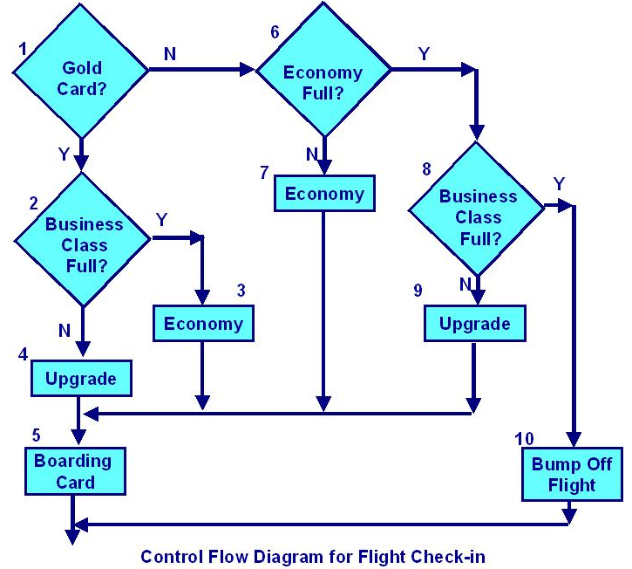

**Three tests have been run:**

**Test 1: Gold card holder who gets upgraded to business class**  
**Test 2: Non-gold card holder who stays in economy**  
**Test 3: A person who is bumped from the flight**

**What is the statement coverage of these three tests?**

1. 60%  
   B. 70%  
   C. 80%  
   D. 90%

**21. Given the following sample of pseudo code:**

01 Input number of male rabbits

02 Input number of female rabbits

03 If male rabbits > 0 and female rabbits > 0 then

04     Input Do you want to breed (Yes / No)

05     If breed = “No”

06          Print “Keep male and female rabbits apart!”

07     End if

08 End If.

**Which of the following test cases will ensure that statement “06” is executed?**

A. male rabbits = 1, female rabbits = 1, breed = “yes”.

B. male rabbits = 1, female rabbits = 1, breed = “no”.

C. male rabbits = 1, female rabbits = 2, breed = “yes”.

D. male rabbits = 1, female rabbits = 0, breed = “no”.

**22. A system under development contains complex calculations and decision logic, and it is assessed as high risk because of the relative inexperience of the development team in the application domain. Which of the following would be the MOST appropriate choice of test design technique for component testing?**

A. Decision testing.

B. Statement testing

C. State transition testing

D. Equivalence partitioning

**23. Given the following flow chart diagram:**

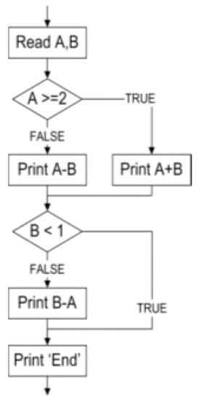

**What is the minimum number of test cases required for 100% statement coverage and 100%decision coverage, respectively?**

A. Statement Coverage = 1, Decision Coverage = 3.

B. Statement Coverage = 2, Decision Coverage = 3.

C. Statement Coverage = 2, Decision Coverage = 2.

D. Statement Coverage = 3, Decision Coverage = 3

**24. Given the following sample of pseudo code:**

Read A, B, C;

If A > B then

Print “Primary ratio is” & A / B;

End If

If A > C then

Print “Secondary ration is” & A / C;

End If.

**Which of the following test cases would achieve 100% statement coverage?**

A. A = 5, B = 10 and C = 2

B. A = 10, B = 10 and C = 10

C. A = 10, B =5 and C = 2

D. A = 2, B= 5 and C = 10