Calculated column

- In DimDate table create Calculated Column “Year Month Label” using FORMAT function
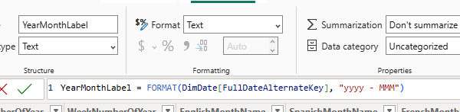
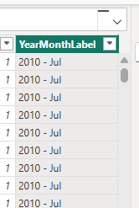
3. Use OrderDate from FactInternetSales – the date hierarchy will be added to X-axis
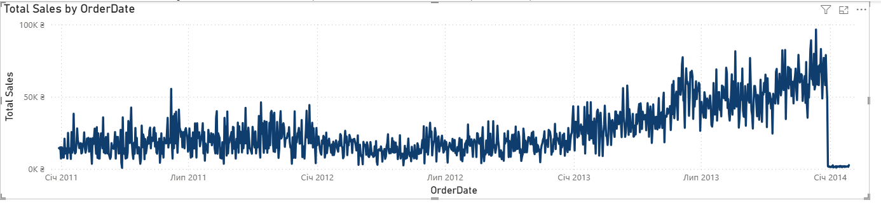
The line chart looks irregular and very dense because the OrderDate field from the FactInternetSales table was used on the X-axis. Power BI automatically applies a Date Hierarchy (Year → Quarter → Month → Day). Since the chart is currently displayed at the day level, it contains a very large number of data points.
Each point on the chart represents the total sales for a specific day, which causes the line to fluctuate frequently and appear jagged. This is expected behavior when visualizing detailed daily transactional data.

4.Month-year label used for X-axis 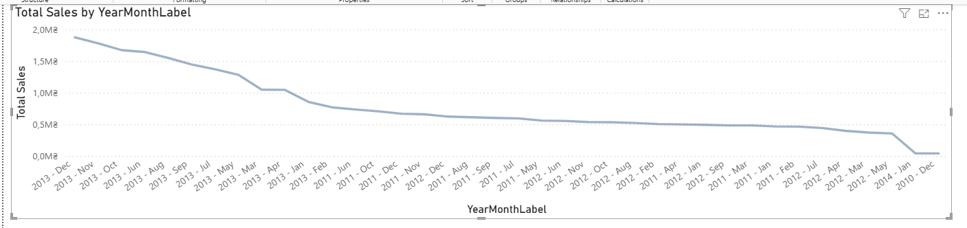
5. 'Calendar Year' field from the 'DimDate' table used in the Filters in this Visual panel and set the filter to show years from and including 2013.

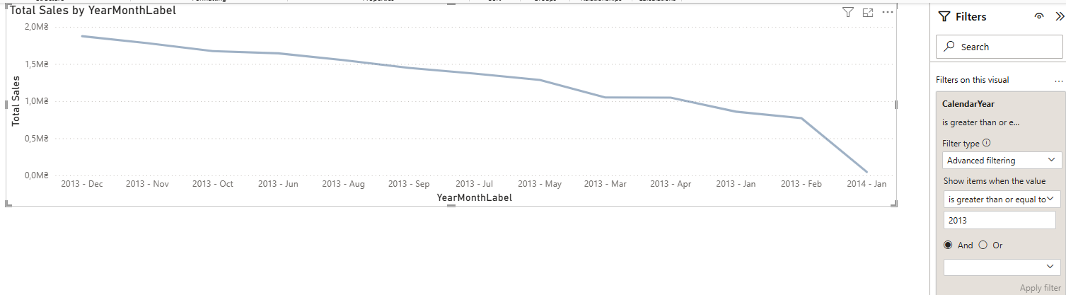
6.Created calculated column YearMonthNumber, sorted column YearMonthLabel by YearMonthNumber. Applied sorting in visual by YearMonthLabel ascending
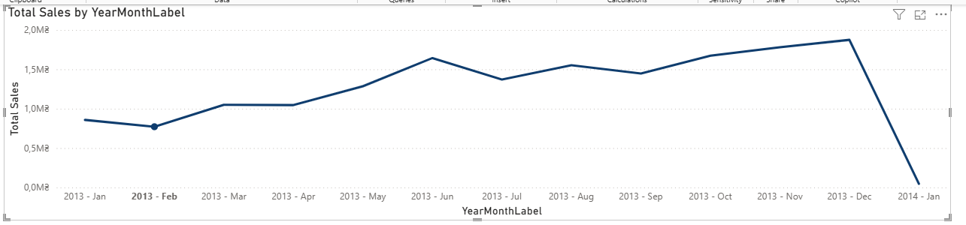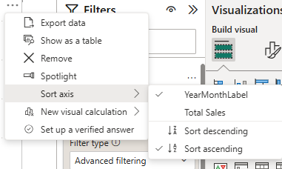
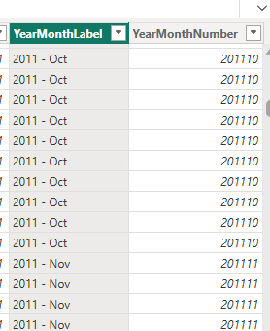
YearMonthNumber = DimDate[CalendarYear] * 100 + DimDate[MonthNumberOfYear]

Measure
Created Today Date = Today()
Changed format to shorter one
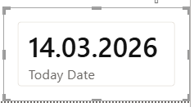
Created measure
Total Orders = SUM(FactInternetSales[OrderQuantity])
Created
Order Quantity YTD =
CALCULATE(
[Order Quantity],
DATESYTD(DimDate[FullDateAlternateKey].[Date])
)
Two visual tables the first one – Order Quantity was used, the second – Order Quantity YTD was used
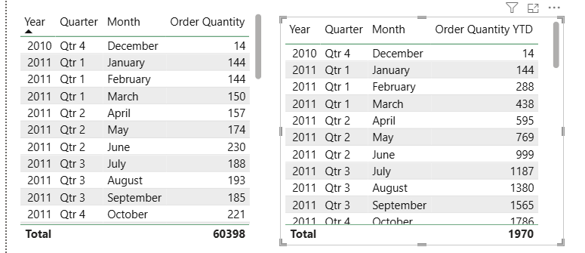

Lab report

1.Created
Order Quantity YTD Previous Year =
CALCULATE(
[Order Quantity YTD],
SAMEPERIODLASTYEAR(DimDate[FullDateAlternateKey])
)
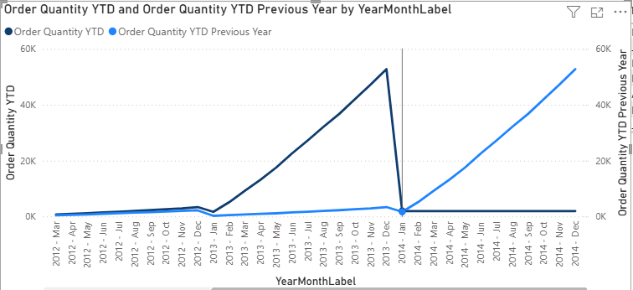

2.Created
Sales Amount = SUM(FactInternetSales[SalesAmount])
Sales Amount YTD =
CALCULATE(
[Sales Amount],
DATESYTD(DimDate[FullDateAlternateKey])
)

Sales Amount YTD Previous Year =
CALCULATE(
[Sales Amount YTD],
SAMEPERIODLASTYEAR(DimDate[FullDateAlternateKey])
)
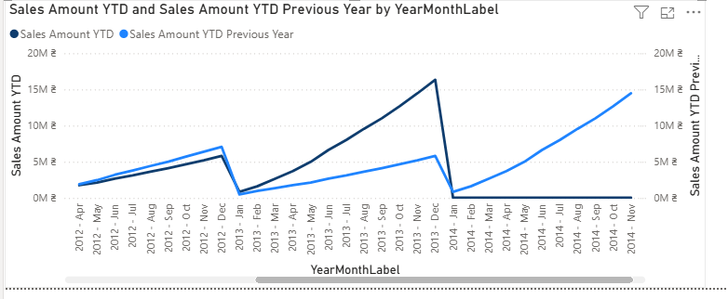
On top of the report displayed current username and current date in the format:
Welcome, [Current User]
Current Date is: [Current Date]
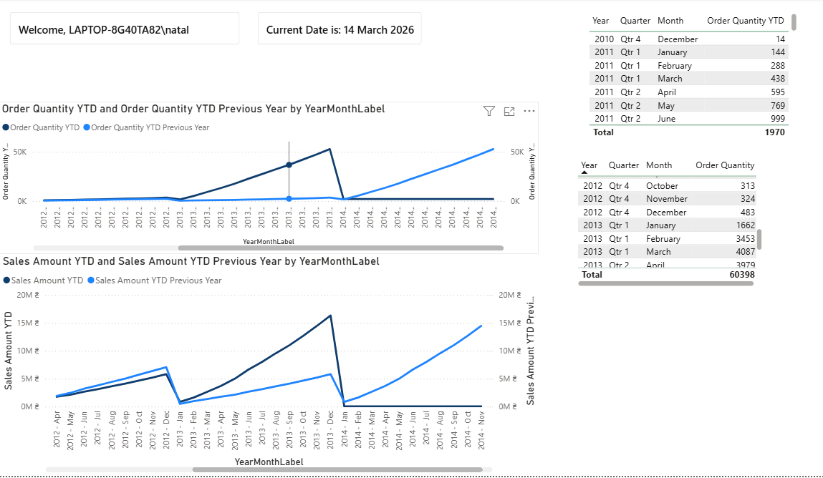

A table that shows Year-Month label that was created during lab work, Product Name, Color, Order Quantity and % of total Order quantity by Year Month Label and Color (see the screenshot below).

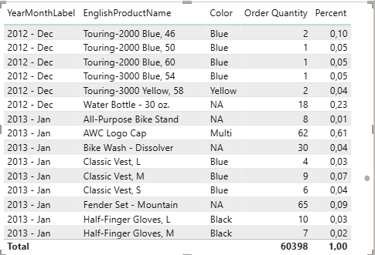
The table displays Year-Month label, Product Name, Color, Order Quantity, and the percentage of total Order Quantity within the same Year-Month and Color. The percentage measure removes only the product filter, so each product is compared against the total quantity for its corresponding month and color group.
Used a new measure
Percent =
DIVIDE(
[Order Quantity],
CALCULATE(
[Order Quantity],
REMOVEFILTERS(DimProduct[EnglishProductName])
)
)

DAX measure and use it in a chart that always shows Sales Amount for maximum OrderDate available.
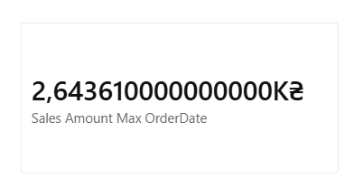
A new measure
Sales Amount Max OrderDate =
CALCULATE(
[Sales Amount],
FILTER(
ALL(FactInternetSales[OrderDate]),
FactInternetSales[OrderDate] = MAX(FactInternetSales[OrderDate]) )
)
The measure was created to always display the Sales Amount for the most recent OrderDate available in the dataset. This was achieved using the CALCULATE function together with a filter that selects the maximum OrderDate from the date table.
The CALCULATE function modifies the filter context and forces the calculation to use only the rows where the OrderDate equals the maximum date in the dataset. As a result, the measure always returns the latest available sales value, regardless of other filters applied in the report.
This method is useful for dashboards because it allows users to quickly see the most up-to-date sales information without manually selecting the latest date. It ensures that the visual always reflects the latest data in the model, making the report easier to monitor and maintain.

DAX measure that shows the country with the highest sales in all years and display the result with a visual.
Country Sales Rank =
RANKX(
ALL(DimSalesTerritory[SalesTerritoryCountry]),
[Sales Amount],
,
DESC,
DENSE
)

Top Country Sales =
IF(
[Country Sales Rank] = 1,
[Sales Amount]
)
To identify the country with the highest sales across all years, a ranking approach was used. First, the RANKX function was applied to rank all countries based on the Sales Amount measure in descending order. This ranking is calculated across all countries using the ALL function to remove filters and evaluate total sales for the entire dataset.
Next, the Top Country Sales measure returns the Sales Amount only for the country with rank 1, which represents the country with the highest sales. This measure was then used in a bar chart, with the country displayed on the axis and the measure displayed as the value. As a result, the chart highlights the country with the maximum sales.
If two or more countries have the same Sales Amount, the RANKX function assigns them the same rank. In this case, multiple countries may have rank 1, and both countries will be displayed in the visual because they share the highest sales value.

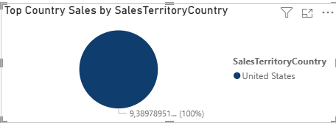

DAX to calculate the ranks of ProductCategory by Sales Amount. In Word file, explain why you chose this particular way to get the result.
Product Category Rank =
RANKX(
ALL(DimProductCategory[EnglishProductCategoryName]),
[Sales Amount],
,
DESC,
DENSE
)

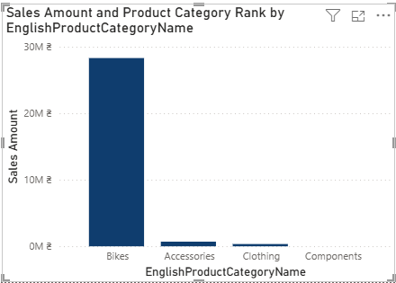
A bar chart was used to visualize Sales Amount by Product Category. The ranking of product categories was calculated using the RANKX function based on the total Sales Amount. Instead of displaying the rank directly on the chart, the ranking is shown in the tooltip when the user hovers over a bar. This approach keeps the visual clean and easy to read while still providing additional analytical information.
The chart displays Sales Amount as the main measure, which makes it easier to compare the actual sales performance of each category. The ranking helps identify the relative position of each category in terms of sales.
Additionally, the (Blank) category was excluded using a visual-level filter, since it represents records that do not have a corresponding product category in the dimension table. Removing this value ensures that the chart only displays meaningful product categories and improves the clarity of the analysis.

