- Table created.
- Isolation level: READ COMMITTED – non-repeatable reads and phantom reads are possible.
Before commit
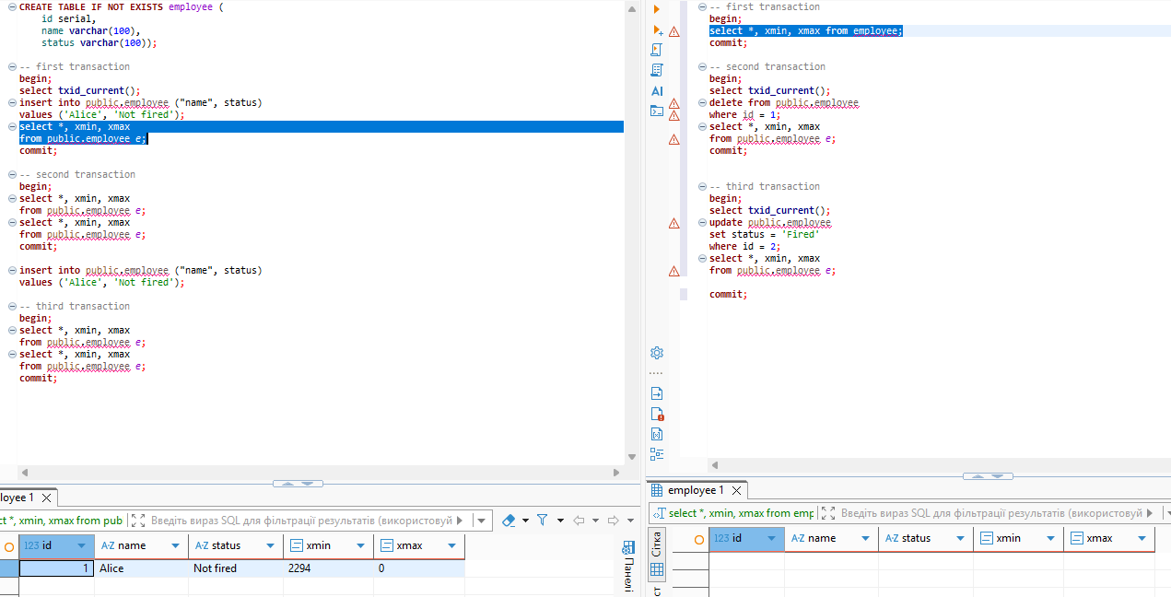

After commit
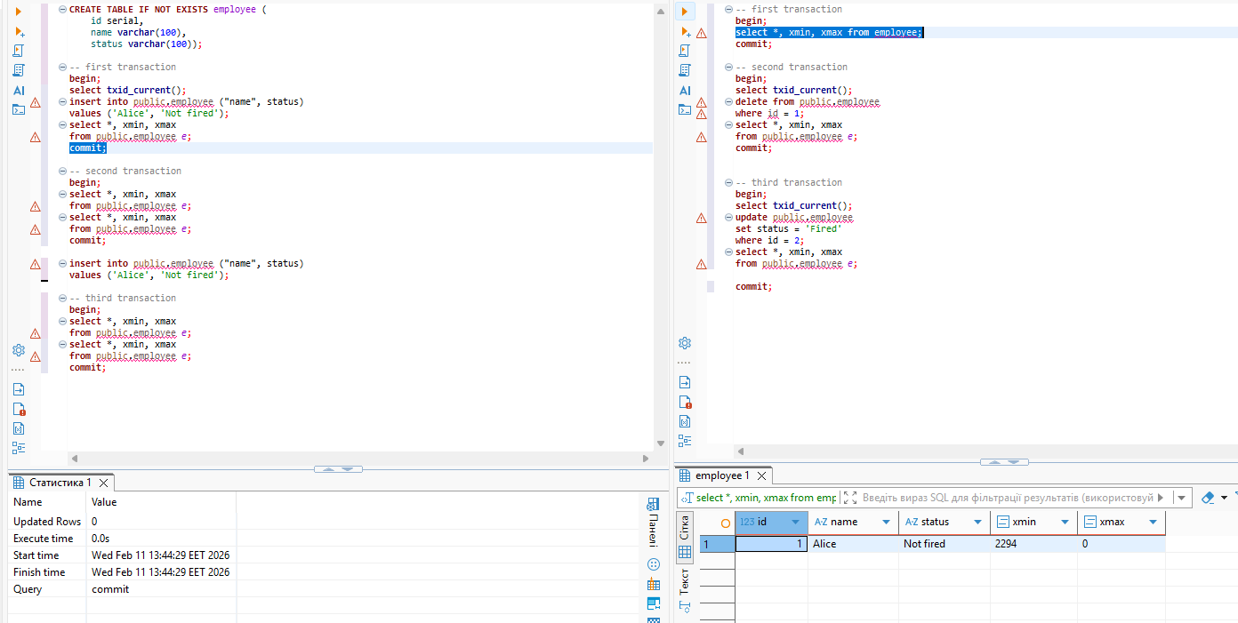

Due to the default isolation level (READ COMMITTED), dirty reads are avoided.
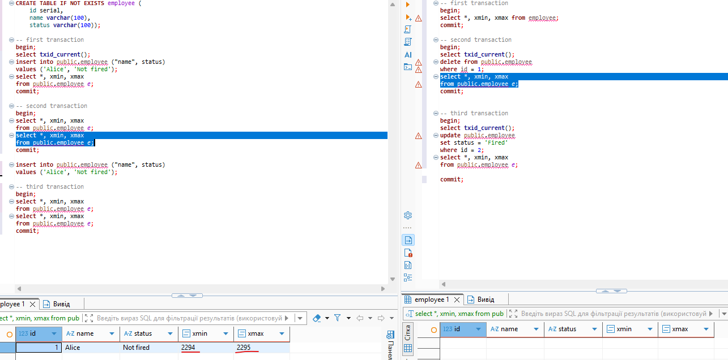
This example shows how MVCC works. In the first transaction (left), we can see in the xmax column which transaction deleted the row. Here, dirty reads are avoided.
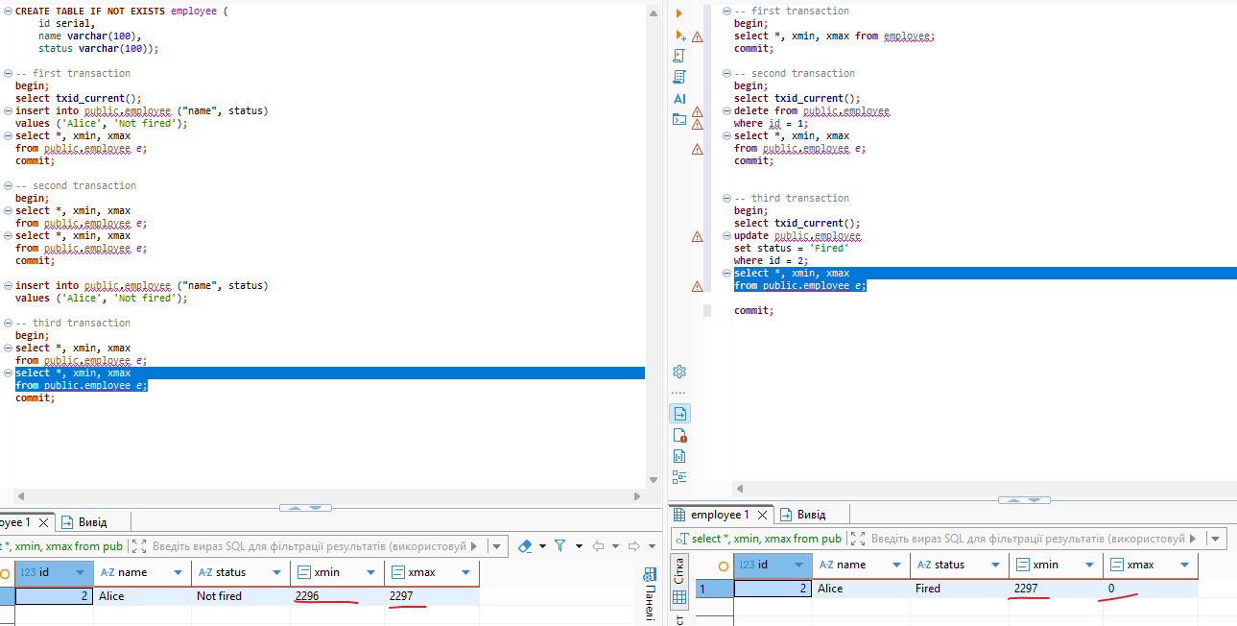
We can also see how the UPDATE command is handled by PostgreSQL. In MVCC, in the right transaction the updated row appears as a newly inserted row, while in the left transaction the old version of the row is marked as deleted in the xmax column.

- SET TRANSACTION ISOLATION LEVEL REPEATABLE READ; Applied
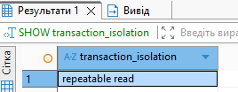
Before commit in right part
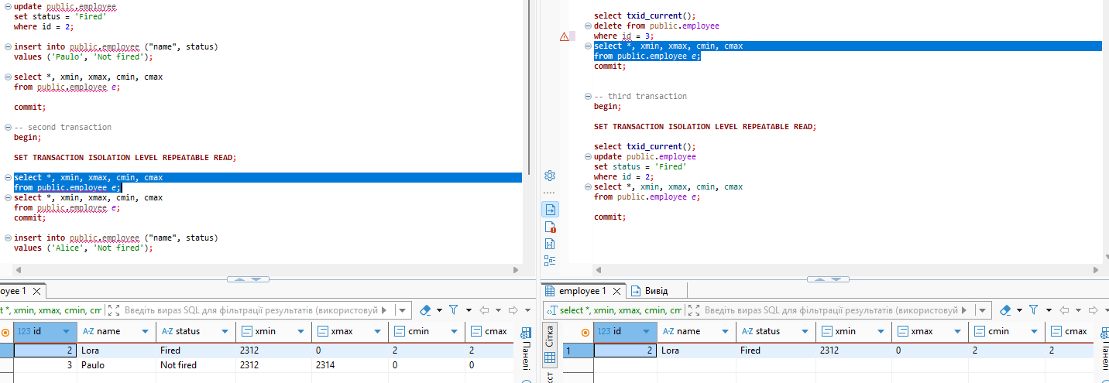
After commit in right part
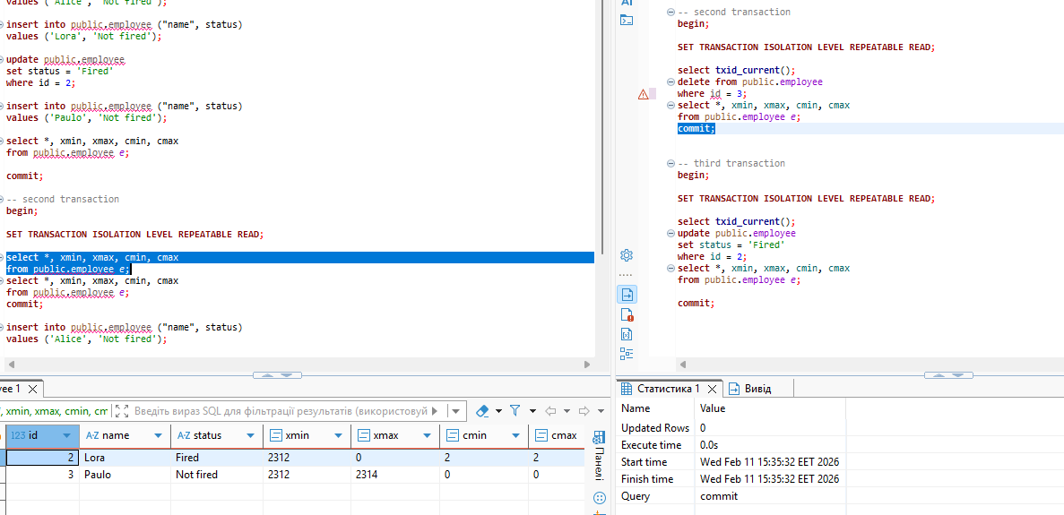
When using the Repeatable Read isolation level, you can observe that after committing DML changes in the first transaction, those changes will not be visible in another ongoing transaction — meaning anomalies such as phantom reads and non-repeatable reads are avoided.
One more example
Before update
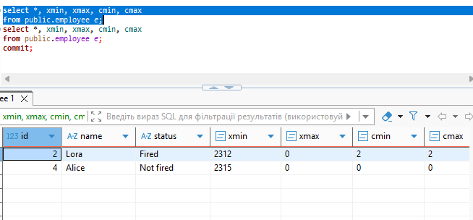
Begin;
update public.employee
set status = 'Fired'
where id = 4;
commit;

Isolation level –read commited.
The same transaction, the second select after commited update . Status updated.

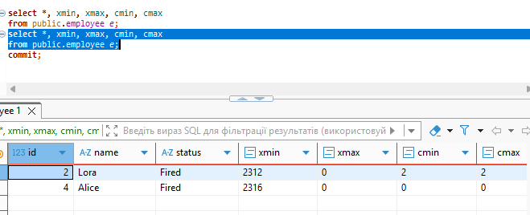
Isolation repeatable read – status unchanged. This transaction doesn’t see updated commited data.

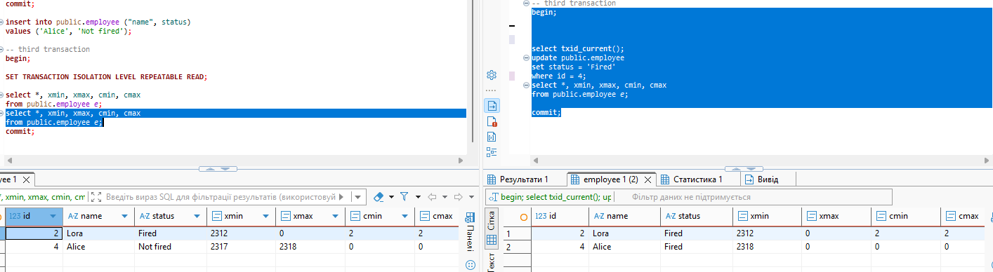

6.Isolation level- repeatable read

TRUNCATE public.employee;

INSERT INTO public.employee(name, status) VALUES
('Alice', 'Not fired'),
('Bob', 'Not fired');

--1st transaction
BEGIN;
SET TRANSACTION ISOLATION LEVEL REPEATABLE READ;

SELECT count(*)
FROM public.employee
WHERE status = 'Not fired';

UPDATE public.employee
SET status = 'Fired'
WHERE name = 'Alice';

--don’t commit for now

--2nd transaction
BEGIN;
SET TRANSACTION ISOLATION LEVEL REPEATABLE READ;

SELECT count(*) FROM public.employee WHERE status = 'Not fired';

UPDATE public.employee
SET status = 'Fired'
WHERE name = 'Bob';

COMMIT;

Go back to the first transaction – Commit
No errors
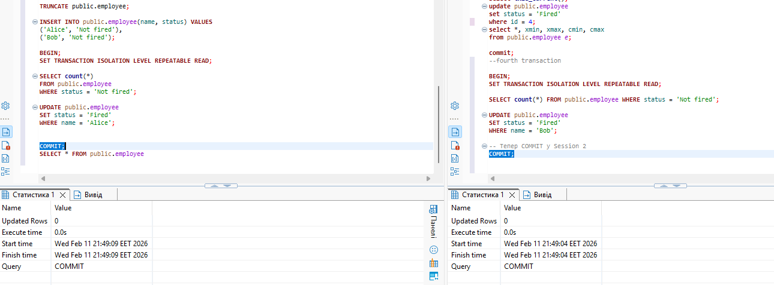
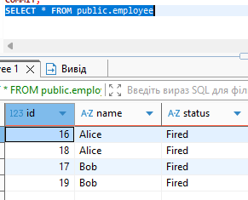

Isolation level- SERIALIZABLE
The same code , but
SET TRANSACTION ISOLATION LEVEL REPEATABLE READ;
Got an error
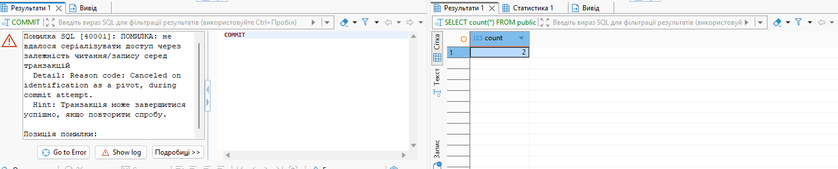

This means: SERIALIZABLE did not allow the serialization anomaly, and forced one transaction to be “replayed” (it simply needs to be repeated from the beginning).

7. Tried to perform lost update anomaly, postgres doesn’t give this it just –“ was hanging”
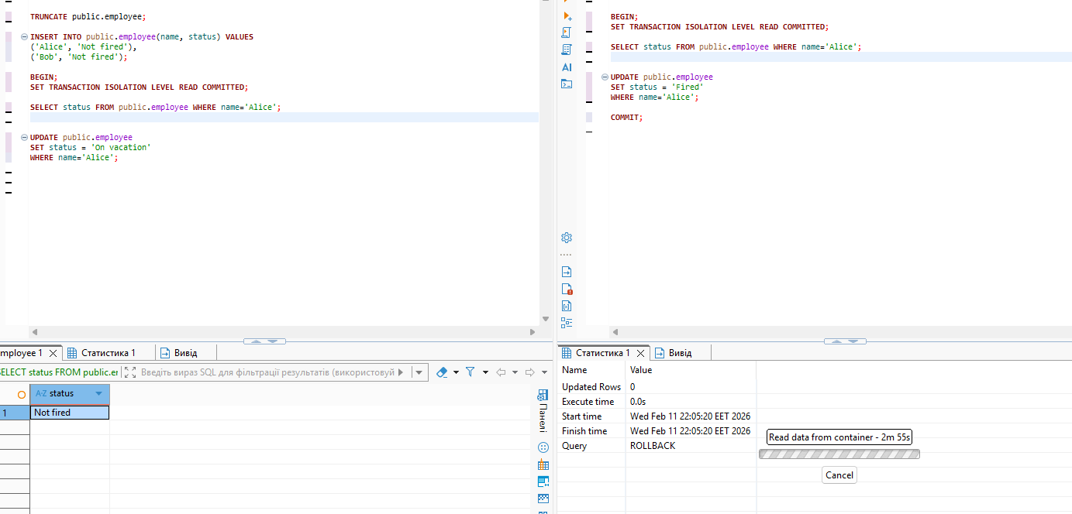
Locked data

Part 3
Before commit in the left part
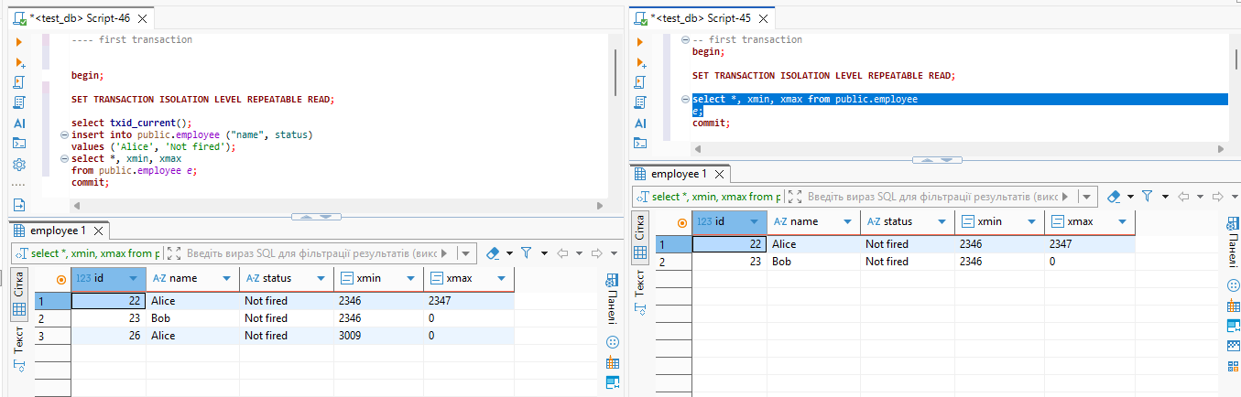
After commit in the left part
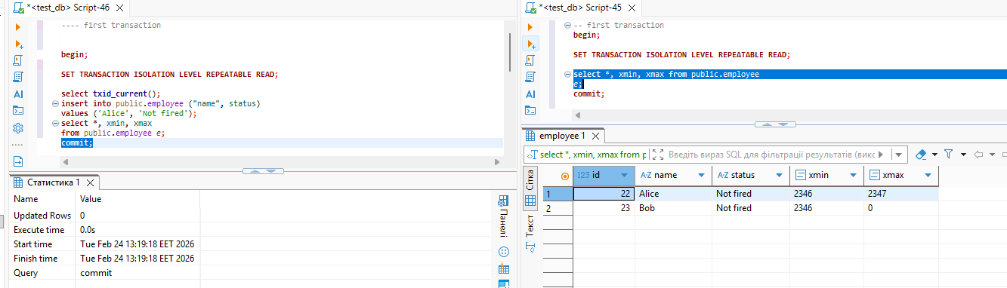

Second test
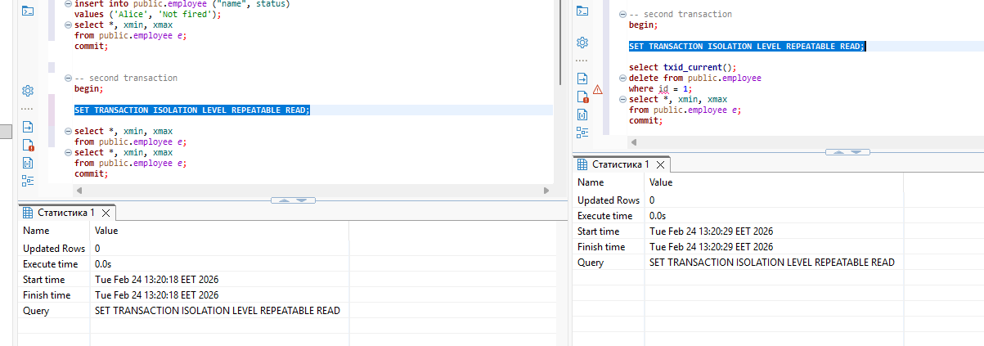
After commit in right part
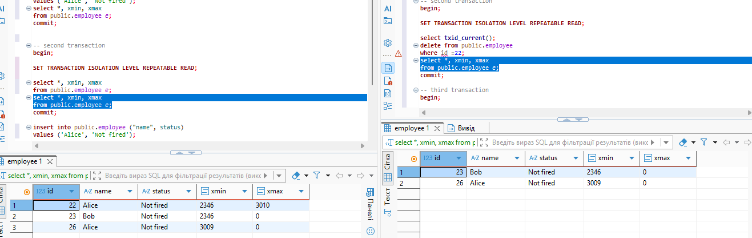
3rd test
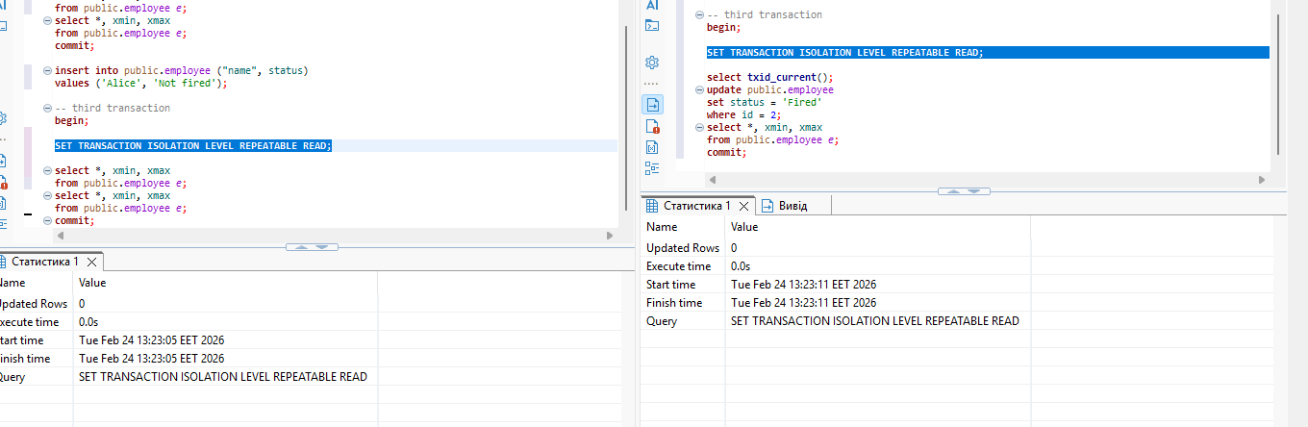
Before commit
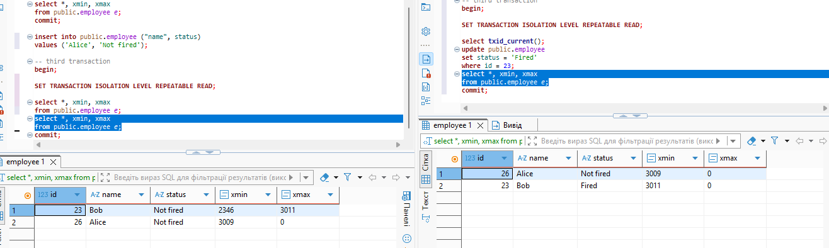
After
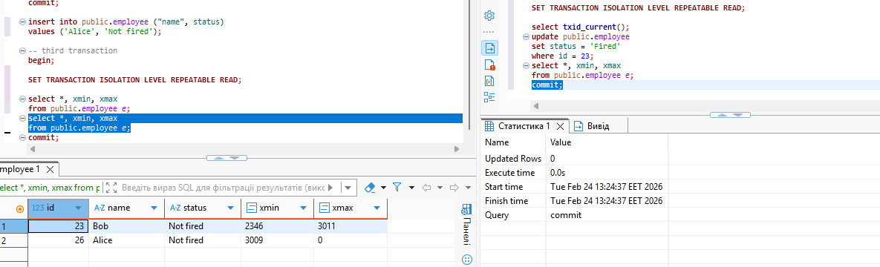
When using the Repeatable Read isolation level, you can observe that after committing DML changes in the first transaction, those changes will not be visible in another ongoing transaction — meaning anomalies such as phantom reads and non-repeatable reads are avoided.

