Business Template

Retail store
Logo / Image

Contents
1 Business Description 3
1.1 Business background 3
1.2 Problems because of poor data management 3
1.3 Benefits from implementing a Data Warehouse 3
1.4 DATASETS DESCRIPTION 3
1.5 GRAIN / DIM / FACT 4
2 Business Layer 3NF 4
3 Business Layer Dimensional Model 4
4 Logical Scheme 4
5 Data Flow 4
6 Fact Table Partitioning Strategy 4

Business Description

Business background
The chosen business domain for this project is Retail, focusing on a company that sells consumer goods through two sales channels: an online store (e-commerce) and physical stores (offline POS). The company operates multiple stores located in different cities and also provides online ordering with delivery services.
In the offline channel, customers purchase goods at checkout counters using POS terminals operated by cashiers. In the online channel, customers place orders via web or mobile devices, apply promo codes, choose delivery types, and receive orders through delivery service providers. These two channels generate large volumes of transactional data and operational context (payments, staff, store/warehouse operations, promotions), which makes the business suitable for implementing a Data Warehouse.
The company aims to consolidate these heterogeneous datasets into a unified analytical environment in order to support decisions related to sales performance, product assortment, customer behavior, promotion effectiveness, logistics, and workforce planning.

Problems because of poor data management
Without a structured Data Warehouse and standardized data management, the company faces several issues:
Fragmented reporting across channels: online and offline systems store data in different formats, which leads to inconsistent KPIs and difficulties in cross-channel comparison.
Limited customer view: offline transactions often contain minimal customer identifiers (e.g., phone for loyalty customers or guest), while online data contains richer customer attributes. This prevents unified customer analytics.
Low transparency of promotion impact: promotions and discounts are applied differently across channels, making it hard to measure their real influence on revenue and profitability.
Operational blind spots: store performance depends on cashier shifts, terminal type, and payment behavior, while online performance depends on fulfillment centers and carriers. Without consolidation, it is difficult to identify bottlenecks.
High manual effort: analytics and reporting require manual extraction and transformation, causing delays and errors.
Poor decision support: the business cannot reliably answer questions about profitability by product hierarchy, store format, loyalty segment, or logistics partner performance.

Benefits from implementing a Data Warehouse
Implementing a Data Warehouse provides a centralized, historical, and consistent data foundation for analytics. The DWH enables:
Unified omnichannel reporting by integrating online and offline sales into a common model.
Consistent financial analytics for sales, costs, discounts, taxes, and profit across both channels.
Product hierarchy analysis (category → subcategory → SKU) for category management and assortment planning.
Customer segmentation using online customer attributes and offline loyalty identifiers.
Promotion effectiveness measurement (promo codes, discount rates, discount amounts, loyalty points).
Operational analytics:
-offline: cashier efficiency, shift productivity, terminal usage, cash vs card share;

-online: fulfillment routing, delivery performance, carrier comparison.
Improved decision-making by enabling reliable KPIs and scalable reporting.
Typical questions that can be answered after DWH implementation:
Which product categories and brands generate the highest revenue and gross profit?
How do profitability and average order value differ between online and offline channels?
Which store formats perform best (hyper/standard/convenience) across regions?
How do loyalty customers differ from walk-in customers in revenue contribution?
Which payment types dominate in stores (cash vs card vs e-wallet)?
Which delivery service providers perform best for online orders (by promised delivery dates and order outcomes)?

DATASETS DESCRIPTION
Online Store Dataset Description
The first dataset represents online sales transactions of a retail company operating an e-commerce platform.
This dataset captures end-to-end information related to customer purchases made through the online channel, including customer characteristics, product details, logistics and delivery information, commercial programs, customer satisfaction indicators, and financial measures.
The dataset contains transactional records covering approximately the last two years, which allows analysis of trends, seasonality, customer behavior, and operational performance over time. Each record represents a single online order line.
Key Entities Identified in the Online Dataset
Based on the structure and business meaning of the data, the following core entities (future Dimensions) can be identified.
Customer
The Customer entity represents individuals who place orders through the online store.
It provides demographic and segmentation information that supports customer behavior analysis and loyalty evaluation.
Attributes include:

Customer identifier
First name and last name
Email and phone number
Gender
Age and age group
Customer segment (e.g., loyalty, walk-in)
This entity enables segmentation of customers by demographic and behavioral attributes and supports analysis of sales performance across different customer groups.
Product
The Product entity describes items sold in the online store and supports product hierarchy analysis.
Attributes include:
Product SKU
Product name
Product category (department)
Product subcategory
Brand
Unit of measure
Supplier identifier
A clear product hierarchy (category → subcategory → product) allows analysis of assortment performance, category profitability, and brand contribution.
Fulfillment Center
The Fulfillment Center entity represents the warehouse or distribution center from which an online order is processed and shipped.
Attributes included in the dataset:
Fulfillment center identifier
Fulfillment city
Only identifiers and basic location attributes are stored at the transactional level. Extended warehouse characteristics (capacity, utilization, staff, KPIs) are planned to be modeled separately in the Data Warehouse.
Delivery Service Provider
The Delivery Service Provider entity represents third-party logistics companies responsible for delivering online orders to customers. This entity focuses on identifying and evaluating delivery partners and their role in the fulfillment of online sales.
Attributes include:
Delivery service provider name (carrier)
Delivery type supported (courier, pickup point, store pickup)
Tracking ID associated with the shipment
Promised delivery date
Delivery destination details (address and postal code)

These attributes enable analysis of delivery partner performance, comparison of logistics providers, evaluation of delivery efficiency, and assessment of service quality across different regions and delivery methods.
Commercial Program (Promotions and Discounts)
The Commercial Program entity describes marketing mechanisms applied to online orders.
Attributes include:
Promotional code
Discount percentage
Discount amount
Shipping fee amount
This entity enables analysis of promotional effectiveness, discount usage, and the financial impact of free or paid delivery strategies.
Customer Satisfaction (Simplified)
Customer satisfaction in the online dataset is represented by a simplified indicator.
Attribute included:
Customer rating (1–10)
The rating serves as a lightweight quality signal directly associated with an order. More detailed complaint handling and feedback processes are considered a separate business process and may be implemented as an additional dataset in the future.
Sales and Cost Measures
The fact part of the dataset contains financial measures required for sales and profitability analysis.
Measures include:
Quantity sold
Unit price
Tax amount
Discount amount
Shipping fee amount
Total sales amount
Cost amount
Gross profit amount
These measures allow detailed analysis of revenue, costs, margins, and profitability of online sales.

Dataset columns
web_order_id — unique online order identifier
txn_ts — transaction date and time
order_status — order status
customer_src_id — unique customer identifier
customer_first_name — customer first name
customer_last_name — customer last name
customer_email — customer email address
customer_phone — customer phone number
gender — customer gender
customer_age — customer age
customer_age_group — customer age group
customer_segment — customer segment
country — delivery country
region — delivery region
city — delivery city
delivery_postal_code — delivery postal code
delivery_address_line1 — delivery street address
fulfillment_center_id — fulfillment center identifier
fulfillment_city — fulfillment center city
delivery_type — delivery method
carrier_name — delivery carrier
tracking_id — shipment tracking number
promised_delivery_dt — promised delivery date
device_type — customer device type
payment_gateway — payment gateway
promo_code — promotional code
discount_pct — discount percentage
discount_amt — discount amount
shipping_fee_amt — shipping fee amount
product_dept — product department
product_subcategory — product subcategory
product_sku — product SKU
product_name — product name
brand — product brand
unit_of_measure — unit of measure
supplier_id — supplier identifier
unit_price_amt — unit price
qty — quantity sold
tax_amt — tax amount
sales_amt — total sales amount
cost_amt — total cost amount
gross_profit_amt — gross profit amount
customer_rating — customer rating

Offline Store (POS) Dataset Description

The second dataset represents offline store sales transactions captured by a Point-of-Sale (POS) system in a retail company.
This dataset includes transactional sales data together with operational context specific to in-store purchases, such as store attributes, cashier information, POS terminal details, payment methods, loyalty participation, promotional mechanics, and a simplified customer satisfaction signal.
The dataset contains transactional records covering approximately the last two years, enabling analysis of store performance over time, demand patterns, staffing efficiency, payment behavior, and profitability across product hierarchies and locations. Each record represents a single POS transaction line.
Key Entities Identified in the Offline Dataset
Based on the structure and business meaning of the data, the following related entities (future Dimensions) can be identified:

Customer
The Customer entity represents shoppers in offline stores. In-store customer data is typically limited compared to online systems; therefore, the dataset includes only minimal identifiers and segmentation fields that can be used for basic customer grouping.
Attributes include:
Customer business identifier (or “guest” for walk-in customers)

Phone number (primarily available for loyalty customers)
Age group
Customer segment (e.g., loyalty, walk-in)
This entity supports analysis of loyalty program participation, customer mix by store, and sales performance by basic customer segments.
Product
The Product entity describes items sold in stores and provides a consistent product hierarchy aligned with the online dataset.
Attributes include:
Product SKU
Product name
Product category (department)
Product subcategory
Brand
Unit of measure
Supplier identifier
The product hierarchy (category → subcategory → SKU) enables category management analysis, assortment performance evaluation, and profitability reporting.
Store
The Store entity represents physical retail locations where transactions occur.
Attributes include:
Store identifier
Store format (e.g., hyper, standard, convenience)
Store opening date
Store opening and closing time
Store location attributes (country, region, city)
This entity supports store benchmarking, analysis of sales and profitability by store format, and comparison of store performance across locations.
Employee (Cashier)
The Employee entity describes store staff responsible for processing transactions at the POS.
Attributes include:
Cashier identifier
Cashier first and last name
Department
Position (e.g., cashier, senior cashier)
Hire date
Shift identifier (morning/day/evening)
These attributes enable workforce analytics, including sales performance by cashier, staffing efficiency by shift, and operational planning.
POS Terminal

The Terminal entity represents the POS device used to complete the transaction.
Attributes include:
Terminal identifier
Terminal type (e.g., cash register, self-checkout)
This entity supports operational analysis such as throughput by terminal type and usage distribution between assisted checkout and self-checkout.
Payment
The Payment entity describes how customers pay in offline stores.
Attributes include:
Payment method (cash, card, e-wallet)
Card type (when applicable)
Receipt type (paper or email)
This entity enables analysis of payment behavior, adoption of cashless methods, and operational reporting for different payment channels.
Commercial Program (Offline Promotions & Loyalty)
The Commercial Program entity captures offline promotional mechanisms applied at checkout and loyalty program-related effects.
Attributes include:
Promotion code
Promotion type
Discount percent
Discount amount
Loyalty points earned
This supports analysis of promotion usage in stores, impact of discounts on profitability, and loyalty value contribution.
Customer Satisfaction (Simplified)
Offline customer satisfaction is represented as a lightweight quality indicator that can be associated with the transaction.
Attribute included:
Customer rating (1–10)
This field supports monitoring of service quality trends and correlation of satisfaction with store/shift/cashier performance.
Sales and Cost Measures
The dataset contains the financial measures required for revenue and profitability reporting.
Measures include:
Quantity
Unit price
Tax amount
Discount amount
Total sales amount
Cost amount
Gross profit amount
Loyalty points earned (operational measure)
These measures support margin analysis, store profitability reporting, and comparisons across products, locations, employees, and payment types.

Dataset columns
ckout — receipt / checkout identifier
txn_ts — transaction date and time
customer_src_id — customer identifier
customer_phone — customer phone number
customer_age_group — customer age group
customer_segment — customer segment
product_dept — product department
product_subcategory — product subcategory
product_sku — product SKU
product_name — product name
brand — product brand
unit_of_measure — unit of measure
supplier_id — supplier identifier
store_id — store identifier
store_format — store format
store_open_dt — store opening date
store_open_time — store opening time
store_close_time — store closing time
country — store country
region — store region
city — store city
terminal_id — POS terminal identifier
terminal_type — POS terminal type
cashier_id — cashier identifier
cashier_first_name — cashier first name
cashier_last_name — cashier last name
cashier_dept — cashier department
cashier_position — cashier position
cashier_hire_dt — cashier hire date
shift_id — work shift identifier
payment_method — payment method
card_type — card type
receipt_type — receipt type
promo_code — promotional code
promo_type — promotion type
discount_pct — discount percentage
discount_amt — discount amount
loyalty_points_earned — loyalty points earned
unit_price_amt — unit price
qty — quantity sold
tax_amt — tax amount
sales_amt — total sales amount
cost_amt — total cost amount
gross_profit_amt — gross profit amount
customer_rating — customer rating

GRAIN / DIM / FACT
Step 1 — Select the Business Process

The selected business process is Retail Sales, covering both online e-commerce orders and offline POS transactions.

Step 2 — Declare the Grain

The grain of the unified dataset is defined as: one row per sales transaction line (per product per transaction), regardless of sales channel
In the online channel, each row represents a single product line within an online order.
In the offline channel, each row represents a single product line within a POS receipt.

This grain was selected because:

it is the lowest available level of detail in both source systems,
it enables consistent aggregation across channels,
it supports profitability, promotion, customer, product, store, and operational analysis,
it allows online and offline data to be combined into a single fact table.

Step 3 — Identify the Dimensions

Dimensions describe the context of each sales transaction and are unified across channels where possible:

Customer
Product
Time
Promotions
Store
Employee
Delivery Service Provider
Terminals
Junk transaction context

Step 4 — Identify the Facts

The fact table stores numeric sales and cost measures required for financial, operational, and profitability analysis.

DIMENSIONS
DIM_CUSTOMER
The Customer dimension represents buyers who generate sales transactions in both online and offline channels. It enables customer segmentation, behavioral analysis, and comparison between loyalty and walk-in customers.
Key Characteristics
Combines rich online customer data (name, email, gender, age) with limited offline customer data.
Serves as a shared dimension across both channels, enabling omnichannel customer analysis.
Walk-in customers are not individually identifiable. Therefore, all anonymous customers are represented in the Customer dimension using a generic source identifier (e.g., “guest”), which allows transactions to be analyzed without artificially creating unique customer records.

Column name | Description | Data Type
CUSTOMER_ID | Surrogate customer key | BIGINT
CUSTOMER_SRC_ID | Customer identifier from source system | VARCHAR
FIRST_NAME | Customer first name (online) | VARCHAR
LAST_NAME | Customer last name (online) | VARCHAR
EMAIL | Customer email (online) | VARCHAR
PHONE | Customer phone number | VARCHAR
AGE_GROUP | Customer age group | VARCHAR
CUSTOMER_SEGMENT | Loyalty / walk-in | VARCHAR
GENDER | Customer gender (online) | VARCHAR

CUSTOMER_ID | CUSTOMER_SRC_ID | FIRST_NAME | LAST_NAME | EMAIL | PHONE | AGE_GROUP | CUSTOMER_SEGMENT | GENDER
1 | guest | n.a. | n.a. | n.a. | n.a. | 55_65 | walk_in | n.a.
2 | c0092216 | n.a. | n.a. | n.a. | 3806182437498 | 25_34 | loyalty | n.a.
3 | c0069452 | nastia | melnyk | nastia.melnyk9247@mail.com | 3800340367261 | n.a. | n.a. | Female
4 | c0099465 | viktor | shevchenko | viktor.shevchenko7002@mail.com | 3809196632878 | n.a. | n.a. | Male

DIM_PRODUCT
The Product dimension describes items sold by the retail company and supports product hierarchy analysis across departments, subcategories, and SKUs.
Key Characteristics
Unified for both online and offline channels.
Contains a clear hierarchy: department → subcategory → product SKU.
Supports assortment planning, category performance analysis, and brand-level reporting.
Column name | Description | Data Type
PRODUCT_ID | Surrogate product key | BIGINT
PRODUCT_SKU | Product SKU | VARCHAR
PRODUCT_NAME | Product name | VARCHAR
PRODUCT_DEPT | Product department | VARCHAR
PRODUCT_SUBCATEGORY | Product subcategory | VARCHAR
BRAND | Brand name | VARCHAR
UNIT_OF_MEASURE | Unit of measure | VARCHAR
SUPPLIER_ID | Supplier identifier | VARCHAR

PRODUCT_ID | PRODUCT_SKU | PRODUCT_NAME | PRODUCT_DEPT | PRODUCT_SUBCATEGORY | BRAND | UNIT_OF_MEASURE | SUPPLIER_ID
1 | ele_0421 | electronics item 02-0421 | electronics | electronics_sub02 | electromax | pcs | sup_026
2 | foo_0131 | food beverages item 01-0131 | food_beverages | food_beverages_sub01 | freshmart | pack | sup_030
3 | hom_0402 | home lifestyle item 01-0402 | home_lifestyle | home_lifestyle_sub01 | homely | pack | sup_028
4 | foo_0206 | food beverages item 01-0206 | food_beverages | food_beverages_sub01 | freshmart | pcs | sup_040

DIM_DATE_DAY
The Time dimension provides a temporal context for sales analysis, enabling trend, seasonality, and period-based reporting.
Key Characteristics
Shared by online and offline transactions.
Supports multiple aggregation levels (day, month, year).
Allows analysis by transaction timestamp as well as calendar-based reporting.
Critical for historical analysis and time-series comparisons.
Column name | Description | Data Type
DATE_ID | Date surrogate key (YYYYMMDD) | INT
TXN_TIMESTAMP | Transaction timestamp | TIMESTAMP
DAY | Day of the month (1–31) | SMALLINT
DAY_OF_WEEK | Numeric day of week (1–7) | SMALLINT
DAY_NAME | Name of the day of week | VARCHAR
WEEK | Week number within a month | SMALLINT
WEEK_OF_YEAR | Week number within a year | SMALLINT
MONTH | Month number (1–12) | SMALLINT
MONTH_NAME | Name of the month | VARCHAR
QUARTER | Quarter of the year (1–4) | SMALLINT
YEAR | Calendar year | SMALLINT
IS_WEEKEND | Indicator whether the date is a weekend (true/false) | BOOLEAN

DATE_ID | TXN_TIMESTAMP | DAY | DAY_OF_WEEK | DAY_NAME | WEEK | WEEK_OF_YEAR | MONTH | MONTH_NAME | QUARTER | YEAR | IS_WEEKEND
202407032024-07-03 10:36:58 | 2024-07-03 10:36:58 | 3 | 3 | Wednesday | 1 | 27 | 7 | July | 3 | 2024 | FALSE

DIM_PROMOTION
The Promotion dimension represents marketing mechanisms applied to sales transactions, such as discounts, promo codes, and loyalty incentives.
Key Characteristics
Unified concept for online and offline promotions.
Captures both percentage-based and amount-based discounts.
Supports analysis of promotion effectiveness and revenue impact.
Enables comparison of promotional strategies across channels.
Column name | Description | Data Type
PROMOTION_ID | Surrogate product key | BIGINT
PROMO_CODE | Promotion code | VARCHAR
PROMO_TYPE | Promotion type (offline) | VARCHAR
DISCOUNT_PCT | Discount percentage | DECIMAL

PROMOTION_ID | PROMO_CODE | PROMO_TYPE | DISCOUNT_PCT
1 | weekend5 | percent_discount | 0.05
2 | member10 | percent_discount | 0.1
3 | n.a. | n.a. | 0.0

DIM_STORE (Offline)
The Store dimension represents physical retail locations where offline POS transactions occur.
Key Characteristics
Applicable only to the offline channel.
Stores attributes such as store format, opening date, and operating hours.
Enables benchmarking of stores by format and location.
The store manager identifier is retained as a business identifier from the source system, preserving original data without introducing additional attributes.
Column name | Description | Data Type
STORE_ID | Store surrogate key | BIGINT
STORE_SRC_ID | Store identifier | VARCHAR
STORE_FORMAT | Store format | VARCHAR
STORE_OPEN_DT | Store opening date | DATE
STORE_OPEN_TIME | Store opening time | TIME
STORE_CLOSE_TIME | Store closing time | TIME
STORE_CITY | Store localization city | VARCHAR
STORE_REGION | Store localization region | VARCHAR
STORE_COUNTRY | Store localization country | VARCHAR

STORE_ID | STORE_SRC_ID | STORE_FORMAT | STORE_OPEN_DT | STORE_OPEN_TIME | STORE_CLOSE_TIME | STORE_CITY | STORE_REGION | STORE_COUNTRY
1 | store_c | convenience | 2020-02-20 | 07:00 | 23:59 | naypyitaw | naypyitaw_union | myanmar
2 | store_a | hyper | 2018-06-15 | 08:00 | 23:59 | yangon | yangon_region | myanmar

DIM_EMPLOYEE (Cashier)(offline)
The Employee dimension represents store staff responsible for processing POS transactions.
Key Characteristics
Applicable only to offline sales.
Supports workforce analytics such as cashier productivity, shift performance, and staffing efficiency.
Includes organizational attributes (department, position, shift).
Enables operational analysis linking sales performance to employees.
Column name | Description | Data Type
EMPLOYEE_ID | Employee surrogate key | BIGINT
EMPLOYEE_SRC_ID | Cashier identifier | VARCHAR
FIRST_NAME | Cashier first name | VARCHAR
LAST_NAME | Cashier first name | VARCHAR
DEPARTMENT | Department | VARCHAR
POSITION | Position | VARCHAR

EMPLOYEE_ID | EMPLOYEE_SRC_ID | FIRST_NAME | LAST_NAME | DEPARTMENT | POSITION
1 | e_0268 | viktor | marchenko | home | cashier
2 | e_0312 | kovalenko | kovalenko | electronics | senior_cashier

DIM_DELIVERY_SERVICE_PROVIDER
The Delivery Service Provider dimension represents delivery-related attributes of online sales transactions from a commercial and sales perspective. It provides contextual information used to analyze how different delivery options and providers influence sales volume, revenue, customer choice, and order outcomes.
Key Characteristics
Applicable only to the online sales channel.
Describes delivery options as part of the sales offer rather than as a logistics process.
Includes attributes such as delivery type, carrier name, tracking identifier, and promised delivery date as they relate to customer purchase decisions.
Enables analysis of sales performance by delivery option (e.g., courier vs pickup point).
Supports evaluation of how delivery conditions affect order completion, revenue, and customer satisfaction.
Functions as a descriptive sales context dimension without storing measures.
Column name | Description | Data Type
DELIVERY_PROVIDER_ID | Surrogate key of delivery service provider | BIGINT
DELIVERY_TYPE | Type of delivery selected by customer (courier, pickup point, store pickup) | VARCHAR
CARRIER_NAME | Name of the delivery service provider | VARCHAR

DELIVERY_PROVIDER_ID | DELIVERY_TYPE | CARRIER_NAME
1 | courier | ukrposhta
2 | pickup_point | nova_poshta

DIM_JUNK_CONTEXT
The Junk Transaction Context dimension combines small, low-cardinality transactional attributes that describe the context of a sales transaction. These attributes do not represent standalone business entities and are used primarily for filtering and grouping in analytical queries.
This dimension simplifies the star schema by reducing the number of small dimensions and supports efficient sales analysis across online and offline channels.
Column name | Description | Data Type
JUNK_CONTEXT_ID | Surrogate key for transaction context | BIGINT
SALES_CHANNEL | Sales channel indicator (online / offline) | VARCHAR
ORDER_STATUS | Order status (online orders) | VARCHAR
DEVICE_TYPE | Customer device type (desktop, mobile) | VARCHAR
PAYMENT_METHOD | Payment method (cash, card, e-wallet) | VARCHAR
PAYMENT_GATEWAY | Online payment gateway (Stripe, LiqPay, etc.) | VARCHAR
CARD_TYPE | Card type used for payment (offline/online when applicable) | VARCHAR
RECEIPT_TYPE | Receipt type (paper, email) | VARCHAR
SHIFT_NAME | Indicates time of shift when purchase was made | VARCHAR

JUNK_CONTEXT_ID | SALES_CHANNEL | ORDER_STATUS | DEVICE_TYPE | PAYMENT_METHOD | PAYMENT_GATEWAY | CARD_TYPE | RECEIPT_TYPE | SHIFT_NAME
1 | online | paid | desktop | n.a. | n.a. | n.a. | n.a. | n.a.
2 | ofline stripe | paid | n.a. | card | n.a. | visa | paper | shift_day
DIM_TERMINALS
Represents point-of-sale terminals used to process offline sales transactions.
This dimension supports operational analysis by terminal type and helps evaluate the performance and utilization of POS infrastructure.
Column name | Description | Data Type
TERMINAL_ID BIGINT PK | Surrogate key of delivery service provider | BIGINT
TERMINAL_SRC_ID | Natural id of the terminal | VARCHAR
TERMINAL_TYPE_NAME | Type of the terminal | VARCHAR

FCT_SALES
Stores unified sales measures for both channels with keys to shared dimensions
Column name | Description | Data Type
DATE_ID | FK to DIM_TIME (YYYYMMDD) | INT
CUSTOMER_ID | FK to DIM_CUSTOMER | BIGINT
PRODUCT_ID | FK to DIM_PRODUCT | BIGINT
PROMOTION_ID | FK to DIM_PROMOTION | BIGINT
DELIVERY_PROVIDER_ID | FK to DIM_DELIVERY_SERVICE_PROVIDER(online only) | BIGINT
STORE_ID | FK to DIM_STORE (offline only) | BIGINT
EMPLOYEE_ID | FK to DIM_EMPLOYEE (offline only) | BIGINT
JUNK_CONTEXT_ID | FK to DIM_JUNK_CONTEXT | BIGINT
TERMINAL_ID | FK to DIM_TERMINALS | BIGINT
PROMISED_DELIVERY_DATE_ID | FK to DIM_DATE_DAY | INT
TXN_ID_SRC | Transaction business ID from source (web_order_id / ckout) | VARCHAR
TXN_TS_SRC | Transaction timestamp | TIMESTAMP
TRACKING_ID_SRC | Purchase tracking code | VARCHAR(100)
QTY | Quantity sold | INT
UNIT_PRICE_AMT | Unit price | DECIMAL(12,2)
TAX_AMT | Tax amount | DECIMAL(12,2)
DISCOUNT_AMT | Discount amount | DECIMAL(12,2)
SHIPPING_FEE_AMT | Shipping fee (online only) | DECIMAL(12,2)
SALES_AMT | Sales amount (gross as in source) | DECIMAL(12,2)
COST_AMT | Cost amount | DECIMAL(12,2)
GROSS_PROFIT_AMT | Gross profit amount | DECIMAL(12,2)
LOYALTY_POINTS_EARNED | Loyalty points (offline only) | INT
CUSTOMER_RATING | Rating (1–10) | DECIMAL(4,1)

DATE_ID | CUSTOMER_ID | PRODUCT_ID | PROMOTION_ID | DELIVERY_PROVIDER_ID | STORE_ID | EMPLOYEE_ID | JUNK_CONTEXT_ID | TXN_ID_SRC | QTY | UNIT_PRICE_AMT | TAX_AMT | DISCOUNT_AMT | SHIPPING_FEE_AMT | SALES_AMT | COST_AMT | GROSS_PROFIT_AMT | LOYALTY_POINTS_EARNED | CUSTOMER_RATING
20240703 | 3 | 1 | 3 | 1 | null | null | 1 | onl_000000001 | 9 | 23.07 | 10.38 | 20.76 | 0.00 | 197.25 | 187.86 | 9.39 | null | 4.9
20251030 | 4 | 2 | 4 | 1 | null | null | 2 | onl_000000002 | 9 | 99.24 | 44.66 | 0.00 | 2.99 | 940.81 | 896.01 | 44.80 | null | 9.0
20240703 | 1 | 4 | 2 | null | 1 | 1 | 3 | pos_000000001 | 3 | 47.65 | 7.15 | 0.00 | null | 150.10 | 142.95 | 7.15 | 0 | 1.0
20240710 | 2 | 3 | 1 | null | 1 | 1 | 4 | pos_000000002 | 2 | 35.00 | 5.60 | 3.50 | null | 70.00 | 60.00 | 10.00  0 | 15 | 8.6

Business Layer 3NF
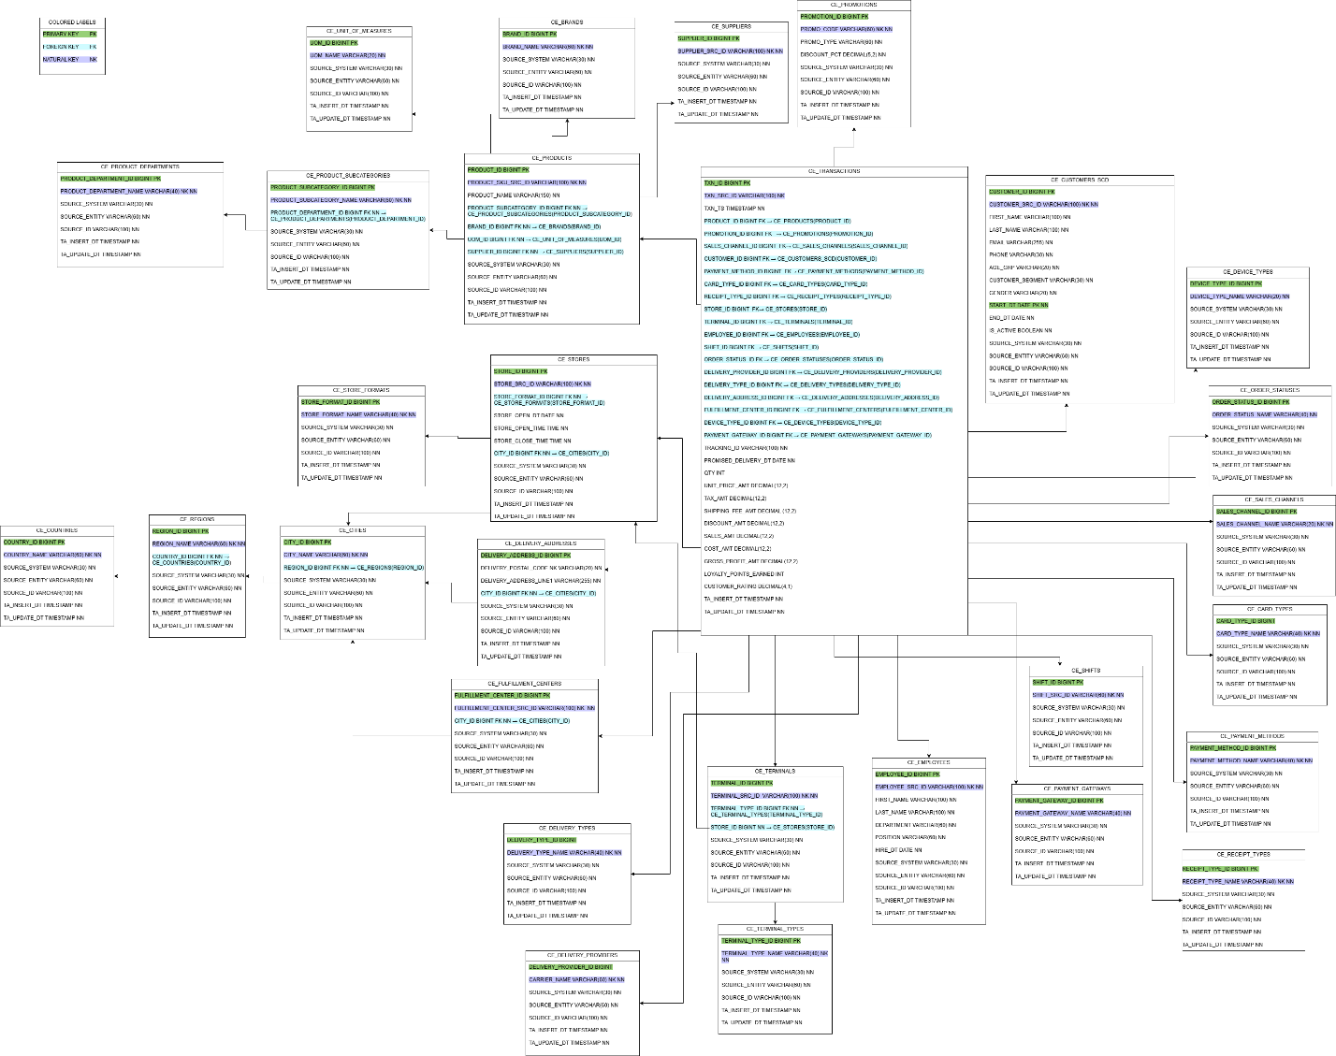
The Business Layer 3NF model (schema BL_3NF) was designed to support the Retail Sales business process using data from two source systems: offline POS and online e-commerce. At the initial stage, the data grain was defined as one row in the source equals one transaction equals one product, which corresponds to a transaction line level of detail and enables the construction of a unified pre-fact structure.
The next step was entity unification. Since both source systems contain data describing the same business entities (Customer, Product, Store, etc.), a single table per entity was created in the 3NF layer. Separate “online” and “offline” versions of the same entities were intentionally avoided. Channel-specific differences were instead handled through attributes, relationships, and an explicit sales channel indicator.
Normalization to the Third Normal Form (3NF) was then performed by systematically eliminating redundancy and dependency issues. Each business entity was represented by a dedicated core entity table (CE_*) with a surrogate key (*_ID BIGINT) and one or more natural keys, typically derived from the source system (*_SRC_ID).
Transitive dependencies were identified and removed. For example, geographical attributes (country, region, city) were normalized into a hierarchy of reference tables (CE_COUNTRIES → CE_REGIONS → CE_CITIES) to avoid repeating country and region names in store and delivery records. A similar approach was applied to product data by separating the hierarchy into CE_PRODUCT_DEPARTMENTS, CE_PRODUCT_SUBCATEGORIES, and CE_PRODUCTS, while brands, units of measure, and suppliers were placed in separate reference tables (CE_BRANDS, CE_UNIT_OF_MEASURES, CE_SUPPLIERS) to prevent duplication across products.
Low-cardinality descriptive attributes such as payment methods, card types, receipt types, terminal types, and sales channels were also normalized into individual lookup tables. This ensures referential integrity and avoids storing repeated text values directly in transactional data.

To support data lineage and traceability, a SOURCE TRIPLET was added to every table in the 3NF model. This triplet consists of SOURCE_SYSTEM, SOURCE_ENTITY, and SOURCE_ID, all defined as NOT NULL. Together, these attributes allow each record to be traced back to its original source system, source entity, and business or technical identifier.
For historical tracking, the Customer entity was selected for Slowly Changing Dimension Type 2 (SCD2) implementation. The table was therefore renamed to CE_CUSTOMERS_SCD in accordance with naming conventions and extended with START_DT, END_DT, and IS_ACTIVE attributes. This design enables the storage of multiple historical versions of a customer record, capturing changes in attributes such as customer segment or contact information over time. The transaction table references the appropriate version of the customer that was valid at the time of the transaction.
Online delivery data was normalized as well. Instead of keeping delivery attributes in a single wide table, the model separates delivery concepts into CE_DELIVERY_TYPES, CE_DELIVERY_PROVIDERS, CE_DELIVERY_ADDRESSES, and CE_FULFILLMENT_CENTERS. This removes transitive dependencies (for example, between delivery type and carrier) and supports reuse of delivery-related reference data. To keep the model simpler, a separate delivery event table was not introduced; instead, delivery-related foreign keys and attributes (such as tracking ID and promised delivery date) were stored directly in the transaction table as part of the transaction context.
The transactional layer was therefore implemented using two pre-fact tables. CE_TRANSACTIONS stores the transaction header and contextual information such as transaction timestamp, sales channel, customer (with SCD2 reference), payment details, promotion, and channel-specific attributes, product-level quantities and monetary measures.
As a result, the final Business Layer 3NF model integrates data from multiple sales channels into a unified structure, removes redundancy through proper normalization, applies surrogate and natural keys consistently, supports full data lineage via the source triplet, implements SCD Type 2 for customers, and prepares a clean and robust foundation for the subsequent dimensional model (DM) layer.

Business Layer Dimensional Model

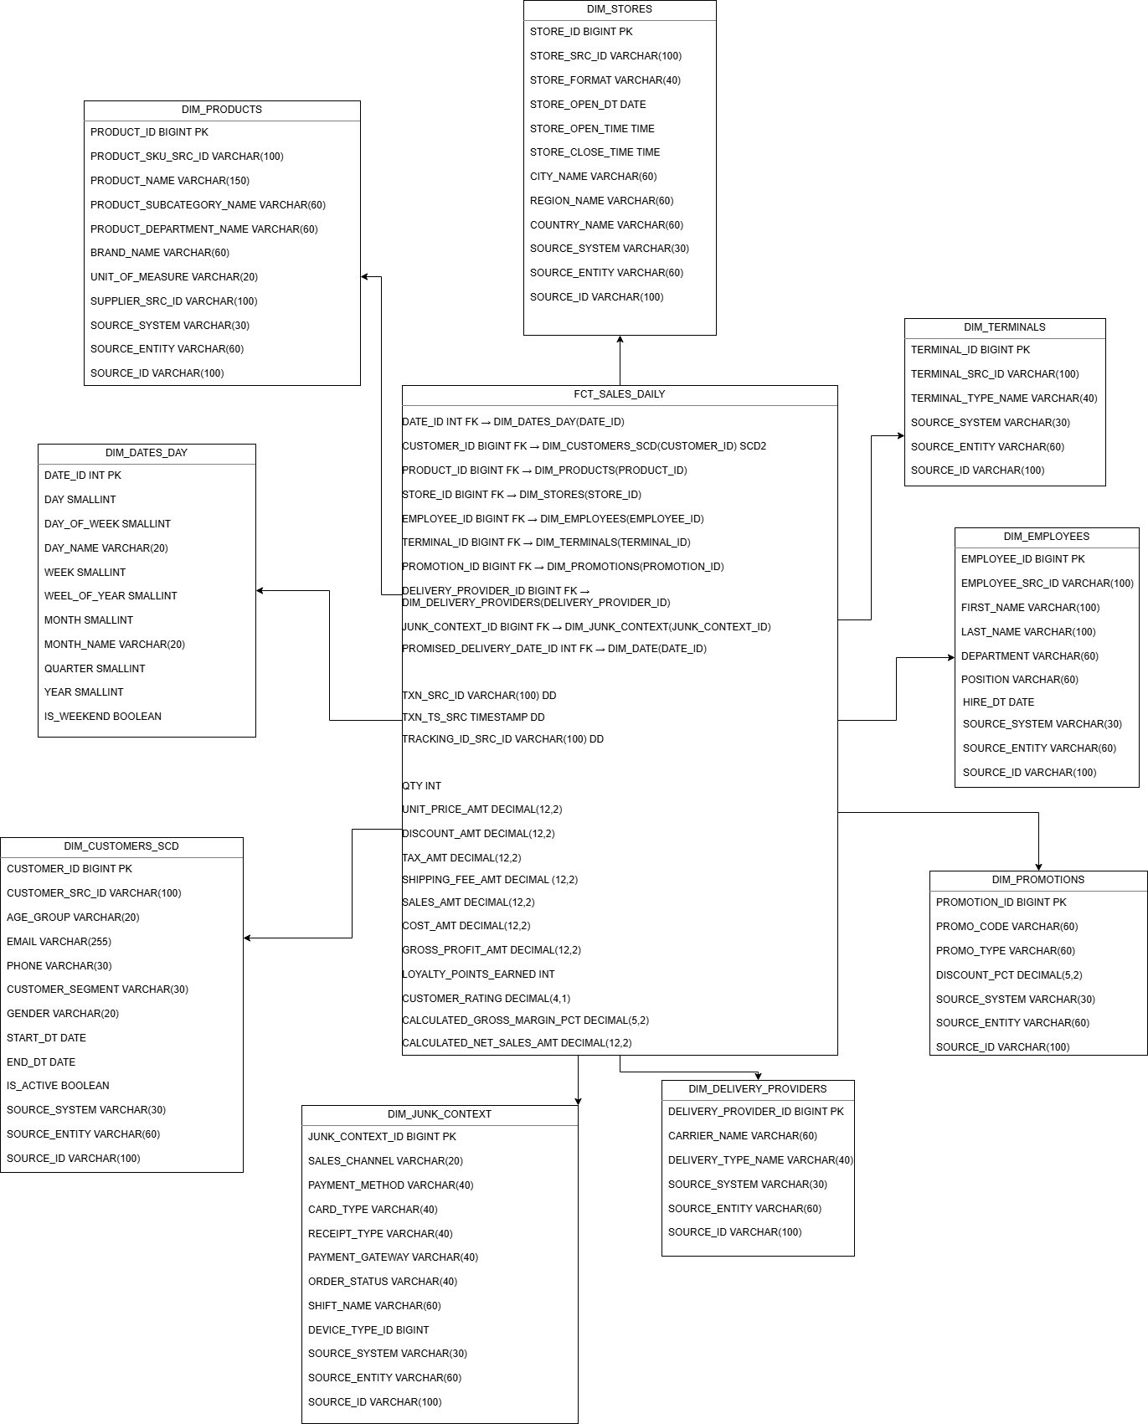

The fact table FCT_SALES_DAILY stores quantitative measures related to retail sales transactions at the grain of one transaction line per product. These metrics support financial, operational, and profitability analysis across online and offline sales channels.

Base Metrics

QTY
Represents the quantity of products sold in a single transaction line.
Used for volume analysis, demand forecasting, and aggregation at product, customer, store, or time level.

UNIT_PRICE_AMT
The unit selling price of a product at the moment of transaction.
Used to analyze pricing strategies and price differences across channels, promotions, and time periods.

DISCOUNT_AMT
The monetary value of the discount applied to the transaction line.
Enables analysis of promotion effectiveness and revenue impact of discounts.

TAX_AMT
The tax amount applied to the transaction line.
Used for tax reporting and analysis of gross versus net sales.

SHIPPING_FEE_AMT
Represents the delivery fee charged for a transaction line.
This metric applies only to online sales and is used to analyze the impact of shipping costs on total revenue and profitability.

SALES_AMT
The total sales amount for the transaction line, as provided by the source system.
This metric represents gross revenue before cost deduction and is the primary measure for revenue analysis.

COST_AMT
The cost of goods sold for the transaction line.
Used to evaluate cost structure and calculate profitability metrics.

GROSS_PROFIT_AMT
The gross profit generated by the transaction line.
Calculated in the source system as the difference between sales amount and cost amount.
This metric is used to assess product, customer, and channel profitability.

LOYALTY_POINTS_EARNED
The number of loyalty points earned for the transaction line (offline sales only).
Used to analyze customer loyalty programs and customer engagement.

CUSTOMER_RATING
Customer satisfaction rating associated with the transaction (when available).
Used for quality and customer experience analysis.

Calculated Metrics

In addition to base metrics, the model includes derived metrics that are calculated based on existing measures in the fact table.

CALCULATED_GROSS_MARGIN_PCT
Represents the gross margin percentage for a transaction line.

Formula:
GROSS_PROFIT_AMT / SALES_AMT

This metric allows comparison of profitability across products, categories, stores, and sales channels independently of absolute sales volume.

CALCULATED_NET_SALES_AMT
Represents net sales after discount deduction.

Formula:
SALES_AMT − DISCOUNT_AMT

This metric is useful for analyzing the true revenue impact of promotional activities.

Summary

The combination of base and calculated metrics in FCT_SALES enables comprehensive analysis of sales performance, pricing, discounting, cost efficiency, and profitability.

Logical Scheme

Data Flow

Fact Table Partitioning Strategy

