Row-Level Security (RLS) Configuration in Power BI
In this task, Row-Level Security (RLS) was implemented based on a territory-based security pattern, where data access is restricted depending on geographical attributes such as country, region, and territory groups.
Three different roles were created to demonstrate both static and dynamic RLS approaches:
1.Static Role – Country Level (Canada)
- This role restricts access to data for a specific country.
- A filter was applied on the Country column with a fixed value:
Country = "Canada"
- This approach is suitable for simple scenarios where users should always see data from one predefined country.
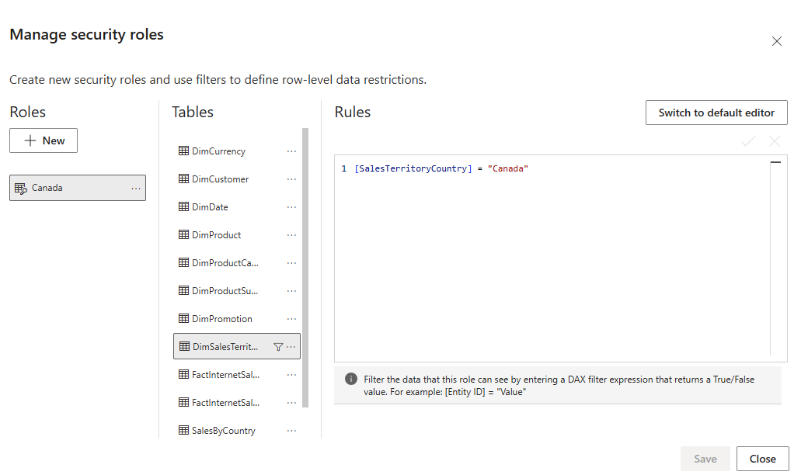
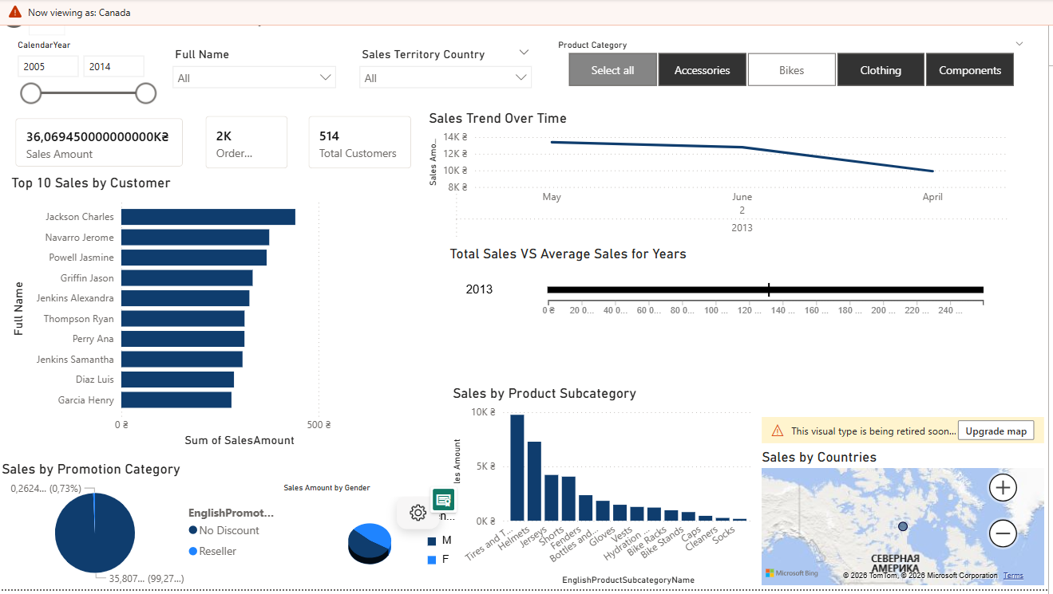
2.Dynamic Role – Region Level
- This role dynamically filters data based on the logged-in user.
- The filter uses the USERPRINCIPALNAME() function:
[Region] = USERPRINCIPALNAME()
- This allows different users to see only the data related to their assigned region without creating separate roles for each user.

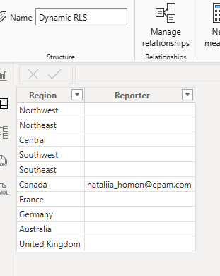
Created relationship
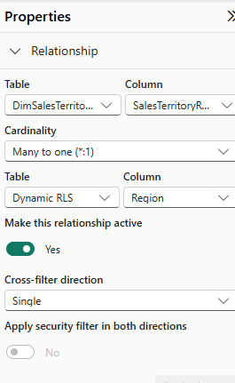
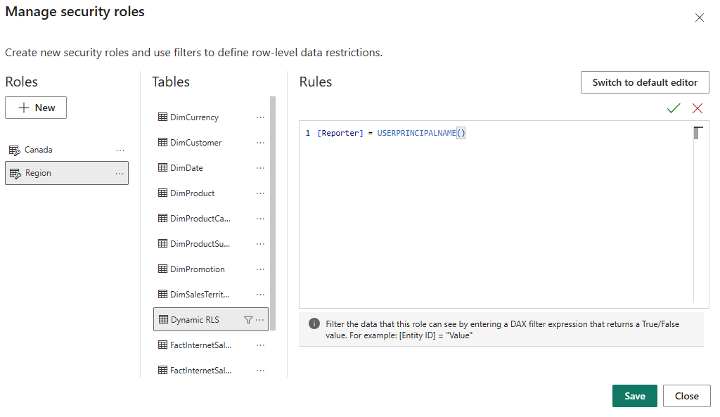

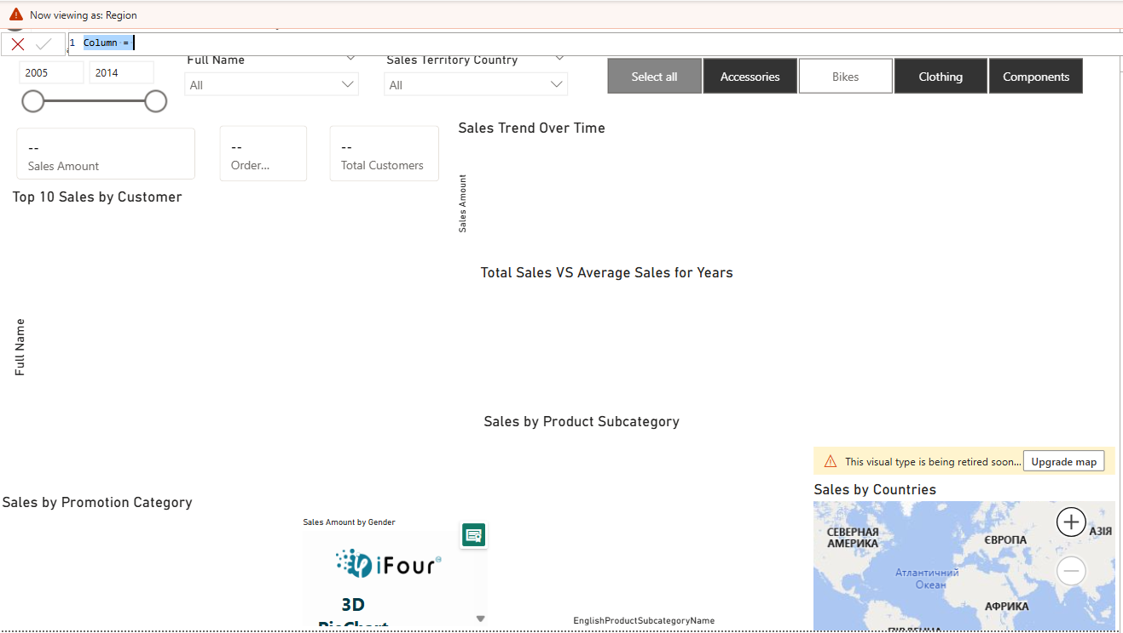

In Power BI Desktop, the current user corresponds to my local machine (laptop). Under the ‘Region’ role, no data is displayed
• Power BI Desktop
- Roles were tested using the “View as” feature to simulate different users and validate the filtering logic.
- This ensured that each role correctly restricted the dataset according to the defined rules.
• Power BI Service (Online)
- Roles were published and assigned to users in the Power BI Service.
- Additional validation was performed to confirm that dynamic functions such as USERPRINCIPALNAME() work correctly in the cloud environment.
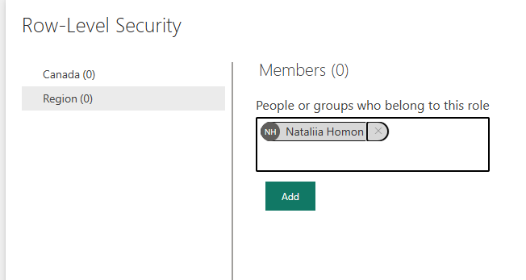

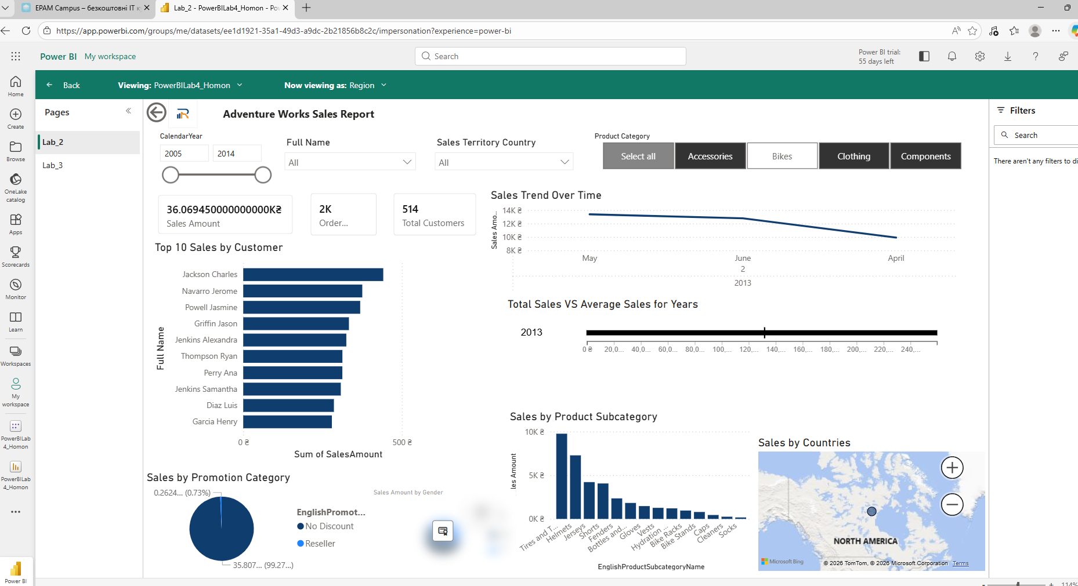
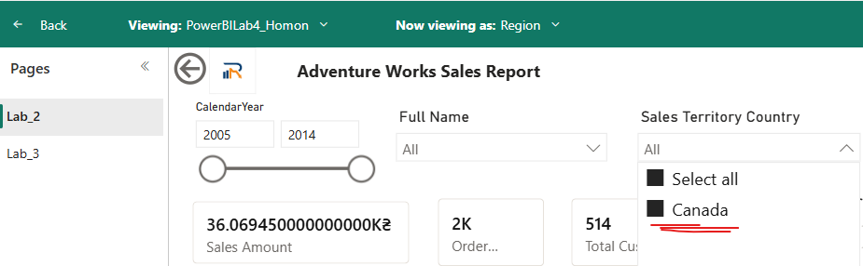
Only Canada how it was defined in the table. Worked as was designed
Dynamic Role – Territory Groups
- This role is based on territorial groups and was tested in Power BI Desktop.
- The filter uses the USERNAME() function:
[TerritoryGroup] = USERNAME()
- This was used because, in Power BI Desktop, the username corresponds to the local machine (e.g., laptop user), making it suitable for testing dynamic behavior locally.
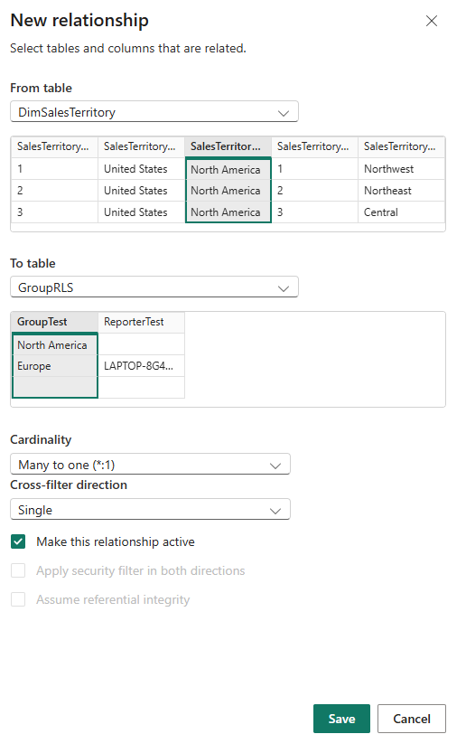
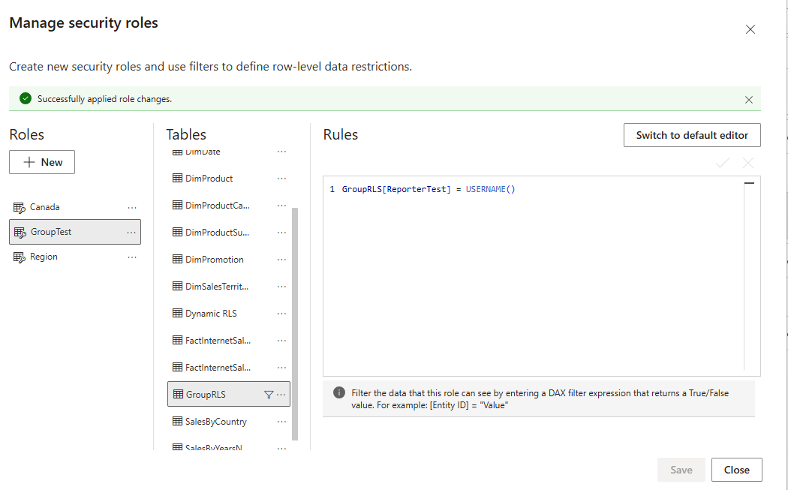
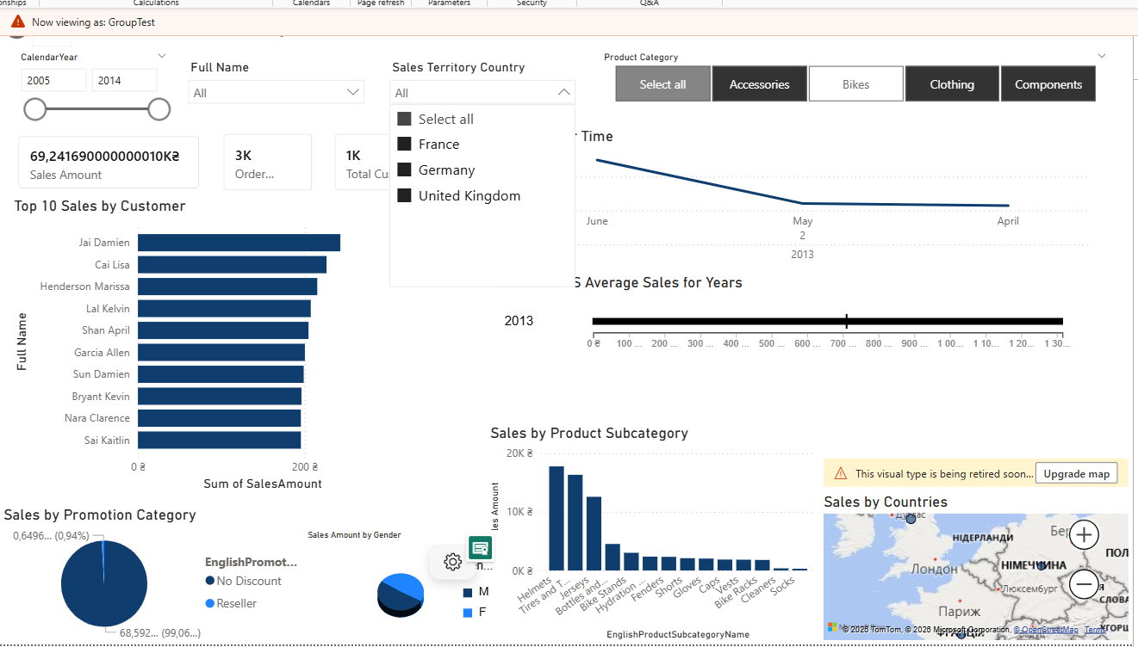

2.
• Created a bar chart and a map visual and placed them in the same area.
• Opened Selection Pane and Bookmarks Pane.
• Set the first state: showed the bar chart and hid the map, created a bookmark (Bar View) and updated it.
• Set the second state: hid the bar chart and showed the map, created a bookmark (Map View) and updated it.
• Created two buttons and assigned actions:
- first button → Bar View
- second button → Map View
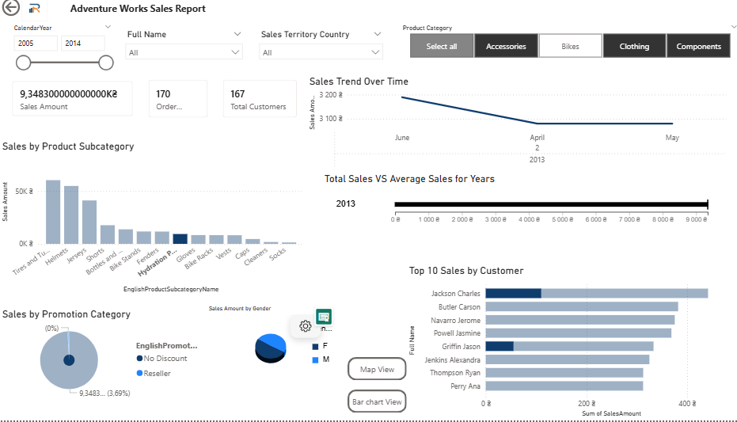
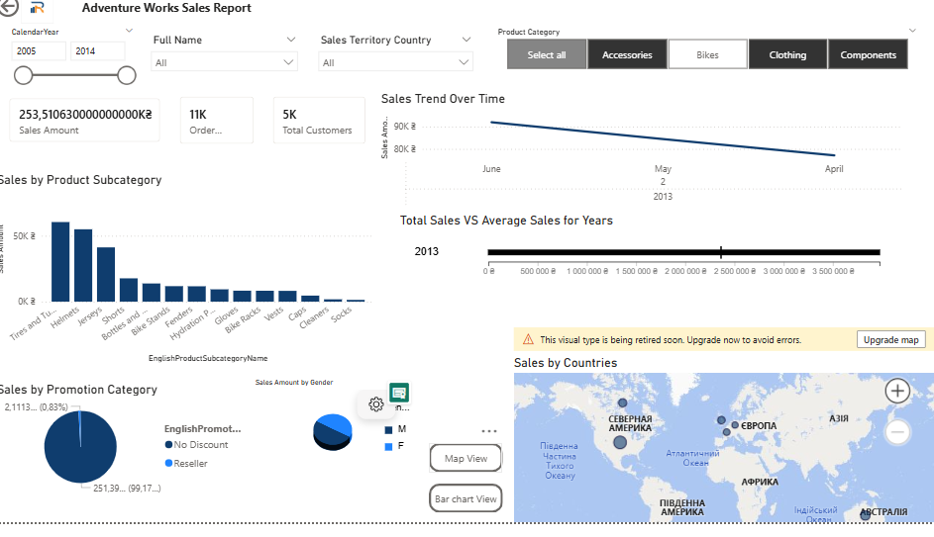
3. Created a disconnected helper table to allow users to select the time period:
Period Selector =
DATATABLE(
"Period", STRING,
{
{"MTD"},
{"QTD"},
{"YTD"}
}
)
- Added a slicer to the report page using the Period column from the Period Selector table to enable user interaction.
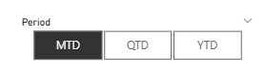

Created Measures

Base Measure(has already been created)
Sales Amount = SUM(FactInternetSales[SalesAmount])

MTD, QTD, YTD Measures
Sales Amount MTD =
CALCULATE(
[Sales Amount],
DATESMTD(DimDate[FullDateAlternateKey])
)
Sales Amount QTD =
CALCULATE(
[Sales Amount],
DATESQTD(DimDate[FullDateAlternateKey])
)
Sales Amount YTD (has already been created)=
CALCULATE(
[Sales Amount],
DATESYTD(DimDate[FullDateAlternateKey])
)

Previous Year Measures
Sales Amount MTD Previous Year =
CALCULATE(
[Sales Amount MTD],
SAMEPERIODLASTYEAR(DimDate[FullDateAlternateKey])
)
Sales Amount QTD Previous Year =
CALCULATE(
[Sales Amount QTD],
SAMEPERIODLASTYEAR(DimDate[FullDateAlternateKey])
)
Sales Amount YTD Previous Year (has already been created) =
CALCULATE(
[Sales Amount YTD],
SAMEPERIODLASTYEAR(DimDate[FullDateAlternateKey])
)

Dynamic Measure (Switcher)
Sales Amount Selected =
SWITCH(
SELECTEDVALUE('Period Selector'[Period], "YTD"),
"MTD", [Sales Amount MTD],
"QTD", [Sales Amount QTD],
"YTD", [Sales Amount YTD]
)
Sales Amount Selected Previous Year =
SWITCH(
SELECTEDVALUE('Period Selector'[Period], "YTD"),
"MTD", [Sales Amount MTD Previous Year],
"QTD", [Sales Amount QTD Previous Year],
"YTD", [Sales Amount YTD Previous Year]
)
SAME for Orders

Final Step
- Replaced existing YTD measures in visuals with:
  - Sales Amount Selected
  - Sales Amount Selected Previous Year
- Now all visuals dynamically change based on the selected value in the slicer (MTD, QTD, or YTD).
I implemented a dynamic switch between MTD, QTD, and YTD views using a slicer connected to a disconnected helper table and a SWITCH-based DAX measure. Separate measures were created for each time aggregation and their previous year equivalents. A dynamic measure selects the appropriate calculation based on the user’s selection. This approach was chosen because it is flexible, scalable, and allows interactive analysis within the same visuals without duplicating them.

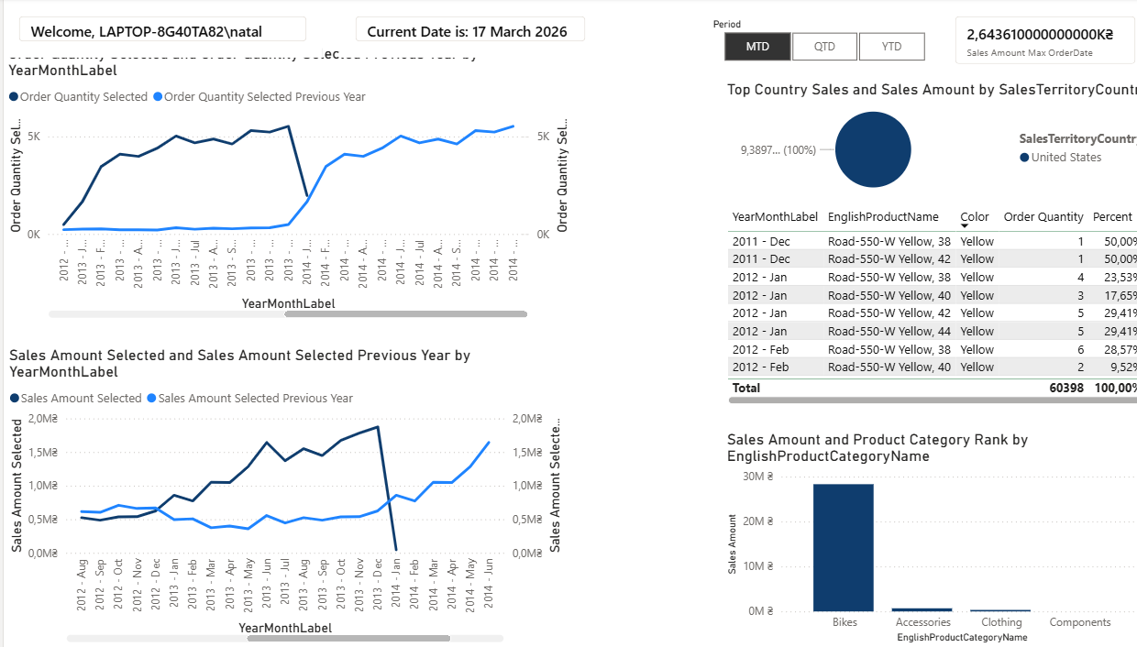
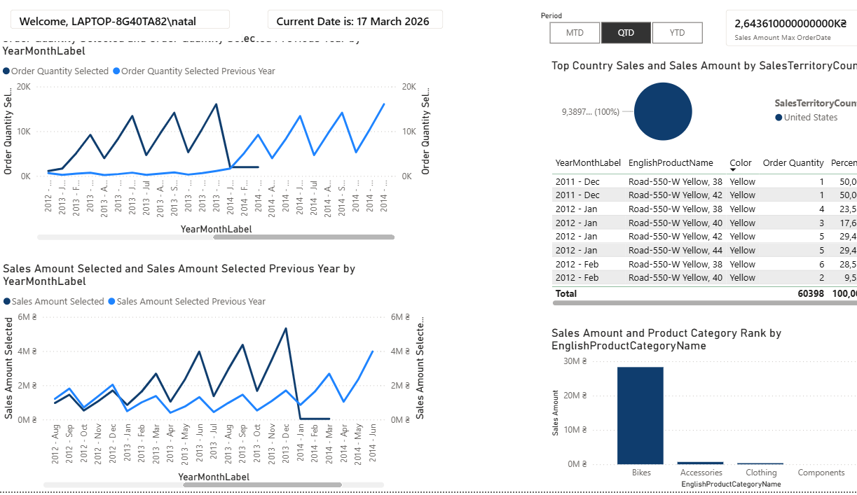
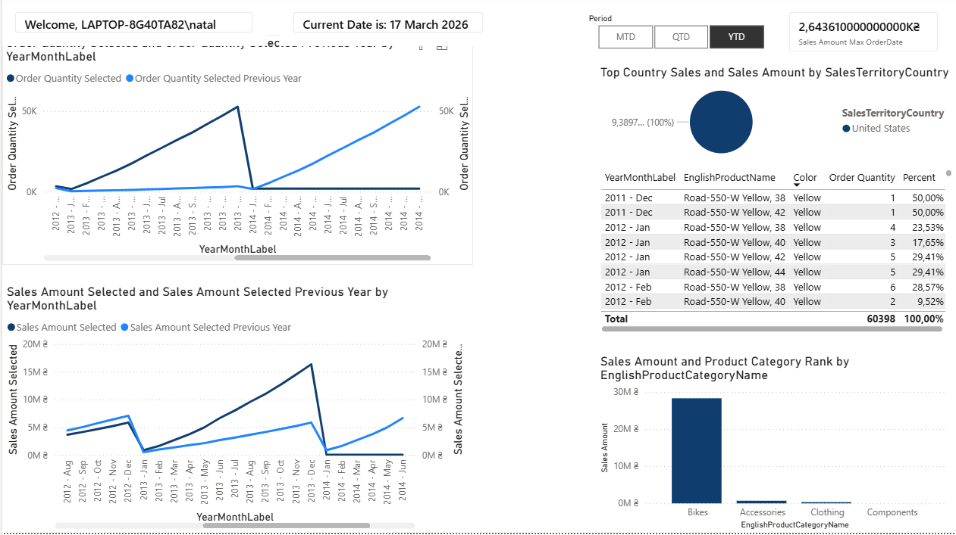

4.
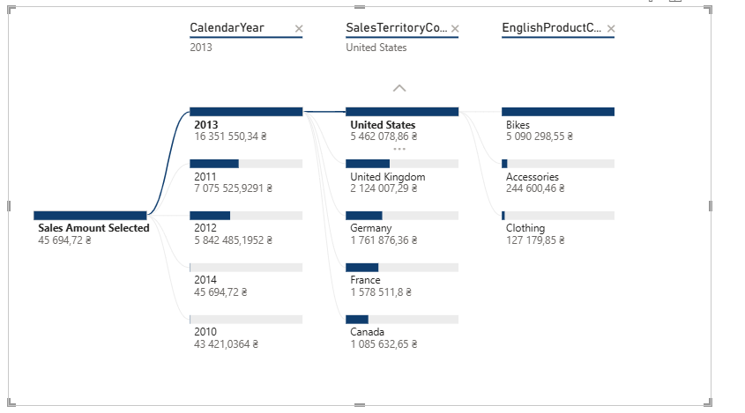
A decomposition tree visual was created to analyze the factors influencing the selected measure (Sales Amount). The measure was added to the “Analyze” field, and multiple independent variables such as Country, Product Category, and Year were added to the “Explain by” field. This visual allows interactive exploration of data by breaking down the total value into contributing factors. It helps to identify key drivers and understand how different dimensions impact the overall result. (Presented on the page Lab4)
5.Created new page + changed page settings+added visuals
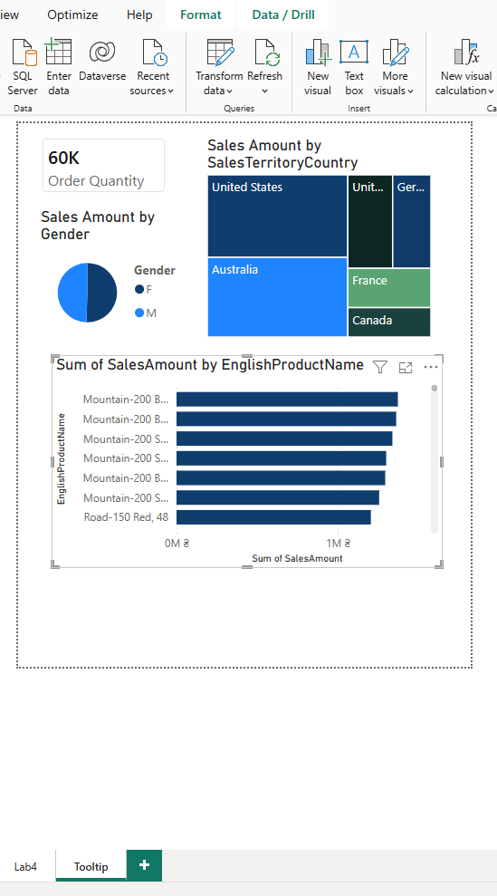
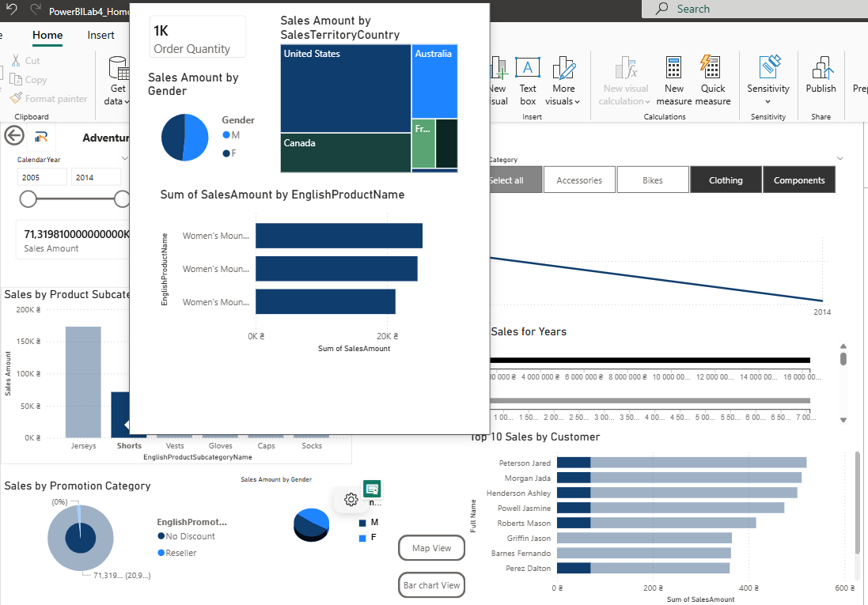

6. Added custom visual (page Lab4)
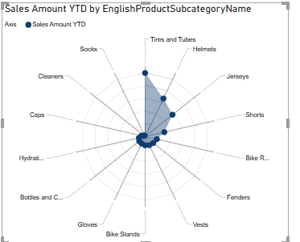
A custom radar chart visual was created to analyze Sales Amount YTD by product subcategories. The YTD measure was used as the main value, and EnglishProductSubcategoryName was added as the axis. This visual allows comparing performance across multiple subcategories in a compact and intuitive way. Compared to standard visuals, the radar chart provides a more visual and pattern-based representation, making it easier to identify leading and underperforming product groups.

