Task 1
Task 1 a link - nataliia_homon_lambda | Functions | Lambda
• Created a Lambda function with a custom name format.
• Configured execution role dilab-lambda-sf-role.
• Implemented Python code to parse input JSON using the event object.
• Extracted values from JSON and displayed them in:
- Lambda response
- CloudWatch logs
• Tested the function using a sample JSON event.
The Lambda function nataliia_homon_lambda successfully parses input JSON.
Parsed values are displayed both in the Response and in CloudWatch Function Logs.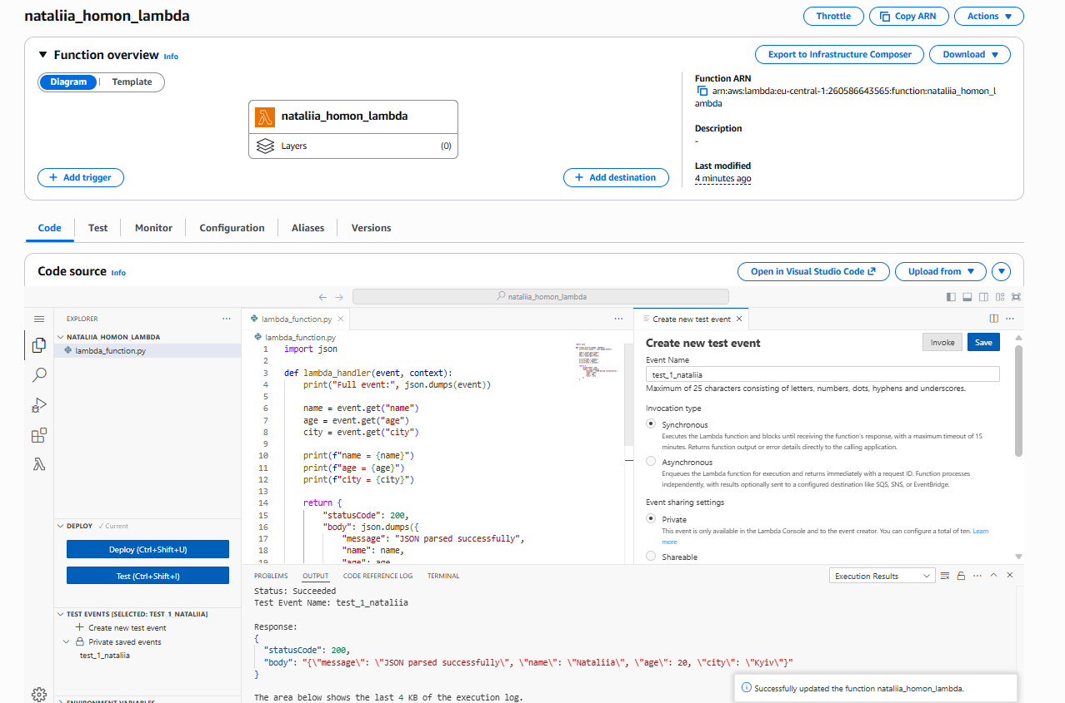
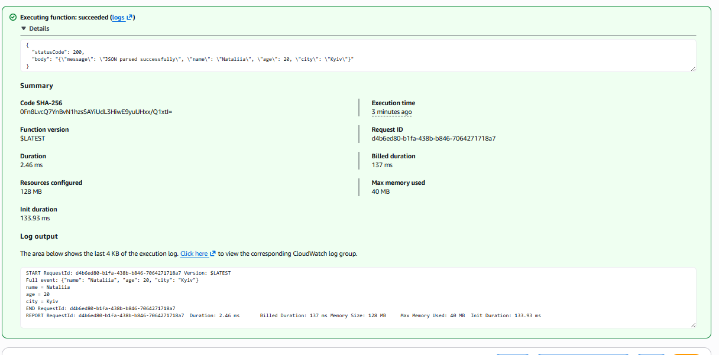

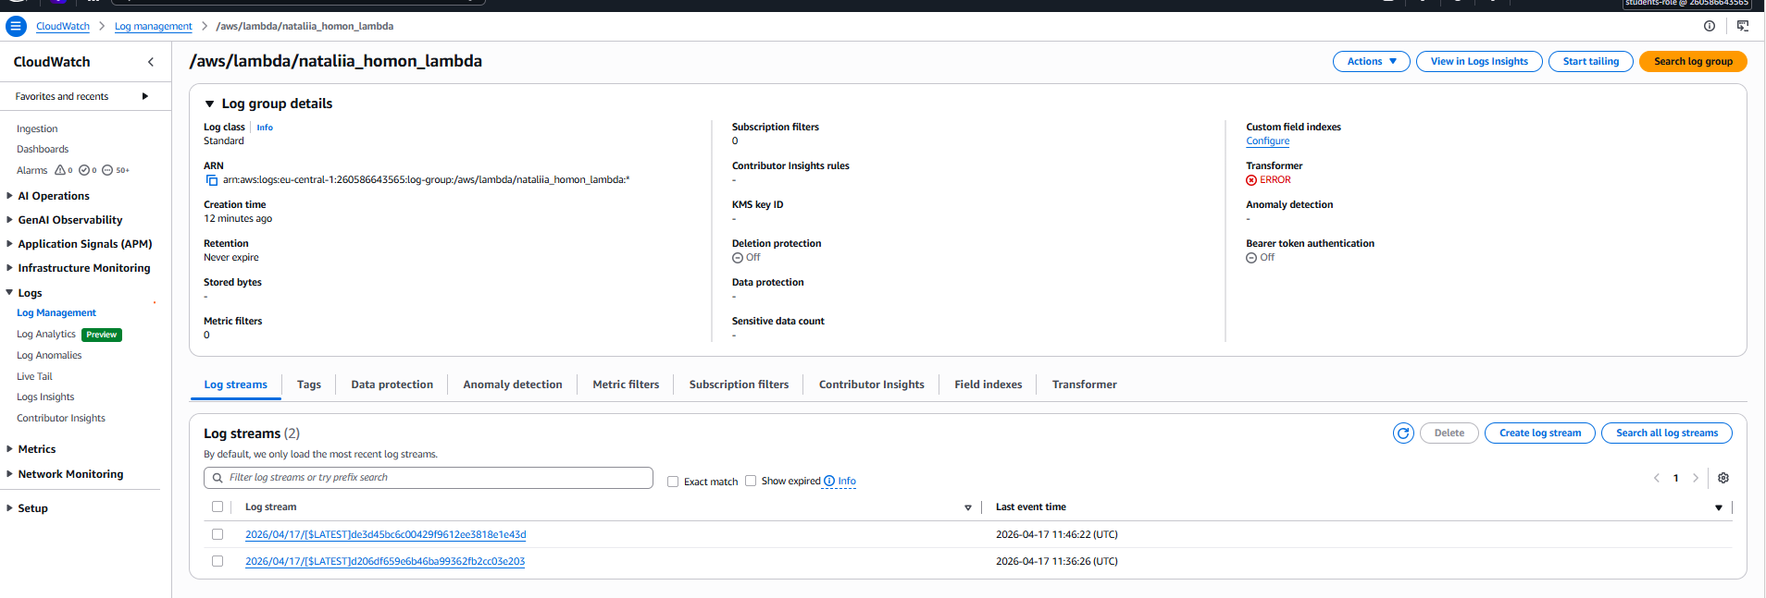

Task 1 b
• Created an Apache Iceberg table in Athena to support UPDATE operations.
• Inserted sample data into the table.
• Executed SQL queries manually in Athena (SELECT, UPDATE, SELECT).
• Created multiple Lambda functions to interact with Athena:
- SELECT query with LIMIT (data retrieval)
- UPDATE query (data modification)
- SELECT query to verify updated data
• Implemented Athena integration using boto3 (StartQueryExecution, GetQueryExecution, GetQueryResults).
• Parsed and displayed query results in Lambda logs.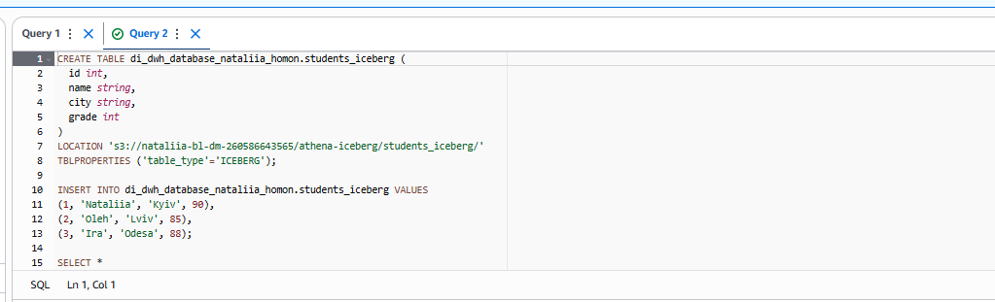
CREATE TABLE di_dwh_database_nataliia_homon.students_iceberg (
id int,
name string,
city string,
grade int
)
LOCATION 's3://nataliia-bl-dm-260586643565/athena-iceberg/students_iceberg/'
TBLPROPERTIES ('table_type'='ICEBERG');

INSERT INTO di_dwh_database_nataliia_homon.students_iceberg VALUES
(1, 'Nataliia', 'Kyiv', 90),
(2, 'Oleh', 'Lviv', 85),
(3, 'Ira', 'Odesa', 88);

SELECT *
FROM di_dwh_database_nataliia_homon.students_iceberg
LIMIT 5;

UPDATE di_dwh_database_nataliia_homon.students_iceberg
SET grade = 95
WHERE id = 1;

SELECT *
FROM di_dwh_database_nataliia_homon.students_iceberg
WHERE id = 1;

Created Lambda for SELECT link - nataliia_homon_athena_select | Functions | Lambda
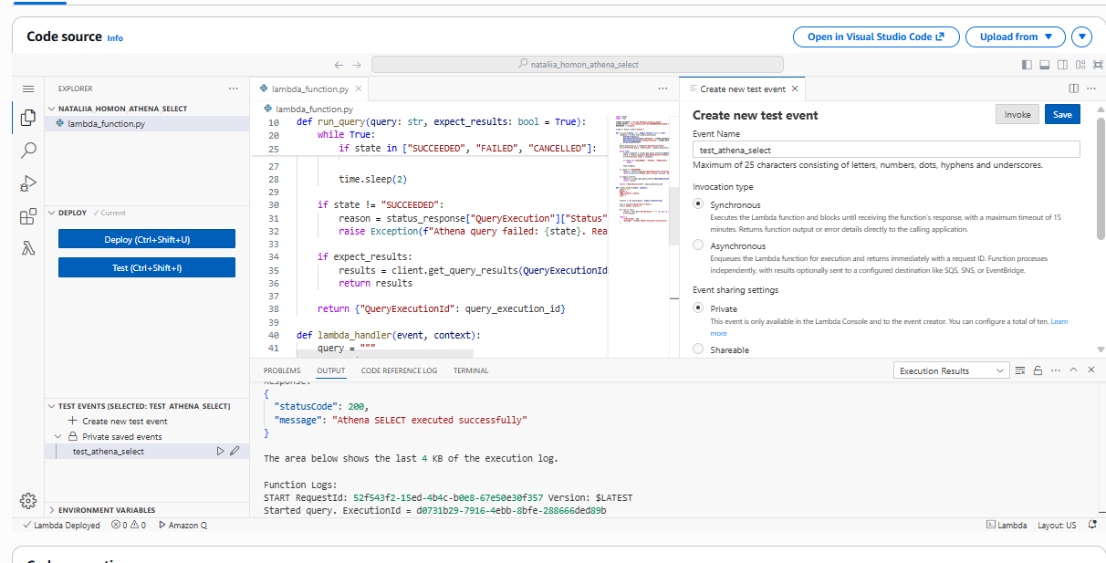
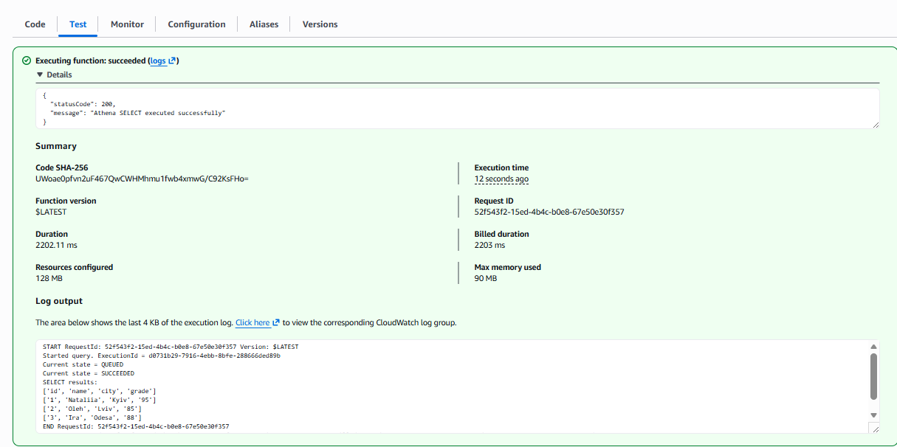
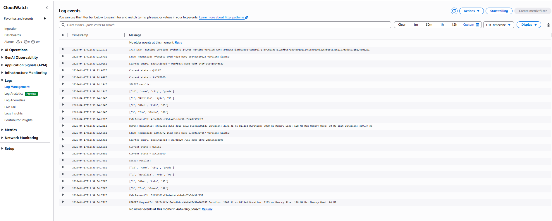
Created lambda Update link - nataliia_homon_athena_update | Functions | Lambda
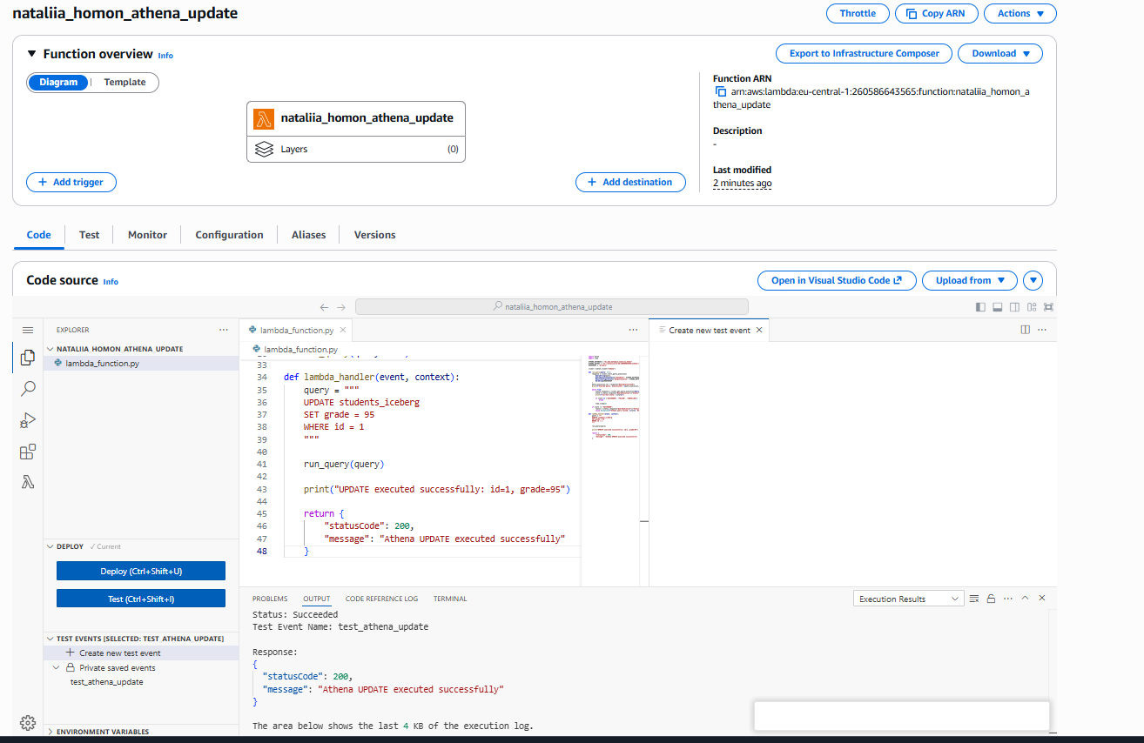
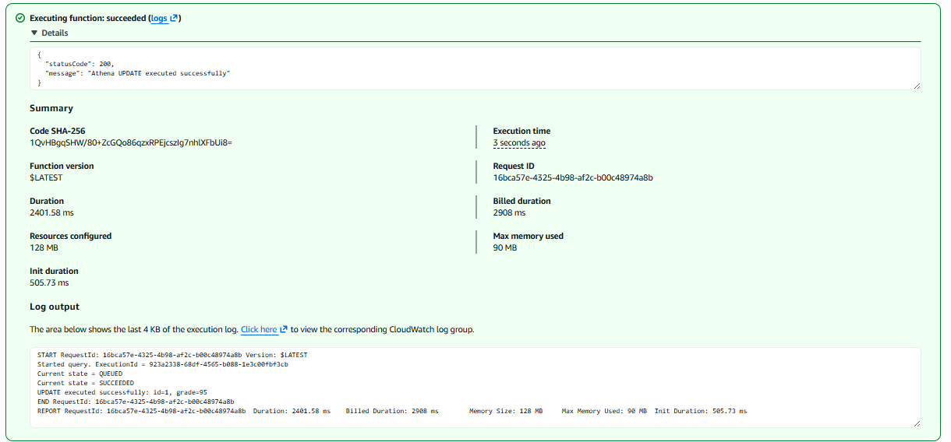
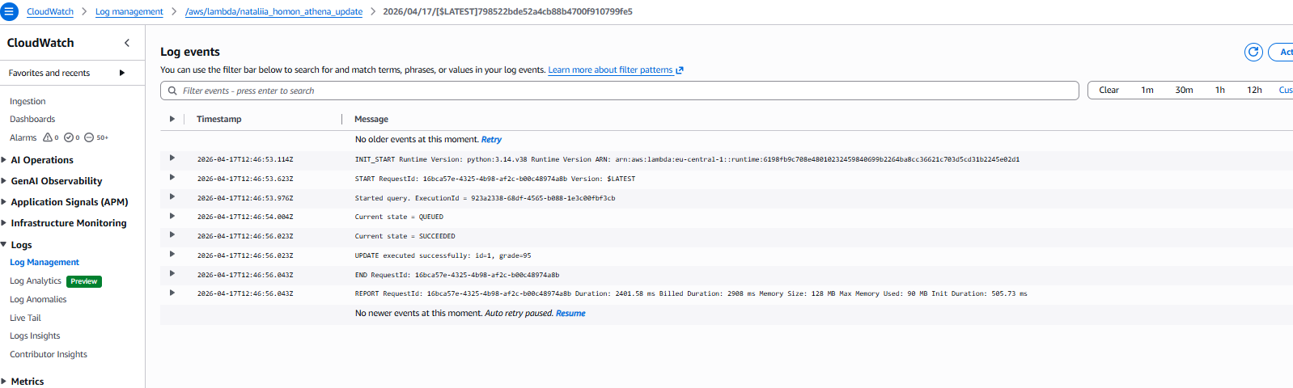
Created lambda SELECT verify link nataliia_homon_athena_verify | Functions | Lambda

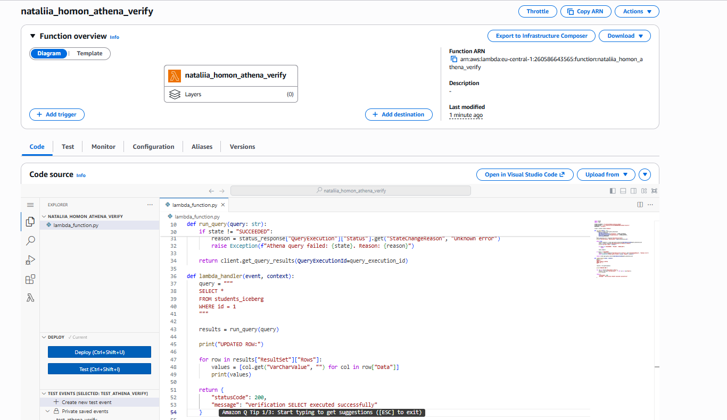
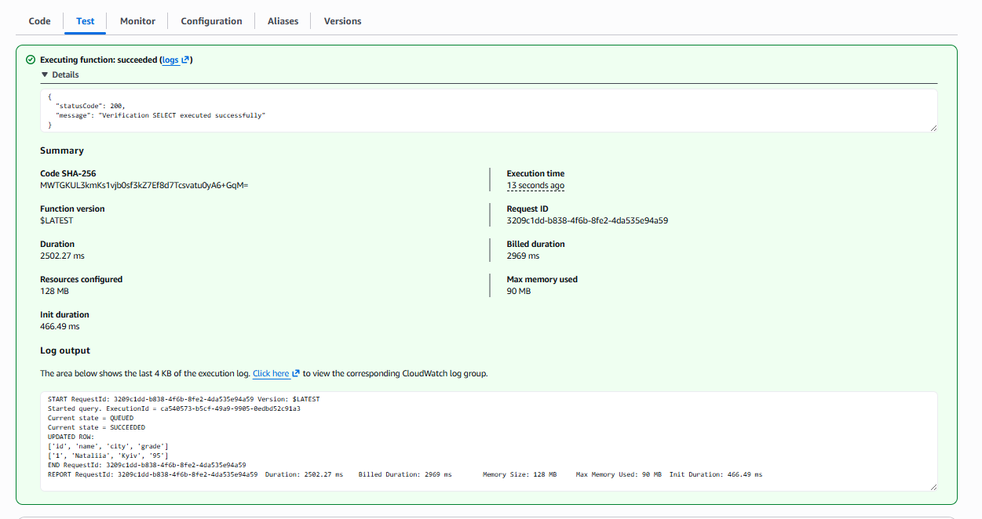
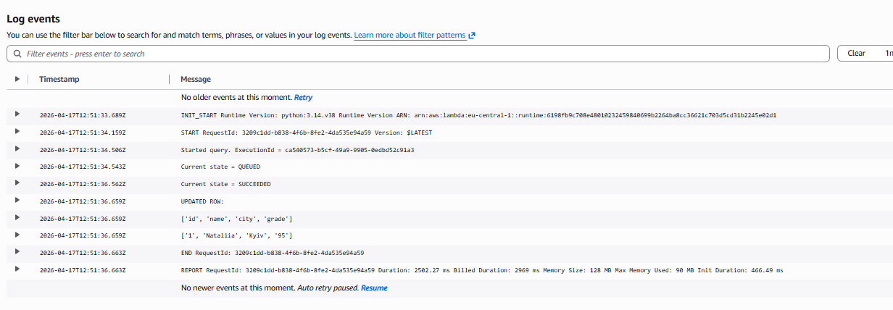
Lambda functions allow programmatic interaction with Athena.
They automate data retrieval (SELECT), modification (UPDATE), and validation (SELECT after update), eliminating the need for manual queries and enabling scalable data processing.

Task 1 c lambda link nataliia_homon_athena_s3 | Functions | Lambda
- Created an AWS Lambda function to parse input JSON and display parsed values in both the response and CloudWatch logs.
- Created an Apache Iceberg table in Amazon Athena and inserted sample data.
- Executed SQL queries in Athena:
  - SELECT with LIMIT to retrieve data
  - UPDATE to modify a value
  - SELECT to verify the updated row
- Created separate Lambda functions to interact with Athena and execute these queries programmatically.
- Uploaded a SQL file to Amazon S3 containing multiple queries.
- Implemented a Lambda function that reads the SQL file from S3, parses queries, and executes a selected query dynamically.

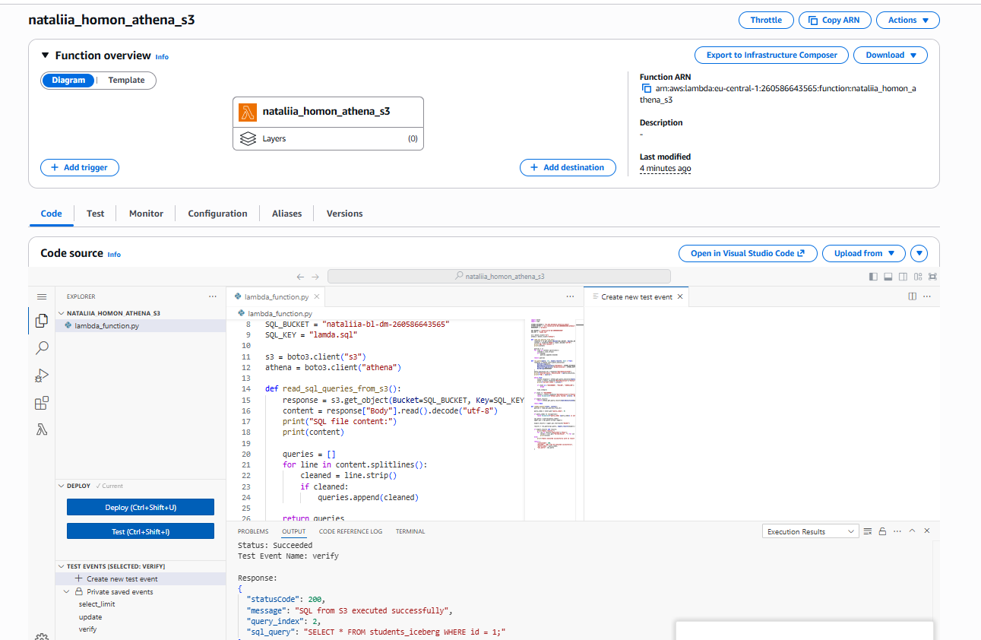
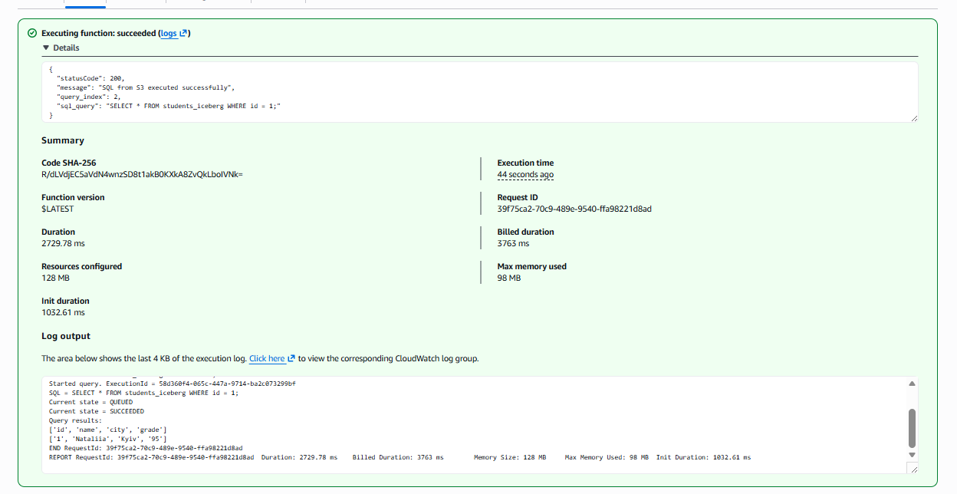
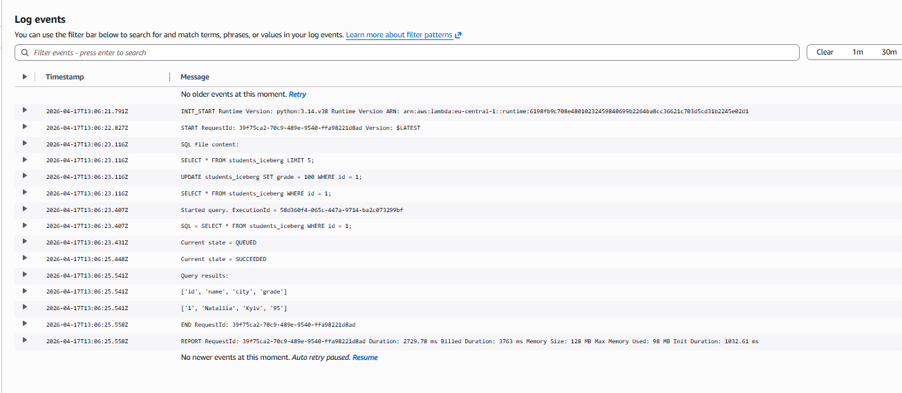
This task demonstrates how AWS Lambda can be used to automate data processing and interact with Amazon Athena. It shows how to retrieve, update, and validate data programmatically instead of running manual SQL queries, as well as how to make solutions more flexible by storing SQL queries in S3 instead of hardcoding them.

Task2
- Сreated three separate AWS Lambda functions for the Redshift workflow:
  - Lambda 1 — first test of the Redshift table
  - Lambda 2 — update of data in the Redshift table
  - Lambda 3 — second test of the same Redshift table
- For all Lambda functions, we used the same configuration as in the example Lambda epam-aleh-shylin-test-lambda:
  - IAM role dilab-lambda-sf-role
  - the same Layer
  - the same VPC
  - the same subnets
  - the same security group
  - increased timeout to 5 minutes
- Used the redshift_connector library in Lambda to connect to Amazon Redshift and execute SQL queries.
- In the first Lambda, performed the first test of the Redshift table by checking whether the table contained data.
- In the second Lambda, executed an UPDATE query to modify data in the Redshift table.
- In the third Lambda, performed the second test to verify that the change had been applied successfully.
- After that, created an AWS Step Function to orchestrate the workflow in the required order:
  - first Redshift test
  - update data in Redshift
  - second Redshift test
  - check both test results
- In the Choice step of the Step Function, checked whether:
  - the first test passed
  - the second test passed
- If both tests returned true, the Step Function finished with Success. Otherwise, it finished with Fail.

SQL queries used

First test query

used a query to check whether the table was not empty:
SELECT COUNT(*) FROM dilab_student73.dim_products;
This query returned the number of rows in the table.
If the row count was greater than zero, the first test was considered passed.

Update query
used an UPDATE query to modify one record in the Redshift table.
General idea:
UPDATE dilab_student73.dim_products
SET <column_name> = <new_value>
WHERE <condition>;
This query changed data in the selected row.

Second test query
used a verification query to confirm that the update was applied successfully.
General idea:
SELECT COUNT(*)
FROM dilab_student73.dim_products
WHERE <updated_condition>;
If this query returned a value greater than zero, the second test was considered passed.

Lambda 1 link - nataliia_homon_redshift_test1 | Functions | Lambda
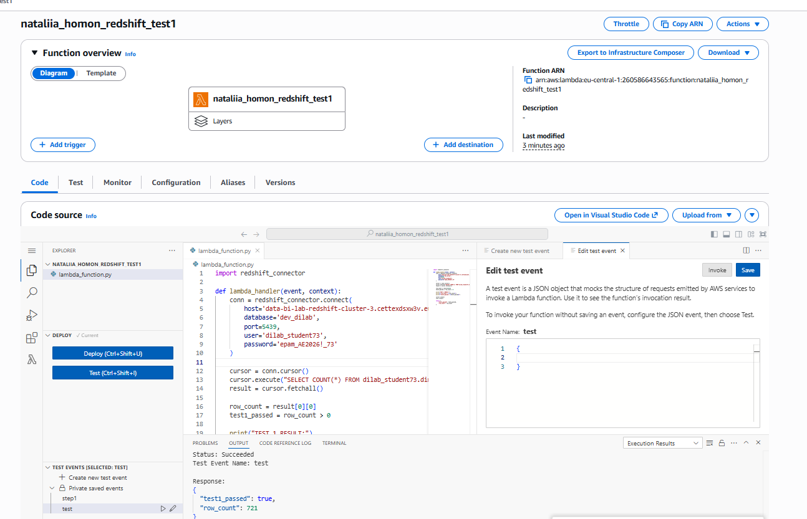

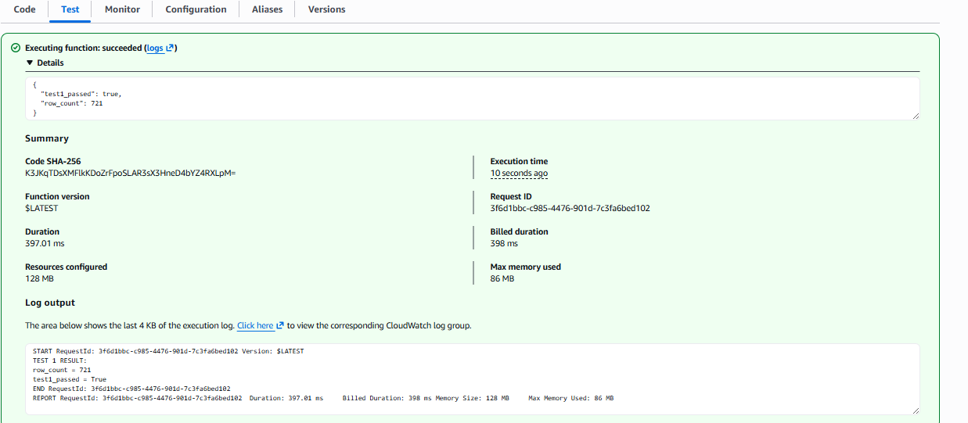
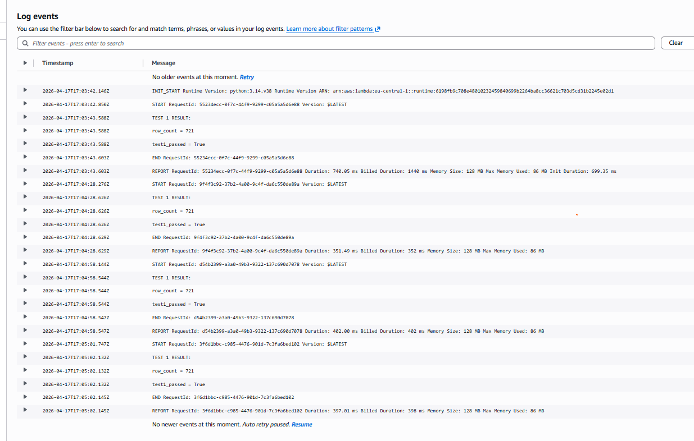

Step 2 lambda link - nataliia_homon_lambda_2step_update | Functions | Lambda

UPDATE dilab_student73.dim_products
SET product_name = 'UPDATED_PRODUCT'
WHERE product_id = (
SELECT MIN(product_id) FROM dilab_student73.dim_products
);

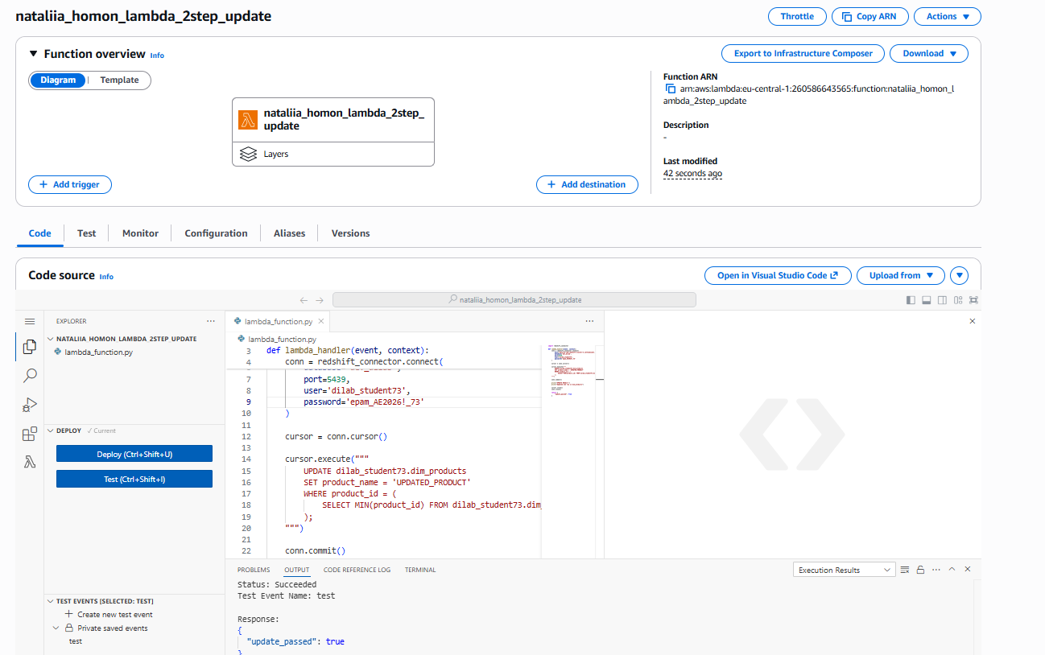
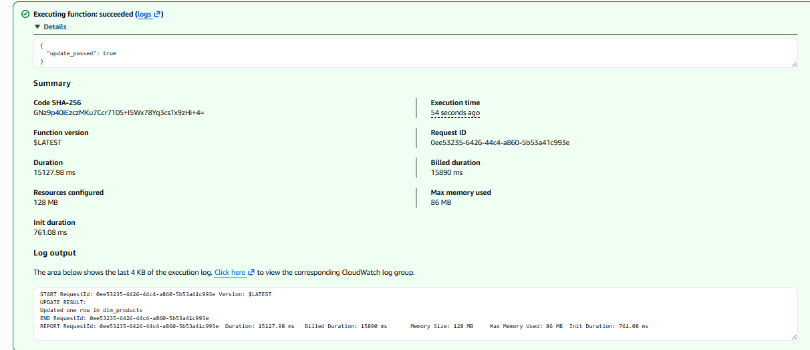
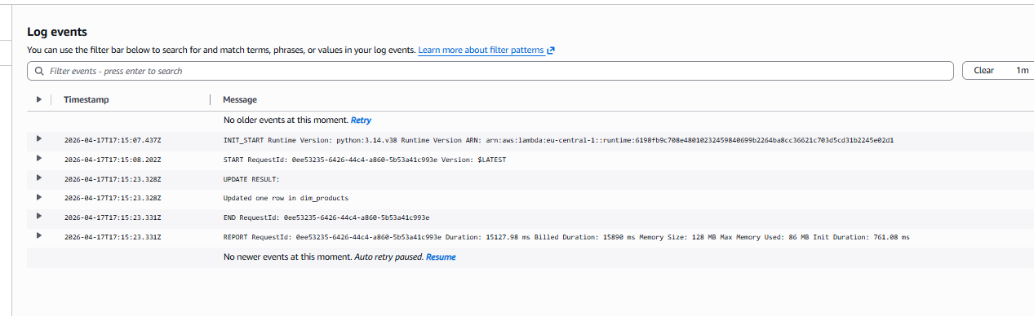

3rd lambda function link - nataliia_homon_3step_lambda_verify | Functions | Lambda
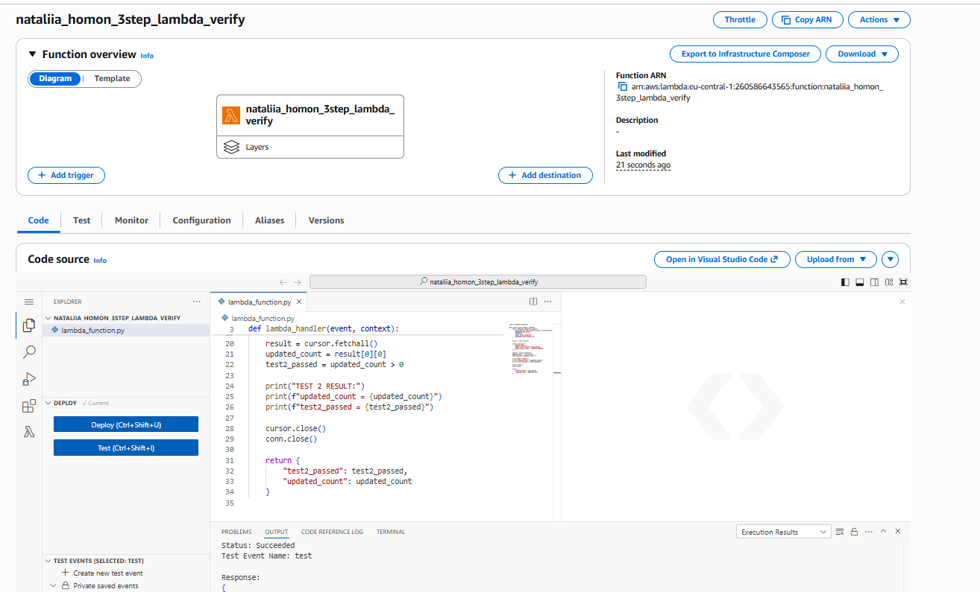
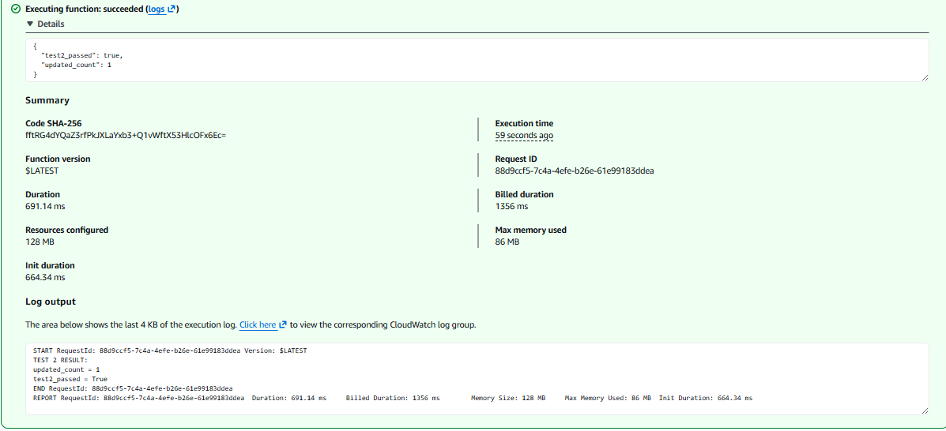
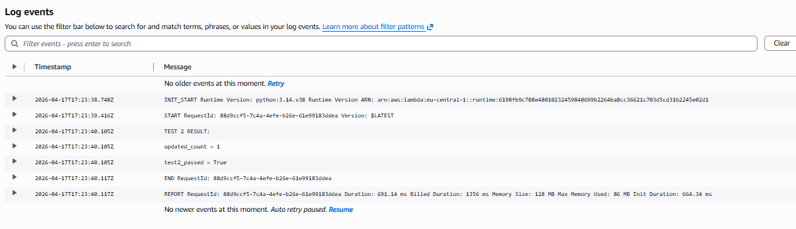

Step function link State machine: nataliia_homon_step_func > State machines > Step Functions | Step Functions | eu-central-1
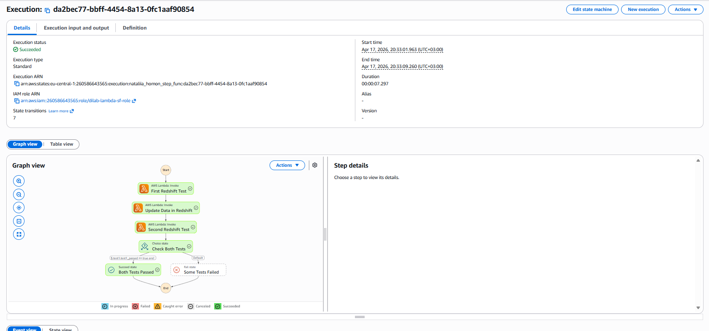
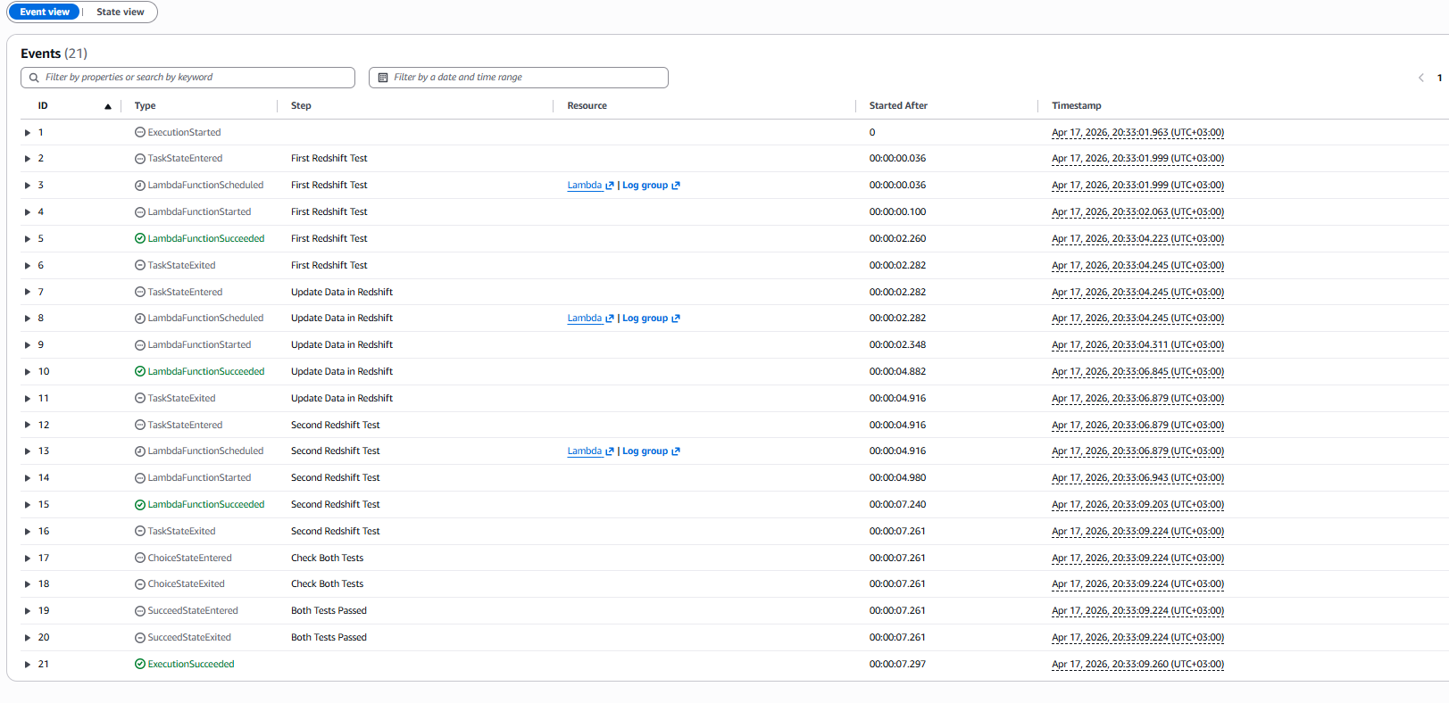

What this functionality gives us
This workflow demonstrates how AWS services can be combined to automate database operations.
- Lambda performs individual actions such as testing data and updating records.
- Redshift stores the data.
- Step Functions controls the order of execution and the decision logic.
This means that instead of running database checks and updates manually, the whole process can be executed automatically as a single workflow.

Purpose of the task
The task shows how to build a serverless data validation and update pipeline in AWS.
It demonstrates:
- Lambda integration with Redshift
- usage of shared infrastructure settings such as Layer, VPC, subnets, and security group
- response parsing from Lambda functions
- orchestration of multiple Lambda functions using AWS Step Functions
- automatic success/failure decision based on test results

