  - TASK 1: NESTED LOOP JOIN
EXPLAIN ANALYZE SELECT * FROM test_joins_a a, test_joins_b b
WHERE a.id1 > b.id1;

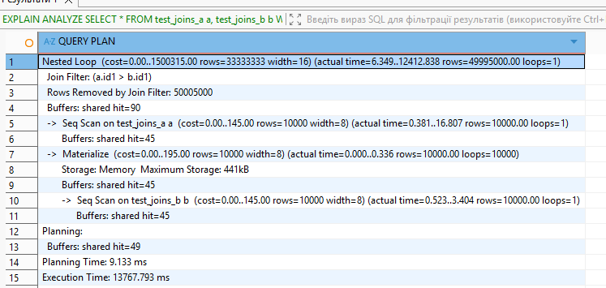

The planner chose a Nested Loop because:
- The join condition is a non-equality (>), so Hash Join is not possible.
- Both tables are relatively small (10k rows each).
- Sequential scans are cheap for small tables.
- Materialize
loops=10000
PostgreSQL:
- Scanned test_joins_b once
- Stored it in memory (~441kB)
- Reused it 10,000 times (once per row from table A)
This avoids re-reading table B from disk repeatedly.
FROM a, b
WHERE a.id1 > b.id1
So PostgreSQL evaluated:
10,000 × 10,000 = 100 million comparisons
Rows Removed by Join Filter: 50,005,000
Rows Returned: 49,995,000

Roughly half the pairs satisfied a.id1 > b.id1.
The main bottleneck here is CPU and result materialization.

EXPLAIN ANALYZE SELECT *
FROM test_joins_a a
CROSS JOIN test_joins_b b;

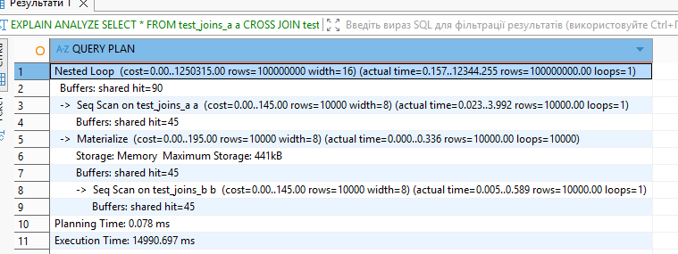
The plan is the same (Nested Loop + materialize), but the first query generates 100 million pairs and returns about 50 million of them (after filtering), while the second query generates and returns all 100 million — therefore it is slower because of the larger result set, even though it does not spend time evaluating a filter condition.

1.2 TASK 2: HASH JOIN

SET enable_nestloop = off;
SET enable_mergejoin = off;

EXPLAIN ANALYZE SELECT * FROM test_joins_a a, test_joins_b b
WHERE a.id1 = b.id1;
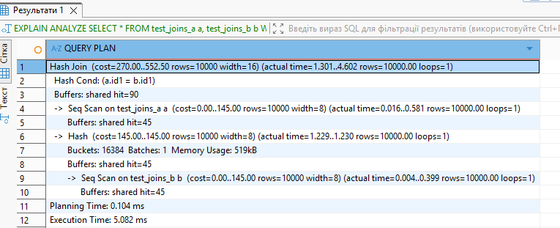
Hash Join is only possible for = conditions. PostgreSQL built a hash table from table b (~519KB). Then it scanned table a and performed fast lookups in the hash table. This resulted in a linear algorithm, which is why execution took about 5 ms.
EXPLAIN ANALYZE
SELECT *
FROM test_joins_a a
WHERE EXISTS (
SELECT 1
FROM test_joins_b b
WHERE b.id1 = a.id1
);
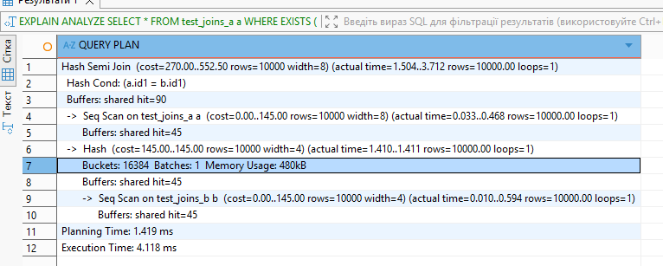
This query uses a Hash Semi Join to return rows from test_joins_a only if a matching id1 exists in test_joins_b. PostgreSQL builds a hash table from table b, then scans table a and performs fast hash lookups to check for matches. Because this is a semi join, it stops at the first match and does not duplicate rows. The execution is efficient and linear in complexity, which is why it completes in about 4 ms.

SET enable_hashjoin = off;

Repeated run
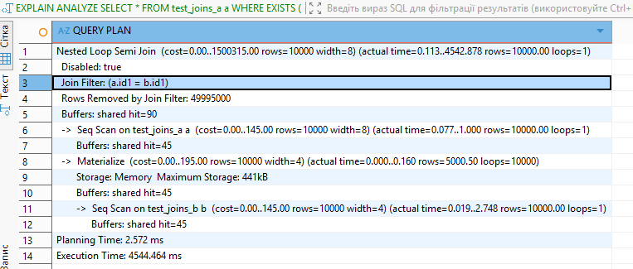Disabling hash join forced PostgreSQL to switch from a Hash Semi Join to a Nested Loop Semi Join, which performs tens of millions of comparisons, making execution thousands of times slower.
1.3 TASK 3: MERGE JOIN
EXPLAIN ANALYZE SELECT * FROM test_joins_a a, test_joins_b b
WHERE a.id1 = b.id1;

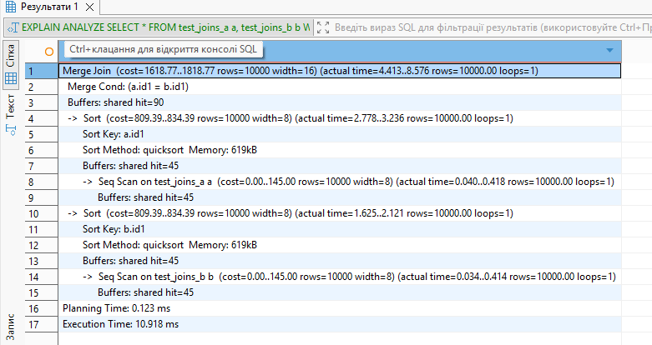
With enable_hashjoin = off, PostgreSQL could not use a Hash Join for the equality condition a.id1 = b.id1, so it chose a Merge Join instead. To perform a Merge Join, both inputs must be sorted on the join key. Since there were no indexes providing pre-sorted data, PostgreSQL executed sequential scans on both tables and then sorted each of them in memory using quicksort.
After sorting, the Merge Join processed the two ordered streams linearly, matching equal values as it advanced through both sides. The execution remained fast (~11 ms) because the tables are small and everything fit in memory, but it was still slower than Hash Join due to the additional sorting step required before the merge phase.
SET enable_hashjoin = off;

EXPLAIN ANALYZE SELECT * FROM test_joins_a a, test_joins_b b
WHERE a.id1 = b.id1;
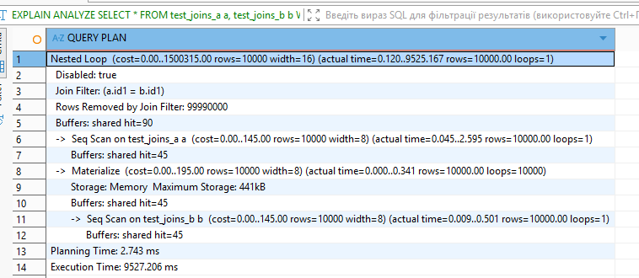
Merge Join took ~11 ms because it “sorted and merged” the inputs.
Nested Loop took ~9.5 seconds because it effectively “multiplied” the tables by iterating over all combinations and then discarded 99.99% of the pairs through the join filter.

2. JOIN ORDER AND LATERAL JOIN
2.1 TASK 4: CHANGING JOIN ORDER
EXPLAIN
SELECT c.id2
FROM test_joins_b b
JOIN test_joins_a a on (b.id1 = a.id1)
LEFT JOIN test_joins_c c on (c.id1 = b.id1);

SET enable_hashjoin = off;
SET enable_mergejoin = off;

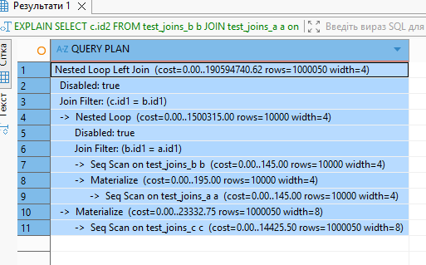
- First, PostgreSQL scans test_joins_b.
- Then it joins test_joins_a to b using a Nested Loop (producing b and a).
- Finally, it LEFT JOINs test_joins_c to the result of (b and a).
The same query + SET enable_mergejoin = on; SET enable_hashjoin = on;
Here the planner switches from nested loops to hash joins, and the join order is different from the previous plan.

Join order (short + clear)
- Build a hash on b and scan c, joining them first
- It scans c (1,000,000 rows)
- It hashes b (10,000 rows)
- Then it does c and b on (c.id1 = b.id1)
This appears as Hash Right Join (same result as b LEFT JOIN c, just executed from the other side).
- Then join the result with a
- It hashes a (10,000 rows)
- And does a hash join on (b.id1 = a.id1)
So, in execution terms, it does: (c and b) → a
(or thinking logically with your original query: (b LEFT JOIN c) → a).

SET join_collapse_limit = 1;
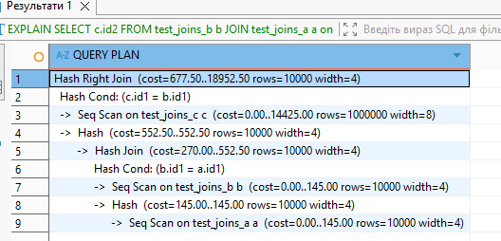

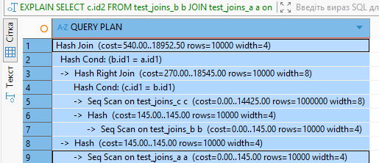
Because it’s 8, the planner is allowed to rearrange the join order, so it chose an order it estimated as cheap: hash the small tables (b, a) and scan/probe the large table (c) where needed.
2.2 TASK 5: LATERAL JOIN

CREATE TABLE labs.orders AS
SELECT id AS order_id,
(id * 10 * random()*10)::int AS order_cost,
'order number ' || id AS order_num
FROM generate_series(1, 1000) AS id;

INSERT INTO labs.stores VALUES
(1, 'grossery shop', '800'),
(2, 'bakery', '100'),
(3, 'manufactured goods', '3000')
;

SELECT s.store_id, s.store_name, o.order_id, o.order_cost, o.order_num
FROM labs.stores s
JOIN LATERAL ( SELECT *
FROM labs.orders o
WHERE o.order_cost<= s.max_order_cost
ORDER BY o.order_cost DESC
LIMIT 10) o ON TRUE
ORDER BY s.store_id, o.order_cost DESC;
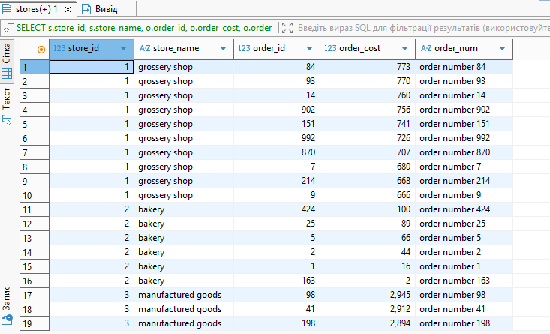
- CTES 3.1 T
ASK 6: RECURSIVE CTE
WITH RECURSIVE man AS (
SELECT e.empno, e.mgr, e.ename, e.ename AS mngname, 1 AS level
FROM labs.emp e
WHERE e.mgr IS NULL

UNION ALL
SELECT e.empno, e.mgr, e.ename, m.ename, m.level + 1
FROM labs.emp e
JOIN man m ON e.mgr = m.empno
)
SELECT* FROM man m
;
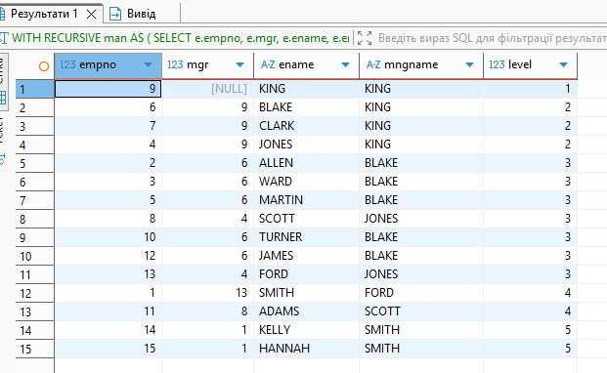

3.2 TASK 7: CHANGING DATA CTE
WITH updated AS (
UPDATE labs.orders o
SET order_cost = (o.order_cost / 2)
WHERE o.order_cost BETWEEN 100 AND 1000
RETURNING o.order_id, o.order_cost AS new_order_cost, o.order_num
),
logged_updates AS (
INSERT INTO labs.order_log (order_id, order_cost, order_num, action_type)
SELECT order_id, new_order_cost, order_num, 'U'
FROM updated
RETURNING 1
),
deleted AS (
DELETE FROM labs.orders o
WHERE o.order_cost < 50
RETURNING o.order_id, o.order_cost, o.order_num
)
INSERT INTO labs.order_log (order_id, order_cost, order_num, action_type)
SELECT order_id, order_cost, order_num, 'D'
FROM deleted;

SELECT * FROM labs.order_log;

