Task 1. Figure out what security precautions are already used in your 'dvd_rental' database. Prepare description
Focus on:
- Existing users/roles and their permissions
- Table-level privileges
- Any existing row-level security policies
- Database-level settings like connection limits or authentication methods
Prepare a detailed description in a text or docx file. Include SQL queries you used and their outputs for evidence

1.Existing users/roles and their permissions

To access the required information, I changed the database display settings and enabled “Show system objects.”
All roles can be viewed through the pg_catalog schema → Views → pg_roles.

SELECT * FROM pg_roles

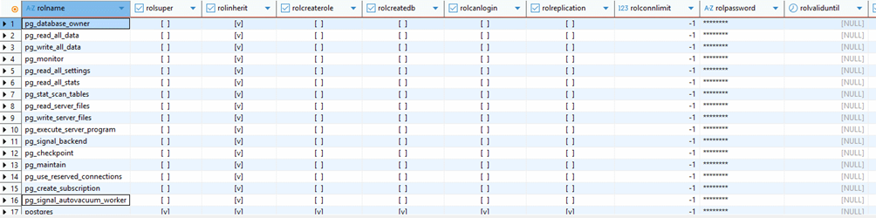
You can also view the source code for each role via the role tab in the sidebar.

The pg_roles system catalog provides metadata about every role in the PostgreSQL cluster.
The columns have the following meaning:

-rolname defines the name of the role. rolsuper indicates whether the role is a superuser with unrestricted privileges.
- rolinherit specifies whether the role inherits privileges from roles it is a member of.
- rolcreaterole shows whether it can create or modify other roles.
- rolcreatedb states whether the role may create databases.
-rolcanlogin indicates whether the role can authenticate and start a session.
-rolreplication determines if the role can initiate replication.
- rolconnlimit defines the maximum number of concurrent connections allowed (-1 means no limit).
-rolpassword contains the password hash, if any.
- rolvaliduntil shows password expiration.
- rolbypassrls indicates whether the role can bypass row-level security policies.
- rolconfig contains role-specific configuration overrides.
- oid is the internal unique identifier of the role.

In the dvd_rental database, all pg_* roles are system-defined, NOLOGIN, and INHERIT, meaning they exist only as privilege containers and cannot log in by themselves.
None of these roles have table-level privileges by default — they only take effect when granted to a login-capable user. The only actual login role is postgres, which is a full superuser with unrestricted privileges and ownership of the dvd_rental database.

To analyze role membership, used a query

SELECT
rol.rolname AS role_name,
mmmb.rolname AS member_name
FROM pg_auth_members ams
JOIN pg_roles rol ON ams.roleid = rol.oid
JOIN pg_roles mmb ON ams.member = mmb.oid
ORDER BY role_name, member_name;
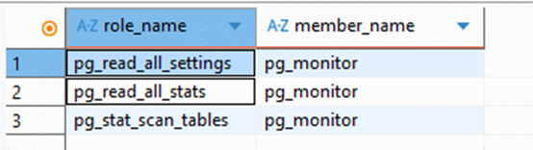

2.Table-Level Privileges
To examine who has access to the tables in the public schema of the dvd_rental database, I used the information_schema.table_privileges view:

SELECT table_schema,
table_name,
grantee,
privilege_type,
is_grantable
FROM information_schema.table_privileges
WHERE table_schema = 'public'
ORDER BY table_name, grantee, privilege_type;

In my instance of the dvd_rental database, all tables in the public schema are owned by the postgres role. No additional application roles with explicit SELECT/INSERT/UPDATE/DELETE privileges were identified. This indicates that all data operations are either performed under the superuser account postgres, or table-level permissions have not yet been configured for any dedicated application users.
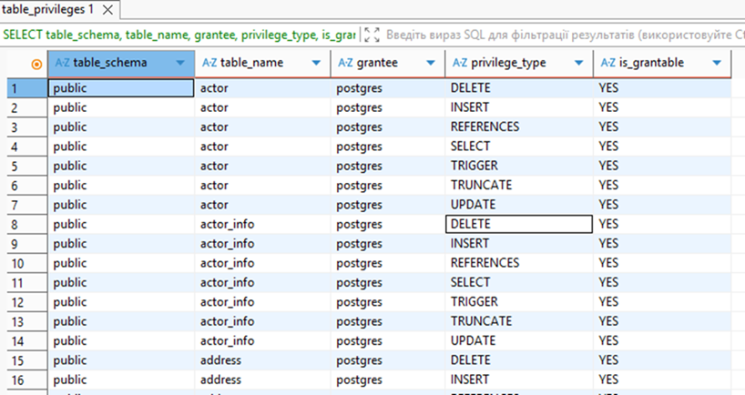
3.Row-Level Security (RLS) Policies
PostgreSQL stores RLS configuration in two system catalogs:
pg_class — stores the RLS flags for each table
pg_policy — stores the actual RLS policies (USING, WITH CHECK, roles, and policy type)
To determine whether RLS is enabled for any tables in the public schema, the following query was executed:
SELECT n.nspname AS schema_name,
c.relname AS table_name,
c.relrowsecurity AS row_level_security_enabled,
c.relforcerowsecurity AS force_rls
FROM pg_class c --stores info about database objects including tables without schema
JOIN pg_namespace n ON n.oid = c.relnamespace --stores info abour schemas
WHERE n.nspname = 'public' –-schema name
AND c.relkind = 'r' --r means that it must be table
ORDER BY c.relname;

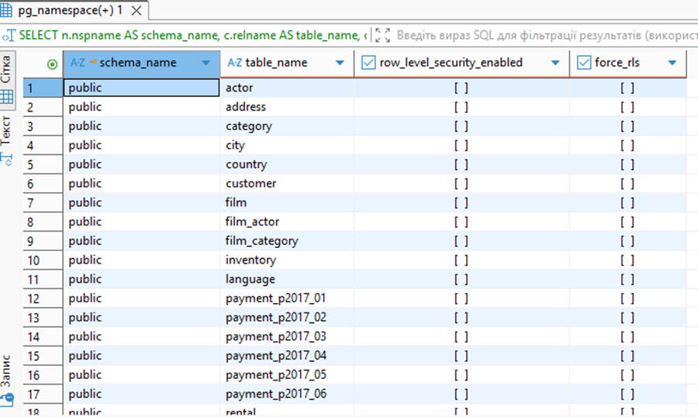

The query showed that all tables in the public schema have relrowsecurity = FALSE and relforcerowsecurity = FALSE, meaning that RLS is not enabled anywhere in the dvd_rental database.
This is expected for a demonstration database.
I additionally checked for defined policies in pg_policy:
SELECT n.nspname AS schema_name,
c.relname AS table_name,
p.polname AS policy_name,
p.polcmd AS policy_cmd,
p.polpermissive,
p.polroles,
pg_get_expr(p.polqual, p.polrelid) AS using_expression,
pg_get_expr(p.polwithcheck, p.polrelid) AS with_check_expression
FROM pg_policy p
JOIN pg_class c ON c.oid = p.polrelid
JOIN pg_namespace n ON n.oid = c.relnamespace
WHERE n.nspname = 'public';

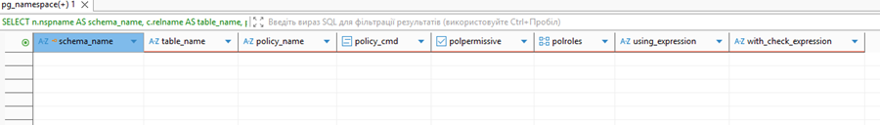

The query returned no rows, confirming the complete absence of RLS policies.
This query reads the pg_policy system catalog, joining it with pg_class and pg_namespace to list all RLS policies for tables in the public schema:
policy name, affected commands (SELECT / INSERT / UPDATE / DELETE), policy type (permissive / restrictive), applicable roles, and the actual USING and WITH CHECK expressions rendered into readable SQL via pg_get_expr.
Database-Level Settings
To analyze database-level configuration for dvd_rental, I queried pg_database:

SELECT datname,
pg_get_userbyid(datdba) AS owner,
encoding,
datcollate,
datctype,
datconnlimit
FROM pg_database
WHERE datname = 'dvdrental';

The results showed that:
• the owner of the database is the postgres role;
• datconnlimit = -1, meaning that no per-database connection limit is configured for dvd_rental;
• the encoding, collation, and ctype settings match the default cluster-level configuration.
Authentication
In my environment, dvd_rental is accessed through DBeaver, using the postgres account (Database Native authentication).
The exact authentication method used (e.g., md5 or scram-sha-256) is defined in the pg_hba.conf file on the PostgreSQL server.
For a local training environment running on localhost, this level of configuration is sufficient.
However, in production deployments, stricter measures are recommended, such as:
• using scram-sha-256 authentication;
• separating application roles with least-privilege access;
• preventing superuser accounts (like postgres) from logging in from external networks.

