Business Template
Art & History Museum

Contents
1 Business Description 3
1.1 Business background 3
1.2 Problems. Current Situation 3
1.3 The benefits of implementing a database. Project Vision 3
2 Model description 3
2.1 Definitions & Acronyms 3
2.2 Logical Scheme 3
2.3 Objects 3
3. Business rules
4. Data Quality and Security Notes

5. Analytical Use Cases

1. Business Description

1.1 BUSINESS BACKGROUND
The Art & History Museum is a multidisciplinary cultural institution that manages a large and continuously growing collection of artworks, historical artifacts, sculptures, textiles, photographs, and other objects of cultural significance.
The museum regularly hosts temporary exhibitions, thematic events, guided tours, and educational programs. Its operations involve multiple stakeholders: visitors, curators, collection managers, restorers, guides, administrative staff, and financial personnel responsible for ticketing and reporting.
The museum’s daily activities generate substantial amounts of operational information:
- records of exhibitions and their items,
- assignments and responsibilities of curators,
- storage and conservation data for collection items,
- visitor attendance and ticketing transactions,
- condition monitoring through scheduled inventory checks,
- financial operations related to payments.
Until now, these data have been stored in fragmented spreadsheets, separate access systems, or maintained manually. As the museum’s operations expand, the need for a centralized, structured, reliable data management solution has become critical.

1.2 PROBLEMS. CURRENT SITUATION
The current information management system faces several challenges:

1. Lack of centralized storage
Data about museum items, exhibitions, employees, visitors, inventory checks, and payments are kept across multiple disconnected sources. This creates duplication, inconsistencies, and difficulty tracking historical changes.

2. Manual processes leading to human errors
Spreadsheets and paper documentation make it easy to introduce mistakes—such as inconsistent naming, missing condition updates, incorrect exhibition assignments, or duplicated records.

3. Limited analytical capabilities
Without structured data, the museum cannot:
- analyze attendance trends,
- assess the financial performance of exhibitions,
- evaluate curator workload,
- monitor the condition of collections over time,
- identify risks such as objects frequently marked as “damaged” or “missing”.

4. Difficulty tracking inventory and storage
Manual inventory checks lead to:
- delayed detection of item movement or loss,
- outdated information about item condition,
- lack of transparency in conservation processes.

5. No unified visitor or employee profile
Visitors and employees share some common data attributes (names, contacts, address). Without unification:
- reports cannot be cross-compared,
- records are duplicated,
- operational processes slow down.

6. Limited access control
Since data is spread across files, granting controlled read-only access (e.g., for managers) is difficult, increasing the risk of unintentional modifications.
Overall, the current system is unsustainable for a modern institution that requires high data integrity, reliability, traceability, and analytical insight.

1.3 THE BENEFITS OF IMPLEMENTING A DATABASE. PROJECT VISION
The implementation of a relational database will transform the museum's operations by providing a centralized, structured, and secure environment for data management.

Key benefits:

1. Centralized and standardized data storage
All essential information—items, exhibitions, employees, visits, payments, and inventory checks—is consolidated into a unified system with well-defined relationships and constraints. This ensures consistency, accuracy, and long-term availability.

2. Improved operational efficiency
Automation of routine tasks reduces administrative workload:
- curator assignments are tracked automatically,
- exhibition items are linked and validated,
- storage and location information is always up to date,
- visitors and payments are recorded accurately.

3. Strong data integrity and quality
The database enforces:
- unique identifiers,
- foreign key relationships,
- CHECK constraints on controlled vocabularies,
- timestamp tracking (created_at, updated_at),
- prevention of duplicate payments or visits.
This minimizes errors and ensures the reliability of museum records.

4. Enhanced decision-making through analytics
The database enables advanced reporting, such as:
- visitor demographics and traffic trends,
- exhibition popularity and revenue,
- condition trends for the museum’s collection,
- identification of high-value items at risk,
- evaluation of curator workload and performance.

5. Transparent audit and conservation processes
Inventory check logs allow:
- tracking of item condition over time,
- identifying patterns of damage or movement,
- documenting responsibility (employee performing the check).

6. Controlled and secure access
Read-only roles (e.g., manager) ensure safe access to data without risk of modification.
This supports accountability and compliance with data governance policies.

Project Vision
The goal is to develop a robust, normalized, scalable, and secure relational database—Art & History Museum DB—that accurately reflects the museum’s operations and supports both current and future analytical needs.
The database will serve as the authoritative source of truth, enabling operational efficiency, improved data quality, trustful reporting, and informed decision-making across the institution.

2. Model description

2.1. Definitions & Acronyms

Term / Acronym | Definition
address | Stores geographic address information used by persons (visitors and employees).
person | Unified entity containing personal details of individuals interacting with the museum.
employee | A person formally employed by the museum with position and employment details.
category | Reference table defining museum item categories.
storage_location | Physical museum locations including building, room, shelf, climate zone.
museum_item | Core table representing artworks or artifacts with unique inventory number.
exhibition | A museum event that displays selected items with dates, venue, status.
exhibition_item | Many-to-many link between exhibitions and museum items.
exhibition_curator | Many-to-many link assigning employees as curators to exhibitions.
visit | A recorded visit of a person to an exhibition.
payment | Financial transaction related to a museum visit.
inventory_check | Scheduled inspection of storage areas performed by employees.
inventory_check_item | Item-level inspection results for each inventory check.
ERD | Entity-Relationship Diagram — visual representation of tables and relationships.
PK | Primary Key — unique identifier of a table record.
FK | Foreign Key — reference to PK in another table.
PFK | Primary-Foreign Key — PK that is also an FK in junction tables.
NN | Not Null — field must contain a value.
UQ | Unique Constraint — ensures no duplicated values.
CHECK() | Constraint validating acceptable values.
DEFAULT | Auto-filled value if none is provided.
0..1 | Optional relationship (zero or one related row).
1..N | One-to-many relationship.
M:N | Many-to-many relationship via junction tables.
INT | Integer numeric type.
NUMERIC(p,s) | Exact numeric type used for prices and monetary values.
VARCHAR(n) | Variable-length text field.
TEXT | Long text field for descriptions.
DATE | Calendar date type.
TIMESTAMP | Date and time type.
BOOLEAN | True/False value.
GENERATED ALWAYS AS | Computed database column.
IDENTITY | Auto-incremented surrogate key.

2.3 Logical Model Diagrams
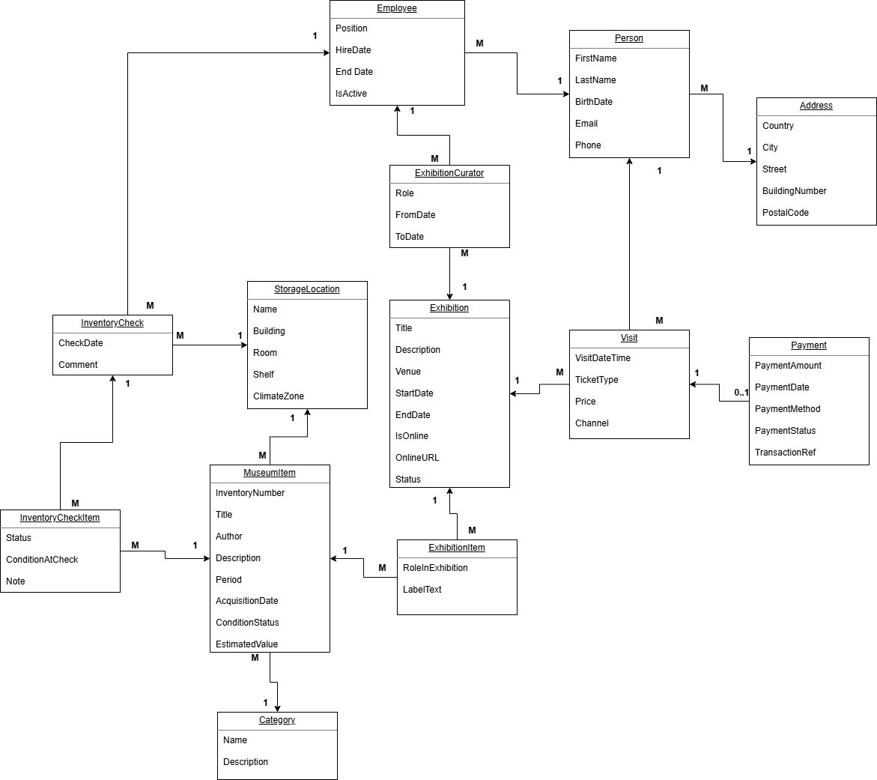
Figure 2.3.1 –Conceptual ERD.
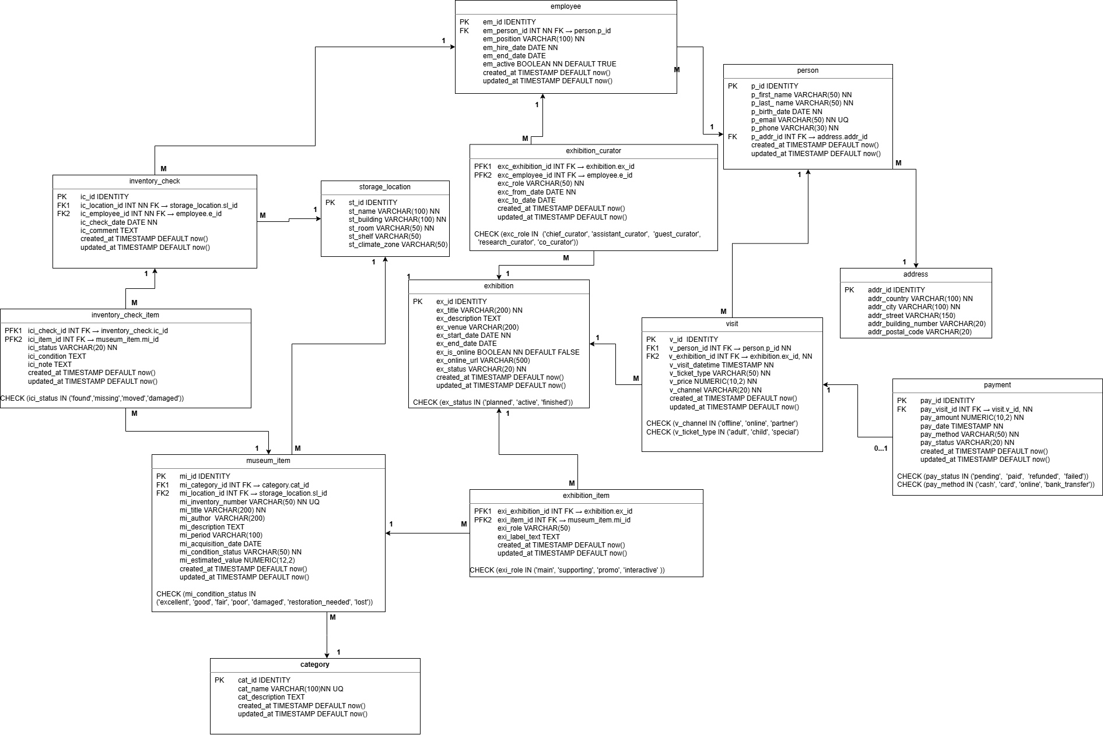
Figure 2.3.2 – Logical ERD.

2.4 Tables description

2.4.01 Table "address"
Description
The "address" table stores address information (country, city, street, building, postal code) used by persons related to the museum.

Table Name | Field name | Field Description | Data Type
address | addr_id | Primary Key (address identifier). | INT IDENTITY
 | addr_country | Country; NN. | VARCHAR(100)
 | addr_city | City; NN. | VARCHAR(100)
 | addr_street | Street name. | VARCHAR(150)
 | addr_building_number | Building / apartment number. | VARCHAR(20)
 | addr_postal_code | Postal / ZIP code. | VARCHAR(20)
 | created_at | Record creation timestamp; NN; DEFAULT now(). | TIMESTAMP
 | updated_at | Record last update timestamp; NN; DEFAULT now(). | TIMESTAMP

Comments on table relationships
Related Table | Relationship Type | Description
person | 1 : N | One address can be used by many persons (person.p_addr_id → address.addr_id).

Example with data
addr_id | addr_country | addr_city | addr_street | addr_building_number | addr_postal_code
1 | Ukraine | Kyiv | Hrushevskoho | 1A | 01001

2.4.02 Table "person"
Description
The "person" table stores information about individuals (visitors and employees) interacting with the museum.

Table Name | Field name | Field Description | Data Type
person | p_id | Primary Key (person identifier). | INT IDENTITY
 | p_addr_id | Address; FK → address.addr_id. | INT
 | p_first_name | First name; NN. | VARCHAR(50)
 | p_last_name | Last name; NN. | VARCHAR(50)
 | p_birth_date | Date of birth; NN. | DATE
 | p_email | E-mail; UQ; NN. | VARCHAR(50)
 | p_phone | Phone number; NN. | VARCHAR(20)
 | created_at | Record creation timestamp; NN; DEFAULT now(). | TIMESTAMP
 | updated_at | Record last update timestamp; NN; DEFAULT now(). | TIMESTAMP

Comments on table relationships
Related Table | Relationship Type | Description
address | N : 1 | Many persons can reference one address (person.p_addr_id → address.addr_id).
employee | 1 : N | A person may have several employee records => has several job positions (employee.em_person_id → person.p_id).
visit | 1 : N | A person can have many museum visits (visit.v_person_id → person.p_id).

Example with data
p_id | p_first_name | p_last_name | p_birth_date | p_email | p_phone
1 | Anna | Pavlik | 1990-05-10 | anna.pavlik@example.com | +380637000001

2.4.03 Table "employee"
Description
The "employee" table extends person records with employment details for museum staff.

Table Name | Field name | Field Description | Data Type
employee | em_id | Primary Key (employee identifier). | INT IDENTITY
 | em_person_id | Person; NN; FK → person.p_id. | INT
 | em_position | Job position; NN. | VARCHAR(100)
 | em_hire_date | Hire date; NN. | DATE
 | em_end_date | End date of employment. | DATE
 | em_active | Flag indicating if employee is active; NN; DEFAULT TRUE. | BOOLEAN
 | created_at | Record creation timestamp; NN; DEFAULT now(). | TIMESTAMP
 | updated_at | Record last update timestamp; NN; DEFAULT now(). | TIMESTAMP

Comments on table relationships
Related Table | Relationship Type | Description
person | N : 1 | A person may have several employee records => has several job positions (employee.em_person_id → person.p_id).
exhibition_curator | 1 : N | An employee may curate multiple exhibitions (exhibition_curator.exc_employee_id → employee.em_id).
inventory_check | 1 : N | An employee can perform many inventory checks (inventory_check.ic_employee_id → employee.em_id).

Example with data
em_id | em_person_id | em_position | em_hire_date | em_active
1 | 1 | chief curator | 2024-09-01 | TRUE

2.4.04 Table "category"
Description
The "category" table stores classification categories for museum items.

Table Name | Field name | Field Description | Data Type
category | cat_id | Primary Key (category identifier). | INT IDENTITY
 | cat_name | Category name; UQ; NN. | VARCHAR(100)
 | cat_description | Description of the category. | TEXT
 | created_at | Record creation timestamp; NN; DEFAULT now(). | TIMESTAMP
 | updated_at | Record last update timestamp; NN; DEFAULT now(). | TIMESTAMP

Comments on table relationships
Related Table | Relationship Type | Description
museum_item | 1 : N | One category can be assigned to many museum items (museum_item.mi_category_id → category.cat_id).

Example with data
cat_id | cat_name | cat_description
1 | Painting | Oil, acrylic and watercolor paintings

2.4.05 Table "storage_location"
Description
The "storage_location" table represents physical storage and exhibition locations inside the museum buildings.

Table Name | Field name | Field Description | Data Type
storage_location | sl_id | Primary Key (storage location identifier). | INT IDENTITY
 | sl_name | Location name; NN. | VARCHAR(100)
 | sl_building | Building identifier; NN. | VARCHAR(100)
 | sl_room | Room number; NN. | VARCHAR(50)
 | sl_shelf | Shelf / section label. | VARCHAR(50)
 | sl_climate_zone | Climate zone type (standard, cold, dry, etc.). | VARCHAR(50)

Comments on table relationships
Related Table | Relationship Type | Description
museum_item | 1 : N | One storage location can contain many museum items (museum_item.mi_location_id → storage_location.sl_id).
inventory_check | 1 : N | Inventory checks are performed per location (inventory_check.ic_location_id → storage_location.sl_id).

Example with data
sl_id | sl_name | sl_building | sl_room | sl_shelf | sl_climate_zone
1 | Main Hall A | Building A | 101 | A1 | standard

2.4.06 Table "museum_item"
Description
The "museum_item" table stores artworks and artifacts in the museum collection, including inventory number, title, author, period, value and condition.

Table Name | Field name | Field Description | Data Type
museum_item | mi_id | Primary Key (museum item identifier). | INT IDENTITY
 | mi_category_id | Category; NN; FK → category.cat_id. | INT
 | mi_location_id | Storage location; NN; FK → storage_location.sl_id. | INT
 | mi_inventory_number | Inventory number; UQ; NN. | VARCHAR(50)
 | mi_title | Item title; NN. | VARCHAR(200)
 | mi_author | Author / creator. | VARCHAR(200)
 | mi_description | Description of the item. | TEXT
 | mi_period | Historical/creative period. | VARCHAR(100)
 | mi_acquisition_date | Acquisition date. | DATE
 | mi_estimated_value | Estimated value; CHECK >= 0. | NUMERIC(12,2)
 | mi_condition_status | Condition status (excellent/good/fair/poor/damaged/restoration_needed/lost). | VARCHAR(50)
 | created_at | Record creation timestamp; NN; DEFAULT now(). | TIMESTAMP
 | updated_at | Record last update timestamp; NN; DEFAULT now(). | TIMESTAMP

Comments on table relationships
Related Table | Relationship Type | Description
category | N : 1 | Each museum item belongs to one category.
storage_location | N : 1 | Each museum item is stored at one location.
exhibition_item | 1 : N | Items can be displayed in multiple exhibitions (via exhibition_item).
inventory_check_item | 1 : N | Items can appear in multiple inventory checks.

Example with data
mi_id | mi_inventory_number | mi_title | mi_author | mi_condition_status
1 | INV-0001 | Sunset over Dnipro | O. Hrytsenko | excellent

2.4.07 Table "exhibition"
Description
The "exhibition" table stores museum exhibitions, including title, venue, date range, online URL and lifecycle status.

Table Name | Field name | Field Description | Data Type
exhibition | ex_id | Primary Key (exhibition identifier). | INT IDENTITY
 | ex_title | Exhibition title; NN. | VARCHAR(200)
 | ex_description | Exhibition description. | TEXT
 | ex_venue | Venue / gallery name. | VARCHAR(200)
 | ex_start_date | Start date; NN; CHECK >= 2024-01-01. | DATE
 | ex_end_date | End date. | DATE
 | ex_is_online | Flag if exhibition is online; NN; DEFAULT FALSE. | BOOLEAN
 | ex_online_url | URL for online exhibition. | VARCHAR(500)
 | ex_status | Status; NN; ('planned','active','finished'). | VARCHAR(20)
 | created_at | Record creation timestamp; NN; DEFAULT now(). | TIMESTAMP
 | updated_at | Record last update timestamp; NN; DEFAULT now(). | TIMESTAMP

Comments on table relationships
Related Table | Relationship Type | Description
exhibition_item | 1 : N | Exhibition includes many items (exhibition_item.exi_exhibition_id → exhibition.ex_id).
exhibition_curator | 1 : N | Exhibition can have several curators (exhibition_curator.exc_exhibition_id → exhibition.ex_id).
visit | 1 : N | Many visits are recorded for an exhibition (visit.v_exhibition_id → exhibition.ex_id).

Example with data
ex_id | ex_title | ex_venue | ex_status
1 | Dnipro Stories | Main Hall A | finished

2.4.08 Table "exhibition_item"
Description
The "exhibition_item" table implements a many-to-many relationship between exhibitions and museum items and stores contextual label information.

Table Name | Field name | Field Description | Data Type
exhibition_item | exi_exhibition_id | Exhibition; PK part; FK → exhibition.ex_id; NN. | INT
 | exi_item_id | Museum item; PK part; FK → museum_item.mi_id; NN. | INT
 | exi_role | Item role in exhibition (main/supporting/promo/interactive). | VARCHAR(50)
 | exi_label_text | Label text displayed to visitors; NN. | TEXT
 | created_at | Record creation timestamp; NN; DEFAULT now(). | TIMESTAMP
 | updated_at | Record last update timestamp; NN; DEFAULT now(). | TIMESTAMP

Comments on table relationships
Related Table | Relationship Type | Description
exhibition | N : 1 | Each row links to one exhibition.
museum_item | N : 1 | Each row links to one museum item.

Example with data
exi_exhibition_id | exi_item_id | exi_role | exi_label_text
1 | 1 | main | Key painting of the exhibition

2.4.09 Table "exhibition_curator"
Description
The "exhibition_curator" table stores curator assignments for exhibitions, linking employees to exhibitions with specific roles and assignment dates.

Table Name | Field name | Field Description | Data Type
exhibition_curator | exc_exhibition_id | Exhibition; PK part; FK → exhibition.ex_id; NN. | INT
 | exc_employee_id | Employee; PK part; FK → employee.em_id; NN. | INT
 | exc_role | Curator role (chief_curator/assistant_curator/guest_curator/research_curator/co_curator); NN. | VARCHAR(50)
 | exc_from_date | Assignment start date; NN. | DATE
 | exc_to_date | Assignment end date. | DATE
 | created_at | Record creation timestamp; NN; DEFAULT now(). | TIMESTAMP
 | updated_at | Record last update timestamp; NN; DEFAULT now(). | TIMESTAMP

Comments on table relationships
Related Table | Relationship Type | Description
exhibition | N : 1 | Each row refers to one exhibition.
employee | N : 1 | Each row refers to one employee.

Example with data
exc_exhibition_id | exc_employee_id | exc_role | exc_from_date
1 | 1 | chief_curator | 2024-08-20

2.4.10 Table "visit"
Description
The "visit" table records visits of persons to exhibitions, including ticket type, price and sales channel.

Table Name | Field name | Field Description | Data Type
visit | v_id | Primary Key (visit identifier). | INT IDENTITY
 | v_person_id | Visitor; NN; FK → person.p_id. | INT
 | v_exhibition_id | Exhibition; NN; FK → exhibition.ex_id. | INT
 | v_visit_datetime | Visit date and time; NN. | TIMESTAMP
 | v_ticket_type | Ticket type (adult/child/special); NN. | VARCHAR(20)
 | v_price | Ticket price; NN; CHECK >= 0. | NUMERIC(10,2)
 | v_channel | Sales channel (offline/online/partner); NN. | VARCHAR(20)
 | created_at | Record creation timestamp; NN; DEFAULT now(). | TIMESTAMP
 | updated_at | Record last update timestamp; NN; DEFAULT now(). | TIMESTAMP

Comments on table relationships
Related Table | Relationship Type | Description
person | N : 1 | Many visits per person (visit.v_person_id → person.p_id).
exhibition | N : 1 | Many visits per exhibition (visit.v_exhibition_id → exhibition.ex_id).
payment | 1 : 0..1 | Each visit may have one related payment (payment.pay_visit_id → visit.v_id).

Example with data
v_id | v_person_id | v_exhibition_id | v_visit_datetime | v_ticket_type | v_price | v_channel
1 | 1 | 1 | 2024-10-01 12:00:00 | adult | 150.00 | offline

2.4.11 Table "payment"
Description
The "payment" table represents payments for museum visits, including method, status and transaction reference.

Table Name | Field name | Field Description | Data Type
payment | pay_id | Primary Key (payment identifier). | INT IDENTITY
 | pay_visit_id | Visit; NN; FK → visit.v_id; UQ. | INT
 | pay_amount | Payment amount; NN; CHECK >= 0. | NUMERIC(10,2)
 | pay_date | Payment date and time; NN. | TIMESTAMP
 | pay_method | Payment method (cash/card/online/bank_transfer); NN. | VARCHAR(50)
 | pay_status | Payment status (pending/paid/refunded/failed); NN. | VARCHAR(20)
 | pay_transaction_ref | External transaction reference; NN. | VARCHAR(100)
 | pay_year | Denormalized year extracted from pay_date (generated column). | INT
 | created_at | Record creation timestamp; NN; DEFAULT now(). | TIMESTAMP
 | updated_at | Record last update timestamp; NN; DEFAULT now(). | TIMESTAMP

Comments on table relationships
Related Table | Relationship Type | Description
visit | 1 : 1 | Each payment is tied to exactly one visit (payment.pay_visit_id → visit.v_id).

Example with data
pay_id | pay_visit_id | pay_amount | pay_method | pay_status | pay_transaction_ref
1 | 1 | 150.00 | cash | paid | TX-1

2.4.12 Table "inventory_check"
Description
The "inventory_check" table logs inventory inspections for specific storage locations performed by employees.

Table Name | Field name | Field Description | Data Type
inventory_check | ic_id | Primary Key (inventory check identifier). | INT IDENTITY
 | ic_location_id | Storage location; NN; FK → storage_location.sl_id. | INT
 | ic_employee_id | Employee performing check; NN; FK → employee.em_id. | INT
 | ic_check_date | Date of the inventory check; NN. | DATE
 | ic_comment | General notes about the check. | TEXT
 | created_at | Record creation timestamp; NN; DEFAULT now(). | TIMESTAMP
 | updated_at | Record last update timestamp; NN; DEFAULT now(). | TIMESTAMP

Comments on table relationships
Related Table | Relationship Type | Description
storage_location | N : 1 | Each check is related to one storage location.
employee | N : 1 | Each check is performed by one employee.
inventory_check_item | 1 : N | A check may include many item-level records (inventory_check_item.ici_check_id → inventory_check.ic_id).

Example with data
ic_id | ic_location_id | ic_employee_id | ic_check_date | ic_comment
1 | 3 | 5 | 2024-10-01 | Monthly check of sculptures

2.4.13 Table "inventory_check_item"
Description
The "inventory_check_item" table stores item-level details for each inventory check, including status and condition notes.

Table Name | Field name | Field Description | Data Type
inventory_check_item | ici_check_id | Inventory check; PK part; FK → inventory_check.ic_id; NN. | INT
 | ici_item_id | Museum item; PK part; FK → museum_item.mi_id; NN. | INT
 | ici_status | Status during check (found/missing/moved/damaged); NN. | VARCHAR(20)
 | ici_condition | Condition description at check time. | TEXT
 | ici_note | Additional notes or actions. | TEXT
 | created_at | Record creation timestamp; NN; DEFAULT now(). | TIMESTAMP
 | updated_at | Record last update timestamp; NN; DEFAULT now(). | TIMESTAMP

Comments on table relationships
Related Table | Relationship Type | Description
inventory_check | N : 1 | Each row belongs to one inventory check.
museum_item | N : 1 | Each row describes the state of a single museum item.

Example with data
ici_check_id | ici_item_id | ici_status | ici_condition | ici_note
1 | 3 | found | No visible damage

3. BUSINESS RULES
- Inventory numbers (mi_inventory_number) must be unique across all museum items.
- A payment can exist only for an existing visit and only one payment per visit is allowed.
- Condition and status columns are restricted to controlled vocabularies via CHECK constraints.
- Exhibition status must be one of 'planned', 'active', or 'finished'.
- Dates for exhibitions must not be earlier than 2024-01-01 for analytical consistency.

4. Data Quality and Security Notes
The model enforces NOT NULL, UNIQUE, and CHECK constraints to preserve data quality. Historization of changes is partially supported via created_at and updated_at timestamps. For security, a read-only role (manager) is granted SELECT privileges on all tables while being restricted from any data modification operations.

5. Analytical Use Cases
- Analyze visitor attendance per exhibition using visit and person tables.
- Evaluate popularity and financial performance of exhibitions using visit and payment.
- Monitor the state of the collection over time with inventory_check and inventory_check_item.
- Assess curator workload and involvement using exhibition_curator and employee.
- Segment visitors by demographics (birth date, city) and behavior (ticket type, channel).

