1. Header
The header displays the report title “Adventure Works Sales Report” and provides the main context for the dashboard. It helps users quickly understand the purpose of the report and the data being analyzed.
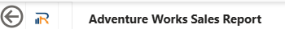
Used insert textbox, image

2. Slicers (Filters)
The slicers allow users to interactively filter the data displayed in the report.
- CalendarYear – filters the report by a selected time period.
- Full Name – allows users to analyze sales data for specific customers.
- Sales Territory Country – filters sales information by country.
- Product Category – enables filtering by product categories such as Bikes, Accessories, Clothing, and Components.
These filters help users focus on specific segments of the data.
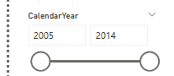
Used slicer “between”
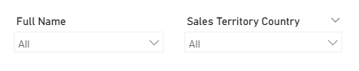
Used slicers drop-down+select all option
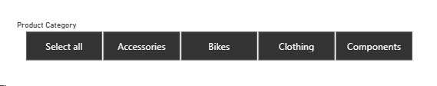
Used tile slicer+select all option+disabled to change to change visual “Total sales vs Average sales for years”

3. KPI Cards
The KPI cards provide a quick summary of the most important metrics in the report.
- Total Sales – shows the total revenue generated.
- Total Orders – displays the number of sales transactions.
- Total Customers – indicates the number of unique customers.
These indicators help users quickly evaluate overall business performance.
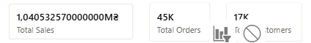
Used here cards (created measurments Total Sales, Total orders, Total customers for studying purpose)

4. Sales Trend Over Time
This line chart visualizes how total sales change over time.
It allows users to identify trends, patterns, and growth in sales across different years.
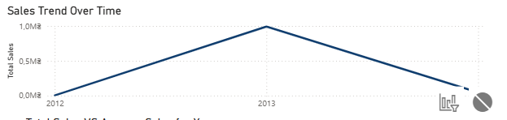
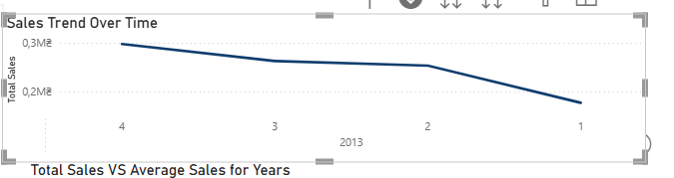
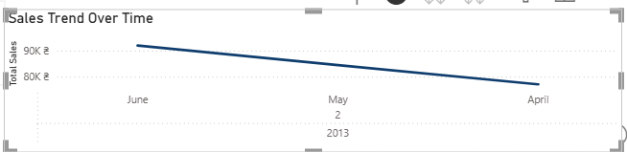
Created a time hierarchy, you can change the time frame to quarter and month

5. Top 10 Sales by Customer
This bar chart shows the top 10 customers based on total sales.
It helps identify the most valuable customers and analyze their contribution to overall revenue.
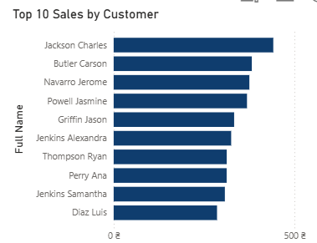
Used bar chart + limitation-top10 with the highest total sales amount

6. Total Sales vs Average Sales for Years (Bullet Chart)
This custom visual compares total yearly sales with the average sales benchmark.
It helps evaluate sales performance and determine whether yearly results are above or below the average level.
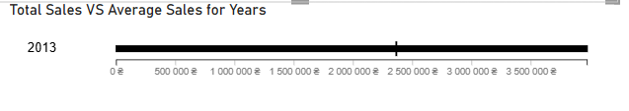
Used new measurement – Average sales for years Average Sales per Year =
AVERAGEX( ALL(DimDate[CalendarYear]), CALCULATE([Total Sales]))

7. Sales by Product Subcategory
This column chart displays sales performance across different product subcategories.
It allows users to identify which product types generate the highest revenue.
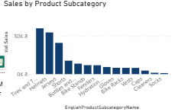
Used column chart

8. Sales by Promotion Category
This pie chart shows the distribution of sales based on promotion types.
It helps analyze the impact of promotions on overall sales performance.
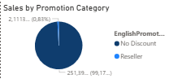
Used pie chart

9. Total Sales by Gender
This custom visual presents sales distribution by customer gender.
It helps understand differences in purchasing behavior between male and female customers.
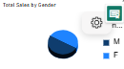

10. Sales by Countries (Map Visual)
The map visual displays the geographical distribution of sales across different countries.
It helps identify regions with the highest sales performance and supports geographic analysis.
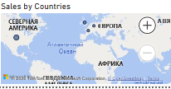

Screenshot for published on Power BI Service Portal report
