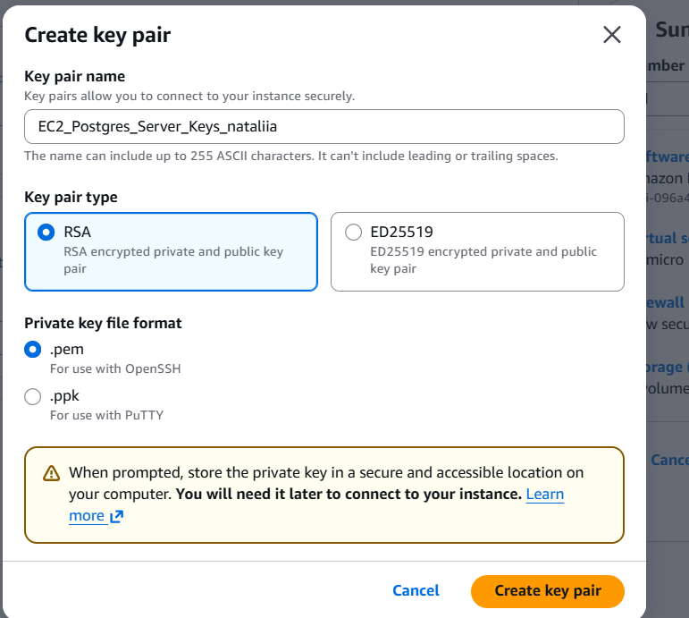
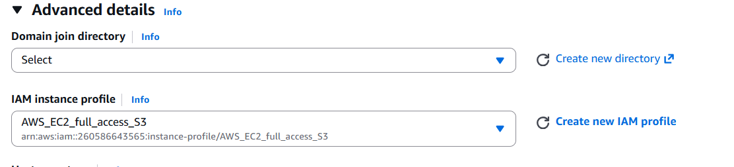
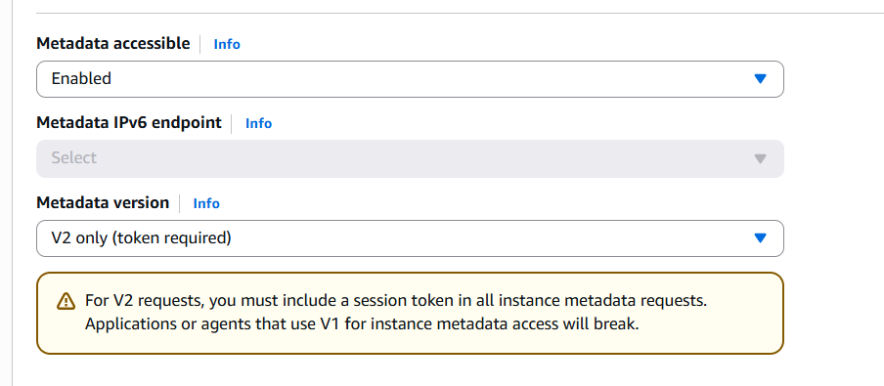

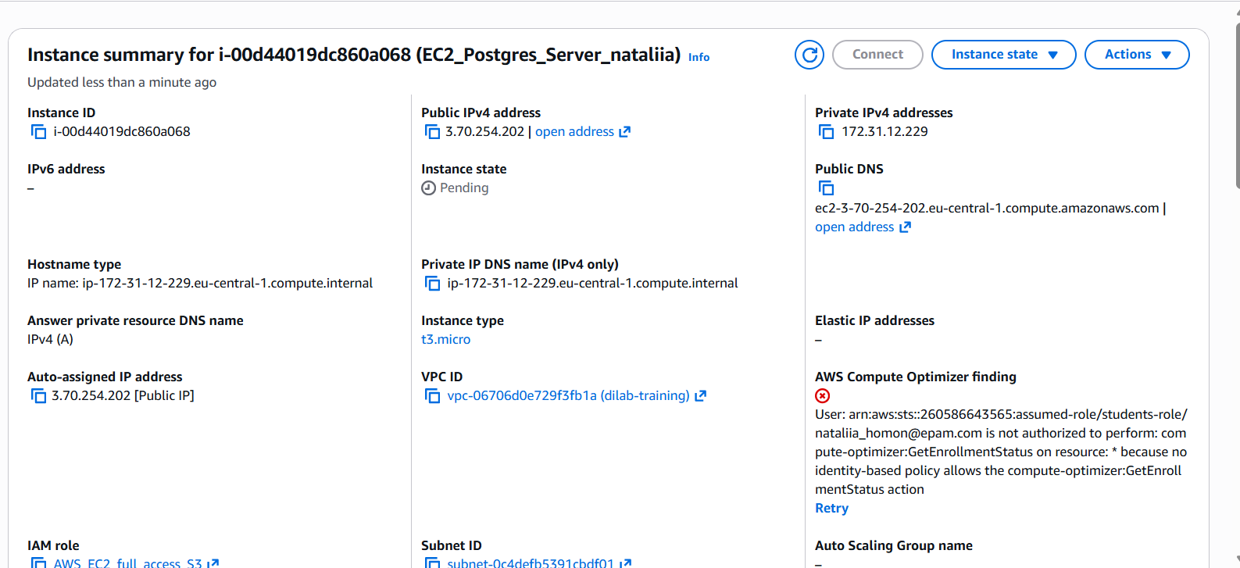
Added one more secure group
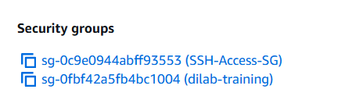
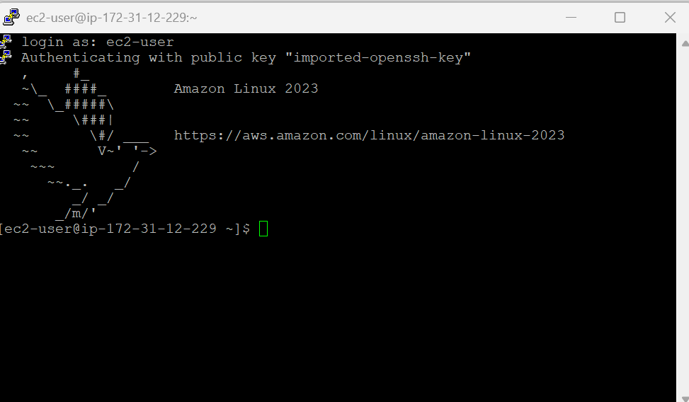
Update
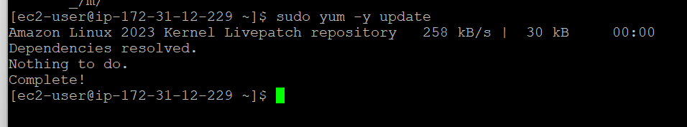
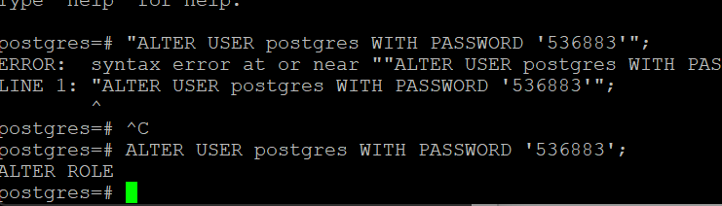
Installed mc
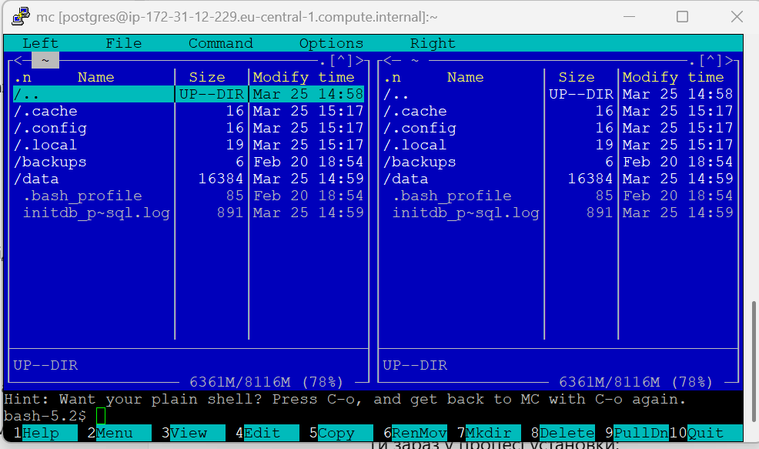
Postgres port is open to EC2 instance
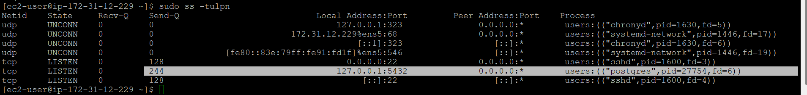

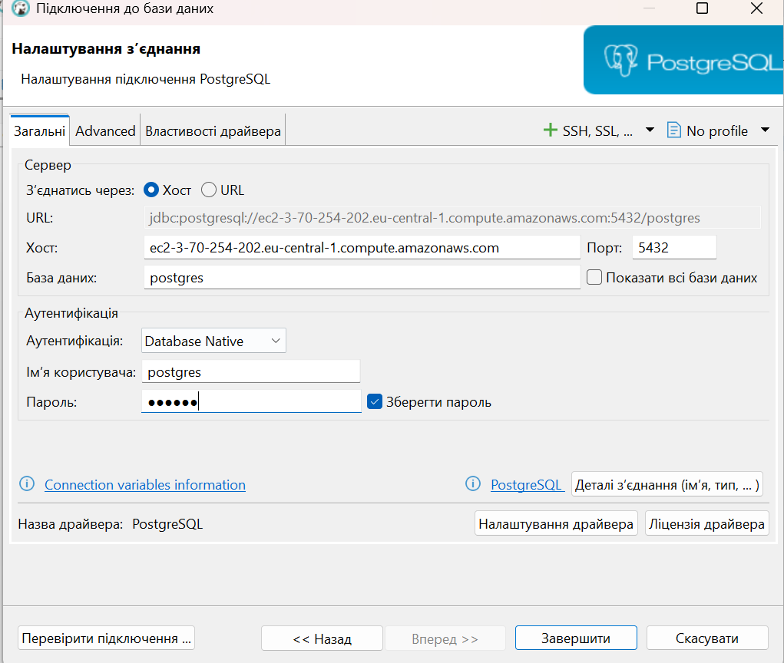
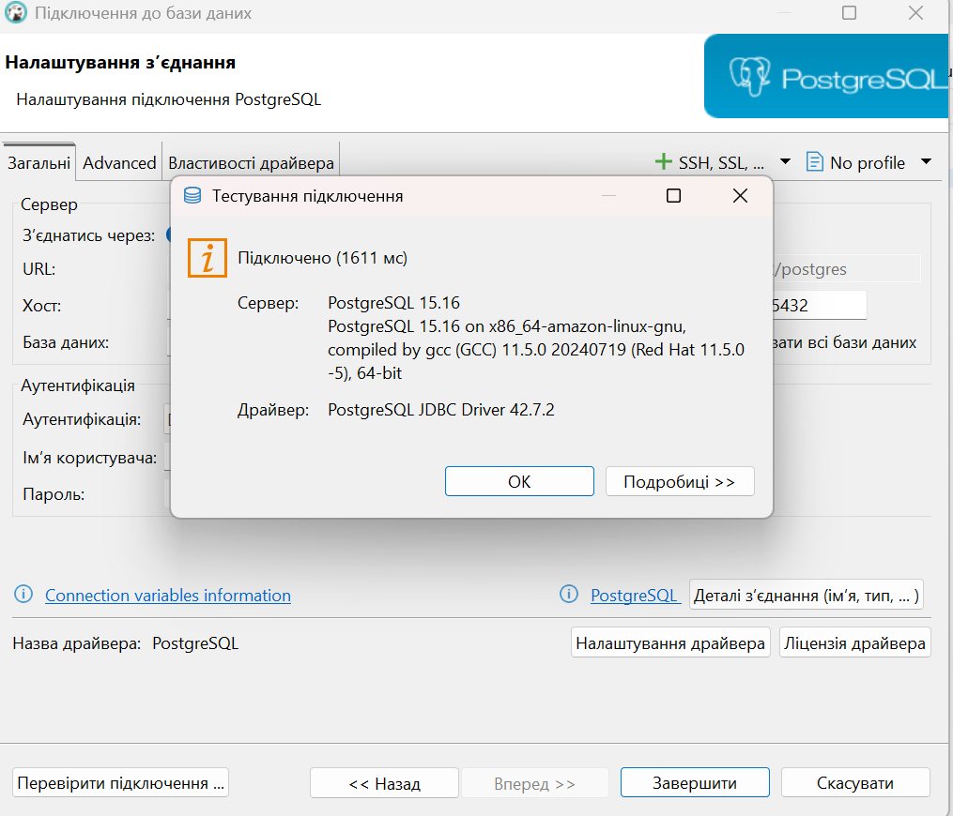
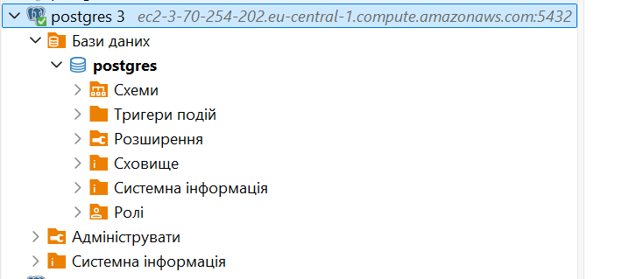
In this database created
CREATE SCHEMA test;
CREATE TABLE test.users (
id SERIAL PRIMARY KEY,
name VARCHAR(50),
age INT
);

INSERT INTO test.users (name, age) VALUES
('Ivan', 25),
('Anna', 30);

CREATE VIEW test.users_view AS
SELECT name, age FROM test.users;

CREATE OR REPLACE FUNCTION test.get_users_count()
RETURNS INTEGER AS $$
DECLARE
total INTEGER;
BEGIN
SELECT COUNT(*) INTO total FROM test.users;
RETURN total;
END;
$$ LANGUAGE plpgsql;
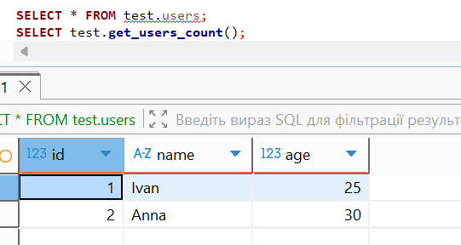
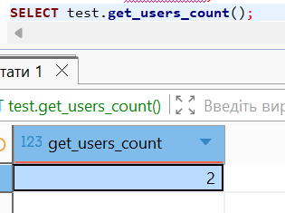
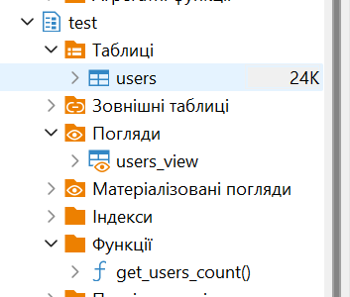

Part2
Added test.txt to my ec2
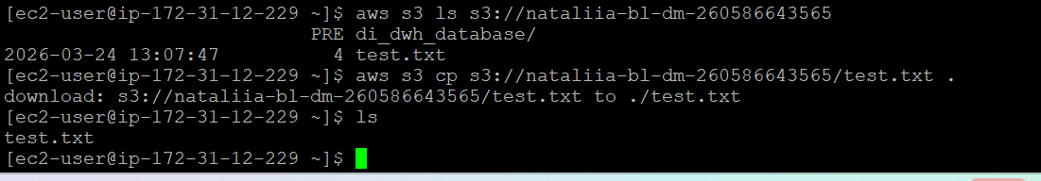added other tables from folder bl_dm
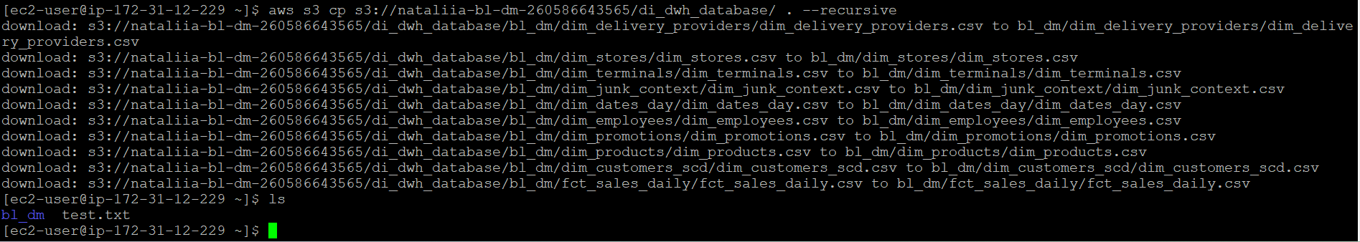
The file was successfully copied from S3 to EC2 using the IAM role. The presence of the file on the EC2 instance was verified using the ls command.
3.Created 2 snapshots for volumes 8 and 10
For 8gb
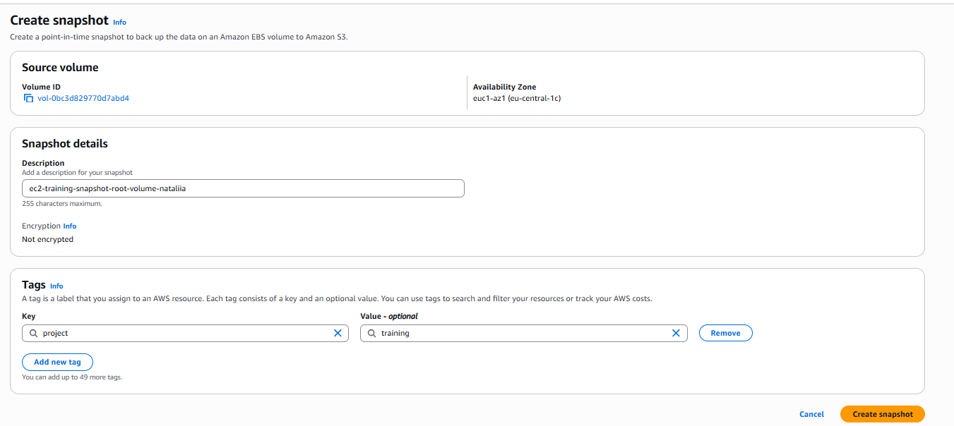
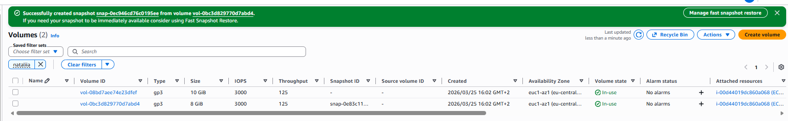
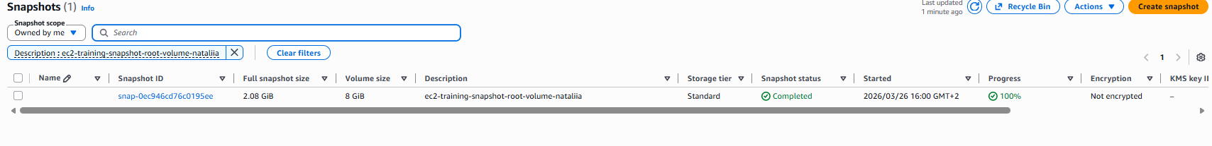
For 10gb
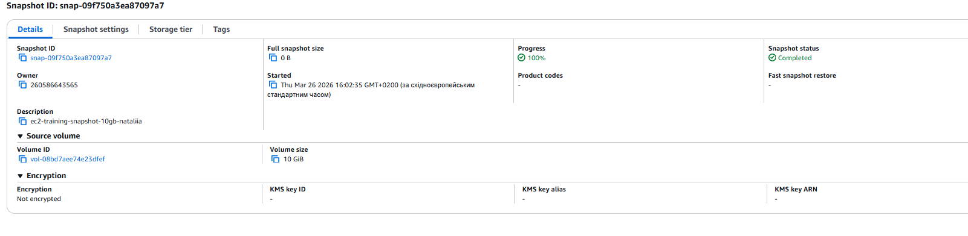
Created image
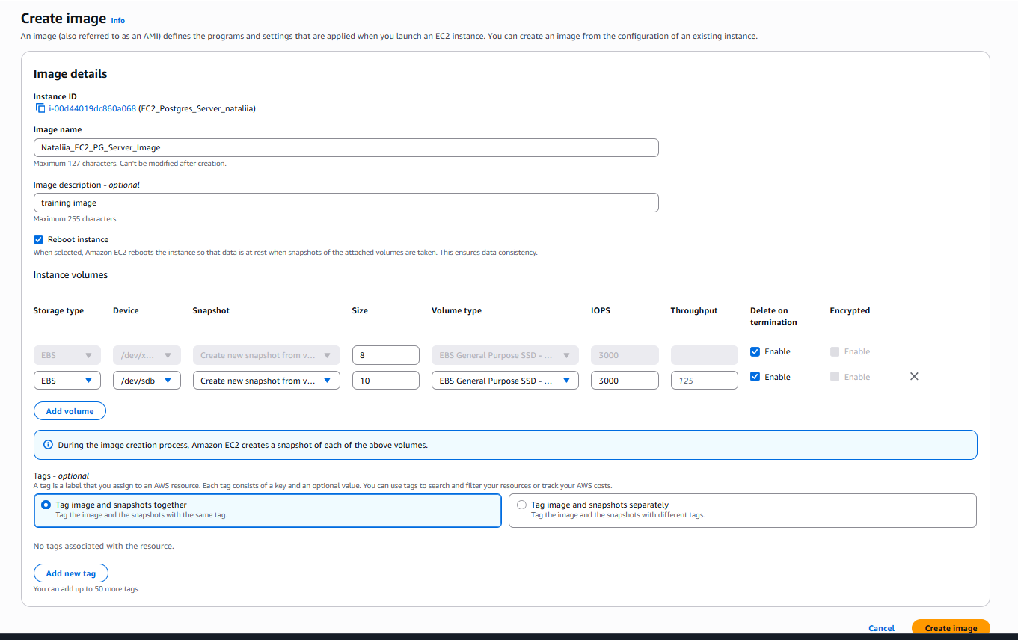
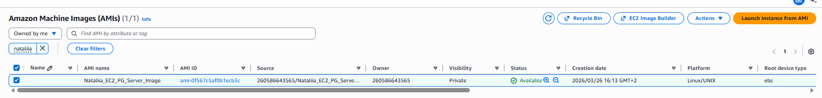

4.
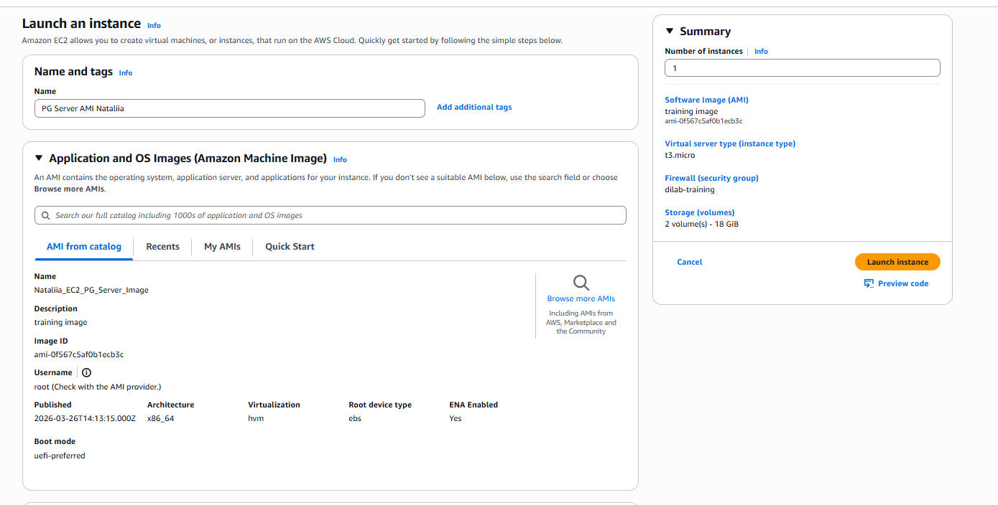
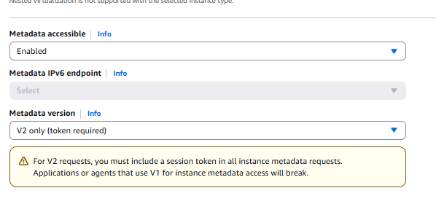
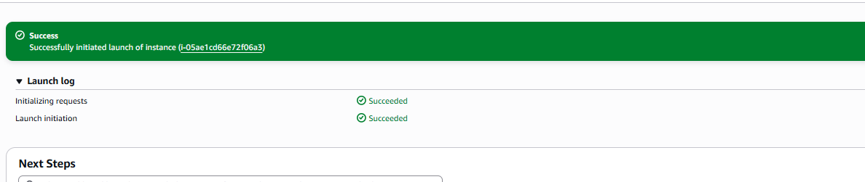
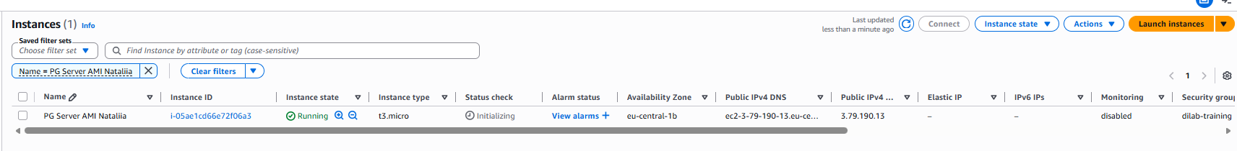
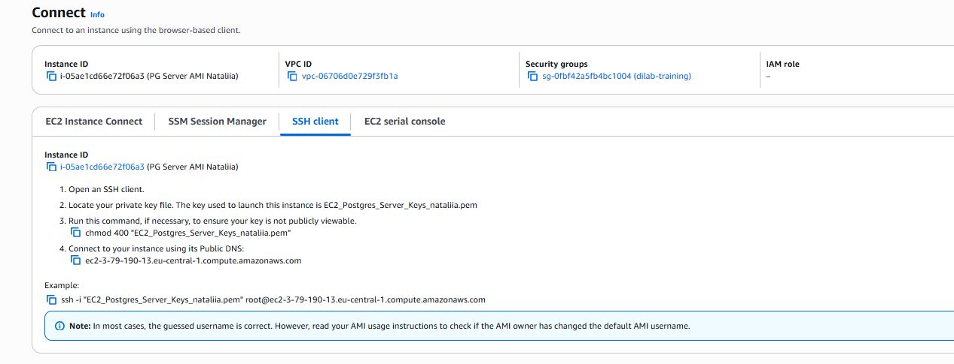

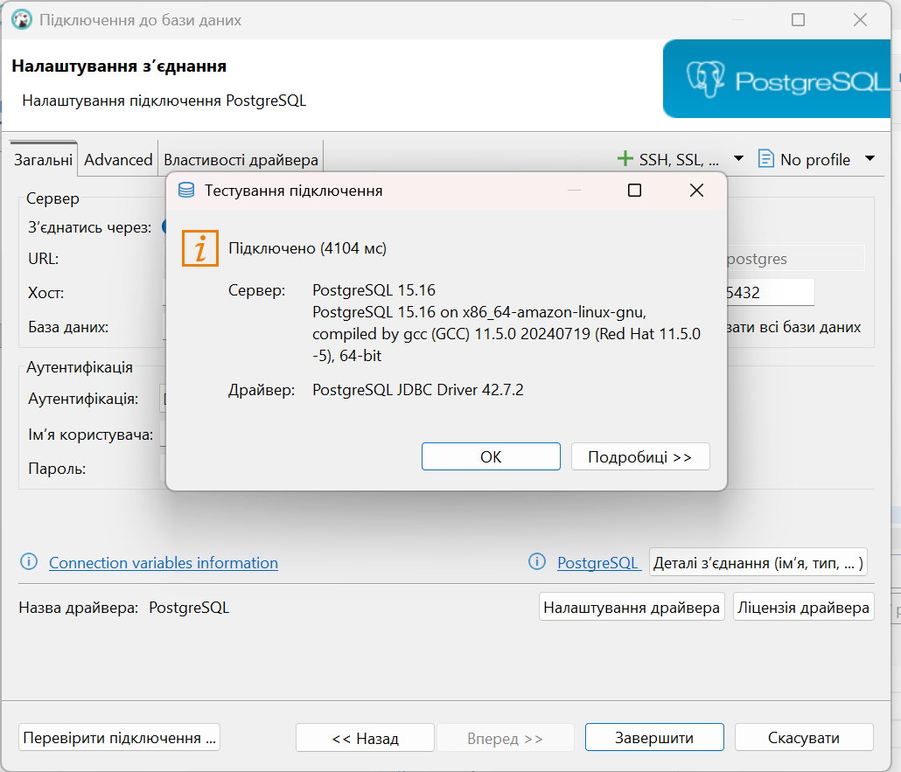
Checking what data are in the instance created from AMI
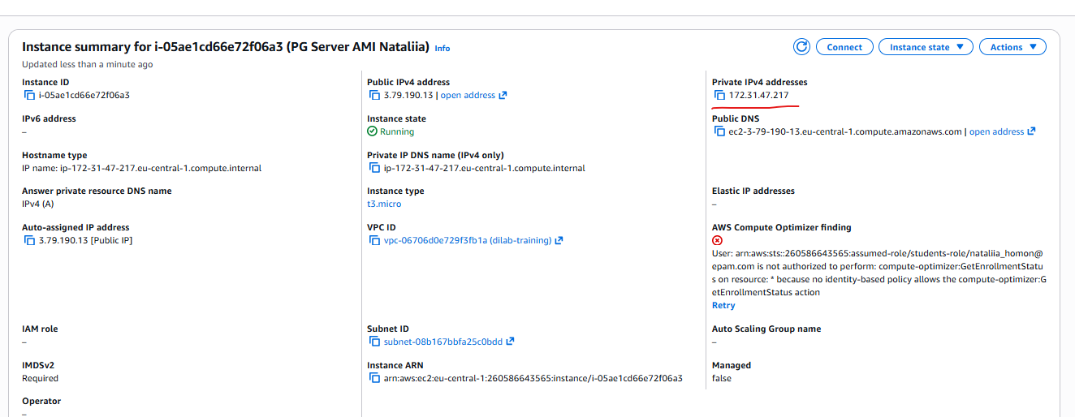
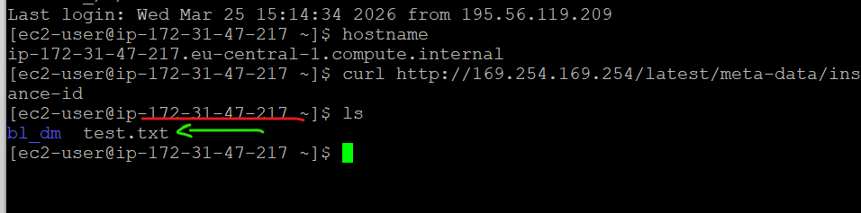
Same IPv4, same data is storage in this new instance
A new EC2 instance was successfully launched from the created AMI. The data file copied from S3 is present on the new instance, confirming that the AMI contains a full copy of the original server.

5. Installed+active apache
Created html page
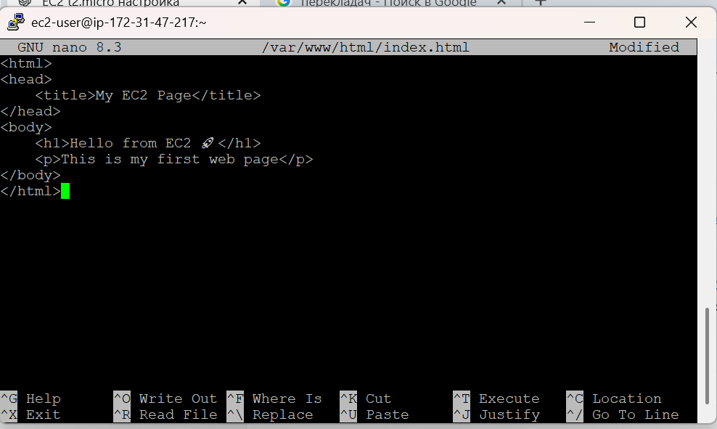

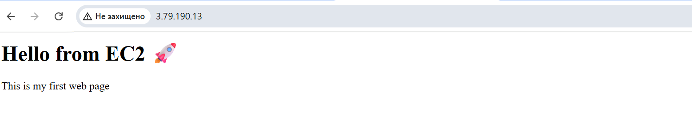
http://3.79.190.13/

6.SNS
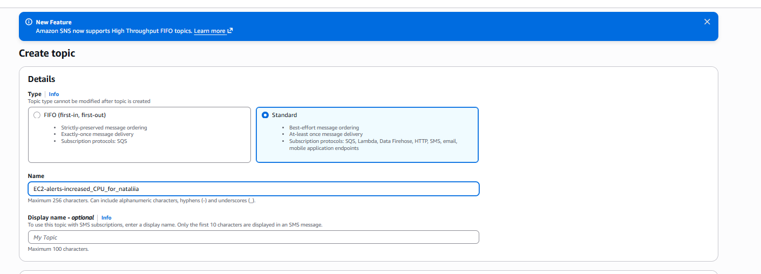
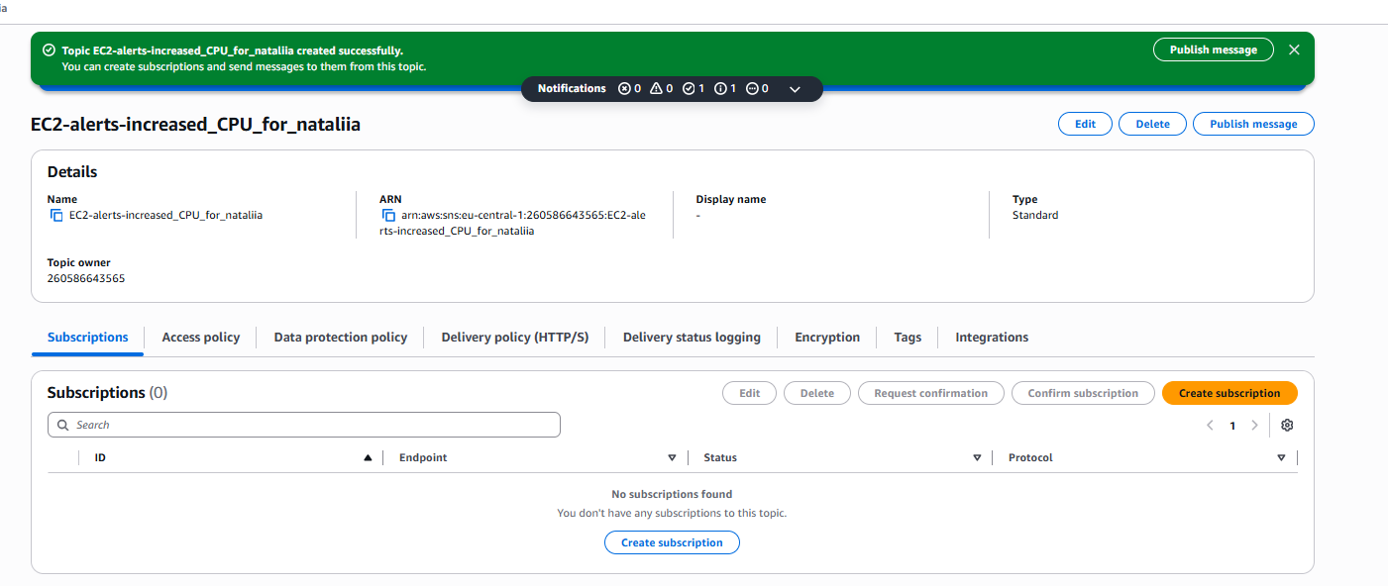
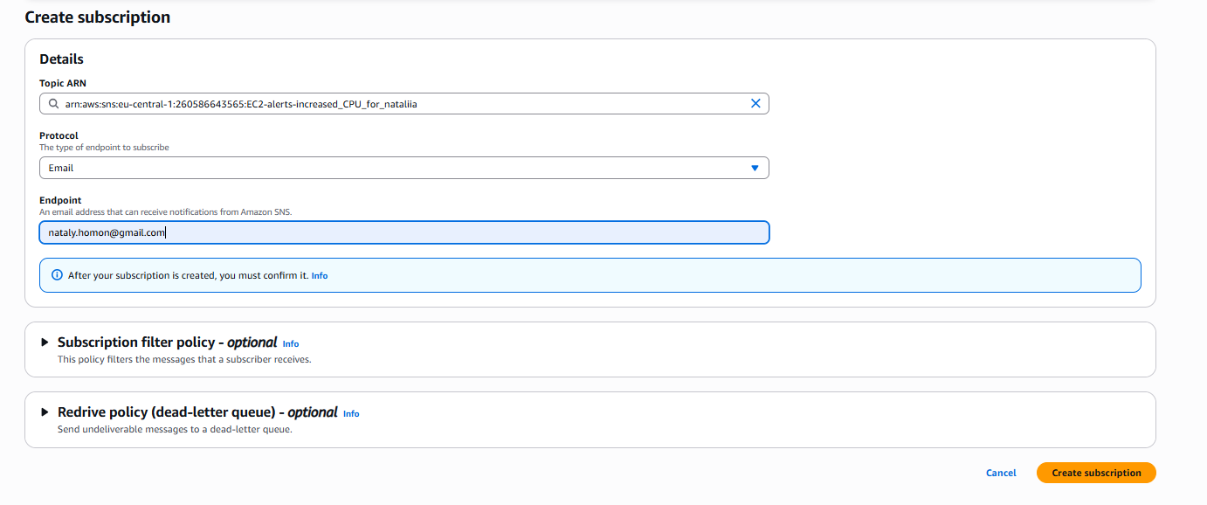
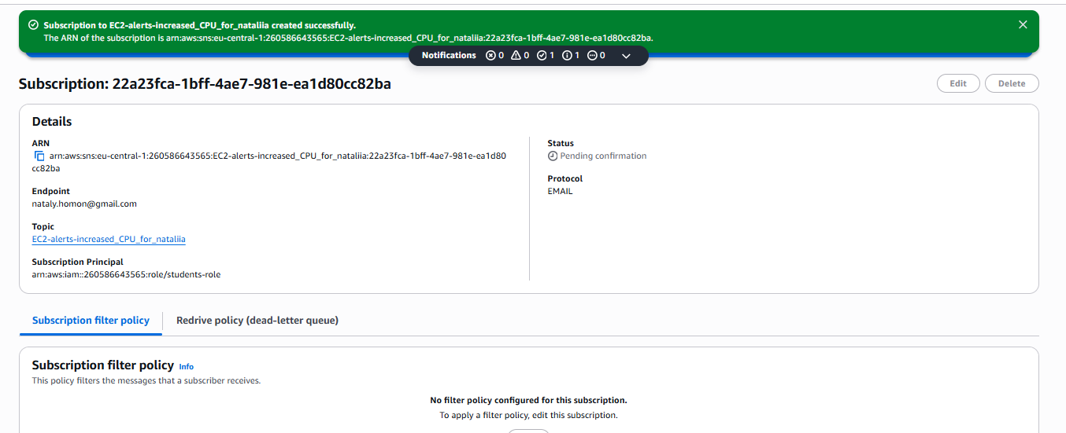
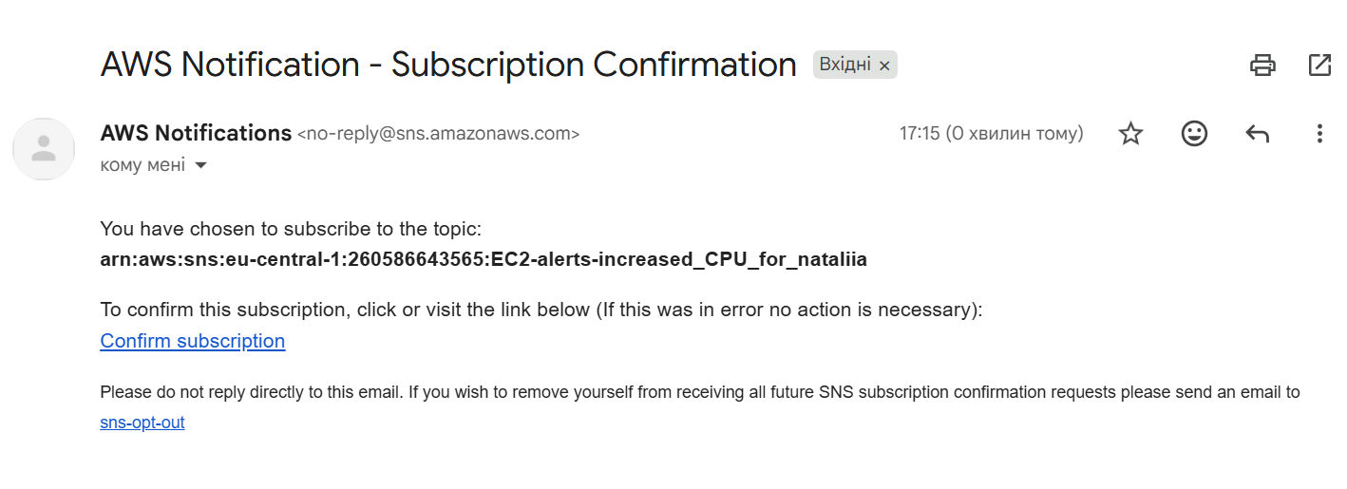
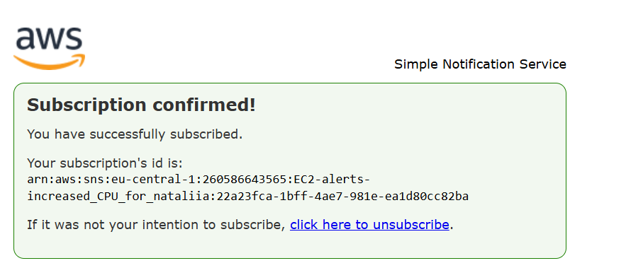
Configs for Cloud Watch
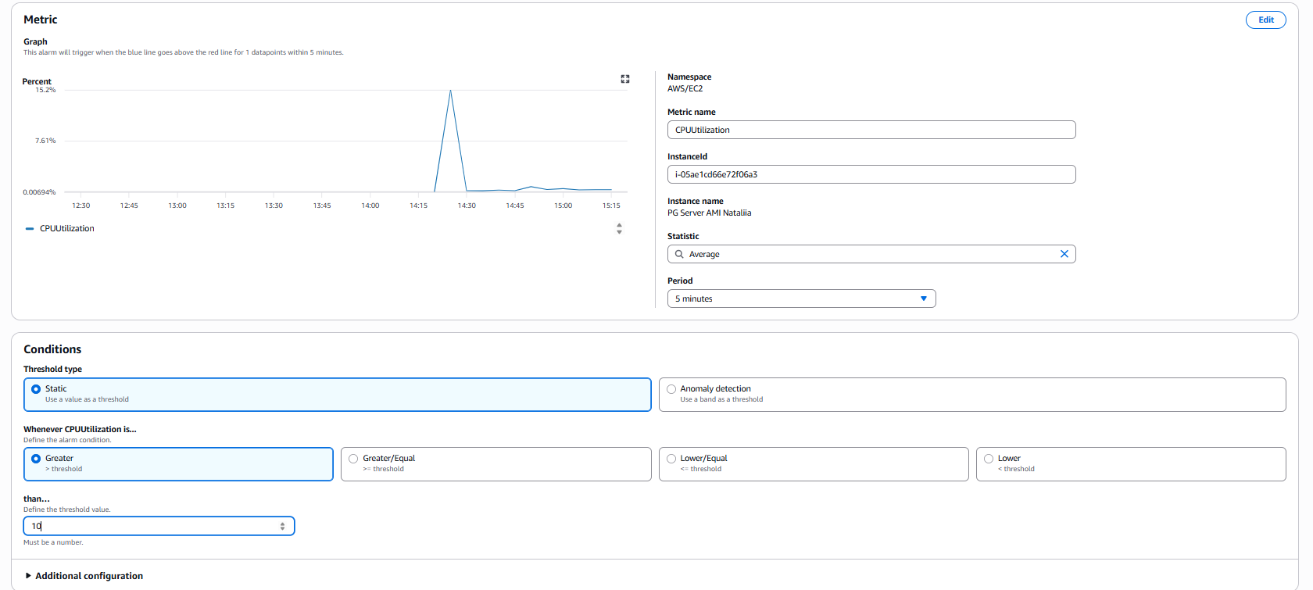
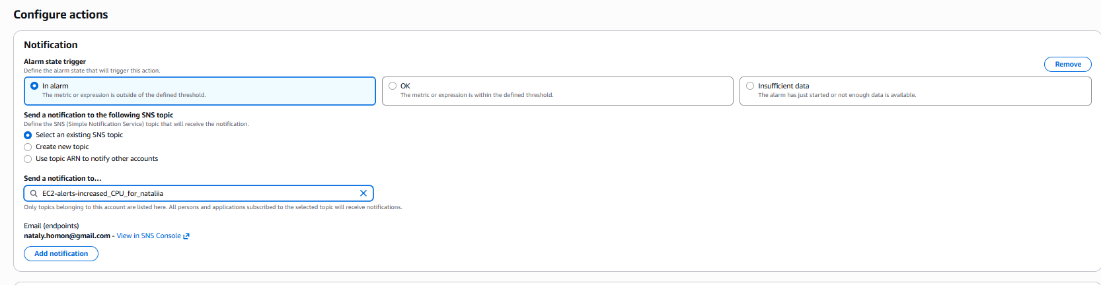
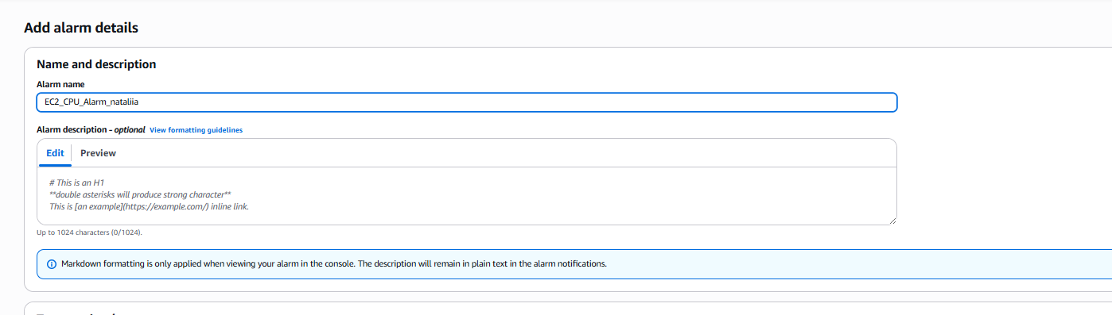
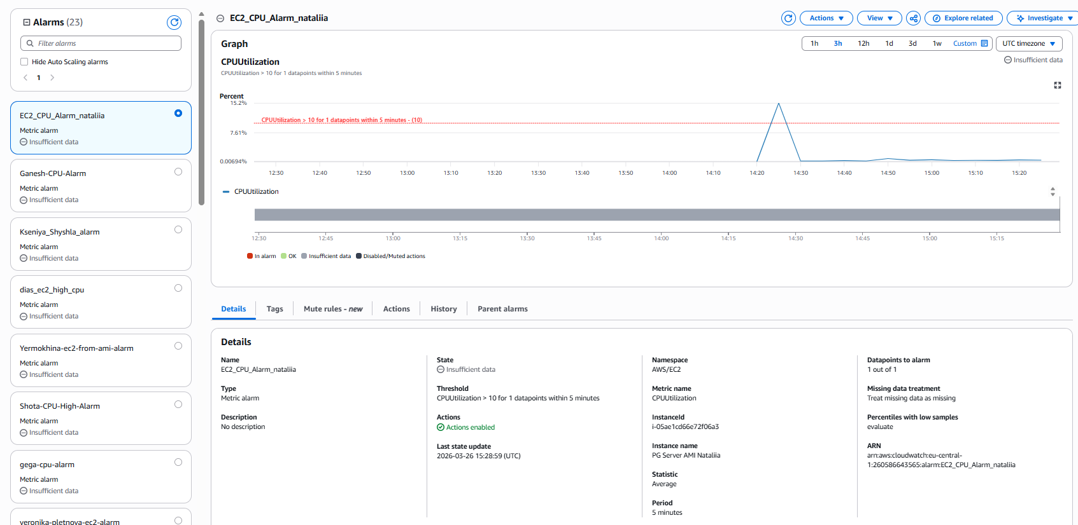

Test – manually increased cpu usage
yes > /dev/null
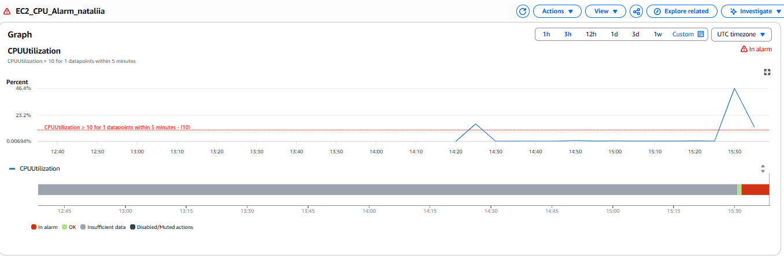
Received email
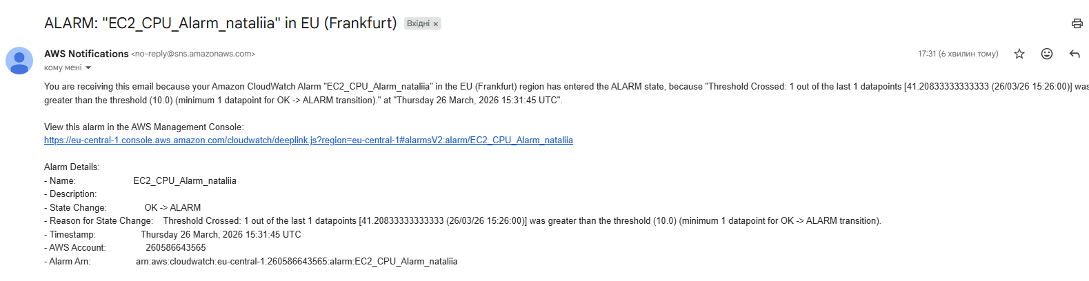

7created instance with the help of cloud formation
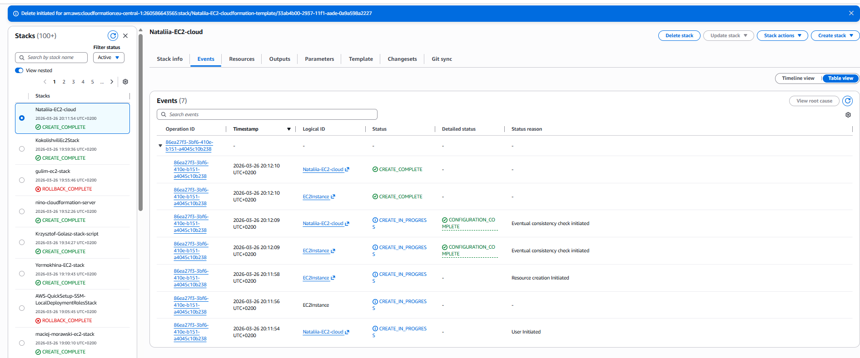
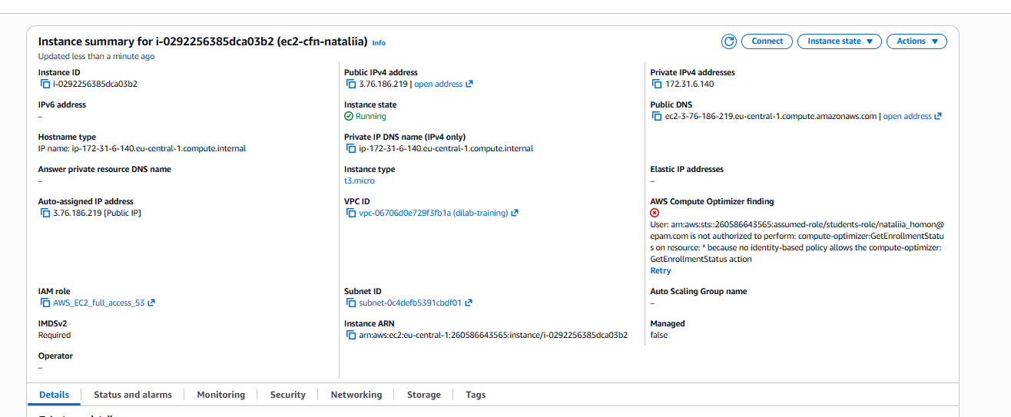
Added yaml file to s3
