1.1 TASK 1: USE INHERITANCE
Insert into sales_info
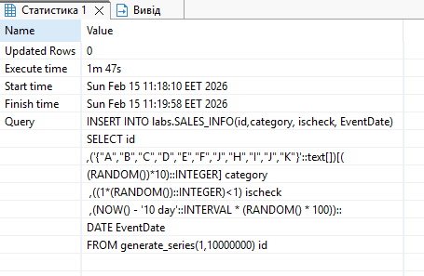
Insert into sales_info_simple (it was quicker then insert into sales_info believe due to absence of additional objects :functions, triggers, child tables)
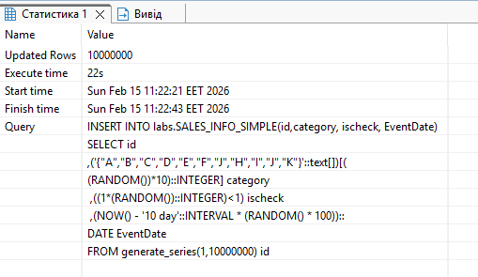
Sales_info | Sales_info_simple
SELECT *FROM
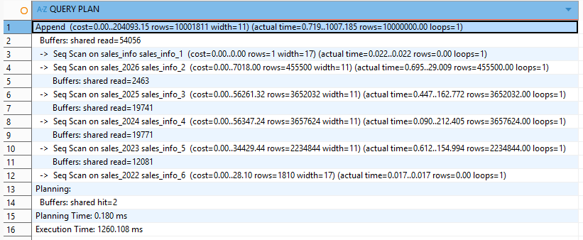 | 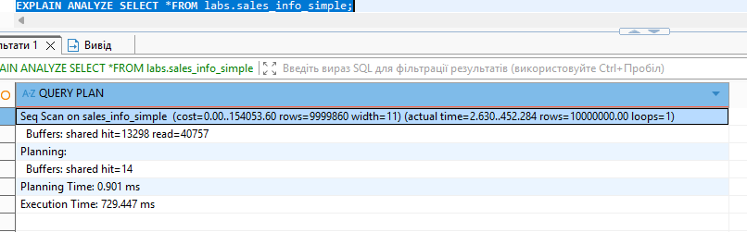
Append + several Seq Scan, Execution time 1260ms, six tables | One Seq Scan Execution time 729ms, 1 table
Summury: for a full-table SELECT without filtering, the single-table design performs significantly faster because it avoids the overhead of scanning and appending multiple child tables.
The inheritance-based approach becomes beneficial only when queries include filtering conditions (e.g., by eventdate) that allow scanning only specific partitions.

SELECT *FROM labs.sales_info s  WHERE eventdate >= '2024-01-01'  AND eventdate < '2025-01-01' ; | SELECT *FROM labs.sales_info_simple s  WHERE eventdate >= '2024-01-01'  AND eventdate < '2025-01-01' ;
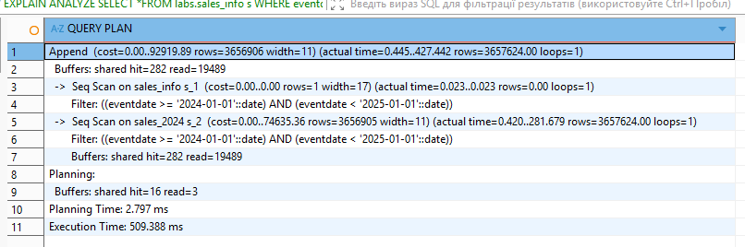 | 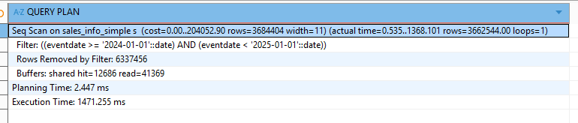
Append plan but scans only the relevant partition (sales_2024). Other partitions are effectively skipped. Only the necessary partition (3.65 million rows) is scanned. Much fewer buffers are read. Execution time: 509 ms | Sequential Scan on the entire table (~10 million rows), then applies the filter condition. As a result:6.3 million rows are removed by the filter. Execution time: ~1471 ms
When filtering by the partition key (eventdate), the partitioned structure significantly improves performance by avoiding unnecessary scans.
SELECT *FROM labs.sales_info s  WHERE eventdate = '2024-01-01'; | SELECT *FROM labs.sales_info_simple s  WHERE eventdate = '2024-01-01';
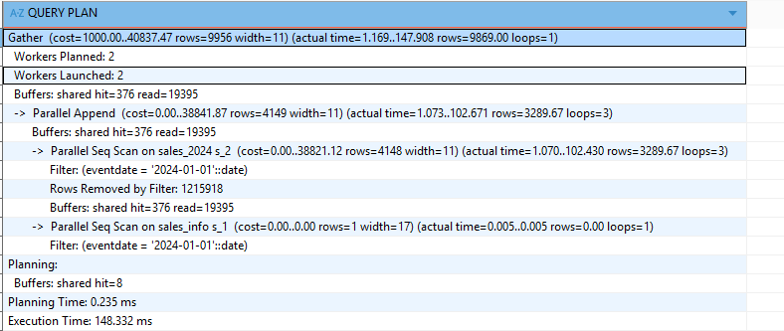 | 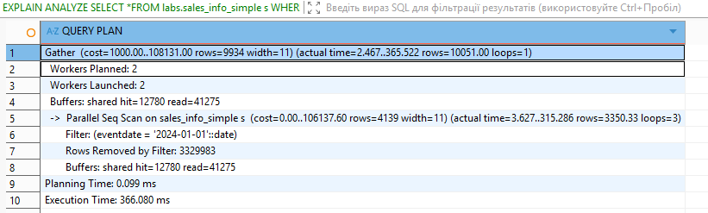
PostgreSQL uses Parallel Append, scanning mainly the relevant partition (sales_2024). Far fewer rows are filtered, and less data is processed overall.  Execution time: ~148 ms. | In the single-table structure, PostgreSQL performs a Parallel Sequential Scan over the entire table and filters out a large number of rows (~3.3 million removed).  Execution time: 366 ms.
EXPLAIN ANALYZE SELECT count(*)FROM labs.sales_info; | EXPLAIN ANALYZE SELECT count(*)FROM labs.sales_info_simple;
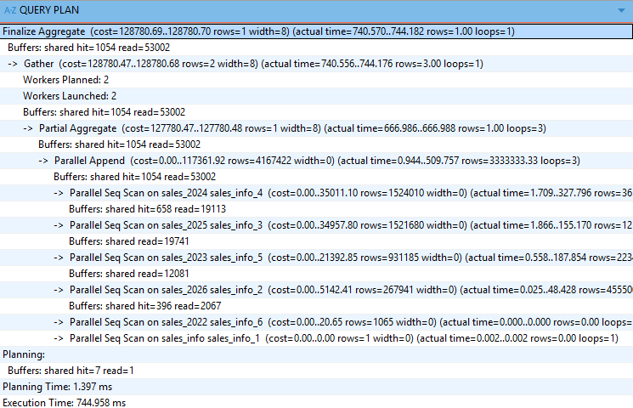 | 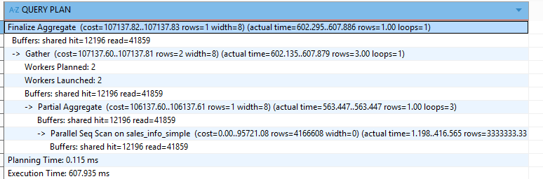
Summury: for a full-table SELECT without filtering, the single-table design performs significantly faster because it avoids the overhead of scanning and appending multiple child tables.
EXPLAIN ANALYZE SELECT count(*)FROM labs.sales_info s  WHERE eventdate >= '2024-01-01'  AND eventdate < '2025-01-01' ; | EXPLAIN ANALYZE SELECT count(*)FROM labs.sales_info_simple s  WHERE eventdate >= '2024-01-01'  AND eventdate < '2025-01-01' ;
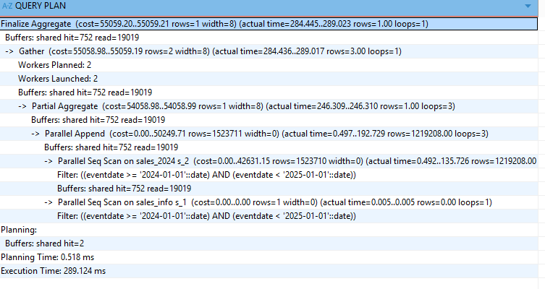 | 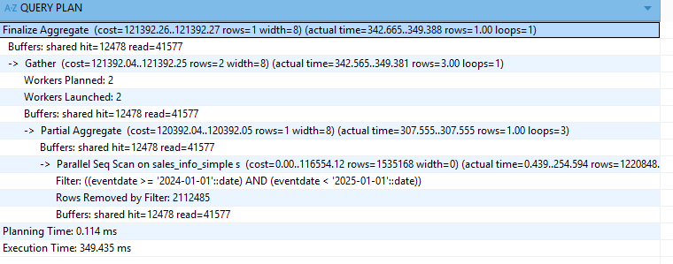
With filtering on the partition key and aggregation, the partitioned design is more efficient because it reduces the amount of scanned data and I/O, resulting in better overall performance.

ALTER TABLE labs. sales_2022 NO INHERIT labs.sales_info;

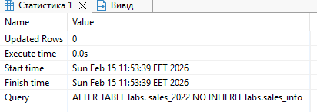
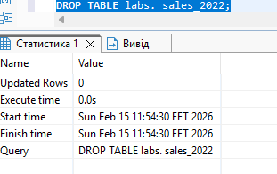
CREATE TABLE labs.SALES_INFO_3000
(
id INTEGER,
category VARCHAR(1),
ischeck BOOLEAN,
eventdate DATE,

CONSTRAINT ch_even_date5 CHECK (eventdate >= DATE '3000-01-01')
);

ALTER TABLE labs.SALES_INFO_3000 INHERIT labs.sales_info;
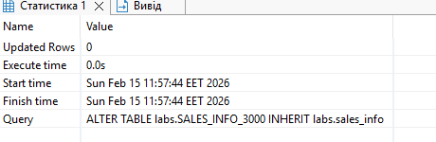
TASK2: USE DECLARATIVE PARTITIONING
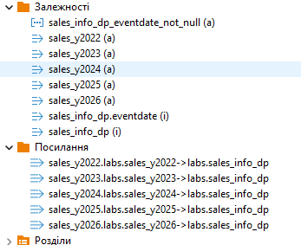

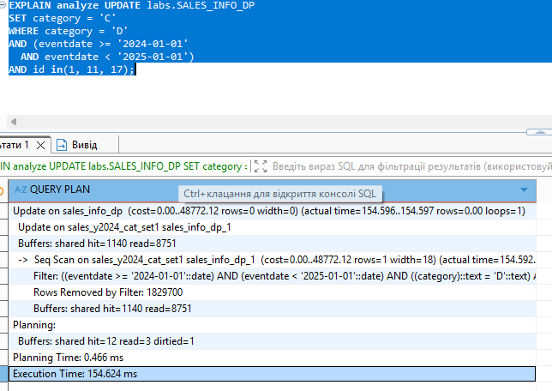

labs.SALES_INFO_DP | labs.sales_info_simple
SELECT *FROM labs.SALES_INFO_DP ; | SELECT *FROM labs.sales_info_simple;
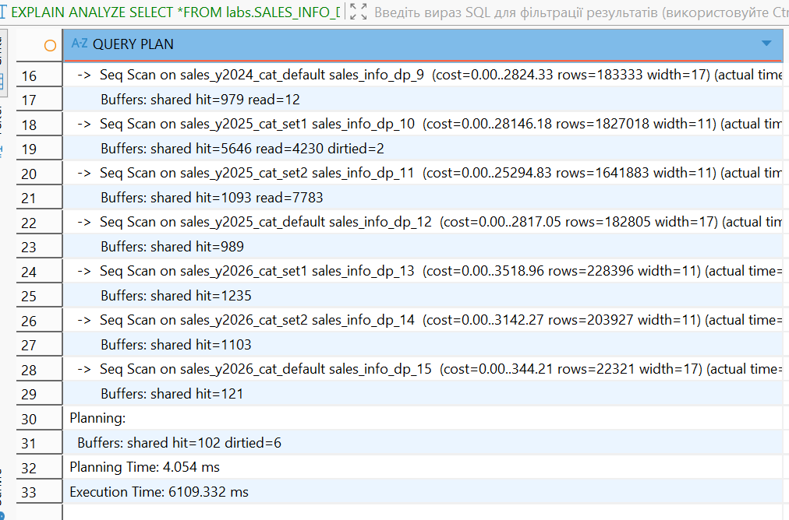 | 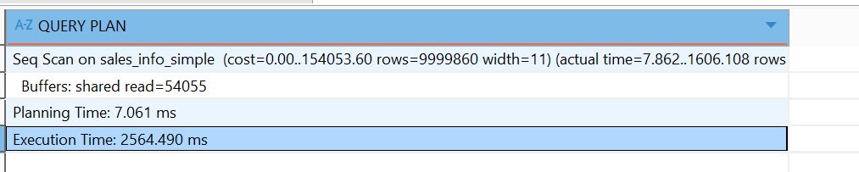
Summury: for a full-table SELECT without filtering, the single-table design performs significantly faster because it avoids the overhead of scanning and appending multiple partition tables.
SELECT *FROM labs.SALES_INFO_DP s  WHERE eventdate >= '2024-01-01'  AND eventdate < '2025-01-01' ; | SELECT *FROM labs.sales_info_simple s  WHERE eventdate >= '2024-01-01'  AND eventdate < '2025-01-01' ;
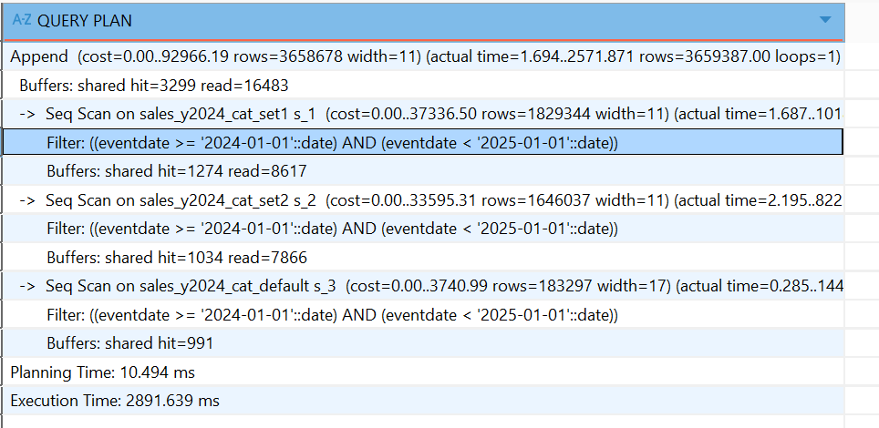 | 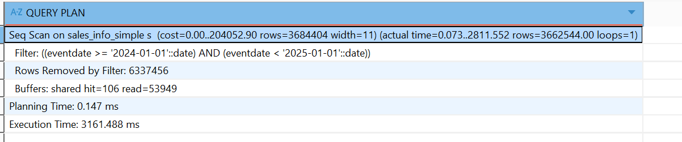
When filtering by the partition key (eventdate), the partitioned structure significantly improves performance by avoiding unnecessary scans. Scaning by partitions costs less and is quicker
SELECT *FROM labs.SALES_INFO_DP s  WHERE eventdate = '2024-01-01'; | EXPLAIN ANALYZE SELECT *FROM labs.sales_info_simple s  WHERE eventdate = '2024-01-01';
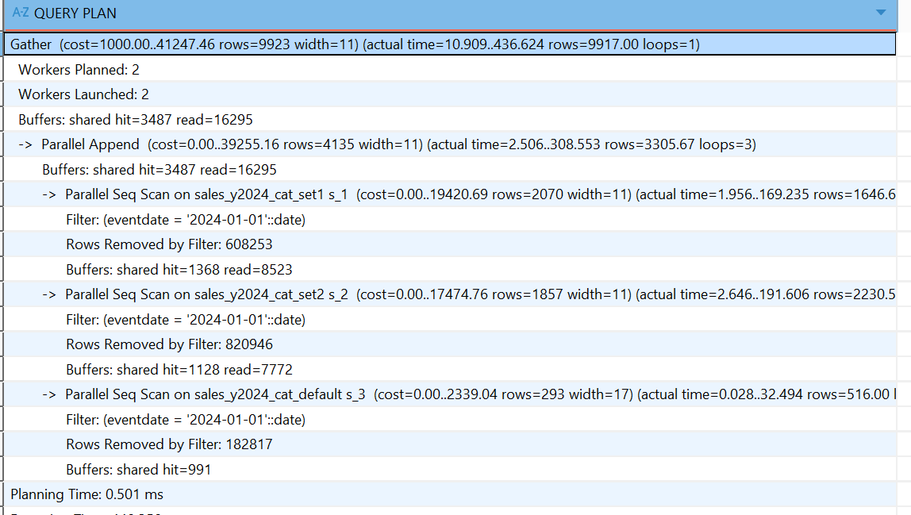 | 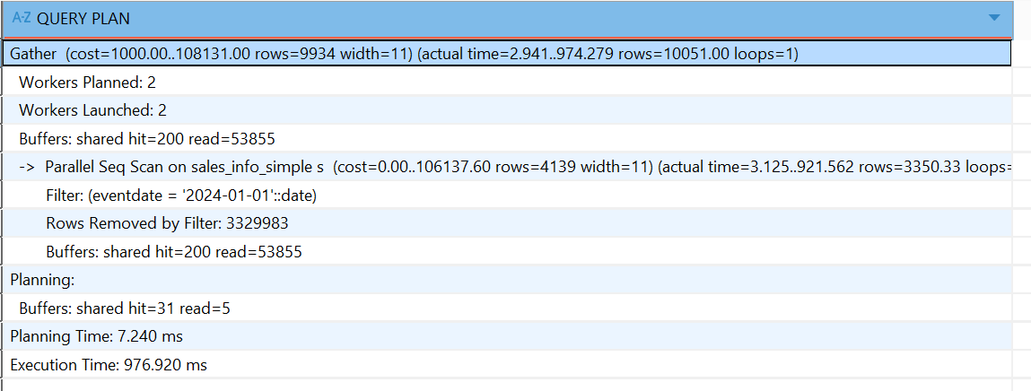
When filtering by the partition key (eventdate), the partitioned structure significantly improves performance by avoiding unnecessary scans. Scaning by partitions costs less and is quicker
SELECT *FROM labs.SALES_INFO_DP s  WHERE category = 'C'; | SELECT *FROM labs.sales_info_simple s  WHERE ecategory = 'C';
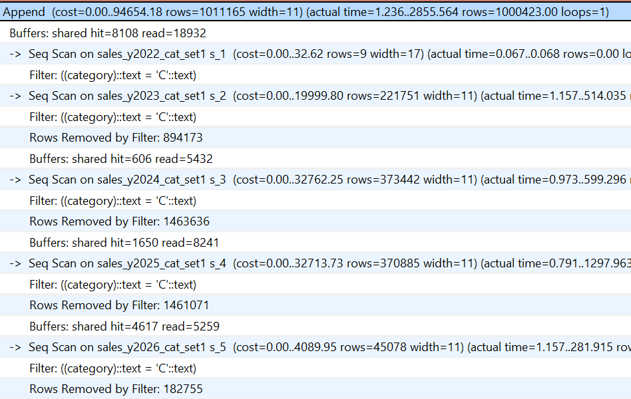 | 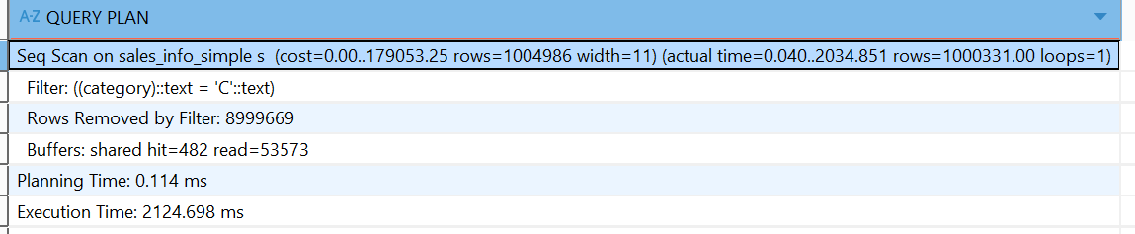
Partitioning improves performance only when the query filters by the partition key.
Since this query filters only by category and not by eventdate, the partitioning strategy does not reduce scanned data and may even introduce extra overhead.
EXPLAIN ANALYZE SELECT *FROM labs.SALES_INFO_DP s  WHERE category IN ('A','C','K'); | EXPLAIN ANALYZE SELECT *FROM labs.sales_info_simple s  WHERE category IN ('A','C','K');
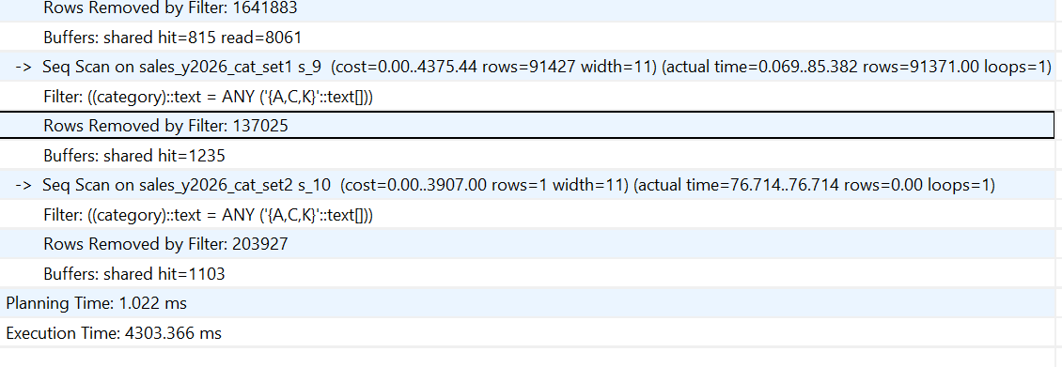 | 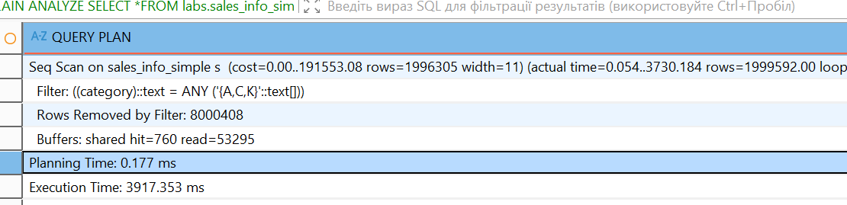
Partitioning improves performance only when the query filters by the partition key.
Since this query filters only by category and not by eventdate, the partitioning strategy does not reduce scanned data and may even introduce extra overhead.
EXPLAIN ANALYZE SELECT *FROM labs.SALES_INFO_DP s  WHERE eventdate = DATE '2024-06-15'  AND category IN ('A','C','K'); | EXPLAIN ANALYZE SELECT *FROM labs.sales_info_simple s  WHERE eventdate = DATE '2024-06-15'  AND category IN ('A','C','K');
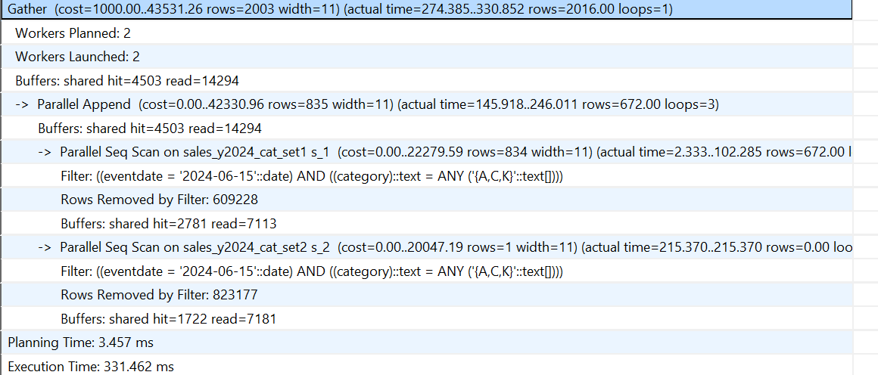 | 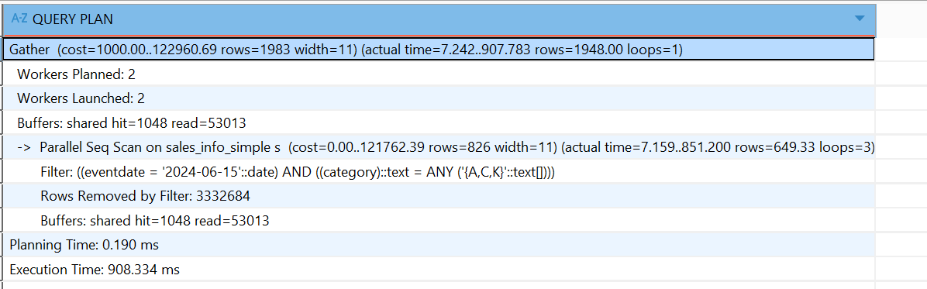
EXPLAIN ANALYZE SELECT count(*)FROM labs.SALES_INFO_DP ; | EXPLAIN ANALYZE SELECT count(*)FROM labs.sales_info_simple;
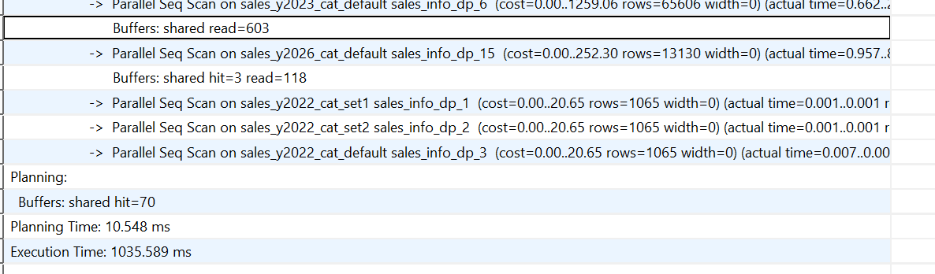 | 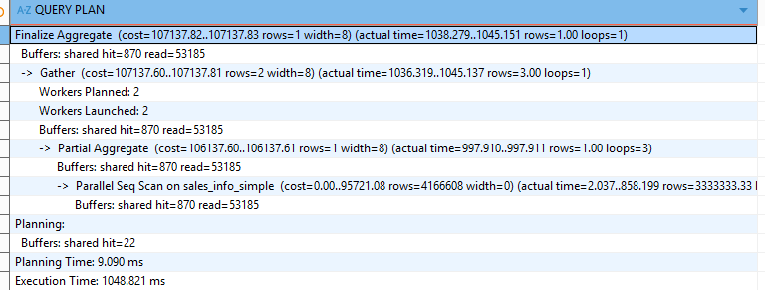
Summury: for a full-table SELECT without filtering execution time is almost the same
EXPLAIN ANALYZE SELECT count(*)FROM labs.SALES_INFO_DP s  WHERE eventdate >= '2024-01-01'  AND eventdate < '2025-01-01' ; | EXPLAIN ANALYZE SELECT count(*)FROM labs.sales_info_simple s  WHERE eventdate >= '2024-01-01'  AND eventdate < '2025-01-01' ;
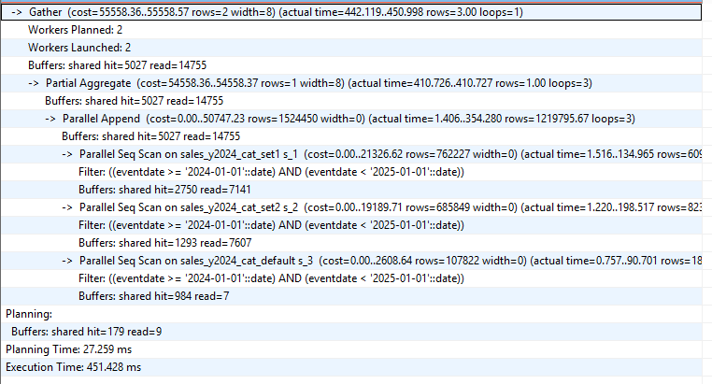 | 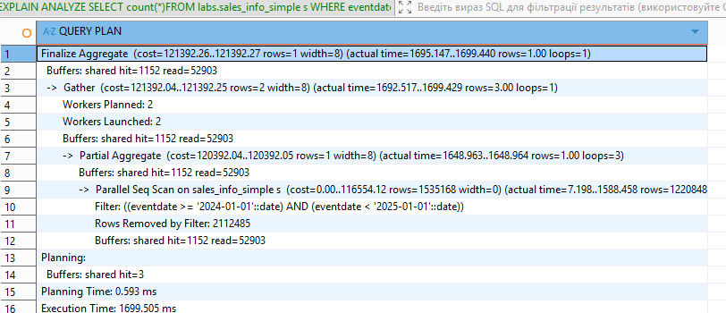
With filtering on the partition key and aggregation, the partitioned design is more efficient because it reduces the amount of scanned data and I/O, resulting in better overall performance.

-- Step 1: Detach the existing wide list partition

ALTER TABLE labs.sales_y2024
DETACH PARTITION labs.sales_y2024_cat_set1;

-- Step 2: Create two new list partitions
CREATE TABLE labs.sales_y2024_cat_abc
PARTITION OF labs.sales_y2024
FOR VALUES IN ('A','B','C');

CREATE TABLE labs.sales_y2024_cat_de
PARTITION OF labs.sales_y2024
FOR VALUES IN ('D','E');

-- Step 3: Move data from the old partition into the new partitions
-- Inserting into the year parent allows PostgreSQL to route rows automatically
INSERT INTO labs.sales_y2024
SELECT * FROM labs.sales_y2024_cat_set1;

-- Step 4: Drop the old detached partition (optional if no longer needed)
DROP TABLE labs.sales_y2024_cat_set1;

TASK 3: USE PARALLEL QUERING

EXPLAIN ANALYZE SELECT * FROM labs.sales_info;
EXPLAIN ANALYZE SELECT * FROM labs.sales_info_dp;
EXPLAIN ANALYZE SELECT * FROM labs.sales_info_simple;

EXPLAIN ANALYZE SELECT * FROM labs.sales_info ORDER BY eventdate;
EXPLAIN ANALYZE SELECT * FROM labs.sales_info_dp ORDER BY eventdate;
EXPLAIN ANALYZE SELECT * FROM labs.sales_info_simple ORDER BY eventdate;

EXPLAIN ANALYZE SELECT COUNT(*) FROM labs.sales_info;
EXPLAIN ANALYZE SELECT COUNT(*) FROM labs.sales_info_dp;
EXPLAIN ANALYZE SELECT COUNT(*) FROM labs.sales_info_simple;

EXPLAIN ANALYZE
SELECT *
FROM labs.sales_info
WHERE eventdate >= DATE '2024-01-01' AND eventdate < DATE '2025-01-01';

EXPLAIN ANALYZE
SELECT *
FROM labs.sales_info_dp
WHERE eventdate >= DATE '2024-01-01' AND eventdate < DATE '2025-01-01';

EXPLAIN ANALYZE
SELECT *
FROM labs.sales_info_simple
WHERE eventdate >= DATE '2024-01-01' AND eventdate < DATE '2025-01-01';

EXPLAIN ANALYZE
SELECT category, COUNT(*) AS cnt
FROM labs.sales_info
GROUP BY category
ORDER BY category;

EXPLAIN ANALYZE
SELECT category, COUNT(*) AS cnt
FROM labs.sales_info_dp
GROUP BY category
ORDER BY category;

EXPLAIN ANALYZE
SELECT category, COUNT(*) AS cnt
FROM labs.sales_info_simple
GROUP BY category
ORDER BY category;

EXPLAIN ANALYZE
SELECT COUNT(*) AS cnt
FROM labs.sales_info s
JOIN labs.sales_info_dp p
ON p.id = s.id
WHERE s.eventdate = DATE '2024-06-15'
AND p.eventdate = DATE '2024-06-15';

-- For declarative partitioned table: creating index on parent creates it on all partitions
-- Index to speed up eventdate filtering and ordering
CREATE INDEX IF NOT EXISTS sales_info_dp_eventdate_idx
ON labs.sales_info_dp (eventdate);

-- Index to speed up category filters/grouping
CREATE INDEX IF NOT EXISTS sales_info_dp_category_idx
ON labs.sales_info_dp (category);

-- Index to speed up join on id
CREATE INDEX IF NOT EXISTS sales_info_dp_id_idx
ON labs.sales_info_dp (id);

-- After indexes: rerun key queries to see plan changes
EXPLAIN ANALYZE SELECT * FROM labs.sales_info_dp WHERE eventdate >= DATE '2024-01-01' AND eventdate < DATE '2025-01-01';
EXPLAIN ANALYZE SELECT * FROM labs.sales_info_dp ORDER BY eventdate;
EXPLAIN ANALYZE SELECT category, COUNT(*) FROM labs.sales_info_dp GROUP BY category;
EXPLAIN ANALYZE SELECT * FROM labs.sales_info_dp WHERE category IN ('A','C','K');
EXPLAIN ANALYZE
SELECT COUNT(*)
FROM labs.sales_info s
JOIN labs.sales_info_dp p ON p.id = s.id
WHERE s.eventdate = DATE '2024-06-15' AND p.eventdate = DATE '2024-06-15';

1) SELECT * (no filters)
- SALES_INFO_SIMPLE is usually the fastest because it performs a single Seq Scan with minimal overhead.
- SALES_INFO (INHERITS) is slower due to the Append plan node and multiple sequential scans across child tables.
- SALES_INFO_DP (partitioned) can also be slower than the simple table because, without filtering on the partition key, PostgreSQL must scan all partitions, adding overhead.
Conclusion: Partitioning does not provide benefits for full-table scans.

2) ORDER BY eventdate
- Without an index on eventdate, all three tables require a large Sort after scanning all rows.
- Partitioned tables may introduce additional overhead (Merge Append, sorting per partition).
- Adding an index on (eventdate) may help in some cases, but for large SELECT * queries, Seq Scan + Sort is often still cheaper.
Conclusion: Sorting large datasets is expensive; indexes help only when result sets are selective.

3) COUNT(*)
- In PostgreSQL, COUNT(*) must scan all rows/pages (there is no “instant count”).
- The simple table often performs best due to structural simplicity.
- Partitioned and inherited tables introduce additional scanning overhead.
Conclusion: Partitioning does not significantly improve full-table COUNT(*).

4) Date range filter (WHERE eventdate >= ... AND < ...)
This is where partitioning shows maximum benefit:
- SALES_INFO_DP performs true partition pruning and scans only relevant year partitions.
- SALES_INFO (INHERITS) may skip tables via constraint exclusion, but this is older and less reliable.
- SALES_INFO_SIMPLE scans the entire table and filters out rows.
Conclusion: For date-based queries, SALES_INFO_DP performs best, followed by INHERITS, then the simple table.

5) GROUP BY category
- Without filtering by eventdate, the entire dataset must be processed.
- In SALES_INFO_DP, LIST partitioning on category allows pruning when a category filter is present.
- An index on category may help selective queries, but aggregation over large datasets still requires scanning significant data.
Conclusion: GROUP BY without filters behaves similarly to full-table scans; partitioning alone does not guarantee improvement.

6) Join (SALES_INFO ↔ SALES_INFO_DP on id + exact date filter + COUNT)
- Best performance occurs when both tables can prune data by eventdate.
- An index on id is critical for efficient joins.
- Composite indexes like (eventdate, id) may further improve performance depending on the plan.
Conclusion: Large joins require both pruning and proper indexing for good performance.

Indexing Considerations

SALES_INFO_DP (Declarative Partitioning)
- CREATE INDEX ON labs.sales_info_dp (...) automatically creates indexes on all partitions.
- Most useful indexes:
  - (eventdate) or (eventdate, category) for range queries
  - (category) for category filters
  - (id) for joins

SALES_INFO (INHERITS)
- Indexes are not inherited.
- They must be created manually on each child table.
- Maintenance is more complex and error-prone.

SALES_INFO_SIMPLE
- Straightforward: one table, one index definition.

Overall Conclusion
- SALES_INFO_SIMPLE is best for full-table scans and simple workloads.
- SALES_INFO_DP (RANGE → LIST) is best for analytical workloads with date-based filtering and mixed predicates.
- SALES_INFO (INHERITS + triggers) is an older approach that requires more manual maintenance and provides less predictable optimization.

Advantages of Using Parallel Scan
When enabling parallel execution (max_parallel_workers_per_gather > 0), PostgreSQL can:
- Divide large table scans across multiple CPU cores.
- Reduce execution time for:
  - Large SELECT *
  - COUNT(*)
  - GROUP BY
  - Large joins
- Use:
  - Parallel Seq Scan
  - Parallel Bitmap Heap Scan
  - Parallel Hash Join
  - Partial Aggregate + Finalize Aggregate

When Parallel Scan Helps Most
- Large tables (millions of rows)
- Full-table scans
- Aggregations
- Queries without highly selective index usage

When It Helps Less
- Highly selective index lookups
- Very small result sets
- I/O-bound systems with limited disk throughput
Final Insight:
Parallel scan significantly improves performance for large analytical queries but does not replace good partitioning or proper indexing. The best performance is achieved when combining partition pruning, appropriate indexing, and parallel execution.

