Business Model Description
The business operates in the retail domain, selling consumer goods through two main sales channels: an online e-commerce platform and offline physical stores (POS).
In the online channel, customers place orders via web or mobile devices, select delivery options, and receive goods through third-party delivery providers. In the offline channel, customers purchase products directly in stores using POS terminals operated by cashiers.
The company manages a wide assortment of products organized in a hierarchical structure (category → subcategory → product), and supports various business processes including promotions, payments, customer segmentation, and logistics.
The integration of both channels enables unified analysis of sales performance, customer behavior, product profitability, and operational efficiency across the business.
The dataset used for analysis contains transactional data at the level of a single product per transaction, allowing detailed and flexible analytical reporting.

Note: The available data in the report starts from October 2025.

1.Corrections in the model
Filtered bl_dm_customers_scd => left only active
Corrected relationship between fact table and customer’s table (many to one)
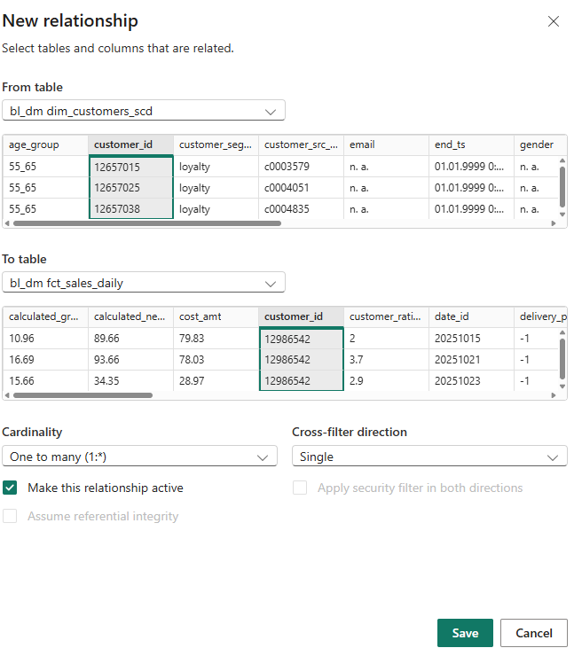

Added new columns in bl_dm dim_dates_day
Full_Date to work with formulas correctly using date type column
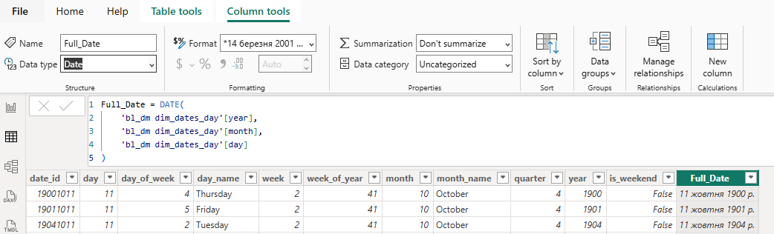

2.Calculated columns
Added new columns
1. Month Year =
FORMAT('bl_dm dim_dates_day'[Full_Date], "MMM YYYY")

Month Year will be sorted by MonthYear Sort

2.Month Year Sort =
YEAR('bl_dm dim_dates_day'[Full_Date]) * 100 + MONTH('bl_dm dim_dates_day'[Full_Date])

3.Quarter Year =
"Q" & 'bl_dm dim_dates_day'[quarter] & " " & 'bl_dm dim_dates_day'[year]
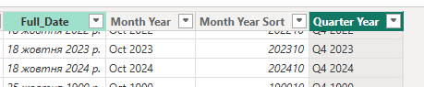
Day Type =
IF(
'bl_dm dim_dates_day'[is_weekend] = TRUE(),
"Weekend",
"Weekday"
)

In bl_dm fct_sales_daily created new calculated column .
This column categorizes each sales record into a profit level (Loss, Low, Medium, High) based on the gross_profit_amt, making it easier to analyze and filter performance by profitability segments.

4.Profit Band =
SWITCH(
TRUE(),
'bl_dm fct_sales_daily'[gross_profit_amt] < 0, "Loss",
'bl_dm fct_sales_daily'[gross_profit_amt] < 20, "Low",
'bl_dm fct_sales_daily'[gross_profit_amt] < 100, "Medium",
"High"
)

5.Channel Label = RELATED('bl_dm dim_junk_context'[sales_channel])

This calculated column was created to bring the sales channel information from the dimension table into the fact table using the existing relationship. The RELATED function was used because it allows retrieving a value from a related table based on that relationship, ensuring that each fact row gets the correct channel. This simplifies analysis and makes it easier to use the channel field in calculations and visuals without referencing the dimension table directly.
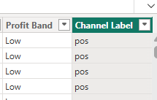

Promo Flag =
SWITCH(
TRUE(),
'bl_dm fct_sales_daily'[promotion_id] = -1, "No Promo",
"Promo"
)

3.Measures
Total Sales = SUM('bl_dm fct_sales_daily'[sales_amt])
Total Cost = SUM('fct_sales'[cost_amt])
Gross Profit = SUM('bl_dm fct_sales_daily'[gross_profit_amt])
Total Discount = SUM('bl_dm fct_sales_daily'[discount_amt])
Net Sales = [Total Sales] - [Total Discount]
Margin % =
DIVIDE([Gross Profit], [Total Sales])
Avg Rating =
AVERAGE('bl_dm fct_sales_daily'[customer_rating])
Transactions =
DISTINCTCOUNT('bl_dm fct_sales_daily'[txn_id_src])
Avg Check =
DIVIDE([Total Sales], [Transactions])
Min Check =
MINX(
VALUES('bl_dm fct_sales_daily'[txn_id_src]),
CALCULATE(SUM('bl_dm fct_sales_daily'[sales_amt]))
)
Max Check =
MAXX(
VALUES('bl_dm fct_sales_daily'[txn_id_src]),
CALCULATE(SUM('bl_dm fct_sales_daily'[sales_amt]))
)

Customers Purchased Category =
DISTINCTCOUNT('bl_dm fct_sales_daily'[customer_id])

Sub Title Sales =
SELECTEDVALUE(
'dim_junk_context'[sales_channel],
"All Channels"
)

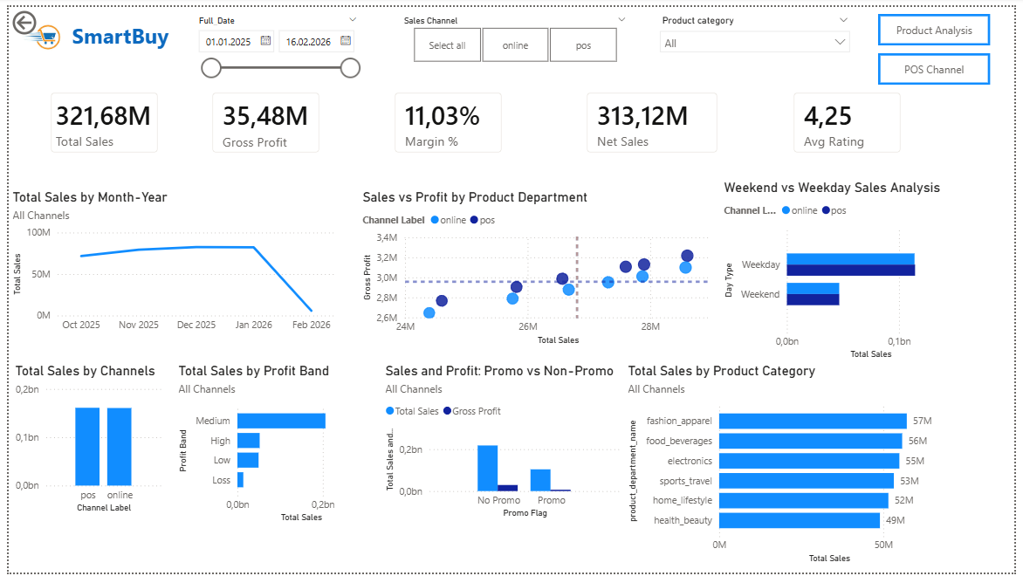

Executive Overview Page
The Executive Overview page provides a high-level summary of the company’s sales performance. It combines key performance indicators, trends, and comparative analytics to support quick decision-making.

Header and Filters
The header includes the company logo (SmartBuy) and report title. Global filters are implemented using slicers, including:
- Date range (Date slicer)
- Sales channel (Button slicer: online / POS)
- Product category (Dropdown slicer)
These filters interact with all visuals on the page.

Navigation Buttons
Two navigation buttons are implemented using Page Navigation buttons:
- Product Analysis — navigates to the detailed product analysis page
- POS Channel — navigates to the channel analysis page
These buttons improve report usability and user navigation.

KPI Section (Card Visuals)
The page includes key business metrics displayed using Card visuals:
- Total Sales
- Gross Profit
- Margin %
- Net Sales
- Average Rating
These KPIs provide a quick overview of overall business performance.

Sales Trend (Line Chart)
A Line Chart is used to display Total Sales by Month-Year.
This visual highlights sales trends over time and allows identification of seasonality patterns.

Sales vs Profit Analysis (Scatter Plot)
A Scatter Chart is used to analyze the relationship between:
- Total Sales (X-axis)
- Gross Profit (Y-axis)
This visual helps identify high-performing and low-performing product categories.

Weekend vs Weekday Analysis (Clustered Bar Chart)
A Clustered Bar Chart compares sales between:
- Weekdays
- Weekends
This allows analysis of customer purchasing behavior across different time periods.

Sales by Channel (Clustered Column Chart)
A Clustered Column Chart is used to compare Total Sales across sales channels (online vs POS).
It shows the contribution of each channel to overall revenue.

Profit Band Distribution (Bar Chart)
A Bar Chart displays Total Sales by Profit Band (Loss, Low, Medium, High).
This helps evaluate the quality and profitability of sales.

Promo vs Non-Promo Analysis (Clustered Column Chart)
A Clustered Column Chart compares:
- Total Sales
- Gross Profit
for promotional vs non-promotional transactions.
This visual supports analysis of promotion effectiveness.

Sales by Product Category (Bar Chart + Drillthrough)
A Bar Chart shows Total Sales by Product Category.
Drillthrough functionality is implemented on this visual:
- Users can right-click on a category
- Navigate to the Product Analysis page
- View detailed metrics filtered by the selected category

Dynamic Subtitles
Dynamic subtitles are implemented using DAX measures.
They automatically update based on the selected sales channel (online / POS), improving context awareness for users.

Interactivity
All visuals are interconnected, enabling cross-filtering.
User selections dynamically update the entire report.

Tooltip Functionality
A custom tooltip is implemented on the Product Category visual (Bar Chart).
When users hover over a category, an additional tooltip appears displaying:
- Total Sales
- Customers Purchased
- Average Rating
The tooltip is built using a dedicated tooltip page, which enhances data visibility without overloading the main report canvas.
This feature improves user experience by providing quick access to additional insights while maintaining a clean and uncluttered layout.

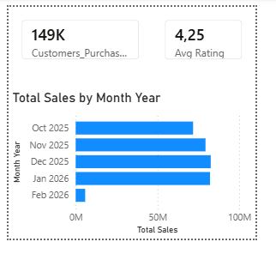

Summary
The Executive Overview page delivers a comprehensive, interactive summary of business performance. It combines KPIs, trend analysis, and category insights, while supporting advanced features such as navigation, dynamic titles, and drillthrough for deeper analysis.

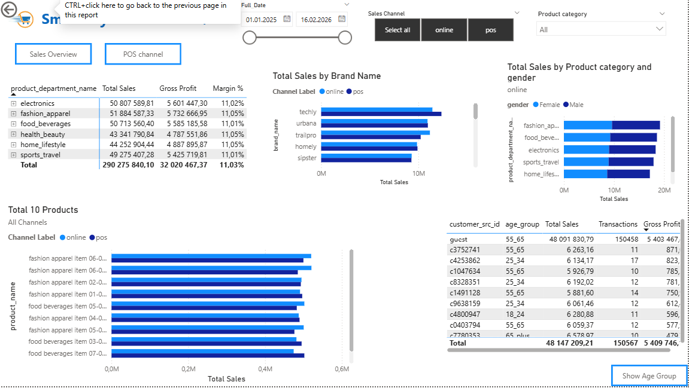

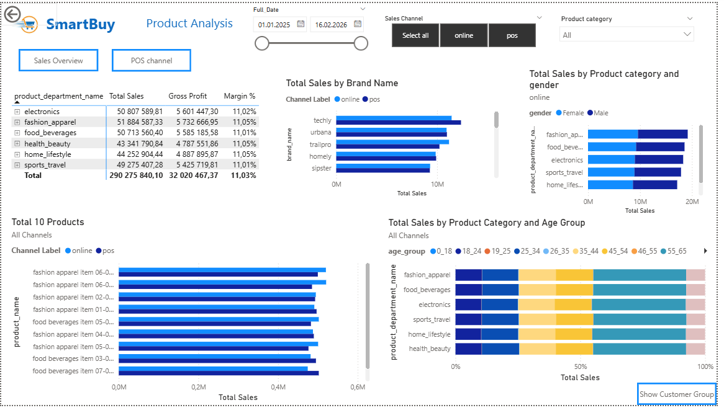

Product Analysis Page
The Product Analysis page provides a detailed view of product performance, focusing on category-level insights, customer behavior, and segmentation analysis.

Header and Filters
The header includes the report title and global slicers:
- Date range (Date slicer)
- Sales channel (online / POS button slicer)
- Product category (dropdown slicer)
These filters dynamically affect all visuals on the page.

Navigation Buttons
Two navigation buttons are implemented using Page Navigation:
- Sales Overview — navigates back to the main overview page
- POS Channel — navigates to the channel analysis page

Product Category Summary (Matrix with Drillthrough)
A Matrix visual displays key metrics by product category:
- Total Sales
- Gross Profit
- Margin %
Drillthrough functionality is implemented on this visual:
- Users can right-click on a selected category
- Navigate to a detailed view filtered by the selected category
- This enables deeper product-level analysis

Top Products (Bar Chart)
A Horizontal Bar Chart shows the Top 10 products by Total Sales.
- Axis: Product Name
- Values: Total Sales
This visual highlights the best-performing products within the selected filters.

Brand Performance (Bar Chart)
A Bar Chart displays Total Sales by Brand Name.
- Axis: Brand Name
- Values: Total Sales
- Legend: Sales Channel
This allows comparison of brand performance across online and POS channels.

Sales by Category and Gender (Clustered Bar Chart)
A Clustered Bar Chart shows Total Sales by product category split by gender.
- Axis: Product Category
- Legend: Gender
- Values: Total Sales
This visual helps identify differences in purchasing behavior between male and female customers.

Sales by Category and Age Group (100% Stacked Bar Chart)
A 100% Stacked Bar Chart presents the distribution of sales by age group across product categories.
- Axis: Product Category
- Legend: Age Group
- Values: Total Sales
This visual highlights which age groups dominate in each category.

Bookmarks and Interactive Views
The page includes interactive buttons implemented using Bookmarks:
- Show Customer Group — switches the page view to display a detailed table of top customers
- Show Age Group — returns to the age group distribution view
These bookmarks dynamically change the visible visuals without navigating to another page.

Customer Details (Table Visual — Bookmark View)
When the Customer Group bookmark is activated, a Table visual is displayed showing:
- Customer ID
- Age Group
- Total Sales
- Transactions
- Gross Profit
This allows analysis of top-performing customers and their contribution to sales.

Dynamic Subtitles
Dynamic subtitles are implemented across visuals using DAX measures.
- They update automatically based on selected filters (e.g., sales channel)
- Provide additional context to the user

Summary
The Product Analysis page delivers an in-depth view of product performance and customer behavior. It combines category-level insights, segmentation analysis (age and gender), and interactive features such as drillthrough and bookmarks, enabling users to explore data at multiple levels of detail.
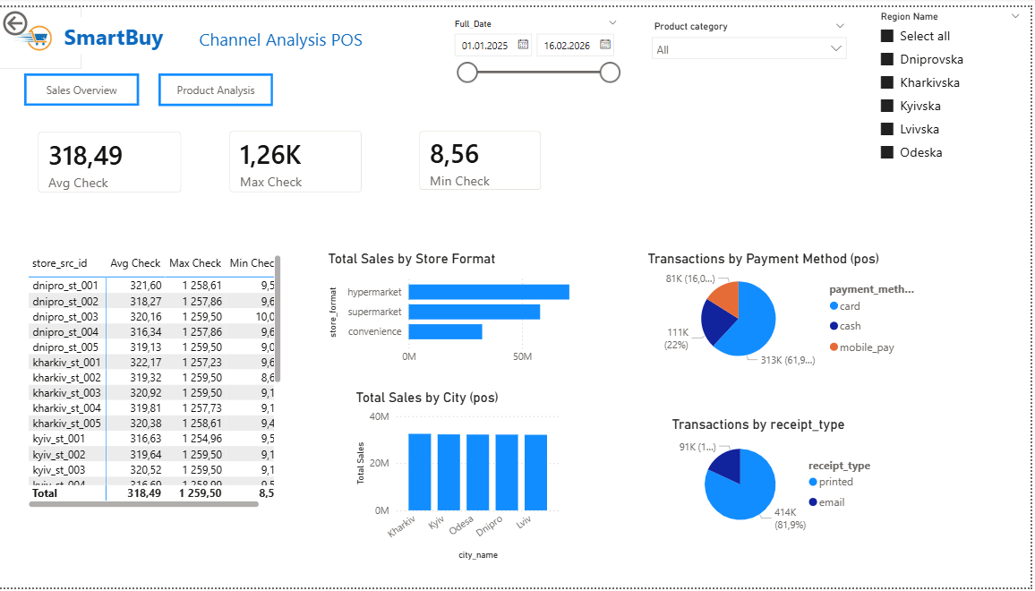

Channel Analysis (POS) Page
The Channel Analysis (POS) page focuses on operational and performance analysis of the offline (Point-of-Sale) channel. It provides insights into store efficiency, customer transactions, and payment behavior.

Header and Filters
The header includes the report title and global filters:
- Date range (Date slicer)
- Product category (Dropdown slicer)
- Region (Checkbox slicer)
These filters allow users to analyze POS performance across different time periods and locations.

Navigation Buttons
Navigation is implemented using Page Navigation buttons:
- Sales Overview — returns to the main dashboard
- Product Analysis — navigates to the product-focused analysis page

KPI Section (Card Visuals)
Key operational metrics are displayed using Card visuals:
- Average Check — average transaction value
- Max Check — highest transaction value
- Min Check — lowest transaction value
These KPIs provide insights into customer spending behavior in stores.

Store Performance (Matrix Visual)
A Matrix visual presents store-level performance:
- Store ID
- Average Check
- Max Check
- Min Check
This allows comparison of store efficiency and customer spending patterns across locations.

Sales by Store Format (Bar Chart)
A Bar Chart displays Total Sales by store format:
- Hypermarket
- Supermarket
- Convenience store
This visual helps evaluate which store types generate the highest revenue.

Sales by City (Column Chart)
A Column Chart shows Total Sales by city.
- Axis: City
- Values: Total Sales
This supports geographic analysis of store performance.

Transactions by Payment Method (Pie Chart)
A Pie Chart visualizes the distribution of transactions by payment method:
- Card
- Cash
- Mobile payment
This helps understand customer payment preferences in offline stores.

Transactions by Receipt Type (Pie Chart)
A Pie Chart displays the share of transactions by receipt type:
- Printed
- Email
This provides insight into customer behavior and digital adoption.

Interactivity
All visuals are interconnected and respond to slicers.
Users can filter data by region, category, and time to explore POS performance in detail.

Summary
The Channel Analysis (POS) page provides a comprehensive operational view of offline sales. It focuses on store performance, transaction behavior, and customer spending patterns, supporting data-driven decisions for retail operations.

