TASK 1 – TABLE WITHOUT INDEX
EXPLAIN SELECT *
FROM labs.test_index_plan
WHERE load_date BETWEEN '2021-09-01 0:00' AND '2021-10-31
11:59:59'
ORDER BY 1;

THE FIRST RUN – PARALLEL PALN=0
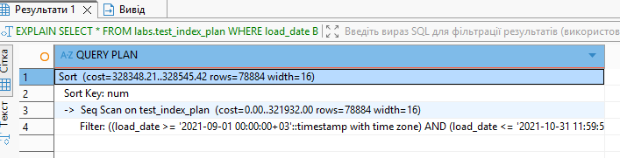
Seq Scan on test_index_plan (cost=0.00..321932.00 rows=78884 width=16)
• PostgreSQL performs a Sequential Scan (full table scan).
• This means it reads all rows in the table and filters them afterward.
Filter: (load_date >= '2021-09-01' AND load_date <= '2021-10-31')
• Rows are filtered by the load_date range.
• Filtering happens after reading the rows, not via an index.
Sort (cost=328348.21..328545.42 rows=78884 width=16)
Sort Key: num
After filtering, PostgreSQL sorts the result.
THE SECOND RUN, PARALLEL PLAN =2
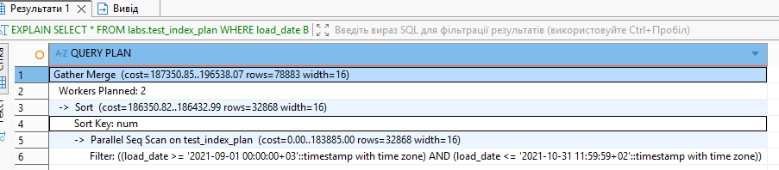
A parallel plan allows PostgreSQL to divide the execution of a single query among multiple workers to run it faster. Instead of one process scanning the entire table, 2–4 processes scan different parts of the table simultaneously, improving CPU utilization and speeding up large queries. That is why cost is less

THE THIRD RUN PARALLEL PLAN =0
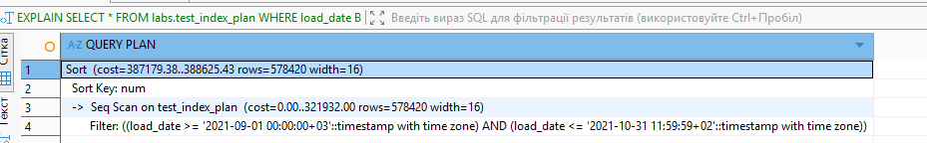
The estimated rows changes, it is typically caused by updated table statistics (AUTOANALYZE), not by caching.

EXPLAIN ANALYZE SELECT *
FROM labs.test_index_plan
WHERE load_date BETWEEN '2021-09-01 0:00' AND '2021-10-31
11:59:59'
ORDER BY 1;

THE FIRST RUN
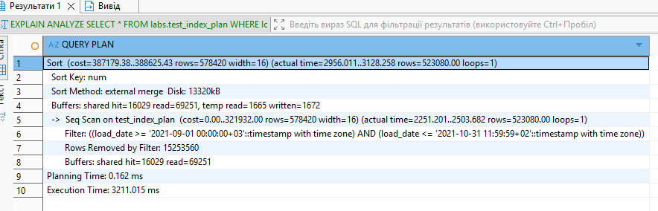

THE SECOND RUN
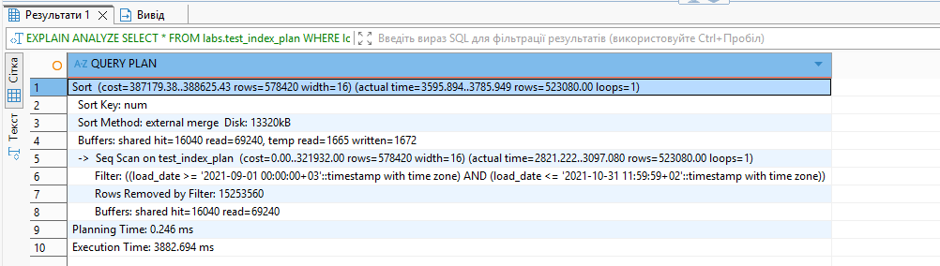
The plan is the same in both executions, because the structure of the plan (Seq Scan → Sort) did not change between runs.
Parallelism is not used, since there are no Gather or Parallel Seq Scan nodes in the plan, which indicates that the query is executed by a single process.
A full table scan is performed, as shown by Seq Scan on test_index_plan, meaning PostgreSQL reads the entire table and then applies the filter condition.
Sorting is performed using an external merge on disk, as indicated by Sort Method: external merge Disk: 13320kB, which shows that work_mem was insufficient and PostgreSQL had to use temporary disk files.
Most of the execution time is spent on sorting rather than filtering, because the Sort node takes a significant portion of the total execution time (actual time up to ~3785 ms), and the plan shows temporary disk reads and writes (temp read / written), confirming that disk-based sorting is the main performance cost.
EXPLAIN (ANALYZE,
BUFFERS) SELECT *
FROM labs.test_index_plan
WHERE load_date BETWEEN '2021-09-01 0:00' AND '2021-10-31
11:59:59'
ORDER BY 1;
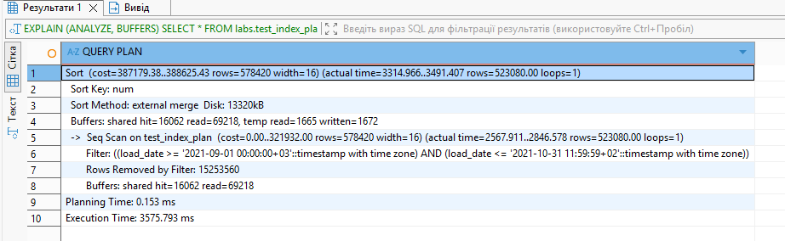
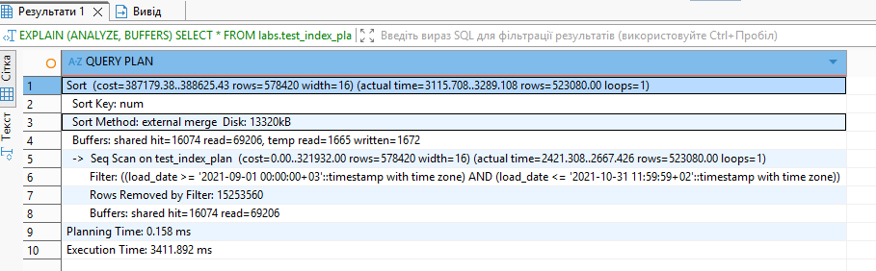
The plan is identical in both runs (Seq Scan + Sort), and no parallelism is used. The second run is slightly faster because some of the table pages were already in shared buffers (more hits, fewer reads). However, sorting is still performed using an external merge on disk (as shown by “Disk” and “temp read/written”), so the sort operation remains the main contributor to the total execution time. The result is the same as using just EXPLAIN ANALYZE for this query

TASK 2 – ADDING INDEX
CREATE INDEX my_ind ON labs.test_index_plan(load_date);

EXPLAIN ANALYZE SELECT *
FROM labs.test_index_plan
WHERE load_date BETWEEN '2021-09-01 0:00' AND '2021-10-31
11:59:59'
ORDER BY 1;
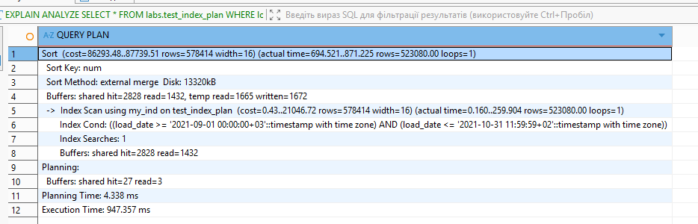
After CREATE INDEX ... (load_date), PostgreSQL switched from a Seq Scan to an Index Scan, which made the query several times faster and significantly reduced the number of disk pages read. However, sorting is still performed using an external merge on disk because ORDER BY num is not supported by this index, and work_mem is too small to keep the sort operation entirely in memory.
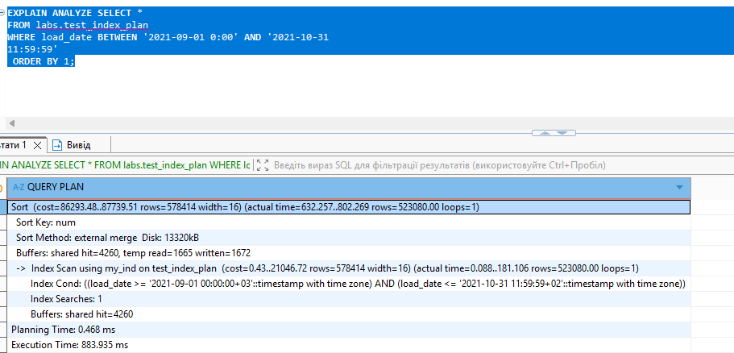
In the second run, the query became faster because all required data pages were already in shared buffers: there were no shared read operations, only shared hit. This improved the performance of the Index Scan. However, the Sort operation is still performed using an external merge with temporary disk files (temp read/written), so sorting remains the main contributor to the total execution time.

INDEX ONLY SCAN method
CREATE INDEX my_ind ON labs.test_index_plan(load_date, num);
EXPLAIN ANALYZE SELECT load_date, num
FROM labs.test_index_plan
WHERE load_date BETWEEN '2021-09-01 0:00' AND '2021-10-31
11:59:59'
ORDER BY load_date;
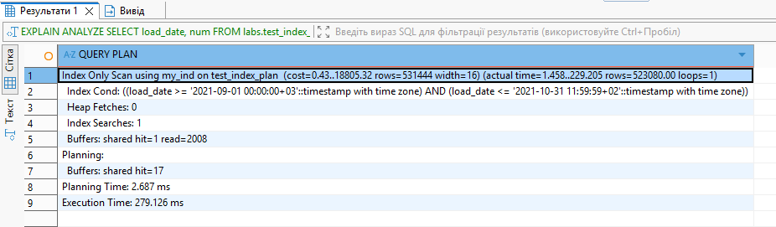
PostgreSQL switched to an Index Only Scan because the query selects only columns that are included in the index and the ordering matches the index order. This allows PostgreSQL to retrieve all required data directly from the index without accessing the table (heap).
The key evidence is Heap Fetches: 0, which means no table rows were accessed — all data was returned from the index pages alone. As a result, there is no Seq Scan, no separate Sort operation, and significantly less I/O.
This is why the execution time dropped dramatically: the query now reads only index pages and avoids both full table scanning and disk-based sorting.
CREATE INDEX my_ind ON labs.test_index_plan USING brin(load_date) ;
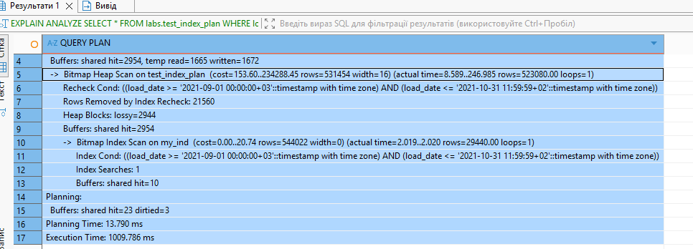
After creating a BRIN index on load_date, PostgreSQL uses a Bitmap Index Scan on the BRIN index to identify candidate heap pages, followed by a Bitmap Heap Scan to fetch those pages and recheck the filter condition (BRIN is block-range based and not exact). The plan still performs an external merge sort on disk due to ORDER BY num and limited work_mem, so sorting remains a major cost.
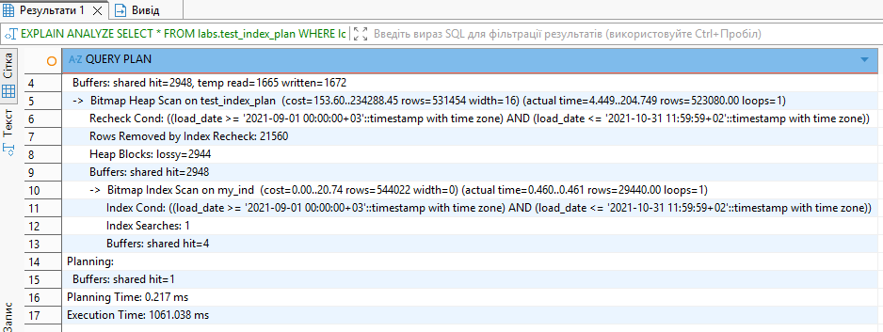
In the second run, the plan is the same (Bitmap Index Scan + Bitmap Heap Scan with lossy pages and recheck). The scan phase becomes faster because the required pages are now in shared buffers (hits only, no reads), so both the bitmap build and heap scan speed up. However, total execution time may still vary because the external disk-based sort (temp read/written) remains the dominant and more variable cost.
2. ADDING DATA WITH INSERT AND COPY
CREATE TABLE labs.test_inserts (
num float NOT NULL,
load_date timestamptz NOT NULL
);

CREATE INDEX ON labs.test_inserts(load_date);
EXPLAIN ANALYZE INSERT INTO labs.test_inserts(num, load_date)
SELECT num, load_date
FROM labs.test_index_plan;

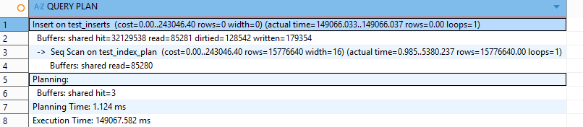
The bulk INSERT took significantly longer because the B-tree index on load_date was created before inserting the data. PostgreSQL had to update the index for each of the 15 million inserted rows, causing heavy I/O and WAL activity. For large data loads, it is more efficient to insert the data first and create the index afterward.
EXPLAIN ANALYZE INSERT INTO emp VALUES (1,'SMITH','CLERK',13,'17-DEC-80');
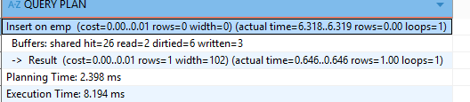
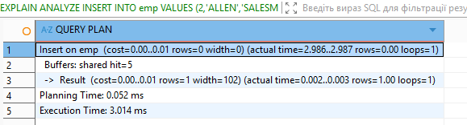
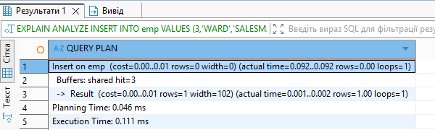
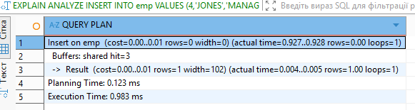
EXPLAIN ANALYZE INSERT INTO emp (empno, ename, job, mgr, hiredate) VALUES
(1,'SMITH','CLERK',13, DATE '17-DEC-80'),
(2,'ALLEN','SALESMAN',6, DATE '20-FEB-81'),
(3,'WARD','SALESMAN',6, DATE '22-FEB-81'),
(4,'JONES','MANAGER',9, DATE '02-APR-81'),
(5,'MARTIN','SALESMAN',6, DATE '28-SEP-81'),
(6,'BLAKE','MANAGER',9, DATE '01-MAY-81'),
(7,'CLARK','MANAGER',9, DATE '09-JUN-81'),
(8,'SCOTT','ANALYST',4, DATE '19-APR-87'),
(9,'KING','PRESIDENT',NULL, DATE '17-NOV-81'),
(10,'TURNER','SALESMAN',6, DATE '08-SEP-81'),
(11,'ADAMS','CLERK',8, DATE '23-MAY-87'),
(12,'JAMES','CLERK',6, DATE '03-DEC-81'),
(13,'FORD','ANALYST',4, DATE '03-DEC-81'),
(14,'MILLER','CLERK',7, DATE '23-JAN-82');

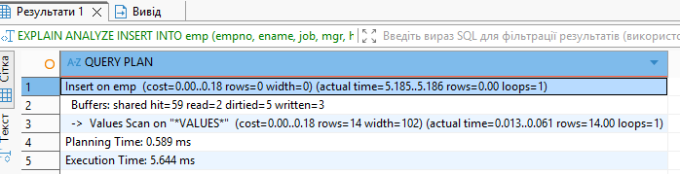
Multiple single-row INSERT statements create more overhead because each statement separately updates the PRIMARY KEY and UNIQUE indexes, writes to WAL, and processes transaction logic. This results in repeated I/O operations for every row.
A bulk INSERT inserts all rows in one statement, reducing transaction overhead, WAL writes, and index updates. Since PRIMARY KEY and UNIQUE automatically create indexes, every INSERT must update them. Performing this once for multiple rows is significantly more efficient than doing it separately for each row.

2.2 TASK 4 COPY COMMAND
COPY (
SELECT num,
'"' || to_char(load_date, 'YYYY-MM-DD HH24:MI:SSOF') || '"' AS load_date
FROM labs.test_index_plan
) TO 'C:/temp/test_index_plan.csv'
WITH (FORMAT csv, DELIMITER ',', HEADER true);

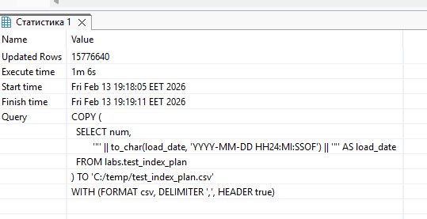
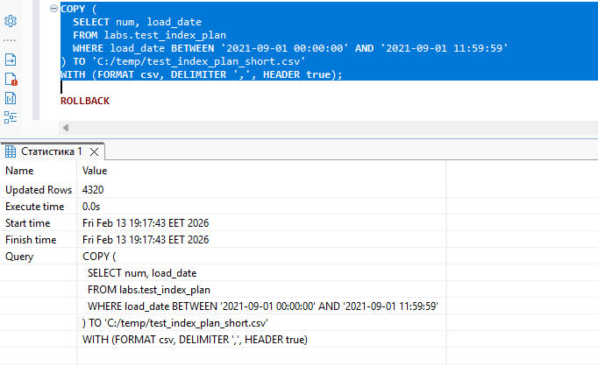
CREATE TABLE labs.test_copy_stage (
num float,
load_date_text text
);
COPY labs.test_copy_stage (num, load_date_text)
FROM 'C:/temp/test_index_plan.csv'
WITH (FORMAT csv, DELIMITER ',', HEADER true);

SELECT * FROM labs.test_copy_stage;

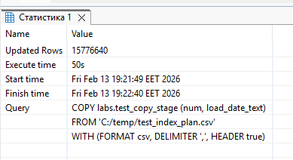
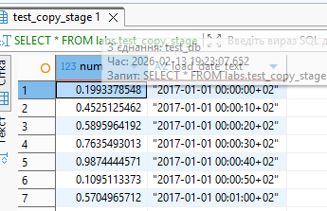
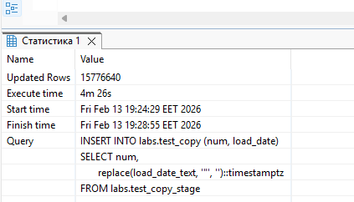
Due to index insert took a lot of time

2.3 TASK 5 UPSERT

