ask1
Connected to the MySQL server RDS
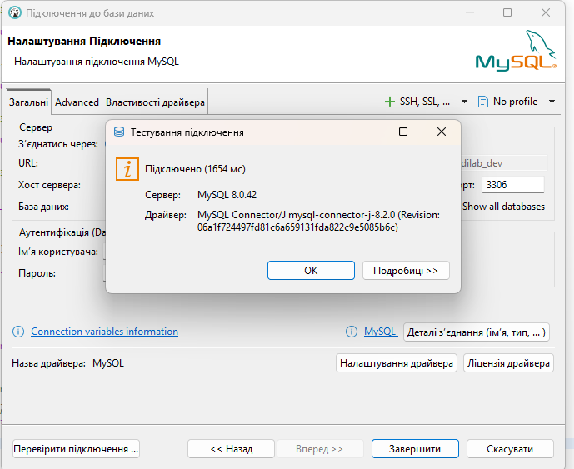
Created new user and DB
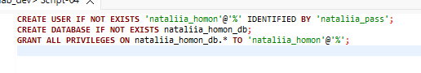
Logged under my user
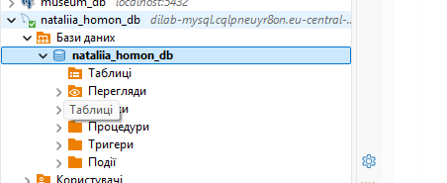

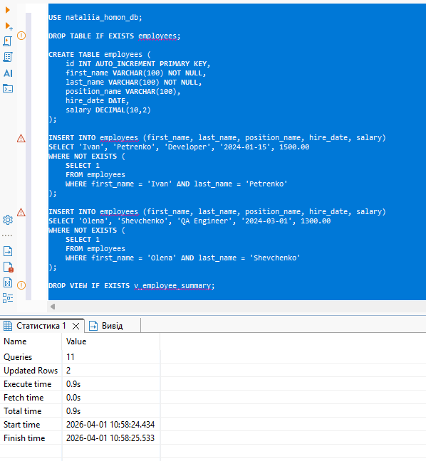
Created needed objects;
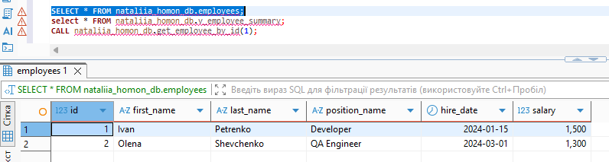
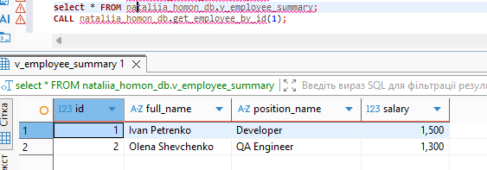
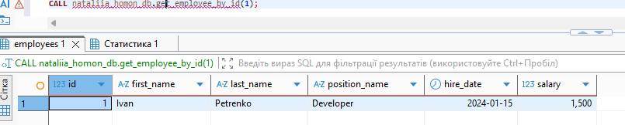
Second run of initial script
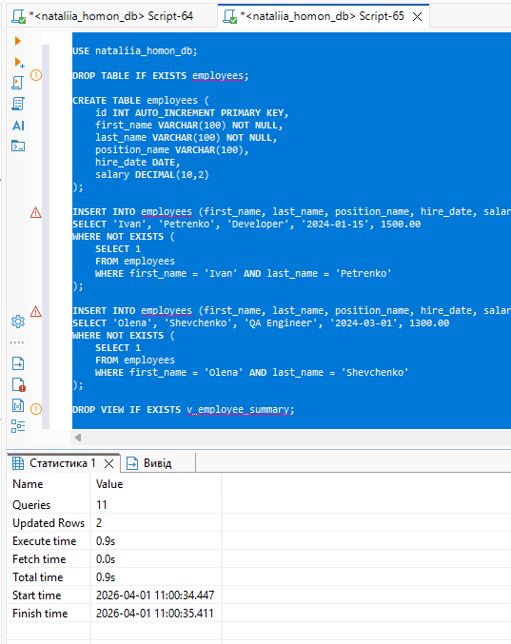
Checked queries again
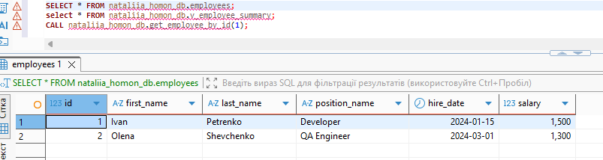
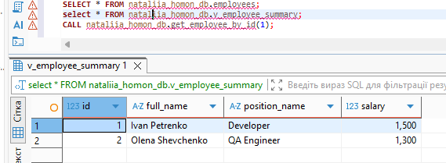
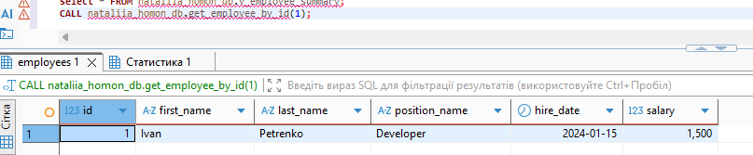

Task 2
Queries via AWS Query editor
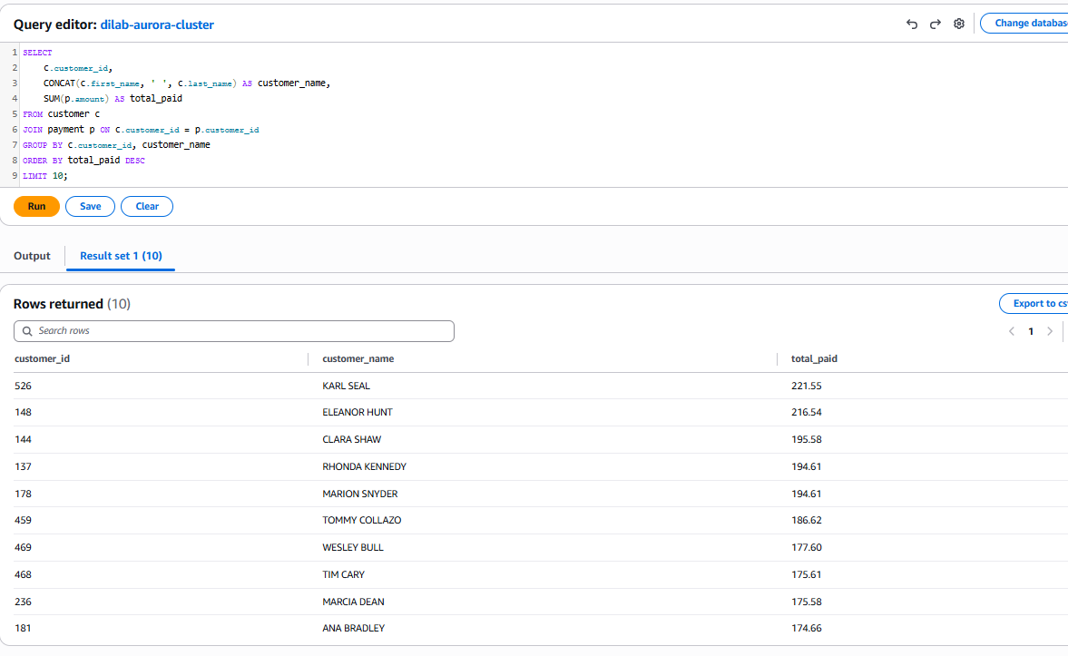
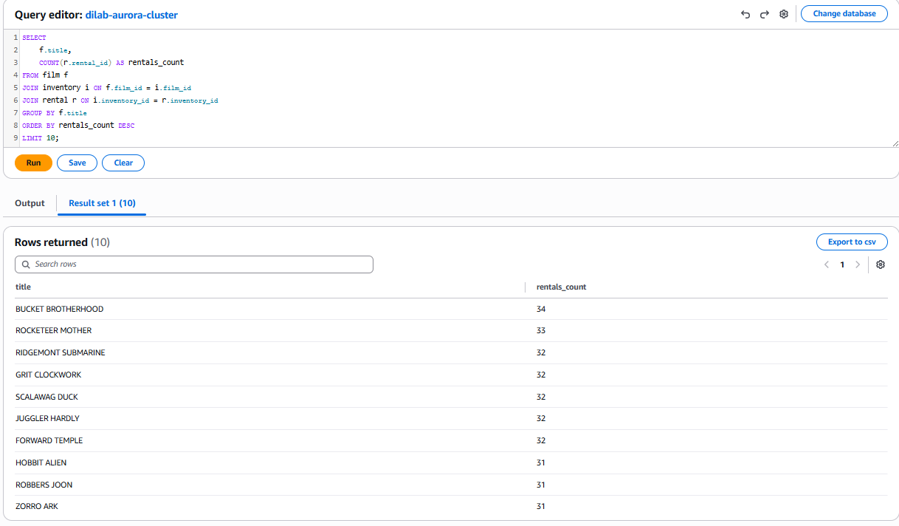
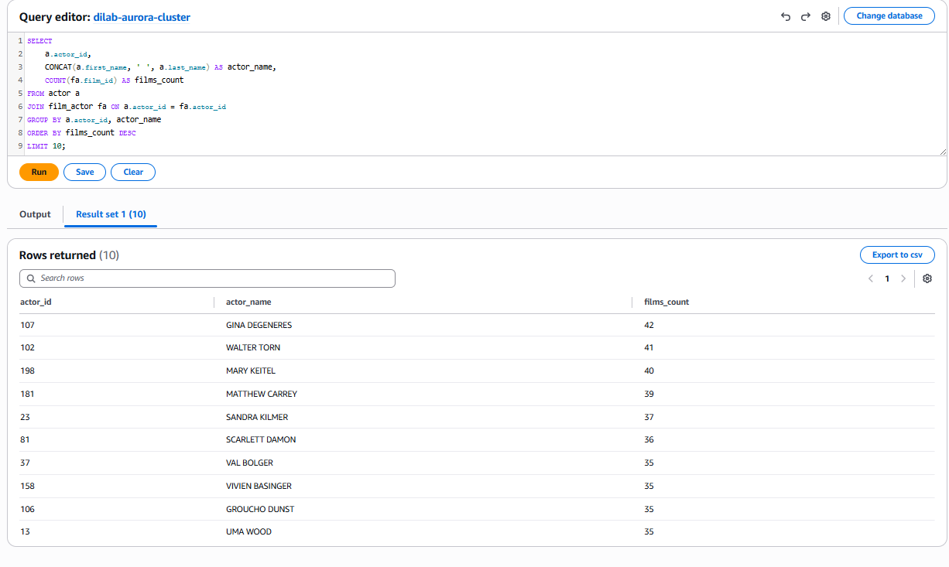
• Aurora access was successfully performed through an EC2 bastion host.
• SQL queries were executed against the precreated sakila schema.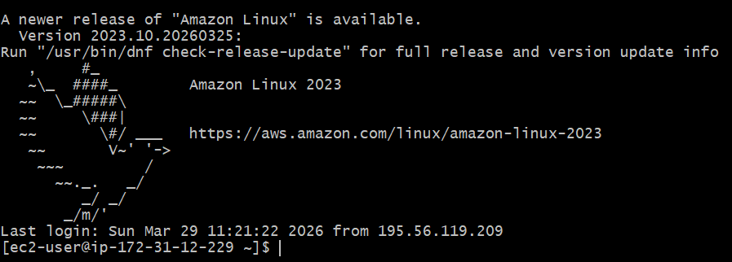

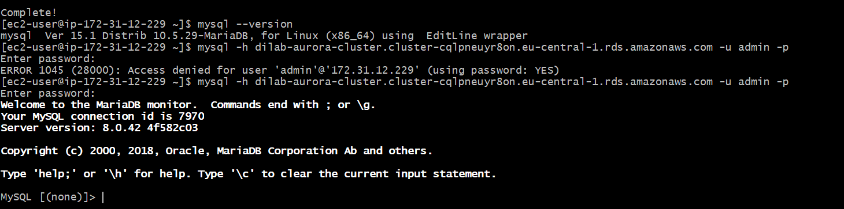
The connection to the Aurora database was successfully established via an EC2 bastion host using SSH. The MySQL client was installed on the EC2 instance, and SQL queries were executed directly from the terminal. This approach was required because the Aurora cluster is deployed in a private subnet and is not accessible directly from the local machine.
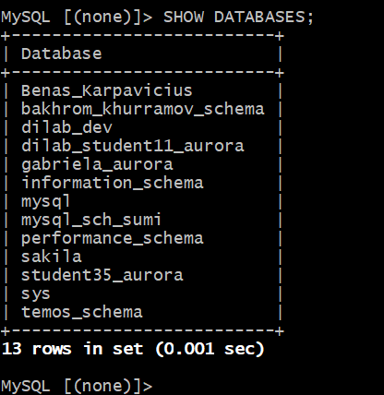
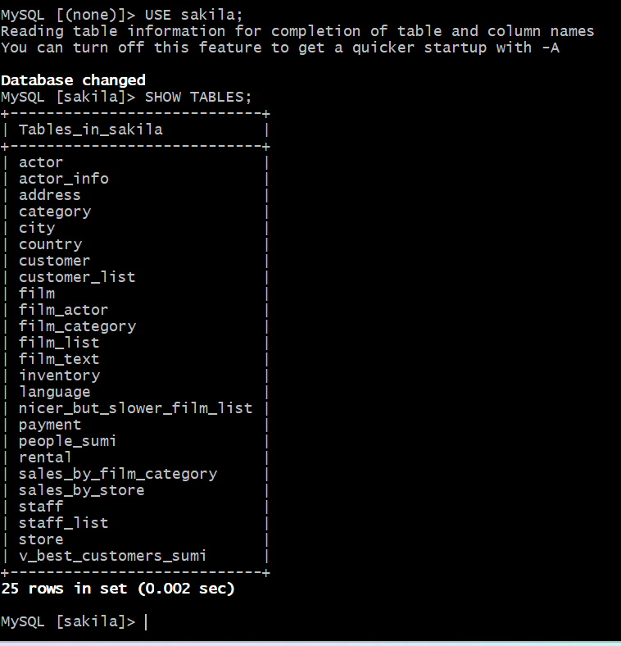
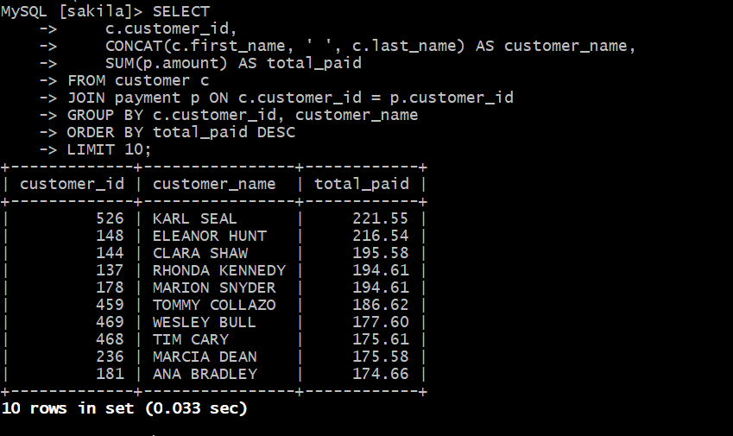
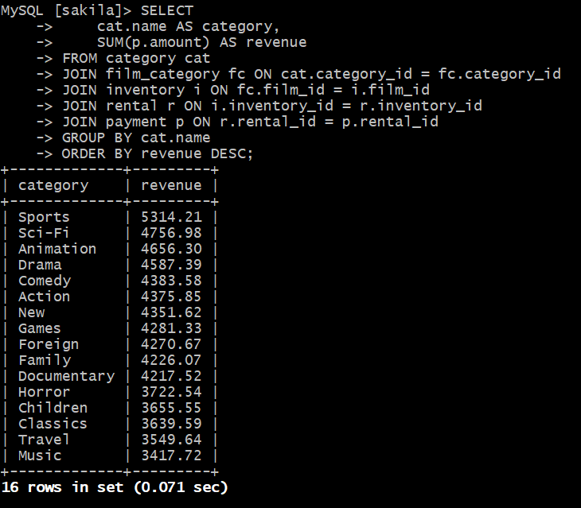
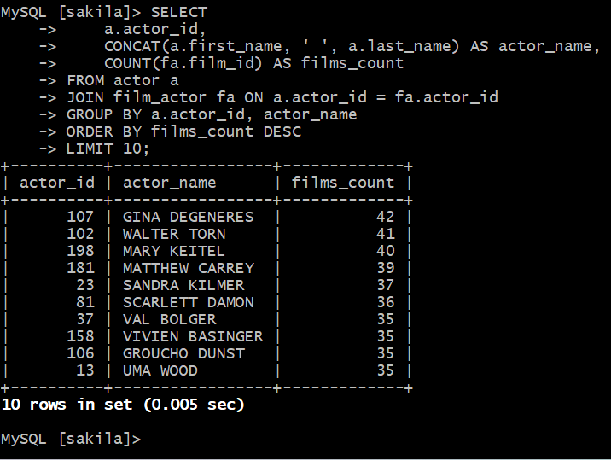
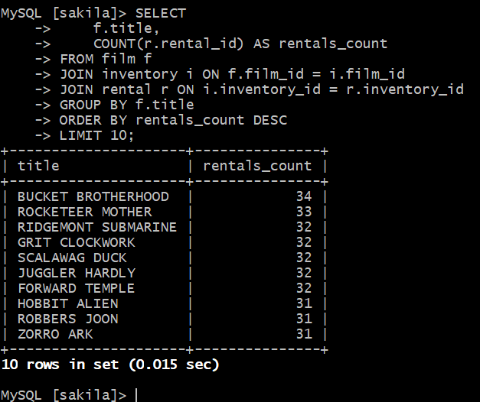

Task 3
Created table in Dynamo DB
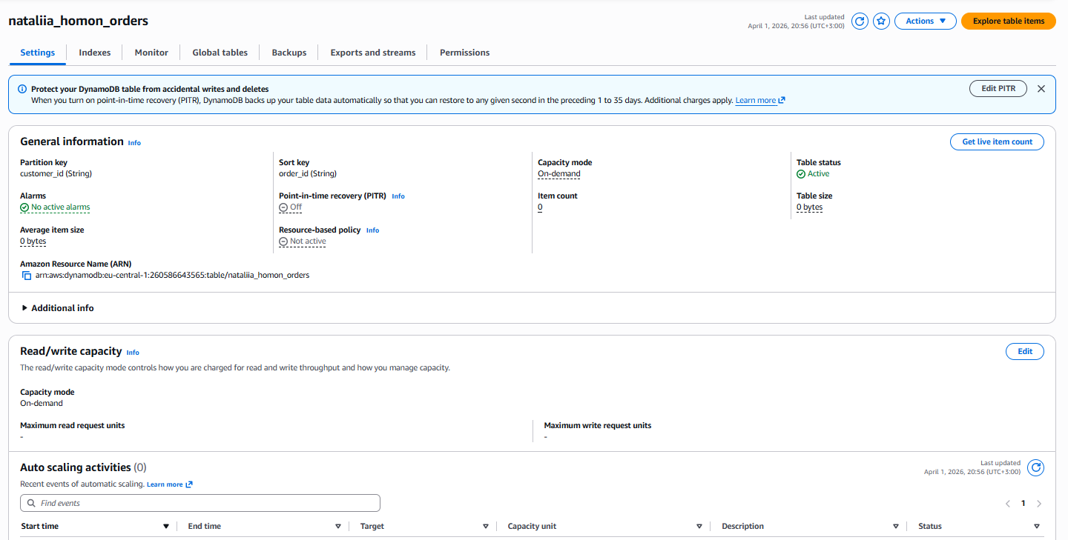
Vreated 20 items
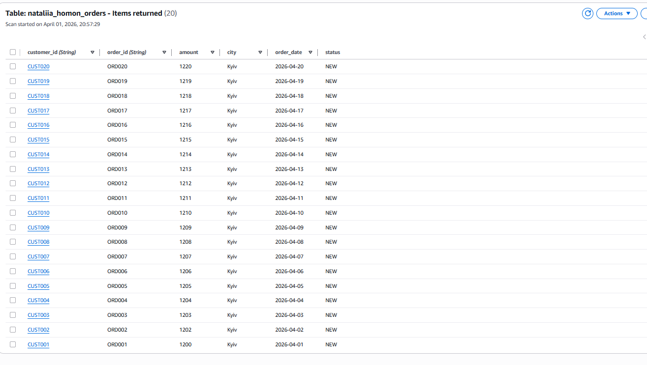
Primary Key Explanation
I used a composite primary key consisting of customer_id as the partition key and order_id as the sort key. This design allows storing multiple orders for a single customer while ensuring that each item in the table remains uniquely identifiable.
The customer_id groups all orders belonging to the same customer, which supports efficient queries when retrieving all orders for a specific user. The order_id ensures uniqueness within each customer’s records and allows precise access to a particular order.
This approach follows AWS DynamoDB best practices, where the partition key distributes data across partitions, and the sort key enables structured querying and organization of related items.
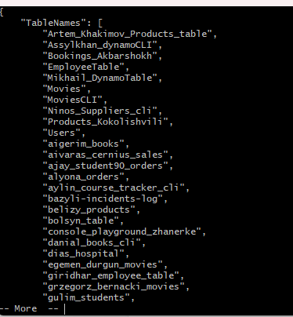
aws dynamodb describe-table \
--table-name nataliia_homon_orders \
--profile students-role \
--region eu-central-1
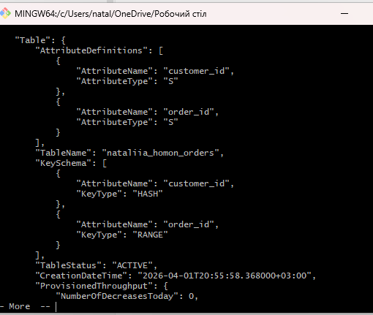
Created nano.json file

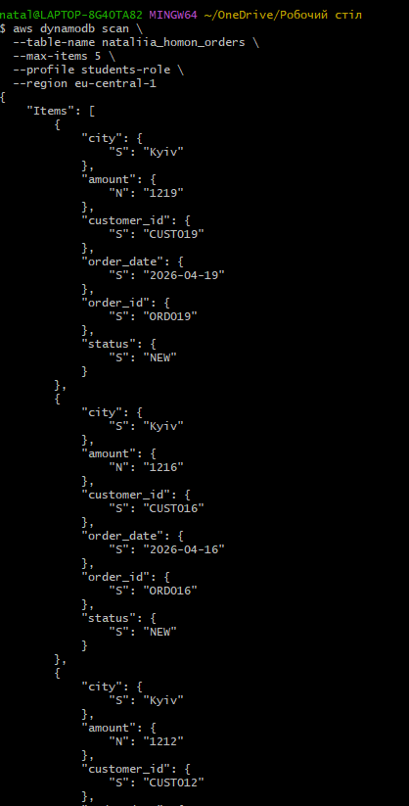
Retrieve 5+ rows using keys
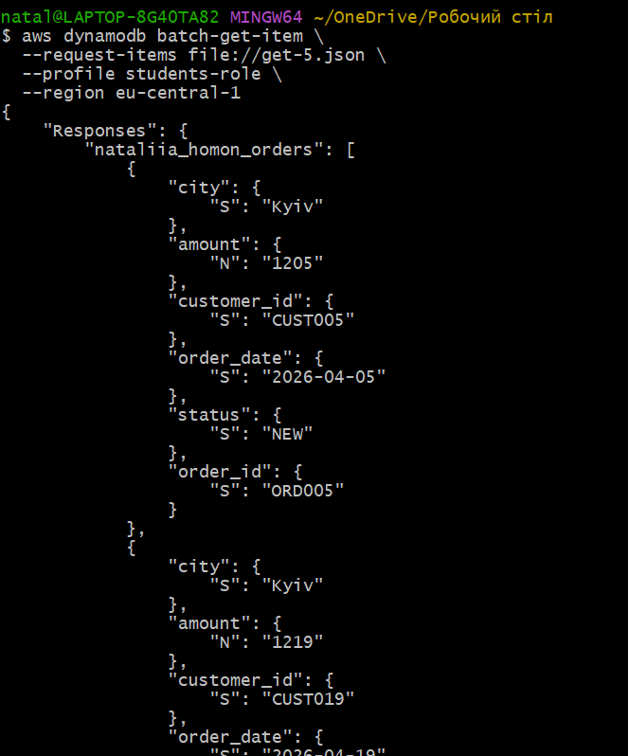
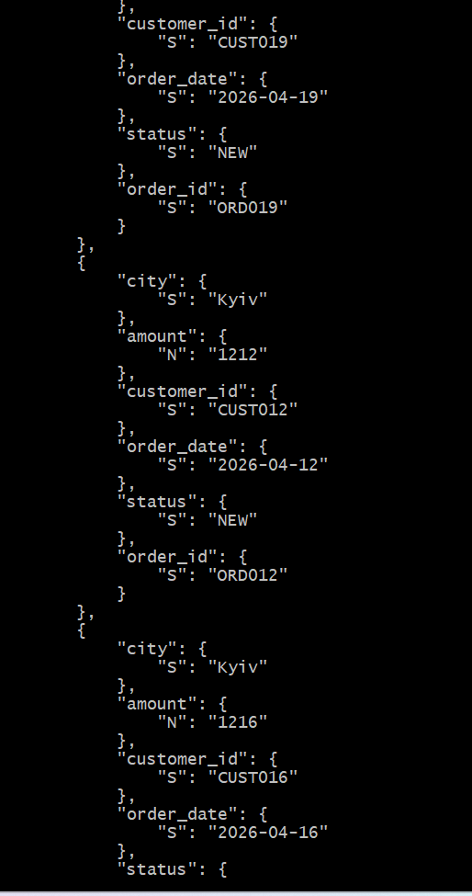
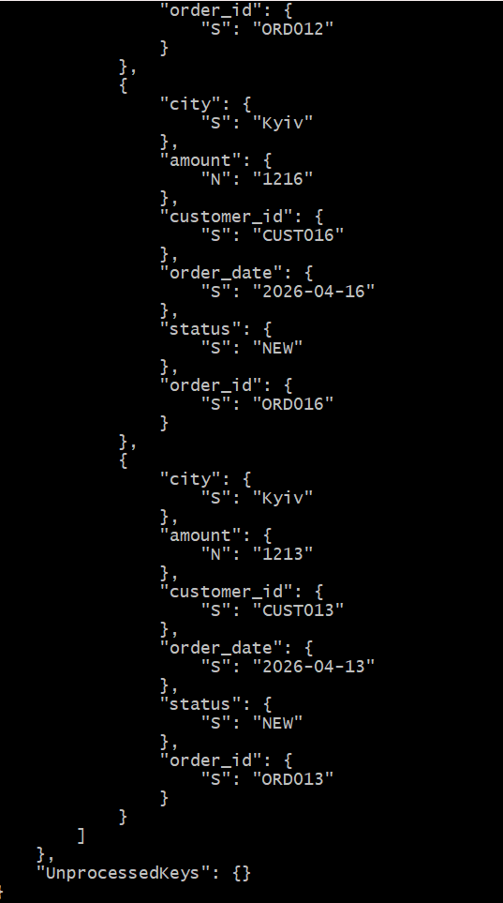

several selects using keys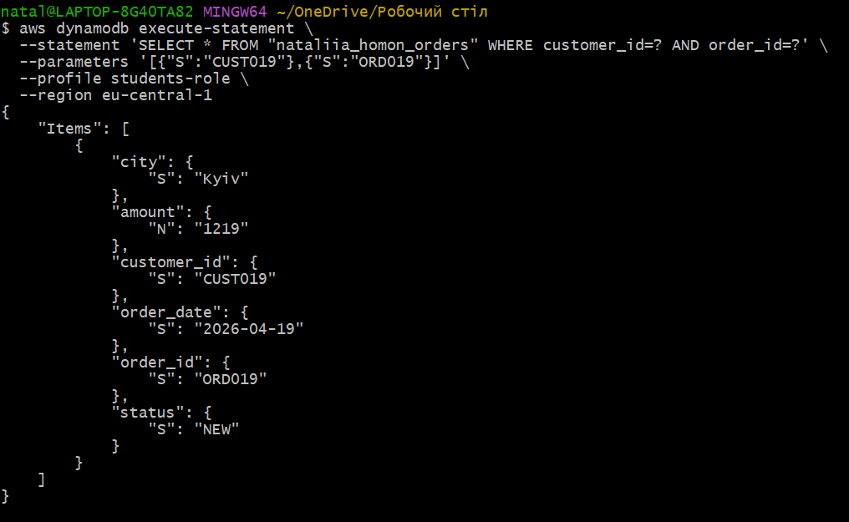
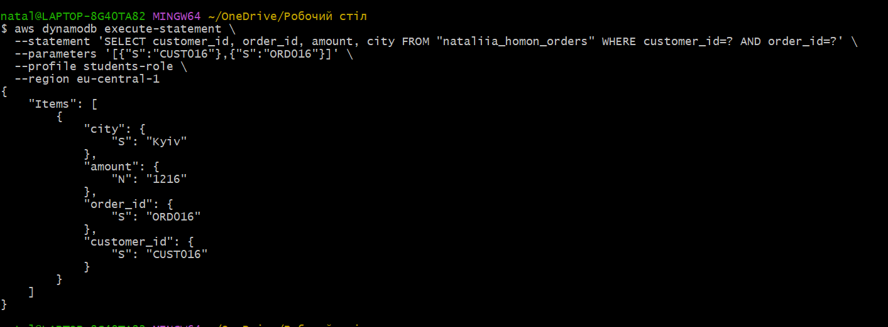
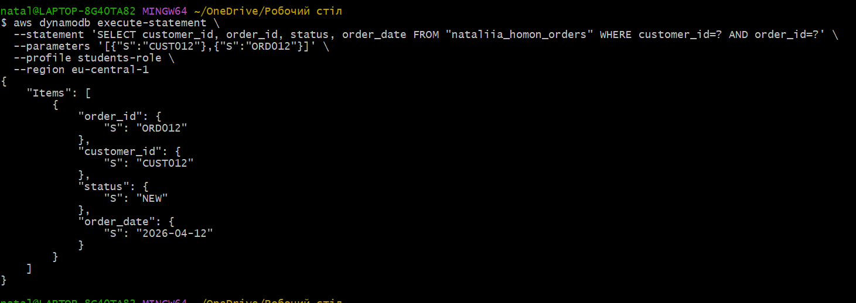
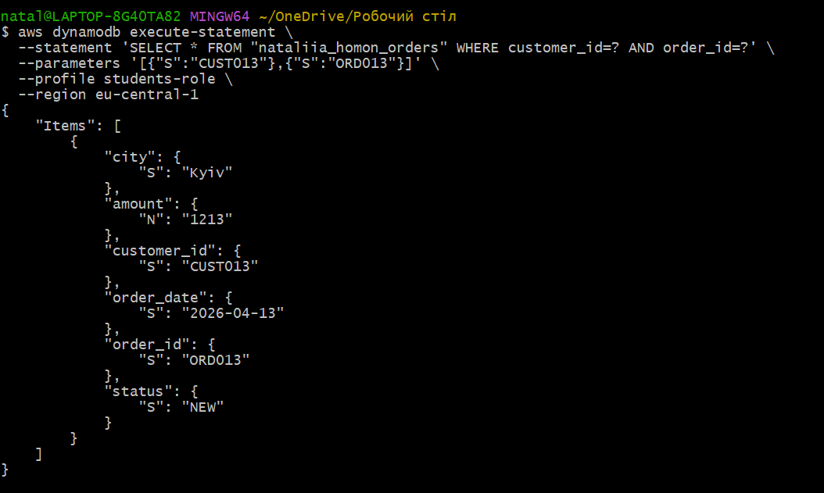
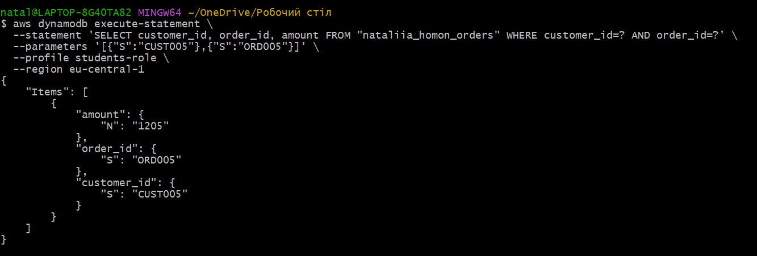

Deleted two rows
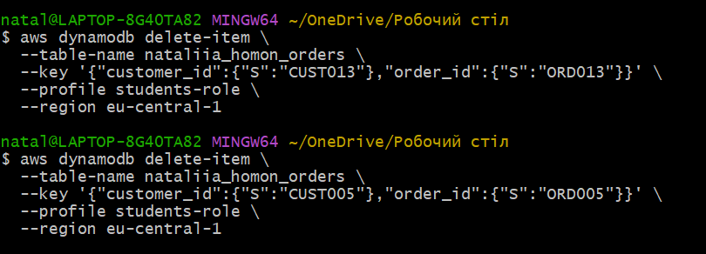
Only 3 left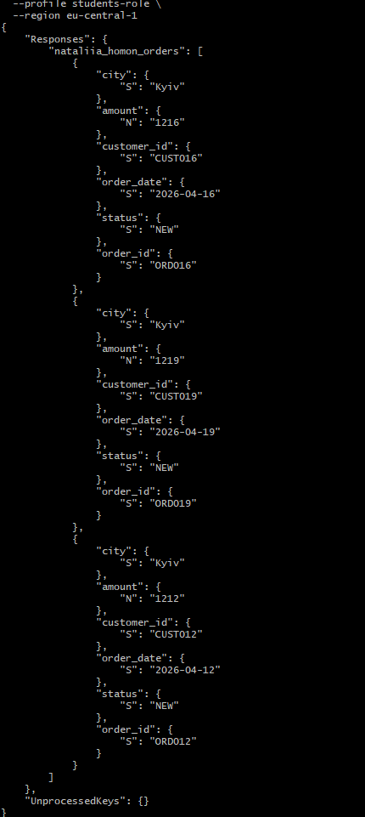

Deleted table
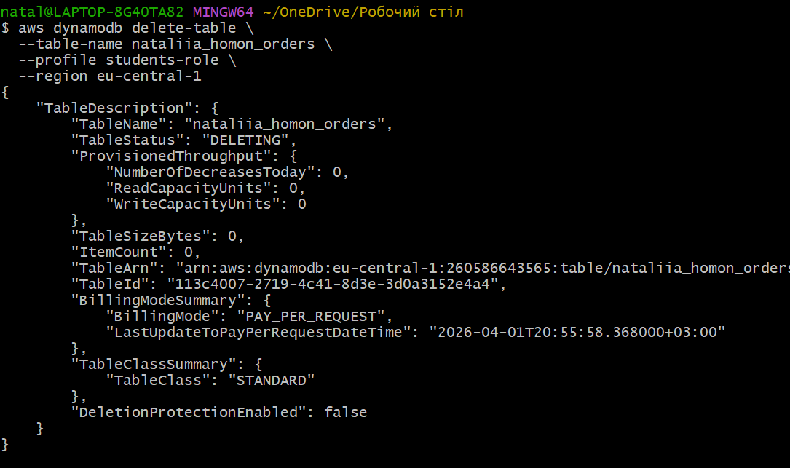
No table in the list
