Nataliia Homon | dilab_student73 | epam_AE2026!_73 | dilab_student73

1.Loged+updated
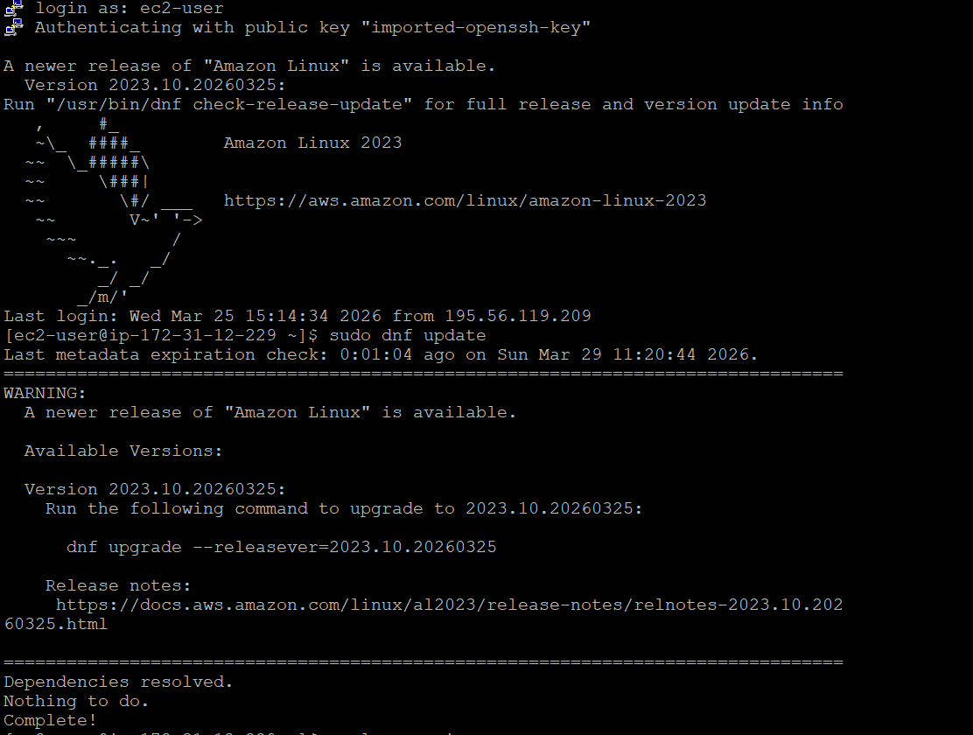
Postgres was installed, status -running before-checked
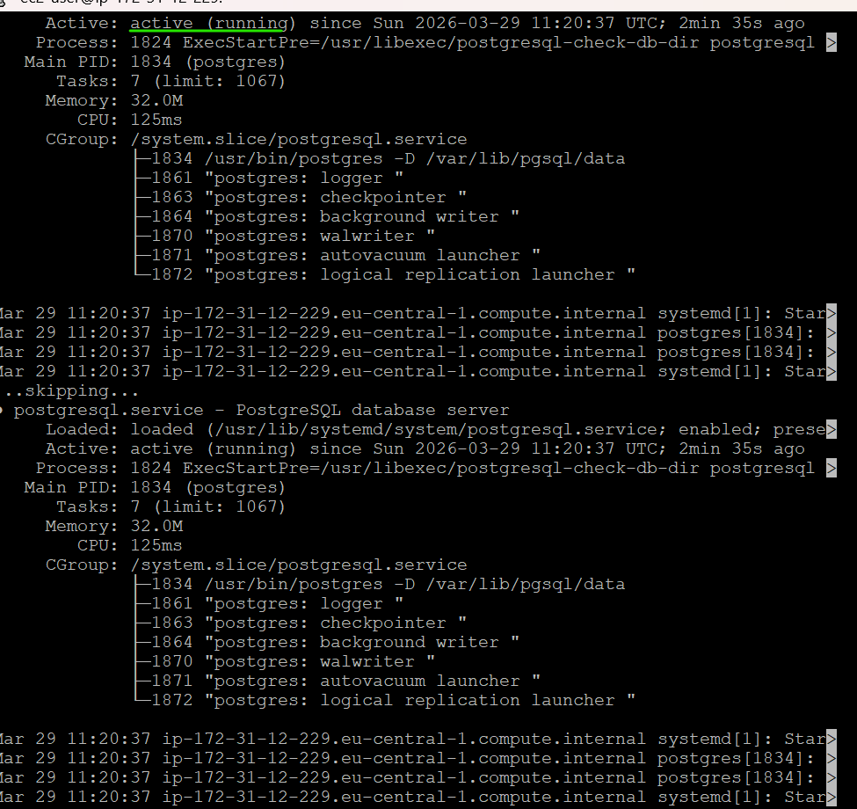
Logged into redshift
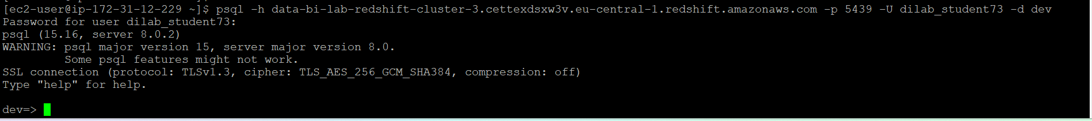
Connected to the redshift through Dbeaver
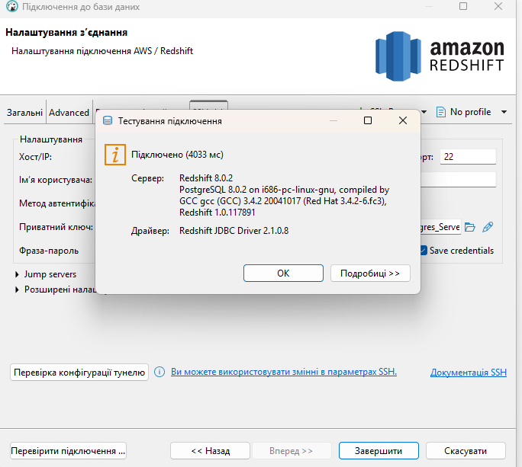
Connection to Amazon Redshift cluster was successfully established via SSH tunnel using EC2 instance.
2.Loaded tables from my s3
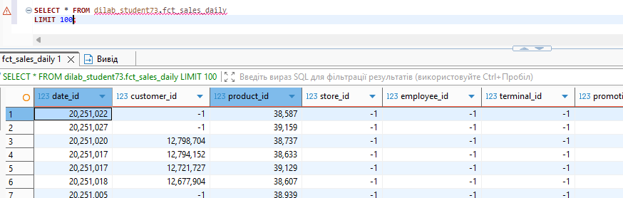
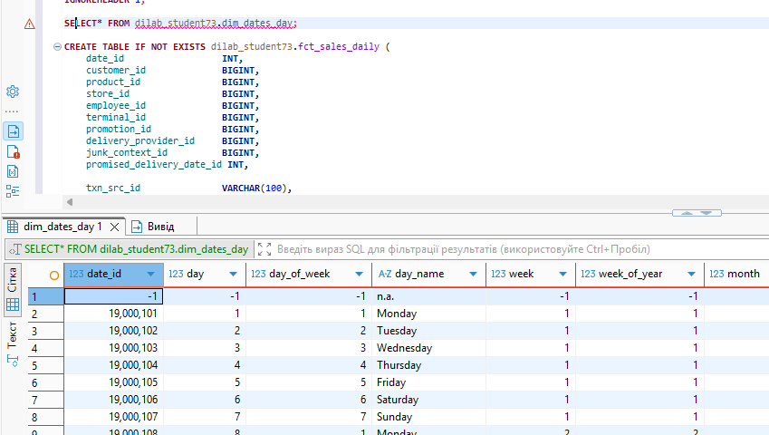
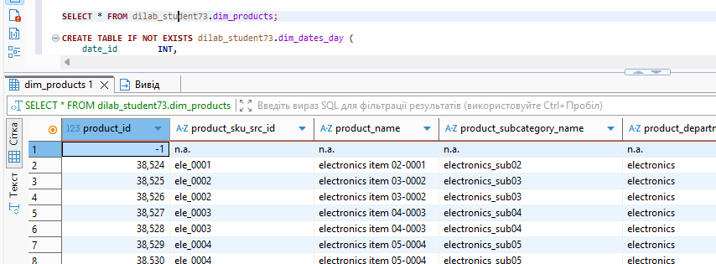
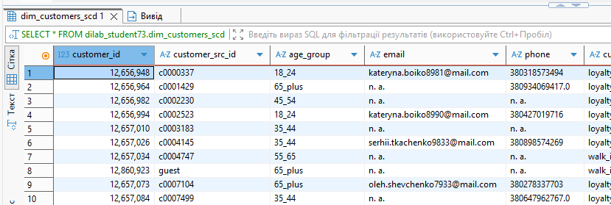
SELECT
"table",
diststyle,
sortkey1,
sortkey_num,
encoded
FROM svv_table_info
WHERE schema = 'dilab_student73';

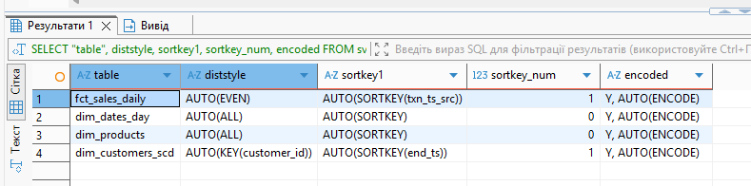
After loading the data into Amazon Redshift, system views were used to analyze table properties such as compression encoding, distribution style, and sort keys.
The results show that Redshift automatically applied optimization settings using AUTO distribution and encoding.

Distribution Style
- The fct_sales_daily table uses AUTO(EVEN) distribution, which ensures balanced data distribution across nodes. However, for analytical workloads, using a key-based distribution (e.g., customer_id) could further improve join performance.
- The dim_dates_day and dim_products tables use AUTO(ALL) distribution. This is optimal for small dimension tables, as it replicates data across all nodes and improves join efficiency.
- The dim_customers_scd table uses AUTO(KEY(customer_id)), which is an efficient choice because it aligns with join operations between fact and dimension tables.

Sort Keys
- The fct_sales_daily table uses SORTKEY(txn_ts_src), which is beneficial for time-based queries and filtering.
- The dim_customers_scd table uses SORTKEY(end_ts), which is appropriate for handling Slowly Changing Dimension (SCD) logic and tracking historical changes.
- Other tables either have no sort keys or use automatic settings.

Compression Encoding
- All tables have compression enabled (AUTO(ENCODE)), which means Redshift automatically selected optimal compression algorithms for each column.
- This improves storage efficiency and query performance by reducing disk I/O.

Conclusion
Overall, Amazon Redshift applied efficient default optimization strategies. The use of automatic distribution and encoding simplifies initial setup, while still providing good performance. Further manual tuning of distribution keys and sort keys could be applied based on specific query patterns and workload requirements.
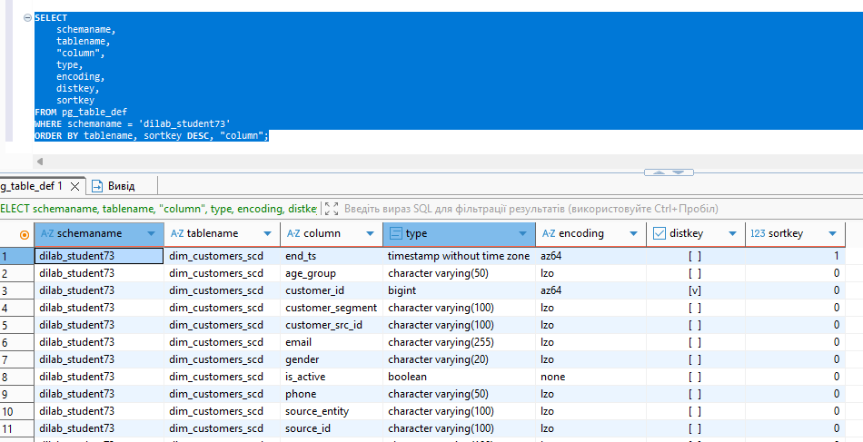
This query provides column-level metadata for tables in Amazon Redshift. It shows the data types, compression encoding, distribution keys, and sort keys for each column. This allows us to analyze how data is stored and optimized for query performance.

3.
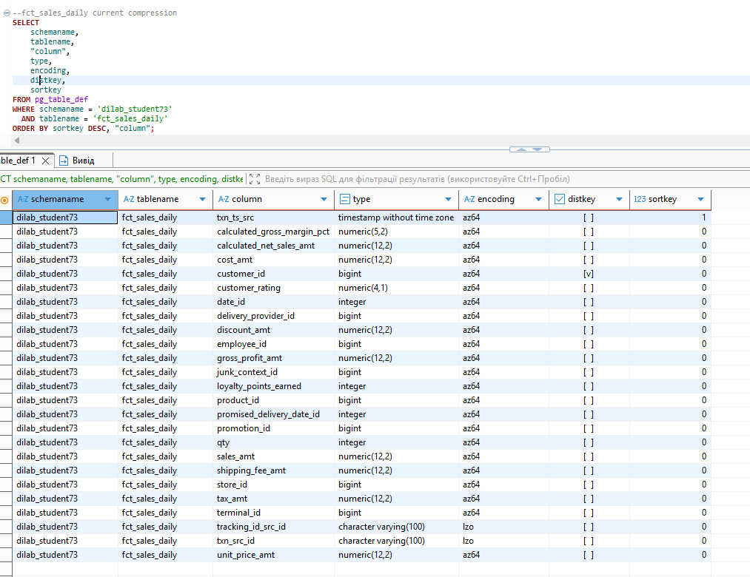
Created a new table without compression
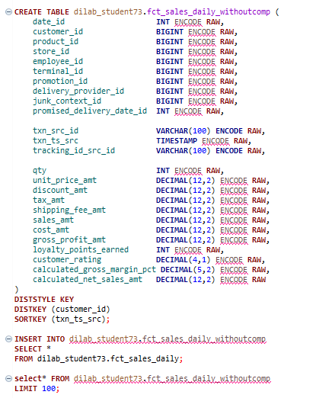
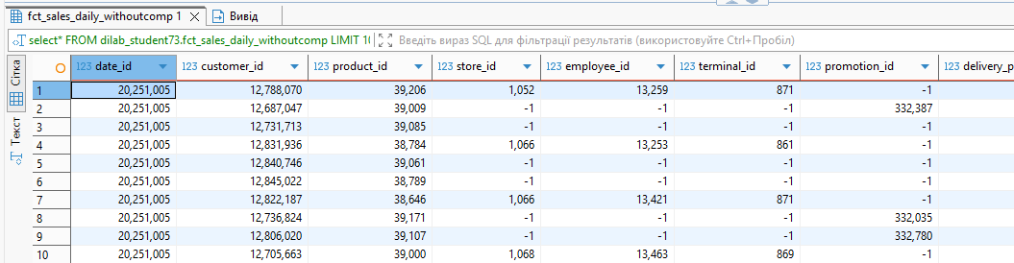
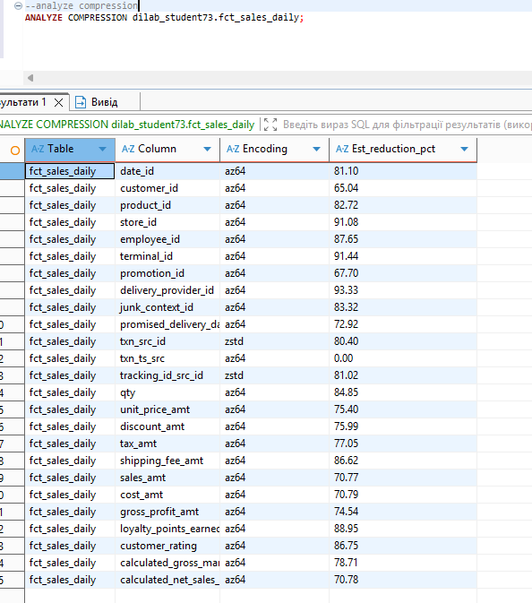
We executed the ANALYZE COMPRESSION command on the fct_sales_daily table to identify optimal compression encodings for each column.
The results show that most numeric and key columns use AZ64 encoding, which provides high compression efficiency (up to ~90% reduction). Text columns such as txn_src_id and tracking_id_src_id use ZSTD encoding, which is effective for string data.
The estimated reduction percentages indicate significant storage savings, especially for large numeric columns and identifiers. This demonstrates that applying proper compression in Amazon Redshift can greatly reduce storage usage and improve query performance.
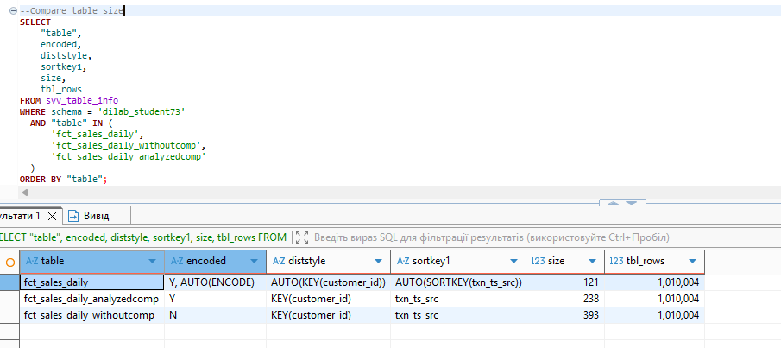
Overall, the analyzed compression is much more efficient compared to RAW encoding and is recommended for large fact tables.

Created a new table with recommended compression options
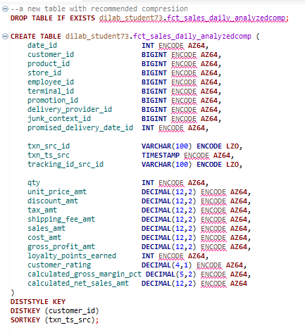

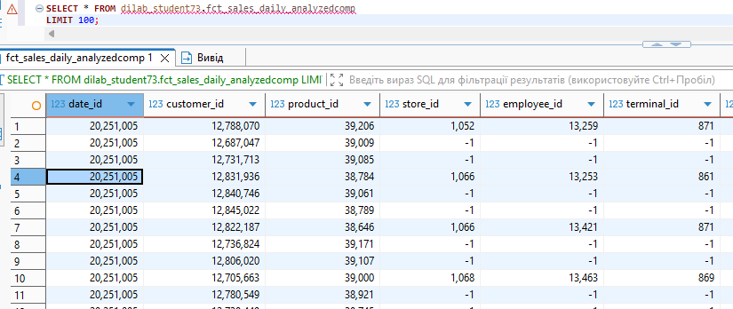

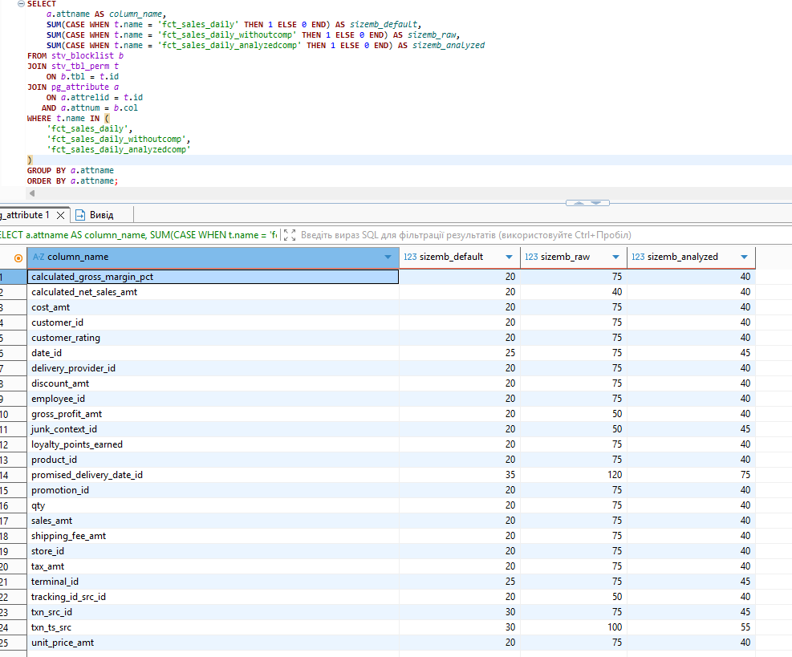

The comparison shows that the table without compression (RAW) has the largest size, while the automatically compressed table (AUTO ENCODE) has the smallest size.
The table with manually applied compression based on ANALYZE COMPRESSION is smaller than the RAW version but larger than the AUTO version. This indicates that Amazon Redshift automatic encoding can be more efficient than manually applied compression.
Overall, compression significantly reduces storage size, and AUTO encoding provides the best optimization in this case.

SELECT
t.name AS table_name,
a.attname AS column_name,
COUNT(*) AS blocks_1mb
FROM stv_blocklist b
JOIN stv_tbl_perm t
ON b.tbl = t.id
JOIN pg_attribute a
ON a.attrelid = t.id
AND a.attnum = b.col
WHERE t.name IN (
'fct_sales_daily',
'fct_sales_daily_withoutcomp',
'fct_sales_daily_analyzedcomp'
)
GROUP BY t.name, a.attname
ORDER BY a.attname, t.name;

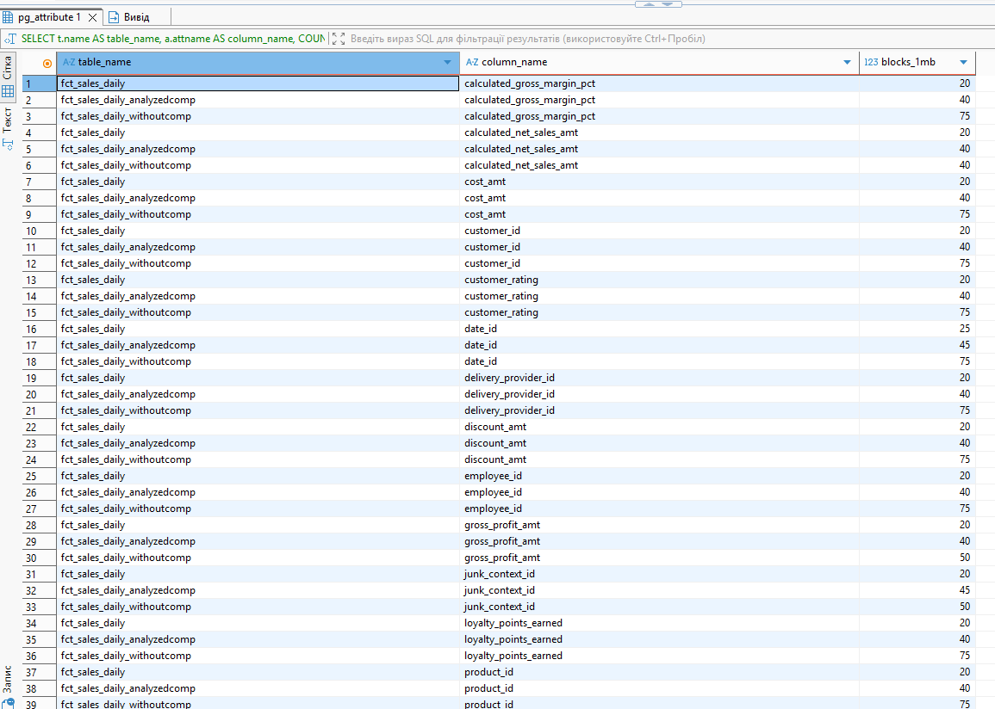
Column-level analysis using system tables showed a clear difference in storage usage between the three table versions.
The table without compression (RAW) consistently uses the highest number of 1MB blocks for each column, indicating the least efficient storage.
The table with analyzed compression significantly reduces the number of blocks compared to RAW, demonstrating the effectiveness of applying optimized encoding methods.
The default AUTO-compressed table uses the smallest number of blocks across most columns, confirming that Amazon Redshift automatic compression provides the most efficient storage in this case.
Overall, compression greatly reduces storage usage at the column level, and both AUTO and analyzed compression outperform RAW encoding, with AUTO achieving the best results.

4.

Query | Prev exec time, sec | Next exec time, sec | Optimized execution plan
EXPLAIN WITH sales_base AS (  SELECT  d.year,  d.month,  d.month_name,  c.customer_segment,  c.age_group,  p.product_department_name,  p.brand_name,  f.txn_ts_src,  f.txn_src_id,  f.qty,  f.sales_amt,  f.discount_amt,  f.gross_profit_amt,  f.customer_rating,  f.calculated_net_sales_amt  FROM dilab_student73.fct_sales_daily f  JOIN dilab_student73.dim_dates_day d  ON f.date_id = d.date_id  JOIN dilab_student73.dim_customers_scd c  ON f.customer_id = c.customer_id  JOIN dilab_student73.dim_products p  ON f.product_id = p.product_id  WHERE d.year IN (2025, 2026)  AND (  (d.year = 2025 AND d.month IN (11, 12))  OR (d.year = 2026 AND d.month = 1)  )  AND c.customer_segment IN ('loyalty', 'walk_in')  ),  agg AS (  SELECT  year,  month,  month_name,  customer_segment,  age_group,  product_department_name,  brand_name,  COUNT(DISTINCT txn_src_id) AS orders_cnt,  SUM(qty) AS total_qty,  SUM(calculated_net_sales_amt) AS total_net_sales_amt,  SUM(gross_profit_amt) AS total_gross_profit_amt,  SUM(discount_amt) AS total_discount_amt,  AVG(customer_rating) AS avg_customer_rating  FROM sales_base  GROUP BY  year,  month,  month_name,  customer_segment,  age_group,  product_department_name,  brand_name  )  SELECT  year,  month,  month_name,  customer_segment,  age_group,  product_department_name,  brand_name,  orders_cnt,  total_qty,  total_net_sales_amt,  total_gross_profit_amt,  total_discount_amt,  avg_customer_rating,  RANK() OVER (  PARTITION BY year, month, customer_segment  ORDER BY total_net_sales_amt DESC  ) AS sales_rank_in_segment_month  FROM agg  ORDER BY  year,  month,  customer_segment,  sales_rank_in_segment_month,  total_net_sales_amt DESC; | 20)the 1sr run) | 0.6 | 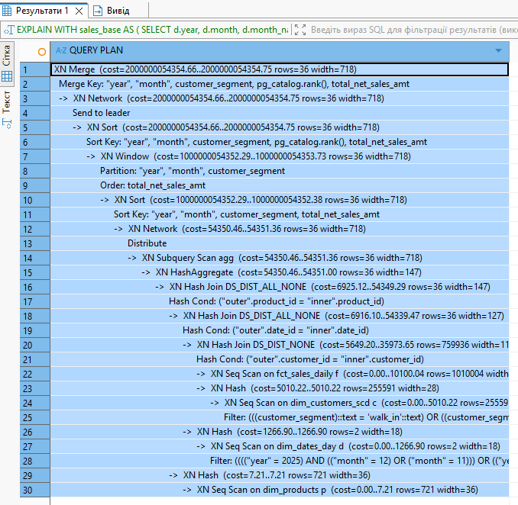
 | 06. | 0.5
 | 0.5 | 0.6
The execution plan shows that Amazon Redshift performs sequential scans on all participating tables: fct_sales_daily, dim_customers_scd, dim_dates_day, and dim_products.
The query uses a series of hash joins. First, the fact table is joined with dim_customers_scd on customer_id. This join uses DS_DIST_NONE, which indicates that no data redistribution is required between nodes. This is efficient and shows that both tables are well aligned by distribution key.
The joins with dim_dates_day and dim_products use DS_DIST_ALL_NONE, which means these smaller dimension tables are available on all nodes and do not require redistribution during joins.
The query also applies a filter on the date dimension, which reduces dim_dates_day to only a small number of rows. This improves selectivity and reduces the number of rows passed to later stages of the plan.
However, the fact table fct_sales_daily is still read using a full sequential scan of more than 1 million rows. This is the most expensive part of the plan and indicates that the current sort key is not fully aligned with the reporting query.

The query execution time was measured after disabling result caching.
The first execution took 20 seconds, while the second and third executions took 0.6 seconds and 0.5 seconds respectively.
The first execution was significantly slower due to additional overhead, including loading data blocks from disk into memory and initializing the execution environment.
Subsequent executions were much faster because the data was already cached and the query execution plan was prepared. Therefore, the second and third runs provide a more accurate representation of the actual query performance.
Created procedure which downloaded report(select result into the table)
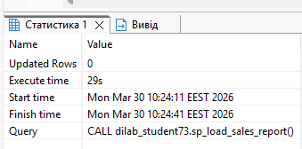
5. created optimazed tables
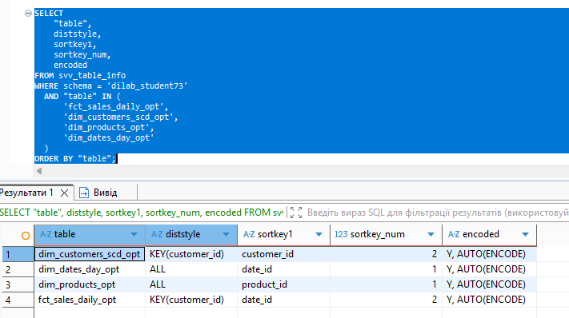
Query | Prev exec time, sec | Next exec time, sec | Optimized execution plan
WITH sales_base AS (  SELECT  d.year,  d.month,  d.month_name,  c.customer_segment,  c.age_group,  p.product_department_name,  p.brand_name,  f.txn_ts_src,  f.txn_src_id,  f.qty,  f.sales_amt,  f.discount_amt,  f.gross_profit_amt,  f.customer_rating,  f.calculated_net_sales_amt  FROM dilab_student73.fct_sales_daily_opt f  JOIN dilab_student73.dim_dates_day_opt d  ON f.date_id = d.date_id  JOIN dilab_student73.dim_customers_scd_opt c  ON f.customer_id = c.customer_id  JOIN dilab_student73.dim_products_opt p  ON f.product_id = p.product_id  WHERE d.year IN (2025, 2026)  AND (  (d.year = 2025 AND d.month IN (11, 12))  OR (d.year = 2026 AND d.month = 1)  )  AND c.customer_segment IN ('loyalty', 'walk_in')  ),  agg AS (  SELECT  year,  month,  month_name,  customer_segment,  age_group,  product_department_name,  brand_name,  COUNT(DISTINCT txn_src_id) AS orders_cnt,  SUM(qty) AS total_qty,  SUM(calculated_net_sales_amt) AS total_net_sales_amt,  SUM(gross_profit_amt) AS total_gross_profit_amt,  SUM(discount_amt) AS total_discount_amt,  AVG(customer_rating) AS avg_customer_rating  FROM sales_base  GROUP BY  year,  month,  month_name,  customer_segment,  age_group,  product_department_name,  brand_name  )  SELECT  year,  month,  month_name,  customer_segment,  age_group,  product_department_name,  brand_name,  orders_cnt,  total_qty,  total_net_sales_amt,  total_gross_profit_amt,  total_discount_amt,  avg_customer_rating,  RANK() OVER (  PARTITION BY year, month, customer_segment  ORDER BY total_net_sales_amt DESC  ) AS sales_rank_in_segment_month  FROM agg  ORDER BY  year,  month,  customer_segment,  sales_rank_in_segment_month,  total_net_sales_amt DESC; | 9.8(the 1st run) | 0.6 | 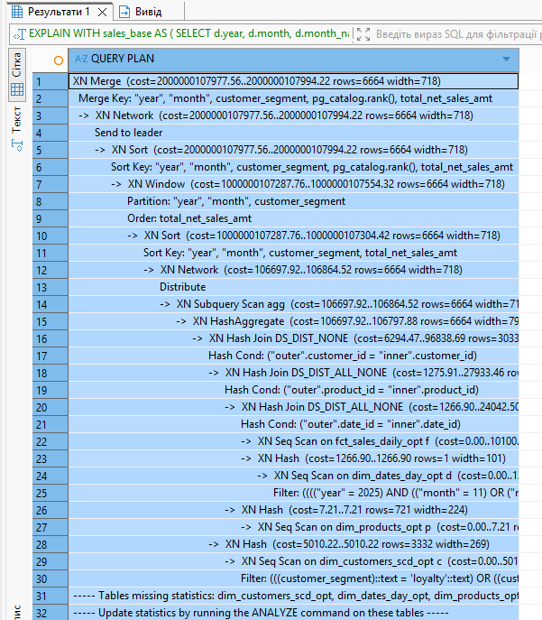
 | 06. | 0.5
 | 0.5 | 0.6
After running ANALYZE on the optimized tables, the execution plan shows a more accurate estimation of row counts and costs.
The query still uses a series of hash joins and a final hash aggregation step. The join between the fact table fct_sales_daily_opt and the customer dimension dim_customers_scd_opt uses DS_DIST_NONE, which indicates that both tables are co-located on the same distribution key (customer_id). This avoids data redistribution and improves join efficiency.

The joins with dim_dates_day_opt and dim_products_opt use DS_DIST_ALL_NONE, meaning these smaller dimension tables are replicated across all nodes. This allows efficient joins without additional data movement.
The query applies filtering on the date dimension, which reduces dim_dates_day_opt to a very small number of rows. This improves selectivity and reduces the number of rows processed in later stages.
However, the fact table is still accessed using a sequential scan, which means all rows are read. Although the sort key was optimized, the execution plan still performs a full scan, indicating that the benefit of the sort key is limited in this case due to join-based filtering rather than direct filtering on the fact table.
After optimization, the query execution time was measured again. The first execution took 9.8 seconds, while the second and third executions took 0.6 seconds and 0.5 seconds respectively.
Compared to the initial version, the first execution improved significantly from 20 seconds to 9.8 seconds. The second and third executions remained almost unchanged.
This indicates that the optimization reduced the initial execution overhead, but had limited impact on repeated executions, which were already efficient.

BEFORE vs AFTER
Before optimization, the query execution time was 20 seconds for the first run, 0.6 seconds for the second run, and 0.5 seconds for the third run.
After optimization, the first run improved to 9.8 seconds, while the second and third runs remained at 0.6 and 0.5 seconds.
The execution plan before and after optimization shows that the main join between the fact table and the customer dimension already used DS_DIST_NONE, meaning no data redistribution was required. The smaller dimension tables used DS_DIST_ALL_NONE, which was also efficient.
After optimization, the same efficient join strategies were preserved. The main improvement comes from better alignment of sort keys and updated statistics, which reduced the overhead of the initial execution.
However, the fact table is still accessed using a sequential scan in both cases, which limits the overall performance improvement. Therefore, the optimization had a moderate impact, mainly improving the first execution time.

6.Created and run procedure
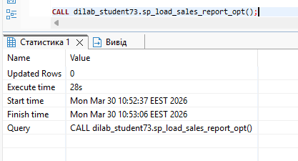
It run 1 s faster then not opt procedure

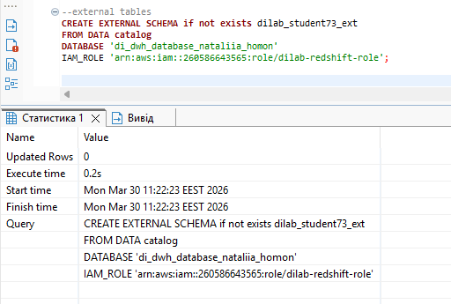
Check
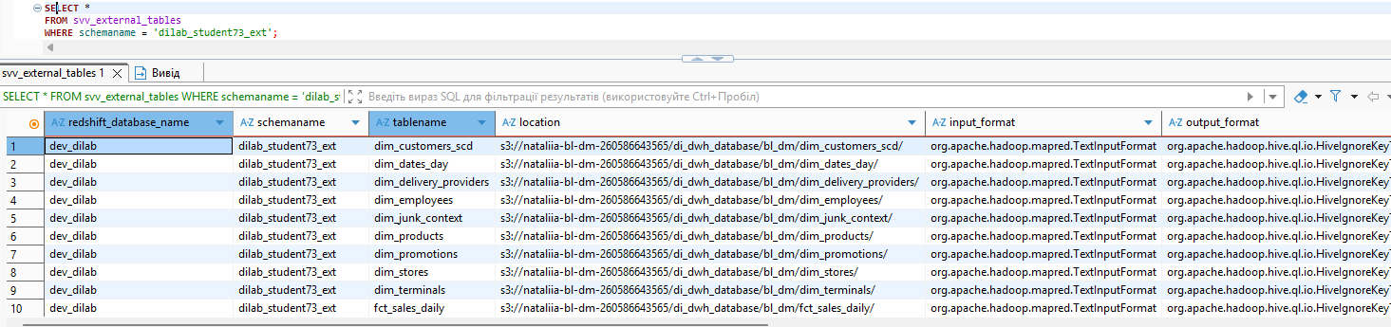
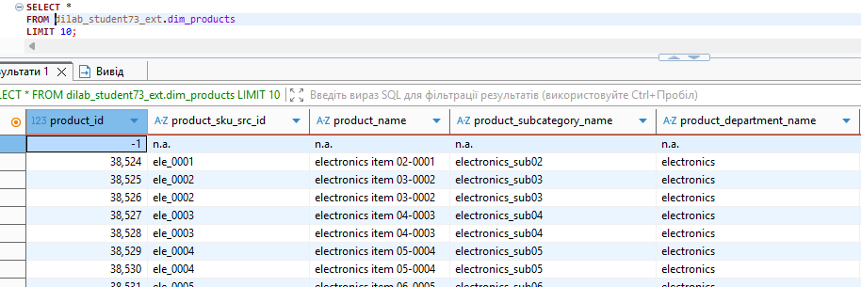

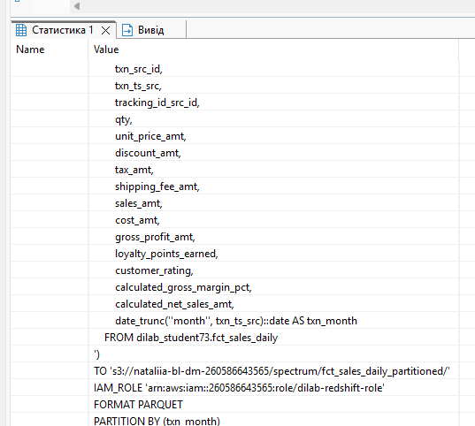
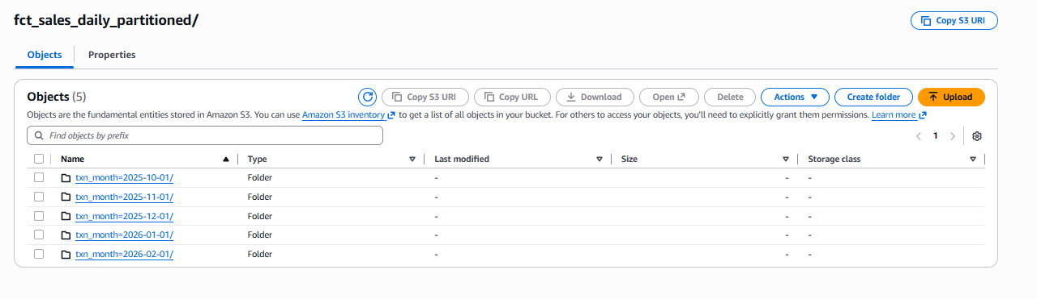
Created external table
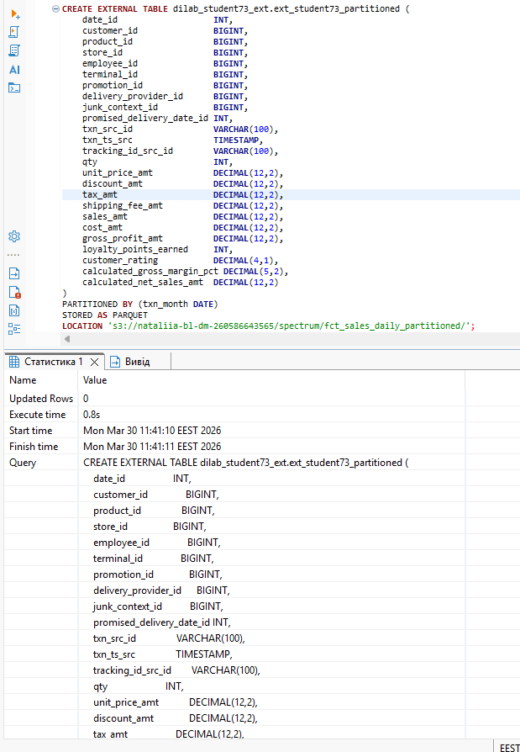

Added partitions
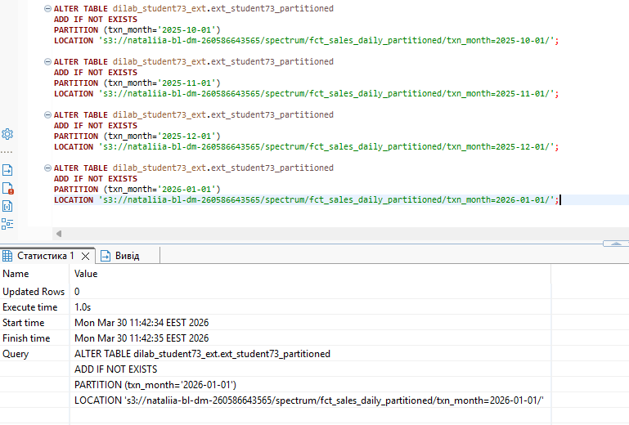

Check
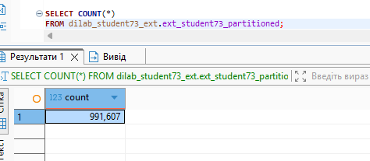
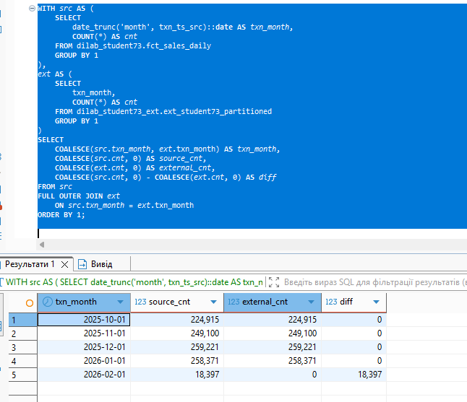
You may see that for Feb 2026 there is difference as for this month partition wasn’t created. Worked as designed

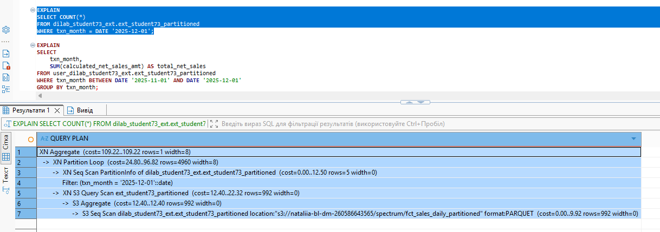
The execution plan shows that Amazon Redshift Spectrum uses partition pruning when querying the partitioned external table.

First, Redshift scans the partition metadata (`PartitionInfo`) and applies the filter on the partition column `txn_month = '2025-12-01'`. This allows the system to identify only the required partition instead of scanning all available monthly partitions.
Then, the `Partition Loop` step processes only the selected partition, and the `S3 Query Scan` reads data only from the corresponding files in S3.
The plan also shows that the external data is stored in Parquet format, which improves query efficiency because it is a columnar format optimized for analytics.
Overall, the plan confirms that partitioning works correctly: only the required monthly partition is scanned, which reduces the amount of data read from S3, improves performance, and lowers query cost.
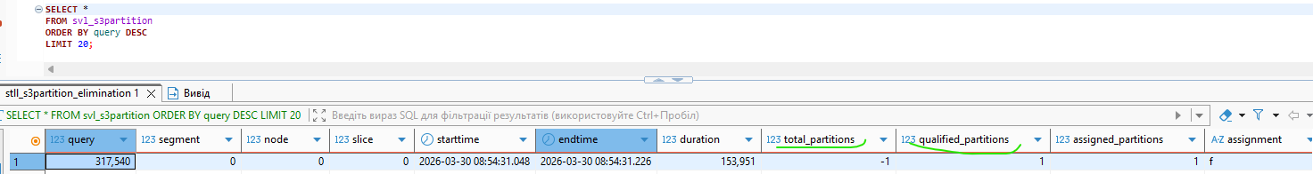
The query results from the SVL_S3PARTITION system table confirm that partition pruning is applied.
The value of qualified_partitions is equal to 1, which means that only one partition was scanned when executing the query with the condition txn_month = '2025-12-01'.
This confirms that Redshift Spectrum reads data only from the required partition instead of scanning all available partitions. As a result, the amount of data read from S3 is reduced, which improves query performance and lowers query cost.

Optional task7
Yes, there is a difference in execution time: 5.26 seconds versus 2.4 seconds.
The reason is that Amazon Redshift COPY performs better when data is split into multiple files instead of being stored in a single large file. When multiple files are available, Redshift can load them in parallel across nodes and slices, which improves throughput and reduces total load time.
Although both locations contain exactly the same data, the folder with multiple files provides better parallelism, so the COPY command finishes faster.
