2.1 TASK 1 CREATE NEW DATABASE
Run query, investigate result: select d.oid, d.datname, d.datistemplate, d.datallowconn, t.spcname from pg_database d join pg_tablespace t on t.oid = d.dattablespace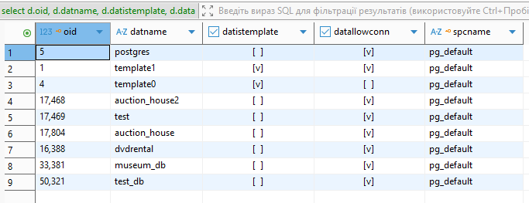
This task demonstrates how to create a new PostgreSQL database and how database metadata is stored in system catalogs. By querying pg_database and pg_tablespace, we can investigate database identifiers (OID), template status, connection permissions, and the tablespace where the database is physically located.
TASK 2 CREATE NEW
Check your tablespace exists in pg_tablespace table: select * from pg_tablespace
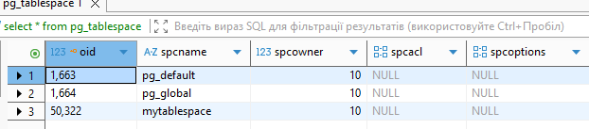
3. Move test_db into new tablespace
Check your directory where tablespace is located.

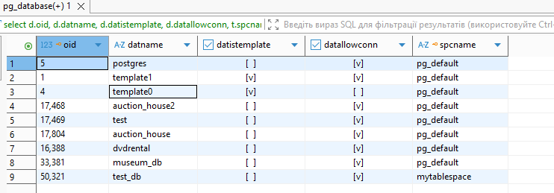
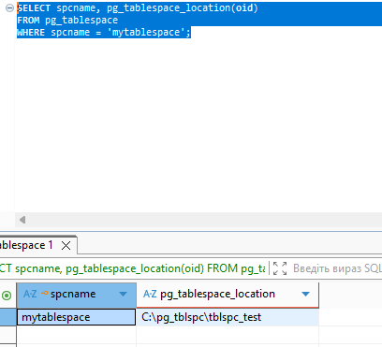
This task shows how to create and manage tablespaces in PostgreSQL. A new tablespace is created at the operating system level and registered in PostgreSQL. The database test_db is then moved to this tablespace, demonstrating how PostgreSQL separates logical database objects from their physical storage on disk.

TASK 3 CREATE NEW SCHEMA

Check the table: SELECT schemaname, tablename FROM pg_tables WHERE tablename = 'person';
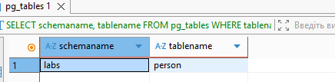
3. Insert into person table values (correct queries if needed): INSERT INTO person VALUES(1, 'Bob'); INSERT INTO person VALUES(2, 'Alice'); INSERT INTO person VALUES(3, 'Robert');
4. Use SHOW search_path and SET search_path to perform INSERTS from previous task without any correction.
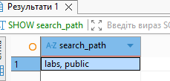
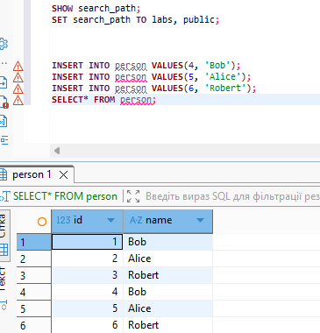
This task demonstrates schema usage for logical object organization inside a database. A new schema labs is created, and a table person is added to it. The task also shows how the search_path parameter affects object name resolution, allowing SQL statements to work without explicitly specifying schema names.

3.1 TASK 4 INVESTIGATE MVCC*
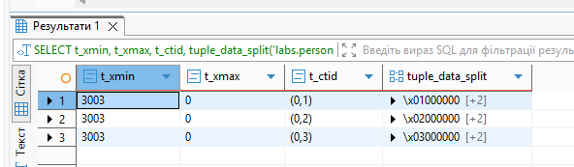

Before transactions
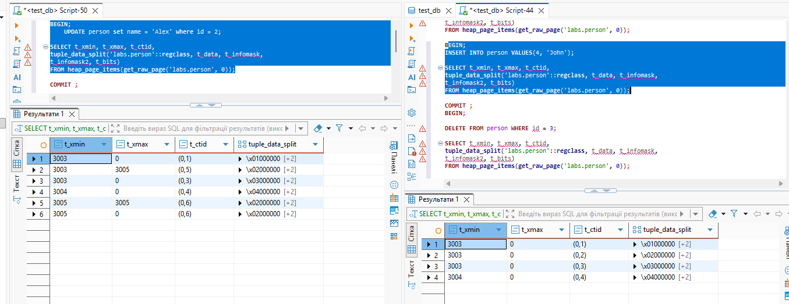
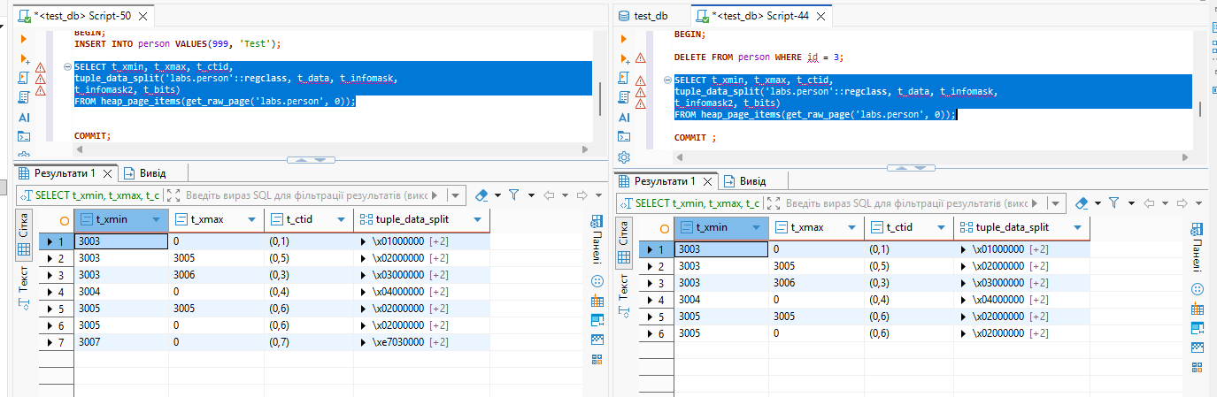
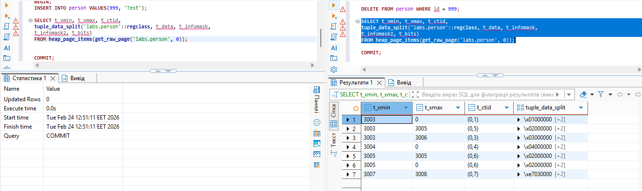

This task demonstrates how PostgreSQL implements MVCC internally. By analyzing system columns (xmin, xmax, ctid) and using the pageinspect extension, we observe how INSERT, UPDATE, and DELETE operations create multiple tuple versions instead of modifying rows in place. This explains how PostgreSQL provides transaction isolation and visibility using snapshots.

3.2 TASK 5 INVESTIGATE VACUUM
Vacuum labs.person
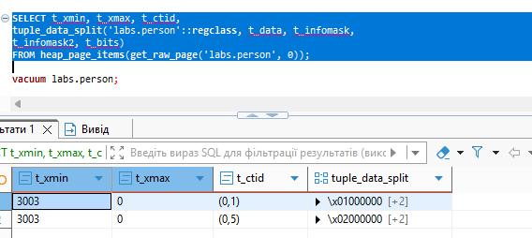
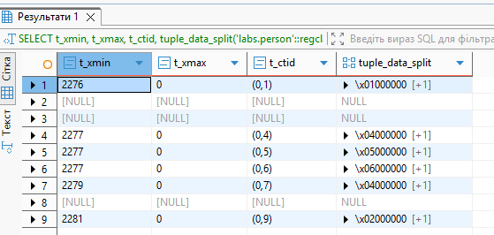

After vacuum full labs.person;
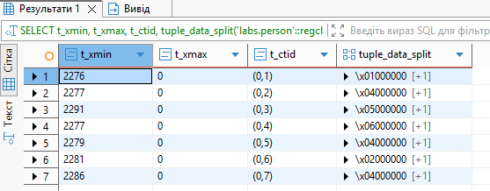
This task demonstrates how PostgreSQL stores and manages tuples internally using MVCC (Multi-Version Concurrency Control). The query using heap_page_items allows us to inspect the physical contents of a table page, including system columns such as t_xmin (the inserting transaction ID), t_xmax (the deleting/updating transaction ID), and t_ctid (the physical location of the tuple within the table file).
After running VACUUM labs.person;, we should observe that nothing changes for live tuples. Their t_xmin, t_xmax, and t_ctid remain the same. Regular VACUUM only removes dead tuples and marks their space as reusable, but it does not physically reorganize or rewrite the table. Therefore, tuple positions stay unchanged.
When we execute INSERT INTO person VALUES (5, 'Sarah');, a new tuple is created. In the page inspection output, we will see an additional row with a new t_xmin corresponding to the current transaction, t_xmax = 0 (meaning the row is alive), and a new t_ctid showing its physical position on the page.
Finally, after running VACUUM FULL labs.person;, the table is completely rewritten. This compacts the data and removes unused space. As a result, all tuples receive new physical locations, and their t_ctid values change. This demonstrates the key difference between VACUUM (logical cleanup only) and VACUUM FULL (physical reorganization and compaction of the table).

