Section 1

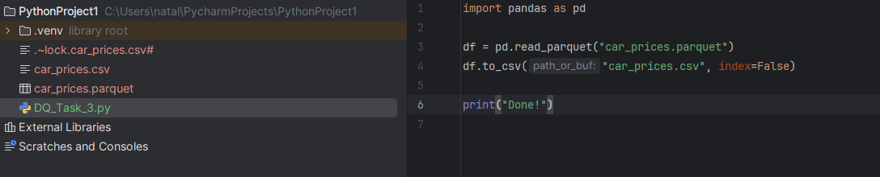
- Car_prices was analysed with ydata-profiling library

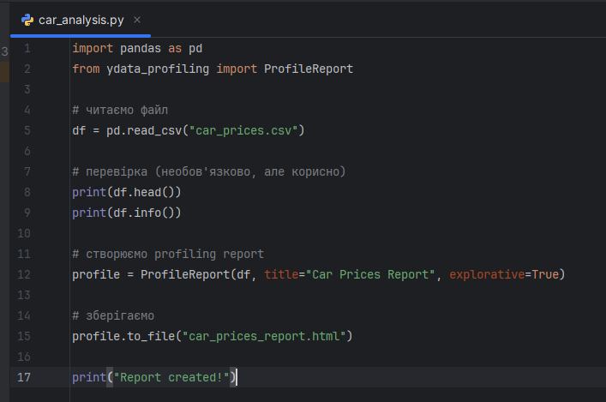

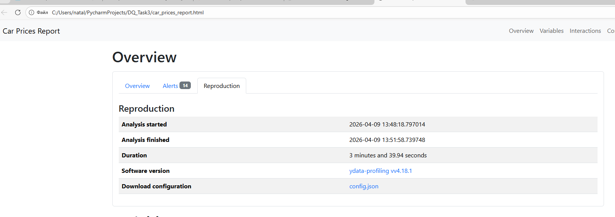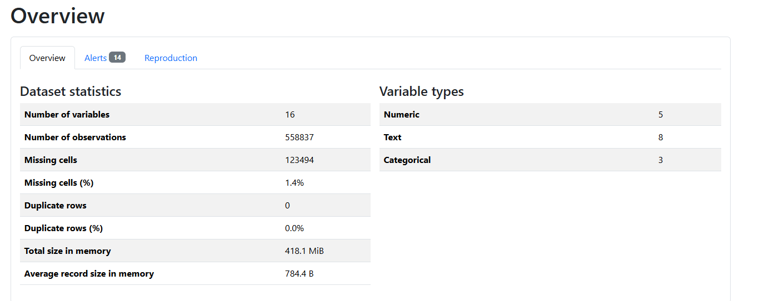

Why Parquet Files Take Less Space Than CSV
Parquet files are smaller than CSV files mainly due to two key reasons: compression and storage structure.
- Columnar Storage Format
Parquet stores data by columns, while CSV stores data by rows.
  - In Parquet, values from the same column are stored together.
  - Since column data often has similar types and repeating values, it can be compressed very efficiently.
  - In contrast, CSV mixes all columns in each row, making compression less effective.
- Efficient Compression Techniques
Parquet uses advanced encoding and compression algorithms (such as run-length encoding and dictionary encoding).
  - Repeated values are stored once and referenced multiple times.
  - Numeric data is stored in a compact binary format.
  - CSV stores everything as plain text, which takes more space and cannot be compressed efficiently without external tools.
- Data Type Optimization
Parquet preserves data types (e.g., integers, floats, dates).
  - This allows it to store data in a binary format using fewer bytes.
  - CSV stores all values as text, which increases file size (e.g., numbers take more characters as strings).

Key Differences Between Parquet and CSV
Feature | CSV | Parquet
Format | Plain text | Binary
Storage | Row-based | Column-based
File size | Larger | Smaller (compressed)
Data types | Not preserved | Preserved
Readability | Human-readable | Not human-readable
Performance | Slower for large data | Faster for analytics

Summary
Parquet files are more space-efficient than CSV because they use columnar storage, built-in compression, and optimized binary encoding. These features reduce redundancy and store data more compactly, making Parquet ideal for big data processing and analytical workloads.

Section 2

car_prices dataset
The car_prices dataset contains information about used vehicles, including attributes such as make, model, year, condition, mileage (odometer), transmission type, color, interior, and selling price.
This dataset can be used by businesses in the automotive industry to:
- analyze factors influencing car prices
- identify market trends
- evaluate vehicle depreciation
- support pricing strategies
- improve decision-making in buying and selling used cars
Overall, the dataset provides valuable insights into vehicle characteristics and their impact on market value.

🔹 bank dataset
The bank dataset contains information about bank customers and their financial and demographic characteristics. It includes attributes such as age, job, marital status, education, account balance, loan status, housing loan, contact type, and interaction duration.
This dataset can be used by financial institutions to:
- analyze customer profiles
- identify patterns in customer behavior
- support marketing campaigns
- assess credit risk and loan eligibility
- improve customer segmentation and targeting
Overall, the dataset helps businesses better understand their customers and make data-driven decisions in banking and financial services.

Section 3
car_prices dataset

1. Missing Values
Dataset: car_prices
Attribute: make
Issue: Missing values
Description: The make column contains 10301 (1.8%) missing values.
How found: Identified using ydata-profiling report (Alerts section).
Why incorrect: Car manufacturer is a key attribute for analysis and segmentation. Missing values reduce data usability.

Dataset: car_prices
Attribute: model
Issue: Missing values
Description: The model column contains 10399 (1.9%) missing values.
How found: Identified using profiling report.
Why incorrect: Missing model information limits detailed analysis of car types.

Dataset: car_prices
Attribute: trim
Issue: Missing values
Description: The trim column contains 10715 (1.9%) missing values.
Why incorrect: Trim level impacts price and features, so missing values affect pricing analysis.

Dataset: car_prices
Attribute: body
Issue: Missing values
Description: The body column contains 13195 (2.4%) missing values.
Why incorrect: Body type is important for classification and segmentation.

Dataset: car_prices
Attribute: transmission
Issue: Missing values
Description: The transmission column contains 65321 (11.7%) missing values.
Why incorrect: Transmission type significantly affects vehicle value and buyer preference.

Dataset: car_prices
Attribute: condition
Issue: Missing values
Description: The condition column contains 11820 (2.1%) missing values.
Why incorrect: Vehicle condition is critical for pricing and quality evaluation.

🔹 2. Imbalanced Data
Dataset: car_prices
Attribute: transmission
Issue: Imbalanced data
Description: The transmission column is highly imbalanced (90.1%), meaning one category dominates the dataset.
How found: Alerts section in profiling report.
Why incorrect: Imbalanced data may bias analysis and machine learning models.
Dataset: car_prices
Attribute: transmission
1st Issue: Invalid categorical values
Description:
The transmission column contains unexpected values such as:
- Sedan
- sedan
- horse-driven
These values do not belong to transmission types (expected values are typically automatic or manual).
How found:
Observed in the value distribution in the profiling report.
Why incorrect:
These values indicate data entry errors or incorrect mapping between columns, which can significantly distort analysis.
2nd Issue: High number of missing values
Description:
The transmission column contains 65321 (11.7%) missing values.
Why incorrect:
This is a critical issue because transmission type is an important feature for pricing and customer preferences.
3rd Issue: Imbalanced distribution
Description:
The transmission column is highly imbalanced, with the majority of vehicles having automatic transmission (85.1%), while manual transmission represents only 3.1% of the data.
How found:
Identified using frequency distribution in the ydata-profiling report.
Interpretation:
This may reflect real-world market trends, where automatic vehicles are more common.
Why it matters:
Although not necessarily a data error, such imbalance may affect statistical analysis and machine learning models by introducing bias.

Dataset: car_prices
Attribute: interior
1st Issue: Invalid placeholder values
Description:
The interior column contains a value "—" which appears in 17077 records (3.1%). This likely represents missing or undefined data but is stored as a valid category.
How found:
Identified in the "Common Values" section of the ydata-profiling report.
Why incorrect:
Using placeholders instead of proper missing values leads to incorrect categorization and may distort analysis results.

2nd Issue: Imbalanced distribution
Description:
The interior color distribution is highly skewed:
- black → 43.7%
- gray → 32.0%
- other colors have significantly lower frequencies
How found:
Observed from frequency distribution in profiling report.
Interpretation:
This may reflect real-world preferences, where neutral interior colors are more common.
Why it matters:
Although not necessarily incorrect, this imbalance may affect statistical analysis and modeling.
3rd Issue: Inconsistent categorization
Description:
The dataset contains a category labeled "Other values (7)", indicating the presence of multiple low-frequency categories grouped together.
Why incorrect:
This reduces data granularity and may hide meaningful distinctions between categories.
4th Issue: Missing values
Description:
The interior column contains missing values (749 records, 0.1%).
Why incorrect:
Missing values reduce data completeness, although the percentage is relatively low.

Bank.csv dataset
The bank dataset was analyzed using DBeaver with a PostgreSQL database.
The dataset was loaded as a foreign table using the file_fdw extension, which allowed direct querying of the CSV file without full data import. SQL queries were then used to perform data profiling, including analysis of missing values, invalid categories, duplicates, and data distribution.

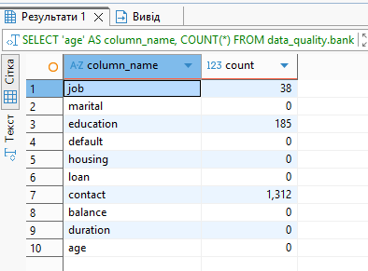

Missing Values Analysis (bank dataset)
Issue: Missing values (NULL + “unknown”)
Description:
Missing values were analyzed in the dataset by considering both actual NULL values and placeholder values such as "unknown", which are commonly used instead of proper missing data.
How found:
Identified using SQL queries with IS NULL conditions and filtering for "unknown" values.

📊 Results Summary
- job: 38 missing values
- education: 185 missing values
- contact: 1312 missing values
- marital, default, housing, loan, balance, duration, age: no missing values detected

🔍 Interpretation
- The dataset does not contain many NULL values, but missing data is represented using "unknown" in several categorical fields.
- The contact column has the highest number of missing values, which may affect communication channel analysis.
- The education and job columns also contain missing values, which may impact customer segmentation and profiling.

⚠️ Why this is a data quality issue
- Using "unknown" instead of NULL leads to:
  - inconsistent representation of missing data
  - incorrect aggregation and analysis
  - potential bias in statistical models

Potential fuzzy duplicates
Issue: Potential fuzzy duplicates
Description:
Potential duplicate records were identified using SQL by grouping rows with the same demographic and categorical attributes, while allowing some numeric fields to differ. These records may represent repeated clients or duplicated entries with minor variations.
Why it matters:
Such duplicates may distort statistics, customer counts and analytical conclusions.
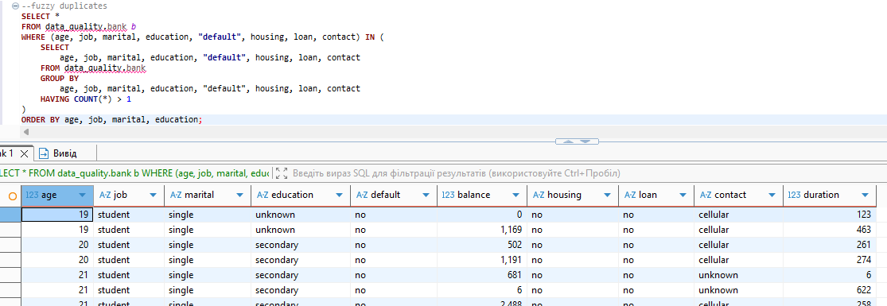

ATTRIBUTE JOB
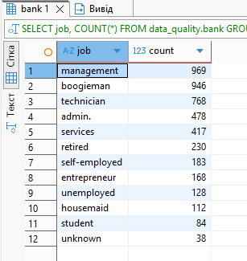

1. Invalid Value – “boogieman”
Dataset: bank
Attribute: job
Issue: Invalid categorical value
Description:
The job column contains a value "boogieman" (946 records), which does not represent any valid profession.
How found:
Identified using SQL query with GROUP BY job.
Why incorrect:
- "boogieman" is not a real job category
- likely caused by data entry error or incorrect data generation
- relatively high frequency (946 records) suggests a systematic issue rather than incident

🔴 2. Inconsistent Formatting – “admin.”
Dataset: bank
Attribute: job
Issue: Inconsistent category formatting
Description:
The dataset contains the value "admin." (with a dot), which may represent the same category as "admin" but is stored differently.
How found:
Observed in distinct values of the job column.
Why incorrect:
- inconsistent formatting leads to incorrect grouping
- the same category may be treated as different values
- affects aggregation and analysis results

🔴 3. Placeholder Values – “unknown”
Dataset: bank
Attribute: job
Issue: Placeholder value used as category
Description:
The value "unknown" appears in the job column (38 records) and represents missing information.
How found:
Identified using frequency analysis.
Why incorrect:
- already identified as missing value (see Missing Values section)
- should not be treated as a valid category

🔴 4. Data Imbalance
Dataset: bank
Attribute: job
Issue: Imbalanced distribution
Description:
Some job categories dominate the dataset:
- management → 969
- boogieman → 946
- technician → 768
while others (e.g., student, housemaid) have significantly fewer records.
Interpretation:
- partial imbalance may reflect real-world distribution
- however, high frequency of invalid value ("boogieman") distorts the distribution
Why it matters:
Imbalance combined with incorrect categories may lead to biased analysis and misleading insights.
ATTRIBUTE EDUCATION
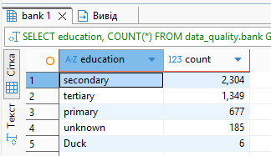

1. Invalid Value – “Duck”
Dataset: bank
Attribute: education
Issue: Invalid categorical value
Description:
The education column contains a value "Duck" (6 records), which is not a valid education level.
How found:
Identified using SQL query with GROUP BY education.
Why incorrect:
- "Duck" is not a recognized education category
- expected values are typically: primary, secondary, tertiary
- likely caused by data entry error or incorrect data generation

🔴 2. Placeholder Values – “unknown”
Dataset: bank
Attribute: education
Issue: Placeholder value
Description:
The value "unknown" appears in the dataset (185 records), representing missing information.
Why incorrect:
- should be treated as missing value
- already addressed in Missing Values section
- not a valid category for analysis
ATTRIBUTE DEFAULT
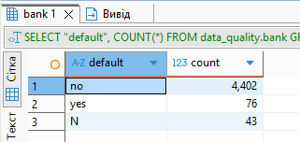

1. Inconsistent Values – “yes” vs “N”
Dataset: bank
Attribute: default
Issue: Inconsistent categorical values
Description:
The default column contains inconsistent representations of categorical values:
- "yes" → 76
- "no" → 4402
- "N" → 43
The value "N" appears to represent the same meaning as "no", but is stored differently.
How found:
Identified using SQL query with GROUP BY default.
Why incorrect:
- inconsistent encoding of the same category
- "no" and "N" should represent the same value
- leads to incorrect aggregation and misleading statistics

ATTRIBUTE LOAN
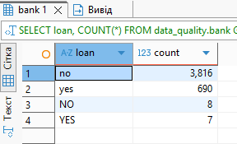

Inconsistent Values – “yes” vs “YES”, “no” vs “NO”
Dataset: bank
Attribute: loan
Issue: Inconsistent categorical values (case sensitivity)
Description:
The loan column contains the same categories represented in different formats:
- "no" → 3816
- "NO" → 8
- "yes" → 690
- "YES" → 7
How found:
Identified using SQL query with GROUP BY loan.
Why incorrect:
- values differ only by letter case
- represent the same meaning but are treated as different categories
- leads to incorrect aggregation and analysis
ATTRIBUTE CONTACT
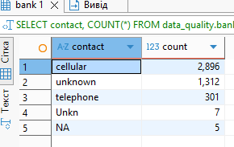

1. Placeholder Values – “unknown”
Dataset: bank
Attribute: contact
Issue: Placeholder value used as category
Description:
The contact column contains the value "unknown" (1312 records), which represents missing information rather than a valid contact type.
How found:
Identified using SQL aggregation (GROUP BY contact).
Why incorrect:
- "unknown" is not a real contact method
- should be treated as missing value
- may distort communication channel analysis

🔴 2. Inconsistent Values – “unknown”, “Unkn”, “NA”
Dataset: bank
Attribute: contact
Issue: Inconsistent representation of missing values
Description:
The dataset contains multiple representations of missing data:
- "unknown" → 1312
- "Unkn" → 7
- "NA" → 5
These values all represent missing information but are stored differently.
How found:
Observed using GROUP BY contact.
Why incorrect:
- inconsistent encoding of the same concept
- leads to incorrect grouping and aggregation
- complicates data cleaning

Data Standardization Issue
Dataset: bank
Attribute: contact
Issue: Lack of standardization
Description:
Different formats are used to represent the same meaning (missing values), indicating inconsistent data entry or preprocessing.
Why incorrect:
- violates data consistency rules
- requires normalization (e.g., converting all to NULL)
ATTRIBUTE BALANCE

Suspicious Numeric Values (balance)
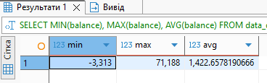
Dataset: bank
Attribute: balance
Issue: Suspicious and extreme values
Description:
Statistical analysis of the balance column shows:
- Minimum: -3313
- Maximum: 71188
- Average: ~1422.66
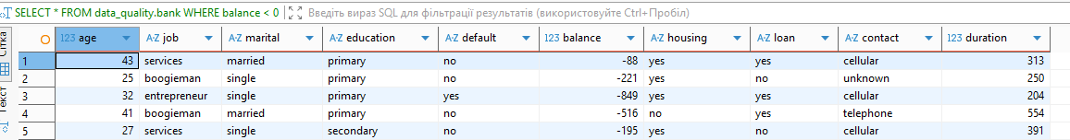
Dataset: bank
Attribute: balance
Issue: Presence of negative values
Description:
The analysis of the balance column revealed a significant number of negative values (e.g., -88, -221, -849, -970, etc.).
How found:
Identified using SQL query:
SELECT *
FROM data_quality.bank
WHERE balance < 0;

🔍 Interpretation
- Negative balance values may indicate:
  - overdraft accounts (possible real-world scenario)
  - or incorrect data entries
- However, the relatively high number of such records suggests that:
  - this is not an isolated case
  - requires validation

⚠️ Why this is a data quality issue
- Negative values may:
  - distort financial analysis
  - affect average balance calculations
  - impact customer segmentation
- Without business context, it is unclear whether:
  - these values are valid
  - or represent data errors

