Section 3
Car Prices Dataset Analysis:

Make / Model Inconsistencies
Issue: Inconsistent formatting (case sensitivity)
Description:
The dataset contains inconsistent representations of the same make and model values due to differences in letter case.
Results:
- 30+ car manufacturers have inconsistent values (e.g., BMW vs bmw)
- 122 car models have inconsistent values (e.g., A4 vs a4, Accord vs accord)
How found:
Identified using Python (pandas):
- Converted values to lowercase using str.lower()
- Grouped by normalized values
- Detected inconsistencies where nunique() > 1
Example code:
df['make_lower'] = df['make'].str.lower()
df.groupby('make_lower')['make'].nunique()
Why incorrect:
- Causes duplicate categories
- Leads to incorrect aggregation results
- Distorts analysis of brand and model popularity
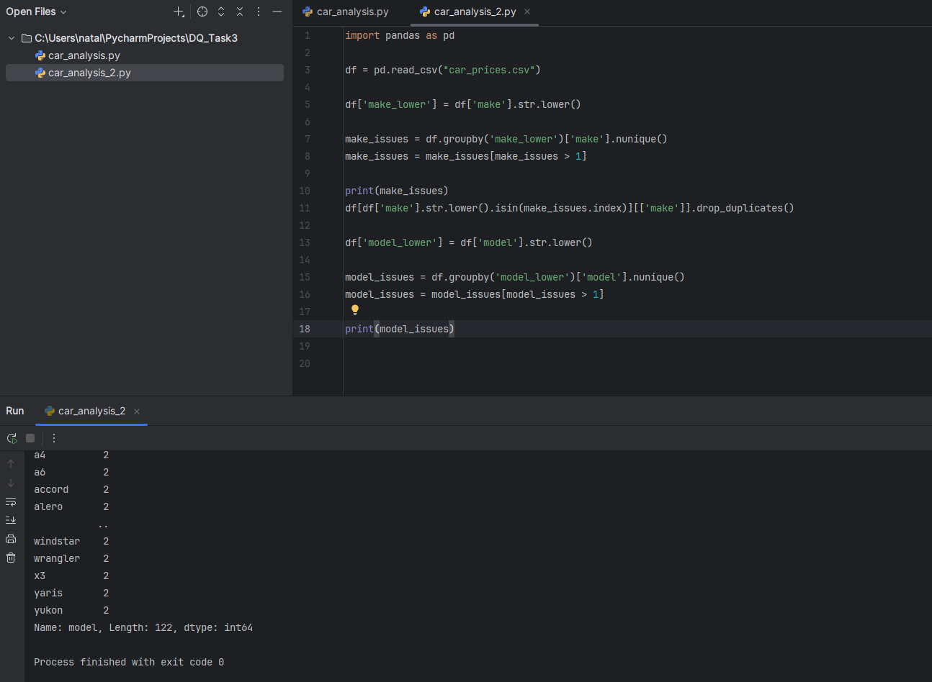

Trim Invalid Values

Issue: Invalid and inconsistent values in the trim column

Description:
The trim column contains values that do not represent valid vehicle trim levels.
These include:
- numeric values (e.g., "2.5", "1.6")
- model-like values (e.g., "328i", "x5")
- unusually long strings
- missing values

How found:
Identified using Python (pandas) by:
- detecting numeric patterns
- checking string length
- filtering NULL and empty values

Why incorrect:
- Trim should represent vehicle configuration (e.g., LX, EX, Sport)
- Invalid values indicate column misalignment or data entry errors
- This affects pricing analysis and feature-based segmentation

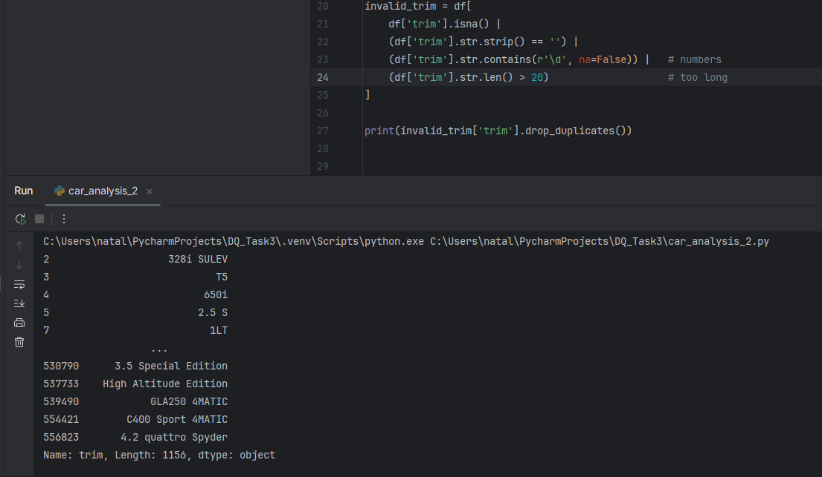
State Anomalies

Issue: Invalid and inconsistent state values

Description:
The state column contains multiple types of anomalies:

1. Formatting issues:
Some values are stored in lowercase (e.g., "ca", "tx") instead of standard uppercase format.

2. Invalid values:
The column contains values that do not represent US state codes, such as strings resembling VIN numbers (e.g., "3vwd17aj4fm236636").

How found:
Identified using Python (pandas) by:
- validating values against a list of US state codes
- checking string format and length
- detecting non-matching patterns

Why incorrect:
- State should contain standardized 2-letter US state codes
- Invalid values indicate data corruption or column misalignment
- These issues affect geographic analysis and aggregation
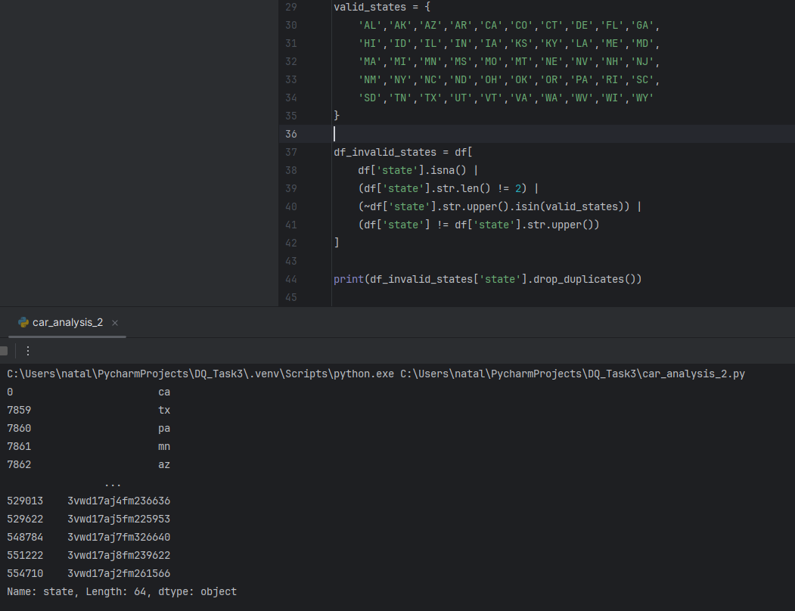
Color Anomalies

Issue: Invalid and inconsistent values in the color column

Description:
The color column contains multiple types of anomalies:

1. Missing values:
- "—", NULL values

2. Inconsistent formatting:
- values like "off-white" which are not standardized

3. Invalid values:
- numeric values (e.g., "4802", "9410", "1167") that do not represent colors

How found:
Identified using Python (pandas) by:
- detecting missing and placeholder values
- identifying numeric patterns in text data
- analyzing distinct values

Why incorrect:
- Color should represent standard vehicle colors (e.g., black, white, silver)
- Numeric values indicate data corruption or column misalignment
- These issues reduce data quality and affect analysis
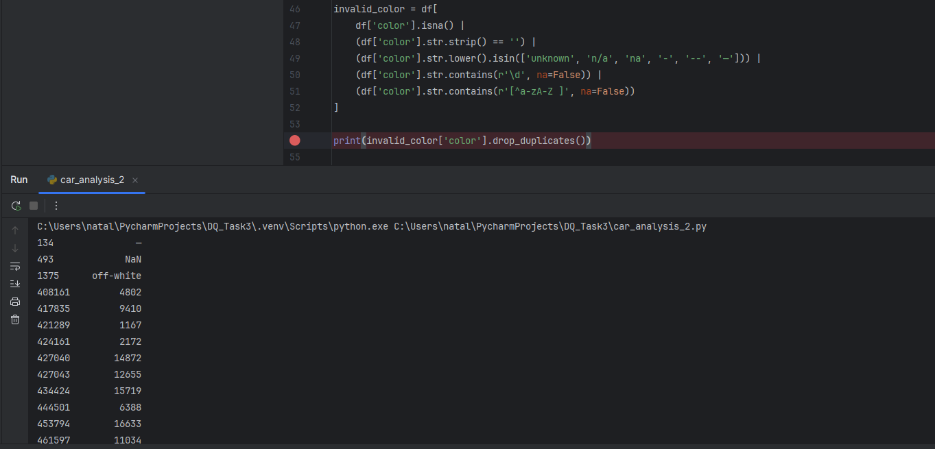
Price Anomalies

Issue: Invalid and missing values in the sellingprice column

Description:
The sellingprice column contains several anomalies:

1. Missing values:
- NULL values detected in multiple records

2. Unrealistic values:
- extremely low values such as 1.0, which do not represent real car prices

How found:
Identified using Python (pandas) by filtering for missing values and unrealistic low values.

Why incorrect:
- Car prices must be positive and within a realistic range
- Values such as 1.0 indicate data entry errors or placeholder values
- Missing values reduce data completeness and affect analysis
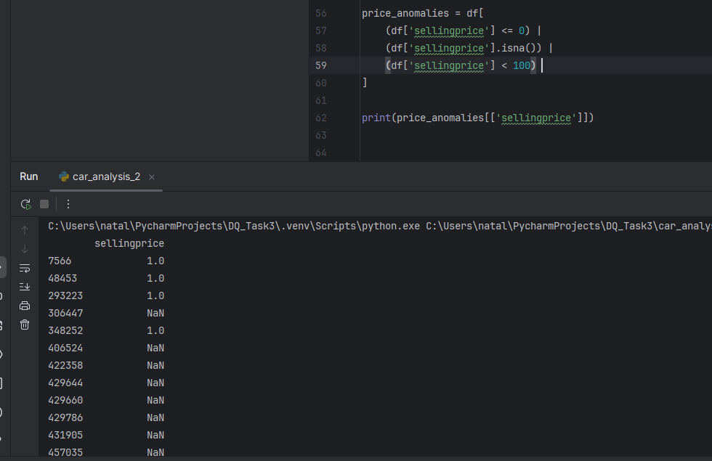

Date Logic Errors
Issue: Cars sold before manufacture year.
Description: The dataset contains records where the sale year is earlier than the vehicle manufacture year. For example, vehicles with year = 2015 were recorded as sold in 2014.
How found: The saledate column was converted to datetime in Python, the sale year was extracted, and compared with the manufacture year. Records where sale_year < year were flagged as date logic errors.
Why incorrect: A car cannot be sold before it is manufactured. These records indicate incorrect dates or data entry errors.
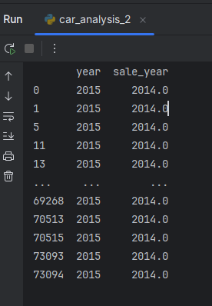

Bank Dataset Analysis
Age Anomalies

Issue: Invalid age values in the dataset

Description:
The age column contains potentially unrealistic values, including:
- ages below 18
- extremely high values (above 100)
- zero or negative values

How found:
Identified using SQL queries by filtering values outside realistic human age ranges.

Why incorrect:
- Bank clients are expected to be adults
- Invalid age values distort customer analysis and segmentation
- These anomalies may indicate data entry errors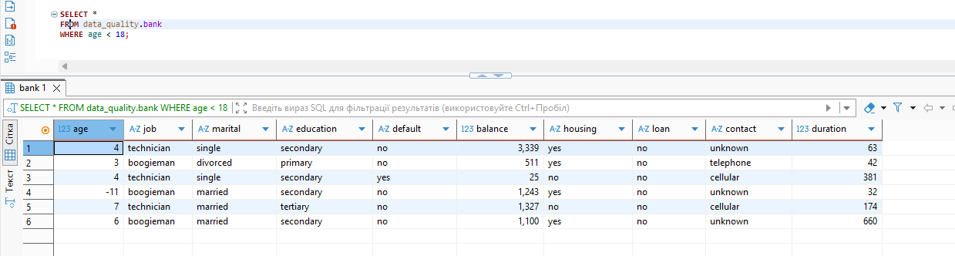
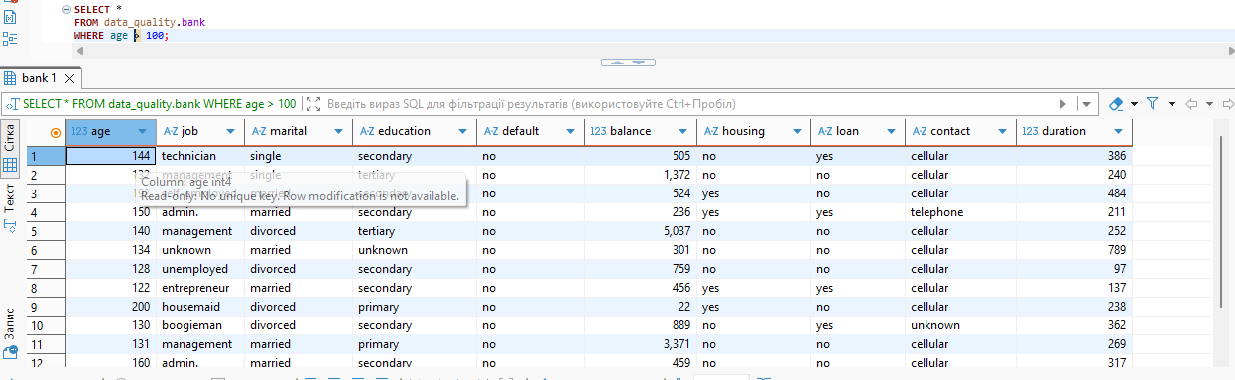
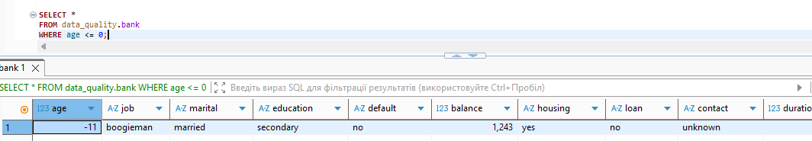

Duration Issues

Issue: Invalid and unrealistic values in the duration column

Description:
The duration column contains anomalies such as:
- zero or negative values
- extremely short durations (less than 5 seconds)

How found:
Identified using SQL queries by filtering values outside realistic ranges for call duration.

Why incorrect:
- Call duration must be a positive value
- Extremely short or long durations may indicate data entry errors or system issues
- These anomalies can distort analysis of customer interactions
