Basic Data Transformation
1.A new column Full Name (merged First name+Last name)
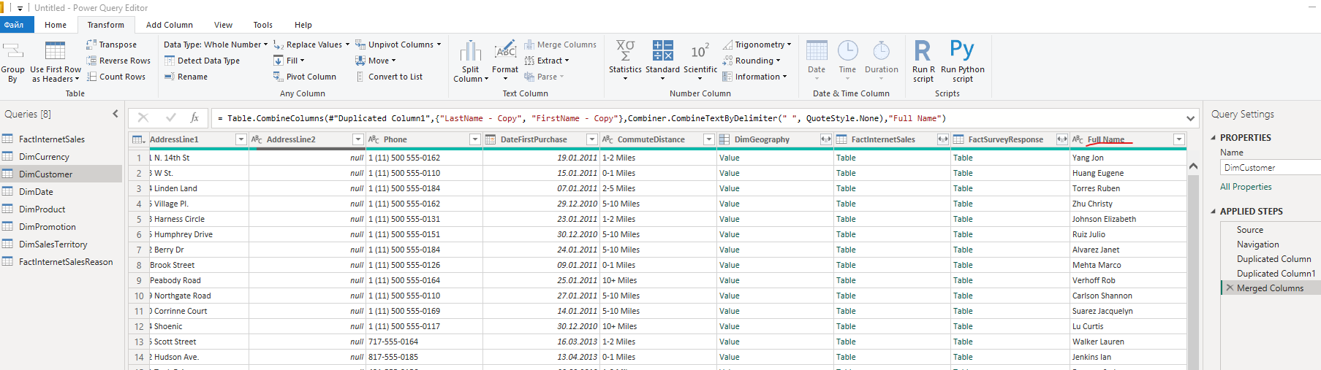
2. Change column type:
Select ‘DiscountPct’ column in ‘DimPromotion’ table.
Change Data Type to Percentage:
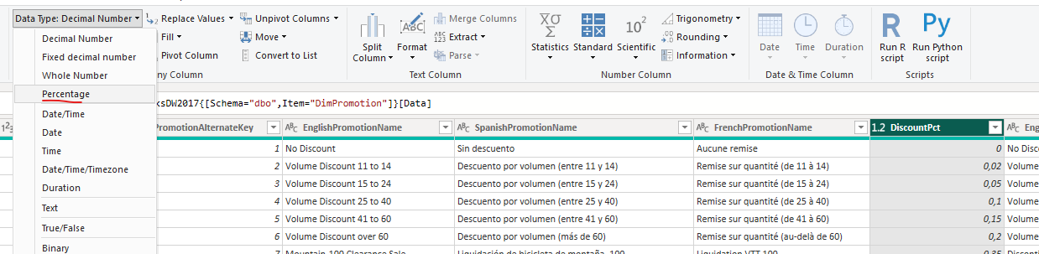
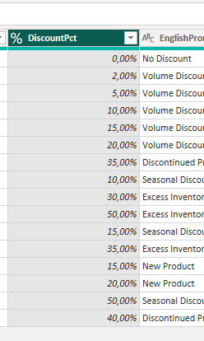
3.Added new custom column with formula = [EndData]-[StartDate]
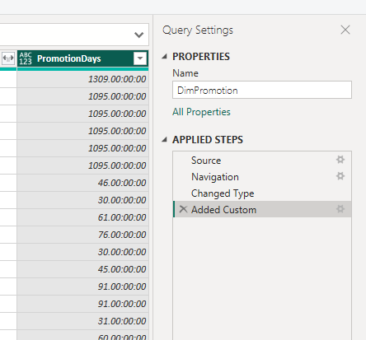

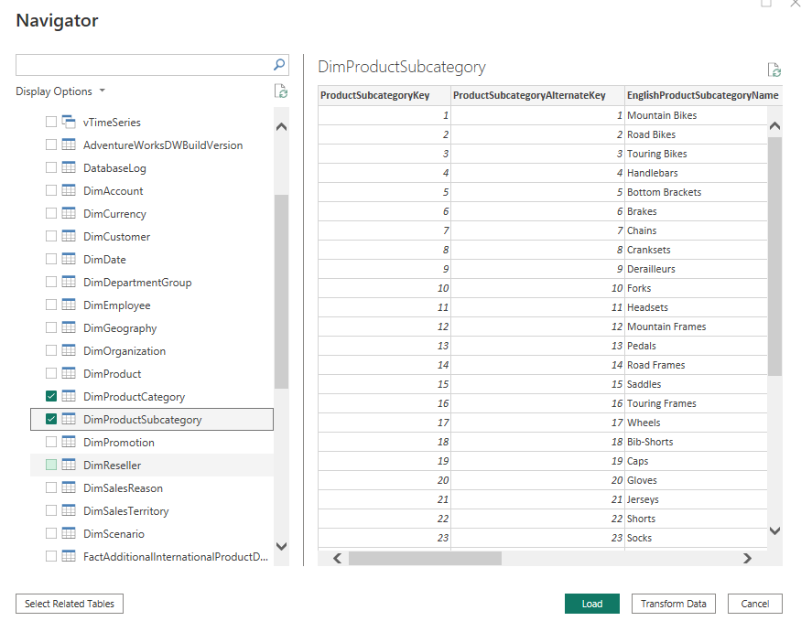
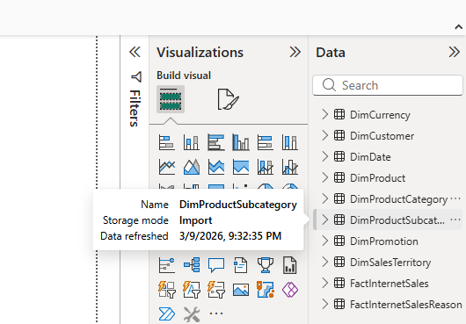
4. the View tab and select options Column Quality, Column distribution and Column profile 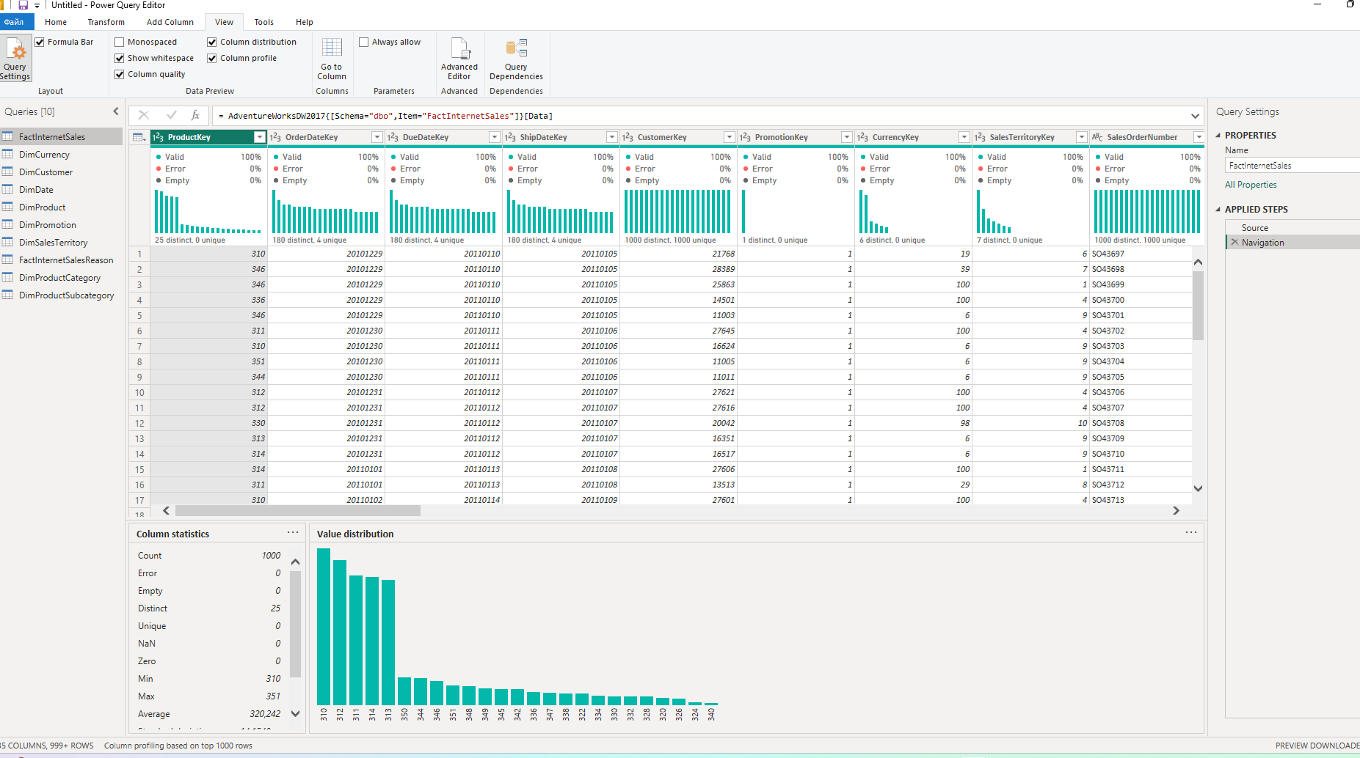
5. Column ‘Order Year’ based on the ‘OrderDate’ column in the table ‘FactInternetSales’
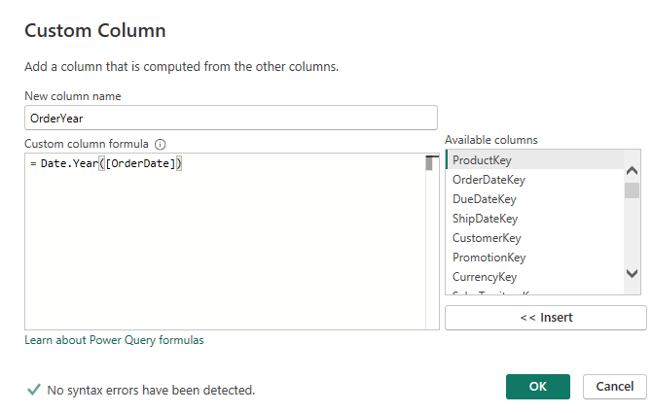
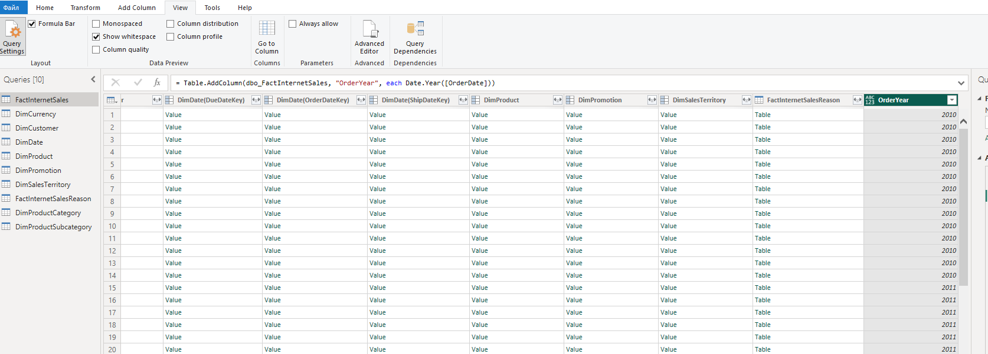
6. Create a new table based on ‘FactInternetSales’:
- Right button click on the table ‘FactInternetSales’ choose Reference in the context menu.
- Set the new name ‘SalesByYearsNPrice’ for the created table.
- In the new table choose the columns ‘Order Year’, ‘OrderQuantity’, ‘DiscountAmount’, ‘SalesAmount’ using CTRL button for multiple selection.
- Right-click on the title of a selected column and click on the Remove Other Columns option.

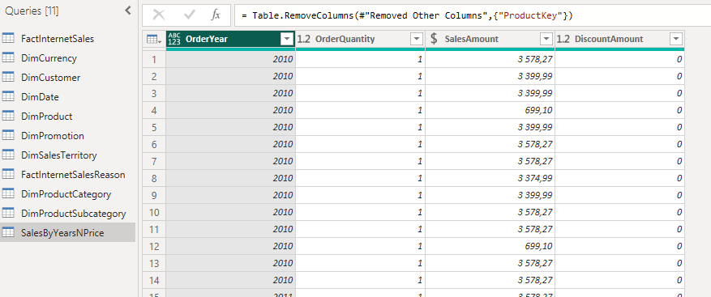
7.Pivoting sales amount column
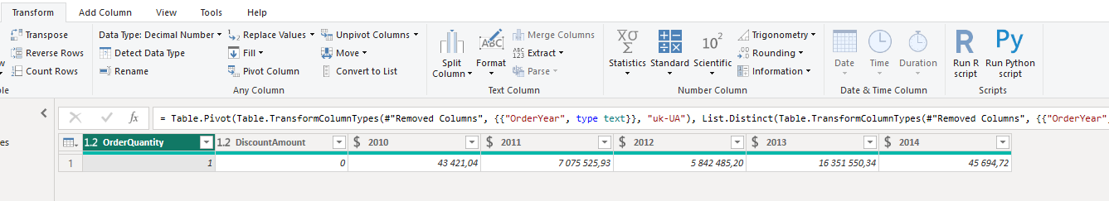
8.Table joining
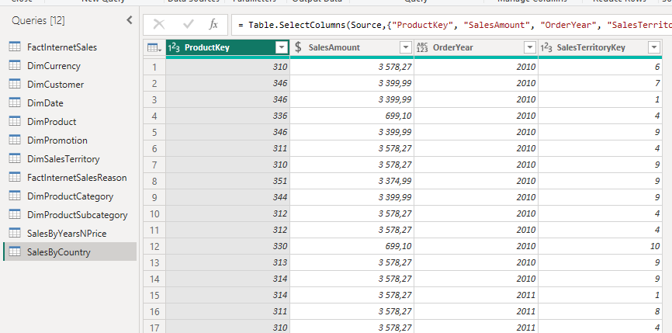
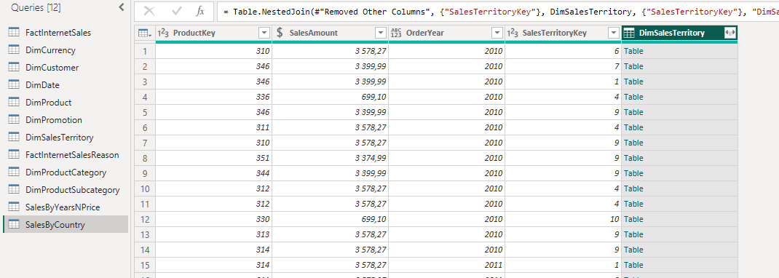
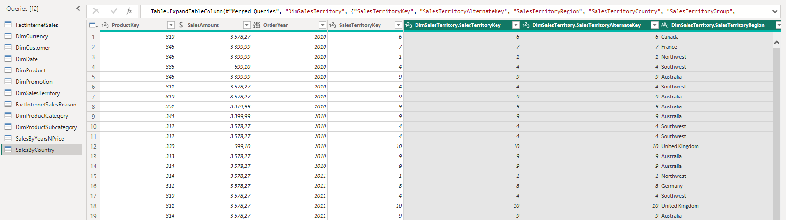
Join DimProduct
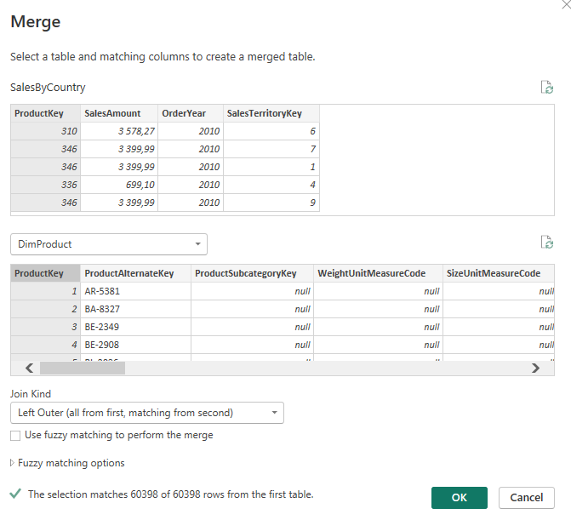
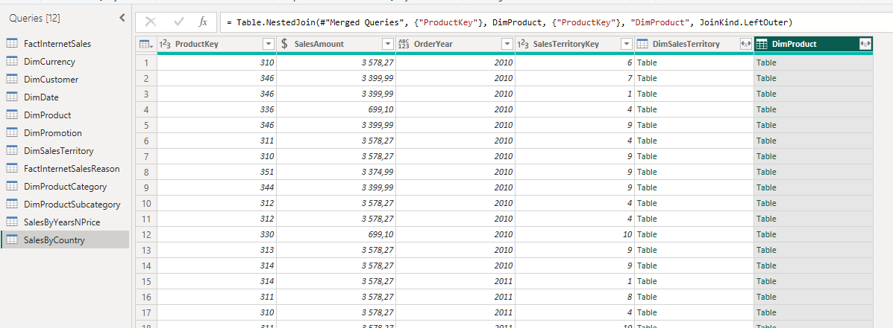
Join subcategory
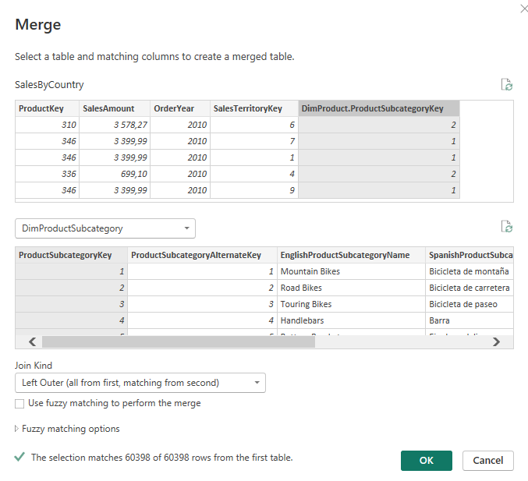
Join category
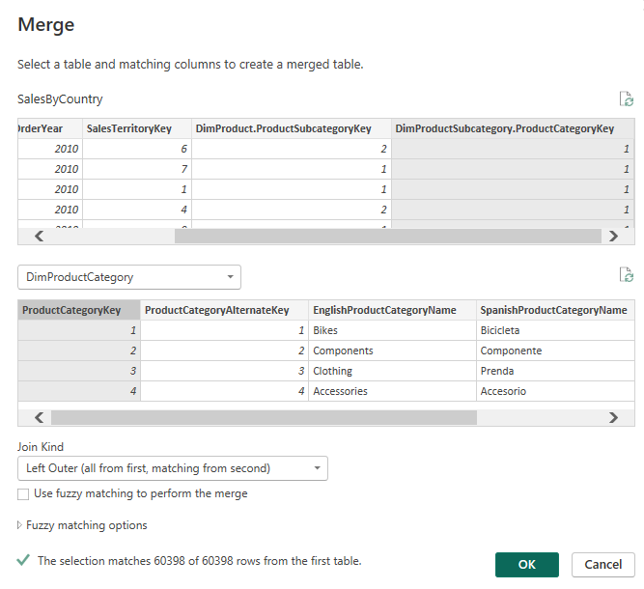
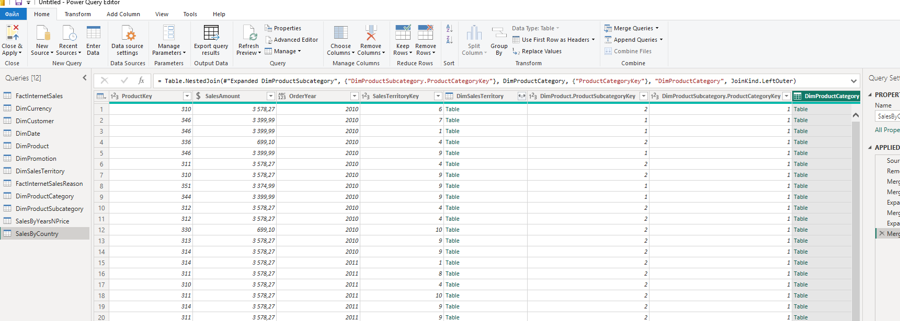
9.Grouping

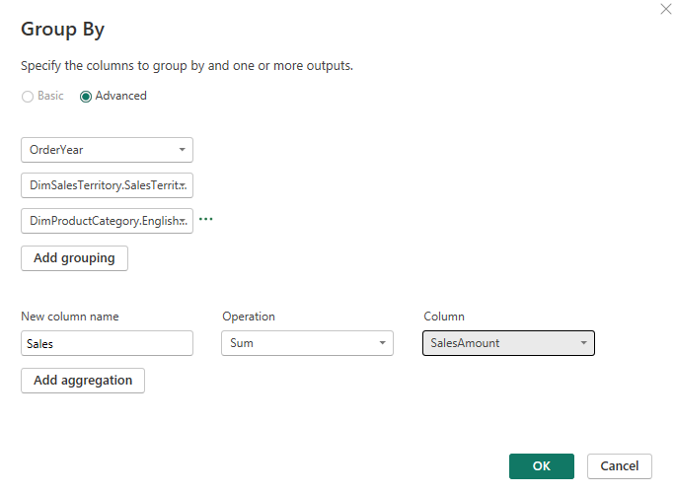
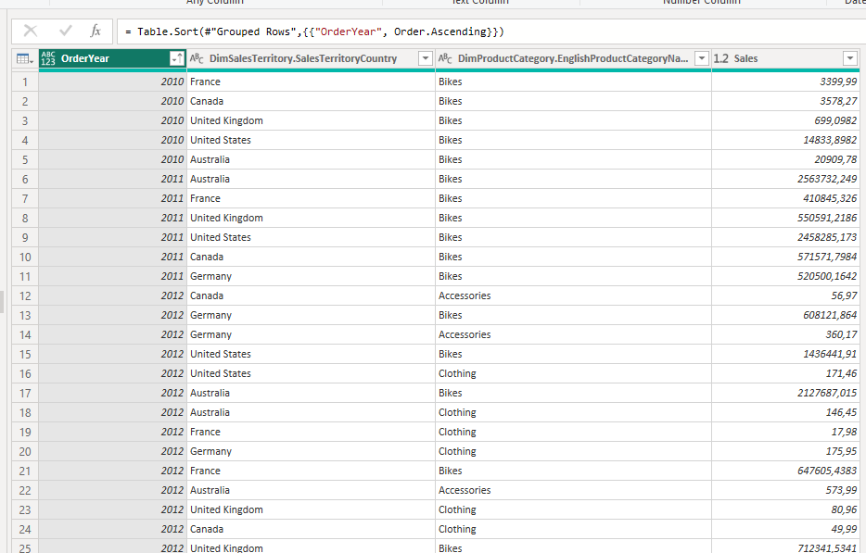
10.saved data into the file on PC

10. IMPORT VS DIRECT QUERY
Added one new column, saved changes – saving took a lot of time(
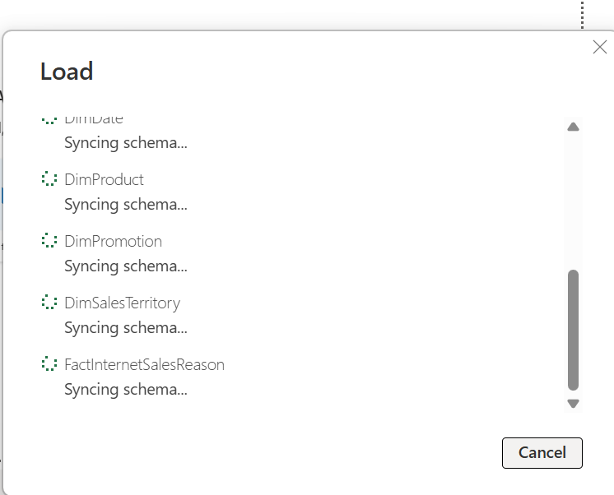
Import mode loads data from the data source into the Power BI model.
The data is stored inside the .pbix file, which allows very fast report performance and full use of Power BI features. However, the data must be refreshed to reflect updates in the source.
DirectQuery mode does not store data in the Power BI model. Instead, queries are sent directly to the data source each time a visualization is used. This ensures that the report always shows the latest data, but performance may be slower and some Power BI features are limited.

11.
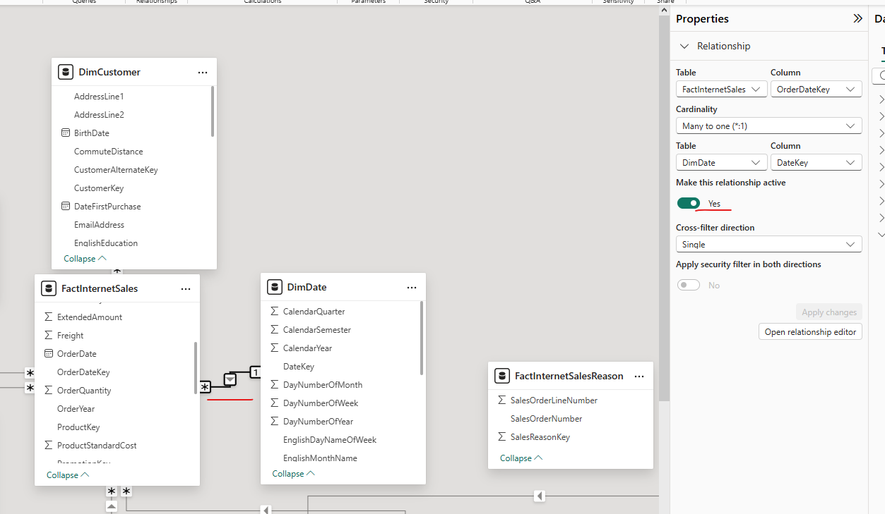
In the Model view, relationships between FactInternetSales and DimDate were reviewed. Multiple date relationships existed (OrderDate, ShipDate, DueDate). Since OrderDate is used as the main date for analysis, other relationships were removed and the OrderDate relationship was set as active.

