--1. PREREQUISITE TASK
SET search_path TO labs, public;
CREATE TABLE labs.person (
id integer NOT NULL,
name varchar(15)
);
INSERT INTO person VALUES(1, 'Bob');
INSERT INTO person VALUES(2, 'Alice');
INSERT INTO person VALUES(3, 'Robert');

EXPLAIN SELECT * FROM person;
EXPLAIN ANALYZE SELECT * FROM person;

/*EXPLAIN

Shows the query execution plan without actually running the query.
It tells you how PostgreSQL plans to execute the query (e.g., sequential scan, index scan, joins).

EXPLAIN ANALYZE

Runs the query and shows the actual execution plan with real performance statistics, including:
Actual execution time
Number of rows processed
Number of loops
It is used to analyze and optimize query performance.*/

--2.1 TASK 1 – PERFOMANCE WITH UNLLOGED TABLES

CREATE TABLE labs.test_simple(a int,b int);
EXPLAIN ANALYZE insert into test_simple values (generate_series(1,1000000));

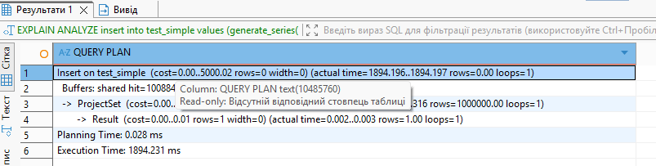

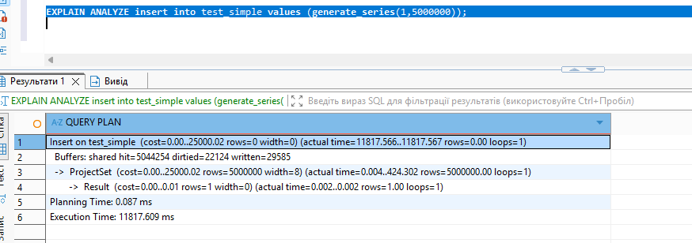

EXPLAIN ANALYZE Output Explanation
cost=startup..total
Estimated cost calculated by the optimizer (not real time).
- First number = startup cost
- Second number = total estimated cost
rows (estimated)
Estimated number of rows the operation will return.
width
Estimated average row size in bytes.
actual time=start..end
Real execution time in milliseconds.
- First number = time to first row
- Second number = total execution time
rows (actual)
Actual number of rows processed/produced.
loops
Number of times this operation was executed.
Buffers
Memory and disk activity:
- hit = pages read from cache
- dirtied = pages modified
- written = pages written to disk
Planning Time
Time spent building the execution plan.
Execution Time
Total real execution time of the query.

CREATE UNLOGGED TABLE labs.test_unlogged(a int,b int);
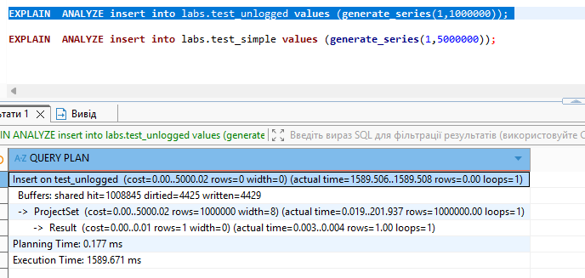
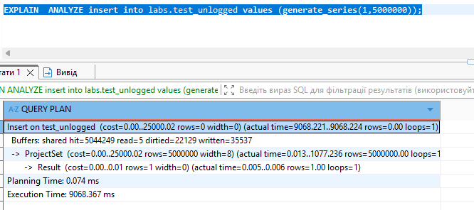
Execution, planning time is less comparing to insert to NOT unlogged table.
It is due to absence of WAL in unlogged tables
2.2 TASK 2 – UNDERSTANDING INHERITED TABLES
CREATE TABLE labs.users(user_id INT GENERATED BY DEFAULT AS IDENTITY
PRIMARY KEY, login VARCHAR(30)) INHERITS (labs.person);

INSERT INTO users(id, name, login) VALUES (1, 'new Bob', 'NewLogin');
INSERT INTO users(id, name, login) VALUES (999, 'TestUser', 'TestLogin');

SELECT * FROM users;

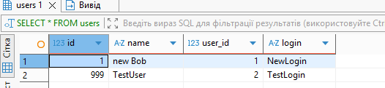

SELECT * FROM person;

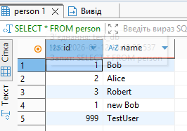

SELECT * FROM ONLY person;
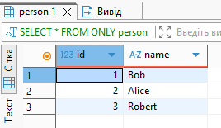

UPDATE person
SET name = 'not Bob'
where id = 1;

UPDATE ONLY person
SET name = 'Bob'
where id = 1;

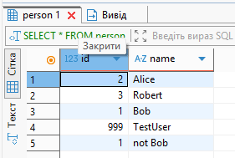

Due to ONLY name with id 1 was changed only in person table

ALTER TABLE person ADD COLUMN status integer DEFAULT 0;
ALTER TABLE person ADD CONSTRAINT status CHECK (status in (0,1)) NO
INHERIT;
ALTER TABLE person ADD CONSTRAINT id UNIQUE (id, name);

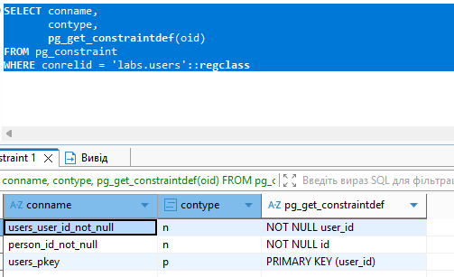

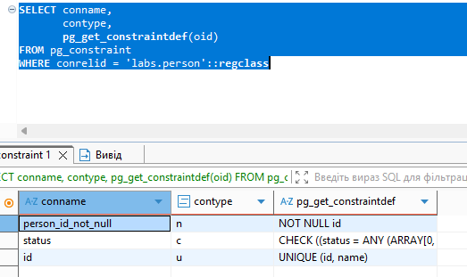

We can see that child tables don’t inherit parents constraints

3.1 TASK 3 - BRIN VS B-TREE

CREATE TABLE labs.test_index (
num float NOT NULL,
load_date timestamptz NOT NULL
);

INSERT INTO test_index(num, load_date)
SELECT random(), x
FROM generate_series('2017-01-01 0:00'::timestamptz,
'2021-12-31 23:59:59'::timestamptz, '10 seconds'::interval) x;

SELECT pg_size_pretty(pg_relation_size('labs.test_index'));

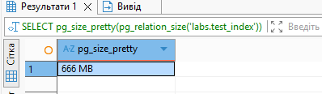

SELECT date_trunc('year', load_date), max(num)
FROM test_index
WHERE load_date BETWEEN '2021-09-01 0:00' AND '2021-10-31 11:59:59'
GROUP BY 1
ORDER BY 1;

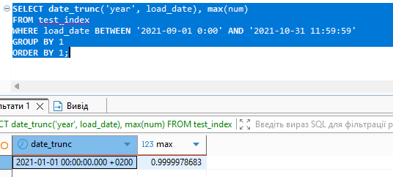
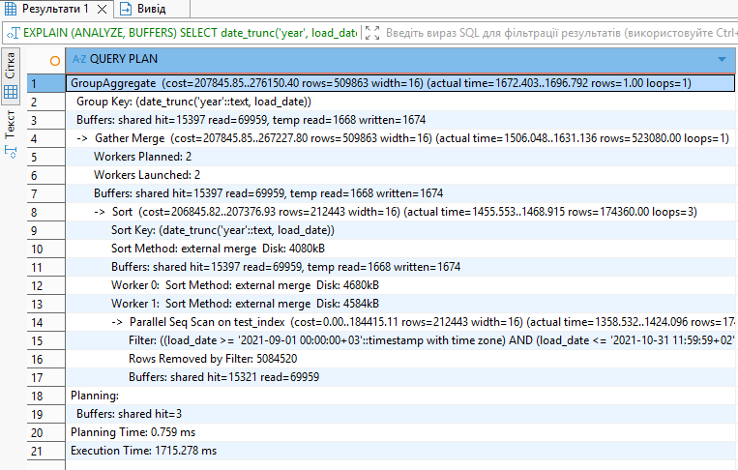
Execution time without index
CREATE INDEX test_idx ON labs.test_index(load_date);
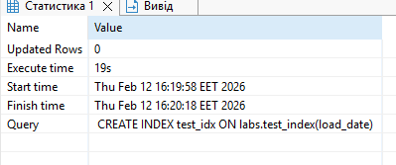

Repeated step 3

EXPLAIN (ANALYZE, BUFFERS)
SELECT date_trunc('year', load_date), max(num)
FROM labs.test_index
WHERE load_date BETWEEN '2021-09-01 0:00' AND '2021-10-31 11:59:59'
GROUP BY 1
ORDER BY 1;

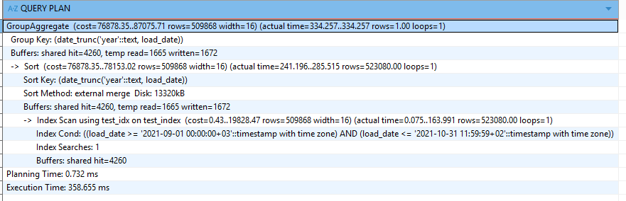
The execution time changed a lot from 1715ms =>358ms

Check the index size
SELECT pg_size_pretty(pg_relation_size('labs.test_idx'));
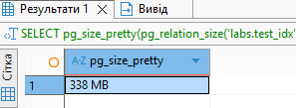
The B-Tree index size of 338 MB is relatively large and close to the table size. This is expected for a B-Tree index on a large time-series dataset, because it stores every indexed value along with row references in a tree structure.
CREATE INDEX test_idx ON labs.test_index USING brin (load_date);
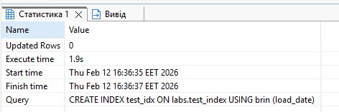
Took less time to create this index then B-tree
Step 3
EXPLAIN (ANALYZE, BUFFERS)
SELECT date_trunc('year', load_date), max(num)
FROM labs.test_index
WHERE load_date BETWEEN '2021-09-01 0:00' AND '2021-10-31 11:59:59'
GROUP BY 1
ORDER BY 1;
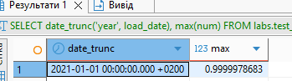
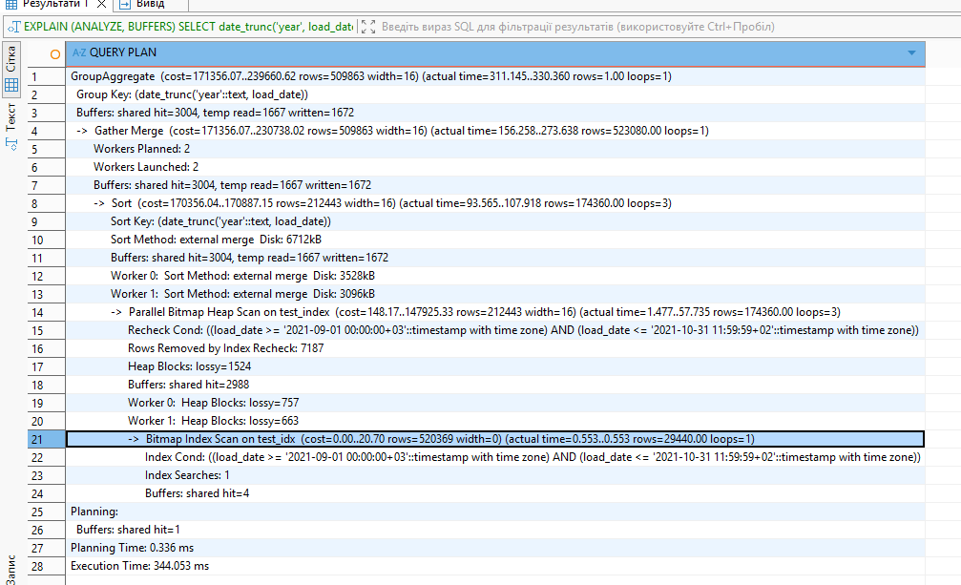
The execution time b-tree vs brin 358=>344
The brin index has less size
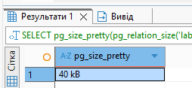

3.2 TASK 4 - GIN VS GIST
CREATE TABLE test_index AS SELECT id, md5(id::text) as t_hash
FROM generate_series(1, 10000000) AS id;
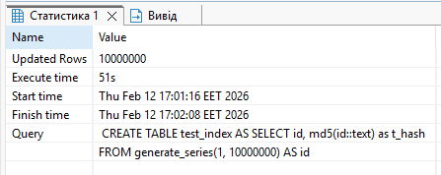
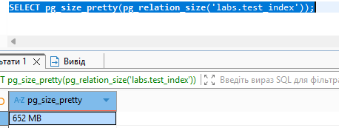
EXPLAIN ANALYZE SELECT * FROM test_index WHERE t_hash LIKE '%ceea167a5a%';
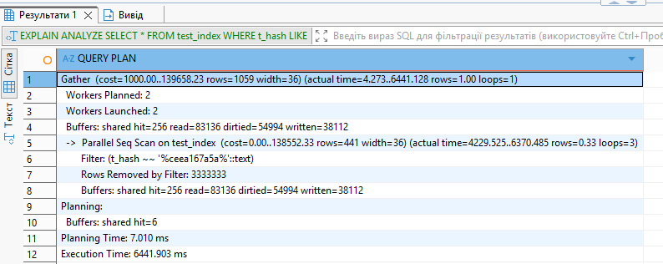

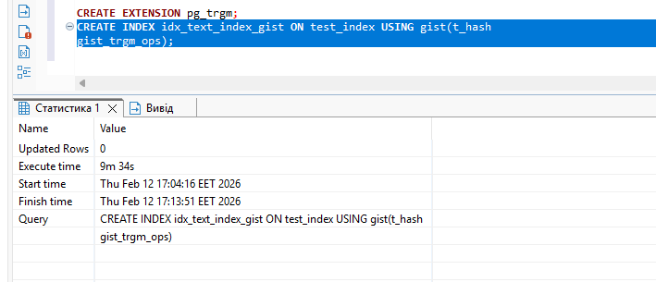
Took 9 minutes
This type of indexes is big
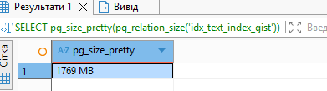
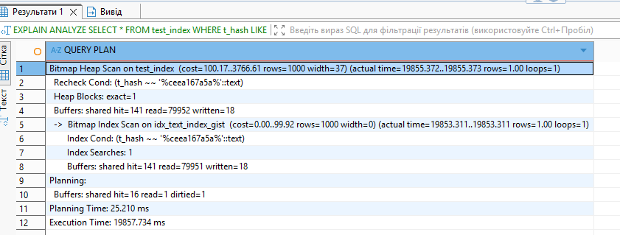
The time of select statement(execution time) is bigger then without index 6441=>19857, but cost is less 138552=>99.92
The index is larger than the table, so using it causes significantly more disk reads and random access operations. As a result, a parallel sequential scan can be faster than a Bitmap Index/Heap Scan when using a large trigram GiST index.
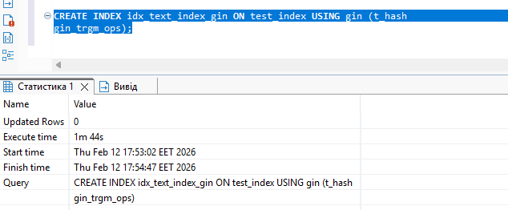
Took less time near 1min
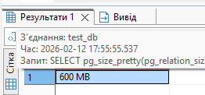
The size is less compared with gist 1769=>600mb
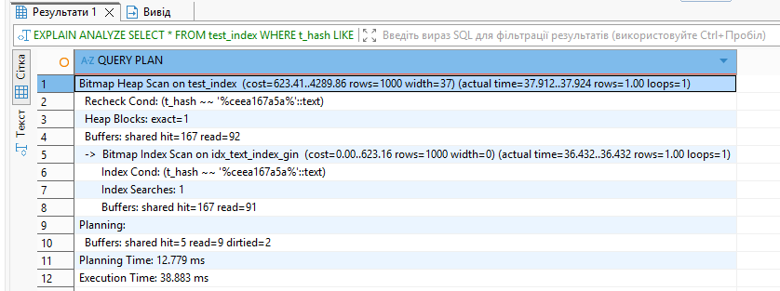
Execution time is less compered with gist 19857=>39ms, without index 6641=>39ms
GIN trigram index is significantly smaller and more efficient than the GiST trigram index.
Because it consumes less disk space and requires fewer disk reads, it dramatically improves query performance for LIKE '%...%' searches.
In this task, different indexing strategies were compared for pattern search queries. Without an index, PostgreSQL used a parallel sequential scan, which was slow on a large table. A GiST trigram index significantly increased index size and disk I/O, making performance worse than a sequential scan. In contrast, a GIN trigram index was much more compact and efficient, reducing disk reads and execution time dramatically. Therefore, for LIKE '%...%' searches on large text columns, a GIN trigram index is the most effective solution.

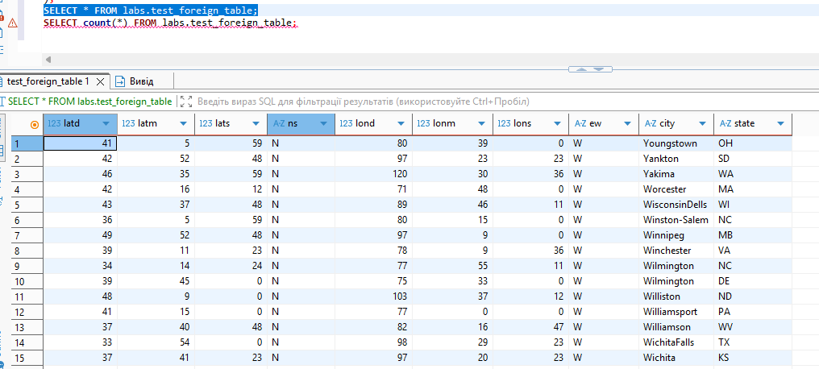
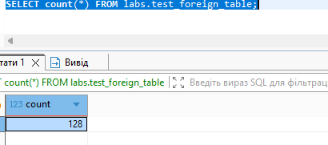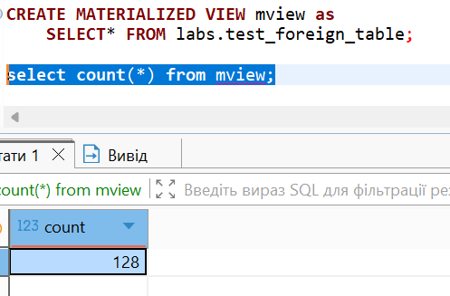
After deleting rows
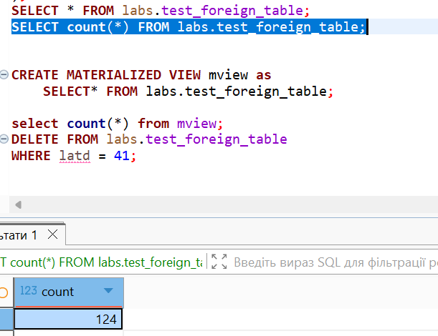
Materialized view the same count
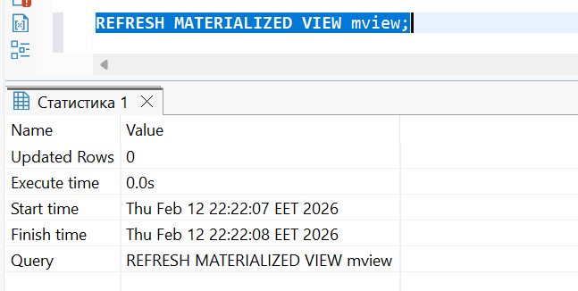
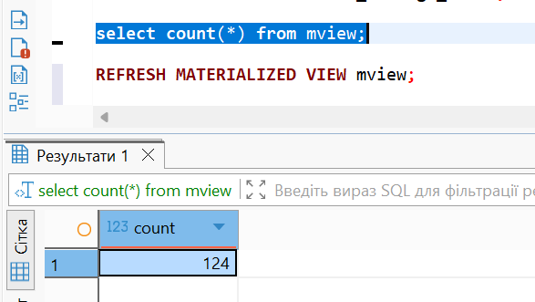

Foreign Data Wrapper (FDW) allows PostgreSQL to work with external data sources as if they were regular database tables.
File_fdw enables reading data directly from a CSV file without importing it into the database. It allows:
- querying external files using SQL,
- accessing external data transparently,
- comparing performance between a foreign table and a materialized view.
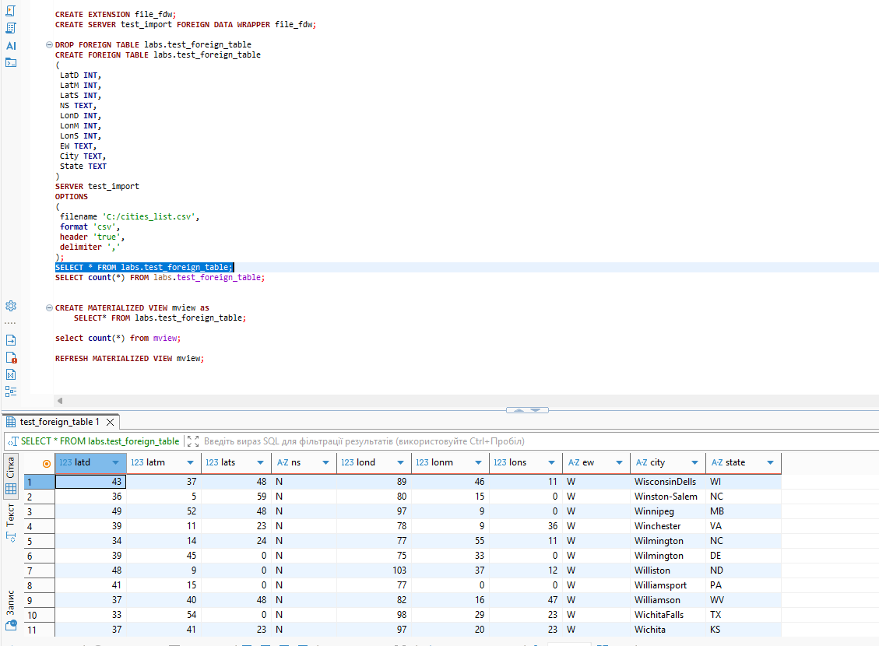
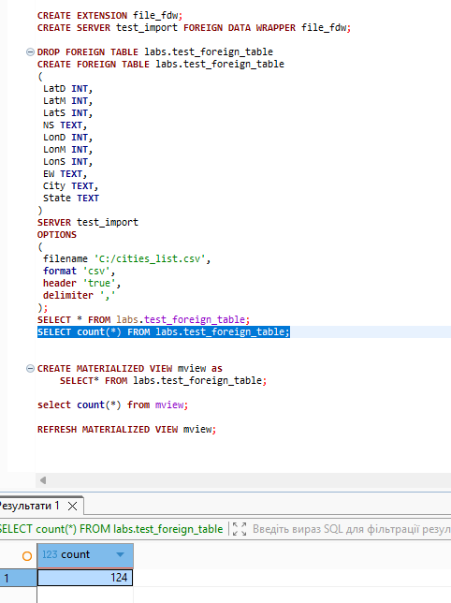
Missed that insert was made only for one column, corrected

