ETL Roles and Privilege Management Logic

Roles Created
Two types of roles were implemented:

1. bl_etl (NOLOGIN role)
- Technical group role.
- Contains all required permissions for the ETL process.
- Cannot log in directly.
- Used to centralize and manage ETL privileges in one place.

2. etl_user_template (LOGIN role)
- Reusable login role for running ETL processes.
- Inherits permissions from bl_etl.
- Does not contain direct object privileges.
- Can be assigned to multiple real users or service accounts.
This separation follows the role-based access control (RBAC) principle.

Privilege Granting Logic
The ETL role was granted only the minimum required permissions based on the principle of least privilege.

Database Level
- CONNECT privilege on database sales_project.

Schema Level
- USAGE on schemas:
  - sa_sales_pos
  - sa_sales_online
  - bl_cl
  - bl_3nf
  - bl_dm

Source Layer (SA)
- SELECT only (read-only access).

Cleansing Layer (BL_CL)
- SELECT, INSERT, UPDATE, DELETE
- EXECUTE on functions and procedures
- Access to sequences

3NF Layer (BL_3NF)
- SELECT, INSERT, UPDATE
- USAGE and SELECT on sequences
- EXECUTE on functions (if required)

Data Mart Layer (BL_DM)
- SELECT, INSERT, UPDATE
- USAGE and SELECT on sequences
- EXECUTE on functions

Default Privileges
Since all database objects are owned by postgres, default privileges were configured:
ALTER DEFAULT PRIVILEGES FOR ROLE postgres ...
This ensures that:
- Any new tables, sequences, or functions created by postgres
- Automatically grant the required privileges to bl_etl.
This prevents future permission errors and guarantees ETL stability.

Security Hardening
The login role was restricted with:
- NOSUPERUSER
- NOCREATEDB
- NOCREATEROLE
- NOREPLICATION
This ensures:
- The ETL user cannot escalate privileges.
- The user cannot create databases or roles.
- The system follows secure production standards.

Final Design Principles Applied
- Role-Based Access Control (RBAC)
- Separation of duties
- Principle of Least Privilege
- Future-proof privilege management using Default Privileges
- Secure service account configuration

Logging and Incremental Control (BL_CL)
bl_cl.mta_etl_log
Purpose: Centralized ETL execution log table.
Stores information about each procedure run: execution timestamp, procedure name, status (START / SUCCESS / ERROR), number of affected rows, message text, SQL error code (if any), and run identifier. It allows monitoring, troubleshooting, and validating repeatable execution (second run = 0 rows affected).
bl_cl.pr_log_write(...)
Purpose: Standardized logging procedure used by all load procedures.
Ensures consistent log records in mta_etl_log and avoids direct inserts into the log table inside each procedure.
bl_cl.mta_load_control
Purpose: Stores watermark values for batch incremental loading.
Key: (procedure_name, source_system, source_entity).
Main attribute: last_success_load_dts – the latest successfully processed load_dts from staging.
It enables incremental logic by loading only records with load_dts greater than the stored watermark.
Table CE_BRANDS
bl_cl.fn_prepare_ce_brands(p_last_dts_online, p_last_dts_pos) RETURNS TABLE
Purpose: Prepares a cleaned and deduplicated dataset of brands from staging sources.
Reads data from sa_sales_online.src_sales_online and sa_sales_pos.src_sales_pos.
Filters records incrementally using load_dts > watermark.
Applies trimming and NULL handling (COALESCE to 'n. a.').
Removes duplicates within the batch and calculates max(load_dts) for proper watermark update.
Returns: brand_name, source_system, source_entity, source_id, max_load_dts.
bl_cl.fn_is_brand_name_valid(p_name text) RETURNS boolean
Purpose: Validates brand names to prevent loading spam-like or corrupted values into the 3NF layer.
Rejects NULL values.
Enforces length between 2 and 60 characters.
Allows only letters, digits, spaces, dot (.), hyphen (-), apostrophes (' , ’) and ampersand (&).
Requires at least two alphabetic characters.
Rejects values where non-alphanumeric characters exceed 40% of the total length.
Returns TRUE for valid brand names and FALSE otherwise.
bl_cl.fn_prepare_ce_brands_validated(p_last_dts_online, p_last_dts_pos) RETURNS TABLE
Purpose: Applies validation logic to the prepared brand dataset.
Uses a FOR LOOP over the result of fn_prepare_ce_brands.
Calls fn_is_brand_name_valid for each record.
Returns only valid brand rows using RETURN NEXT.
Implements the requirement “Use For Loop over query result” and additional RETURNS TABLE logic.
bl_cl.pr_load_ce_brands()
Purpose: Loads CE_BRANDS using batch incremental logic.
Ensures control rows exist in mta_load_control.
Reads watermark values.
Writes START log entry.
Inserts default row (-1, 'n. a.') if not present.
Performs idempotent upsert from fn_prepare_ce_brands_validated using ON CONFLICT with update only when values differ.
Calculates affected row count.
Updates watermark using max(max_load_dts).
Writes SUCCESS log entry.
Handles errors in EXCEPTION block and logs ERROR with SQLSTATE and message.
CHECKS
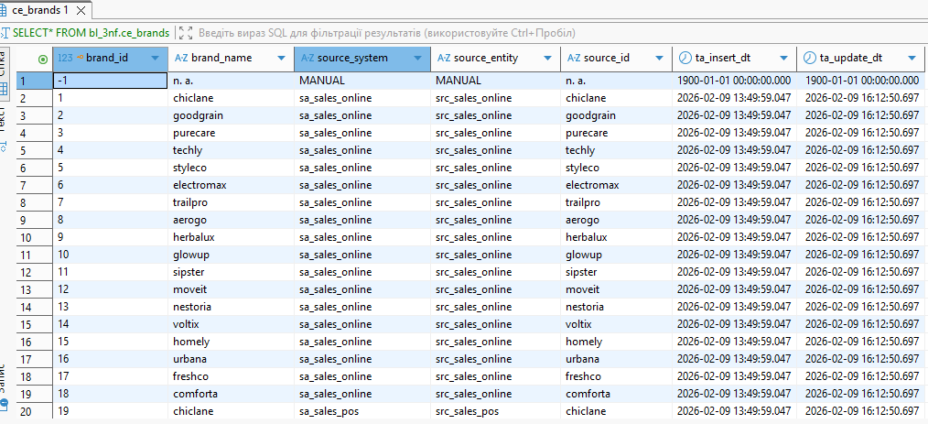
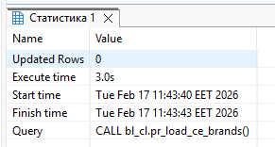
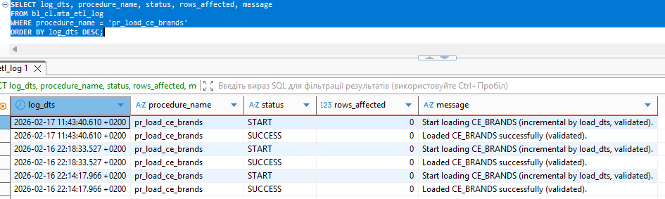
Since the brands table was already populated with data that was no different from the data from the source with BL_SA, the procedure did not insert new rows.
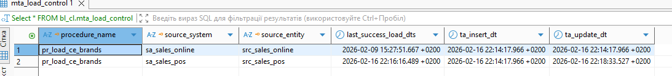
As part of testing, I deleted the BL_3NF schema, recreated it, and executed the load procedure again. The result was that only the default row (-1, 'n. a.') was inserted.
This behavior occurred because the incremental load mechanism relies on the watermark (last_success_load_dts) stored in BL_CL.MTA_LOAD_CONTROL. Since the watermark had been updated during the previous successful load, it was greater than the current max(load_dts) in the staging tables. Therefore, no records satisfied the incremental condition:
load_dts > last_success_load_dts
This confirms that the incremental logic functions correctly and prevents reloading already processed data.
To handle such scenarios (for example, after truncating or recreating target tables), a controlled full reload mechanism was implemented using a procedure parameter:
p_full_reload = true
When this parameter is set to true, the procedure ignores the stored watermark and performs a full reload of the target table. When p_full_reload = false (default behavior), the procedure performs standard incremental loading.
This approach was selected because it follows production best practices:
- Full reload is an expensive operation and must be executed intentionally.
- Automatic full reload based solely on an empty target table may cause unexpected heavy processing.
- Using an explicit parameter ensures operational control and predictability.
- Incremental behavior remains stable and consistent across executions.
- The system supports both incremental and full reload modes in a controlled and transparent manner.
Therefore, the implemented solution guarantees correct incremental loading while providing a safe and explicitly controlled full reload option when required.
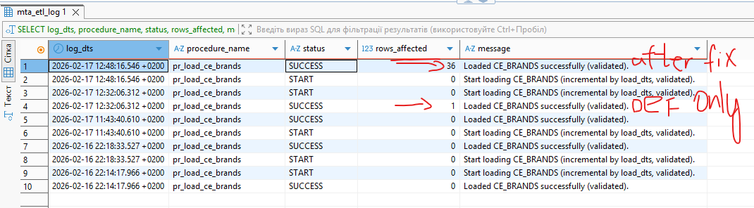
CALL bl_cl.pr_load_ce_brands(false); -- Incremental load
CALL bl_cl.pr_load_ce_brands(true); -- Full reload
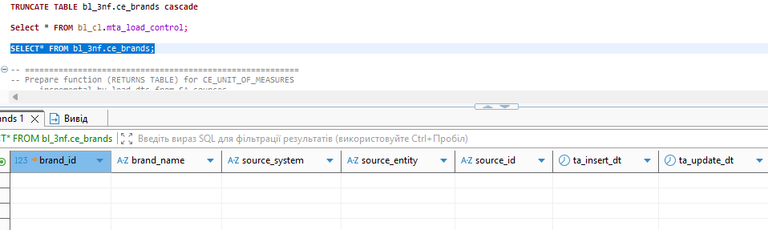
Table after truncate command
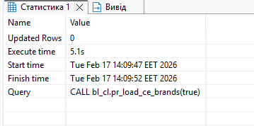
CALL bl_cl.pr_load_ce_brands(true); -- Full reload
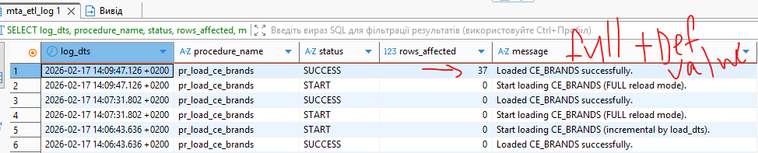

Table CE_UNIT_OF_MEASURES
bl_cl.fn_prepare_ce_unit_of_measures(p_last_dts_online, p_last_dts_pos) RETURNS TABLE
Purpose: Prepares a cleaned and deduplicated dataset of units of measure from staging sources.
Reads data from both staging systems.
Applies incremental filter using load_dts > watermark.
Cleans and normalizes values (trim, COALESCE to 'n. a.').
Removes duplicates and calculates max(load_dts) for watermark update.
Returns: uom_name, source_system, source_entity, source_id, max_load_dts.
bl_cl.pr_load_ce_unit_of_measures()
Purpose: Loads CE_UNIT_OF_MEASURES using incremental SCD Type 0 logic.
Ensures control rows exist in mta_load_control.
Reads watermark values.
Writes START log entry.
Inserts default row (-1, 'n. a.') if not present.
Inserts new units using ON CONFLICT DO NOTHING (no updates for SCD0).
Calculates affected row count.
Updates watermark using max(max_load_dts).
Writes SUCCESS log entry.
Handles errors in EXCEPTION block and logs ERROR accordingly.
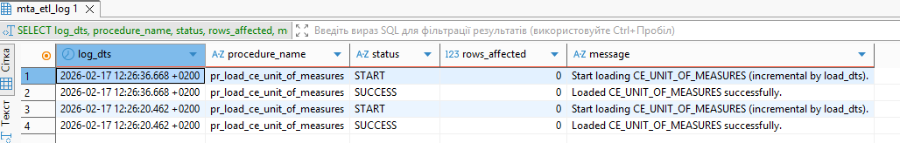
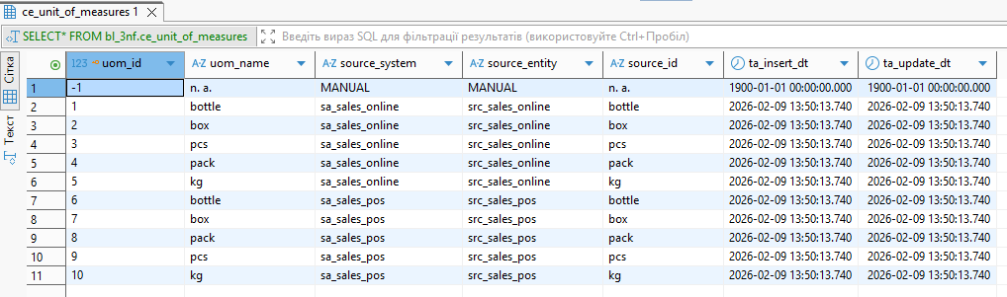
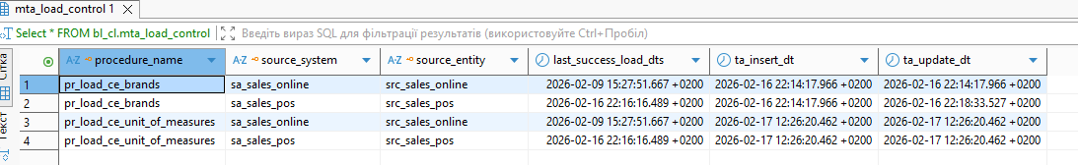
Since the brands table was already populated with data that was no different from the data from the source with BL_SA, the procedure did not insert new rows.

After deleted this table -> run procedure without fix=> inserted only 1 default row
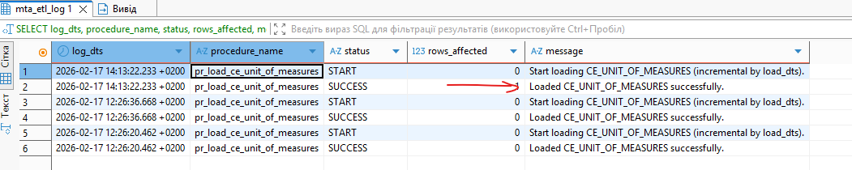
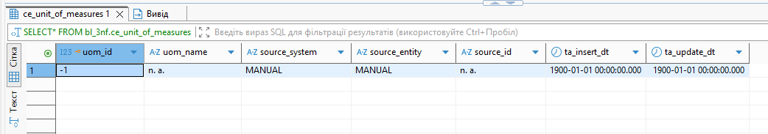

CALL bl_cl.pr_load_ce_unit_of_measures(true);
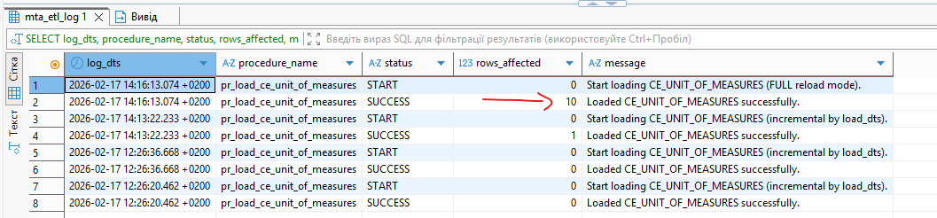
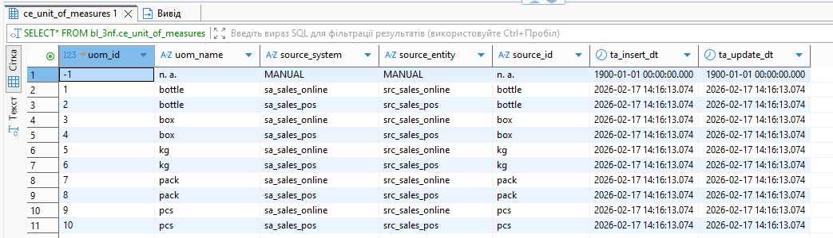
CALL bl_cl.pr_load_ce_unit_of_measures();

Run again to recheck
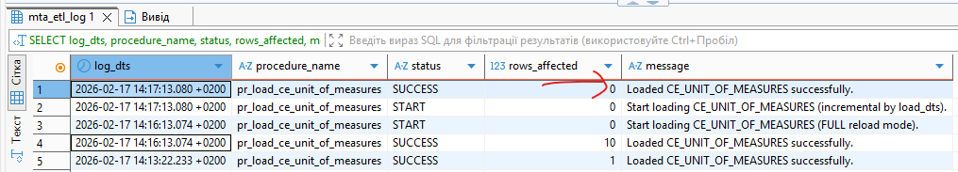
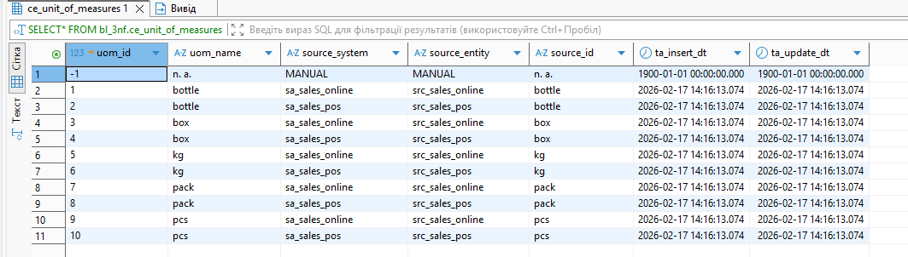
No dublicates

The logic for creating functions and procedures for the other tables (except ce_transactions and ce_customers) is the same as for the previous ones (ce_brands, ce_units_of_measures).
Next, I will demonstrate the results of successful tests. The first execution of the procedure is performed on an empty table, and the second run of the procedure should not produce duplicate records.

Table CE_SUPPLIERS
FIRST RUN
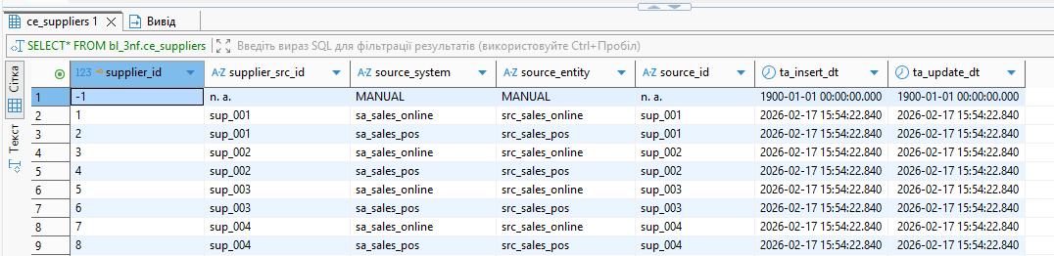
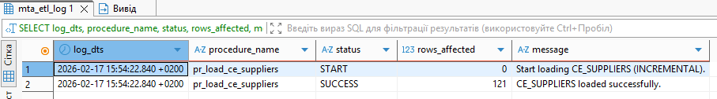
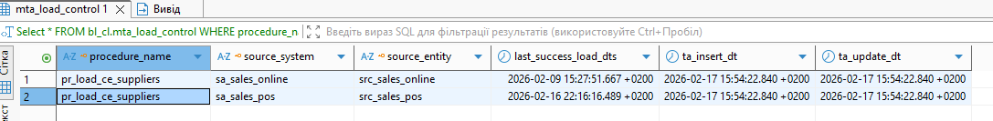

SECOND RUN
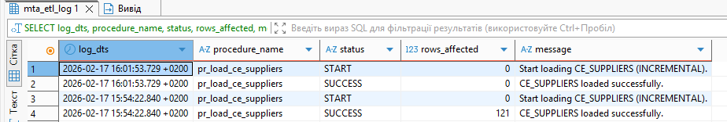
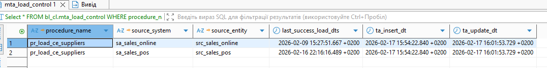

Table CE_ PRODUCT_DEPARTMENTS

FIRST RUN
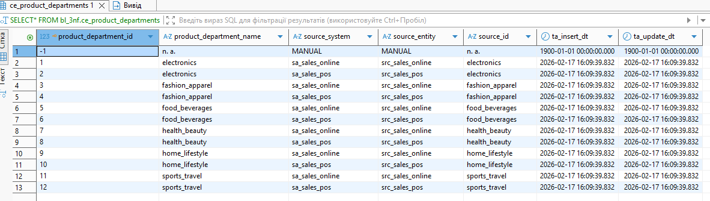
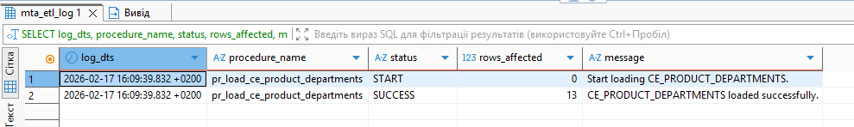
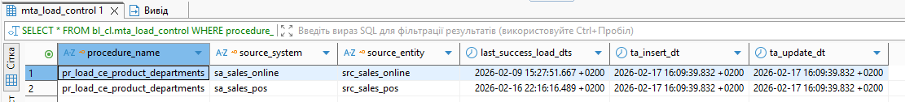

SECOND RUN
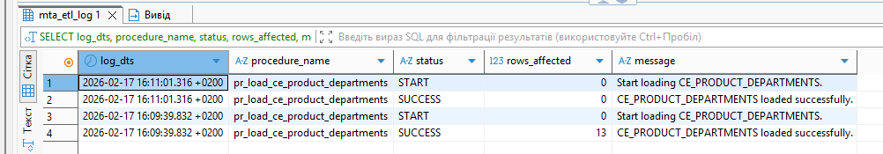
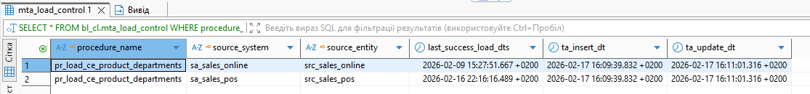
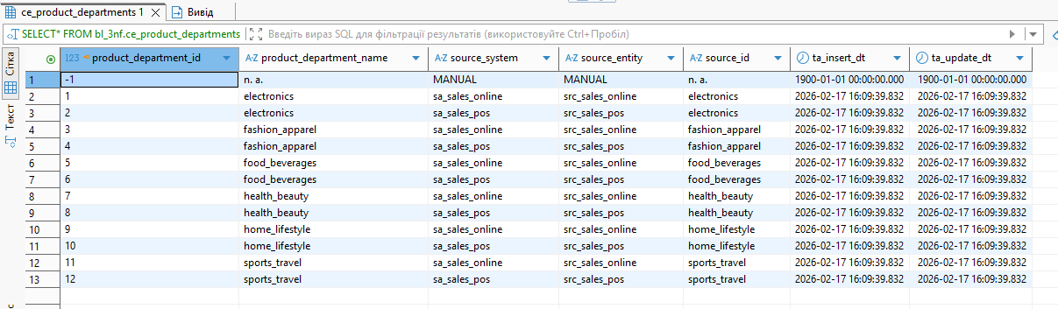

Table CE_ PRODUCT_SUBCATEGORIES

FIRST RUN
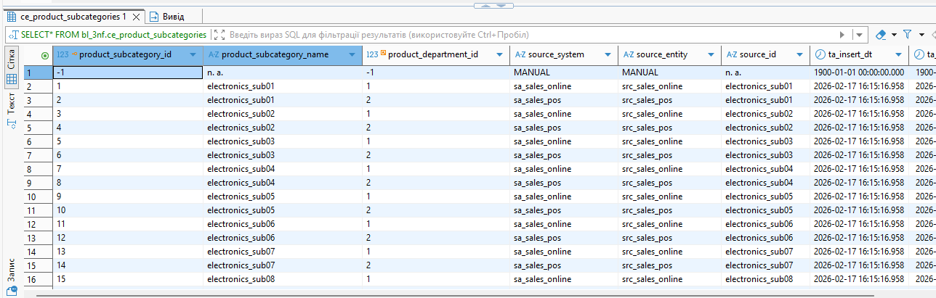
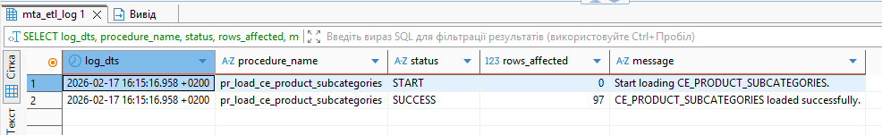
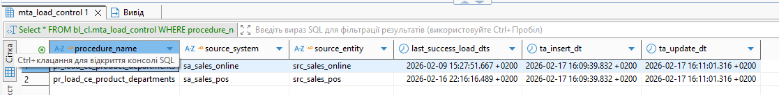

SECOND RUN
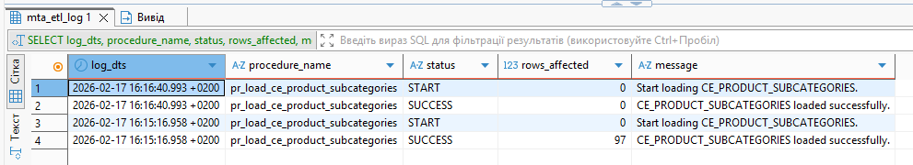
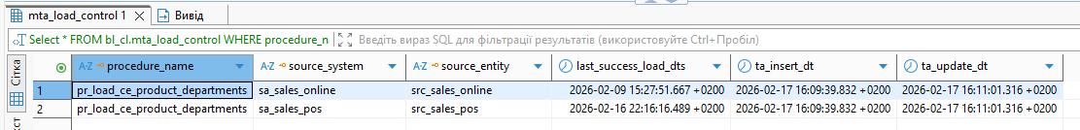
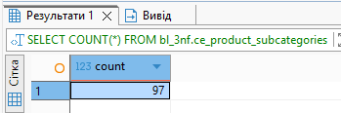

Table CE_ PRODUCTS

FIRST RUN
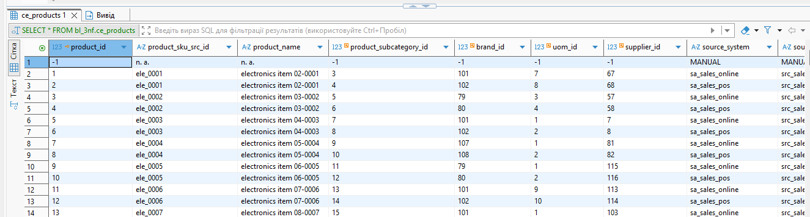
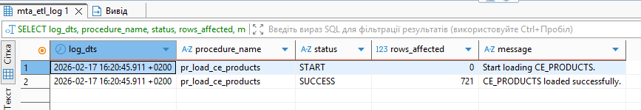
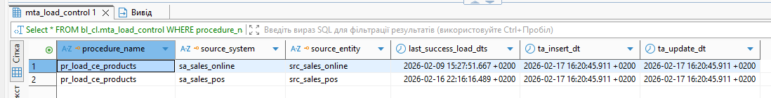

SECOND RUN
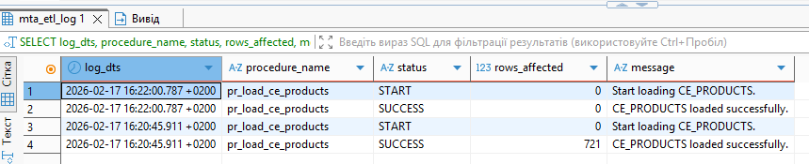
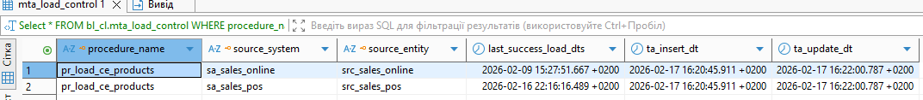
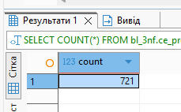

Table CE_ PROMOTIONS

FIRST RUN
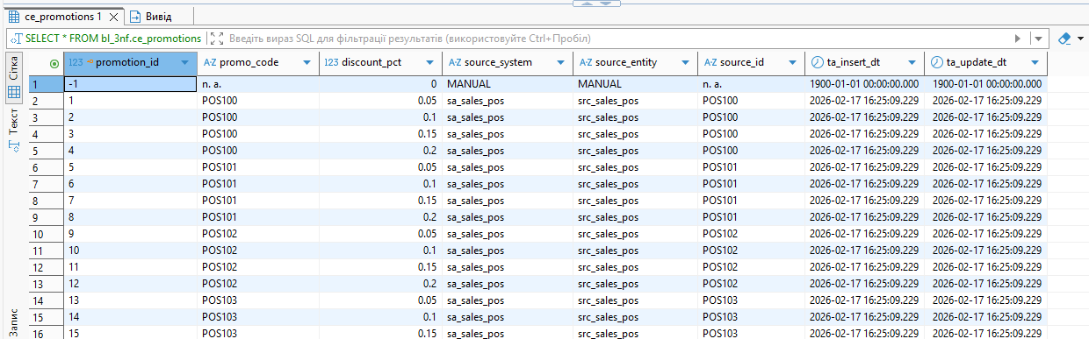
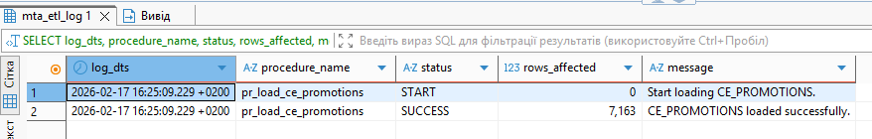

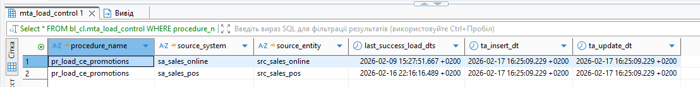

SECOND RUN
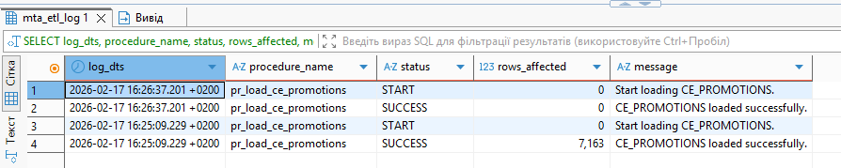
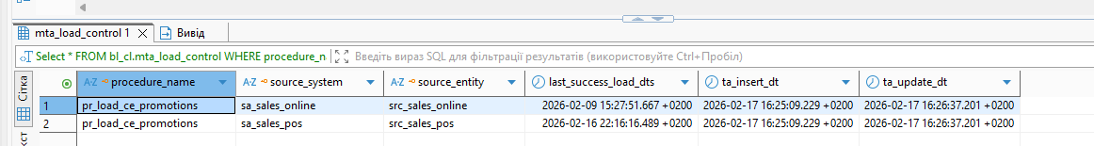
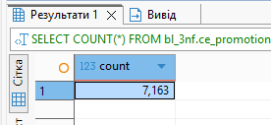

Table CE_ COUNTRIES

FIRST RUN
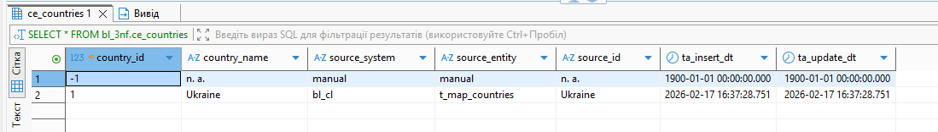
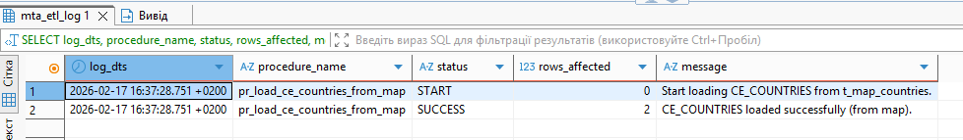
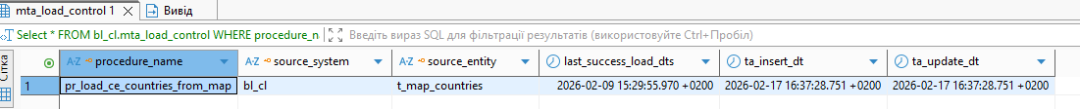

SECOND RUN
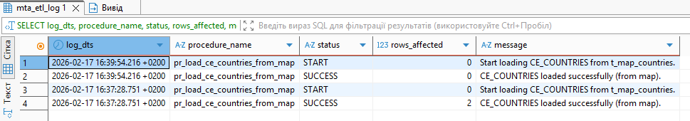
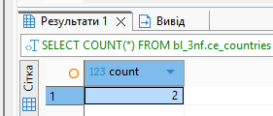

Table CE_ REGIONS

FIRST RUN

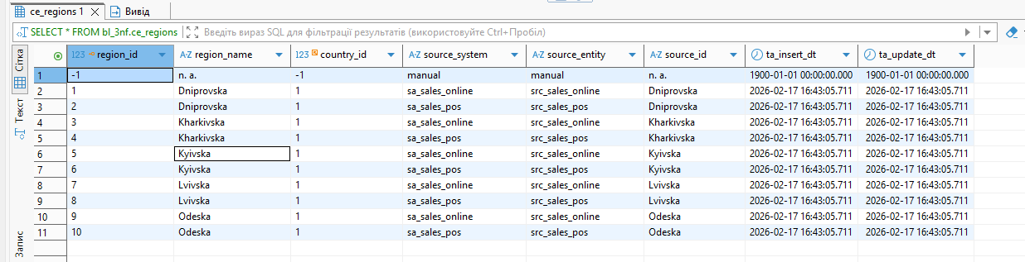
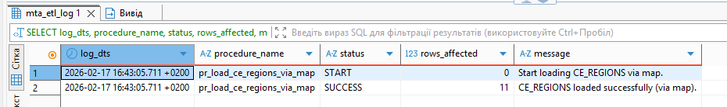
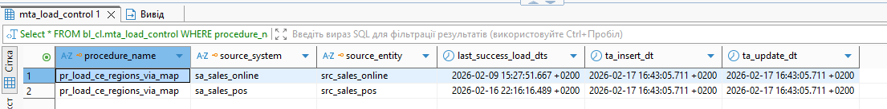

SECOND RUN

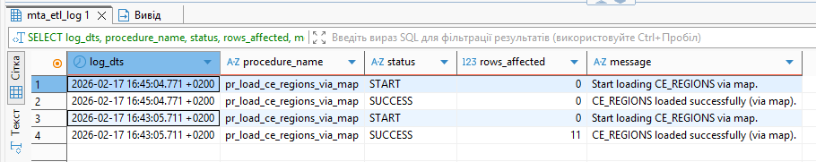
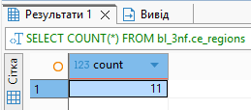

Table CE_ CITIES

FIRST RUN
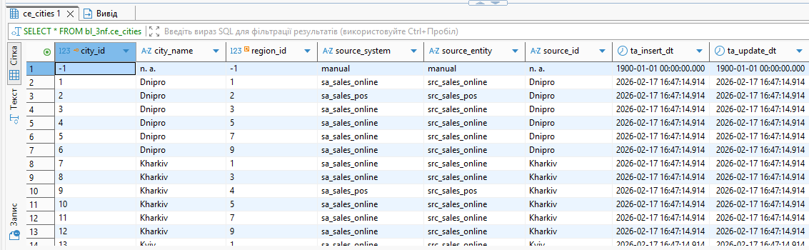
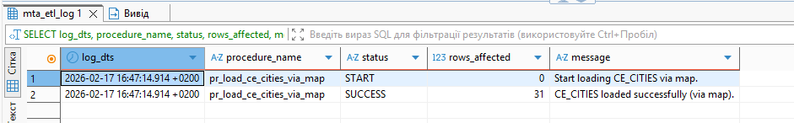
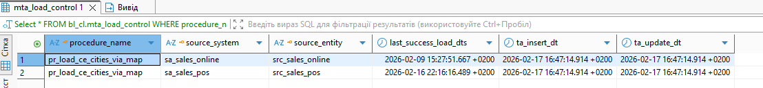

SECOND RUN
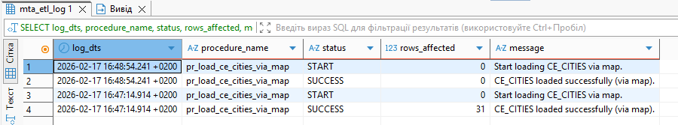
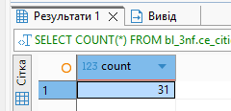

Table CE_STORE_FORMATS

FIRST RUN
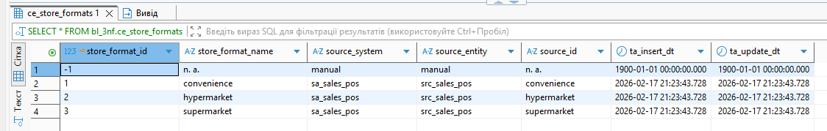
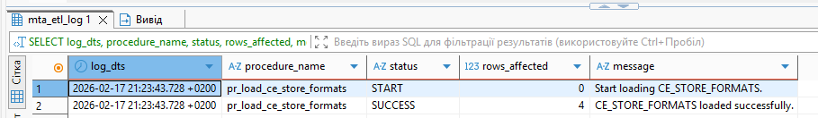
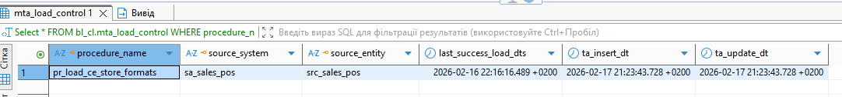

SECOND RUN
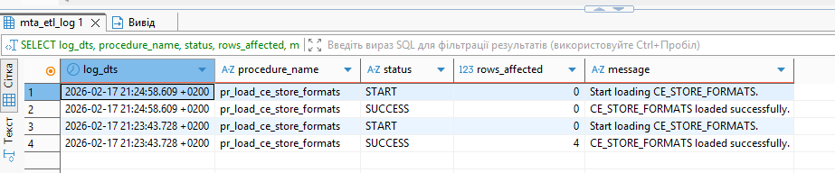
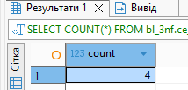

Table CE_STORES

FIRST RUN
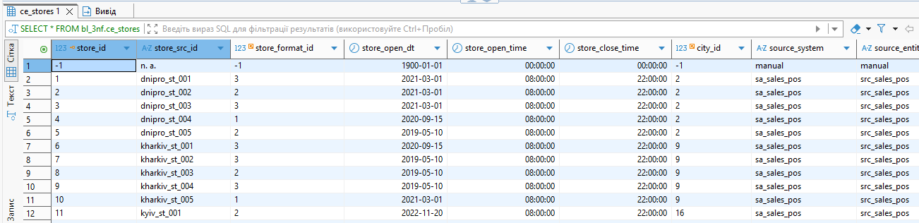
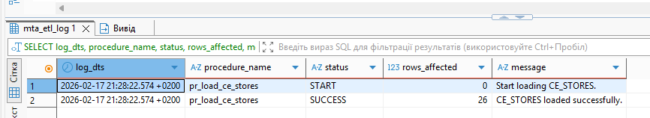
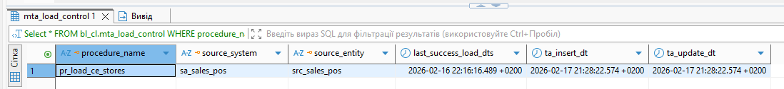SECOND RUN
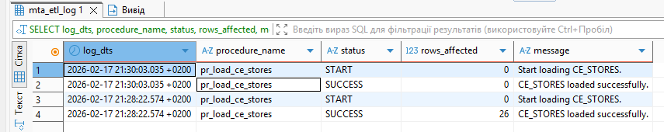
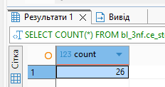

Table CE_DELIVERY_ADDRESSES
FIRST RUN
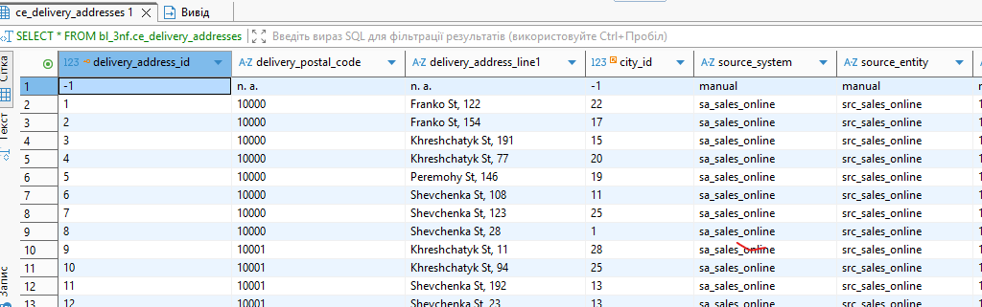
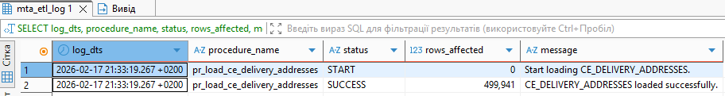
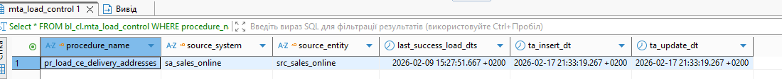
SECOND RUN
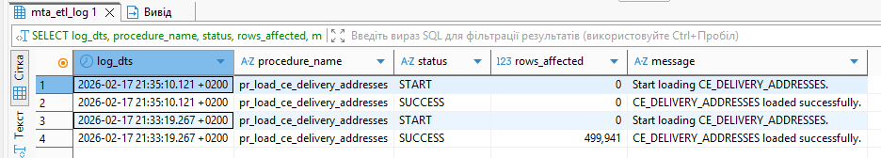
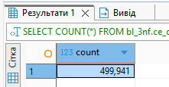

Table CE_FULFILLMENT_CENTERS
FIRST RUN +SECOND
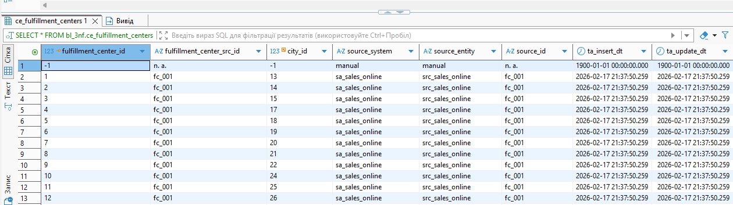
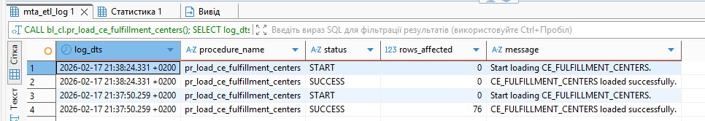
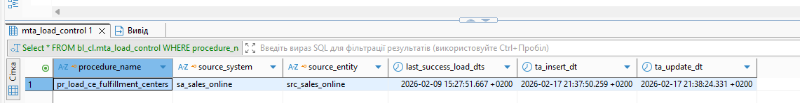

Table CE_DELIVERY_TYPES

FIRST RUN
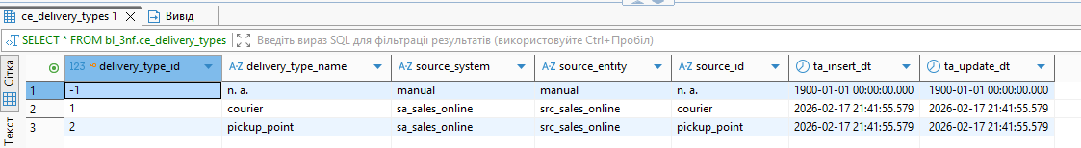
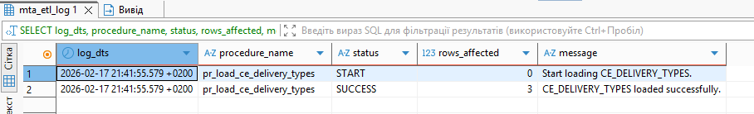
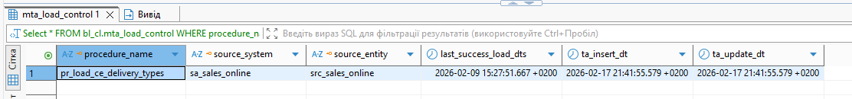
SECOND RUN
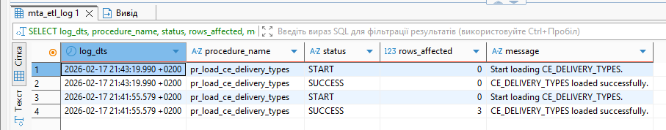
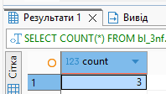

Table CE_ CE_DELIVERY_PROVIDERS

FIRST RUN
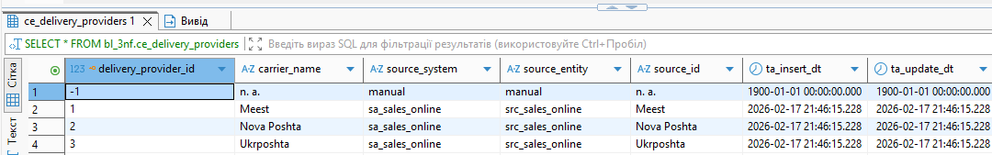
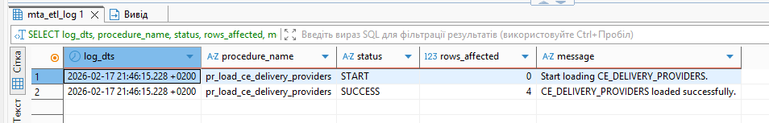
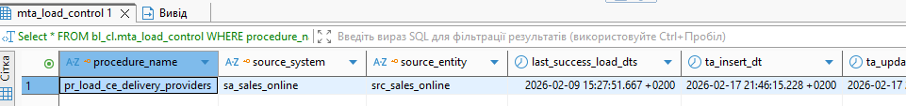
SECOND RUN
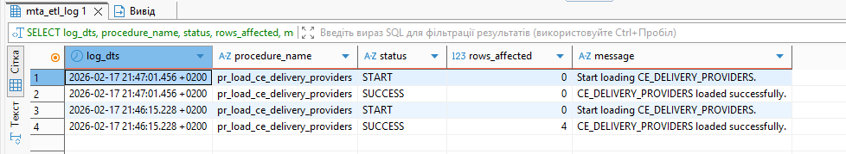
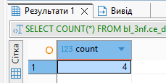

Table CE_ CE_SALES_CHANNELS

FIRST RUN
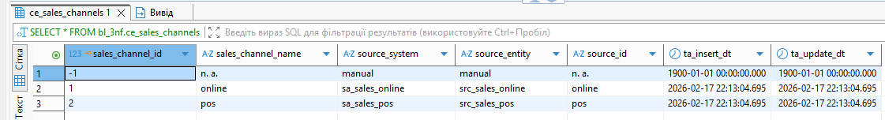
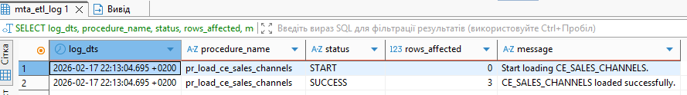
SECOND RUN
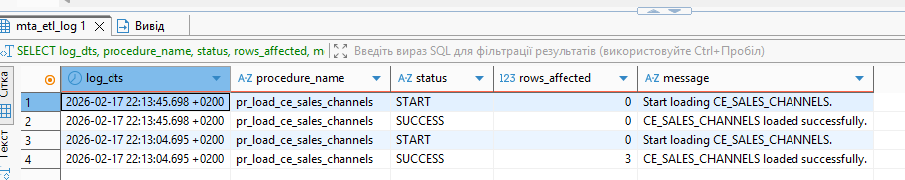
Table CE_PAYMENT_METHODS

FIRST RUN
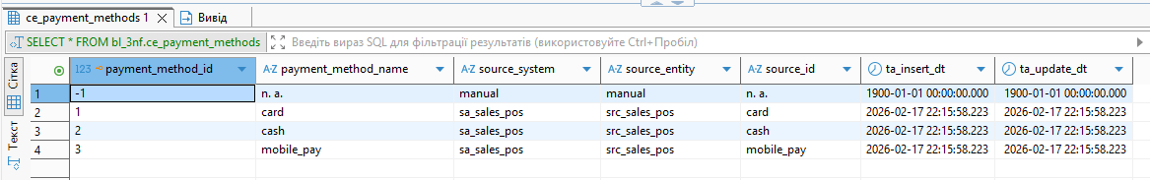
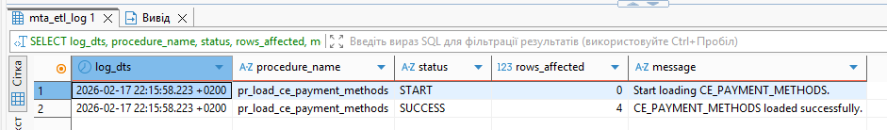

SECOND RUN
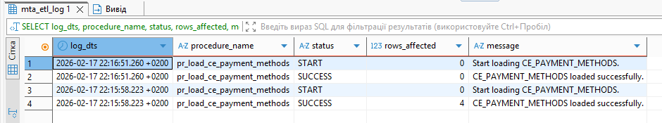
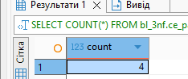

Table CE_PAYMENT_GATEWAYS

FIRST RUN
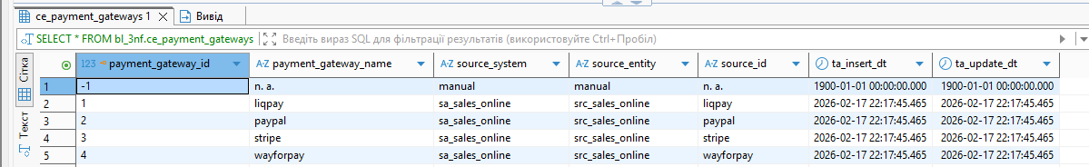
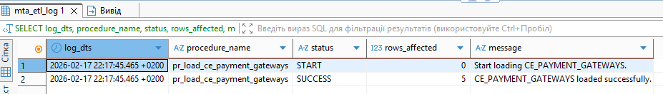

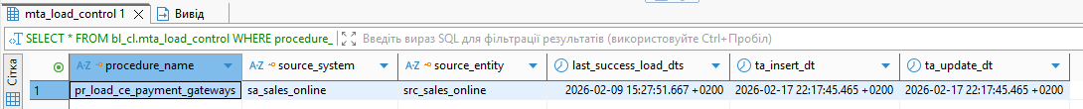
SECOND RUN
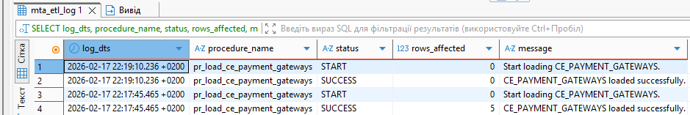
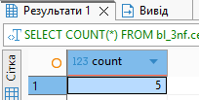

Table CE_ORDER_STATUSES

FIRST RUN
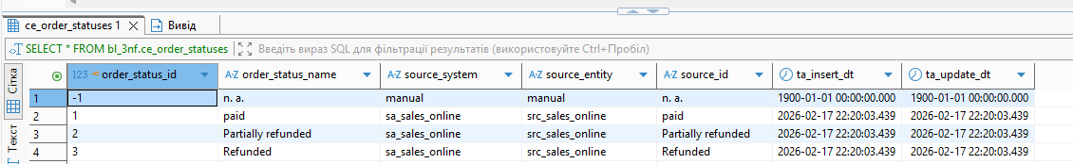
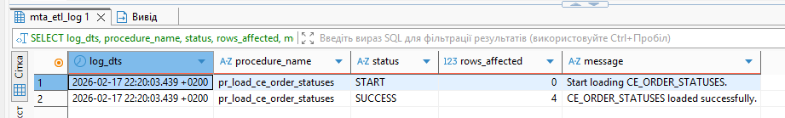
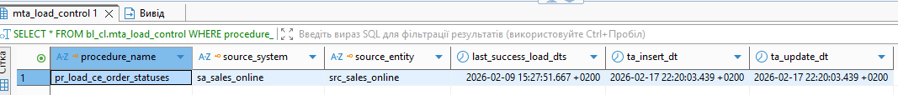

SECOND RUN
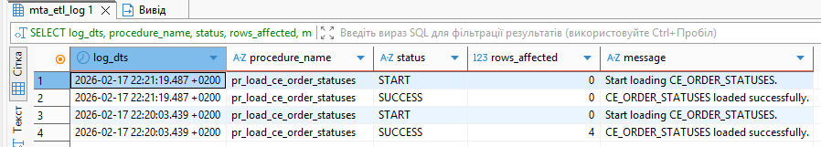
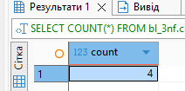

Table CE_RECEIPT_TYPES

FIRST RUN
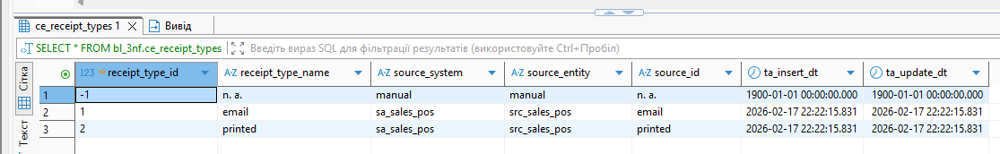
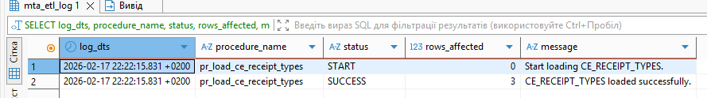
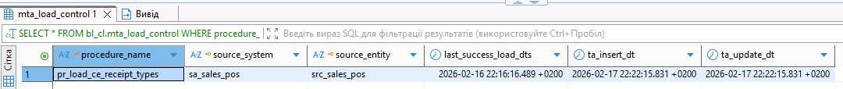
SECOND RUN
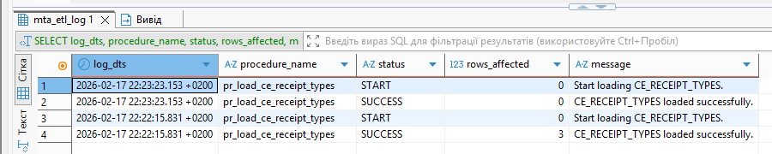
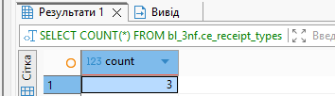

Table CE_CARD_TYPES

FIRST RUN
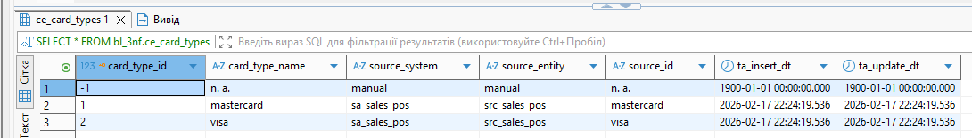
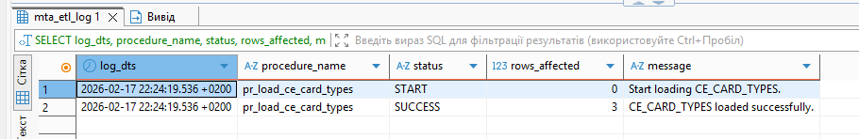
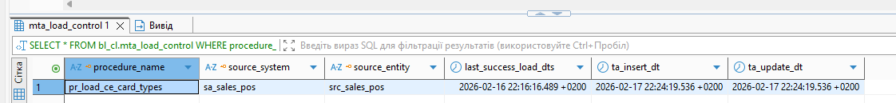
SECOND RUN
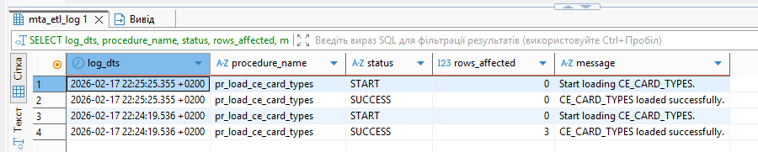
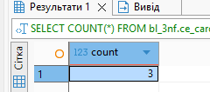

Table CE_DEVICE_TYPES

FIRST RUN
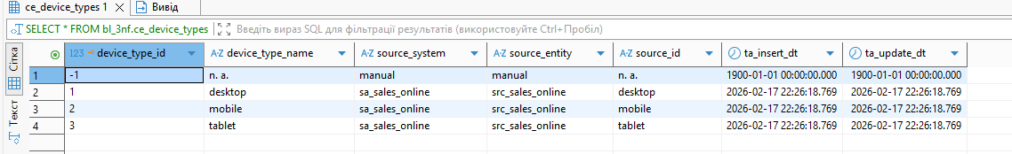
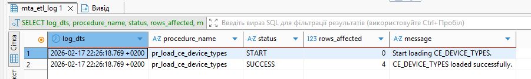
SECOND RUN
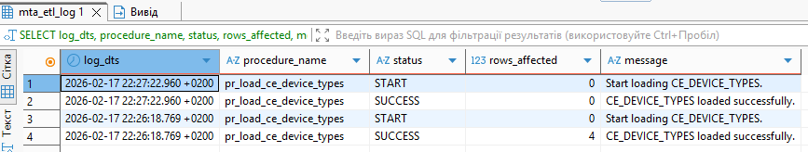
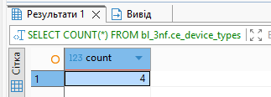

Table CE_TERMINAL_TYPES

FIRST RUN
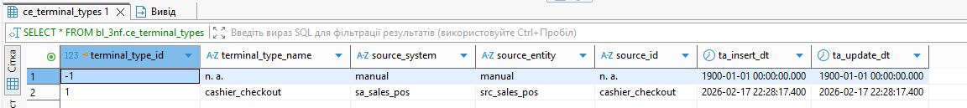
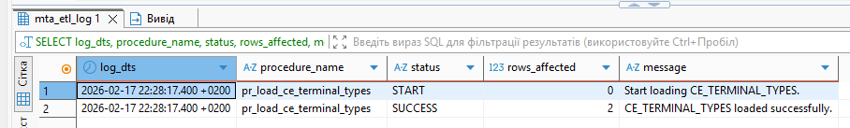

SECOND RUN
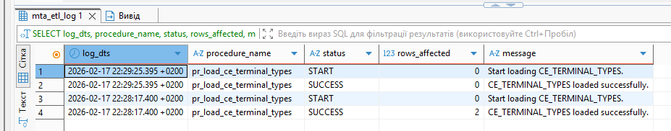

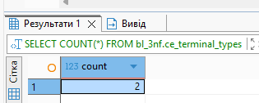

Table CE_TERMINALS (POS)
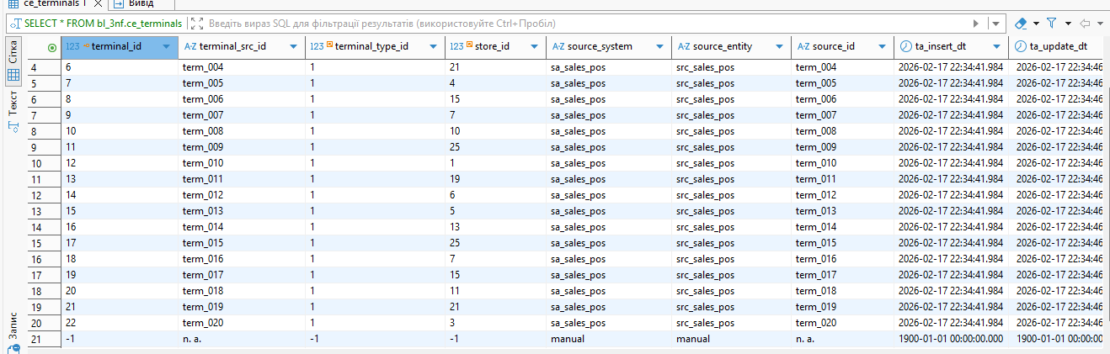
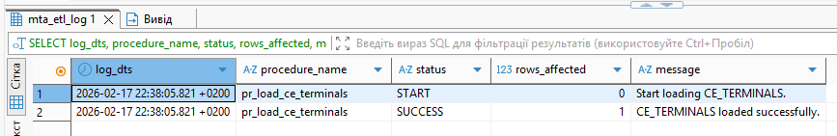
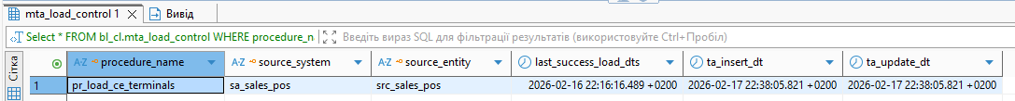
Here I had some some problems with reusable. I checked insert with my DML script. Inserted data. Corrected function. As data have been already inserted. After procedure 0 rows were inserted

Table CE_SHIFTS
FIRST RUN
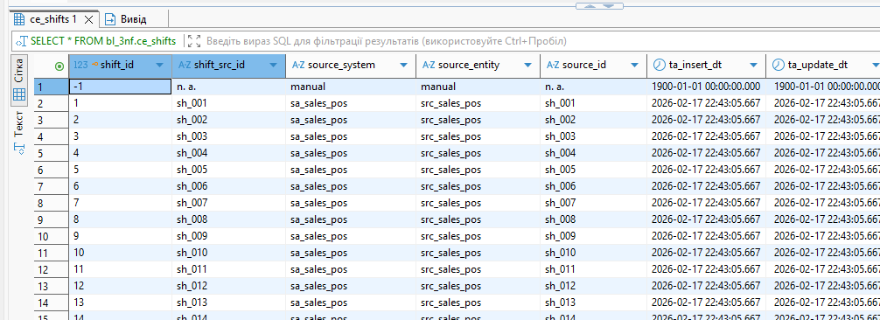
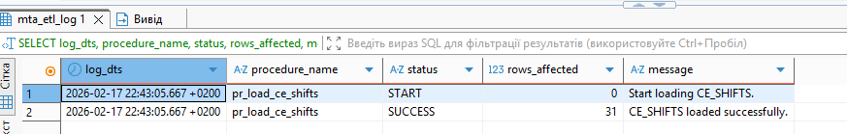
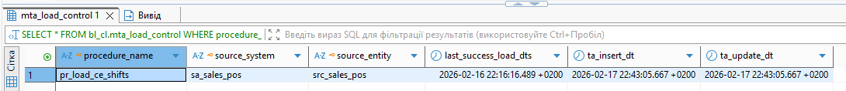
SECOND RUN
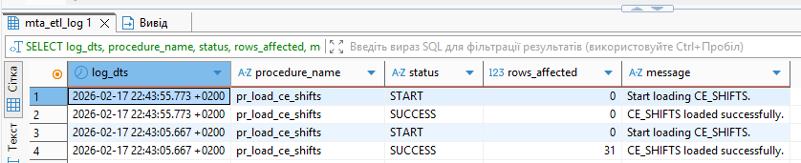
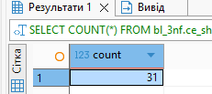

Table CE_EMPLOYEES
FIRST RUN
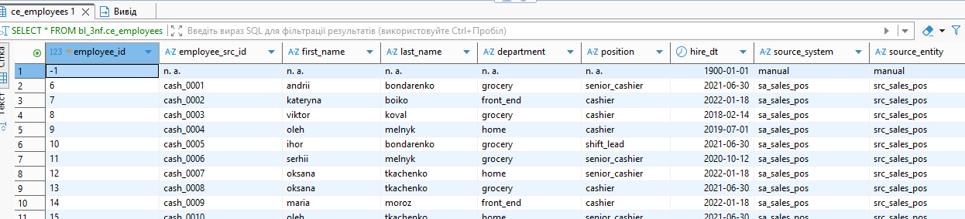
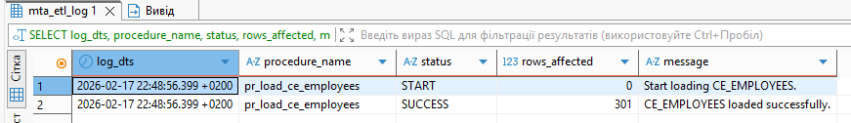
SECOND RUN
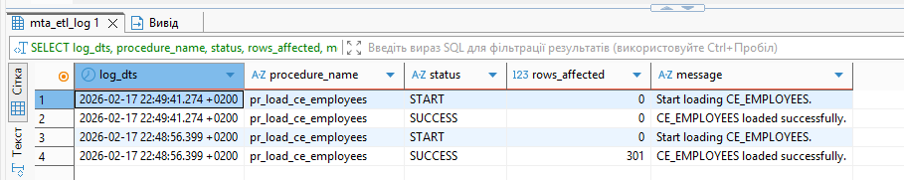
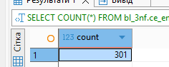

Table CE_CUSTOMERS_SCD

FIRST RUN
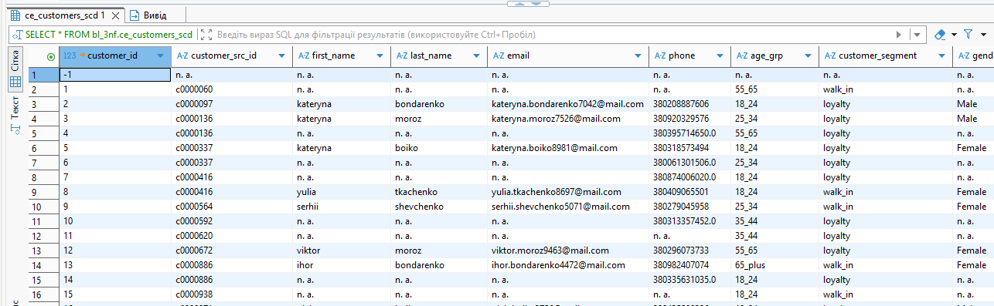
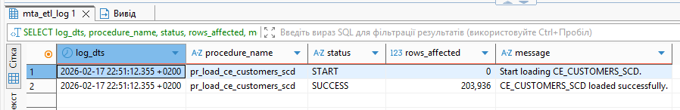

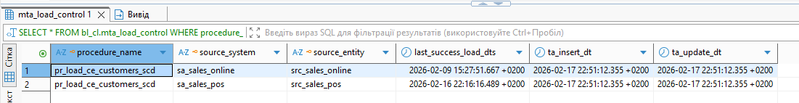
SECOND RUN
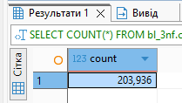
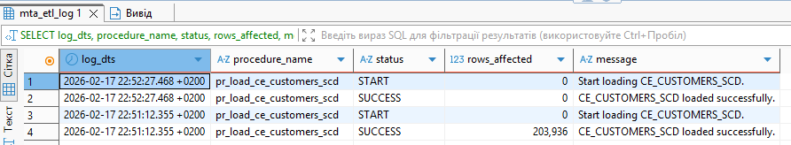

I implemented additional logging logic compared to the initial version. When a new transaction containing updated customer data was processed (e.g., updating one customer), two rows were affected due to SCD Type 2 logic. Therefore, I adjusted the logging structure and separated it into distinct sections to accurately capture and display insert and update operations.

Check SCD type 2
New transaction with new customer’s data

Call procedure
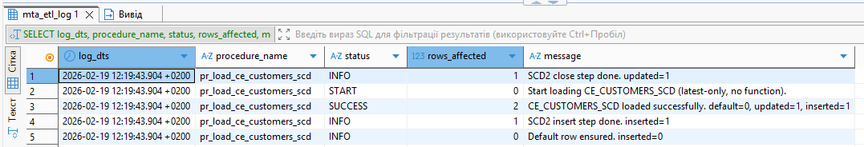

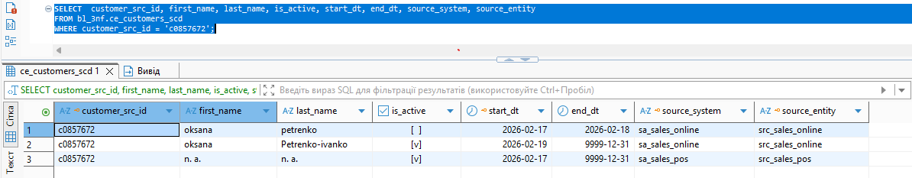

Execution Summary

The procedure executed successfully and performed the following actions:

START
- The ETL process began.
- Log entry created with status START.

SCD2 Close Step (UPDATE)
- 1 active customer record was identified as changed.
- The previous version was:
  - Set to is_active = false
  - Closed with end_dt = CURRENT_DATE - 1
- Log entry:
  - Status: INFO
  - updated = 1

SCD2 Insert Step (INSERT)
- 1 new version of the customer was inserted.
- The new record:
  - start_dt = CURRENT_DATE
  - end_dt = 9999-12-31
  - is_active = true
- Log entry:
  - Status: INFO
  - inserted = 1

Default Row Check
- The default record (customer_id = -1) already existed.
- No new default row was inserted.
- Log entry:
  - Status: INFO
  - inserted = 0

SUCCESS (Final Result)
- Total affected rows = 2
  - updated = 1
  - inserted = 1
  - default = 0
- Log entry:
  - Status: SUCCESS
  - rows_affected = 2

Final Outcome
For one customer:
- 1 old record was closed
- 1 new active record was created

Second run Check

