DIM_PRODUCTS

Logic of the pr_validate_na_only Procedure
The purpose of the pr_validate_na_only procedure is to validate data quality in the 3NF layer before loading data into the Dimensional Model (DM).
The procedure performs the following steps:
- Counts occurrences of the value 'n.a.' in a specified column of a given 3NF table.
The comparison is case-insensitive and ignores leading/trailing spaces.
- Ignores the default row from the previous layer.
The default record (e.g., where the primary key equals -1) is excluded from validation to prevent false warnings.
- If any 'n.a.' values are found:
  - A WARN record is written into the logging table with the total count.
  - A refcursor is opened to retrieve the first N example rows (e.g., 5).
  - Each example is logged individually, including the 3NF primary key value.
- If no 'n.a.' values are found, the procedure completes without logging warnings.
This validation step ensures that invalid or placeholder values from the previous layer are detected before loading data into the DM layer, while properly ignoring predefined default records.

Methods Used in the Implementation of pr_validate_na_only
The validation procedure was implemented using several advanced PL/pgSQL techniques:

Dynamic SQL (EXECUTE)
The procedure uses dynamic SQL to build queries at runtime based on input parameters (table name, column name, primary key column).
This makes the procedure fully reusable for different 3NF tables and columns without hardcoding object names.
Dynamic SQL is used for:
- Counting 'n.a.' values
- Selecting example rows for logging

Refcursor (Cursor Variable)
A refcursor is used to retrieve the first N example rows containing 'n.a.'.
The refcursor:
- Opens a dynamic SELECT statement
- Fetches rows one by one
- Logs each example separately
- Closes after processing
This demonstrates row-by-row processing while still keeping the main ETL logic set-based.

Cursor Loop (FETCH + LOOP)
Inside the refcursor logic, a loop is used:
- OPEN cursor FOR EXECUTE ...
- FETCH cursor INTO record
- EXIT WHEN NOT FOUND
- Log each example row
This allows controlled iteration over validation results and ensures that only a limited number of example rows (e.g., 5) are logged.

Parameterized and Reusable Design
The procedure accepts:
- Table name
- Column name
- Primary key column
- Default PK value to ignore
- Optional source filters
This makes the validation logic generic and scalable across multiple dimensions.

Logging Integration
The procedure integrates with the centralized logging mechanism (pr_log_write), ensuring:
- Full traceability of validation steps
- Clear separation of START / WARN / SUCCESS messages
- Auditable ETL execution

Conclusion
The implementation demonstrates:
- Use of dynamic SQL for flexibility
- Use of refcursor for controlled row-level validation
- Proper exclusion of default records
- Structured logging for auditability
- Reusable and scalable ETL validation design

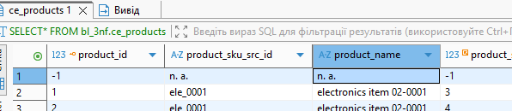
UPDATE bl_3nf.ce_products
SET product_name = 'n.a.'
WHERE product_id = 1;

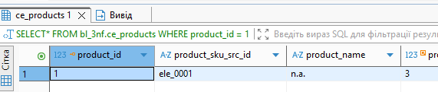
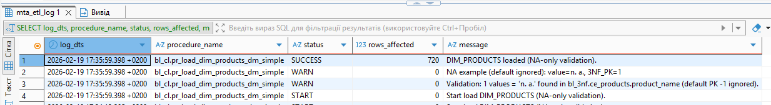
From the logs we can see that the procedure bl_cl.pr_load_dim_products_dm_simple is working correctly:
- START record confirms that the procedure began execution.
- WARN record (Validation) shows that the validation procedure detected 1 value equal to 'n.a.' in the 3NF table.
It also clearly states that the default row (PK = -1) was ignored, which confirms that the validation correctly excludes predefined default records.
- WARN record (Example) logs a specific example of the detected 'n.a.' value along with its 3NF primary key, proving that the refcursor correctly retrieved sample problematic rows.
- SUCCESS record confirms that the dimension was loaded successfully and shows that 720 rows were inserted/updated, meaning the main ETL process executed properly.

Logic of the Procedure bl_cl.pr_load_dim_products_dm_simple
The procedure pr_load_dim_products_dm_simple is responsible for loading data from the 3NF layer (bl_3nf) into the Dimensional Model layer (bl_dm), specifically into the dim_products table.
We used a composite type (t_source_ctx) to store source/lineage metadata (source layer/entity and DM lineage constants) as a single structured object. This reduces hardcoded string duplication in the ETL procedure and makes the code cleaner and easier to maintain while fulfilling the requirement to use composite types.
The procedure performs the following steps:

Start Logging
At the beginning, the procedure writes a START record into the centralized logging table (mta_etl_log).
This ensures traceability and auditability of the ETL execution.

Data Validation (NA Check)
Before loading data into the DM layer, the procedure calls the validation procedure pr_validate_na_only.
This validation:
- Checks for values equal to 'n.a.' in the product_name column.
- Ignores the predefined default row (e.g., where product_id = -1).
- Logs warnings and example rows if such values are found.
This step ensures basic data quality control before the load.

Data Transformation and Loading (Set-Based Logic)
The procedure performs a set-based INSERT…SELECT from multiple 3NF tables:
- ce_products
- ce_product_subcategories
- ce_product_departments
- ce_brands
- ce_unit_of_measures
- ce_suppliers
It joins these tables to construct the full dimensional record.

Lineage Tracking
When inserting into dim_products, the procedure populates technical lineage fields:
- source_system = 'BL_3NF'
- source_entity = 'CE_PRODUCTS'
- source_id = product_id (Primary Key from 3NF)
This guarantees traceability from the DM layer back to the 3NF layer.

Upsert Logic (Repeatable Execution)
The procedure uses:
ON CONFLICT (source_system, source_entity, source_id)
This ensures:
- If the record does not exist → INSERT
- If it already exists → UPDATE only if values changed
This makes the procedure repeatable:
- Running it multiple times on unchanged data results in rows_affected = 0.

Success Logging
At the end, the procedure logs a SUCCESS record, including the number of rows inserted or updated.
If any error occurs, an ERROR record is written into the log.

Key Implementation Techniques Used
- ✔ Set-based SQL (efficient bulk loading)
- ✔ UPSERT (ON CONFLICT) for idempotent loads
- ✔ Dynamic validation procedure
- ✔ Refcursor usage in validation
- ✔ Centralized logging mechanism
- ✔ Data lineage tracking

Conclusion
The procedure implements a controlled, auditable, and repeatable ETL process from the 3NF layer to the Dimensional Model.
It ensures data quality validation, proper lineage tracking, and consistent behavior across multiple executions.

SECOND RUN

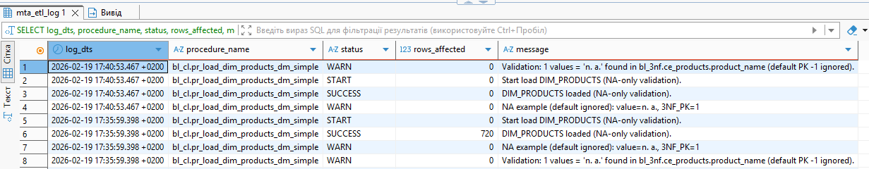

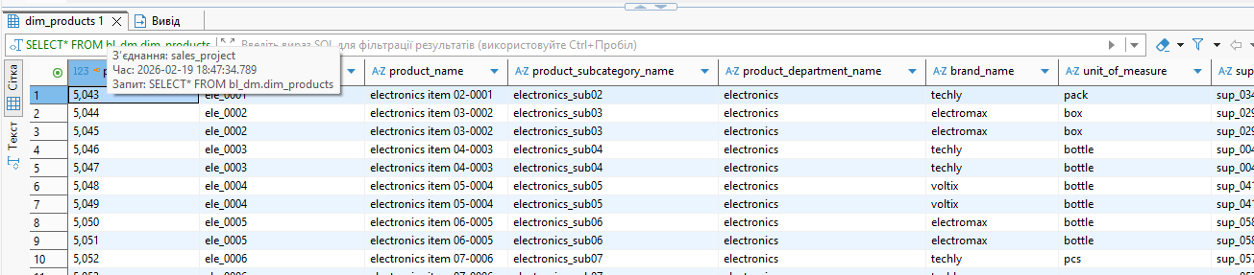
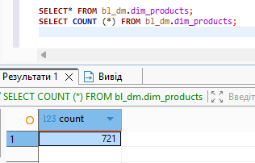
SECOND RUN 720 +default row inserted before

DIM_STORES

First run
✔ Composite type (t_source_ctx)
✔ Validation procedure (pr_validate_na_only)
✔ Ignore default row (store_id = -1)
✔ Data lineage (BL_3NF → CE_STORES → store_id)
✔ UPSERT (repeatable execution)
✔ Centralized logging
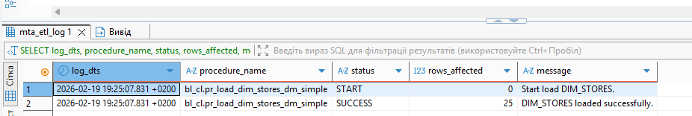

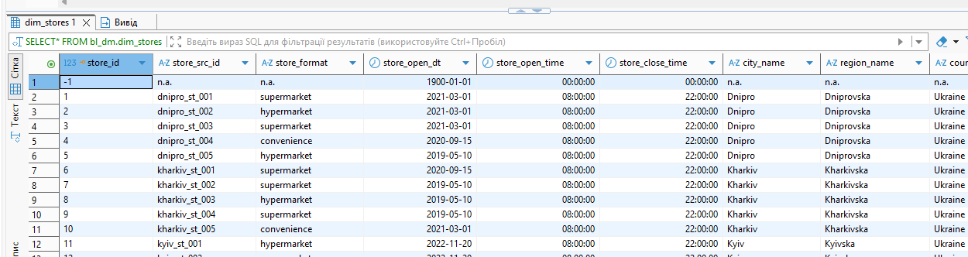

Second run
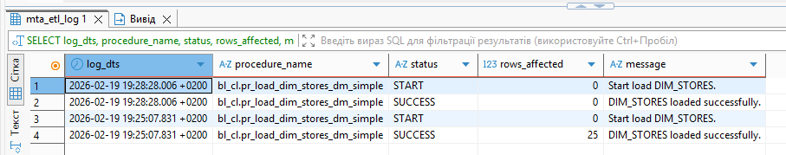

DIM_TERMINALS
✔ Composite type (t_source_ctx)
✔ Validation procedure (pr_validate_na_only)
✔ Ignore default row
✔ Data lineage
✔ UPSERT (repeatable execution)
✔ Centralized logging

FIRST RUN
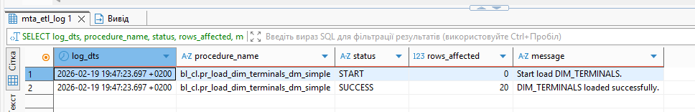
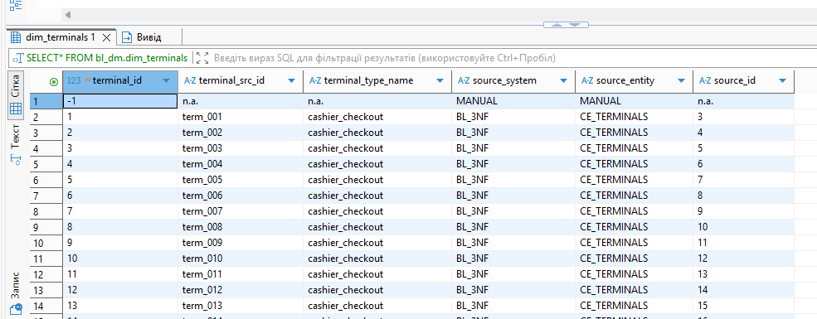
SECOND RUN
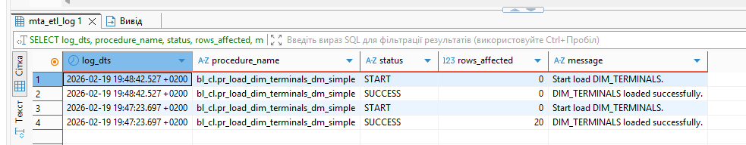

DIM_EMPLOYEES
✔ Composite type (t_source_ctx)
✔ Validation procedure (pr_validate_na_only)
✔ Ignore default row
✔ Data lineage
✔ UPSERT (repeatable execution)
✔ Centralized logging

FIRST RUN
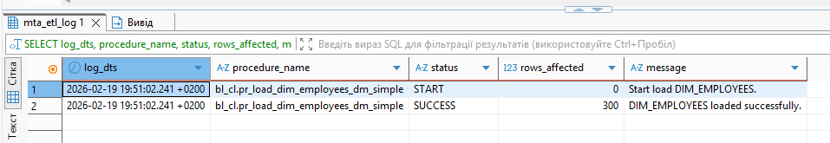
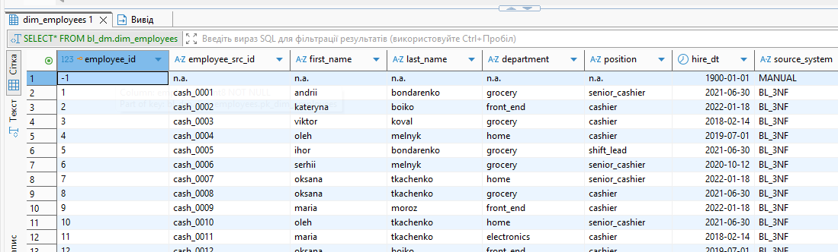
SECOND RUN
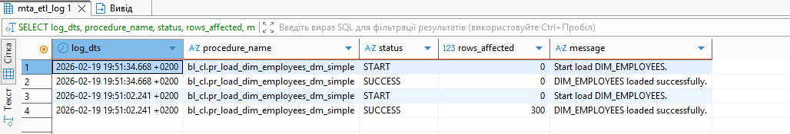

DIM_PROMOTIONS
✔ Composite type (t_source_ctx)
✔ Validation procedure (pr_validate_na_only)
✔ Ignore default row
✔ Data lineage
✔ UPSERT (repeatable execution)
✔ Centralized logging

FIRST RUN
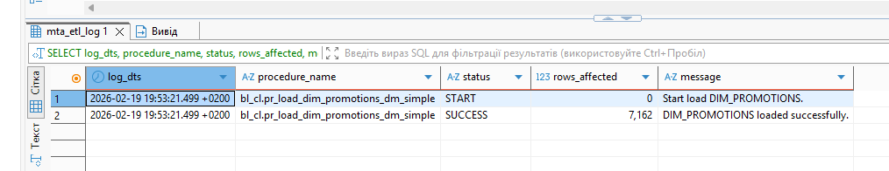

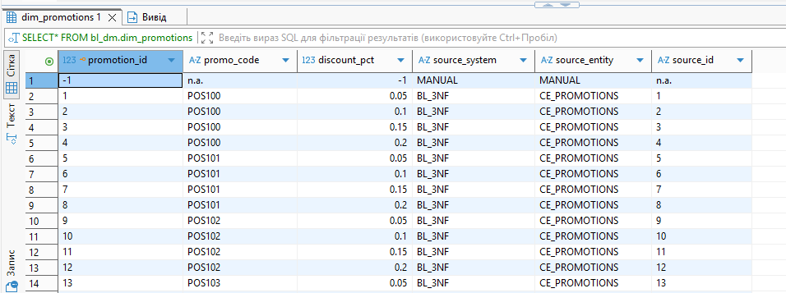
SECOND RUN
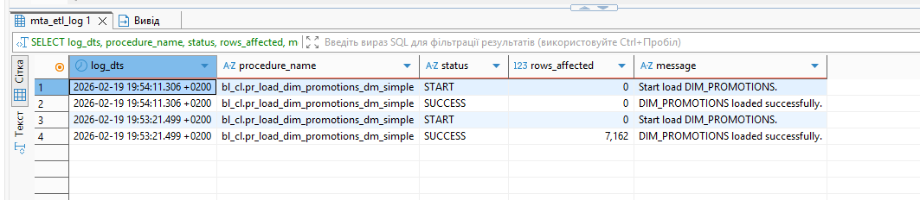
DIM_DELIVERY_PROVIDERS
✔ Composite type (t_source_ctx)
✔ Ignore default row
✔ Data lineage
✔ UPSERT (repeatable execution)
✔ Centralized logging

FIRST RUN

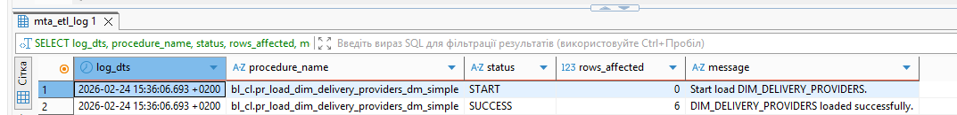
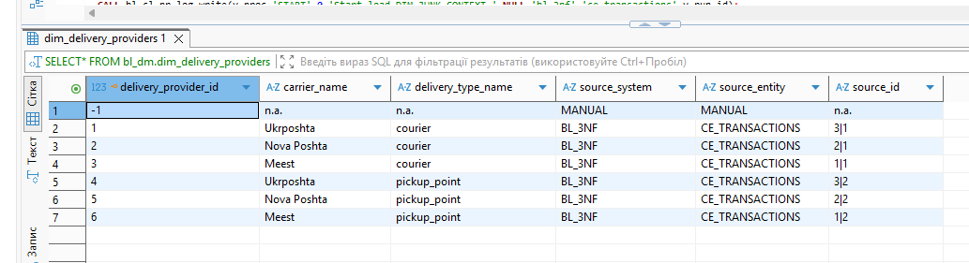
SECOND RUN
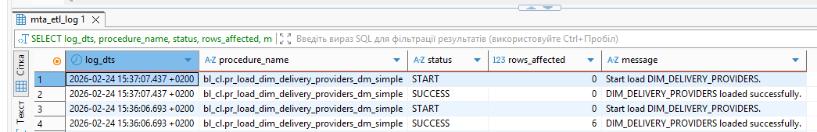
DIM_JUNK_CONTEXT (3NF: ce_transactions + lookup tables)
✔ Data lineage
✔ UPSERT (repeatable execution)
✔ Centralized logging

FIRST RUN
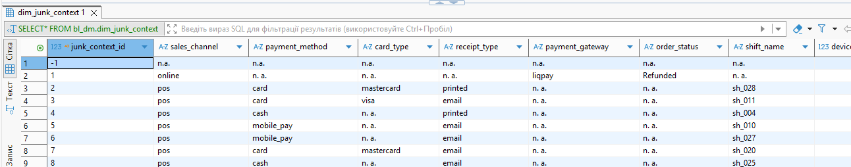
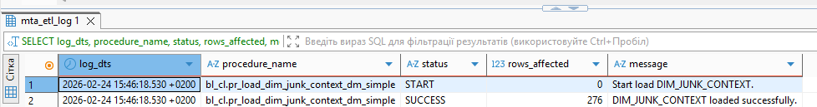
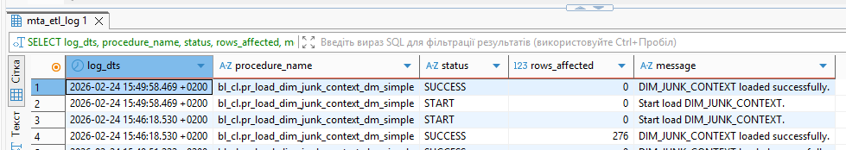

DIM_DATES_DAY
✔ Composite type (t_source_ctx)
✔ Data lineage
✔ UPSERT (repeatable execution)
✔ Centralized logging

FIRST RUN
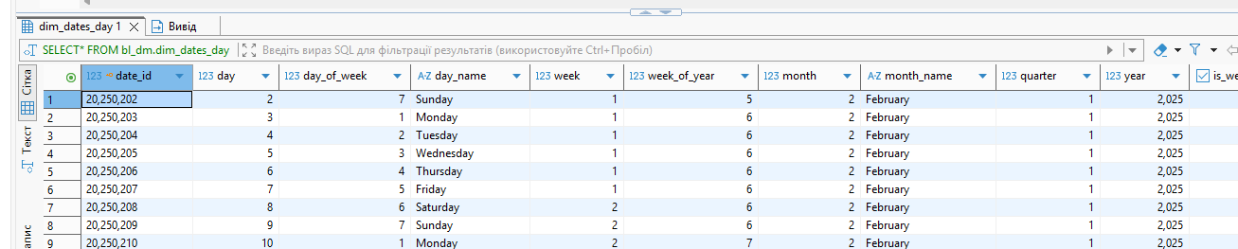
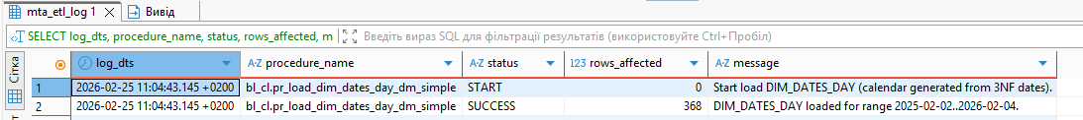
SECOND RUN
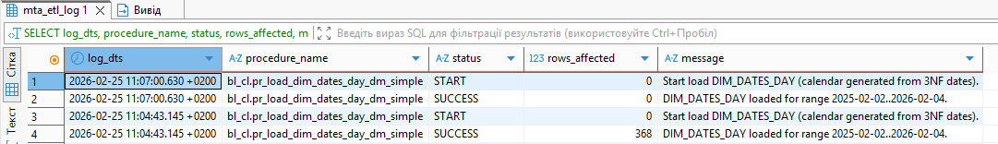
DIM_CUSTOMERS_SCD
✔ Composite type (t_source_ctx)
✔ Validation procedure (pr_validate_na_only)
✔ Ignore default row
✔ Data lineage
✔ UPSERT (repeatable execution)
✔ Centralized logging

FIRST RUN
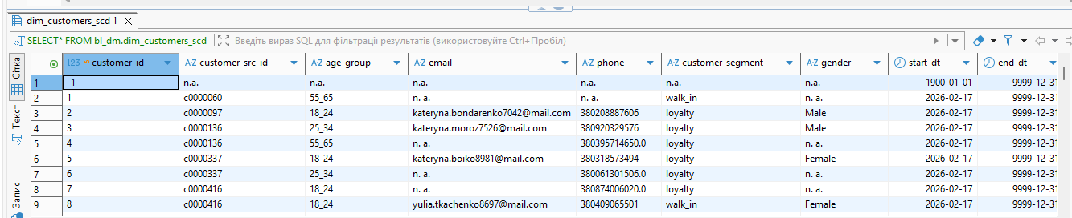
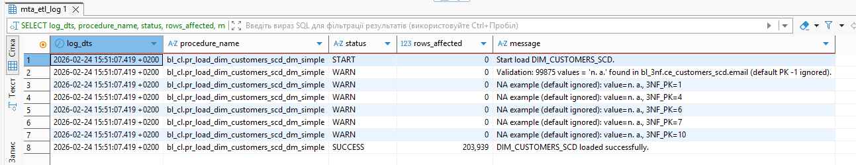SECOND RUN
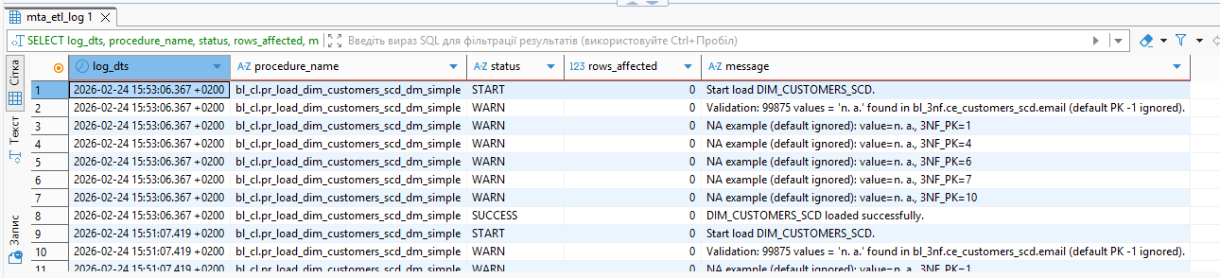
SCD type 2
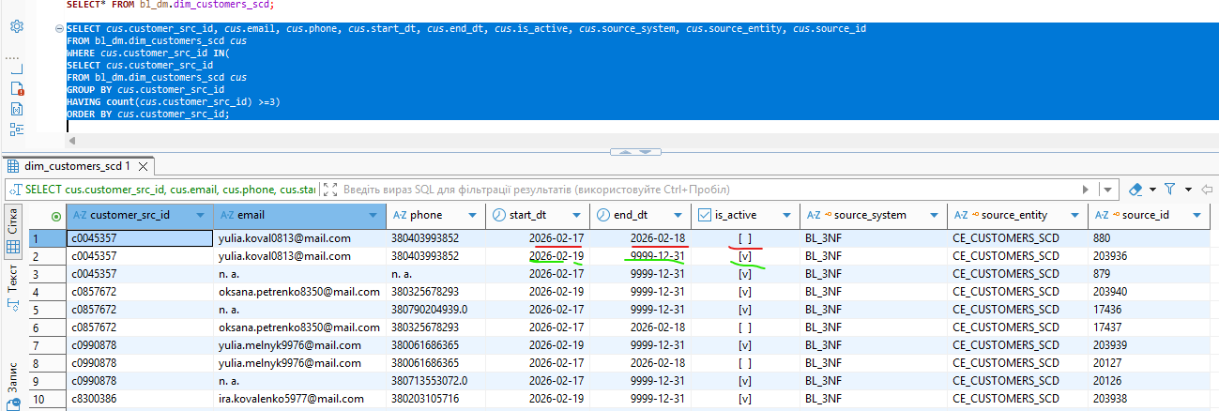

On this screenshot, it can be seen that this table displays the history of customer data changes according to the SCD Type 2 requirements. The start date, end date, and active flag are updated accordingly. However, I would like to note that since the data is loaded from two sources (POS and online), a single customer with the same ID has two active records due to the uniqueness constraint defined by the combination of source_system, source_entity, and source_id.

