CE_TRANSACTIONS TABLE 3NF

Procedure Logic – pr_load_ce_transactions (Short Description)
The procedure performs incremental loading of the ce_transactions fact table in the 3NF layer using a watermark mechanism based on the load_dts column from the source (SA) tables.

Main Steps
- Initialize Load Control
  - Ensures that a record exists in mta_load_control for both sources:
    - sa_sales_online.src_sales_online
    - sa_sales_pos.src_sales_pos
  - Retrieves the last successful load timestamp (last_success_load_dts) for each source.
- Full Reload Option
  - If p_full_reload = TRUE, the watermark is reset to '1900-01-01', forcing a complete reload.
- Incremental Source Extraction
  - Extracts only new or changed records from SA tables where:
load_dts > last_success_load_dts
  - This ensures only newly loaded data is processed.
- Deduplication Logic
  - Uses DISTINCT ON (txn_src_id, source_system, source_entity)
  - Keeps only the latest version of each transaction based on src_load_dts DESC
  - Prevents duplicate processing of the same business key.
- Business Key Mapping
  - Maps source attributes to surrogate keys in 3NF dimension tables.
  - Missing references are defaulted to -1.
- UPSERT into ce_transactions
  - Uses:
ON CONFLICT (txn_src_id, source_system, source_entity)
DO UPDATE
  - Ensures idempotent behavior:
    - No duplicates
    - Updated transactions are refreshed
    - Safe repeated execution
- Watermark Update
  - Updates mta_load_control.last_success_load_dts
  - Sets it to MAX(load_dts) from processed records.
  - Guarantees correct incremental behavior in the next run.
- Logging
  - Writes START and SUCCESS/ERROR records into mta_etl_log
  - Captures number of affected rows.

Result
- Fully incremental fact load
- Safe to execute repeatedly (idempotent)
- No duplicate business keys
- Correct watermark management
- Supports optional full reload mode

FIRST +SECOND RUN, AS DATA WAS INSERTED BEFORE WE HAVE 0 INSERTED ROWS
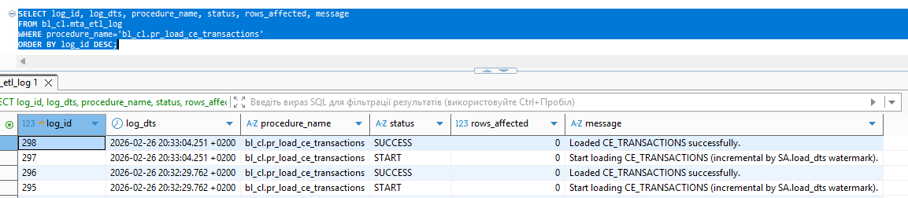
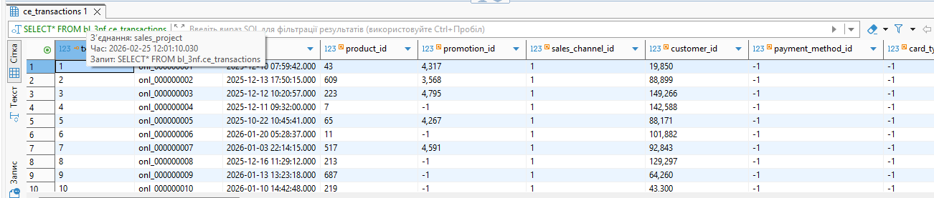

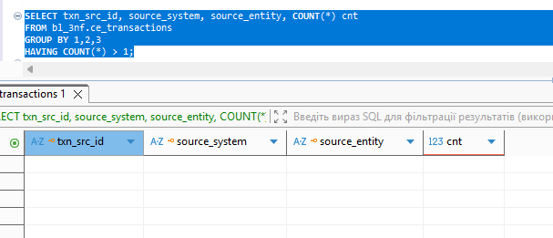
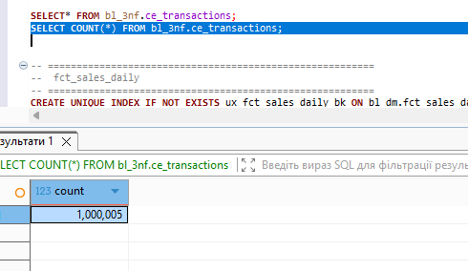

To verify completeness of the ETL load from the Source Area (SA) to the 3NF layer by identifying business keys (transactions) that exist in SA but are missing in the target ce_transactions table.
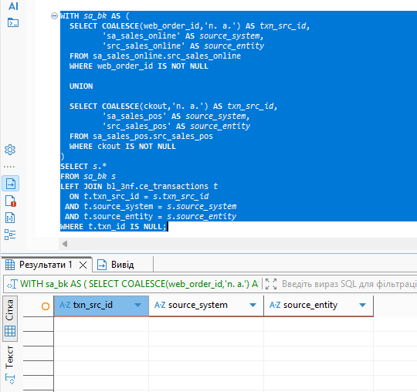

FACT TABLE

pr_manage_fct_sales_daily_partitions

Purpose
Manages the rolling window partitions for the fct_sales_daily fact table.

Logic Overview

1. Initialize Logging
Writes a START record to the ETL log.

2. Ensure DEFAULT Partition Exists
Creates a DEFAULT partition (fct_sales_daily_default) if it does not exist.
This partition acts as a catch-all for rows that fall outside the defined monthly partitions.

3. Create Rolling Monthly Partitions
- Calculates:
  - v_start_month → first month of rolling window
  - v_end_month → next month after current
- Iterates month by month
- Creates partition:
fct_sales_daily_YYYYMM
using FOR VALUES FROM (...) TO (...)

4. Detach Old Partitions
- Identifies partitions older than rolling window start
- Detaches them from parent table
- Logs the operation
Ensures:
- Required monthly partitions exist
- Old partitions are detached
- DEFAULT partition prevents “no partition found” errors

pr_load_fct_sales_daily_dm

Purpose
Loads and upserts transactional data from 3NF into the DM fact table (fct_sales_daily) using a rolling window approach.

Logic Overview

1. Initialize Logging
Writes START record to ETL log.

2. Manage Partitions
Calls pr_manage_fct_sales_daily_partitions() to:
- Create needed partitions
- Ensure DEFAULT exists

3. Ensure Unknown Date
Inserts date_id = -1 into dim_dates_day if missing.

4. Extract Data from 3NF
Filters ce_transactions by:
txn_ts >= v_from_date
txn_ts < v_to_date
(rolling window logic)

5. Map 3NF Keys to DM Surrogate Keys
Uses LEFT JOINs to map:
- Products
- Promotions
- Stores
- Terminals
- Employees
- Customers (SCD active only)
- Delivery providers
- Junk dimension
Missing mappings default to -1.

6. Calculate Derived Metrics
Calculates:
- calculated_gross_margin_pct
- calculated_net_sales_amt

7. UPSERT into Partitioned Fact Table
Inserts into parent table:
bl_dm.fct_sales_daily
Postgres automatically routes rows to correct partitions.
Uses:
ON CONFLICT (date_id, txn_src_id)
Updates only if values changed using:
IS DISTINCT FROM
This prevents unnecessary updates.

8. Log Results
Stores number of affected rows and writes SUCCESS log entry.

FIRST RUN
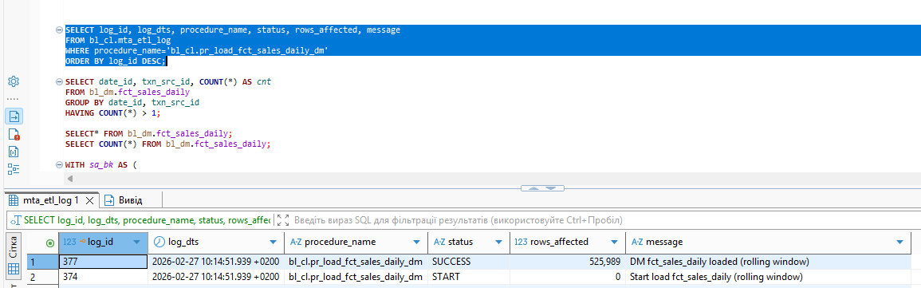
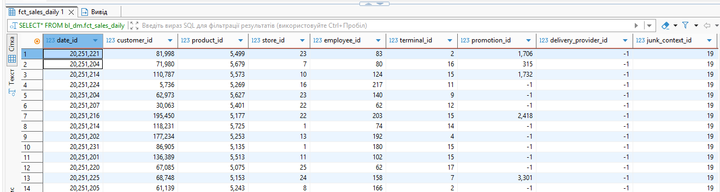
SECOND RUN
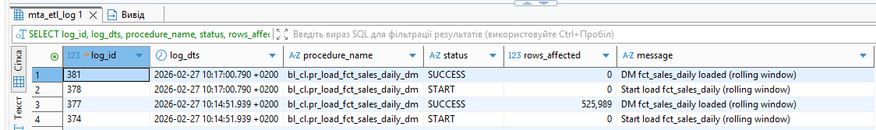
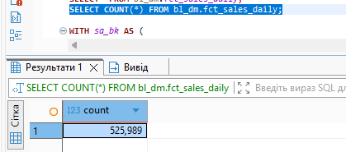
To validate data completeness by identifying transactions that exist in the 3NF layer within the rolling window period but are missing in the fct_sales_daily fact table in
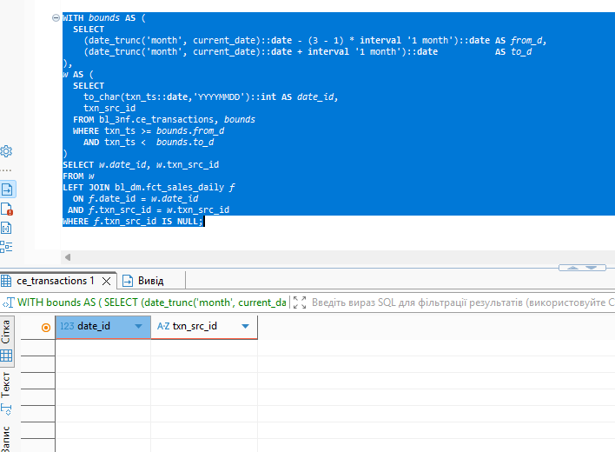

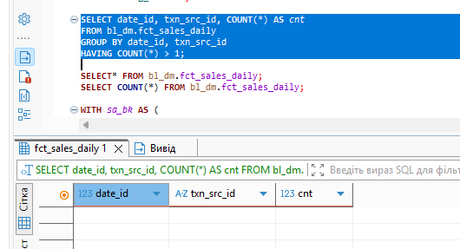

FIRST RUN FOR LAST 12 MONTHS
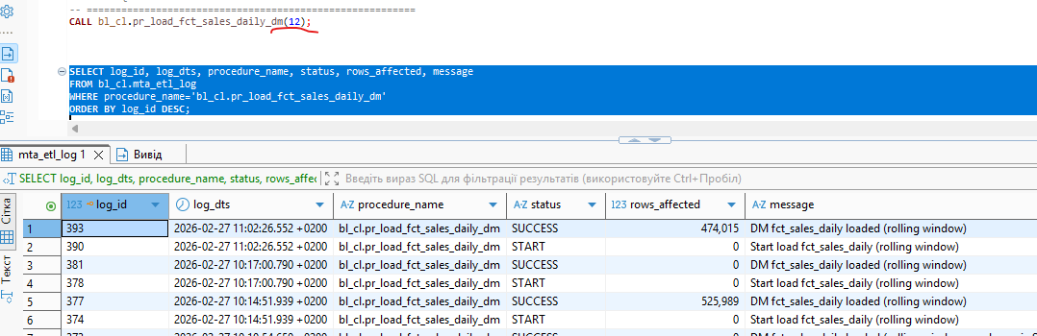
Older records went to default partition
