# Ozon Application

## Account Management

To manage your account in Ozon application go to **My Ozon -> Account management**.

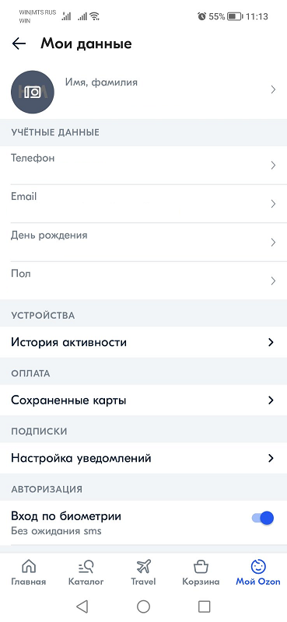

Image . Account management page

On the opened page you can manage the following options:

* **Personal details**  
  Tap on the **Name** to change the first and last name associated with current account.  
  Tap on the **Photo icon** to add your photo to the account. If you have already added a photo, you can change it by tapping on it.
* **Credentials**  
  You can change the **Phone number**, **Email**, **Birth date** and **Gender** by tapping on the appropriate option. To change the phone number or email, you will have to enter a verification code that will be sent to you.
* **Devices**  
  Tap on the **Activity history** to check on which device and when you were logged in besides the current device. On the opened page you can log out on all devices.
* **Payment**  
  Tap on the **Saved cards** to check your cards that were saved in the system. On the opened page you can delete saved card or add the new one.
* **Subscriptions**  
  Tap on the **Notifications management** to manage the notifications that are sent by the system. On the opened page you can choose which notifications, in what cases and where they will be sent.
* **Authorization**  
  If you want to enter to the application by biometrics and without sending the sms, turn on the **Entering by biometrics** option.  
  If you want to enter to the application using Google Smart Lock after the reinstallation, turn on the **Automatic entry** option.
* **Account**  
  Tap on the **Sign out** to sigh out. On the opened page you can choose whether you want to remember you on the current device.  
  Tap on the **Other actions** to delete your account from the system.