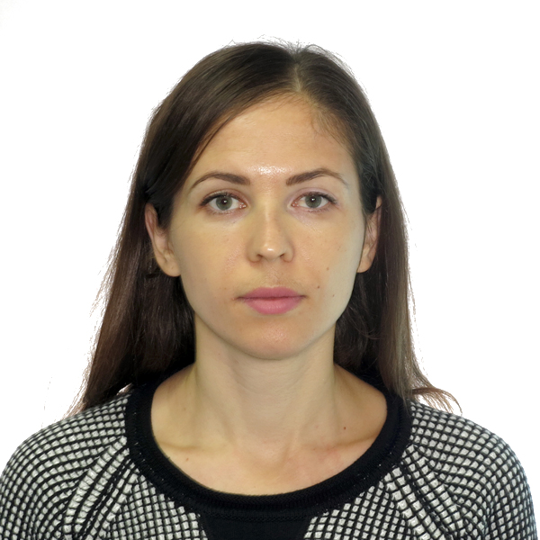
Demianova Nataliia

Kremenchuk, Ukraine, 39600
Cell: +380 (98) 990 55 90
E-mail: natalya.demiyanova@gmail.com
Skype: natka_200

Professional Summary
Highly qualified professional with 6+ years of experience in the design of heating and ventilation systems for passenger rail cars. Dependable and organized team player with the ability to communicate effectively and efficiently. Skilled at building relationships with staff across all levels of an organization. Attentive to details.
Key Qualifications
- Development of equipment drawings | - Contract management
- Carrying out calculations for projects | - Budgeting
- Selection of materials for the manufacture of equipment | - Coordination of projects with customers
Work Experience
09/2012 – present: «Kryukovsky railway car building works» PJSC, Kremenchuk, Ukraine
Design Engineer
Business sector: manufacture of railway cars

Responsibilities:
▪ Technical projects development for railway car building needs
▪ Design of components and equipment for heating and ventilation systems of railway cars
▪ Development maintenance standards
▪ Investigation of mechanical failures of the equipment
▪ Development of technical documentation
▪ Document management

10/2010 – 04/2011: «Teploenergo» Utility Production Enterprise, Horishni Plavni, Ukraine
Heat point operator
Responsibilities:
▪ Ensuring uninterrupted and economical operation of heating boilers
▪ Maintaining the set temperature and water pressure in the system
▪ Monitoring the operation of water pumps
▪ Identification and elimination of equipment malfunctions
▪ Maintenance of operational documentation

Demianova Nataliia Page 2
Work Experience, Cont.

08/2009 – 07/2010: «Ferolit» Research and Production Enterprise, Horishni Plavni, Ukraine
Energy Engineer
Business sector: manufacture of cast iron grinding media balls

Responsibilities:
▪ Development of technical documentation
▪ Preparation of applications for the purchase of materials, parts, tools
▪ Conclusion and maintenance of contracts for the supply of electricity, water, gas
▪ Accounting and analysis of energy consumption
▪ Budgeting
▪ Interaction with government agencies

Education
09/2004 – 06/2009
Master of Science in Heating and Ventilation
Poltava National Technical Yuri Kondratyuk University
09/2008 – 06/2009
Master of Science in Finance
Poltava National Technical Yuri Kondratyuk University

