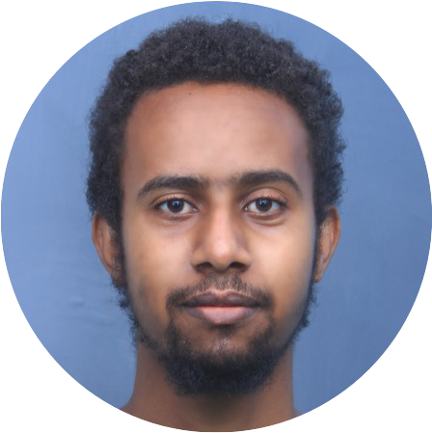NATAN MESELE

*Leadership & PROGRAMMER*

# Profile

My name is Natan Mesele. I graduated from Infolink University College with a degree in Computer Science. I scored a good grade of 3.83 GPA & Also, in 2014, I graduated also from Infolink University College Masters of Business Administration with a 3.8 with a very good research result. I have more than 4 years of work experience in total.

Interests

**Interest**

Read a book and Also, taking actions that will help



me change my life, Outdoor activities., Community service, Playing music instrument

# Experience

## 2010 - 2012

**2013 - Present**

## Rift valley University, Atlas college

Instructor , Hawassa

Instructor in computer science department & TVET coordinator

Skills

**Skill group**

Ability to perform work properly Management skill Communication skill

**Skill group**

Problem-solving skills

Active listening Customer service skills

**Zion College, Unique star college** Computer science department Head, Ha wassa

Computer science department Head & Instructor in computer science department

# Education

## 2006 - 2009

**2013 - 2014**

## Computer science

Infolink University College, Hawassa The study of computers and other computational systems is computer science.

## Masters of Business Administration (MBA)

Infolink University College, Hawassa

An MBA is offers both academic and practical instruction in business or investment Management.

# Contact

 Ethiopia, Hawassa

 +251926412563 / +251939602491

→ [huluale12@gmail.com](mailto:huluale12@gmail.com)

↑ Natan Mesele

 @Nathan_mesele1

 Di Natalie Nathan Mesele