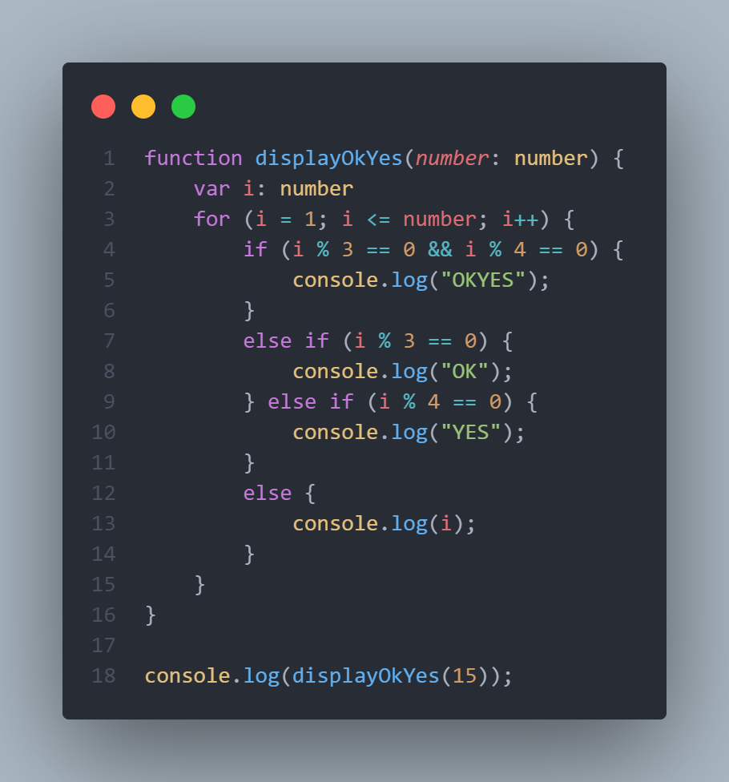

1. 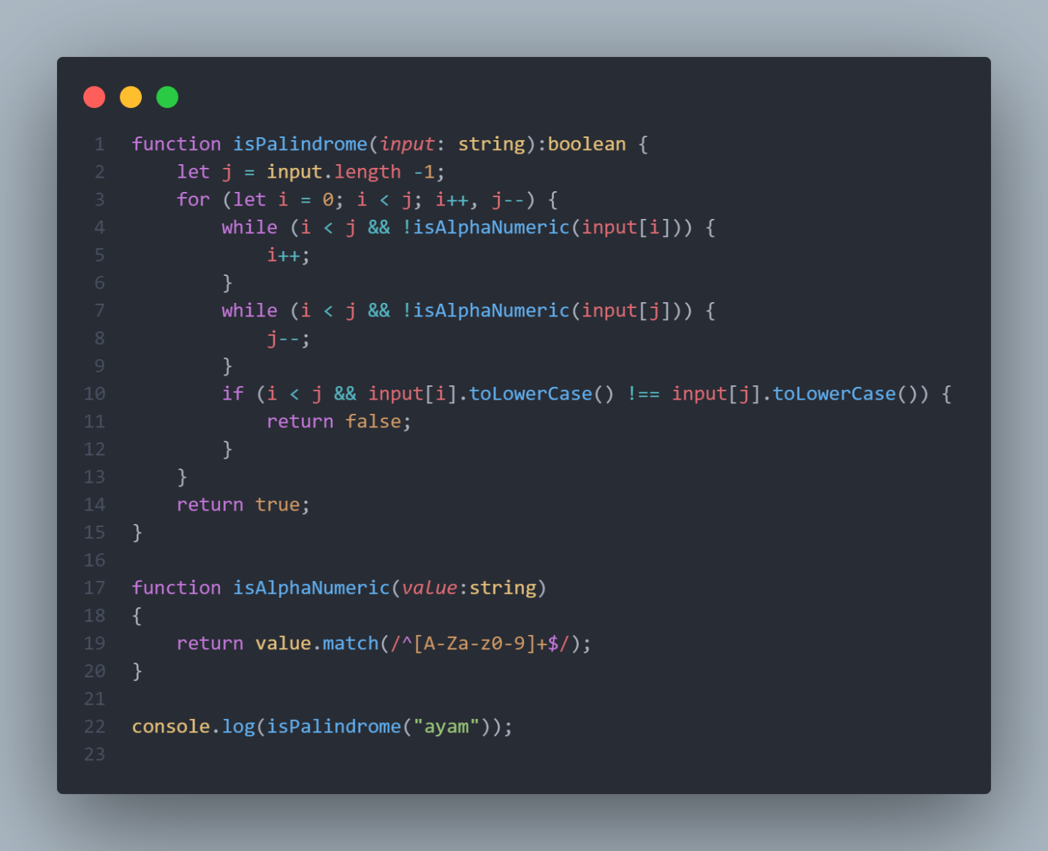
2. 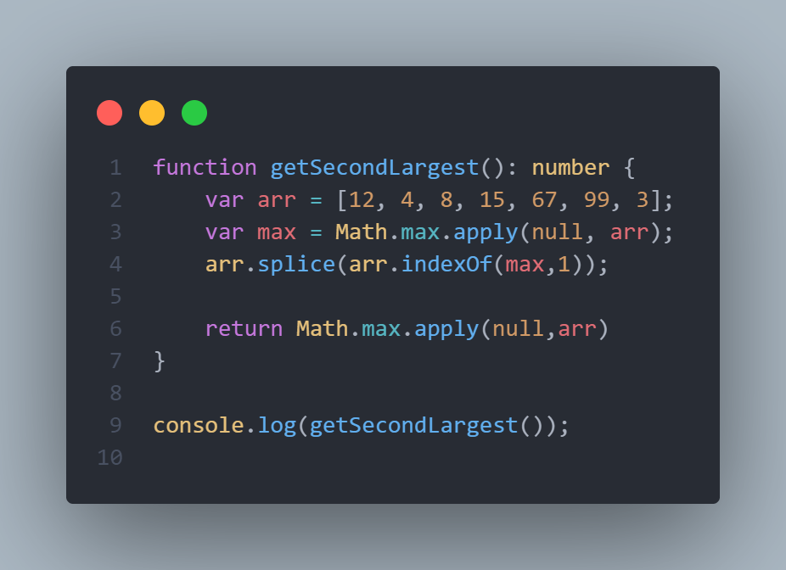
3. SELECT count(employee_id) as total_employees,department_name from employees left join departments on employees.department.id = department.department.id group by department orderBy department_name
4. ParentClass : Employees

Attribute : firstname,lastname,joindate

ChildClass : Role

Attribute :roleName

Method : getRole

ChildClass : SalaryByRole

Attribute :role,basicSalary

Method: getSalary

childClass : tunjanganByRole

attribute : bonus,commission,transportasi,makan

method : getTunjanganByRole

childClass : totalSaalary

attribute :total

method: getTotalSalary