Schuler tabelle
app.post('/api/admin/import/students'
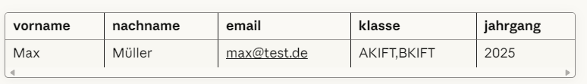

Lehr tabelle
app.post('/api/admin/import/teachers'
