Visual Learning
Design & UX Audit
Site reviewed: zsvl.onslate.in
Reference sites: zohoschools.com (brand/color), Coursera, Udacity, Skillshare (edtech UX benchmarks)
Prepared for: Nattu — ZS-Batch 2026-2028
Date: 16 September 2026

Executive Summary
Visual Learning is a well-built React course shell — the design system already defines a full token set (colors, radii, shadows) in client-src/src/styles/base.css, and the code path for progress, unlocking, and the embedded lesson frame is genuinely solid. The mistakes below are almost all inconsistencies between what the design system defines and what actually ships, or gaps in how that system was extended for new content — not missing engineering effort.
Fourteen issues are documented across five areas: brand identity and color, layout and use of space, visual consistency across lesson cards, navigation and redundant labeling, and accessibility. Each finding below cites the exact source file and CSS rule so it can be fixed at that line, and closes with a prioritized action list.

Scope & Method
The review covers the site shell (home, browse-all, a course page, and the lesson chrome) plus two representative lessons, captured live at zsvl.onslate.in. Findings are cross-checked against the source in client-src/src/styles/*.css so every recommendation points at a real CSS rule or token, not a guess from the rendered page alone.
Two references anchor the comparison: zohoschools.com, the parent brand this site names itself after (the "ZOHO SCHOOLS" eyebrow on the home page), for color and tone; and three well-regarded course platforms — Coursera, Udacity, and Skillshare — for interaction and information-architecture patterns that learners already expect.

Findings

A. Brand Identity & Color System
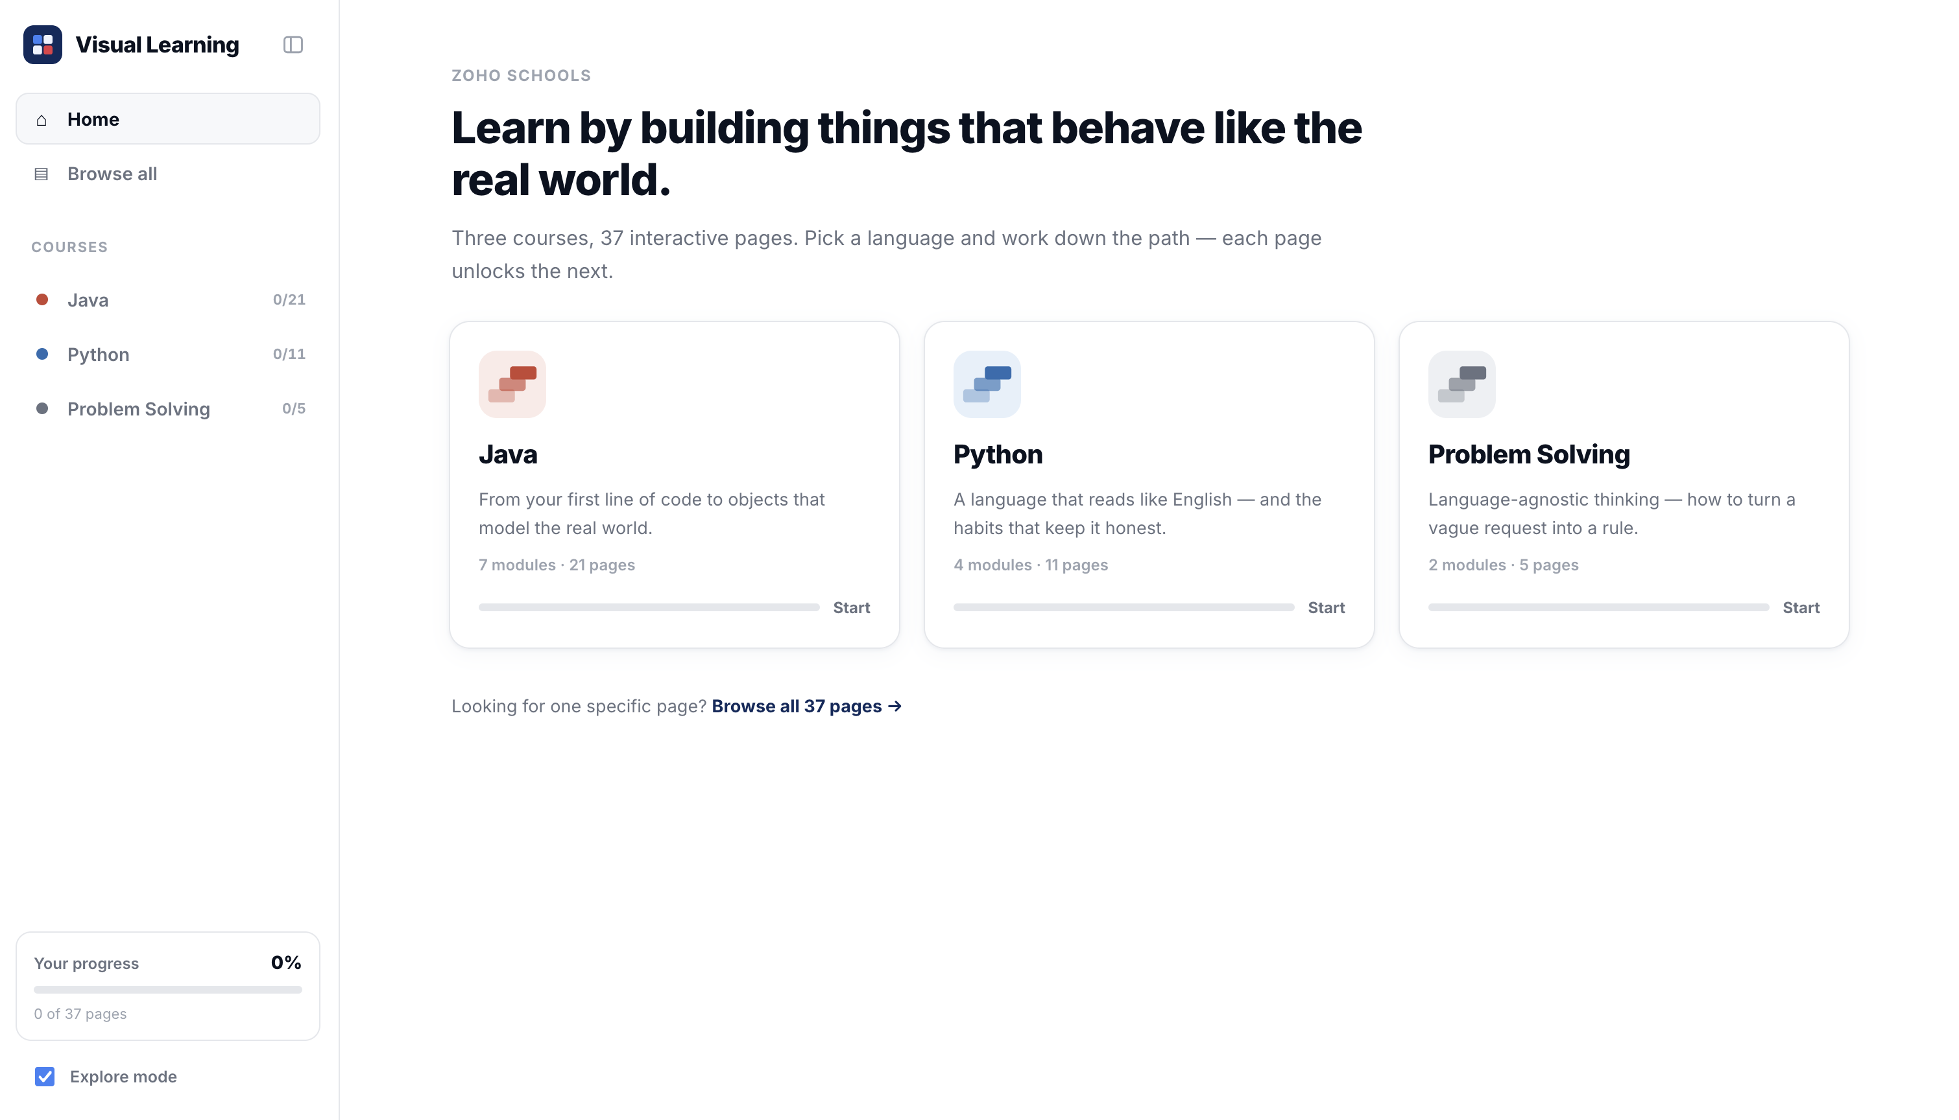
Home page — the "ZOHO SCHOOLS" eyebrow is the only place the parent brand appears.
1 The parent brand is named once, faintly, and nowhere else
Issue: "ZOHO SCHOOLS" appears only as a 12px, letter-spaced, --text-faint (#9CA3AF) label above the home page headline (course.css, .home-eyebrow). It does not appear in the sidebar, in the browser tab, on the course or lesson pages, or anywhere near the "Visual Learning" wordmark that is the actual persistent logo (shell.css, .sb-brand-text).
Why it matters: A learner who lands on any page except the home page has no way to tell this is a Zoho Schools product. The one mention that exists is styled to be the least noticeable text on the page — lower contrast and smaller than the body copy beneath it.
Recommended fix: Either fold the Zoho Schools mark into the sidebar lockup (e.g. "Visual Learning · a Zoho Schools course") so it persists across every page, or drop the reference entirely if the two brands are meant to stay separate. Right now it is a half-measure.
2 The product's primary color doesn't match the brand it names itself after
Issue: zohoschools.com uses warm orange as its call-to-action color against a light, high-contrast neutral background. Visual Learning’s entire CTA system — .hero-cta, .ln-complete, .nf-btn in course.css/lesson.css — is built on --navy-900 (#0F2A5C), a cool navy blue.
Why it matters: Since the app explicitly invokes the Zoho Schools name, a visitor arriving from zohoschools.com meets a completely different color identity one click later. That inconsistency reads as two unrelated products rather than one brand family.
Recommended fix: Either adopt an accent pulled from the Zoho Schools palette for primary CTAs (Start course, Mark complete) and keep navy for structural chrome, or make the "Zoho Schools" reference smaller/omit it so the mismatch stops being visible.
3 The third course has no identity color
Issue: base.css defines a distinct accent + tint pair for Java (--java #C74634 / --java-bg) and Python (--python #2B6CB0 / --python-bg), but Problem Solving falls back to --others (#6B7280) — the same neutral gray used for "locked" and generic/undefined states elsewhere in the same file.
Why it matters: On the home page and browse grid, Java and Python read as two deliberately branded subjects; Problem Solving reads as the placeholder/unfinished one, purely because of a missing color token, even though the content itself is complete (5 pages, 2 modules).
Recommended fix: Add a --problem-solving accent (e.g. a violet or teal, distinct from both the done-state blue and the locked-state gray) and a matching *-bg tint, then wire it the same way java/python are wired in catalog.css and course.css.
4 "Completed" and "Python" use almost the same blue
Issue: --status-done is #3B82F6; --python is #2B6CB0. Both are mid-saturation blues used as the primary identifying color in the same views (the lesson-path dot for a finished page, and the course badge/accent for any Python page).
Why it matters: On a Python course page, a learner scanning dot colors down the lesson path can’t rely on "blue" to mean one specific thing — it is simultaneously the course’s brand color and the completion color for every course. This is the kind of collision color-blind users (roughly 1 in 12 men) notice first.
Recommended fix: Keep --status-done a color no course accent shares — green is the conventional "done" signal in the reference platforms (Coursera, Udacity) and is already unused elsewhere in the token set.

Dead token: an unused page background
base.css defines --bg: #F4F6FA as a soft gray canvas color, but html, body is painted with --surface-canvas: #FFFFFF instead — the gray token is never referenced anywhere in the five stylesheets. That single dropped line is very likely the root cause of Finding 6 below (cards that don’t visually separate from the page).

B. Layout & Use of Space
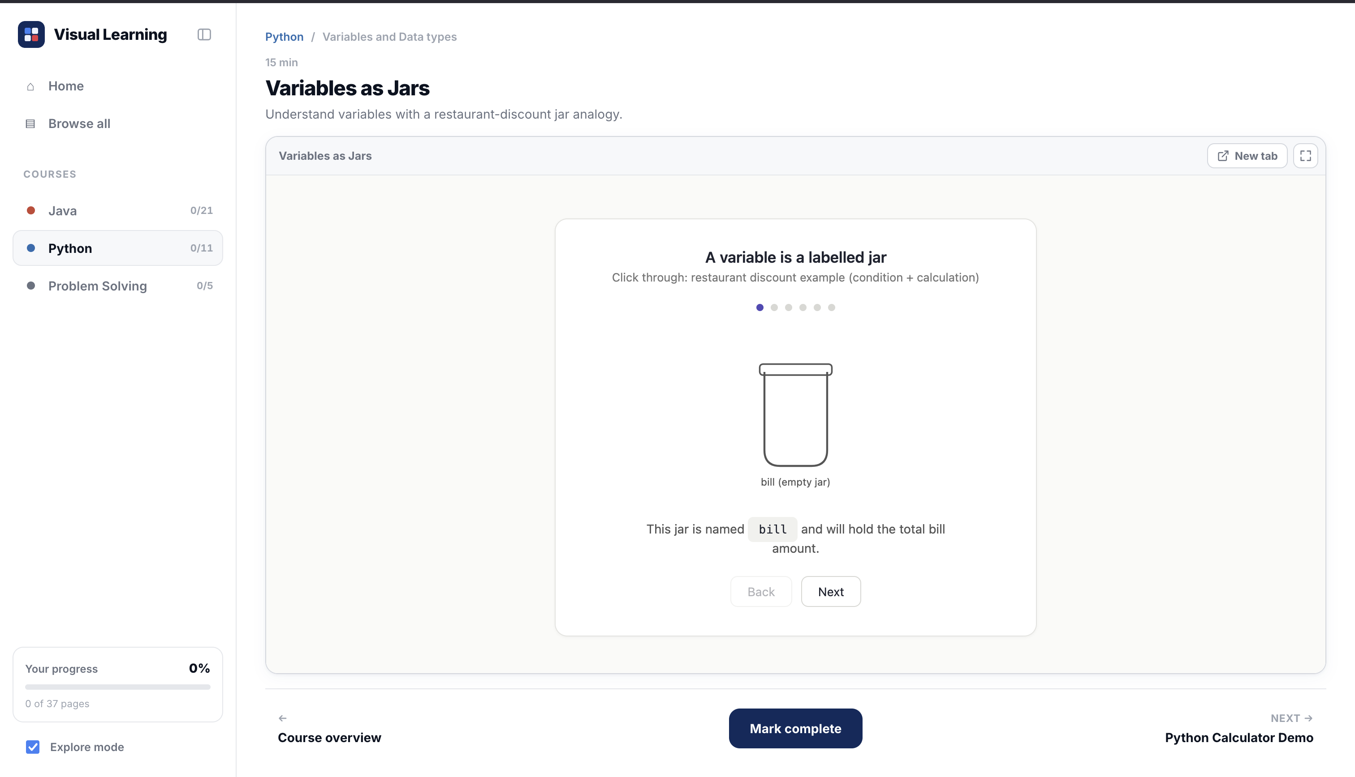
A lesson in its normal, chrome-wrapped view.
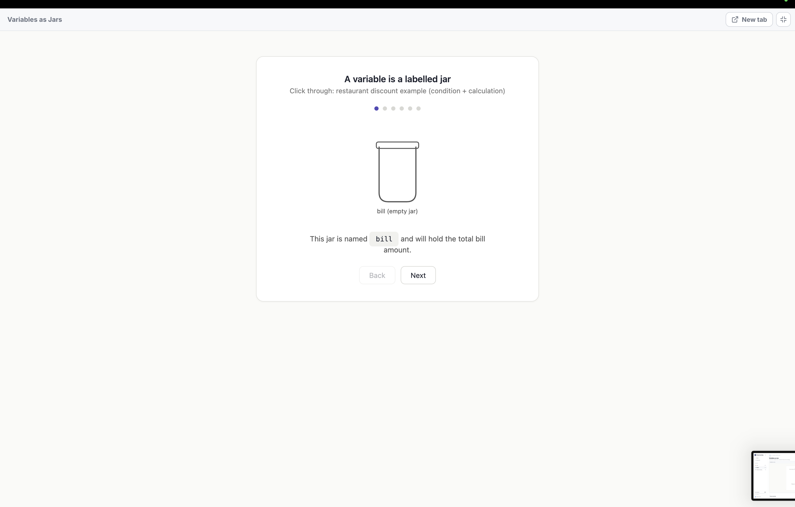
The same lesson in full-screen — the interactive card now occupies roughly a sixth of the viewport.
5 Full-screen mode makes the content smaller, not bigger
Issue: The interactive slide component ("A variable is a labelled jar") is a fixed-width card that does not grow with the viewport. Full-screen mode (lesson.css, .lab-standalone) removes the sidebar and lesson chrome — which should give the lab more room — but the lab itself still renders at the same fixed size, now centered in a much larger empty page.
Why it matters: Full-screen is the mode a learner reaches for specifically to focus on the content, typically right before presenting it or moving to a larger display. Here it does the opposite: the exercise gets visually smaller relative to the screen, and the surrounding emptiness reads as a broken or half-loaded page.
Recommended fix: Have interactive lesson content scale its width to its container (max-width in relative units, not a fixed px card) so .lab-standalone and .lab-frame.is-full actually fill the space lesson.css already carves out for them.
6 Cards float on a page with no visible surface
Issue: Because of the dead --bg token above, every card (.ccard, .card, .lnode-card, .hero) sits directly on pure white with only a 1px --rail (#E5E7EB) border and a very soft shadow to separate it from the page.
Why it matters: On a large monitor this reads as one continuous white field rather than a set of distinct content blocks — visible in the lesson screenshots above, where the boundary between "page" and "card" is barely perceptible. Low contrast between a surface and its container is one of the most common reasons a UI feels unfinished even when every element is individually well-designed.
Recommended fix: Apply the existing --bg (#F4F6FA) to the page canvas and keep cards on white — this single change (already defined, just not wired to html/body) should measurably improve perceived polish with no new design work.
7 A one-lesson module gets the same heavy header as a five-lesson one
Issue: .module-head in course.css is a fixed-padding, bordered, tinted bar with a title, a count, and an icon button — rendered identically whether a module has 1 page ("Data types," "Loops and Conditional Statement") or several.
Why it matters: On the Java course page, two of the seven modules exist only to wrap a single lesson card, so the learner scrolls past two full-width structural bars that carry no more information than the card beneath them already does.
Recommended fix: Collapse the module header to an inline label (no bordered bar) when a module has exactly one lesson, reserving the full treatment for modules that actually group multiple pages.

C. Visual Consistency Across Cards & Thumbnails
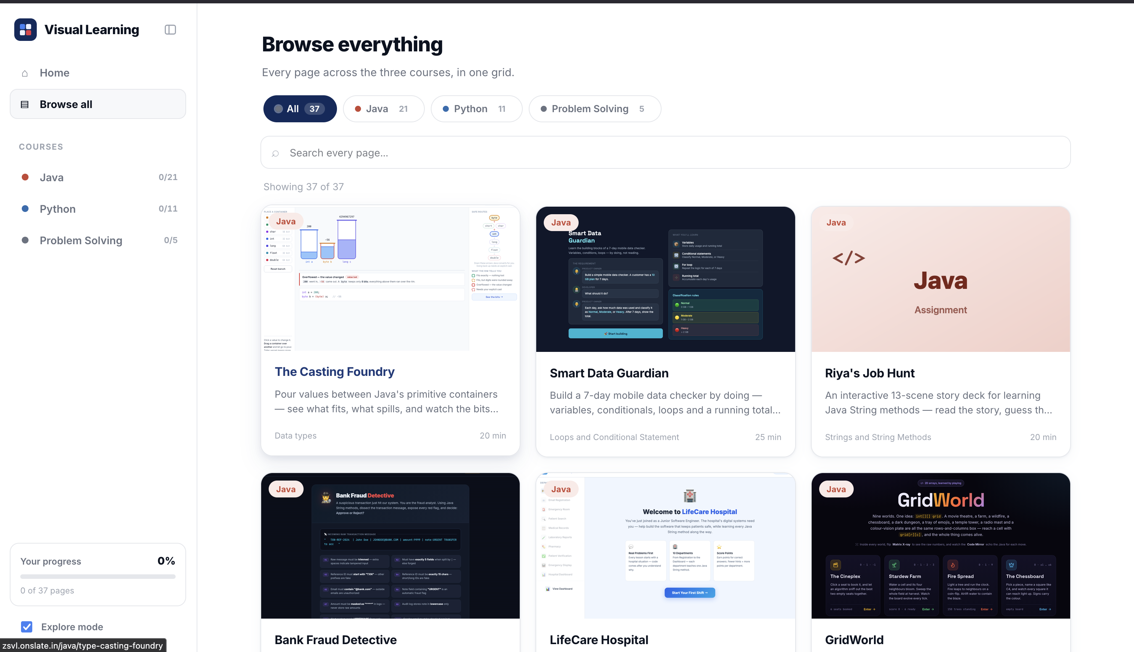
Browse-all grid — screenshot thumbnails, dark UI mockups, and flat icon cards side by side.
8 Three unrelated thumbnail styles compete in the same grid
Issue: catalog.css and course.css both define a proper fallback thumbnail (.lthumb, with .lthumb-lines / .lthumb-num for entries without a real screenshot), yet the rendered browse grid mixes three different visual languages: real light-UI screenshots ("The Casting Foundry"), dark polished app mockups ("Smart Data Guardian," "GridWorld"), and flat solid-color "assignment" cards with a bare icon and no preview at all ("Riya’s Job Hunt").
Why it matters: A course catalog is scanned quickly; consistent thumbnail treatment is what lets a learner tell "this is another lesson like the others" at a glance. Here, adjacent cards look like they belong to three different products, and the flat assignment-style cards in particular give no preview of what the lesson actually contains.
Recommended fix: Standardize on one thumbnail contract for every lesson folder — a real light-themed screenshot at a fixed viewport, generated the same way for every project — and reserve the flat "assignment" treatment only for a clearly-labeled content type, applied consistently, not as a fallback for missing thumbnails.
9 Lesson-path status icons mix metaphors
Issue: On the Java course page, the first lesson shows a clock-face icon and the second shows a triangular play icon, both inside the same .lnode-dot circle style, with no on-page legend for either.
Why it matters: Clock and play are two different metaphors (time remaining vs. start-this-now) doing the same job (this lesson is next). A first-time learner has to guess whether the icon encodes something they should act on differently.
Recommended fix: Pick one icon per lesson-path state (not-started / current / done / locked) and use it everywhere — course.css already defines the states via .is-done / .is-current / .is-locked classes, so this is a matter of auditing the icon set assigned to each, not adding new states.

D. Navigation, Labels & Redundancy
10 The lesson title repeats itself within the same view
Issue: A lesson page shows the same title twice: once as the page’s 30px H1 (.lesson-title) and again, seconds of eye travel later, as the 12.5px label in the embedded lab’s own toolbar (.lab-frame-title) — both reading "Variables as Jars" in the screenshot above.
Why it matters: The repetition adds vertical scroll with no new information, and on the height-constrained desktop lesson layout (.shell-main.is-lesson trims every other element specifically to save space) it works against the file’s own stated goal of giving the lab more room.
Recommended fix: Drop the .lab-frame-title text (or replace it with something that isn’t the lesson name, e.g. a generic "Lab" label) since the page H1 immediately above already states the title.
11 Two icon-only controls have no visible label
Issue: The module "notes" toggle (.module-notes-btn, a 34px square icon button) and the sidebar collapse control (.sb-collapse) both ship as bare icons with no tooltip or aria-label evident in the markup.
Why it matters: A control whose only affordance is an unlabeled icon forces every new user to click it to find out what it does — acceptable for one throwaway button, risky for a toggle (notes) that changes what’s visible on the page.
Recommended fix: Add a title/aria-label to both (e.g. "Show module notes," "Collapse sidebar") — a one-line change per component with no visual impact for users who already know the icon.

E. Accessibility Gaps
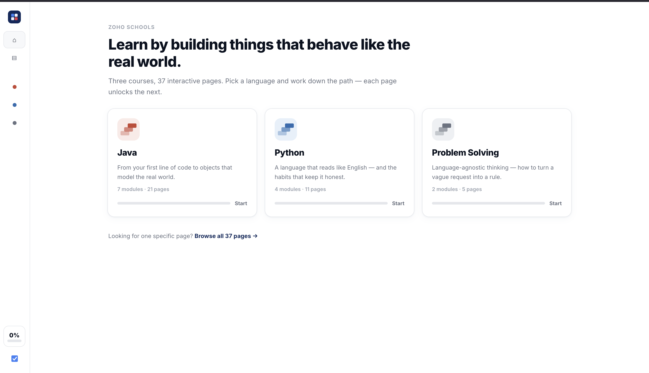
Collapsed sidebar — every text label, including the Explore-mode toggle, disappears.
12 Collapsing the sidebar removes the label from a mode-changing control
Issue: shell.css’s .shell-collapsed rule hides .sb-explore span — the text label next to the Explore-mode checkbox — along with every other sidebar label. Explore mode is not cosmetic: per the project README, it unlocks every lesson in every course, overriding the normal one-page-at-a-time progression.
Why it matters: In the collapsed rail (screenshot above), that checkbox is indistinguishable from any other icon in the rail. A learner who collapses the sidebar for more reading room can toggle a behavior-changing setting without any indication of what it does or that it changed.
Recommended fix: Exempt .sb-explore from the label-hiding rule (keep at minimum a tooltip on hover/focus, ideally via a native title attribute) even when the rest of the rail collapses to icons.
13 Progress disappears entirely in the collapsed rail
Issue: The same collapse rule hides .sb-progress-top span and .sb-progress-sub, leaving only a bare percentage-less circle where the "12 of 37 pages" summary used to be (visible in the screenshot: the progress card reduces to an unlabeled "0%" chip).
Why it matters: Progress is the platform’s main motivational device (course.css’s .bar / .ccard-pct exist for exactly this reason). Removing its text in the one layout mode meant to save space is removing the feature the space-saving mode is least equipped to lose.
Recommended fix: Keep the numeric percentage visible in the collapsed state (it already fits in the circular badge shown in the screenshot) even though the descriptive sub-label can reasonably collapse.
14 Home page eyebrow text fails contrast at its size
Issue: .home-eyebrow renders at 12px using --text-faint (#9CA3AF) on a white background — roughly 2.5:1 contrast, below the WCAG AA minimum of 4.5:1 for text this small.
Why it matters: This is the same "ZOHO SCHOOLS" brand mention flagged in Finding 1 — it fails accessibility contrast guidelines in addition to being easy to miss, which compounds rather than offsets the branding problem.
Recommended fix: If the eyebrow stays, raise it to at least --text-muted (#6B7280), which clears AA at 12px; the brand-visibility fix in Finding 1 should address size/placement separately.

Reference Comparison: zohoschools.com
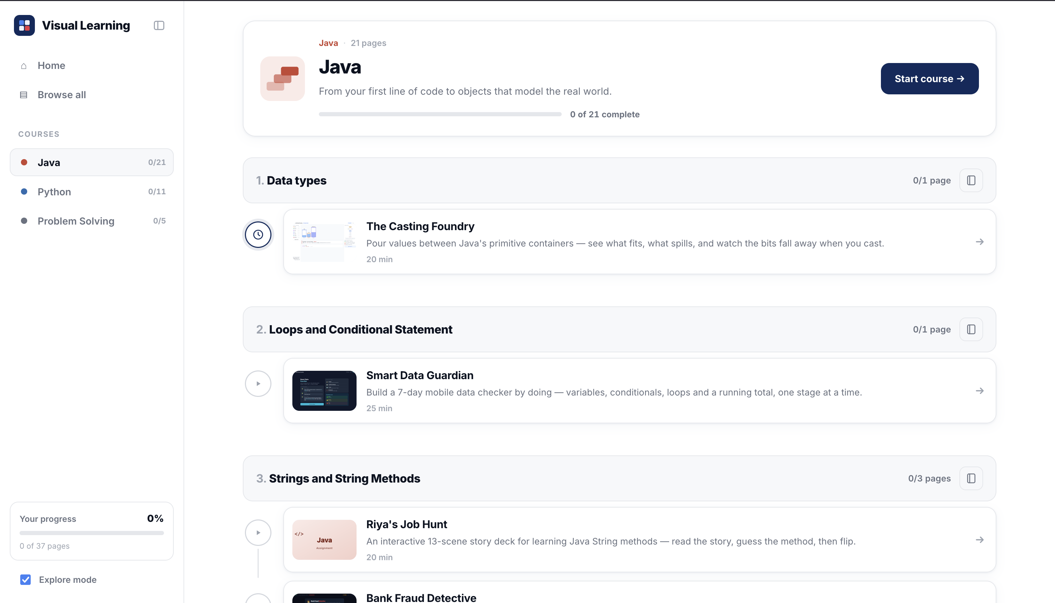
Visual Learning course page, for side-by-side reference against the parent brand.
zohoschools.com was reviewed for color and tone, since Visual Learning names it directly on the home page.
Dimension | zohoschools.com | Visual Learning | Gap
Primary CTA color | Warm orange | Navy blue (--navy-900) | No shared accent between the two products
Background | White / light, high contrast | White (intended gray canvas unused — Finding 5) | Coincidentally similar, for the wrong reason
Imagery | Photography, alumni testimonials, video | None — icons and product screenshots only | Expected given this is a tool, not a marketing site
Tone | "Curious nonconformist," youthful + professional | Neutral, utilitarian course-platform copy | Consistent with a learning tool; no action needed
Brand presence | Every page | One faint mention on the home page only (Finding 1) | Direct gap

Reference Comparison: Established EdTech Platforms
Coursera, Udacity, and Skillshare were used as behavioral benchmarks — not for their visual style, but for interaction patterns learners already carry into any course platform.
Pattern | Reference platforms | Visual Learning today
Progress visibility | Always-on progress bar/checkpoints (Udacity) | Present on home & course pages; disappears when sidebar is collapsed (Finding 13)
Visual consistency | One card/thumbnail style throughout (Coursera) | Three competing thumbnail styles in the same grid (Finding 8)
Primary action clarity | One unmistakable "Continue/Start" CTA | "Start"/"Mark complete" present but thin progress bar undersells it (course.css .ccard-progress .bar is 6px)
Icon-only controls | Labeled or tooltipped | Notes toggle & sidebar collapse unlabeled (Finding 11)

Prioritized Recommendations
Ordered by effort-to-impact: the first three rows are one-line CSS fixes with outsized visual payoff.
Priority | Area | Issue | Recommended fix
Critical | Layout | Page canvas has no visible surface behind cards | Apply the already-defined --bg (#F4F6FA) to html/body
Critical | Accessibility | Explore-mode label disappears when sidebar collapses | Exempt .sb-explore span from the collapse rule
Critical | Layout | Full-screen mode shrinks lesson content instead of enlarging it | Make the interactive lab component fluid-width
High | Consistency | Three clashing thumbnail styles in the browse grid | Standardize one screenshot-based thumbnail contract per lesson
High | Branding | Problem Solving has no accent color | Add --problem-solving + tint, wire like java/python
High | Branding | "Done" blue collides with Python’s brand blue | Move --status-done to green; keep blues course-specific
Medium | Accessibility | Collapsed sidebar drops the numeric progress % | Keep % visible in the collapsed badge
Medium | Navigation | Lesson title repeats in the lab toolbar | Remove or genericize .lab-frame-title
Medium | Navigation | Notes toggle & sidebar collapse have no label | Add title/aria-label to both icon buttons
Medium | Consistency | Status icons mix clock/play metaphors | One icon per lesson-path state, audited across content
Low | Layout | Single-lesson modules get a full module header | Inline label instead of the bordered bar for 1-page modules
Low | Branding | Zoho Schools mention is faint and page-limited | Fold into the persistent sidebar lockup, or remove it
Low | Accessibility | Home eyebrow text fails AA contrast | Raise from --text-faint to --text-muted
Low | Layout | Home progress bar/CTA is visually thin | Increase .bar height or add a filled button state on cards

Appendix — Suggested Token Changes
Concrete edits to client-src/src/styles/base.css that address the Critical/High findings above without touching component markup.
:root {
/* was unused — apply to html, body */
--bg: #F4F6FA;

/* new: give Problem Solving its own identity */
--problem-solving: #6D4AFF;
--problem-solving-bg: #EFEAFF;

/* was #3B82F6 — collided with --python */
--status-done: #16A34A;
--status-done-bg: #DCFCE7;
}

html, body { background: var(--bg); }
.card, .ccard, .hero, .lnode-card, .lab-frame { background: var(--surface-raised); }

Every other recommendation in this report is a markup/behavior change (labels, thumbnail sourcing, fluid sizing) rather than a token change, and is scoped separately in the table above.

