1. Before Adding: -

1. Adding: -

{

    "accountType":"Saving",

    "balanceAmount":2000,

    "customer":{

        "firstName":"Usha",

        "lastName":"Sharma",

        "address":"Delhi",

        "contactNumber":1234567890,

        "aadharNo":"UshaADHAR"

    }

}

{

    "accountType":"Current",

    "balanceAmount":4000,

    "customer":{

        "firstName":"Arun",

        "lastName":"Thakur",

        "address":"Pune",

        "contactNumber":7894561234,

        "aadharNo":"ArunADHAR"

    }

}

1. Get ALL

1. FindById

1. findByAccountType

1. GetBalanceOf

1. FundTransferfromOneAccountToAnother

1. MoneyDeposit

1. MoneyWithdrawl

1. Update

1. DeleteAll

1. DeleteById

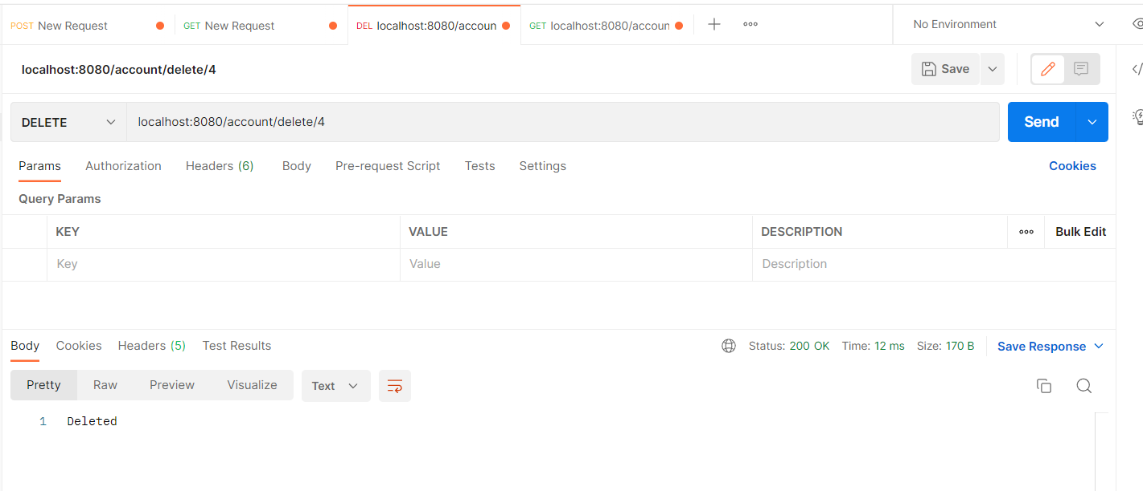

TEST CASES: -

CUSTOMER:

1. getAll

1. FindCustomer with id

1. Update Customer

