AWS Cloud Security Monitoring and Hardening Project-Natasha V

1. Project Overview
This project demonstrates the deployment, security hardening, monitoring, and alerting of a cloud-based virtual server using Amazon Web Services (AWS). The objective was to build a secure EC2 instance, restrict unauthorized access, and implement monitoring using CloudWatch with automated email alerts through SNS.

2. Project Objectives
- Deploy an EC2 instance using AWS.
- Restrict inbound traffic using Security Groups.
- Configure secure SSH access.
- Set up CloudWatch monitoring for CPU utilization.
- Create a threshold-based CloudWatch alarm.
- Enable automated email notifications using Amazon SNS.

3. Technologies Used
- Amazon EC2
- Amazon CloudWatch
- Amazon Simple Notification Service (SNS)
- AWS Security Groups
- Ubuntu Linux
- Secure Shell (SSH)

4. Implementation Details

4.1 EC2 Instance Deployment
An EC2 instance was launched using the Ubuntu operating system under the AWS Free Tier. A key pair was generated to enable secure SSH access to the server.

4.2 Network Security Configuration
Security Groups were configured to control inbound traffic. SSH access on port 22 was restricted to the user's public IP address to prevent unauthorized access. This configuration follows the principle of least privilege.

4.3 SSH Configuration Review
The SSH configuration file was reviewed to verify secure authentication settings. Password-based authentication was disabled, and root login permissions were checked to enhance system security.

4.4 CloudWatch Monitoring Setup
Amazon CloudWatch was configured to monitor CPU utilization of the EC2 instance. The metric selected was CPUUtilization under EC2 Per-Instance Metrics.

4.5 Alarm Configuration
The CloudWatch alarm was configured with the following parameters:
- Metric: CPUUtilization
- Statistic: Average
- Period: 1 minute
- Threshold: Greater than 80 percent
- Evaluation: 5 out of 5 datapoints
- Missing Data Treatment: Treat as missing
This configuration ensures that the alarm triggers only if CPU usage exceeds 80 percent continuously for five minutes.

4.6 SNS Email Notification Setup
An Amazon SNS topic was created to send email alerts. The email subscription was confirmed to enable notifications when the alarm enters the ALARM state.

5. Security Concepts Applied
- Least Privilege Access Control
- Network Access Restriction
- Continuous Monitoring
- Threshold-Based Alerting
- Incident Notification and Response

6. Results
The EC2 instance was successfully deployed and secured. The CloudWatch alarm transitioned from INSUFFICIENT_DATA to OK after collecting sufficient metrics. The monitoring system is capable of detecting high CPU utilization and sending real-time email alerts.

7. Key Learnings
- Hands-on experience with AWS core services.
- Understanding of cloud infrastructure security principles.
- Practical knowledge of monitoring and alerting systems.
- Importance of cleaning up unused resources to avoid unnecessary costs.

8. Screenshots
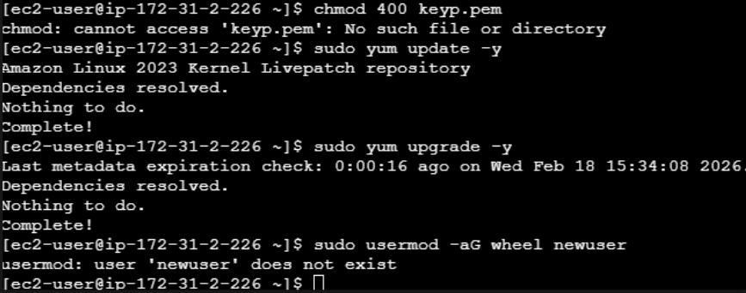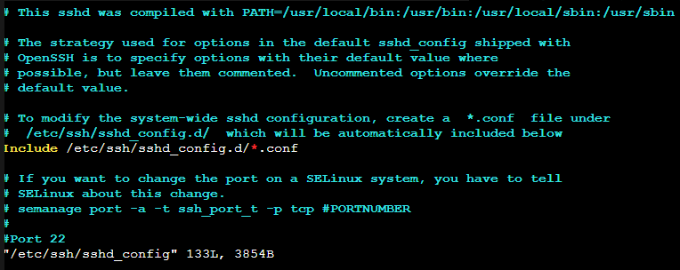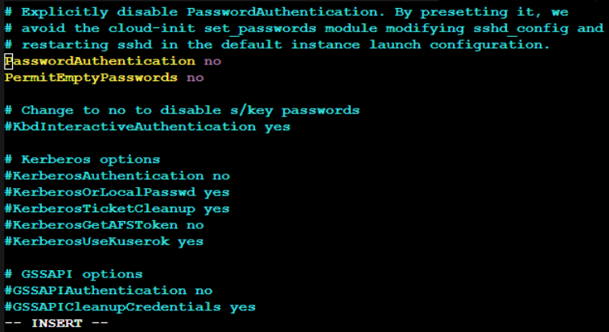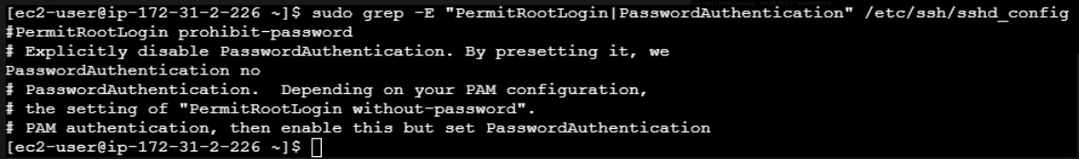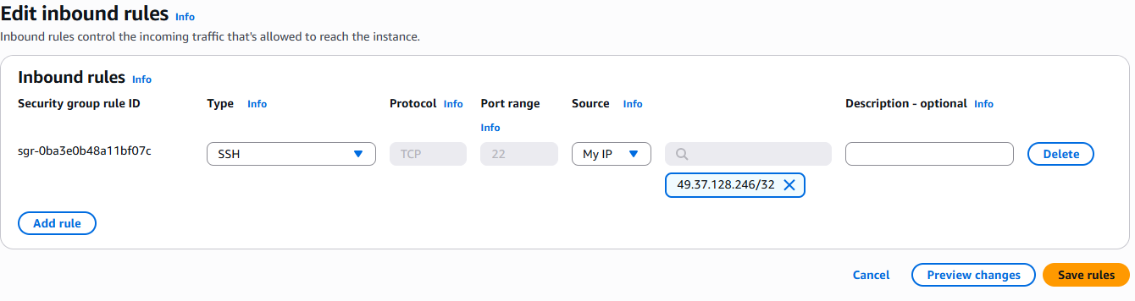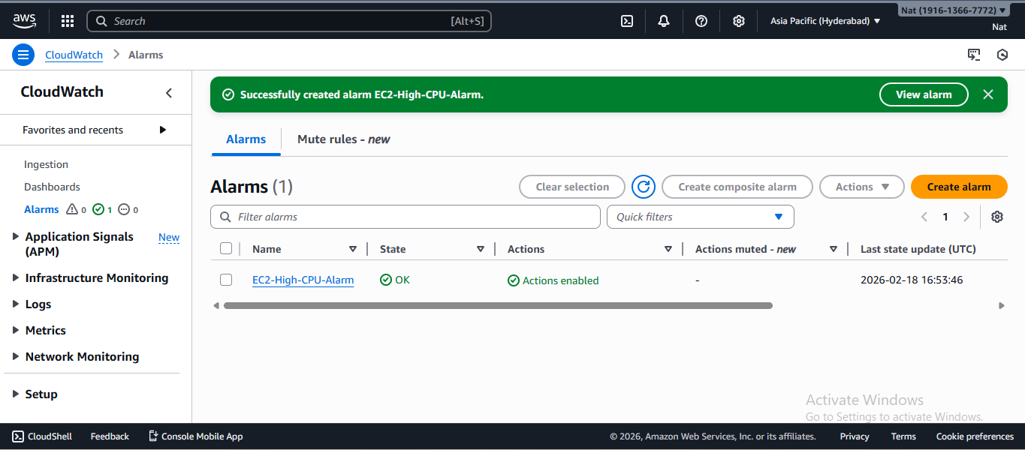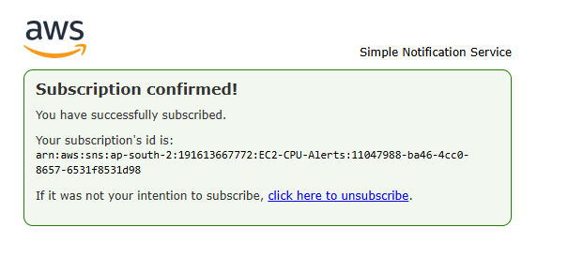

9. Conclusion
This project demonstrates the ability to deploy, secure, monitor, and manage cloud infrastructure using AWS. It reflects practical understanding of cloud security best practices and operational monitoring.

