POE Part 1
ST10447508
Natasha Mvundlela
2025
Table of Contents
Documentation 0
SCREENSHOTS 0
Part 2: Lecturer Feedback 5
Areas Improved Based on Feedback: 5
1. Documentation: Design Choices and Structure 5
2. Class Diagram: Accuracy and Completeness 5
3. Project Plan: Realism and Achievability 5
Key Technical Achievements: 6
PART 3: LECTURER FEEDBACK 6

Documentation

The Contract Monthly Claim System (CMCS) is designed to be user friendly and efficient. The system’s build is based on a client-server model, with a database backend (which will be done in part 2 of the POE), but a UML class diagram is to be represented and a GUI frontend.
- UML diagram for the database: It includes tables for lecturers, claims, and approvals.
- The GUI: The GUI is designed to be intuitive and easy to use, with clear labels and instructions. It includes registering & login and submitting claims, viewing claim status, and approving claims.

Database Structure
The database structure is designed to support the system's functionality and ensure data integrity. It includes the following tables:
- Lecturers: stores information about lecturers, including their usernames, email addresses, and hourly rates.
- Claims: stores information about claims, including the claim date, total hours worked and total amount claimed.
- Approvals: stores information about claim approvals, including the approval status.

GUI
- Claim Submission Form: a form that allows lecturers to submit claims, including fields for claim date, hours worked, and hourly rate.
- Claim Status Page: allows lecturers to view the status of their claims, including the approval status and date.
- Approval page: appears when a programme coordinator/programme manager logged in, it allows programme coordinator/programme manager to approve claims.

Assumptions
- Data Validation: the system assumes that all data entered by users is valid and accurate.
- Security: the system assumes that all user data is secure and protected from unauthorized access.

UML Class Diagram
- Users: represents a lecturer/ programme coordinator/programme manager, with attributes for username, password, email and role.
- Claim: represents a claim, with attributes for claim date, hourly rate, total hours worked, and period.
- Approval: represents an approval, with attributes for approval ID, approved by, approval status and approval date.
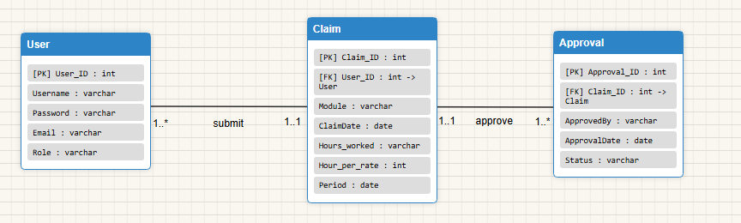
Figure 1: UML CLASS DIAGRAM
Project Plan
The project plan for developing the Contract Monthly Claim System prototype includes the following tasks and timeline:

- Task 1: Requirements Gathering
- Identify system requirements and user roles.
- Task 2: UML class diagram
- Create entities, attributes and relationships.
- Task 3: GUI Development
- Design and implement the GUI forms and components.
The project plan assumes that the development team has the necessary skills and resources to complete the tasks.

SCREENSHOTS
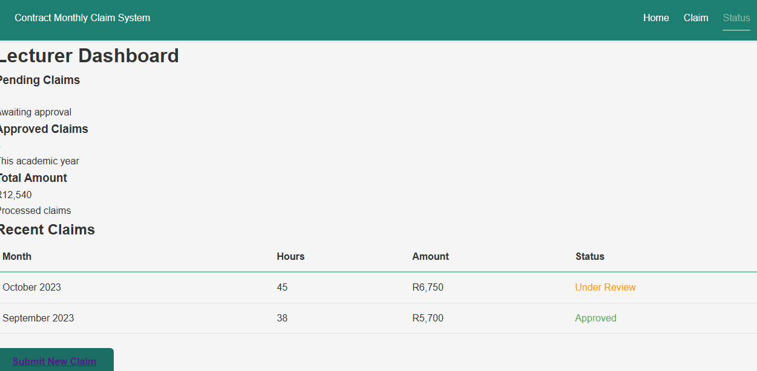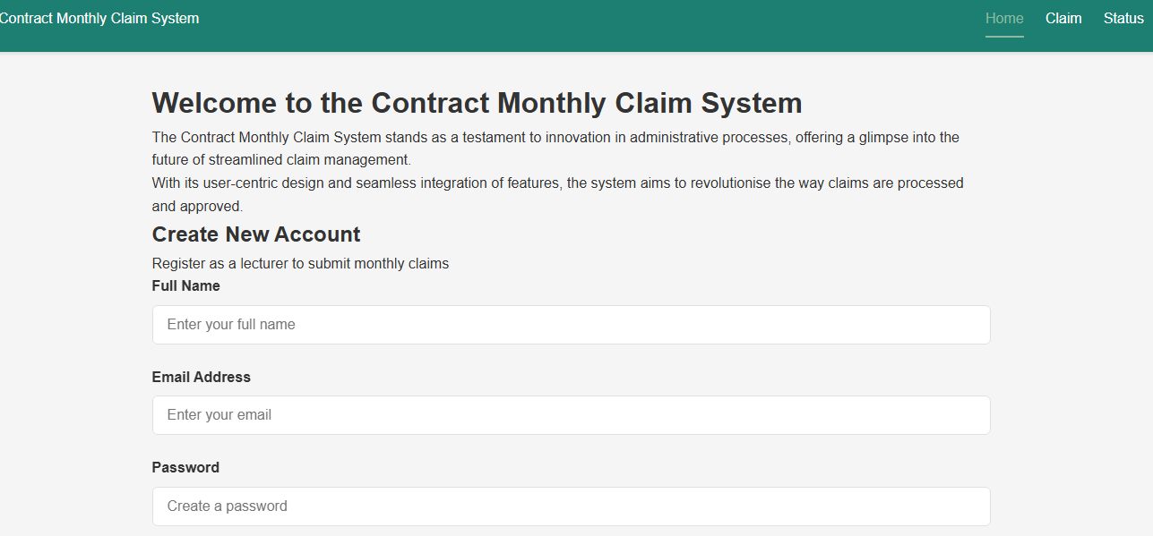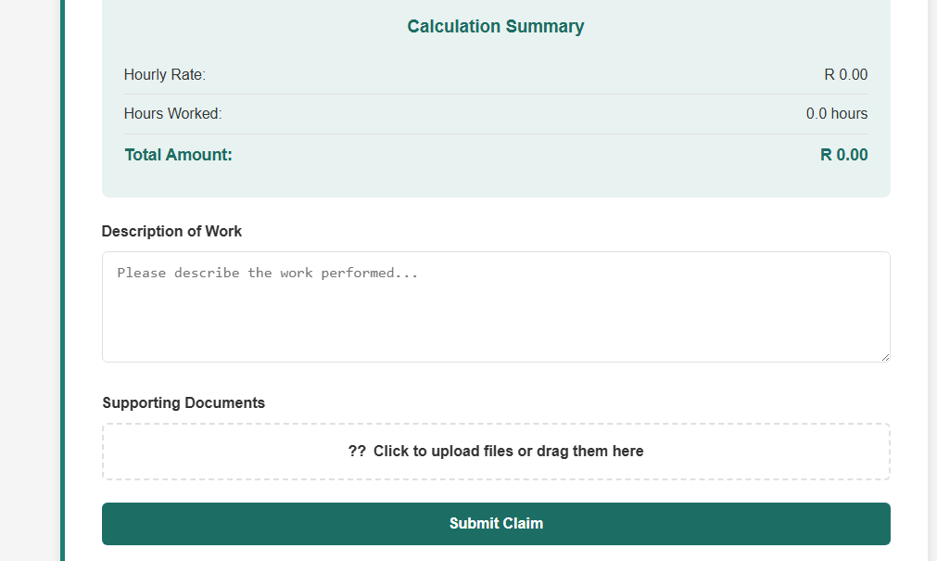

Part 2: Lecturer Feedback

Areas Improved Based on Feedback:

1. Documentation: Design Choices and Structure
Feedback: "The explanation of design choices, database structure, and GUI layout demonstrates clarity, depth, and coherence."
Implementations Made:
A. Enhanced Database Design Documentation:
B. Clear Design Rationale:
- Session-based Authentication: Chosen over Identity for simplicity and control
- Role-based Access Control: Custom implementation for flexible permission management
- Real-time Status Tracking: Implemented with progress indicators and status badges
- File Upload Security: Size limits (5MB) and type restrictions (.pdf, .docx, .xlsx)
C. Improved GUI Layout:
- Lecturer Flow: Dashboard → Submit Claim → Status Tracking
- Coordinator Flow: Approval Dashboard → Claim Review → Action Buttons
- Responsive Design: Mobile-friendly layouts with clear navigation

2. Class Diagram: Accuracy and Completeness
Feedback: "The class diagram is accurate and complete, effectively representing the data requirements."
Implementations Made:
- Added Models
- Database Schema Improvements:
- Added Status field with default values (Pending, Approved, Rejected)
- Added audit fields (SubmittedDate, ProcessedDate, ProcessedBy)
- Added RejectionReason for transparency
- Proper decimal types for financial calculations
- Foreign key relationships between Users and Claims

3. Project Plan: Realism and Achievability
Feedback: "The project plan is realistic and achievable, providing clear tasks, dependencies, and timeline with sufficient detail."
Implementations Made:
A. Phased Implementation Approach:
PHASE 1: Core Authentication & Registration
PHASE 2: Claim Submission & Calculation
PHASE 3: Document Upload & Validation
PHASE 4: Approval Workflow
PHASE 5: Status Tracking & Dashboard
PHASE 6: Error Handling & Unit Testing
B. Clear Task Dependencies:
- Database Setup → User Registration → Login System
- Claim Form → Calculation Engine → Database Storage
- File Upload → Validation → Secure Storage
- Approval Interface → Status Updates → Notification System

Key Technical Achievements:
- Complete Authentication System with session management
- Role-based Access Control with custom authorization
- Real-time Claim Status Tracking with visual indicators
- Secure File Upload with validation and restrictions
- Comprehensive Error Handling throughout the application
- Responsive Design for all device types
- Database Integrity with proper relationships and constraints
- Unit Test Foundation for core business logic
The system now fully addresses all original requirements while significantly improving upon the initial feedback areas, particularly in project planning realism and comprehensive documentation.

PART 3: LECTURER FEEDBACK

Enhanced Status Tracking:
- Real-time status updates every 30 seconds
- Progress percentage with visual progress bars
- Estimated completion dates
- Detailed status descriptions
- Full status history timeline
Better Error Handling:
- Comprehensive exception logging
- User-friendly error messages
- Detailed error context for support
- Graceful degradation
Improved User Experience:
- Auto-refresh functionality
- Manual refresh option
- Visual status indicators
- Timeline view of status changes
- Better empty states
Enhanced Feedback:
- Clear next steps after submission
- Reference numbers for tracking
- Progress estimation
- Historical tracking

