|  |
| --- |
| **Name:- Natasha Oza**  **Roll No. – TIA36**  **Subject :- WAD LAB** |

**PRACTICAL – 1A**

**Index.html .,**

<!DOCTYPEhtml>

<htmllang="en">

<head>

<metacharset="UTF-8">

<metaname="viewport"content="width=device-width, initial-scale=1.0">

<title>Luxury Store</title>

<linkrel="stylesheet"href="styles.css">

</head>

<body>

<!-- Sidebar Toggle Button -->

<buttonclass="sidebar-toggle"onclick="toggleSidebar()">☰</button>

<!-- Sidebar -->

<navclass="sidebar"id="sidebar">

<buttonclass="close-btn"onclick="toggleSidebar()">✖</button>

<ul>

<li><ahref="index.html">🏠 Home</a></li>

<li><ahref="categories.html">📦 Categories</a></li>

<li><ahref="trending.html">🔥 Trending</a></li>

<li><ahref="deals.html">💰 Deals</a></li>

<li><ahref="contact.html">📞 Contact</a></li>

</ul>

</nav>

<!-- Hero Section with Background Image -->

<headerclass="hero">

<divclass="hero-overlay">

<h1>Welcome to Luxury Store</h1>

<p>Discover exclusive collections and premium brands</p>

<ahref="trending.html"class="btn-primary">Explore Now</a>

</div>

</header>

<!-- Main Content -->

<mainclass="main-content">

<h2>✨ Trending Collections</h2>

<divclass="product-grid">

<divclass="product">

<imgsrc="img\watch.jpg"alt="Luxury Watch">

<h3>Luxury Watch</h3>

<p>$999</p>

<buttonclass="btn-buy">Buy Now</button>

</div>

<divclass="product">

<imgsrc="img\Bag.jpg"alt="Designer Handbag">

<h3>Designer Handbag</h3>

<p>$1,299</p>

<buttonclass="btn-buy">Buy Now</button>

</div>

</div>

</main>

<scriptsrc="script.js"></script>

</body>

</html>

**Styles.css .,**

.product {

background: #1c1c1c;

padding: 15px;

border-radius: 10px;

text-align: center;

transition: transform 0.3s;

max-width: 200px;

}

.productimg {

width: 100%;

border-radius: 8px;

}

.product:hover {

transform: scale(1.05);

}

.btn-buy {

background: #ffd700;

color: black;

padding: 8px12px;

border: none;

border-radius: 5px;

cursor: pointer;

transition: background0.3s;

}

.btn-buy:hover {

background: #c9a400;

}

/* Deals Grid */

.deal-grid {

display: flex;

gap: 20px;

justify-content: center;

flex-wrap: wrap;

}

.deal {

background: #1c1c1c;

padding: 15px;

border-radius: 10px;

text-align: center;

transition: transform 0.3s;

max-width: 220px;

}

.dealimg {

width: 100%;

border-radius: 8px;

margin-bottom: 10px;

}

.deal:hover {

transform: scale(1.05);

}

.btn-deal {

background: #ffd700;

color: black;

padding: 8px12px;

border: none;

border-radius: 5px;

cursor: pointer;

transition: background0.3s;

}

.btn-deal:hover {

background: #c9a400;

}

**Script.js**

functiontoggleSidebar() {

letsidebar=document.getElementById("sidebar");

letoverlay=document.getElementById("overlay");

sidebar.classList.toggle("active");

overlay.classList.toggle("active");

}

// Close sidebar if user clicks outside

document.addEventListener("click", function (event) {

letsidebar=document.getElementById("sidebar");

letsidebarToggle=document.querySelector(".sidebar-toggle");

if (!sidebar.contains(event.target) &&!sidebarToggle.contains(event.target)) {

sidebar.classList.remove("active");

document.getElementById("overlay").classList.remove("active");

}

});

**Trending.html .,**

<!DOCTYPEhtml>

<htmllang="en">

<head>

<metacharset="UTF-8">

<metaname="viewport"content="width=device-width, initial-scale=1.0">

<title>Trending Products</title>

<linkrel="stylesheet"href="styles.css">

</head>

<body>

<buttonclass="sidebar-toggle"onclick="toggleSidebar()">☰</button>

<navclass="sidebar"id="sidebar">

<buttonclass="close-btn"onclick="toggleSidebar()">✖</button>

<ul>

<li><ahref="index.html">🏠 Home</a></li>

<li><ahref="categories.html">📦 Categories</a></li>

<li><ahref="trending.html">🔥 Trending</a></li>

<li><ahref="deals.html">💰 Deals</a></li>

<li><ahref="contact.html">📞 Contact</a></li>

</ul>

</nav>

<mainclass="main-content">

<h1>🔥 Trending Products</h1>

<divclass="product-grid">

<divclass="product">

<imgsrc="img\watch.jpg"alt="Luxury Watch">

<h3>Luxury Watch</h3>

<p>$999</p>

<buttonclass="btn-buy">Buy Now</button>

</div>

<divclass="product">

<imgsrc="img\Bag.jpg"alt="Designer Handbag">

<h3>Designer Handbag</h3>

<p>$1,299</p>

<buttonclass="btn-buy">Buy Now</button>

</div>

<divclass="product">

<imgsrc="img\shoes.jpg"alt="Premium Sneakers">

<h3>Premium Sneakers</h3>

<p>$299</p>

<buttonclass="btn-buy">Buy Now</button>

</div>

</div>

</main>

<scriptsrc="script.js"></script>

</body>

</html>

**Categories.html .,**

<!DOCTYPEhtml>

<htmllang="en">

<head>

<metacharset="UTF-8">

<metaname="viewport"content="width=device-width, initial-scale=1.0">

<title>Categories</title>

<linkrel="stylesheet"href="styles.css">

</head>

<body>

<buttonclass="sidebar-toggle"onclick="toggleSidebar()">☰</button>

<navclass="sidebar"id="sidebar">

<buttonclass="close-btn"onclick="toggleSidebar()">✖</button>

<ul>

<li><ahref="index.html">🏠 Home</a></li>

<li><ahref="categories.html">📦 Categories</a></li>

<li><ahref="trending.html">🔥 Trending</a></li>

<li><ahref="deals.html">💰 Deals</a></li>

<li><ahref="contact.html">📞 Contact</a></li>

</ul>

</nav>

<mainclass="main-content">

<h1>📦 Product Categories</h1>

<divclass="category-grid">

<divclass="category">👗 Fashion</div>

<divclass="category">📱 Electronics</div>

<divclass="category">💄 Beauty</div>

<divclass="category">🏡 Home & Living</div>

</div>

</main>

<scriptsrc="script.js"></script>

</body>

</html>

**Deals.html .,**

<!DOCTYPEhtml>

<htmllang="en">

<head>

<metacharset="UTF-8">

<metaname="viewport"content="width=device-width, initial-scale=1.0">

<title>Deals & Offers</title>

<linkrel="stylesheet"href="styles.css">

</head>

<body>

<buttonclass="sidebar-toggle"onclick="toggleSidebar()">☰</button>

<navclass="sidebar"id="sidebar">

<buttonclass="close-btn"onclick="toggleSidebar()">✖</button>

<ul>

<li><ahref="index.html">🏠 Home</a></li>

<li><ahref="categories.html">📦 Categories</a></li>

<li><ahref="trending.html">🔥 Trending</a></li>

<li><ahref="deals.html">💰 Deals</a></li>

<li><ahref="contact.html">📞 Contact</a></li>

</ul>

</nav>

<mainclass="main-content">

<h1>💰 Exclusive Deals</h1>

<divclass="deal-grid">

<divclass="deal">

<imgsrc="img/perfume.jpg"alt="Luxury Perfume">

<h3>Luxury Perfume - 50% Off</h3>

<p>Now at just $199!</p>

<buttonclass="btn-deal">Grab Now</button>

</div>

<divclass="deal">

<imgsrc="img\Smartphones.jpg"alt="Smartphone">

<h3>Smartphone - 30% Off</h3>

<p>Limited-time deal at $699!</p>

<buttonclass="btn-deal">Shop Now</button>

</div>

<divclass="deal">

<imgsrc="img\headphones.jpg"alt="Wireless Headphones">

<h3>Wireless Headphones - 40% Off</h3>

<p>Only $149 for premium sound!</p>

<buttonclass="btn-deal">Buy Now</button>

</div>

</div>

</main>

<scriptsrc="script.js"></script>

</body>

</html>

**Contact.html .,**

<!DOCTYPEhtml>

<htmllang="en">

<head>

<metacharset="UTF-8">

<metaname="viewport"content="width=device-width, initial-scale=1.0">

<title>Contact Us</title>

<linkrel="stylesheet"href="styles.css">

</head>

<body>

<buttonclass="sidebar-toggle"onclick="toggleSidebar()">☰</button>

<navclass="sidebar"id="sidebar">

<buttonclass="close-btn"onclick="toggleSidebar()">✖</button>

<ul>

<li><ahref="index.html">🏠 Home</a></li>

<li><ahref="categories.html">📦 Categories</a></li>

<li><ahref="trending.html">🔥 Trending</a></li>

<li><ahref="deals.html">💰 Deals</a></li>

<li><ahref="contact.html">📞 Contact</a></li>

</ul>

</nav>

<mainclass="main-content">

<h1>📞 Contact Us</h1>

<formclass="contact-form">

<inputtype="text"placeholder="Your Name"required>

<inputtype="email"placeholder="Your Email"required>

<textareaplaceholder="Your Message"required></textarea>

<buttontype="submit">Send Message</button>

</form>

</main>

<scriptsrc="script.js"></script>

</body>

</html>

**OUTPUT :-**

**Home Page .,**

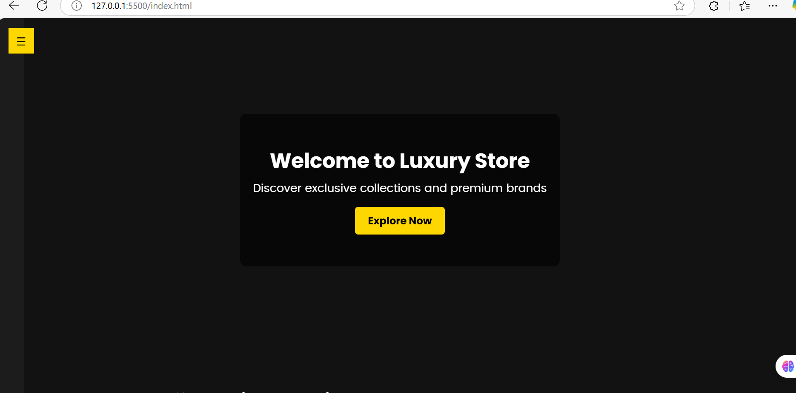

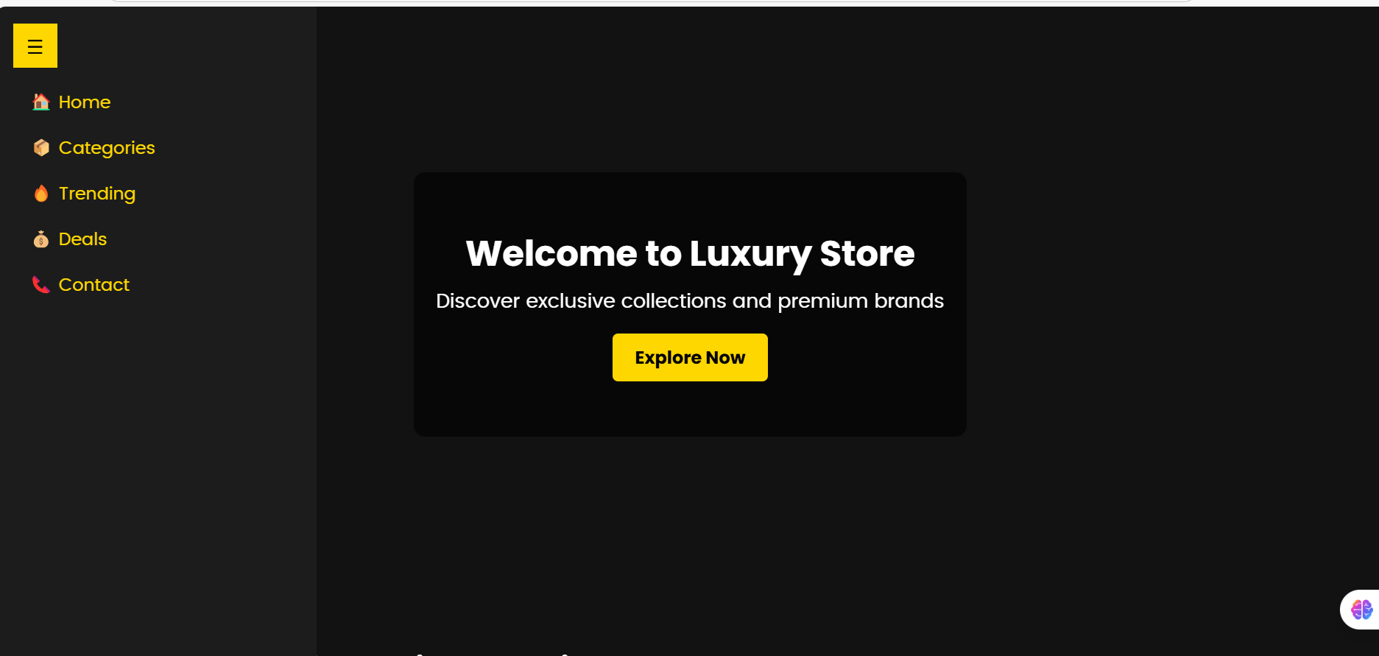

**Trending page .,**

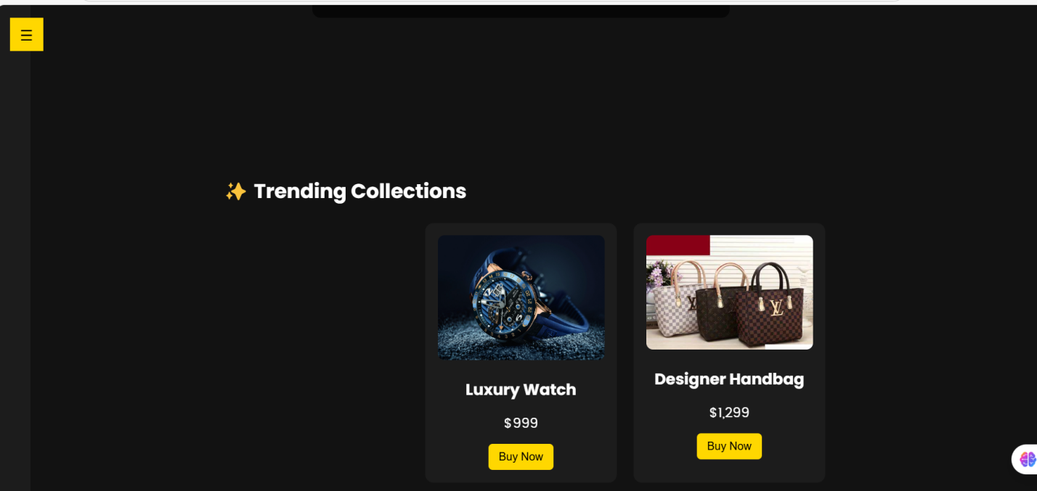

**Product Categories .,**

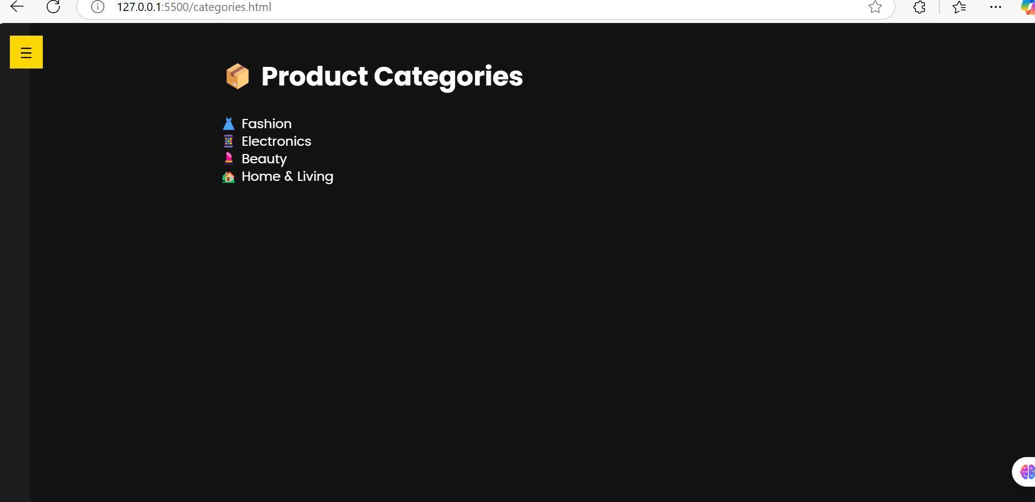

**Deals .,**

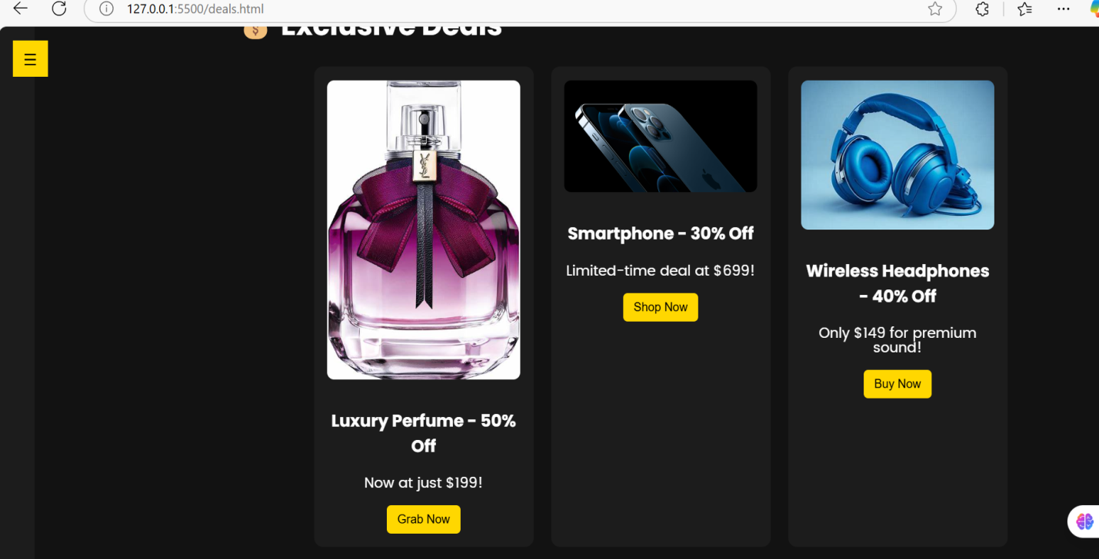

**Contact .,**

