This project will discuss an Italian ceramic as a part of an Ancient Roman terra sigillata, the neck of a red slip ware pottery lagynos jug. Reflectance Transformation Imaging (RTI) enhanced both design elements and abrasion allowing further examination of terra sigillata production and its cultural significance.

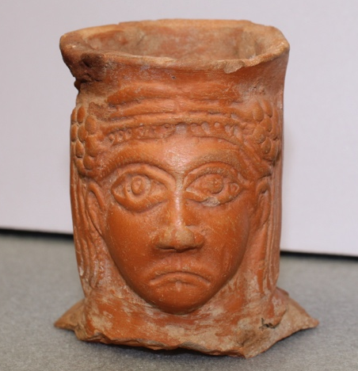
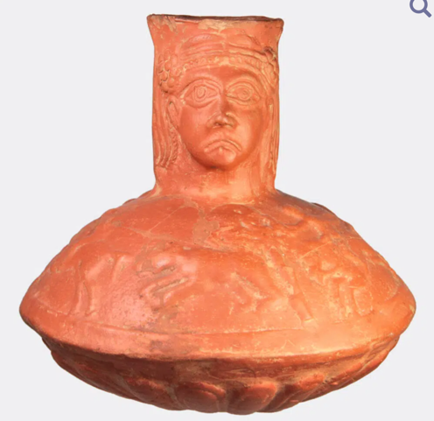

Figure 2: Complete Lagynos Jug published online (Helios Gallery, 2022)
Figure 1: Artefact used for RTI, room (325), donated by Giovanna Senni

Aims
The neck of this terra sigillata was retrieved from the Villa estate culturally relevant to the Ad Decimum settlement. The term 'terra sigillata', derived from Latin, translates to 'clay bearing little images' (St.James, 2021). The first aim of this project is to highlight the cultural significance of ceramic design choices. Varied light angles highlight facial details of Bacchus, the god of wine (Wasson, 2023) and distinguishes between sgraffito and abrasion. Secondly, this project aims to analyse material composition and identify eroded features. Scholars note a consumer revolution's impact on the Western Roman Empire's economic infrastructure via Terra Sigillata. Terra Sigillata's ease of production using clay and water, poses challenges for preservation.

Objectives
Investigating how design choices emphasise cultural significance in ceramics involves accurately positioning lighting using 8 viewpoints. Similarly, positioning terra sigillata appropriately highlights dimensions of facial features. Distinguishing between abrasion and sgraffito is crucial - digitising Bacchus using RTIBuilder should emphasise intentional strokes in more detail. To identify the neck as a broken terra sigillata it is critical to analyse material erosion based on features of abrasion like pigmentation, texture, scale, potsherd, and environmental erosion. Leveraging RTI, should minimise handling of fragile artefacts and produce a dimensional image.

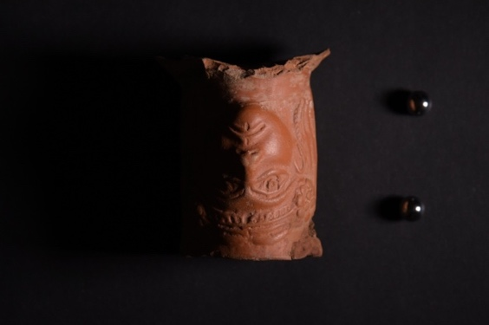
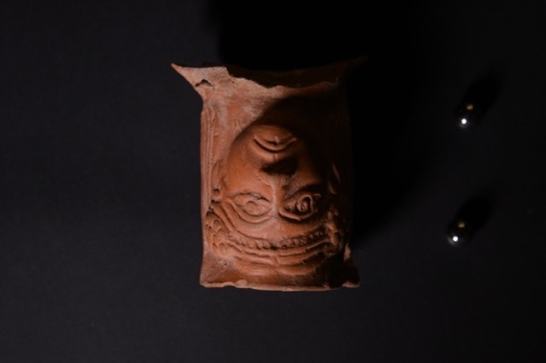
Figures 3 and 4: RAW .jpg images of left and right angles of light.

Results
RAW images were taken from 56 angles, lit utilising 8 viewpoints at 7 heights. RTIViewer allowed interactive exploration of the object's surface under different lighting conditions. Bacchus, depicted as young and fit, is accessorised by a crown of ivy representing fertility (National Museums Liverpool, 2024). Bacchus embodies the function of the lagynos jug for consuming wine at Roman dinner parties. As the God of wine, Bacchus possesses characteristics of beauty through feminine features, Bacchus’s large-scale eyes, long hair and protruding slender face. Bacchus's downturned mouth conveys a look of stoic resignation associated with his masculinity. RAW images with underexposure and overshadowing were removed within software to optimise gendered details. RTIViewer distinguishes sgraffito for the style of African red slip pottery from abrasion by clarifying discolouration neck abrasion and a chipped right cheek. African red slip was tied to the agriculture of Rome's North African provenance coinciding with the popularisation of central motifs of humans and animals during the 5th century (Tiza, 2023). RTIBuilder was an accessible recording method to analyse abrasion from material and environmental conditions. RTI emphasised green pigmentation on Bacchus’s nose due to weathering by chemical degradation, its scratched surface texture emphasises how fine-grained clay used to construct thin walls is difficult to preserve (Santa et al., 2023). Abrasion from the distribution edges of potsherd pointing outwards suggest damage to the bottom of the lagynos jug was separated by force. Structural insight of the artefact could be gained using thermal imaging to reveal temperature variations, indicating hidden defects.

Figure 5: Screengrab of final project using RTIViewer

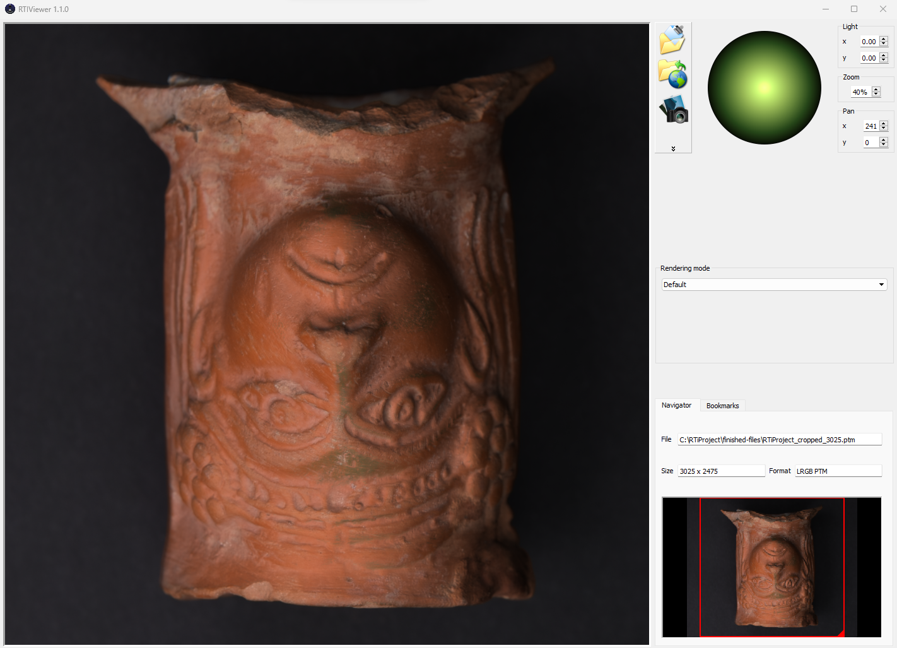

Works Cited
Helios Gallery (2022) Roman pottery wine Lagynos with hunting scene and head of Bacchus, Helios Gallery. Available at: https://heliosgallery.com/antiquities/catalogue/not-catalogued/roman-pottery-wine-lagynos-with-hunting-scene-and-head-of-bacchus/ (Accessed: 24 March 2024).
National Museums Liverpool (2024) Head of Bacchus, National Museums Liverpool. Available at: https://www.liverpoolmuseums.org.uk/artifact/head-of-bacchus (Accessed: 23 March 2024).
Santa, A.C. et al. (2023) ‘Atmospheric deterioration of ceramic building materials and future trends in the field: A Review’, Heliyon, 9(4). doi:10.1016/j.heliyon.2023.e15028.
St James Ancient Art (2021) Terra sigillata: Clay Bearing Little images, St James Ancient Art. Available at: https://www.ancient-art.co.uk/terra-sigillata-clay-bearing-little-images/ (Accessed: 23 March 2024).
Tiza (2023) The development of animal motifs in contemporary art, KunstLoft. Available at: https://www.kunstloft.co.uk/magazine/animal-motifs-in-contemporary-art/ (Accessed: 23 March 2024).
Wasson, D.L. (2023) Bacchus, World History Encyclopedia. Available at: https://www.worldhistory.org/Bacchus/ (Accessed: 23 March 2024).

