Nature of Project
This project, submitted as part of the requirements of the ARCH 5107 unit, was designed to digitally record the neck of a broken terra sigillata sourced from room 325 using Reflectance Transformation Imaging (RTI).
Originally this project was supposed to be conducted using the RTI dome which automated lighting from various angles to digitally construct and inspect the artefact using appropriate software. Unfortunately, due to the malfunctioning of the control box this project instead used a manual approach which required lighting to be positioned around the artefact at 8 viewpoints and 7 heights per viewpoint. To reduce the likelihood of low-quality images due to movement a wireless shutter release connected to the camera rigged directly above the artefact set on black paper. 56 images were then finalised and exported onto a computer to be run through RTIbuilder software.
Table 1: Equipment used for RTI Project
Equipment | Metadata
Camera Make | Nikon
Camera Model | Nikon D750
Shutter release remote | ML-L3 Wireless IR Remote Control
Light Source | Selens LED Portable Studio Light Lamp
Camera rig | Lens height: 17.5 inches
Computer model | HP EliteDesk 800 SFF G5
RTI spheres | Silver 3mm
Background | A3 paper sheet - black
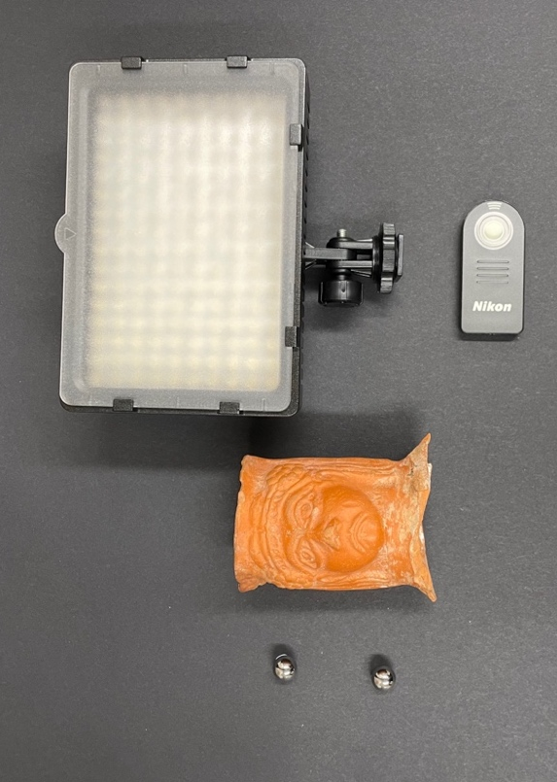

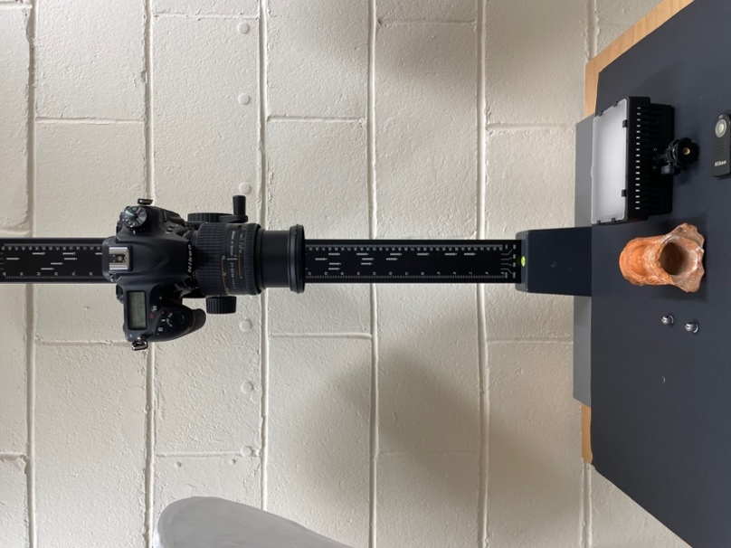

Figure 2: camera positioned over artefact using rig and RTI spheres.
Figure 1: Equipment used: light source, shutter release, artefact and RTI spheres.
Table 2: Manual settings for RAW images.

Camera Settings | Metadata
ISO | 800
Aperture | f/8
Shutter-speed | 1/80
Focal length | 85mm

ISO 800 allowed the camera to capture more light, resulting in a brighter image, balancing capturing sufficient light and minimising image noise. Using a smaller aperture helped to maintain a deeper depth of field. 1/80 shutter speed allowed the camera to gather more light over a slightly longer period and a longer focal length like 85mm provided more magnification without compromising the scale of the artefact.

Software
Processing images relied on RTIBuilder to generate the lp configuration files to locate the LEDs in 3D space and were presented using RTIViewer software and a PTM (polynomial texture mapping) workflow. Ultimately, RTIBuilder was an accessible recording method which required little specialist equipment and was straightforward to navigate.
Summary of workflow:
- Preparing centralised folders for RAW files and converted files.
- Converting file type to .jpeg and selecting project type (Highlight Based PTM Fitter).
- Loading the images onto the software.
- (Folder Preview Plugin) Removing under and over exposed images.
- Specifying the lighting positions for each image: (Ball Detection) detecting spheres and highlights (Plugin HighLight Detection).
- Downloading PTM fitter exe file (Plugin PTMfitter)
- Software calculated the Reflectance Transformation Function (RTF) to generate an interactive RTI viewer file.

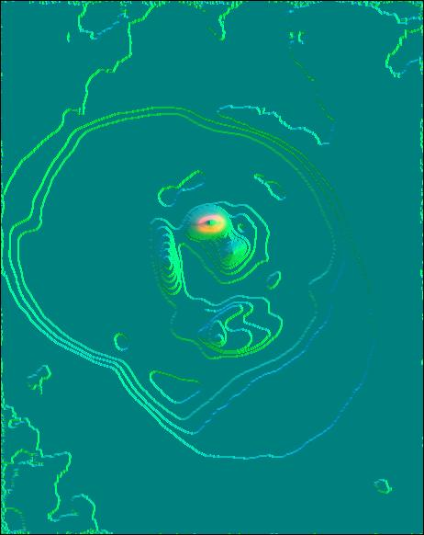
Figure 3: Ball detection fairly inaccurate due to colour of spheres not showing up well in low lighting (important to consider a brighter colour)
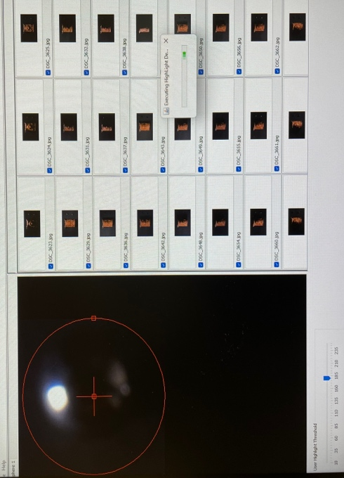
Figure 4: Finalising highlight detection after confirming ball placement and grid of applied RAW images.

Works Cited
Malzbender, T. (2000) Polynomial texture maps, Johns Hopkins University . Available at: https://www.cs.jhu.edu/~misha/ReadingSeminar/Papers/Malzbender01.pdf (Accessed: 23 March 2024).
Teaching Archaeoinformatics (2024) Using the rtibuilder, rti:rtibuilder [Teaching Archaeoinformatics!]. Available at: https://teaching.hageneuer.de/doku.php?id=rti%3Artibuilder (Accessed: 23 March 2024).
Vitelli, G. (2021) Antiquities.

