Title: Quantifying wildlife conflicts with metabarcoding and traditional dietary analyses: applied to seabird predation by long-nosed fur seals

Running head: Quantifying wildlife conflicts

Abstract

Wildlife conflicts require robust quantitative data on incidence and impacts, particularly among species of conservation and cultural concern. We apply a multi-assay framework to quantify predation in a southeastern Australian scenario where complex management implications and calls for predator culling have grown despite a paucity of data on seabird predation by recovering populations of long-nosed fur seals (Arctocephalus forsteri). We apply two ecological surveillance techniques to analyse this predator’s diet – traditional morphometric (prey hard-part) and environmental DNA metabarcoding (genetic) analyses using an avian specific primer for the 12S ribosomal RNA (rRNA) gene – to provide managers with estimated predation incidence, number of seabird species impacted and prey relative importance to the predator. DNA metabarcoding proved more sensitive in identifying additional seabird taxa and provided relative quantitative information where multiple prey species occur within a sample; while parallel use of both genetic and hard-part analyses revealed a greater diversity of taxa than either method alone. Using data from both assays, the estimated frequency of occurrence of predation on seabirds by long-nosed fur seals ranged from 9.1–29.3% of samples and included up to 6 detected prey species. The most common seabird prey was the culturally valued little penguin (Eudyptula minor) that occurred in 6.1–25.3% of samples, higher than previously reported from traditional morphological assays alone. We then explored DNA haplotype diversity for little penguin genetic data, as a species of conservation concern, to provide a preliminary estimate of the number of individuals consumed. Polymorphism analysis of consumed little penguin DNA identified five distinct mitochondrial haplotypes – representing a minimum of 16 individual penguins consumed across 10 fur seal scat samples. We recommend rapid uptake and development of cost-effective genetic techniques and broader spatiotemporal sampling of fur seal diets to further quantify predation and hotspots of concern for wildlife conflict management.

Introduction

New wildlife conservation and management scenarios are emerging during the Anthropocene as some species experience population increases through successful conservation efforts, while others continue to decline (Roman et al., 2015; Marshall et al., 2016; Cammen et al., 2019). Complex management scenarios arise when species recovery results in negative interactions with other species of value, whether that reflects a trophic role in the ecosystem, conservation status, community connection or economic opportunity (Marshall et al., 2016), for example between killer whales, sea otters and salmon (Estes et al., 1998; Williams et al., 2011); New Zealand sea lions and yellow-eyed penguins (Lalas et al., 2007); wolves and caribou (Hervieux et al., 2014). The interactions are natural but present a need for accurate information on natural predation levels and impacts to prey (Hervieux et al., 2014) to avoid unjustified persecution of the predator (Granquist et al., 2018), and for effective management of all species concerned (Marshall et al., 2016).
A key goal of investigating predator-prey interactions involves determining prey inter- and intra-specific diversity, dietary proportions, and abundances or biomass consumed by the predator (reviewed by Pompanon et al., 2012), while achieving reliable detection of predation (Deagle et al., 2005). Developments in eDNA extraction and metabarcoding techniques are demonstrating reliability for this level of environmental monitoring (Thomsen & Willerslev 2015) by: (i) identifying prey at high taxonomic resolution and when missed by other methods (Bowen & Iverson, 2013; Stat et al. 2019); (ii) estimating dietary proportions, reconstructing approximate biomass and abundances of prey consumed through relative genetic importance (Deagle et al., 2019); (iii) identifying species’ intraspecific genetic diversity within environmental samples for wildlife forensics and population estimation (Sigsgaard et al., 2016; Seersholm et al., 2018; Tsuji et al., 2020).
In southeastern Australia, the recovery of long-nosed fur seals (Arctocephalus forsteri) could cumulatively threaten populations of little penguins (Eudyptula minor) in addition to other known stressors (Reinhold et al. 2022). Both species are federally protected and garner significant cultural and conservation value (Environment Protection and Biodiversity Conservation Act, 1975 & 1999), albeit listed as ‘Least Concern’ by the IUCN Redlist (IUCN 2020). Little penguins are a popular tourist attraction and valued species to communities across southern Australia (Tisdell & Wilson, 2012). Little penguin populations are estimated at 470,000 individuals (BirdLife International, 2021); yet 60% of sites have unknown population trends, 29% of colonies are declining, and most persist on offshore islands in southern Australia and are difficult to census (BirdLife International, 2021). Little penguins forage at sea but breed on land, making them susceptible to threats from both environments. Major contributors to declines in little penguin populations include: (i) changes in land-use and predators introduced by European settlers (Dann, 1991; Kirkwood et al., 2014) and (ii) susceptibility to hyperthermia during more frequent terrestrial heat waves (Lauren Tworkowski, La Trobe University, unpublished data). Ocean warming and large-scale changes to food webs caused by climate change as well as competition with fisheries are threatening processes of concern (Ropert-Coudert et al., 2019).
The fur seals were decimated by fur trade through the 1800’s and culling into the late 1900’s due to perceived competition for resources with fishers (Shaughnessy et al., 1999). Long-nosed fur seals have experienced range-wide increasing population trends, reported at 97,200 in the state of South Australia (2013–14 census; Shaughnessy et al., 2015) where an estimated 83% of their recorded pup production occurs. While the original population size is unknown, harvesting records suggest that the current population represents a small fraction of that prior to European colonisation and exploitation (Ling, 2014). The recovery of the species in Australia continues to conflict with some communities and fisheries (Shaughnessy et al., 2003; Goldsworthy & Page, 2007; Cummings et al., 2019) due to their potential predation impacts to prey species. While it is realistic to expect high levels of predation to affect prey population size or behaviour (Visser et al., 2008), recurring, popular discussion to cull the long-nosed fur seal population in South Australia have grown despite an absence of quantitative information (Goldsworthy et al. 2019).
Little penguins and other seabirds were identified in juvenile, sub-adult, and adult male long-nosed fur seal diets, at two locations in southern Australia and at low occurrence frequencies (Page et al. 2005; Hardy et al. 2017; Goldsworthy et al. 2019). Across several sites in Bass Strait and Eastern Victoria, long-nosed fur seals were more likely to predate little penguins originating from sites in closest proximity to them (Reinhold et al., 2022). However, beyond presence of diagnostic remains scat samples, we fundamentally lacked any further quantitative information on this predator-prey interaction, particularly for ‘unquantifiable remains’, such as feathers and when prey are not consumed whole. Page et al. (2005) proposed a single scat containing feathers was equivalent to a single bird consumed; however, mass-balanced trophodynamic modelling in the Great Australian Bight marine ecosystem suggested that this likely overestimated predation and that multiple scats containing feathers could also represent a single bird consumed (Goldsworthy et al. 2013). This issue affects all predation systems where prey are not consumed whole, or where diagnostic hard parts do not survive digestion, and where they are lacking in the first place for soft-bodied animals; yet traditional morphological analyses of stomach or gut contents remains the standard in predator diet analyses. Here, that we refer to prey “hard parts” when describing their morphological remains, and to “hard-part” or “morphological” analyses when describing the assay technique that examines their morphological remains.
To assess predation incidence and potential impact on little penguins and seabirds across southeastern Australia, we apply two complementary surveillance techniques simultaneously, morphometric (prey hard-part) and avian-specific DNA metabarcoding (genetic) assays, to long-nosed fur seal scats. We consider these techniques complementary rather than overlapping, in that they are designed to detect evidence of predation from different sources of tissues when applied simultaneously to bulk sample processing, namely soft vs. hard remains of prey which are known to be differentially affected by digestion (Casper et al., 2007; Tollit et al., 2009). Of note, it is important to understand that when hard parts are present in samples there are known differences in the quantities of DNA that can be obtained from chitinous compared to soft tissues (McDonald & Griffith, 2011). Therefore, (i) we compare overall seabird and little penguin detection rates across groups of samples, using hard-part and genetic assays; (ii) we investigate the diversity and relative importance of seabirds consumed by long-nosed fur seals apparent from both assays; and (iii) with the output of the genetic assay, we explore a minimum estimate of penguin abundance consumed by analysing mitochondrial haplotype diversity among little penguin DNA obtained.

Methods

Key terminology & definitions

The ultimate goal of this study is to provide fully leveraged information from diet analyses which practitioners can use to make conservation and management decisions. To this end, it is important to clarify several terms and metrics reported in in this study, for ease of understanding of the methods and results and their recommendations. While incidence, frequency and occurrence are synonyms in the English language, we use “predation incidence” when discussing the impacts of our findings, because seabird predation by long-nosed fur seals to date has been incidental and infrequent (Page et al. 2005; Hardy et al. 2017; Goldsworthy et al. 2019). We use the frequency at which seabirds and little penguins were detected from two assay techniques to calculate the “frequency of occurrence” of these taxa across the range of samples to inform our reported range of predation incidence. There is concern that to refer to predation “frequency” implies that it is “frequent”, and we emphasize that this distinction requires additional monitoring of the prevalence of the patterns identified in this study.
As commonly practiced in diet studies, we report the “detection” of seabirds and little penguin remains when comparing the results of the genetic and morphological assays, and “occurrence” in comparison to other covariates (i.e., location) and studies. This is because all samples have been submitted to the same detection conditions and those detections form a representative sample of the occurrence of prey consumption in relation to locations sampled within the study, and in relation to other studies using the same metrics. We note that diet studies commonly calculate frequency of occurrence based the number of samples in which prey taxa were detected, and all studies understand that this is simply a representation of the true frequency of occurrence or incidence of predation. Finally, in addition to occurrence information, we report the relative and total abundances of prey sequences (Supplementary Information). This is because experiments performed on seals have shown useful relationships between the biomass of prey consumed and the relative sequence abundance, as well as the level of importance of prey species (Deagle et al., 2005, 2019; Thomas et al., 2014, 2016), and highlight the potential for this information to be useful in the future further experiments enable the development of correction factors.

Sample collection

Individual predator scat samples (n = 99) were collected across multiple time points from four long-nosed fur seal breeding colonies in Victorian Bass Strait and New South Wales (NSW), southeastern Australia (Fig. 1 & 2). Pup abundances are illustrated as a conventional proxy for relative seal population abundance (Fig. 1; Appendix S1.1). Most samples were collected from the two larger colonies, Barunguba and Cape Bridgewater, in the Austral spring (September) 2016 and summer (January) 2017, with additional samples included from spring 2015 and summer 2016 at Cape Bridgewater. Samples from Gabo Island were collected from summer 2017. One sample was opportunistically collected from a lactating female at Deen Maar Island and included in assays. Sample sizes resulted from balancing adequate replication per site with availability of fresh samples.
Whole and fresh (< 48 h old) scats were sampled to minimise bias from differential DNA degradation or partial loss of material. Whole scats were thoroughly mixed with individual disposable spatulas at point of collection and a 2 mL subsample was taken from each field-homogenised scat for genetic analyses of prey tissues (Hardy et al. 2017). The remaining whole scats were collected for analyses of morphological prey remains, using individual, zip-lock bags. Samples were stored within hours of collection between -10˚ and -20˚C in portable freezers (WAECO) for up to 7 d in the field and transferred to -20˚C freezer facilities.

Identification of seabird morphological and genetic remains

In total, 99 faecal DNA sample extracts were processed using morphological and genetic assays. For the morphological assay, all prey items recovered from scat samples were identified from hard parts using the methods described by Page et al. (2005). Birds were identified using feathers and other remains such as feet, flippers, and heads (Fig. 2, Appendix S1.2).
For the genetic assay, prey DNA extractions used 250 mg of faecal subsamples and MoBio PowerSoil® DNA Isolation Kits (www.mobio.com) effective for DNA extraction from highly inhibited and mixed samples of faecal origin (similar to Carroll et al. 2019), with modifications to the manufacturer’s instructions made to optimise DNA extraction. These included an overnight digestion phase in cell lysis buffer (C2 solution) at 4˚C, and the incubation step in inhibitor removal solution was extended from 5 to 60 minutes at 4˚C. No host inhibitor step was required because no mammalian DNA was extracted. Target DNA was then eluted in 10 mM Tris buffer, MoBio PowerSoil® C6 solution, (www.mobio.com) and stored at -20˚C. DNA extract concentrations were measured and verified using a NanoDrop™ Spectrophotometer (www.thermofisher.com/). For use in positive controls and to test primer specificity, nuclear DNA was extracted from the centre of the muscle tissue matrix (25 mg) of a domestic chicken (Gallus gallus domesticus) and a little penguin carcass obtained by Phillip Island Nature Parks, using Bioline Isolate II Genomic DNA Kits (www.bioline.com/us/) as per manufacturer instructions. A dedicated controlled eDNA laboratory was used at RMIT University, Bundoora, Victoria, with separate spaces and rooms designated for the physical separation of eDNA extraction, pre-PCR preparations and post-PCR procedures. Positive and negative controls (extraction and PCR) were used to identify potential contamination at each laboratory procedural step from DNA extraction to diagnostic PCR steps.
The 99 faecal DNA sample extracts were screened in duplicate and at two DNA concentrations (neat and 1:10 dilutions), alongside extraction blanks (n = 5), PCR blanks (n = 4), and positive controls (n = 2) by diagnostic endpoint PCR (dPCR) using the Bird12sa/h assay (forward 5’ CTGGGATTAGATACCCCACTAT to 3’, reverse 5’ CCTTGACCTGTCTTGTTAGC to 3’), a conservative primer ‘Bird12sa/h’ targeting a ~230 base pair (bp) fragment of the avian 12S ribosomal RNA (rRNA) gene (Cooper, 1994) (Table 1). PCRs were run on Bio Rad C1000 Touch thermal cycler using cycling steps outlined in Table S2, and using the AmpliTaq Gold® 360 Master Mix using reagents and concentrations provided by the manufacturers. All duplicate dPCR products were run on 1.5% agarose gels to determine the presence/absence of amplified target bird DNA. We obtained optimal amplification and low inhibition from neat DNA concentrations.
Of note, we conducted an initial pilot study using the Bird12sa/h and a second previously tested assay also for mitochondrial DNA, the AWCF1/R6 primer pair targets a longer fragment (~850 bp) of the cytochrome c oxidase 1 gene (COI) (Patel et al., 2010) (Table S1 & S2, described in Appendix S1.3). Both primers were tested using both positive controls (little penguin and chicken DNA) and run on a gradient PCR from 52–58˚C (with 1˚C increments) to optimise the annealing temperature. We selected 57˚C for the Bird12sa/h primer (Cooper, 1994), and 54˚C for AWCF1/R6 (Patel et al., 2010) as the optimal temperature for PCR for these primers and to further test their amplification success rates on a subset of our faecal DNA samples.
The Bird12sa/h assay targeting a shorter gene fragment was more sensitive than the COI primer targeting a long fragment environmental DNA, which was expected given the degraded nature of DNA found in faecal samples. Additionally, the Bird12sa/h primer produced a similar proportion of positive results for seabird eDNA to the overall detection rates of diagnostic seabird hard-parts in samples (~30%), while detection rates using COI primer were very low (~5% of samples) in our samples. Consequently, due to time constraints and costs, we chose to continue with only the Bird 12sa/h assay and discuss the availability and use of multiple specific genetic assaying tools in avian eDNA. Finally, because both primers are avian specific, there was no need to inhibit the host DNA (Cooper, 1994; Berry et al. 2017). We share this information to assist future studies in primer selection and optimisation.
Using the avian specific Bird12sa/h assay, a total of 32 samples (of 99) showed target amplicons in both or a single duplicate at neat DNA concentration, all extraction and PCR controls were negative. DNA extracts of the 32 samples that tested positive for birds, and two extraction blanks and one positive control (n = 35 samples for sequencing) were therefore sent for quantitative PCR (qPCR), cleanup, rarefaction analysis and appropriate sequencing depth and next generation sequencing performed by Ramaciotti Centre for Genomics (RCG), University of New South Wales. There, a single-step fusion tagging PCR procedure was used to attach and assign unique MID (Multiplex IDentifier) tag combinations, next generation sequencing (NGS) adaptors and the Bird12sa/h assay. Amplicons were purified and blended at RCG in equimolar concentrations to form a library, which was sequenced with a 150 bp paired-end sequencing kit (Illumina Miseq v2 Nano 150 bp). We used the single-step fusion PCR procedure over the two-step PCR approach to reduce the risk of ‘tag jumping’ during the second amplification step where MID tags are assigned (Taberlet et al., 2018, Schnell et al., 2015). This type of error is difficult to detect and risks cross-contamination of amplified DNA among samples between initial PCR products and terminal PCR products. Single-step fusion PCR procedures therefore provide us with the least risk of sample cross-contamination over other procedures. After sequencing, samples were ‘demultiplexed’ and assigned to the correct original sample by their individual MID tags.
We used Geneious R8.1.5 (Kearse et al., 2012) to merge the paired-end forward and reverse sequences (2x ~150 bp fragments, with overlap of 70 bp) and retain only those with exact flanking MID tags, primers, and adapter sequences. Once paired, the MID tags, NGS adaptor sequences and the Bird12sa/h forward and reverse primers, were subsequently trimmed, leaving the complete target sequences for each sample. Sequences were discarded if they did not contain exact matches to both the forward and reverse PCR primers, tags and adaptor sequences, failed to pair, or were > 10% shorter than the primer product length (expected 220 bp, discarded below 200 bp) (as in Berry et al., 2017, and Hardy et al., 2017). Discarded sequences typically corresponded to low-quality reads or primer dimer. We therefore obtained 64,361 disaggregated and 7,370 aggregated unique sequences from this first bioinformatic processing step.
These sequences were quality filtered and clustered into molecular operational taxonomic units (OTUs) using the UPARSE algorithm in USEARCH (Edgar, 2010; Edgar & Flyvbjerg, 2015) using a 97% similarity criterion (as in Berry et al., 2017). This process removes sequencing error, PCR artefacts, identifies chimeras (which are then removed), and low abundance clusters using a threshold of < 1% (n < 74) of the total abundance of unique sequences (n = 7,370). As Illumina’s Miseq has been found to have an error rate of about 0.1% (Fox et al. 2014), our conservative 1% abundance cut off further minimises the risk of erroneous sequences and false positives, and vastly improves confidence in the analysis of the remaining sequences. This second filtering and quality control procedure resulted in 35,498 total filtered sequences, 26 unique (sequences because thousands were combined to within 97% similarity), 5 OTU’s, for 25 samples. We then mapped back filtered sequences to existing OTUs. Thus allowing for the inclusion of data from individual samples that contain very low to trace amounts of target sequences of high quality.
Consensus sequences for each OTU were queried against the National Center for Biotechnology Information’s (NCBI) GenBank nucleotide database using the algorithm BLASTn (Basic Local Alignment Search Tool; Benson et al., 2005). The resulting ‘blasted’ sequences were assigned to taxa, following criteria and taxonomic reference databases outlined in Hardy et al. (2017) and Appendix S1.4 (Table S3). These criteria maximised confidence in making a taxonomic identification by remaining conservative in our assignments (i.e., selecting an identification at genus level) where multiple species were found to be closely related on the Bird12s gene, or where other likely and related prey lacked genetic reference material, which could lead to false assignment to a genetically related taxon with representative genetic reference material. All the identified seabirds occurred within the geographic ranges of the LNFS and are considered viable prey species for LNFS.

Haplotype polymorphism analysis

As a species of conservation concern and key avian prey species, we sought to identify a minimum number of individual little penguins by exploring mtDNA haplotypes from 12S rRNA sequences obtained for little penguins. While dependent on sequence fidelity, such approaches have been used to explore intraspecific diversity in genetic data (similar to Seersholm et al., 2018). The 12s rRNA gene is a mitochondrial gene with very low levels of homopolymeric bases across the target sequence, meaning there is much less likelihood of intra-individual variation within the length of the target than a diploid nuclear gene such as 18S. We imported the quality-filtered file containing 35,498 seabird DNA sequences, produced just prior to OTU clustering, we disaggregated and matched these sequences in relation to sample identifiers and formed these into clusters of unique sequences in Geneious (Kearse et al., 2012).
Six samples contained abundant penguin DNA (Table S4). From each of these we selected the most abundant unique sequences to form the basis of the first two Haplotypes (Haplotypes 1 & 2). We then examined the abundance of the remaining sequences in each sample. Within the Sept16:5 sample there were two potential haplotypes (Haplotypes 4 & 5), each had an abundance of 400 or more sequences. These two haplotypes were unlikely to be the result of error as they diverged from the most abundant sequences by 4 and 8 bases. The final haplotype selected (Haplotype 3) was from the Jan17:6 sample. While this haplotype differed only by a single base from the most abundant sequence, the abundance of Haplotype 3 (262) was almost half of that of the main haplotype in that sample; Haplotype 1 (589). This sequence ratio indicates that Haplotype 3 is not the result of sequencing error (Table S5).
We produced a minimum spanning haplotype network using the software PopART (Leigh & Bryant, 2015) from an alignment of these nine penguin sequences to visualise relationships between haplotypes consumed, and between samples from the different locations sampled. All samples containing little penguin DNA (n = 10) were then searched for the presence of these five identified haplotypes. We estimated the number of penguins likely consumed based on the number of haplotypes within each sample. Additionally, as samples were collected across multiple days from each location and sampling time, we treated each sample as from distinct predators or predation events.

Statistical analyses

To account for different sampling times and locations, samples were assigned one of seven unique grouping factors that combined location and time (e.g., Barunguba, January 2017). The single scat sample collected from Deen Maar Island was not included in statistical tests, but results were reported for future comparisons. The presence of seabird and specifically little penguin remains across samples using different dietary assay techniques (hard-part vs. DNA; Table S6, Appendix S2) were examined using two generalised linear models (GLMs), constructed in the stats package in R version 4.0.3 (R Core Team, 2020). A binomial error distribution for presence-absence data was used and additive term included to account for long-nosed fur seal group (location and time). Model fit was assessed using deviance explained and variable significance (p < 0.05).

Results

Overall, the detection rates of seabirds were statistically similar for each method (Fig. 3, Table S3). The assays tended to detect seabird remains in different samples, with an overlap in detection of the same taxon using both assays for a third of the seabird positive samples, which was to be expected when using assays that target different tissue types (soft vs. hard parts) and with different passage times through predation digestion. Notably, DNA metabarcoding offered additional information: (i) improved sensitivity in detecting multiple prey taxa within a single scat (Fig. 4) that never occurred with the hard-part methods, (ii) total and relative abundance information for amounts of DNA recovered (Fig. S1 & 5, Table S4), and (iii) exploration of within-sample genetic diversity assessed here for little penguin 12S rRNA enabling the estimation of a potential number of predated penguins (Fig. 6, Table S5).

Comparing diagnostic hard-part and genetic assays

There was no statistical difference in overall detection rates between the hard-part and genetic assays, indicating that a random assay using either method could provide similar estimates of predation incidence (Table S6). Seabirds were detected in 29.3% (n = 29) of samples using diagnostic hard-parts, and 21.2% (n = 21) of samples using DNA metabarcoding (Fig. 3a). Most of these detections were little penguins, detected in 25.3% (n = 25) of samples with hard-parts and 10.1% (n = 10) of samples with DNA (Fig. 3b). These detection rates, when calculated across all samples amount to reporting frequency of occurrence, provide the upper estimate of predation incidence in long-nosed fur seal samples for seabirds and little penguins.
The genetic assay provided additional useful in establishing a range of estimates of predation incidence and likely relative importance of prey species identified. All positive detections were obtained after quality control and filtering; despite this, the majority of DNA sequences for all seabird taxa were identified in 9 out of 21 seabird-positive samples, and for little penguins in 6 out of 10 penguin-positive samples, relative to the total DNA obtained for each taxon (Figs 3 & S1, Table S4), and providing a lower conservative estimate for predation of seabirds in 9.1% of samples, and for little penguins in 6.1%, across 99 samples.
While detection rates were statistically similar for both methods for seabirds and penguins (Table S6), there was greater variability across locations using hard-parts compared to DNA (Fig. S2 & S3). Minor, albeit statistically significant, differences were observed across sampling groups for seabird occurrences (Fig. S3a, Table S6) (binomial GLM for seabird occurrence ~ location: p-value = 0.017; Table S6), but not for penguins (Fig. S3b) (binomial GLM for penguin occurrence ~ location: p-value = 0.2291; Table S6). Occurrence variability was high across sampling locations, times and methods used (Fig. S2 & S3). Little penguins were detected by the hard-part assay from Gabo Island samples, confirming predation occurs at this location, however only a few sequences of little penguin DNA were detected at Gabo Island and Deen Maar Island, and these sequences did not pass DNA quality filtering.

Seabird diversity in long-nosed fur seal diets

DNA-based metabarcoding was more sensitive in detecting taxonomic mixtures in scat samples compared to hard-part analysis (Fig. 4), by detecting 2 distinct seabird taxa in 5 of the samples. Using hard-part analysis, no sample was found to contain more than one identified bird taxon (Fig. 4a). Little penguins were the main seabird prey species detected using both analyses (Fig. 4), and this was reflected in all datasets obtained from DNA beyond detection of occurrence (Fig. 4), with greater total abundance of sequences (Fig. S1) and greater relative sequence abundance (Fig. 5) than any other seabird prey identified.
Hard-part analysis revealed two other taxa in addition to little penguins: a shearwater family group (Procellaridae spp.,n = 2), and Australasian gannet (Morus serrator, n = 1) (Fig. 4). DNA metabarcoding detected abundant DNA from two distinct shearwater taxa, also identified at family-level, Procellarid spp. 1 in 9.1% (n = 9) and Procellarid spp. 2 in 5% (n = 5) and of samples (Tables S3 & S4, Appendix S2). Black-browed albatross (Thalassarche melanophris) and greater crested tern (Sterna bergii) were each detected once (Fig. 4, Tables S3 & S4). Importantly, parallel use of both genetic and hard-part analyses revealed a greater diversity of taxa than either method alone.

Towards quantifying little penguin consumption

From the six scats containing abundant penguin DNA, a total of five mtDNA haplotypes were identified in samples from Cape Bridgewater (haplotypes 1–2 and 4–5) and Barunguba (haplotypes 1–3) (Fig. 6a). Only haplotype 3 was unique to Barunguba, haplotypes 4 & 5 were unique to Cape Bridgewater and the remaining two haplotypes (1 & 2) were detected at both sites (Figs. 6b). Haplotype 1 matched the 12s rRNA gene fragments of two independent penguin samples (MF370525, MK761006) from whole genomes from the same region (Sarker et al., 2017; Vianna et al., 2020). Across all ten penguin positive scat samples, six contained a single haplotype, three contained 2 haplotypes and one contained 4 haplotypes (Fig. 6b). Due to the small size of the penguins (< 1.5 kg; Williams, 1995) in comparison to the predators (males are up to 150 kg; McKenzie et al., 2007) and the largely solitary foraging behaviour of long-nosed fur seals, taking two distinct genetic haplotypes present within a sample to represent at least two distinct individual birds consumed, we estimated at least 16 individual penguins were consumed across the 99 scat samples, from two sampling locations and multiple seasons.

Discussion

We leveraged the growing utility of metabarcoding alongside traditional diet analysis methods (Bowen et al. 2013), to investigate a wildlife conflict in southeastern Australia. Our first goal was to sample seabird remains in long-nosed fur seal diets from a greater number of locations in southeastern Australia compared to surveys previously performed sporadically in space and time. Secondly, we aimed to perform the traditional morphological assay alongside the new and complementary method of sampling DNA metabarcoding to better relate these methods for this study system. Thirdly, we aimed to fully exploit information available from both morphological and genetic assays to improve monitoring of this wildlife interaction by reporting relative quantitative information and genetic diversity of little penguins consumed.
We provide an updated and nuanced predation incidence range for seabirds overall (9.1–29.3%) and little penguins (6.1–25.3%) in long-nosed fur seal diets based on detection rates of hard-part and genetic assays, as well as the detection rate of genetically abundant samples, compared to previous information on occurrence rates (2–13%) (Page et al. 2005; Hardy et al. 2017; Goldsworthy et al. 2019). We confirm that little penguins remain the most commonly consumed seabird by long-nosed fur seals in comparison to other avian taxa as detected by both assay types. Here, DNA metabarcoding offered key advantages over morphological analysis – quantitative information on: (i) greater diversity discovery by detection of multiple prey taxa within a single scat sample, (ii) absolute and relative abundances of taxa recovered using DNA to provide more conservative and nuanced estimates of predation rates, and (iii) preliminary estimates of predation impact, likely involving at least 16 individual penguins, by exploring the spatial and temporal distribution of haplotypes.

Implications for long-nosed fur seal and little penguin interactions

Previous studies using either assay technique alone have identified little penguin remains at relatively low frequencies in relation to seals’ total diets (as a percentage of samples: 5.9% in Page et al. 2005, <2% in Hardy et al. 2017, ~13% in Goldsworthy et al. 2019). The lower range of estimates observed here (9.1% of samples for seabirds, 6.1% for penguins), which corresponded to the number of samples containing large quantities of prey DNA, corroborate these previously reported predation rates for the region. However, the detection from hard part remains (29.3% of samples for seabirds, and 25.3% for penguins) and the upper range of estimates from genetic remains (21.2% of samples for seabirds, and 10.1% for penguins) is realistic and could be concerning if further evidence highlights an increase in penguin consumption by long-nosed fur seals. We are confident that both assays were applied under best practice operating conditions, and the reason we report this range of predation occurrence is mainly biological – because regardless of the assay used, the persistence of feathers or soft tissues in scats remains an area of research and development (Goldsworthy et al., 2019), as does the relationship between genetic information and quantity of prey consumed (Thomas et al., 2014; Deagle et al. 2019). Improving confidence in the results of these assays requires longer-term replication of the work and ongoing monitoring of the wildlife conflict using multiple surveillance techniques, paired with experimentation (Reinhold et al., 2022) to ascertain the closest to reality estimate of consumption of a species of conservation concern.
DNA-based metabarcoding was useful in detecting taxonomic mixtures in scat samples containing up to 2 distinct seabird prey taxa compared to hard-part analysis, which here did not detect more than one prey taxon at a time. Notably, Page et al. (2005) assume that scats containing feathers from any seabird species represent consumption of one individual of that species, while Goldsworthy et al. (2013) posit from mass-balance modelling and experimental work that multiple scats could also result in passing feathers from a single bird, thus highlighting that multiple individuals are historically impossible to distinguish from feathers and the number of scats required to pass a single bird is equally hard to quantify in the field. Additionally, while multiple prey species of fish and cephalopods are frequently detected using hard parts, in practice this rarely occurs for seabirds and this could be due to the fact that seabird consumption is still relatively uncommon for fur seals and due to the volume of feathers that need to pass to equate to an individual.
Indeed most scats with penguin DNA contained a single haplotype, however, we found that four scats contained up to 4 distinct genetic haplotypes, suggesting that long-nosed fur seals can consume not only multiple seabird taxa but also multiple penguins in a single foraging trip (or within about 48h of sampling). This result is more consistent with pinniped foraging ecology than previous assumptions that each scat containing feathers corresponded to a single bird, because fur seals typically process large prey by shaking it and breaking it up at the surface and may predate multiple prey in a single foraging event (Page et al., 2005, Mumma et al. 2016; Hocking et al., 2016). This can result in partial consumption of the prey item and incomplete consumption of diagnostic hard parts. Therefore using genetic tools to identify intraspecific genetic diversity within samples warrants further application and validation using additional genetic assays that target long fragments of less conserved genes which would enable greater detection of intra-specific genetic diversity than the conservative 12s ribosomal gene (Banks et al., 2002), which likely produced an underestimate of the number of penguins that could have been consumed.
While not their preferred prey in comparison to cephalopods and fishes (Page et al., 2005; Goldsworthy et al., 2013; Hardy et al., 2017), it is entirely plausible for long-nosed fur seals which can weigh from 50–150 kg (McKenzie et al., 2007) to consume more than 4 individual little penguins weighing less than 1.5 kg (Williams, 1995). If little penguin predation becomes an important individual foraging strategy even for a fraction of long-nosed fur seal populations, this could have serious negative impacts for isolated penguin populations. In the context of recent crashes in little penguin colonies (Sutherland et al. 2022), these data signal a need for broader and increased monitoring of predation mortality to help inform conservation and management strategies. Predatory behaviours could be transmitted to other predator populations such as the Australian fur seal (A. pusillus pusilus) that shares their range, particularly in response to food web disruption under ocean warming and changes in prey availability (Kliska et al. 2022) and this could have cascading effects on penguin populations.
We note that two thirds of the LNFS samples did not contain seabird DNA and likely consist of fishes and cephalopods, their more common prey (Hardy et al. 2017), thus further research of their total diet is ongoing using additional primers to detect and assess the importance of the non-avian composition of long-nosed fur seal diets in southeastern Australia. Additionally, the impacts of long-nosed fur seal predation need to be considered and managed within the wider forum, ideally using up-to-date cumulative impact assessments for threats to little penguins. For little penguins and in other wildlife conflict situations, endemic predation is natural whereas habitat degradation, environmental change and invasive species are more significant sources of impact to susceptible species (Hervieux et al., 2014; Marshall et al., 2016; Ropert-Coudert et al., 2019).

Important methodological considerations and improvements

We highlight that for all assays (i.e., morphological vs. genetic, and many others) and metrics (i.e., detections vs. relative abundance data), there are important biological and methodological constraints and biases to consider when attempting to estimate predation incidence (detection and frequency-based) and magnitude (impacted number of prey) in reality.
In a recent review of 20 DNA metabarcoding studies, Deagle et al. (2019) explored both frequency of occurrence and relative read abundance reported in DNA metabarcoding datasets from 20 independent studies. They highlight issues with occurrence data that typically inflates the importance of food consumed in low quantities and results from this metric are influenced by count thresholds. In addition, they simulated the impacts of biases on diet summaries, and this indicated that relative read abundance information often provided a more accurate and nuanced view of population-level diet, despite known recovery biases (i.e., such as from amplification bias). As a result, we highlight that is important to report not only frequency based information from the detection or occurrence both from seabird hard parts and genetic information, but also the relative and total abundance data from the genetic assay.
Experiments performed on seals have shown useful relationships between relative read abundance and the level of importance of prey species, as well as correlation with biomass consumed such that it is possible to develop correction factors (Deagle et al., 2005, 2019; Thomas et al., 2014, 2016). With sufficient conservation concern and financial interest, it is feasible to anticipate the development of tissue correction factors through experimental diet studies (applied to genetic assay and similar to Reinhold et al., 2022) for this wildlife conflict scenario. Therefore, publishing all sound information on predation of seabirds by long-nosed fur seals may provide useful information with which to continue to investigate this species interaction and wildlife conflict scenario.
Notably, while our decision to report samples in relation to sequence abundance requires caution, we do so after they have passed stringent sequence quality filtering steps, including the choice to increase the threshold for excluding sequences from the recommended 0.1% (Fox et al., 2014) to 1% of total sequence abundance. This also follows many conservative decisions for the entire pipeline, including the use of a custom single-step fusion PCR over two-step PCR which reduces the risk of sample cross-contamination at a risky point in the workflow, that of amplification (Taberlet et al., 2018; Schnell et al., 2015). Metabarcoding studies crucially rely on and have reported quantitative and semi-quantitative results from genetic assays for decades (Deagle et al., 2005). Current debate over reporting quantitative information from genetic assays likely does more harm to the field than good.
For morphological analyses of hard-parts used traditionally and in identifying seabird predation for pinnipeds, there is currently no way to accurately determine the abundance of penguins consumed from feathers or even diagnostic hard-parts (feet, beaks, heads), because of the serious biological biases that affect if and when these parts are consumed or pass through seal’s GI tracts. In contrast, the genetic assay provided two options for quantitative information on penguins consumed: firstly, a relative read abundance metric that confirmed little penguins as the most common seabird prey and a conservative estimate of individual intraspecific diversity. Notably, when using the relative read abundance information, this provided a more conservative estimate of predation incidence based on samples that contained large quantities of DNA and thus assumed to represent a fresher meal and more recent predation event. These estimates, of 6.1% of samples containing little penguins, were also similar to past results, albeit from hard-part analyses, which were generated from much larger datasets (> 1000 samples, <5% of samples; Page et al., 2005).
As a species of conservation concern and public value, the distinct variation in little penguin metabarcodes obtained in this study, beyond that attributed to sequencing error, led us to explore how many individuals might be within the data (similar to Seersholm et al., 2018 and Tsuji et al., 2020). However, haplotype diversity on this locus was likely underestimated, firstly because the 12S ribosomal RNA is highly conserved within species (Banks et al., 2002), and we selected it for proven reliability in detecting interspecific variability in seabirds (Berry et al. 2017, Hardy et al. 2017). Targeting alternative markers (variable barcodes or microsatellites) could reveal greater genetic diversity, however we did not succeed with a COI barcode (Appendix S1.2) due to the scarcity of longer fragments of DNA in samples. To avoid interpreting error (PCR or sequencing) as separate individuals we followed stringent sequence quality and abundance filtering to exclude the possibility of false positives beyond sequencing error, however stringency also represents a significant loss of data on wildlife interactions and we likely excluded several true positives with low DNA-abundance (Deagle et al., 2013).
While both metabarcoding and morphological methods provided statistically similar results in overall detection rates, in applying these assays together or separately, it is not realistic to assume these methods should detect target taxa in the same samples or even at the same rates and further research to better understand and potentially convert information between these assay types is needed (Thomas et al. 2014). Here, a greater diversity of prey were detected using both assays than by either assay alone and both assays cumulatively provide a range of estimates of predation and a range of information with which to assess predation incidence (detection and frequency-based) and magnitude (impacted number of prey) more rigorously than either method would alone, a finding shared by over 40 similar comparative studies (Hardy, PhD Thesis, 2018). Here, the two assays typically detected seabird and little penguin diagnostic remains in mostly different samples, with overlap between methods occurring in one third to half of samples. Different detection rates reported between these methods and on a sample-by-sample basis in this study are also common across a broad range of predator and prey taxa (Tollit et al., 2009; Zarzoso-Lacoste et al., 2013), with studies reporting as little as 10% of positive samples containing both the hard-parts and DNA of the same species.
Many methodological and biological factors differentially affect the recovery of diagnostic genetic and morphological materials. The first factor being that prey soft tissues travel at different rates to their hard parts in predators’ gastrointestinal tracts. In another pinniped species tested, gut passage rates were up to 48 hours for prey soft tissues and up to 7 days for hard parts (Tollit et al., 2009). Further, soft tissues may contain greater DNA quantities and concentrations, particularly for mitochondrial DNA, than do hard parts (Mumma et al., 2016; Granquist et al., 2018). Soft tissue remains could be preferentially amplified compared to other DNA available from hard parts (i.e., feather, fur, or bone) in the same sample because DNA from chitinous tissues is of poorer quality and requires a different process for extraction (McDonald & Griffith, 2011; Rothe & Nagy, 2016). Ultimately, despite rigorous sampling, subsampling and experimental design, the current body of knowledge on predator diet analyses indicates that the hard parts of a given species could be detected by a morphological assay alongside DNA from a completely different species consumed up to 7 days later in pinniped systems, with similar issues identified across other taxa with broad diets (Hardy, PhD Thesis, 2018).
We therefore emphasise that genetic and morphological analyses represent complementary assays of predation. When investigating contentious predation scenarios where greater confidence is needed to affect management actions, we recommend simultaneous applications using both methods, because they target different tissues which are subject to different biases. For many conservation practitioners and ecologists aiming to investigate population-level predation across a range of wildlife interaction scenarios, treating these assays as semi-independent sampling methods that provide complementary information on predation will be fit-for-purpose. However, in monitoring interactions and consumption between rare species, and species of high conservation concern, additional assays and experimental design procedures would enable direct sample-by-sample comparison of consumed taxa, such as greater sub-sample replication, as well as amplification and sequencing of all samples beyond samples containing a positive in initial screening PCR, but at additional costs. In our case, this was not financially feasible and we posit for this study syste, that additional funding could be spent on value-add assays such as: (i) including screening for predator genetic diversity to identify individuals in a population contributing to predation of a sensitive or valuable species (Wegge et al., 2012), (ii) developing species-specific probes using older and cheaper technology (Fox et al., 2012), cross-validation of eDNA data with quantitative PCR (Murray et al. 2011), and/or (iii) development of penguin-specific DNA-to-tissue-based correction factors which could provide consumed biomass information (Thomas et al., 2014).

Conclusions

Validating and applying modern dietary surveillance tools, such as metabarcoding, to complex conservation scenarios can better inform decision making, also providing transferable information across long-term monitoring timeframes. Our results provide updated information on predation incidence by long-nosed fur seals on culturally valued little penguins in southeastern Australia at a critical time in the conservation management of both species. Importantly, our multi-assay framework for prey detection simultaneously uses traditional morphometric (hard-part) analysis and new DNA metabarcoding techniques: providing updated and more nuanced estimates of possible predation rates, including additional semi-quantitative information useful for conservation practitioners in understanding the potential range in predation incidence. The genetic assay enabled exploration of genetic diversity within samples and an useable estimate of the number of penguins consumed within the cross-section of sampled locations and times. This study demonstrates a need for research and development of techniques at the nexus of population genetics and environmental sampling. Additionally, predator impacts need to be considered and managed within up-to-date cumulative impact assessments for threats. We have delivered an important step towards this for little penguins in south-eastern Australia.

Supporting Information

Supplementary information have been submitted alongside this manuscript.

Data Availability

Datasets and code used for figures and analyses will be placed in a public online repository upon acceptance of this manuscript for publication.

Acknowledgements

We are grateful to the assistance of Cecilia Power and Lisa Lee Nen That in the Bott Laboratory at RMIT Bundoora. We thank Dáithí Murray for the provision and use of his bioinformatics pipeline. We are grateful to all field volunteers for sample collections, especially Tony Mitchell (Department of Energy, Environment and Climate Action), and Francois and Clover (Underwater Safaris Narooma) for their dedication ensuring sample collections. This project was funded by Phillip Island Nature Parks and the Australian Research Council Linkage Grant to Will Figueira (LP120100228) for support in NSW sample collections and processing. Samples from NSW were collected for another project and sub-samples were submitted to Phillip Island Nature Parks for screening of bird DNA. Samples from NSW were collected under University of Sydney ethics permit (L04/9-2013/4/6056); Australian Government permits to conduct research under the EPBC Act (AU-COM2013-224), and from the Office of Environment and Heritage NSW Scientific License (SL101244). Victorian research was performed under Phillip Island Nature Parks Ethics Permit (2.2016) and Department of Environment, Land, Water and Planning Research Permit (10007974). Harley Schinagl at Phillip Island Nature Parks produced Fig. 1. We thank Karling Roberts, Taylor McLeod, Jerry Moxley and anonymous peer-reviewers for vastly improving this manuscript. We acknowledge the following Nations and Traditional Owners on whose unceded lands we conducted this research: Yuin (Barunguba), Bunurong (Millowl, Phillip Island), Gunditjmara (Cape Bridgewater and Deen Maar Island), Eastern Maar (Deen Maar Island), Kulin (RMIT Bundoora) and Eora (USYD). The authors declare no conflict of interest.

Literature Cited

ALA. (2019). Atlas of Living Australia. Global Biodiversity Information Facility, Canberra. Available from www.ala.org.au (accessed January 2019).
Banks, J.C., Mitchell, A. D., Waas, J.R., & Paterson, A.M. (2002). An unexpected pattern of molecular divergence within the blue penguin (Eudyptula minor) complex. Notornis, 49(1), 29-38.
Benson, D.A., Karsch-Mizrachi, I., Lipman, D.J., Ostell, J., & Wheeler, D.L. (2005). GenBank. Nucleic Acids Research 33: suppl_1, D34–D38. doi.org/10.1093/nar/gki063
Berry, T E., Osterrieder, S.K., Murray, D.C., Coghlan, M.L., Richardson, A.J., Grealy, A.K., Stat, M., Bejder, L., & Bunce, M. (2017). DNA metabarcoding for diet analysis and biodiversity: A case study using the endangered Australian sea lion (Neophoca cinerea). Ecology and Evolution 7:14, 5435–5453. doi.org/10.1002/ece3.3123
BirdLife International. (2021). Species factsheet: Eudyptula minor. BirdLife International, Cambridge. Available from www.birdlife.org (accessed January 2021)
Bowen, W.D., & Iverson, S.J. (2013). Methods of estimating marine mammal diets: A review of validation experiments and sources of bias and uncertainty. Marine Mammal Science 29:4, 719–754. doi.org/10.1111/j.1748-7692.2012.00604.x
Cammen, K.M., Rasher, D.B., & Steneck, R.S. (2019). Predator recovery, shifting baselines, and the adaptive management challenges they create. Ecosphere 10:2, e02579. doi.org/10.1002/ecs2.2579.
Carroll, E. L., Gallego, R., Sewell, M. A., Zeldis, J., Ranjard, L., Ross, H. A., Tooman, L. K., O’Rorke, R., Newcomb, R. D. & Constantine, R. (2019). Multi-locus DNA metabarcoding of zooplankton communities and scat reveal trophic interactions of a generalist predator. Scientific Reports, 9(1), 1-14.
Casper, R.M., Jarman, S.N., Gales, N.J., & Hindell, M.A. (2007a). Combining DNA and morphological analyses of faecal samples improves insight into trophic interactions: a case study using a generalist predator. Marine Biology, 152(4), 815-825.
Cooper, A. (1994). DNA from Museum Specimens. In B. Herrmann & S. Hummel (Eds.), Ancient DNA: Recovery and Analysis of Genetic Material from Paleontological, Archaeological, Museum, Medical, and Forensic Specimens (pp. 149–165). Springer. doi.org/10.1007/978-1-4612-4318-2_10
Cummings, C.R., Lea, M.A., & Lyle, J.M. (2019). Fur seals and fisheries in Tasmania: An integrated case study of human-wildlife conflict and coexistence. Biological Conservation 236, 532–542. doi.org/10.1016/j.biocon.2019.01.029
Dann, P. (1991). Distribution, Population Trends and Factors Influencing the Population Size of Little Penguins Eudyptula minor on Phillip Island, Victoria. Emu 91:5, 263–272. doi.org/10.1071/mu9910263
Deagle, B. E., Tollit, D. J., Jarman, S. N., Hindell, M. A., Trites, A. W., & Gales, N. J. (2005). Molecular scatology as a tool to study diet: analysis of prey DNA in scats from captive Steller sea lions. Molecular Ecology, 14(6), 1831-1842.
Deagle, B.E., Thomas, A.C., Shaffer, A.K., Trites, A.W., & Jarman, S.N. (2013). Quantifying sequence proportions in a DNA‐based diet study using Ion Torrent amplicon sequencing: which counts count? Molecular Ecology Resources, 13(4), 620-633.
Deagle, B.E., Thomas, A.C., McInnes, J.C., Clarke, L.J., Vesterinen, E J., Clare, E.L., Kartzinel, T.R., & Eveson, J.P. (2019). Counting with DNA in metabarcoding studies: How should we convert sequence reads to dietary data? Molecular Ecology 28:2, 391–406. doi.org/10.1111/mec.14734
Edgar, R.C. (2010). Search and clustering orders of magnitude faster than BLAST. Bioinformatics, 26:19, 2460–2461. doi.org/10.1093/bioinformatics/btq461
Edgar, R.C., & Flyvbjerg, H. (2015). Error filtering, pair assembly and error correction for next-generation sequencing reads. Bioinformatics 31:21, 3476–3482. doi.org/10.1093/bioinformatics/btv401
Environment Protection and Biodiversity Conservation Act (1975). Office of Legislative Drafting and Publishing, Attorney-General’s Department. Canberra, Australia.
Environment Protection and Biodiversity Conservation Act (1999). Office of Legislative Drafting and Publishing, Attorney-General’s Department. Canberra, Australia.
Estes, J.A., Tinker, M.T., Williams, T.M., & Doak, D.F. (1998). Killer Whale Predation on Sea Otters Linking Oceanic and Nearshore Ecosystems. Science 282:5388, 473–476. doi.org/10.1126/science.282.5388.473
Fox, C.J., Taylor, M.I., Kooij, J. van der, Taylor, N., Milligan, S.P., Albaina, A., Pascoal, S., Lallias, D., Maillard, M., & Hunter, E. (2012). Identification of marine fish egg predators using molecular probes. Marine Ecology Progress Series 462, 205–218. doi.org/10.3354/meps09748
Fox, E. J., Reid-Bayliss, K. S., Emond, M. J. & Loeb, L. A. (2014). Accuracy of Next Generation Sequencing Platforms. Next Generation Sequencing & Applications, 1.
Goldsworthy, S.D., & Page, B. (2007). A risk-assessment approach to evaluating the significance of seal bycatch in two Australian fisheries. Biological Conservation 139:3, 269–285. doi.org/10.1016/j.biocon.2007.07.010
Goldsworthy, S.D., Page, B., Rogers, P.J., Bulman, C., Wiebkin, A., McLeay, L.J., Einoder, L., Baylis, A.M.M., Braley, M., Caines, R., Daly, K., Huveneers, C., Peters, K., Lowther, A.D., & Ward, T.M. (2013). Trophodynamics of the eastern Great Australian Bight ecosystem: Ecological change associated with the growth of Australia’s largest fishery. Ecological Modelling 255, 38–57. doi.org/10.1016/j.ecolmodel.2013.01.006
Goldsworthy, S.D., Bailleul, F., Nursey-Bray, M., Mackay, A., Oxley, A., Reinhold, S.-L., & Shaughnessy, P.D. (2019). Assessment of the impacts of seal populations on the seafood industry in South Australia (p. 334). South Australian Research and Development Institute (Aquatic Sciences).
Granquist, S.M., Esparza-Salas, R., Hauksson, E., Karlsson, O., & Angerbjörn, A. (2018). Fish consumption of harbour seals (Phoca vitulina) in northwestern Iceland assessed by DNA metabarcoding and morphological analysis. Polar Biology, 41(11), 2199-2210.
Hardy, N. A. (2018). Investigating trophic effects of recolonising generalist predators in complex ecosystems (Doctoral dissertation). University of Sydney, NSW, Australia.
Hardy, N.A., Berry, T., Kelaher, B.P., Goldsworthy, S.D., Bunce, M., Coleman, M.A., Gillanders, B.M., Connell, S.D., Blewitt, M., & Figueira, W. (2017). Assessing the trophic ecology of top predators across a recolonisation frontier using DNA metabarcoding of diets. Marine Ecology Progress Series 573, 237–254. doi.org/10.3354/meps12165
Hervieux, D., Hebblewhite, M., Stepnisky, D., Bacon, M., & Boutin, S. (2014). Managing wolves (Canis lupus) to recover threatened woodland caribou (Rangifer tarandus caribou) in Alberta. Canadian Journal of Zoology 92:12, 1029–1037. doi.org/10.1139/cjz-2014-0142
IUCN (2020). The IUCN Red List of Threatened Species, Cambridge. Available from www.iucnredlist.org (accessed July 2020).
Kearse, M., Moir, R., Wilson, A., Stones-Havas, S., Cheung, M., Sturrock, S., Buxton, S., Cooper, A., Markowitz, S., Duran, C., Thierer, T., Ashton, B., Meintjes, P., & Drummond, A. (2012). Geneious Basic: An integrated and extendable desktop software platform for the organization and analysis of sequence data. Bioinformatics 28:12, 1647–1649. doi.org/10.1093/bioinformatics/bts199
Kirkwood, R., Sutherland, D.R., Murphy, S., & Dann, P. (2014). Lessons from long-term predator control: A case study with the red fox. Wildlife Research 41:3, 222–232. doi.org/10.1071/WR13196
Kliska K, McIntosh RR, Jonsen I, Hume F, Dann P, Kirkwood R, Harcourt R (2022) Environmental correlates of temporal variation in the prey species of Australian fur seals inferred from scat analysis. Royal Society open science 9:211723
Lalas, C., Ratz, H., McEwan, K., & McConkey, S. D. (2007). Predation by New Zealand sea lions (Phocarctos hookeri) as a threat to the viability of yellow-eyed penguins (Megadyptes antipodes) at Otago Peninsula, New Zealand. Biological Conservation 135:2, 235–246. doi.org/10.1016/j.biocon.2006.10.024
Leigh, J. W., & Bryant, D. (2015). PopArt: Full-feature software for haplotype network construction. Methods in Ecology and Evolution 6:9, 1110–1116. doi.org/10.1111/2041-210X.12410
Ling, J. (2014). Exploitation of fur seals and sea lions from Australian, New Zealand and adjacent subantarctic islands during the eighteenth, nineteenth and twentieth centuries. Australian Zoologist 31:2, 323–350. doi.org/10.7882/AZ.1999.036
Marshall, K. N., Stier, A. C., Samhouri, J. F., Kelly, R. P., & Ward, E. J. (2016). Conservation Challenges of Predator Recovery. Conservation Letters 9:1, 70–78. doi.org/10.1111/conl.12186
McDonald, P.G. & Griffith, S.C. (2011). To pluck or not to pluck: the hidden ethical and scientific costs of relying on feathers as a primary source of DNA. Journal of Avian Biology 42:3, 197-203. doi.org/10.1111/j.1600-048X.2011.05365.x
McKenzie, J., Page, B., Shaughnessy, P.D. and Hindell, M.A. 2007. Age and reproductive maturity of New Zealand fur seals (Arctocephalus forsteri) in southern Australia. Journal of Mammalogy 88: 639-648.
Mumma, M.A., Adams, J.R., Zieminski, C., Fuller, T.K., Mahoney, S.P., & Waits, L.P. (2016). A comparison of morphological and molecular diet analyses of predator scats. Journal of Mammalogy, 97(1), 112-120.
Murray, D.C., Bunce, M., Cannell, B.L., Oliver, R., Houston, J., White, N.E., Barrero, R.A., Bellgard, M.I. and Haile, J. (2011). DNA-based faecal dietary analysis: a comparison of qPCR and high throughput sequencing approaches. PLoS One, 6, e25776.
Page, B., McKenzie, J., & Goldsworthy, S.D. (2005). Dietary resource partitioning among sympatric New Zealand and Australian fur seals. Marine Ecology Progress Series 293, 283–302. doi.org/10.3354/meps293283
Pompanon, F., Deagle, B.E., Symondson, W.O.C., Brown, D.S., Jarman, S.N., & Taberlet, P. (2012). Who is eating what: Diet assessment using next generation sequencing. Molecular Ecology 21:8, 1931–1950. doi.org/10.1111/j.1365-294X.2011.05403.x
R Core Team. (2020). R: A language and environment for statistical computing, version 4.0.3. Vienna, Austria, R Foundation for Statistical Computing.
Reinhold, S. L., Goldsworthy, S. D., Arnould, J. P., Gillanders, B. M., Connell, S. D., & McIntosh, R. R. (2022). Tracing Seal Predation Back to the Source Colony of Their Penguin Prey: A Trace Element and Stable Isotope Analysis. Frontiers in Marine Science, 9, 813106.
Roman, J., Dunphy-Daly, M.M., Johnston, D.W., & Read, A.J. (2015). Lifting baselines to address the consequences of conservation success. Trends in Ecology & Evolution 30:6, 299–302. doi.org/10.1016/j.tree.2015.04.003
Ropert-Coudert, Y., Chiaradia, A., Ainley, D., Barbosa, A., Boersma, P.D., Brasso, R., Dewar, M., Ellenberg, U., García-Borboroglu, P., Emmerson, L., Hickcox, R., Jenouvrier, S., Kato, A., McIntosh, R.R., Lewis, P., Ramírez, F., Ruoppolo, V., Ryan, P.G., Seddon, P.J., Sherley, R.B., Vanstreels, R.E.T., Waller, L.J., Woehler, E.J., Trathan, P.N. (2019). Happy Feet in a Hostile World? The Future of Penguins Depends on Proactive Management of Current and Expected Threats. Frontiers in Marine Science 6. doi.org/10.3389/fmars.2019.00248
Rothe, J. & Nagy, M. (2016). Comparison of two silica-based extraction methods for DNA isolation from bones. Legal Medicine 22: 36-41. doi.org/10.1016/j.legalmed.2016.07.008
Sarker, S., Das, S., Frith, S., Forwood, J. K., Helbig, K., & Raidal, S. R. (2017). Complete mitochondrial genome sequence of an Australian little penguin (Eudyptula minor novaehollandia, JR Forster, 1781). Mitochondrial DNA Part B, 2(2), 428-429
Schnell IA, Bohmahh K, Gilbert TP. (2015) Tag jumps illuminaated – reducing sequence-to-sample misidentifications in metabarcoding studies. Molecular Ecology Resources. 15, 1289-1303.
Seersholm, F.V., Cole, T.L., Grealy, A., Rawlence, N.J., Greig, K., Knapp, M., Stat, M., Hansen, A.J., Easton, L.J., Shepherd, L., Tennyson, A.J.D., Scofield, R.P., Walter, R., & Bunce, M. (2018). Subsistence practices, past biodiversity, and anthropogenic impacts revealed by New Zealand-wide ancient DNA survey. Proceedings of the National Academy of Sciences 115:30, 7771–7776. doi.org/10.1073/pnas.1803573115
Shaughnessy, P.D., (1999). The action plan for Australian seals. Environment Australia, Australia. catalog.hathitrust.org/api/volumes/oclc/43839899.html
Shaughnessy, P.D., Kirkwood, R., Cawthorn, M., Kemper, C., & Pemberton, D. (2003). Pinnipeds, cetaceans and fisheries in Australia; a review of operational interactions. In Marine mammals: Fisheries, tourism and management issues. Editors: N. Gales, M. Hindell and R. Kirkwood., pp. 136-152. CSIRO Publishing.
Shaughnessy, P.D., Goldsworthy, S.D., Mackay, A.I. (2015). The long-nosed fur seal (Arctocephalus forsteri) in South Australia in 2013–14: Abundance, status and trends. Australian Journal of Zoology 63:2, 101–110. doi.org/10.1071/ZO14103
Sigsgaard, E E., Nielsen, I.B., Bach, S.S., Lorenzen, E.D., Robinson, D.P., Knudsen, S.W., Pedersen, M.W., Jaidah, M.A., Orlando, L., Willerslev, E., Møller, P.R., & Thomsen, P.F. (2016). Population characteristics of a large whale shark aggregation inferred from seawater environmental DNA. Nature Ecology & Evolution 1:1, 1–5. doi.org/10.1038/s41559-016-0004
Stat, M., John, J., DiBattista, J.D., Newman, S.J., Bunce, M., & Harvey, E. S. (2019). Combined use of eDNA metabarcoding and video surveillance for the assessment of fish biodiversity. Conservation Biology 33:1, 196–205. doi.org/10.1111/cobi.13183
Sutherland, D. R., Schinagl, H., Dann, P. (2022). Catastrophic decline in a super colony of little penguins. Island Ark Symposium VII, Partnering for Land, Sea and Coast. 5-9 September 2022. Phillip Island Nature Parks, Penguin Parade Visitor Centre, Victoria. Pg 28. https://islandarks.com.au/files/2022/08/Abstracts_final.pdf
Taberlet, P., Brown, A., Zinger, L., and Coissac, E. (2018). Environmental DNA for Biodiversity Research and Monitoring. Oxford University Press, Oxford, United Kingdom.
Thomas, A.C., Jarman, S.N., Haman, K.H., Trites, A.W., & Deagle, B.E. (2014). Improving accuracy of DNA diet estimates using food tissue control materials and an evaluation of proxies for digestion bias. Molecular Ecology 23:15, 3706–3718. doi.org/10.1111/mec.12523
Thomas, A. C., Deagle, B. E., Eveson, J. P., Harsch, C. H., & Trites, A. W. (2016). Quantitative DNA metabarcoding: improved estimates of species proportional biomass using correction factors derived from control material. Molecular Ecology Resources, 16(3), 714-726.
Thomsen, P.F., & Willerslev, E. (2015). Environmental DNA – An emerging tool in conservation for monitoring past and present biodiversity. Biological Conservation, 183, 4–18. doi.org/10.1016/j.biocon.2014.11.019
Tisdell, C.A., & Wilson, C. (2012). Little penguins and other seabirds as tourist draw cards. In Nature-based Tourism and Conservation: New Economic Insights and Case Studies (pp. 355–380). Edward Elgar Publishing.
Tollit, D.J., Schulze, A.D., Trites, A.W., Olesiuk, P.F., Crockford, S.J., Gelatt, T.S., Ream, R.R., & Miller, K.M. (2009). Development and application of DNA techniques for validating and improving pinniped diet estimates. Ecological Applications, 19(4), 889-905.
Tsuji, S., Maruyama, A., Miya, M., Ushio, M., Sato, H., Minamoto, T., & Yamanaka, H. (2020). Environmental DNA analysis shows high potential as a tool for estimating intraspecific genetic diversity in a wild fish population. Molecular ecology resources, 20(5), 1248-1258.
Vianna, J.A., Fernandes, F.A.N., Frugone, M.J., Figueiro, H.V., Pertierra, L.R., Noll, D., Bi, K., Wang-Claypool, C.Y., Lowther, A., Parker, P., Le Bohec, C., Bonadonna, F., Wienecke, B., Pistorius, P., Steinfurth, A., Burridge, C.P., Dantas, G.P.M., Poulin, E., Simison, W.B., Henderson, J., Eizirik, E., Nery, M.F. and Bowie, R.C.K. (2020). Genome-wide analyses reveal drivers of penguin diversification. Proceedings of the National Academy of Sciences, 117(36), 22303-22310.
Visser, I.N., Drennan, M.P., White, R.W., MacLean, S.F., Lagerstrom, L.C., & Francis, J.M. (2008). Antarctic Fur Seals (Arctocephalus gazella) Observed Predating Adélie (Pygoscelis adeliae) and Chinstrap Penguins (P. antarctica), Antarctic Peninsula. Aquatic Mammals 34:2, 193–199. doi.org/10.1578/AM.34.2.2008.193
Wegge, P., Shrestha, R., & Flagstad, Ø. (2012). Snow leopard Panthera uncia predation on livestock and wild prey in a mountain valley in northern Nepal: Implications for conservation management. Wildlife Biology 18:2, 131–141. doi.org/10.2981/11-049
Williams, Tony D. (1995). The penguins : Spheniscidae. Editors: Rory P. Wilson, P. Dee Boersma, David L. Stokes. Illustrated by: Jeff Davies & John Busby. Oxford: Oxford University Press. ISBN 0-19-854667-X. OCLC 30736089.
Williams, R., Krkošek, M., Ashe, E., Branch, T.A., Clark, S., Hammond, P.S., Hoyt, E., Noren, D.P., Rosen, D., & Winship, A. (2011). Competing Conservation Objectives for Predators and Prey: Estimating Killer Whale Prey Requirements for Chinook Salmon. PLoS ONE 6:11. doi.org/10.1371/journal.pone.0026738
Zarzoso-Lacoste, D., Corse, E., Vidal, E. (2013). Improving PCR detection of prey in molecular diet studies: importance of group-specific primer set selection and extraction protocol performances. Molecular Ecology Resources, 13, 117–127.

Tables

Table 1. Primers used, target taxa and genes, as well as designer references.
PCR Assay | Primer set used | Target Taxa | Gene | Primer sequence 5' to 3' | Amplicon length (base pairs) | Reference | Assay Temp (˚C)
Bird12S | 12Sa (F) | Birds | 12S rRNA | CTGGGATTAGATACCCCACTAT | ~230 bp | Cooper (1994) | 57˚
 | 12Sh (R) |  |  | CCTTGACCTGTCTTGTTAGC

Figure Legends

Figure 1. a) Long-nosed fur seal scat collection sites (n = total number of samples), including pup abundances for sampling locations (McIntosh et al., 2014) as an index of seal population relative importance of sites. Sampled sites were Cape Bridgewater (38.3013° S, 141.4062° E) and nearby Deen Maar Island (formerly Lady Julia Percy Island, 38.4161° S, 142.0038° E) from western Bass Strait, Victoria; Gabo Island in eastern Bass Strait, Victoria (37.5649° S, 149.9133° E); and Barunguba (formerly known as Montague Island 36.2510° S, 150.2270° E) at the northeastern breeding range in New South Wales (NSW). Species distributions shown for b) long-nosed fur seals and c) little penguins (data from ALA, 2019).

Figure 2. a) A long-nosed fur seal, Arctocephalus forsteri, from Barunguba, NSW; b) the little penguin, Eudyptula minor, often burrowing near fur seal colonies; c) and d) seabird remains are conspicuous at long-nosed fur seal haul-outs and colonies, among scats and regurgitates.

Figure 3. Detections of a) seabird and b) little penguin diagnostic hard-parts (‘HP’) and DNA (‘DNA’), as a percentage of all long-nosed fur seal samples (n = 99). We report all genetic sequences obtained from standard sequence quality control and filtering ‘DNA (all)’, and for samples that contained large sequence quantities of sequences ‘DNA (abundant)’ (> 90% of filtered sequences); and the number of samples that contained both the morphological and genetic remains of the same seabird (‘same taxon’).

Figure 4. The diversity of seabirds identified in long-nosed fur seal samples: a) using hard-part analyses (n = 29) and b) using DNA metabarcoding (n = 21). GI = Gabo Island.

Figure 5. Relative genetic contribution within seabird-positive long-nosed fur seal samples (n = 21) of seabird taxa identified and illustrated as a proportion of DNA abundance recovered for each taxon within each sample, and for locations and sampling times.

Figure 6. Little penguin genetic diversity detected from sequences from the avian specific Bird12sa/h assay (for ~230 bp 12S rRNA gene): a) presented as a minimum spanning network of five distinct haplotypes, and b) number of haplotypes contained within each penguin-positive sample, including haplotype sequence abundances within samples.

Figures

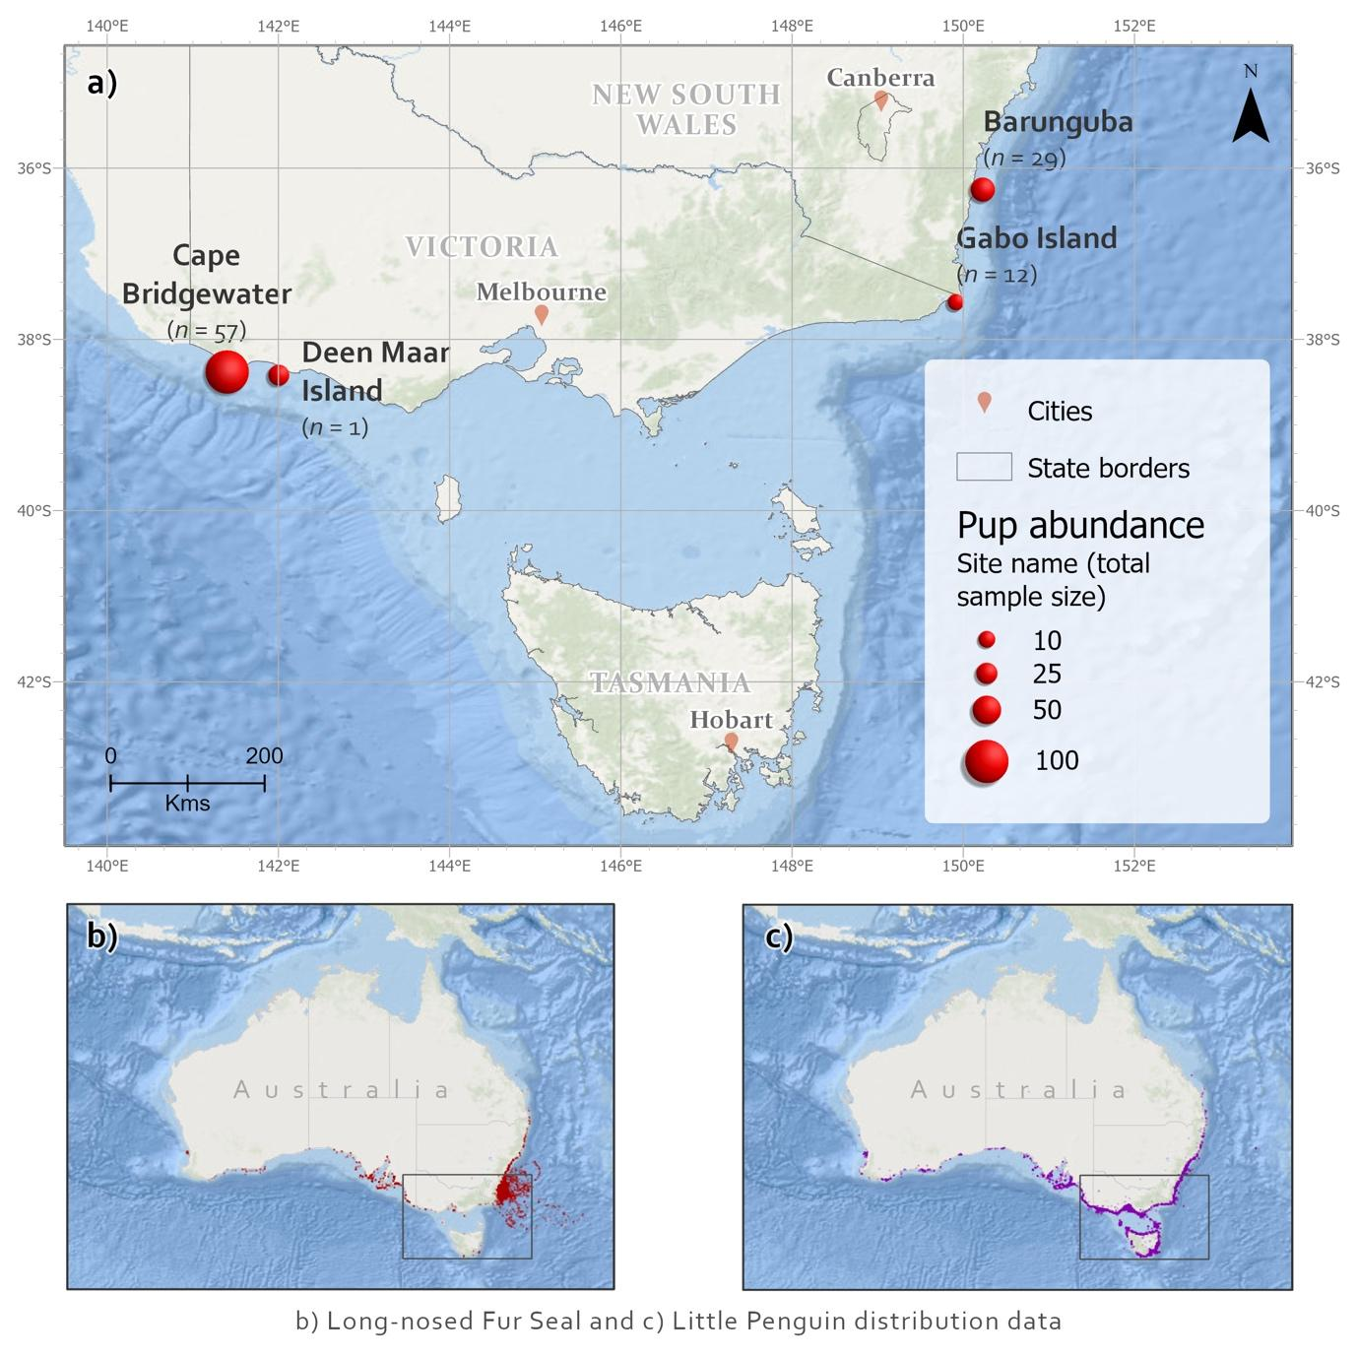
Figure 1.

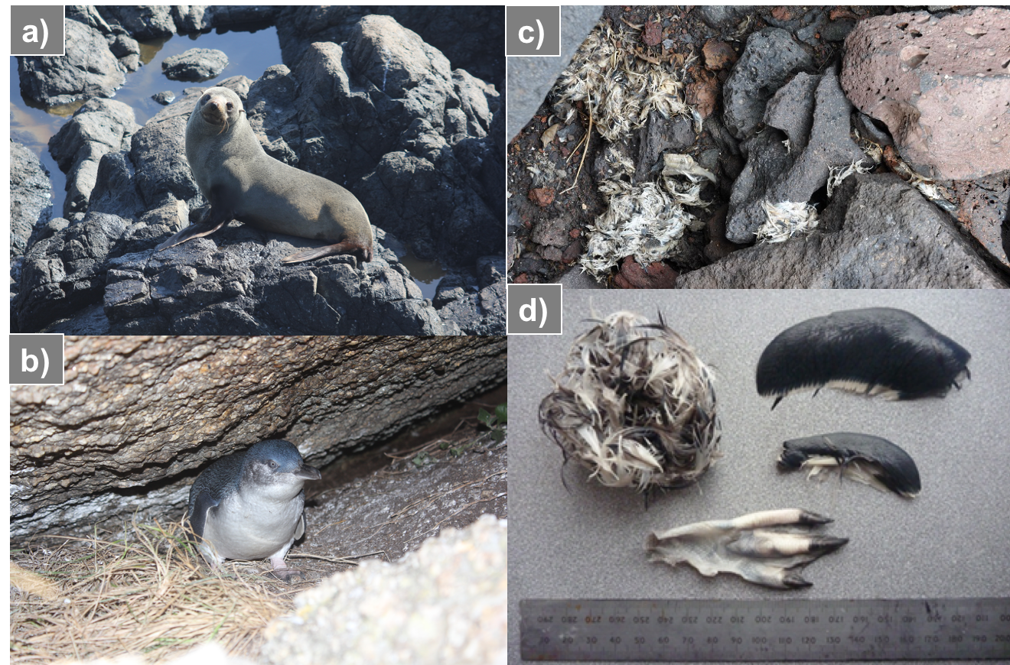
Figure 2.

Figure 3.

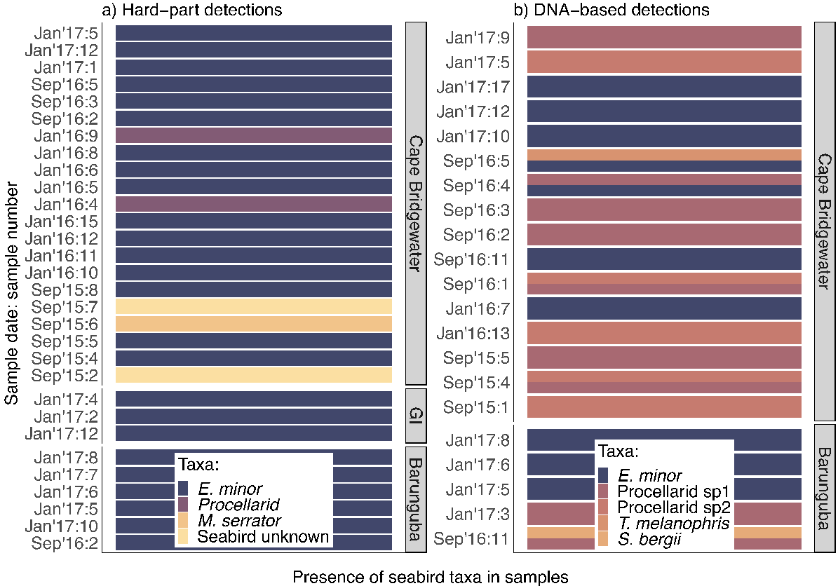
Figure 4.
​​
Figure 5.

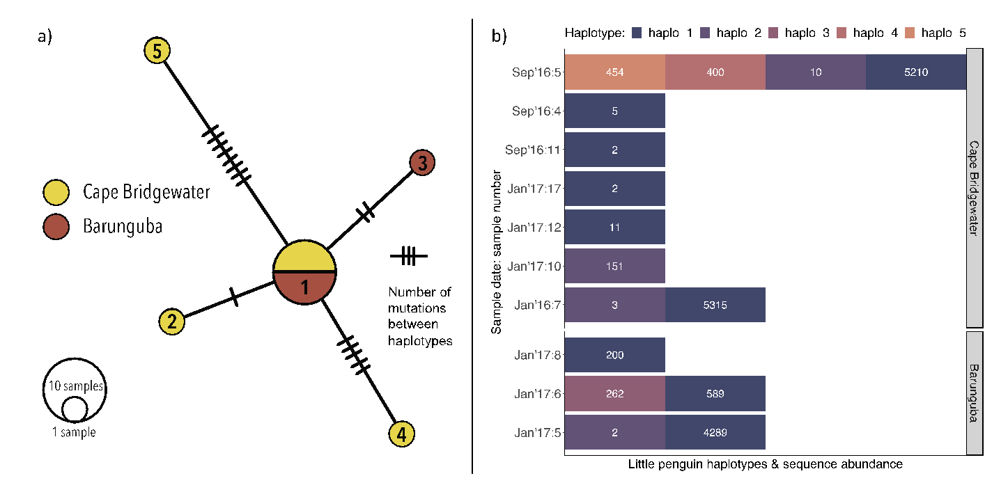
Figure 6.

