Title: Quantifying wildlife conflicts with multi-assay eDNA metabarcoding and traditional diet analyses

Running head: Quantifying wildlife conflicts

Abstract (297)

Wildlife conflict interactions require robust quantitative data on incidence and impacts, particularly among species of conservation and cultural concern. Conflicts between iconic species will likely increase with mounting pressures during the Anthropocene. We present a modular, mutli-assay framework for quantifying predation across systems and wildlife conflict scenarios. We apply two ecological surveillance techniques to predator diet analysis, traditional morphometric (hard-part) and DNA metabarcoding (genetic) analyses, to provide managers with estimated incidence of predation, the number of species impacted and prey relative importance to the predator. We also perform a polymorphism analysis on prey DNA obtained for a species of conservation concern to provide an estimate of individuals consumed. We apply this framework to an emerging wildlife conflict where complex management implications and calls for predator culling are growing in southeastern Australia, despite the paucity of predation data. We estimate that the incidence of predation by recovering and protected long-nosed fur seals (Arctocephalus forsteri) ranges from 9–29% of samples and included up to 6 seabird species. Their seabird prey – the culturally valued little penguin (Eudyptula minor) occurred in 6–25% of samples. This is higher than previously reported from traditional morphological assays alone. DNA metabarcoding proved more sensitive in identifying additional seabird taxa and provided relative quantitative information where multiple prey species occur within a sample. Polymorphism analysis of consumed little penguin DNA identified five distinct mitochondrial haplotypes – representing a minimum of 16 individual penguins consumed across 10 fur seal scat samples. We recommend rapid follow-up of this work with broad spatiotemporal sampling of predator diets to further quantify predation incidences and hotspots of concern for wildlife conflict management using similar cost-effective assaying techniques. The utility of DNA metabarcoding techniques are highlighted, providing reliable quantitative information on predation incidence and likely abundance of impacted species of conservation concern.

Introduction (923)

Conflicts between iconic species are likely to increase with mounting human pressures on wildlife during the Anthropocene. New conservation and wildlife management scenarios are emerging as some species experience population increases through successful conservation efforts, while others continue to decline (Roman et al., 2015; Marshall et al., 2016; Cammen et al., 2019). Complex management scenarios arise when a species recovery results in negative interactions with other species of value, whether that reflects a trophic role in the ecosystem, conservation status, community connection or economic opportunity (Marshall et al., 2016). Prominent examples abound of conflicting predator-prey interactions among species of value: killer whales, sea otters and salmon (Estes et al., 1998; Williams et al., 2011); New Zealand sea lions and yellow-eyed penguins (Lalas et al., 2007); wolves and caribou (Hervieux et al., 2014). The interactions themselves are natural, however they present a need for accurate information on natural predation levels and impacts to prey (Hervieux et al., 2014) to avoid unjustified persecution of the predator (Granquist et al., 2018), and for effective management of all species concerned (Marshall et al., 2016).
The ultimate goals in investigating the incidence and impacts of predator prey interactions involve determining prey identities, dietary proportions, and abundances or biomass consumed by the predator (reviewed by Pompanon et al., 2012). Developments in eDNA extraction and metabarcoding techniques are demonstrating reliability for environmental monitoring (Thomsen & Willerslev 2015; Stat et al. 2019) and utility for achieving these goals by: (i) identifying prey at high taxonomic resolution and when missed by other methods (Bowen & Iverson, 2013; Stat et al. 2019); (ii) estimating dietary proportions, reconstructing biomass and abundances of prey consumed through relative genetic importance (Deagle et al., 2019; Cavallo et al., 2020); (iii) identifying species’ intraspecific genetic diversity within environmental samples for wildlife forensic purposes and sample population estimation (Sigsgaard et al., 2016; Seersholm et al., 2018).
An emerging wildlife conflict in southeastern Australia involves the recovery of long-nosed fur seals (Arctocephalus forsteri) and their potential to threaten populations of the culturally valued little penguin (Eudyptula minor). The fur seals were decimated by the the fur trade through the 1800’s and culling into the late 1900’s due to perceived competition for resources with fishermen (Shaughnessy et al., 1999). Long-nosed fur seals are the only mainland Australian seal species with increasing population trends, reported at 97,200 in the state of South Australia (2013–14 census; Shaughnessy et al., 2015) where an estimated 83% of their known pup production occurs. While the original population size is unknown, harvesting records suggest that the current long-nosed fur seal population represents a small fraction of their population prior to European colonisation (Ling, 2014).
Little penguins are a popular tourist attraction and valued species to communities across southern Australia (Tisdell & Wilson, 2012), with an estimated 470,000 individuals (BirdLife International, 2021). Yet, 60% of sites have unknown population trends, 29% of colonies are declining, most persist on offshore islands in southern Australia and are difficult to census (BirdLife International, 2021). Major contributors to decline include: (i) changes in land-use and land predators introduced by European settlers (Dann, 1991; Kirkwood et al., 2014), (ii) increasing susceptibility to hyperthermia during increasingly frequent terrestrial heat waves (Lauren Tworkowski, La Trobe University, unpublished data), and (iii) large-scale changes to food webs caused by climate change and competition with fisheries (Ropert-Coudert et al., 2019). Little penguins and other seabirds were identified in juvenile, sub-adult, and adult male long-nosed fur seals diets, at two locations in southern Australia and at relatively low frequencies (Page et al. 2005; Hardy et al. 2017; Goldsworthy et al. 2019). However, the number of penguins consumed and the impact are unknown, particularly for ‘unquantifiable remains’, such as feathers. Page et al. (2005) proposed a single scat containing feathers was equivalent to a single bird consumed; however, mass-balanced trophodynamic modelling in the Great Australian Bight marine ecosystem suggested that this likely overestimates predation (Goldsworthy et al. 2013).
Both species are federally protected and garner significant cultural and conservation value (Environment Protection and Biodiversity Conservation Act, 1975 & 1999). Both are also listed as ‘Least Concern’ by the IUCN Redlist (IUCN 2020). However, the recovery and protection of Australian seal species continues to conflict with communities and fisheries (Shaughnessy et al., 2003; Goldsworthy & Page, 2007; Cummings et al., 2019) due to their potential predation impacts to prey species. While it is realistic to expect high levels of predation to affect prey population size or behaviour (Visser et al., 2008), persistent and vocal calls to cull the long-nosed fur seal population in South Australia are growing despite an absence of quantitive information (Goldsworthy et al. 2019).
To assess predation incidence and potential impact on little penguin and seabirds across southeastern Australia, we apply two ecological surveillance techniques – morphometric (hard-part) and DNA metabarcoding (genetic) assays of long-nosed fur seal scats. Due to known biological and methodological differences in dietary information obtained from hard-parts compared to soft tissues (Casper et al., 2007a, 2007b; Tollit et al., 2009), and differences in the quantities of DNA available from hard parts compared to soft tissues (McDonald & Griffith, 2011, Rothe & Nagy, 2016), we apply and present the results of the morphological and DNA metabarcoding techniques as simultaneously informative and complementary assaying techniques. Thus, we compare overall seabird and little penguin detection rates across groups of samples, rather than sample-by-sample, investigate the diversity and relative importance of seabirds consumed by long-nosed fur seals and, we provide a minimum estimate of penguin abundance consumed by analyzing mitochondrial haplotype diversity among little penguin DNA obtained.

Methods (1251)

Collections of long-nosed fur seal scats across southeastern Australia

Individual predator scat samples (n = 99) were collected across multiple time points from four long-nosed fur seal breeding colonies in Bass Strait and NSW, southeastern Australia (Fig. 1, 2a & 2b), where long-nosed fur seals have only recently begun breeding. Pup abundances are illustrated as a conventional proxy for relative seal population (Fig. 1; Appendix S1.1). Most samples were collected from the two larger colonies, Barunguba and Cape Bridgewater, in spring (September) 2016 and summer (January) 2017, with additional samples included from spring 2015 and summer 2016 at Cape Bridgewater. Samples from Gabo Island were collected from summer 2017 only. Additionally, one sample was opportunistically collected from Deen Maar Island and included in assays. Sample sizes used resulted from balancing adequate replication per site with availability of fresh samples and the costs of genetic analyses.
Whole and fresh (soft and moist, < 48 hr old) scats were sampled to minimise bias from differential DNA degradation or partial loss of material. Whole scats were thoroughly mixed with individual disposable spatulas at point of collection and a 2 mL subsample was taken from each field-homogenized scat for DNA-based analyses of prey remains. The remaining whole scats were collected for analyses of morphological prey remains, using individual air-tight, zip-lock bags. Samples were stored within hours of collection between -10˚ and -20˚C in portable freezers (WAECO) for up to 7 d in the field and transferred to -20˚C freezer facilities.

Morphological identification of seabird remains in long-nosed fur seal scats

Seabird morphological remains are conspicuous across long-nosed fur seal colonies in southeastern Australia (Fig. 2c). All prey items were identified from hard parts using methods described by Page et al. (2005). Data on diet items other than birds are the subject of a broader investigation on long-nosed fur seal diet across southeastern Australia. Birds were identified using feathers and other remains such as feet, flippers and heads (Fig. 2d, Appendix S1.2).

DNA metabarcoding of seabird genetic material from long-nosed fur seal scats

Prey DNA extractions used 250 mg of faecal subsamples and MoBio PowerSoil® DNA Isolation Kits (www.mobio.com) with modifications to the manufacturer’s instructions made in response to extraction optimisation (Appendix S1.3). DNA was eluted in 10 mM Tris buffer, MoBio PowerSoil® C6 solution, (www.mobio.com) and stored at -20˚C. Nuclear DNA for positive controls was extracted from a domestic chicken (Gallus gallus domesticus) and a little penguin using muscle tissue (25mg) from the centre of the birds’ tissue matrix with Bioline Isolate II Genomic DNA Kits (www.bioline.com/us/) as per manufacturer instructions.
In total, 99 faecal DNA sample extracts at two DNA concentrations (neat and 1:10 dilutions), as well as extraction blanks (n = 5), PCR blanks (n = 4), and positive controls (n = 2) were screened in duplicates by diagnostic endpoint PCR (dPCR) using the Bird12sa/h assay (Cooper, 1994) (Table S1 and S2, Appendix S1). The dPCR products were run on 1.5% agarose gels to determine the presence/absence of amplified target bird DNA in each duplicate. A total of 32 samples showed target amplicons in both or one duplicate, but not in the extraction blanks and PCR blanks (negative controls). We proceeded with sequencing using a single sample of DNA extract (neat concentration) for each of the 32 samples that tested positive for birds, and we included two extraction blanks and one positive control. Target samples and controls were each assigned a unique MID (Multiplex IDentifier) tag combination, combined with next generation sequencing (NGS) adaptors and the Bird12sa/h assay using a single-step fusion tagging PCR procedure. The sequencing workflow – single-step fusion PCR (Appendix S1), library build, sequencing (150 bp paired-end Illumina Miseq: v2 Nano 150 bp) and demultiplexing – was performed by Ramaciotti Centre for Genomics, University of New South Wales.
The bioinformatics and sequence quality filtering procedures are described in reproducible detail in Appendix S1.3. We used Geneious R8.1.5 (Kearse et al., 2012) to process the paired-end sequences and retain only those sequences with exact matched genetic tags and primers for each sample. Primers and tags were removed after this initial filtering step to leave the target sequences in each sample. These were quality filtered and clustered into molecular operational taxonomic units (OTUs) using the UPARSE algorithm and a custom bioinformatics pipeline primarily performed in USEARCH (Edgar, 2010; Edgar & Flyvbjerg, 2015). L
ow abundance sequences (below a threshold of 1% of the total abundance of unique sequences) were removed to reduce the occurrence of sequencing error and chimeras, and sequences were then clustered using a 97% similarity criterion (similar to Berry et al., 2017). Thus 7370 unique seabird DNA sequences, representing a total of 64,700 disaggregated bird sequences, were parsed through standard sequence filtering and OTU clustering pipeline (with cluster size threshold value of 73), resulting in 47,478 filtered sequences across all 99 samples and 5 clustered OTUs.
Consensus sequences for each OTU were queried against the National Center for Biotechnology Information’s (NCBI) GenBank nucleotide database using the algorithm BLASTn (Basic Local Alignment Search Tool) (Benson et al., 2005). The resulting ‘blasted’ sequences were assigned to taxa, following criteria and taxonomic reference databases outlined in Hardy et al. (2017) and Appendix S1.3. These criteria ensured maximum confidence in making a taxonomic identification and a minimum risk of false positives.

Haplotype analysis and assessment of penguin abundance consumed

Due to their high cultural and conservation value, we identifed individual little penguin mtDNA haplotypes from the (12S rRNA) sequences obtained to estimate the minimum number of penguins consumed within samples assayed (similar to Seersholm et al., 2018). We imported the file containing 47,478 filtered seabird DNA sequences, disaggregated and matched these sequences in relation to sample identifier and formed these into clusters of unique sequences in Geneious. From the six samples that contained abundant penguin DNA (Table S5), we selected the nine most abundant unique sequences. Each of these represents a sequence abundance of greater than 7.5% of the total sequence abundance of the sample (Table S6). This process was used to exclude sequences that could be attributed to sequencing error (Illumina’s Miseq typically results in a pattern of error that shows sequences with a single base pair change at an abundance of around 1% of the parent sequence; Berry, T. E., unpublished data).
We produced a minimum spanning haplotype network using the software PopART (Leigh & Bryant, 2015) from an alignment of these nine penguin sequences to visualise relationships between haplotypes consumed, their abundances within and between samples from the different locations sampled. All samples containing little penguin DNA (n = 10) were then searched for the presence of haplotypes identified. We estimated the number of penguins likely consumed based on haplotype diversity within each sample. Logically, two distinct mtDNA haplotypes (12s rRNA) found within a sample correspond to two distinct birds consumed. Additionally, as samples were collected across multiple days from each location and sampling time, we treated each sample to be from distinct predators.

Statistical analyses

To account for different sampling times and locations, samples were assigned one of seven unique grouping factors that combined location and time (e.g. Barunguba, January 2017). The single scat sample collected from Deen Maar Island was not included in statistical tests, but results were reported for future comparisons. The overall detection rates of seabirds and specifically little penguins using different dietary analysis techniques (hard part vs. DNA; Table S3, Appendix S2) were examined using two generalised linear models (GLMs), constructed in the stats package in R version 4.0.3 (R Core Team, 2020). A binomial error distribution for presence-absence data was used and additive term included to account for long-nosed fur seal group (location and time). Model fit was assessed using deviance explained and variable significance (p < 0.05).

Results (826)

Overall, the detection rates of seabirds were statistically similar for each method, the morphological identification of prey hard parts and the DNA metabarcoding technique, examining predator diet analysis from scat samples (n = 99; Fig. 3, Table S3). However, DNA metabarcoding offered additional information: (i) absolute and relative abundance information for amounts of DNA recovered (Fig. S1 & S2, Table S5), (ii) improved sensitivity in detecting multiple prey taxa within a single scat sample (Fig. 4), and (iii) identification of genetic diversity enabling estimation of penguin abundances consumed (Fig. 5).

Comparing diagnostic hard part and genetic assays

Seabirds were detected in 29.3% (n = 29) of samples using diagnostic hard-parts, and 21.2% (n = 21) of samples using DNA metabarcoding (Fig. 3a). The majority (> 99%) of DNA sequences for each seabird taxon, obtained after quality control and filtering, were identified in just 9% (n = 9) of samples (Fig. 3a). The remaining samples (n = 12) contained low amounts (< 1%) of DNA, relative to the total DNA obtained for each taxon (Table S5). The same seabird taxa were detected by both methods simultaneously in only half the positive samples (n = 10) (Fig. 3a), and half of these (n = 5) contained little penguin hard-parts and DNA (Fig. 3b). An additional 5 samples contained DNA and hard-parts that did not belong to the same seabird taxon (Figs. 3 & 4). While the combined proportion of samples containing either diagnostic hard-parts or DNA from seabirds, or both, amounted to 40% (n = 40), both methods represent two quasi-independent assays and we argue, are therefore not additive.
Mean detection rates were statistically similar for hard parts compared to DNA methods for seabirds overall and penguins (Table S3). There was greater variability in detection rates across locations using hard-parts compared to DNA (Fig. S3). Minor, albeit statistically significant, differences were observed across sampling groups for seabird detection rates (Fig. S3a, Table S3), but not for penguins (Fig. S4b) (GLM binomial seabird detection ~ location: p-value = 0.017; Table S3) and this was likely driven by the high variability in detections across sampling locations, times and methods used (Fig. S3a).

Seabird diversity in long-nosed fur seal diets

DNA-based metabarcoding was more sensitive in detecting mixtures of taxa in scat samples compared to hard-part analysis (Fig. 4), with 2 distinct seabird taxa detected in 5 samples and a single seabird taxon in the remaining 16 samples (Fig. 4b). In contrast, diagnostic prey hard-parts typically corresponded to a single seabird species within samples and no samples contained more than one identified bird taxon using this method (Fig. 4a).
Little penguins were the main seabird prey species detected using both morphological and DNA-based analyses (Fig. 4) – in frequency of occurrence (Fig. 4b), total abundance of sequences (Fig. S2), and relative sequence abundance (Fig. S3). Across all samples in this study, 25.3% (n = 25) contained penguin hard-parts and 10.1% (n = 10) had DNA detection for little penguins (Figs. 3b & 4b) and the majority (> 99%) of little penguin DNA was obtained from 6% of samples (n = 6) (Fig. 3b & S1).

Morphological analysis revealed two additional taxa: shearwaters at family level (Procellaridae spp.) (n = 2 samples), and Australasian gannet (Morus serrator) (n = 1) (Fig. 4). DNA metabarcoding detected abundant DNA from two distinct families of shearwater taxa in 5% (n = 5) and 9.1% (n = 9) of samples, respectively (Tables S4 & S5, Appendix S2). Black-browed albatross (Thalassarche melanophris) and greater crested tern (Sterna bergii) occurred in one sample apiece (Fig. 4, Table S5). Parallel use of both DNA metabarcoding and hard-part analysis revealed a greater diversity of taxa than would either method alone.

Trace amounts of little penguin DNA were detected at Gabo Island and Deen Maar Island; however, these sequences did not pass DNA quality filtering procedures. Thus conservatively, we would report that whilst penguins were detected from morphological remains in scats from Gabo Island, we have not yet reliably detected penguin predation by long-nosed fur seals there or at Deen Maar Island using DNA.

Towards quantifying little penguin consumption

From the six long-nosed fur seal scat samples containing abundant penguin DNA, a total of five mtDNA haplotypes were identified from Cape Bridgewater (haplotypes 1 and 3–5) and Barunguba (haplotypes 1–3) (Fig. 5a). Only haplotype 5 was unique to Barunguba, the remaining six haplotypes were detected at both sites (Figs. 5b), Haplotype 1 was also identified from DNA extracted from our positive control – a little penguin carcass from Philip Island Nature Parks and also matched an unverified sample (MK761006) of a whole little penguin genome from the region (REF). We subsequently searched all ten penguin positive scat samples for the presence of these haplotypes, six of these contained a single haplotype, whilst the remaining four contained between 2–4 individual mtDNA haplotypes (Fig. 5b). Taking two distinct genetic haplotypes present within a sample to represent at least two distinct individual birds consumed, we posit at least 16 individual penguins were consumed across the 99 scat samples, from two sampling locations and multiple seasons.

Discussion (1142 < 850 goal)

Conflicts between iconic species will likely increase with mounting human pressures on wildlife and wild spaces during the Anthropocene. Validating and applying modern surveillance tools, such as DNA screening, to complex conservation scenarios can better inform decision making.

We leveraged recent advances in genetic assaying tools, applied alongside traditional diet analysis methods, to investigate a growing wildlife conflict in southeastern Australia.
We provide conservation practitioners with an updated and improved predation prevalence range for seabirds overall (9–29%) and little penguins (6–25%) in long-nosed fur seal diets in southeastern Australia, using two widely applied diet assay techniques. We confirm that little penguins remain the most consumed seabird by long-nosed fur seals in comparison to other seabirds (e.g., procellarids, black-browed albatross, greater crested tern, and Australasian gannet). DNA metabarcoding also offered key quantitative information on: (i) absolute and relative abundances of DNA recovered, (ii) detection of multiple prey taxa within a single scat sample, and (iii) genetic diversity enabling estimation of penguin abundances consumed accounting for at least 16 penguins consumed across samples.
Previous studies using either assay techniques have identified little penguin remains at relatively low frequencies in relation to seals’ total diets (5.9% in Page et al. 2005, <2% in Hardy et al. 2017, ~13% in Goldsworthy et al. 2019). The lower range of estimates observed here (9% of samples for seabirds, 6% for penguins) and based on sampled containing large quantities of prey DNA corroborate these previously reported predation rates for the region. However, the upper range of estimates observed in this study (10% and 25% of samples, respectively for DNA and hard-parts) signal a need for increased monitoring across larger spatio-temporal scales, as long-nosed fur seal abundances are expected to increase across south-eastern Australia (Shaughnessy et al. 2015). Furthermore, predatory behaviours could be transmitted to other predator populations, particularly in response to food web disruption under ocean warming and changes in prey availability and this could have cascading effects on pegnguin populations. Analysis of the predator’s total diet is also warranted to gauge the relative importance of different prey items, besides seabirds.
Based on haplotype polymorphism, we identified 5 haplotypes consumed and determined that at least 16 penguins were consumed, present in 10 of the 99 long-nosed fur seal scat samples that were positive for penguin DNA and passed stringent sequence filtering procedures. This is very likely an underestimate of predation, firstly, because we used a conserved mitochondrial gene, 12S ribosomal RNA (Banks et al., 2002), and recovered ~230 bp DNA fragments, selected for proven reliability in detecting seabirds (Hardy et al. 2017). It is possible that targeting a longer barcode could reveal greater genetic diversity, however we did not succeed in doing so with a COI barcode (Appendix S1.2). Secondly, we followed stringent sequence quality filtering and we were extremely selective for representative haplotype sequences within samples to exclude the possibility of false positives beyond sequencing error and reasonable doubt. Deagle et al. (2013) cautions that stringent DNA processing steps do exclude true positives and quantitative information on prey consumption. Less stringent threshold- and algorithm-based protocols for haplotype selection may be warranted to obtain to better estimate predation impacts to declining prey species and for large sampling efforts (Tsuji et al., 2020). Additionally, little penguin genetic diversity is poorly resolved, divergent between Australian and New Zealand populations and thought to amount to contain up to 6 subspecies (Banks et al. 2002). However, in southeastern Australia, a large number of penguins share a small number of haplotypes and their diversity is highly conserved and limited in spatial variability (Peucker et al., 2009; Burridge et al., 2015; Vardeh, 2015).
Individual scats contain up to 4 distinct genetic haplotypes, indicating that long-nosed fur seals can consume multiple penguins in a single foraging trip. This result provides practitioners with a significantly more reliable method of estimating predation incidence and impact than previous methods constrained to assuming that each scat containing feathers corresponded to a single consumed bird (Page et al., 2005, Mumma et al. 2016). We highly recommend future studies also screen for predator genetic diversity to more accurately investigate how many predators in a population contribute to predation of a sensitive or valuable species (similar to Wegge et al., 2012), particularly when considering controversial predator population control strategies.

Species-specific and cost-effective probes can be developed using older and cheaper genomic technology, and applied to large sample sizes and numerous predatory taxa for the detection of specific taxonomic groups of high conservation or commercial interest (Fox et al., 2012). It is possible to estimate consumed prey biomass information by developing DNA-to-tissue-based correction factors (Thomas et al., 2014).
While both methods provided statistically similar results, we emphasize that these represent quasi-independent assays of predation, complementary but not additive. Seabirds hard-parts occurred in more samples (n = 29), than their DNA (n = 21), and both types of remains for the same prey taxa were detected simultaneously by both methods in only 10 samples. Different detection rates between these methods are common across a broad range of predator and prey taxa (Tollit et al., 2009; Zarzoso-Lacoste et al., 2013; Mumma et al., 2016). Many methodological and biological factors differentially affect the recovery of diagnostic genetic and morphological materials. In another pinniped species, prey soft tissues may have a gut passage rate of 48 hours compared to 7 days for hard-parts (Tollit et al., 2009). Soft tissues may contain greater DNA quantities and concentrations, particularly mitochondrial (Mumma et al., 2016; Granquist et al., 2018), and could be preferentially amplified compared to scarcer DNA available from hard-parts, (i.e., feather, fur or bone). DNA from these chitinised or keratinized tissues is of poor quality and requires a different process for extraction (McDonald & Griffith, 2011, Zarzoso-Lacoste et al., 2013; Rothe & Nagy, 2016). Typically, studies report higher detection rates from genetic assays compared to morphological analyses (Egeter et al., 2015; Mumma et al., 2016), but the lower detection rates here are consistent with other pinniped studies (Tollit et al., 2009) and with over-representation of feathers across fur seal scats (Goldsworthy et al., 2019), explaining the higher detection rate from these hard-parts.
We demonstrate significant advantages from DNA-based methods compared to morphological diet analysis for wildlife conflict surveillance and impact assessment between species of conservation priority. In addition to providing more quantitative information, DNA-based methods are highly modular and transferable across systems and offer vast potential for technological and methodological improvements over traditional morphological diet assays.
A final consideration – predator impacts need to be considered and managed within up-to-date cumulative impact assessments for threats. We have delivered an important step towards this for little penguins in south-eastern Australia. Similar to other wildlife conflict situations, endemic predation is natural and often habitat degradation, environmental change and invasive species are more significant sources of impact to susceptible species (Hervieux et al., 2014; Marshall et al., 2016; Ropert-Coudert et al., 2019). Our results indicate that seabird and particularly little penguin predation may be a relatively important individual foraging strategy for some long-nosed fur seals, with potentially negative impacts for local penguin populations.

Supporting Information

PINP_Bird_supplement.docx document included in submission.

Data Availability

Datasets and code used to produce these analyses and figures will be made available via an online data publication repository upon acceptance of this manuscript for publication.

Literature Cited (2140)

ALA. (2019). Atlas of Living Australia. Global Biodiversity Information Facility, Canberra. Available from www.ala.org.au (accessed January 2019).
Banks, J. C., Mitchell, A. D., Waas, J. R., & Paterson, A. M. (2002). An unexpected pattern of molecular divergence within the blue penguin (Eudyptula minor) complex. Notornis, 49(1), 29-38.
Benson, D. A., Karsch-Mizrachi, I., Lipman, D. J., Ostell, J., & Wheeler, D. L. (2005). GenBank. Nucleic Acids Research 33:suppl_1, D34–D38. doi.org/10.1093/nar/gki063
Berry, T. E., Osterrieder, S. K., Murray, D. C., Coghlan, M. L., Richardson, A. J., Grealy, A. K., Stat, M., Bejder, L., & Bunce, M. (2017). DNA metabarcoding for diet analysis and biodiversity: A case study using the endangered Australian sea lion (Neophoca cinerea). Ecology and Evolution 7:14, 5435–5453. doi.org/10.1002/ece3.3123
BirdLife International. (2021). Species factsheet: Eudyptula minor. BirdLife International, Cambridge. Available from www.birdlife.org (accessed January 2021)
Bowen, W. D., & Iverson, S. J. (2013). Methods of estimating marine mammal diets: A review of validation experiments and sources of bias and uncertainty. Marine Mammal Science 29:4, 719–754. doi.org/10.1111/j.1748-7692.2012.00604.x
Burridge, C. P., Peucker, A. J., Valautham, S. K., Styan, C. A., & Dann, P. (2015). Nonequilibrium Conditions Explain Spatial Variability in Genetic Structuring of Little Penguin (Eudyptula minor). Journal of Heredity 106:3, 228–237. doi.org/10.1093/jhered/esv009
Cammen, K. M., Rasher, D. B., & Steneck, R. S. (2019). Predator recovery, shifting baselines, and the adaptive management challenges they create. Ecosphere 10:2, e02579. doi.org/10.1002/ecs2.2579
Casper, R. M., Jarman, S. N., Gales, N. J., & Hindell, M. A. (2007a). Combining DNA and morphological analyses of faecal samples improves insight into trophic interactions: a case study using a generalist predator. Marine Biology, 152(4), 815-825.
Casper, R. M., Jarman, S. N., Deagle, B. E., Gales, N. J., & Hindell, M. A. (2007b). Detecting prey from DNA in predator scats: a comparison with morphological analysis, using Arctocephalus seals fed a known diet. Journal of Experimental Marine Biology and Ecology, 347(1-2), 144-154.
Cavallo, C., Chiaradia, A., Deagle, B. E., Hays, G. C., Jarman, S., McInnes, J. C., Ropert‐Coudert, Y., Sánchez, S., & Reina, R. D. (2020). Quantifying prey availability using the foraging plasticity of a marine predator, the little penguin. Functional Ecology 34:8, 1626–1639. doi.org/10.1111/1365-2435.13605
Cooper, A. (1994). DNA from Museum Specimens. In B. Herrmann & S. Hummel (Eds.), Ancient DNA: Recovery and Analysis of Genetic Material from Paleontological, Archaeological, Museum, Medical, and Forensic Specimens (pp. 149–165). Springer. doi.org/10.1007/978-1-4612-4318-2_10
Cummings, C. R., Lea, M. A., & Lyle, J. M. (2019). Fur seals and fisheries in Tasmania: An integrated case study of human-wildlife conflict and coexistence. Biological Conservation 236, 532–542. doi.org/10.1016/j.biocon.2019.01.029
Dann, P. (1991). Distribution, Population Trends and Factors Influencing the Population Size of Little Penguins Eudyptula minor on Phillip Island, Victoria. Emu 91:5, 263–272. doi.org/10.1071/mu9910263
Deagle, B. E., Thomas, A. C., Shaffer, A. K., Trites, A. W., & Jarman, S. N. (2013). Quantifying sequence proportions in a DNA‐based diet study using Ion Torrent amplicon sequencing: which counts count?. Molecular Ecology Resources, 13(4), 620-633.
Deagle, B. E., Thomas, A. C., McInnes, J. C., Clarke, L. J., Vesterinen, E. J., Clare, E. L., Kartzinel, T. R., & Eveson, J. P. (2019). Counting with DNA in metabarcoding studies: How should we convert sequence reads to dietary data? Molecular Ecology 28:2, 391–406. doi.org/10.1111/mec.14734
Edgar, R. C. (2010). Search and clustering orders of magnitude faster than BLAST. Bioinformatics, 26:19, 2460–2461. doi.org/10.1093/bioinformatics/btq461
Edgar, R. C., & Flyvbjerg, H. (2015). Error filtering, pair assembly and error correction for next-generation sequencing reads. Bioinformatics 31:21, 3476–3482. doi.org/10.1093/bioinformatics/btv401
Egeter, B., Bishop, P. J., & Robertson, B. C. (2015). Detecting frogs as prey in the diets of introduced mammals: A comparison between morphological and DNA‐based diet analyses. Molecular Ecology Resources, 15(2), 306-316.
Environment Protection and Biodiversity Conservation Act, Office of Legislative Drafting and Publishing, Attorney-General’s Department. Canberra, Australia (1975).
Environment Protection and Biodiversity Conservation Act, Office of Legislative Drafting and Publishing, Attorney-General’s Department. Canberra, Australia (1999).
Estes, J. A., Tinker, M. T., Williams, T. M., & Doak, D. F. (1998). Killer Whale Predation on Sea Otters Linking Oceanic and Nearshore Ecosystems. Science 282:5388, 473–476. doi.org/10.1126/science.282.5388.473
Fox, C. J., Taylor, M. I., Kooij, J. van der, Taylor, N., Milligan, S. P., Albaina, A., Pascoal, S., Lallias, D., Maillard, M., & Hunter, E. (2012). Identification of marine fish egg predators using molecular probes. Marine Ecology Progress Series 462, 205–218. doi.org/10.3354/meps09748
Goldsworthy, S. D., & Page, B. (2007). A risk-assessment approach to evaluating the significance of seal bycatch in two Australian fisheries. Biological Conservation 139:3, 269–285. doi.org/10.1016/j.biocon.2007.07.010
Goldsworthy, S. D., Page, B., Rogers, P. J., Bulman, C., Wiebkin, A., McLeay, L. J., Einoder, L., Baylis, A. M. M., Braley, M., Caines, R., Daly, K., Huveneers, C., Peters, K., Lowther, A. D., & Ward, T. M. (2013). Trophodynamics of the eastern Great Australian Bight ecosystem: Ecological change associated with the growth of Australia’s largest fishery. Ecological Modelling 255, 38–57. doi.org/10.1016/j.ecolmodel.2013.01.006

Goldsworthy, S. D., Bailleul, F., Nursey-Bray, M., Mackay, A., Oxley, A., Reinhold, S.-L., & Shaughnessy, P. D. (2019). Assessment of the impacts of seal populations on the seafood industry in South Australia (p. 334). South Australian Research and Development Institute (Aquatic Sciences).
Granquist, S. M., Esparza-Salas, R., Hauksson, E., Karlsson, O., & Angerbjörn, A. (2018). Fish consumption of harbour seals (Phoca vitulina) in north western Iceland assessed by DNA metabarcoding and morphological analysis. Polar Biology, 41(11), 2199-2210.
Hardy, N., Berry, T., Kelaher, B. P., Goldsworthy, S. D., Bunce, M., Coleman, M. A., Gillanders, B. M., Connell, S. D., Blewitt, M., & Figueira, W. (2017). Assessing the trophic ecology of top predators across a recolonisation frontier using DNA metabarcoding of diets. Marine Ecology Progress Series 573, 237–254. doi.org/10.3354/meps12165
Hervieux, D., Hebblewhite, M., Stepnisky, D., Bacon, M., & Boutin, S. (2014). Managing wolves (Canis lupus) to recover threatened woodland caribou (Rangifer tarandus caribou) in Alberta. Canadian Journal of Zoology 92:12, 1029–1037. doi.org/10.1139/cjz-2014-0142
Hocking, D. P., Fitzgerald, E. M. G., Salverson, M., & Evans, A. R. (2016). Prey capture and processing behaviors vary with prey size and shape in Australian and subantarctic fur seals. Marine Mammal Science 32:2, 568–587. doi.org/10.1111/mms.12285

IUCN (2020). The IUCN Red List of Threatened Species, Cambridge. Available from www.iucnredlist.org (accessed July 2020).
Kearse, M., Moir, R., Wilson, A., Stones-Havas, S., Cheung, M., Sturrock, S., Buxton, S., Cooper, A., Markowitz, S., Duran, C., Thierer, T., Ashton, B., Meintjes, P., & Drummond, A. (2012). Geneious Basic: An integrated and extendable desktop software platform for the organization and analysis of sequence data. Bioinformatics 28:12, 1647–1649. doi.org/10.1093/bioinformatics/bts199

Kirkwood, R., Sutherland, D. R., Murphy, S., & Dann, P. (2014). Lessons from long-term predator control: A case study with the red fox. Wildlife Research 41:3, 222–232. doi.org/10.1071/WR13196
Lalas, C., Ratz, H., McEwan, K., & McConkey, S. D. (2007). Predation by New Zealand sea lions (Phocarctos hookeri) as a threat to the viability of yellow-eyed penguins (Megadyptes antipodes) at Otago Peninsula, New Zealand. Biological Conservation 135:2, 235–246. doi.org/10.1016/j.biocon.2006.10.024
Leigh, J. W., & Bryant, D. (2015). popart: Full-feature software for haplotype network construction. Methods in Ecology and Evolution 6:9, 1110–1116. doi.org/10.1111/2041-210X.12410
Ling, J. (2014). Exploitation of fur seals and sea lions from Australian, New Zealand and adjacent subantarctic islands during the eighteenth, nineteenth and twentieth centuries. Australian Zoologist 31:2, 323–350. doi.org/10.7882/AZ.1999.036
Marshall, K. N., Stier, A. C., Samhouri, J. F., Kelly, R. P., & Ward, E. J. (2016). Conservation Challenges of Predator Recovery. Conservation Letters 9:1, 70–78. doi.org/10.1111/conl.12186
McDonald, P. G. & Griffith, S. C. (2011). To pluck or not to pluck: the hidden ethical and scientific costs of relying on feathers as a primary source of DNA. Journal of Avian Biology 42:3, 197-203. doi.org/10.1111/j.1600-048X.2011.05365.x
Mumma, M. A., Adams, J. R., Zieminski, C., Fuller, T. K., Mahoney, S. P., & Waits, L. P. (2016). A comparison of morphological and molecular diet analyses of predator scats. Journal of Mammalogy, 97(1), 112-120.
Page, B., McKenzie, J., & Goldsworthy, S. D. (2005). Dietary resource partitioning among sympatric New Zealand and Australian fur seals. Marine Ecology Progress Series 293, 283–302. doi.org/10.3354/meps293283
Peucker, A. J., Dann, P., & Burridge, C. P. (2009). Range-Wide Phylogeography of the Little Penguin (Eudyptula minor): Evidence of Long-Distance Dispersal. The Auk 126:2, 397–408. doi.org/10.1525/auk.2009.08055
Pompanon, F., Deagle, B. E., Symondson, W. O. C., Brown, D. S., Jarman, S. N., & Taberlet, P. (2012). Who is eating what: Diet assessment using next generation sequencing. Molecular Ecology 21:8, 1931–1950. doi.org/10.1111/j.1365-294X.2011.05403.x
R Core Team. (2020). R: A language and environment for statistical computing, version 4.0.3. Vienna, Austria, R Foundation for Statistical Computing.
Roman, J., Dunphy-Daly, M. M., Johnston, D. W., & Read, A. J. (2015). Lifting baselines to address the consequences of conservation success. Trends in Ecology & Evolution 30:6, 299–302. doi.org/10.1016/j.tree.2015.04.003
Ropert-Coudert, Y., Chiaradia, A., Ainley, D., Barbosa, A., Boersma, P. D., Brasso, R., Dewar, M., Ellenberg, U., García-Borboroglu, P., Emmerson, L., Hickcox, R., Jenouvrier, S., Kato, A., McIntosh, R. R., Lewis, P., Ramírez, F., Ruoppolo, V., Ryan, P. G., Seddon, P. J., Sherley, R. B., Vanstreels, R. E. T., Waller, L. J., Woehler, E. J., Trathan, P. N. (2019). Happy Feet in a Hostile World? The Future of Penguins Depends on Proactive Management of Current and Expected Threats. Frontiers in Marine Science 6. doi.org/10.3389/fmars.2019.00248
Rothe, J. & Nagy, M. (2016). Comparison of two silica-based extraction methods for DNA isolation from bones. Legal Medicine 22: 36-41. doi.org/10.1016/j.legalmed.2016.07.008

Seersholm, F. V., Cole, T. L., Grealy, A., Rawlence, N. J., Greig, K., Knapp, M., Stat, M., Hansen, A. J., Easton, L. J., Shepherd, L., Tennyson, A. J. D., Scofield, R. P., Walter, R., & Bunce, M. (2018). Subsistence practices, past biodiversity, and anthropogenic impacts revealed by New Zealand-wide ancient DNA survey. Proceedings of the National Academy of Sciences 115:30, 7771–7776. doi.org/10.1073/pnas.1803573115
Shaughnessy, P. D., Australia, & Environment Australia. (1999). The action plan for Australian seals. Environment Australia. catalog.hathitrust.org/api/volumes/oclc/43839899.html
Shaughnessy, P. D., Kirkwood, R., Cawthorn, M., Kemper, C., & Pemberton, D. (2003). Pinnipeds, cetaceans and fisheries in Australia; a review of operational interactions. In Marine mammals: Fisheries, tourism and management issues. (N. Gales, M. Hindell and R. Kirkwood., pp. 136-152.). CSIRO Publishing.
Shaughnessy, P. D., Goldsworthy, S. D., Mackay, A. I. (2015). The long-nosed fur seal (Arctocephalus forsteri) in South Australia in 2013–14: Abundance, status and trends. Australian Journal of Zoology 63:2, 101–110. doi.org/10.1071/ZO14103

Sigsgaard, E. E., Nielsen, I. B., Bach, S. S., Lorenzen, E. D., Robinson, D. P., Knudsen, S. W., Pedersen, M. W., Jaidah, M. A., Orlando, L., Willerslev, E., Møller, P. R., & Thomsen, P. F. (2016). Population characteristics of a large whale shark aggregation inferred from seawater environmental DNA. Nature Ecology & Evolution 1:1, 1–5. doi.org/10.1038/s41559-016-0004

Stat, M., John, J., DiBattista, J. D., Newman, S. J., Bunce, M., & Harvey, E. S. (2019). Combined use of eDNA metabarcoding and video surveillance for the assessment of fish biodiversity. Conservation Biology 33:1, 196–205. doi.org/10.1111/cobi.13183

Thomas, A. C., Jarman, S. N., Haman, K. H., Trites, A. W., & Deagle, B. E. (2014). Improving accuracy of DNA diet estimates using food tissue control materials and an evaluation of proxies for digestion bias. Molecular Ecology 23:15, 3706–3718. doi.org/10.1111/mec.12523
Thomsen, P. F., & Willerslev, E. (2015). Environmental DNA – An emerging tool in conservation for monitoring past and present biodiversity. Biological Conservation, 183, 4–18. doi.org/10.1016/j.biocon.2014.11.019
Tisdell, C. A., & Wilson, C. (2012). Little penguins and other seabirds as tourist draw cards. In Nature-based Tourism and Conservation: New Economic Insights and Case Studies (pp. 355–380). Edward Elgar Publishing.
Tollit, D. J., Schulze, A. D., Trites, A. W., Olesiuk, P. F., Crockford, S. J., Gelatt, T. S., ... & Miller, K. M. (2009). Development and application of DNA techniques for validating and improving pinniped diet estimates. Ecological Applications, 19(4), 889-905.

Tsuji, S., Maruyama, A., Miya, M., Ushio, M., Sato, H., Minamoto, T., & Yamanaka, H. (2020). Environmental DNA analysis shows high potential as a tool for estimating intraspecific genetic diversity in a wild fish population. Molecular ecology resources, 20(5), 1248-1258.
Vardeh, S. (2015). Population Genetics, Demography and Population Viability of Little Penguins (Eudyptula minor) in Australia. School of Biological, Earth and Environmental Sciences, The University of New South Wales, Evolution and Ecology Research Centre.
Visser, I. N., Drennan, M. P., White, R. W., MacLean, S. F., Lagerstrom, L. C., & Francis, J. M. (2008). Antarctic Fur Seals (Arctocephalus gazella) Observed Predating Adélie (Pygoscelis adeliae) and Chinstrap Penguins (P. antarctica), Antarctic Peninsula. Aquatic Mammals 34:2, 193–199. doi.org/10.1578/AM.34.2.2008.193
Wegge, P., Shrestha, R., & Flagstad, Ø. (2012). Snow leopard Panthera uncia predation on livestock and wild prey in a mountain valley in northern Nepal: Implications for conservation management. Wildlife Biology 18:2, 131–141. doi.org/10.2981/11-049
Williams, R., Krkošek, M., Ashe, E., Branch, T. A., Clark, S., Hammond, P. S., Hoyt, E., Noren, D. P., Rosen, D., & Winship, A. (2011). Competing Conservation Objectives for Predators and Prey: Estimating Killer Whale Prey Requirements for Chinook Salmon. PLoS ONE 6:11. doi.org/10.1371/journal.pone.0026738
Zarzoso-Lacoste, D., Corse, E., Vidal, E. (2013). Improving PCR detection of prey in molecular diet studies: importance of group-specific primer set selection and extraction protocol performances. Molecular Ecology Resources, 13, 117–127.

Figure Legends

Figure 1. a) Long-nosed fur seal scat collection sites (n = total sampling effort numbered). Pup abundance, as an index of seal population, has been included for sampling locations, to illustrate the relative importance of these sites for long-nosed fur seal populations in southeastern Australia. Sampled sites were: Cape Bridgewater (38.3013° S, 141.4062° E) and nearby Deen Maar Island (formerly Lady Julia Percy Island, 38.4161° S, 142.0038° E) from western Bass Strait, Victoria; Gabo Island in eastern Bass Strait, Victoria (37.5649° S, 149.9133° E); and Barunguba (formerly known as Montague Island 36.2510° S, 150.2270° E) at the northeastern breeding range in New South Wales (NSW). Range of both species shown for b) long-nosed fur seals and c) little penguins using Atlas of Living Australia distribution data (ALA, 2019).

Figure 2. Contextual images of a) the long-nosed fur seal, Arctocephalus forsteri, from Barunguba, NSW; b) the little penguin, Eudyptula minor, often burrowing near fur seal colonies; and examples of seabird remains in c) and d), often found as regurgitates, from long-nosed fur seal haul-outs and colonies.

Figure 3. Detections across long-nosed fur seal samples of a) seabird and b) little penguin diagnostic hard-parts (hp) and DNA (dna), as a percentage of all samples (n = 99). We report genetic sequences obtained from standard sequence quality filtering, ‘DNA (all)’, as well as for samples that contained large quantities of sequences, ‘DNA abundant’ (> 99% of sequences filtered after sequence quality filtering). We also illustrate the number of samples that contained both the morphological and genetic remains of the same seabird (same taxon).

Figure 4. The diversity of seabird taxa identified in long-nosed fur seal samples: a) using hard-part analyses (n = 29) and b) using DNA-based methods (n = 21). GI = Gabo Island. The total (Fig. S2) and relative (Fig. S3) contribution of seabird taxa within samples based on DNA abundance are included in Appendix S2.

Figure 5. Little penguin genetic diversity (for 230 bp 12S rRNA gene) a) presented as a minimum spanning network of 7 distinct haplotypes, and b) estimated number of individuals consumed across the sample region and time period based on haplotype consumption, including haplotype sequence abundances within samples. Numbers in each circle represent a unique haplotype identifier. Here, each unique haplotype within an individual fur seal scat sample represents an individual penguin consumed (b) and we overlay the genetic sequence abundance identified within samples that tested positive for penguin (n = 10) for each haplotype.

Figures

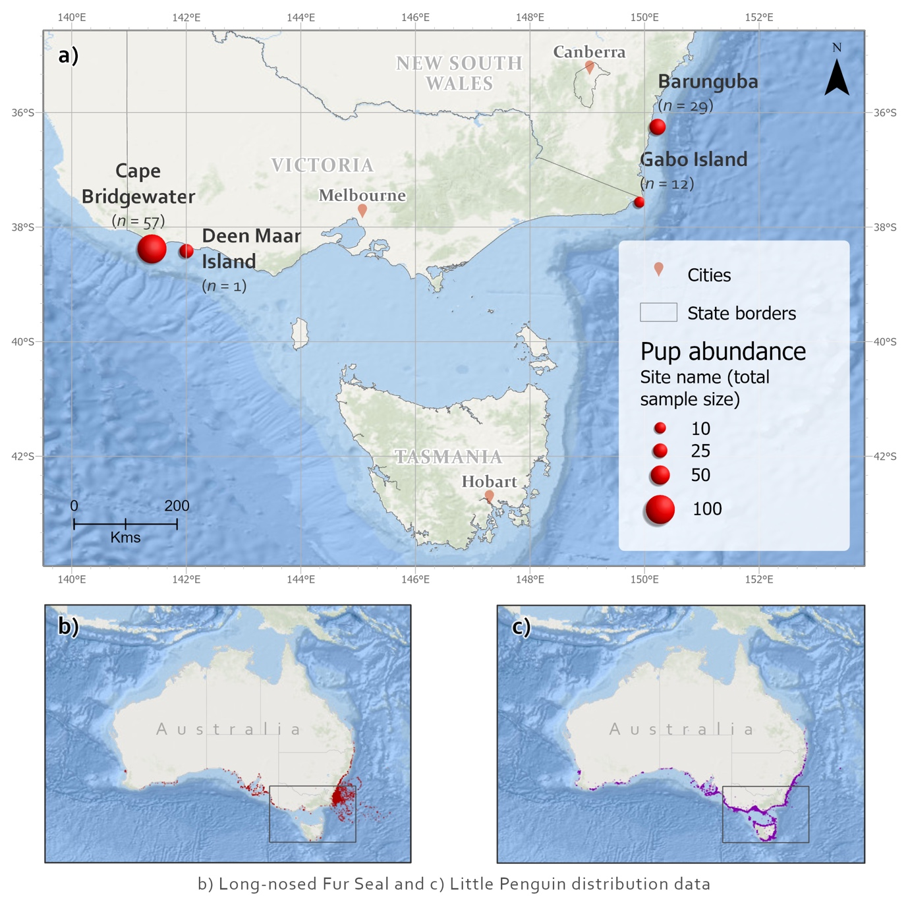
Figure 1.

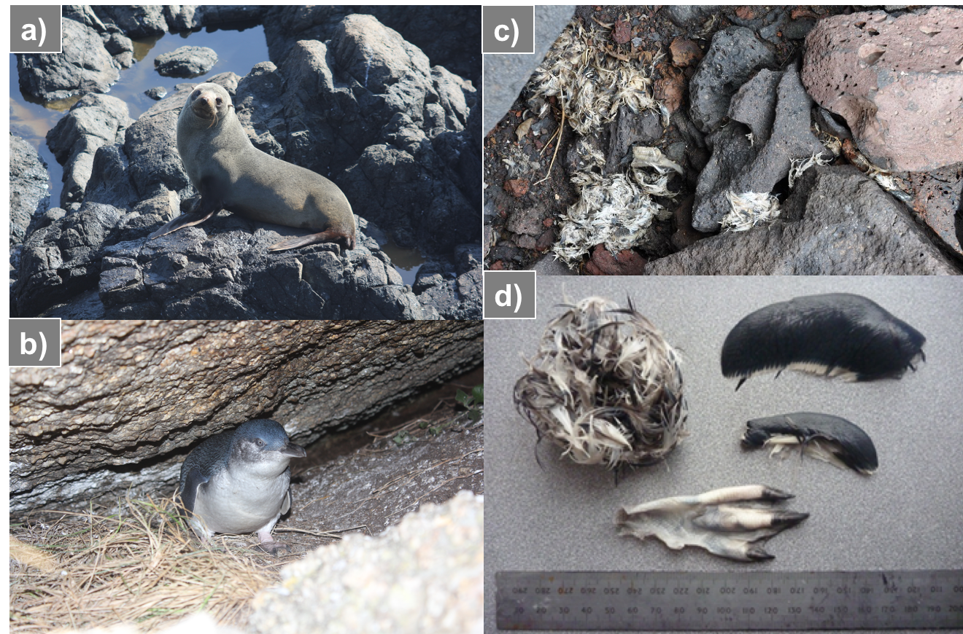
Figure 2.

Figure 3.

Figure 4.
Figure 5.
UPDATE THIS
