Natasha Colletta

5/10/2018

Assignment 1.4 – Data Models

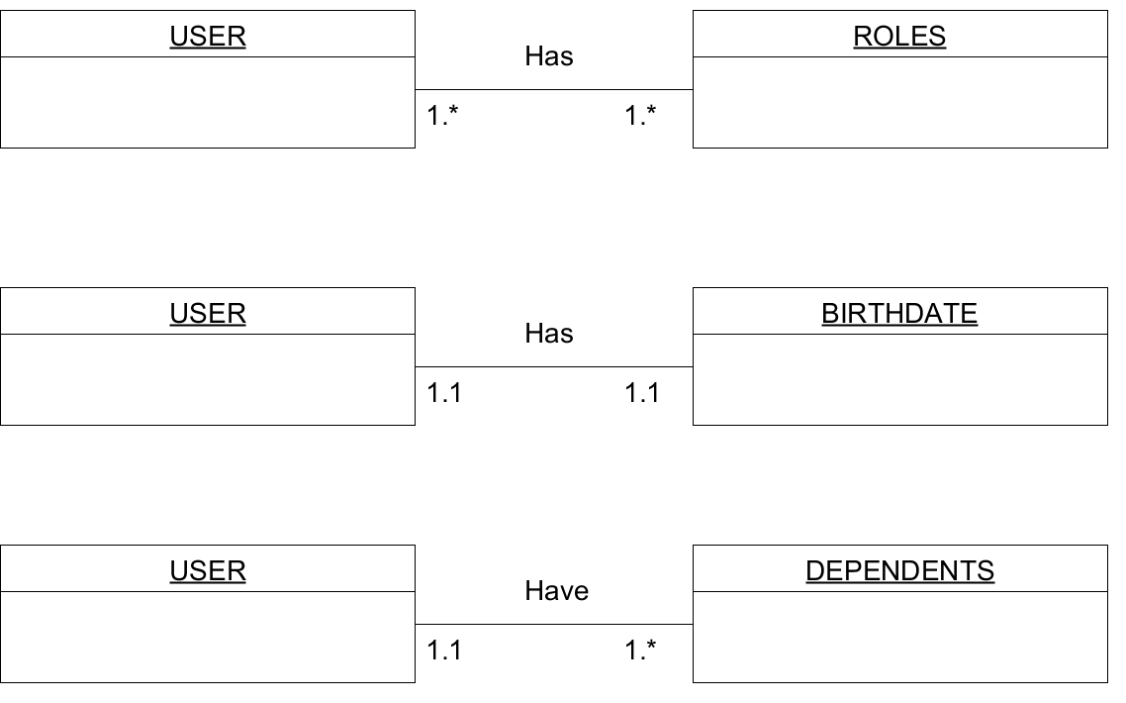

{"roles": [

{"type": "student"},

{"type": "teacher"}

],

"birthdate": "May 8th 2018",

"dependents": [

{"relationship": "daughter"},

{"relationship": "son"}

]

}