Natasha Colletta

5/17/2018

Assignment 2.2 - NodeShopper ORD

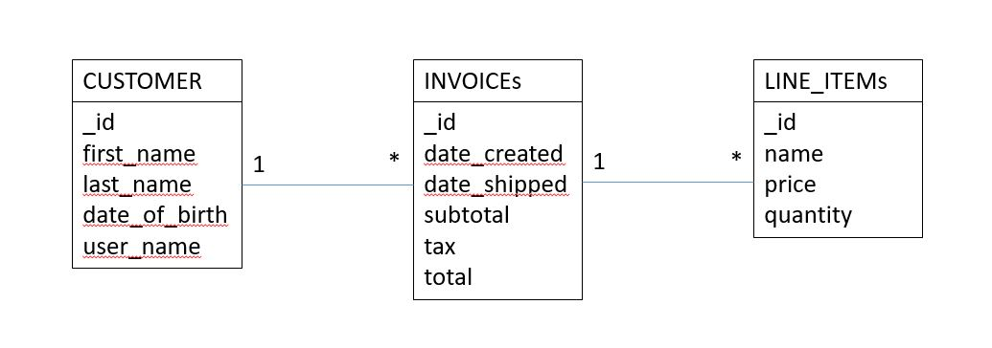

{"customer": {

"id":1,

"first_name": "Natasha",

"last_name": "Colletta",

"date_of_birth: "1/2/1880",

"user_name": "user123",

"invoices": [{

"id":2,

"lineitems": [{

"id":3,

"name": "box",

"price": "$99.99",

"quantity": "1"

}],

"date_created": "5/9/2018",

"date_shipped": "5/10/2018",

"subtotal": "$99.99",

"tax": "$0.01",

"total": "$100.00"

}]

}

}