Natasha Colletta

5/17/18

Assignment 3.2

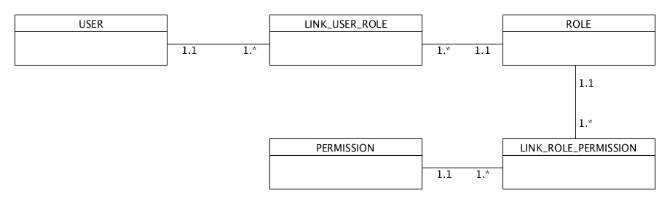

Business Rules:

1.a USER can have many ROLEs

2.a ROLE can be assigned to many USERs

3.a ROLE can have many PERMISSIONs

4.a PERMISSION can be associated with many ROLEs

------------------------------------------------------

Data Fields:

user_name

user_number

role_name

role_code

permission_access

permission_id

------------------------------------------------------

NoSQL Data Structure

{

"user": [

{"name": "John"},

{"number": "456-7891"}

],

"role": [

{"name": "KM"},

{"code": "42"}

],

"permission": [

{"access": "full control"},

{"id": "24"}

]

}