NodeQuiz TDD

1. **Introduction:**
   1. **Purpose:**
      1. Providing an end-to-end learning experience for the internal employees of NodeQuiz L.L.C. Three quizzes have been provided for the employees to test their knowledge. Options to add more quizzes are available.
   2. **Terminology:**
      1. Node
      2. Express
      3. MongoDB
   3. **User Personas:**
      1. **Student:**
         1. Age: 24
         2. Occupation: Retail/Full time student
         3. Status: Single
         4. Location: Kansas City, KS
         5. Tier: End user
         6. Tech Experience:
            1. IT/Internet: 100%
            2. Software: 95%
            3. Mobile Apps: 100%
            4. Social Networks: 100%
         7. Motivations:
            1. Incentive: 100%
            2. Fear: 30%
            3. Achievement: 95%
            4. Growth: 85%
            5. Power: 35%
            6. Social: 90%
         8. Goals:
            1. Pass class
            2. Learn more
         9. Bio:
            1. Student has been attending school for 3 years in route of trying to get B.S. in X topic. They are extremely tech savvy and a social butterfly in the online forums.
         10. Personality:
             1. Extrovert: 90%
             2. Introvert: 10%
             3. Thinking: 80%
             4. Feeling: 20%
             5. Perceiving: 85%
             6. Judging: 15%
      2. **Teacher:**
         1. Age: 38
         2. Occupation: Professor at X University
         3. Status: Married, two kids
         4. Location: Kansas City, KS
         5. Tier: Middle Tier/End User
         6. Tech Experience:
            1. IT/Internet: 90%
            2. Software: 100%
            3. Mobile Apps: 80%
            4. Social Networks: 70%
         7. Motivations:
            1. Incentive: 80%
            2. Fear: 0%
            3. Achievement: 100%
            4. Growth: 100%
            5. Power: 50%
            6. Social: 60%
         8. Goals:
            1. Teach effectively
            2. Be available for students who need assistance
         9. Bio:
            1. Teacher has been with X university for 10 years, teaching multiple subjects and is slowly becoming an online teacher. They have two kids and have been married since high school. Background is in X subject while hobbies including reading, and online gaming.
         10. Personality:
             1. Extrovert: 70%
             2. Introvert: 30%
             3. Thinking: 90%
             4. Feeling: 10%
             5. Perceiving: 85%
             6. Judging: 15%
      3. **System Admin:**
         1. Age: 29
         2. Occupation: System Admin for X University
         3. Status: Married, One kid
         4. Location: Omaha, NE
         5. Tier: Backend User
         6. Tech Experience:
            1. IT/Internet: 100%
            2. Software: 100%
            3. Mobile Apps: 70%
            4. Social Networks: 60%
         7. Motivations:
            1. Incentive: 80%
            2. Fear: 20%
            3. Achievement: 70%
            4. Growth: 80%
            5. Power: 30%
            6. Social: 70%
         8. Goals:
            1. Keep information actively available for customers
            2. Work towards new software and improvements for end users
         9. Bio:
            1. System admin has been in the business for 5-6 year’s work on networking and servers and now does back-end support for the teacher’s courses and programs. Sys admin uses their free time working on bettering their resuming and studying new software and security practices.
         10. Personality:
             1. Extrovert: 40%
             2. Introvert: 60%
             3. Thinking: 95%
             4. Feeling: 5%
             5. Perceiving: 80%
             6. Judging: 20%
   4. **User Stories:**
      1. **Student:**
         1. As a student, I want to be able to go back after selecting a quiz so that if I select the wrong one I can correct my mistake.
         2. As a student, I want to be able to go back and change my answers before submitting my quiz so that I can review and make changes if I need to.
         3. As a student, I want to be able to preview the quiz topics before starting the quiz so that I can verify I am selecting the correct topic.
         4. As a student, I want see my scores for all the quizzes so that I can see I missed any of them.
         5. As a student, I want to be able to logout so that I can change ids if I use the wrong one.
      2. **Teacher:**
         1. As a teacher, I want access to see my student’s scores so that I can see who needs assistance.
         2. As a teacher, I want access to add or remove students so that the roster is up to date.
         3. As a teacher, I want access to be able to update quiz questions so that the most current questions are listed.
         4. As a teacher, I want be able to see all students scores so that I can verify which students have taken which quizzes.
         5. As a teacher, I want to be able to see the presentations separate for the quizzes so that I can verify the students have information they need.
      3. **System Admin:**
         1. As a system admin, I want access to see the website as all types of users so that I can verify all users see what they need to see and not more.
         2. As a system admin, I want the ability to add and remove users so that the correct people have access.
         3. As a system admin, I want to be able to modify permissions so that individuals have the ability to do what they need to do.
         4. As a system admin, I want be able to see the different pages for each quiz so that I can verify the end users can take each quiz they need to take.
         5. As a system admin, I want be able to modify employee ids so that I can fix issues that users may see.
   5. **Time Estimates**
      1. **Node/Express routing connections (4hrs)**
      2. Predefined employee Id’s in MongoDB database (1.5hr)
      3. **Sign in page design (4hrs)**
      4. Selectable quizzes retrieved from a MongoDB database (1.5hr)
      5. **Selectable quiz page (4hrs)**
      6. 12-slide presentation (.jpeg) associated with a give question retrieved from a MongoDB database (1hr)
      7. 10-questions associated with a given quiz retrieved from a MongoDB database (2hrs)
      8. 4-selectable answers associated with a give question retrieved from a MongoDB database (2hrs)
      9. **10-question Quiz page (3hrs)**
      10. **Results summary page saved to a MongoDB database (4hrs)**
      11. **Cumulative summary page with summary of all the quizzes taken, associated scores and a running total average, populated based on selected employeeId (5hrs)**
      12. three 12-slide presentations (6hrs)
      13. three 10-question/4-answer quizzes(6hrs)
      14. Unit testing (2hrs)
      15. QA testing (2hrs)
2. **Process Design**
   1. **Prototypes**
      1. A close up of a piece of paper

         Description automatically generated
      2. A close up of a piece of paper

         Description automatically generated
      3. A close up of text on a white background

         Description automatically generated
   2. **ORD (Object Relational Diagram(s))**
      1. 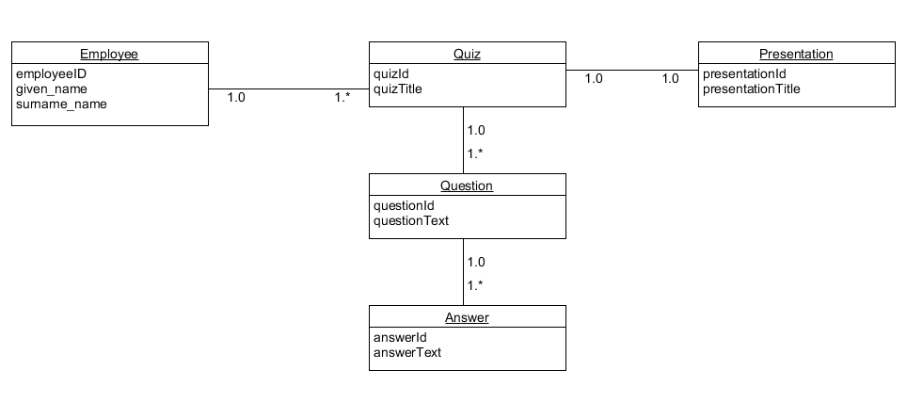
   3. **NoSQL Document Diagram**
      1. 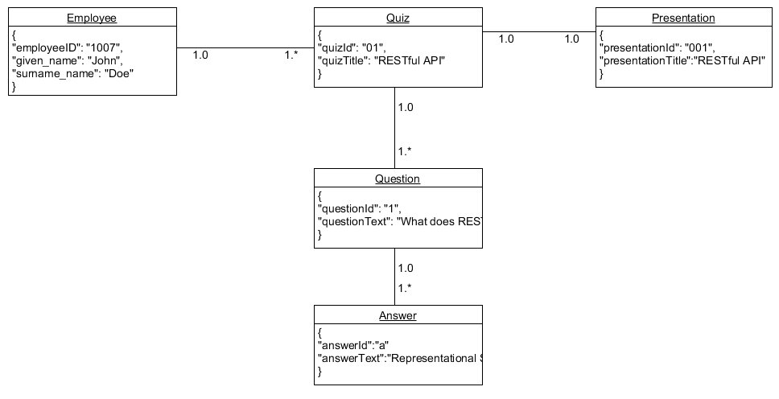
   4. **NoSQL Data Structure**
      1. 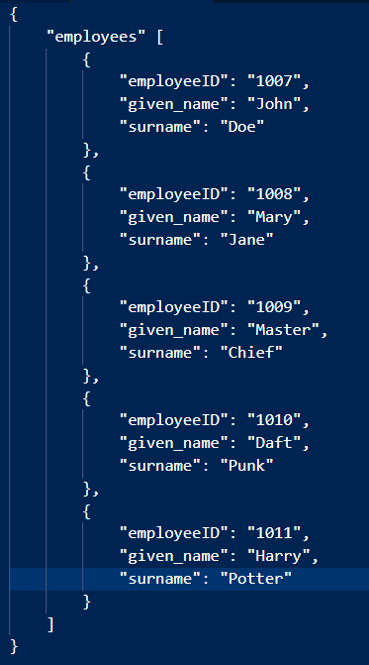
3. **QA Testing**
   1. **QA Test Plan**
   2. **Unit Tests**