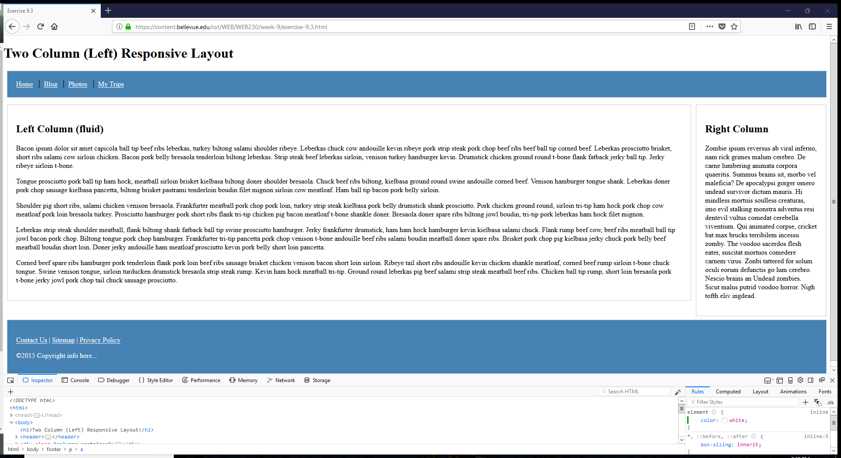

1. Press f12
2. Use selector tool to select header
   1. From here in the CSS there is a section for header and footer, this is where you add the background color for steelblue
   2. Under the .nav > li, there is a section to put the color as white
3. For the footer, the color is changed from step 2a
   1. I was able to add in the header/footer section color:white, to give the copyright text color
   2. I had to select each item in the nav to get the color to white. (not sure why this was different from the header, could be because it was a <p> not a <li>