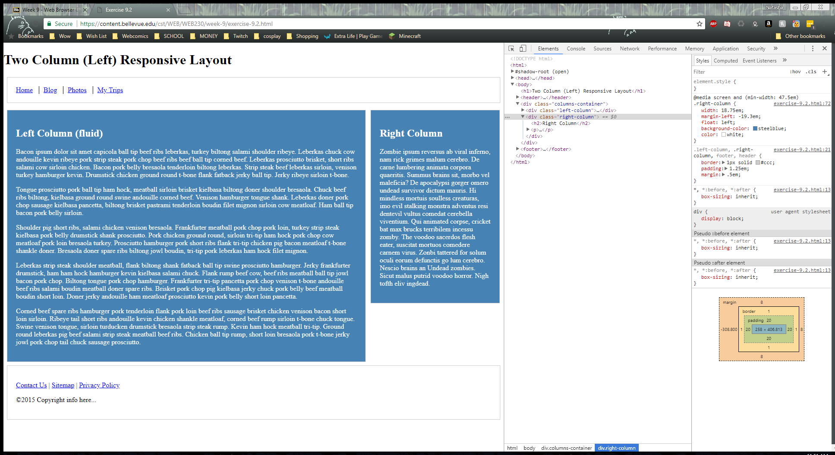

1. Using the select cursor, click on the right column and under the style tab find the properties for the right column specifically
2. Under the current properties add ‘background color: steelblue;’ and ‘color: white;’
3. Doing the same steps as 1 and 2, select the left column and follow the same direction